**INFORME ANUAL CURSO 2021/2022** 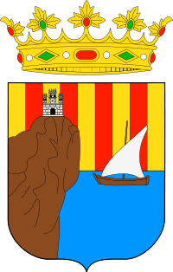

|  |  |
| --- | --- |
| **Alumno/a:** Jorge Rey Simón |  |
| **Profesor/a:** Eduardo Morales Mirón |
| **Clase:** 3-B |
|  |

|  |  |  |  |  |  |
| --- | --- | --- | --- | --- | --- |
| **ASIGNATURA** | **PRIMER TRIMESTRE** | **SEGUNDO TRIMESTRE** | **TERCER TRIMESTRE** | **NOTA TOTAL** | |
| BIOLOGÍA | 7.4 | 5.9 | 5.9 | **7.0** | APROBADO |
| CULTURA CLÁSICA | 5.1 | 7.0 | 7.0 | **5.4** | APROBADO |
| EDUCACIÓN FÍSICA | 7.5 | 4.6 | 4.6 | **6.3** | APROBADO |
| EDUCACIÓN PLÁSTICA | 8.0 | 4.7 | 4.7 | **6.0** | APROBADO |
| ÉTICA | 5.8 | 7.7 | 7.7 | **6.8** | APROBADO |
| FRANCÉS | 7.4 | 6.6 | 6.6 | **7.2** | NOTABLE |
| GEOGRAFÍA E HISTORIA | 6.3 | 5.2 | 5.2 | **6.4** | APROBADO |
| INGLÉS | 7.4 | 7.2 | 7.2 | **6.6** | APROBADO |
| LENGUA CASTELLANA Y LITERATURA | 7.3 | 7.4 | 7.4 | **6.7** | APROBADO |
| MATEMÁTICAS | 4.9 | 6.0 | 6.0 | **6.1** | APROBADO |
| MÚSICA | 4.9 | 6.8 | 6.8 | **5.8** | APROBADO |
| TECNOLOGÍA | 4.2 | 4.4 | 4.4 | **4.8** | SUSPENSO |

**Progreso trimestral:**

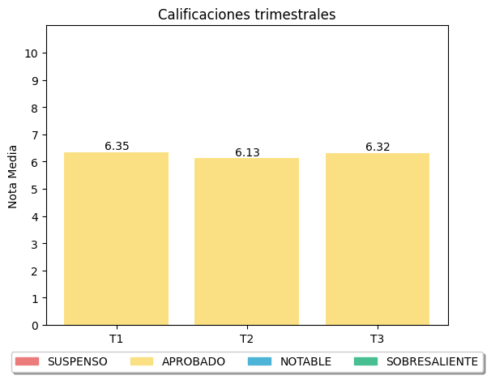

|  |
| --- |
| **COMENTARIOS** |
|  |
|