**INFORME ANUAL CURSO 2021/2022** 

|  |  |
| --- | --- |
| **Alumno/a:** Natalia Marquina Monedero |  |
| **Profesor/a:** Eduardo Morales Mirón |
| **Clase:** 3-C |
|  |

|  |  |  |  |  |  |
| --- | --- | --- | --- | --- | --- |
| **ASIGNATURA** | **PRIMER TRIMESTRE** | **SEGUNDO TRIMESTRE** | **TERCER TRIMESTRE** | **NOTA TOTAL** | |
| BIOLOGÍA | 9.0 | 9.5 | 9.5 | **9.5** | SOBRESALIENTE |
| CULTURA CLÁSICA | 9.0 | 9.5 | 9.5 | **9.5** | SOBRESALIENTE |
| EDUCACIÓN FÍSICA | 6.3 | 4.4 | 4.4 | **6.2** | APROBADO |
| EDUCACIÓN PLÁSTICA | 7.8 | 5.6 | 5.6 | **5.8** | APROBADO |
| ÉTICA | 7.6 | 6.3 | 6.3 | **6.5** | APROBADO |
| FRANCÉS | 9.0 | 9.5 | 9.5 | **9.5** | SOBRESALIENTE |
| GEOGRAFÍA E HISTORIA | 7.1 | 5.5 | 5.5 | **6.0** | APROBADO |
| INGLÉS | 4.3 | 7.1 | 7.1 | **6.0** | APROBADO |
| LENGUA CASTELLANA Y LITERATURA | 7.4 | 5.8 | 5.8 | **6.4** | APROBADO |
| MATEMÁTICAS | 4.7 | 4.2 | 4.2 | **4.7** | SUSPENSO |
| MÚSICA | 7.4 | 6.6 | 6.6 | **6.1** | APROBADO |
| TECNOLOGÍA | 7.5 | 7.3 | 7.3 | **7.2** | NOTABLE |

**Progreso trimestral:**

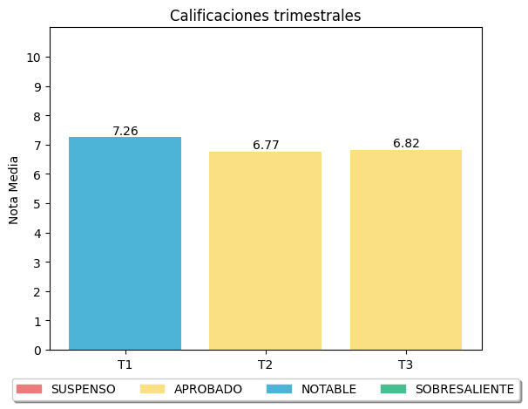

|  |
| --- |
| **COMENTARIOS** |
|  |
|