**INFORME ANUAL CURSO 2021/2022** 

|  |  |
| --- | --- |
| **Alumno/a:** Nicolás Francisco Árias |  |
| **Profesor/a:** Eduardo Morales Mirón |
| **Clase:** 3-C |
|  |

|  |  |  |  |  |  |
| --- | --- | --- | --- | --- | --- |
| **ASIGNATURA** | **PRIMER TRIMESTRE** | **SEGUNDO TRIMESTRE** | **TERCER TRIMESTRE** | **NOTA TOTAL** | |
| BIOLOGÍA | 7.0 | 4.4 | 4.4 | **5.2** | APROBADO |
| CULTURA CLÁSICA | 9.0 | 9.5 | 9.5 | **9.5** | SOBRESALIENTE |
| EDUCACIÓN FÍSICA | 1.7 | 8.6 | 8.6 | **4.7** | SUSPENSO |
| EDUCACIÓN PLÁSTICA | 3.1 | 1.3 | 1.3 | **2.5** | SUSPENSO |
| ÉTICA | 9.5 | 1.3 | 1.3 | **4.4** | SUSPENSO |
| FRANCÉS | 2.9 | 4.6 | 4.6 | **4.1** | SUSPENSO |
| GEOGRAFÍA E HISTORIA | 8.1 | 6.4 | 6.4 | **7.9** | NOTABLE |
| INGLÉS | 9.9 | 2.3 | 2.3 | **4.3** | SUSPENSO |
| LENGUA CASTELLANA Y LITERATURA | 6.5 | 6.4 | 6.4 | **6.2** | APROBADO |
| MATEMÁTICAS | 9.0 | 9.5 | 9.5 | **9.5** | SOBRESALIENTE |
| MÚSICA | 5.9 | 3.0 | 3.0 | **5.5** | APROBADO |
| TECNOLOGÍA | 6.0 | 9.7 | 9.7 | **6.5** | APROBADO |

**Progreso trimestral:**

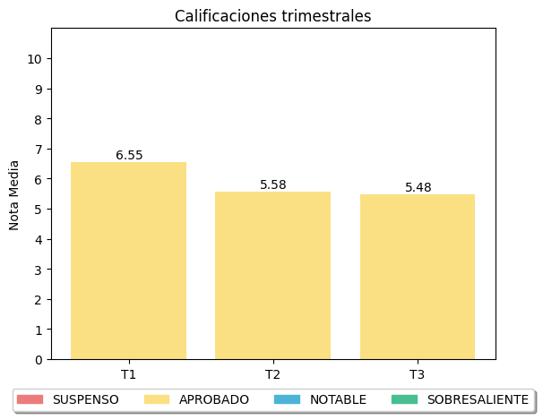

|  |
| --- |
| **COMENTARIOS** |
|  |
|