**INFORME ANUAL CURSO 2021/2022** 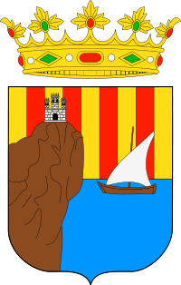

|  |  |
| --- | --- |
| **Alumno/a:** Sonia Trepat Lázaro |  |
| **Profesor/a:** Eduardo Morales Mirón |
| **Clase:** 3-C |
|  |

|  |  |  |  |  |  |
| --- | --- | --- | --- | --- | --- |
| **ASIGNATURA** | **PRIMER TRIMESTRE** | **SEGUNDO TRIMESTRE** | **TERCER TRIMESTRE** | **NOTA TOTAL** | |
| BIOLOGÍA | 1.3 | 10.0 | 10.0 | **4.4** | SUSPENSO |
| CULTURA CLÁSICA | 3.3 | 2.0 | 2.0 | **2.3** | SUSPENSO |
| EDUCACIÓN FÍSICA | 1.3 | 10.0 | 10.0 | **6.0** | APROBADO |
| EDUCACIÓN PLÁSTICA | 7.0 | 8.4 | 8.4 | **6.4** | APROBADO |
| ÉTICA | 9.4 | 8.9 | 8.9 | **9.1** | SOBRESALIENTE |
| FRANCÉS | 5.0 | 5.1 | 5.1 | **3.5** | SUSPENSO |
| GEOGRAFÍA E HISTORIA | 6.1 | 1.3 | 1.3 | **4.8** | SUSPENSO |
| INGLÉS | 5.5 | 2.0 | 2.0 | **2.9** | SUSPENSO |
| LENGUA CASTELLANA Y LITERATURA | 9.0 | 9.5 | 9.5 | **9.5** | SOBRESALIENTE |
| MATEMÁTICAS | 3.1 | 3.0 | 3.0 | **4.0** | SUSPENSO |
| MÚSICA | 9.0 | 9.5 | 9.5 | **9.5** | SOBRESALIENTE |
| TECNOLOGÍA | 0.6 | 6.5 | 6.5 | **5.2** | APROBADO |

**Progreso trimestral:**

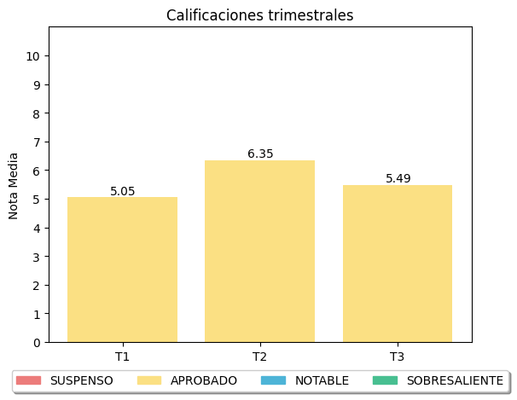

|  |
| --- |
| **COMENTARIOS** |
|  |
|