

**Team :** Honey Badgers

**Members:**

Cuzco

Díaz Antun Stefany Maricela

Garcia Galarza Mateo Jarén

García Romero Eduardo David

**NRC:** 14575

**Course:** Object Oriented Programming

**Date :** 2023-11-18

**Period:** SII-2023

**Assignment :** Workshop

**Topic:**  Finding Object then classes, then models

**PROBLEM**

La tienda “Viveres Gaby” ubicada en la provincia de Morona Santiago, cantón“Tiwintza”, presenta una gran afluencia de clientela, conforme avanza el tiempo la distribución del stock entre bodega y la venta al público se complica de llevar manualmente, además que el operador requiere bajar los precios manualmente de cada producto cuando se aplica un descuento de temporada, por otra parte se pretende solventar la necesidad del sistema facturero y contable, permitiendo al usuario generar informes contables completos de manera automática a la par que se registra los datos tanto de clientes como de productos para su posterior administración.

**OVERVIEW**

The general aim of the project is to assist in the management and administration of a grocery store, streamlining and automating processes to become a practical tool applicable in daily life.

The main functionalities offered by this software revolve around five key points:

* Warehouse and store stock registration: Facilitating inventory control and availability of groceries and other products through a CRUD (Create, Read, Update, Delete) system.
* Customer registration: Simplifying the invoicing process by requiring a single registration, thereby automating the billing process.
* Invoicing and Financial Reporting: Generating dynamic invoices based on customer and entered products, calculating the total amount. Subsequently, the software allows for the download of a PDF document containing the comprehensive financial report, facilitating tax calculations.
* Taxes: Offering tax calculations based on changing government data. A clear example is the calculation of VAT, for which web scraping will be performed on the website: https://codex.com.ec/tabla-de-retenciones-de-iva/.
* Seasonal offers and corresponding control: The system will provide support for implementing and managing seasonal offers.
* This solution aims to be a comprehensive tool that simplifies store management, from inventory control to invoicing and tax calculations, enabling more efficient and practical administration in the day-to-day operations of the business.

**BACKGROUND**

Tiwintza, a canton located in the province of Morona Santiago, has around 6,695 inhabitants, which means that despite being a small neighborhood compared to those in the city, it is quite busy with residents and at the same time by people who visit the place. It is for this reason that in this case we will focus on the "Víveres Gaby" store, which in its beginnings was only visited by a small part of the population surrounding the place, precisely because it had a small amount of basic products for sale.

It can even be mentioned that at that time there was no problem in manually counting the products sold, or keeping a detailed record of the profits that were generated daily. However, everything mentioned above began to complicate with the passage of time, since the “Víveres Gaby” store began to be recognized little by little, thus obtaining a constant growth in its clientele and an increase in the purchase of more merchandise to supply the store. With this increase in demand, manual inventory management has become increasingly complex and prone to errors, and in the same way, we can talk about the distribution of stock, since this requires meticulous tracking, but the lack of an automated system that helps perform this task.

A clear example of everything mentioned occurred shortly after the implementation of the venture, where only 3 to 4 people at most came in to purchase the products, for this reason it was easy to register one by one, all of them. the purchases they made. However, after 1 year, the store already had more merchandise and for this reason many people came to purchase products, whether health, food, among others. And that is where the problem was reflected, since even though the saleswoman was able to count all the products sold and the profits obtained, it was very tiring and as the days went by it became even more complicated. further.

Another relevant and very important point is the need to apply discounts to products on important dates such as Christmas, New Year's Eve, Mother's Day, among others. Well, this involved the salesperson making that discount percentage manually and in the same way at the beginning, it was easy due to the little merchandise the store was stocked with, but once it increased, it was difficult because she did not have the ability to quickly highlight discounts since the number of buyers was robust and many mistakes could be made due to the pressure of the moment due to the number of buyers.

In this sense, this situation not only affects operational efficiency, but can also result in lost revenue or customer dissatisfaction if discounts are not applied accurately and in a timely manner.

Additionally, the absence of an integrated billing and accounting system has led to a manual and laborious process to maintain accurate financial records. Generating complete accounting reports has become a time-consuming and error-prone task, making it difficult to make informed decisions.

**SEASONAL DISCOUNTS**

Products will not have a fixed price; it is intended that these prices can decrease based on determining variables such as holidays, seasonal fruits, tax reduction, Black Friday, Christmas, among others.

The main idea behind this section of the program is to allow the user to control product prices by sections, applying discounts for a defined delimited time. Thus, if a product purchase is registered, the system will be capable (autonomously) of setting its price based on a percentage.

The conditions that determine the price of a product on a seasonal discount are defined as follows:

Time: Which dates will be suitable for applying the offer.

Percentage or promotion: Where the algorithm will determine the final price of the product for public sale (PVP) regarding:

Percentage: Percentage Discount

Multiplicity: 2x1, 3x2, among others.

Seasonal discounts are also recorded in a history contributing to financial analysis. The key points preserved as very important for this section are:

Persistent Data Integration

Continuous Evaluation and Optimization: Losses will always be notified when they occur.

Automation: Users must provide minimal information for execution.

User Guide: Users will always be kept informed about program operation.

Example of tables that could be implemented:

First, we define the promotions of multiplicity that could be contributed.

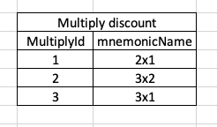

Afterward, we define a promotion; in this case, let's suppose that mangoes are in season, so the manager has decided to apply a 2x1 discount.

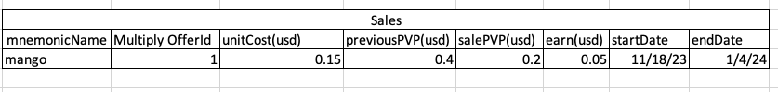

Regarding percentage discounts, a reduction is implemented and calculated based on it.

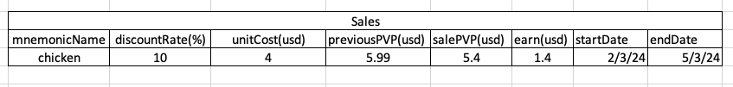

An important point to note is that discounts can also represent an economic loss for the store, as many offers may solely aim to attract clientele.

**BILLING SYSTEM**

The billing system will require some important topics to be able to function correctly with respect to the store in general and its customers. We have several specific needs that we must meet such as:

* **Inventory management:** to maintain precise control of the inventory of products both purchased and sold, this system will have real-time programming, with replenishment alerts and notifications of products that are about to expire.
* **Electronic Billing:** to comply with tax regulations and streamline the billing process, generating electronic invoices that have an integrated local tax system and secure storage in a database
* **Customer management:** being able to build a customer database, record their purchase history, among other requirements.
* **Supplier management:** in order to maintain an efficient relationship with them, having a strict record of them, order tracking, price comparison and evaluation of supplier performance.
* **Integration of barcode readers:** to streamline the product registration process at the point of sale by having compatibility with barcode readers to facilitate product entry and avoid manual errors.
* **Accounting integration:** being able to facilitate the accounting process and avoid possible duplication of records, creating an export of accounting data in standard formats integrating an already existing accounting software system.

These specific needs and functionalities provide a foundation for the invoice system, addressing crucial aspects to improve efficiency and operational management of the store.

The design of this billing system has a design of structures and reference tables starting with the database:

* **Product Table**: Contains detailed information about products, including name, barcode, price, quantity in stock, and supplier.

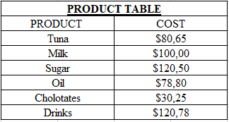

* **Customer Table:** Stores customer data such as name, address and contact details.

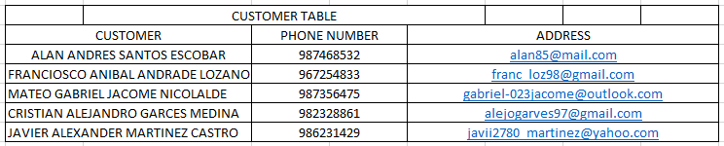

* **Transaction Table**: Records each sales transaction, linking products and customers, and providing temporal details.

Likewise, the billing system will have a user interface that contains specifications such as:

* Intuitive and friendly design: with an easy-to-navigate point-of-sale interface, with intuitive icon and color options to indicate statuses (out of stock products).
* Search and filtering functionalities: quick search for products by name or barcode and filters to classify products by category, prices, among other aspects.

And lastly and most importantly we have the main functionalities of the billing system which are:

* Generation of electronic invoices.
* Registration of products and prices.
* Customer and supplier management.
* Inventory control in real time.

However, we must not forget that an important part of this billing system has to do with the technologies used, which have to do with the choice of the programming language, the selected database and the development and testing tools at the time of implementation. All of these things will achieve an improvement in speed in the billing system, a reduction in administrative times and an increase in customer satisfaction.

**INVENTORY MANAGEMENT**

Inventory management, or stock management, is a process used to control the quantity of products or goods available. This process involves the planning, organization, and monitoring of all stages related to the entry, exit, and storage of products in a company or business. For the Inventory Management process at "Viveres Gaby," the following stages are presented:

1. **Initial Stock Registration:**

Each product available in the store is recorded in the system with information such as name, product type, base price, and supplier. Additionally, the system automatically applies discounts to designated products during discount seasons.

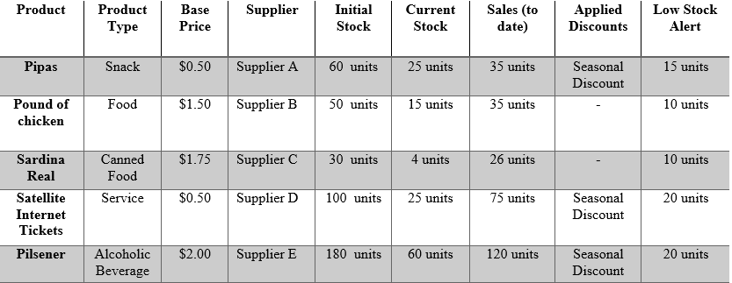

Díaz S. (2023). Inventory Management at "Viveres Gaby." Víveres Gaby Store.

1. **New Stock Entry:**

When new merchandise arrives, products are scanned or registered in the system, indicating the quantity received and automatically updating the inventory.

1. **Automatic Stock and Sales Update:**

The system will update sales in real-time by selecting products and the quantity sold, automatically adjusting the available stock level as sales are made. All transactions, whether it be receiving merchandise, sales, or discount applications, are recorded in a historical database for future analysis.

1. **Low Stock Alerts:**

The system issues automatic alerts when the stock level of a product reaches a defined quantity.

1. **Stock Monitoring:**

The business owner has access to control panels that allow real-time monitoring of the inventory, identifying sales trends, and making informed decisions.

This comprehensive inventory management process at "Viveres Gaby" ensures efficient and automated management, minimizing manual errors, improving accuracy in data recording and calculations, and optimizing product availability to meet customer demand.