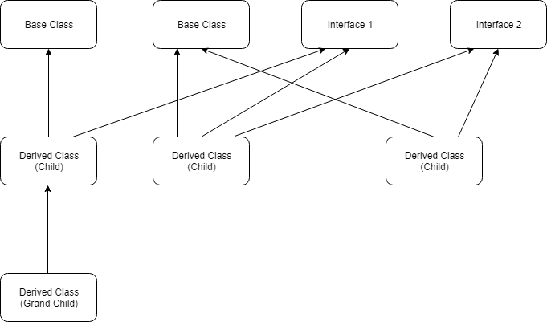

Customer

Order

Feature

Product

Restaurant/

hotels

Regular

Customer

Product

IProduct

ICustomer

Also make sure,

1.Customer class should have a method that can be overriden by child classes

1.Customer class should not allow its instantiation.

1. Product class should have a method that must be overriden by child classes1.

1. regular customer class should have a method that hides a parent method.

1. Feature product should have a propery that hides a property in a parent class.

1. Feature product should have a method that is overriden and uses base class implementation of that method as well.

1. Resturent/hotel should protect itself from getting inherited.

1. Show case all the use-cases above in Main().