Exercise: Smart Wallet
A Smart Wallet Web App is a digital platform that enables users to manage their finances, perform secure fund transfers, and monitor transactions conveniently from their browser. You will have to create an application which has several pages and core components.
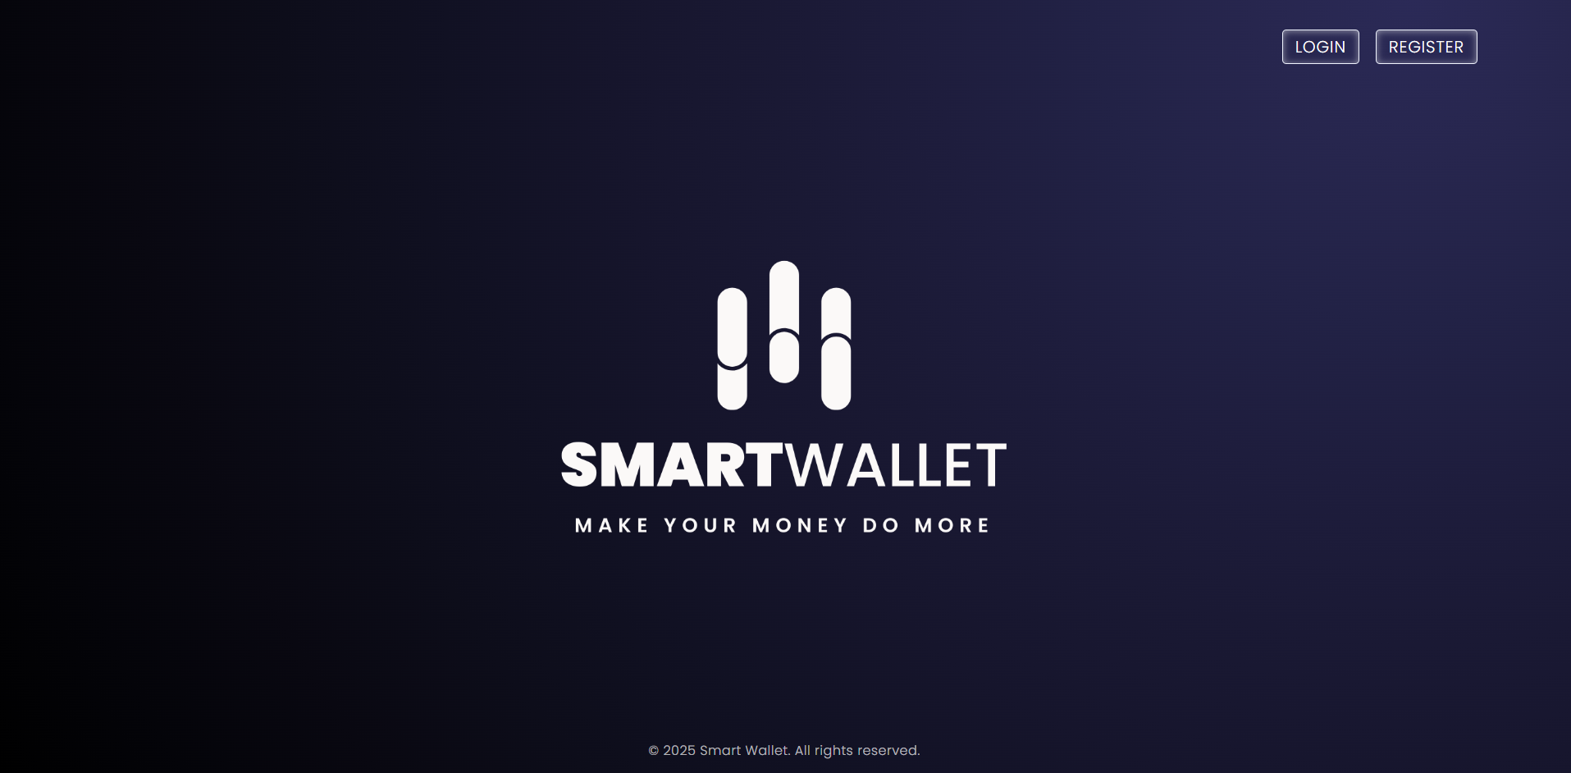

Model
This is the model layer of the application. There are some objects for you to implement first.

User
- id – an UUID.
- username – a String, the username of the user
- firstName – a String, the first name of the user
- lastName – a String, the last name of the user
- profilePicture – a String, URL containing link to picture of the user
- email – a String, email of the user
- password – a String, password of the user
- role – a UserRole, enumerated value (ADMIN, USER)
- country – a Country, enumerated value (BULGARIA, GERMANY, FRANCE)
- isActive – a boolean value which indicates whether the User is active
- createdOn – LocalDateTime, the date and time the User account was initialized
- updatedOn – LocalDateTime, the date and time the User account was updated
- subscriptions – a List of Subscription containing user's subscriptions
- wallets – a List of Wallet containing user's wallets

Wallet
- id – an UUID
- owner – a User, the owner of the Wallet
- status – a WalletStatus, enumerated value (ACTIVE, INACTIVE)
- balance – a BigDecimal, the amount available in the wallet
- currency – a Currency of the amount in the wallet
- createdOn – LocalDateTime, the date and time the new Wallet was created
- updatedOn – LocalDateTime, the date and time the Wallet state was updated

Subscription
- id – an UUID
- owner – a User, the owner of the Subscription
- status – a SubscriptionStatus, enumerated value (ACTIVE, COMPLETED, TERMINATED)
- period – a SubscriptionPeriod, enumerated value (MONTHLY, YEARLY)
- type – a SubscriptionType, enumerated value (DEFAULT, PREMIUM, ULTIMATE)
- price – a BigDecimal, the price of the subscription the user paid
- renewalAllowed – a boolean value which indicates whether the Subscription plan can be automatically renewed by our system - if the user buys a monthly subscription, then the system will automatically renew their subscription when the time comes, if the subscription is yearly, there will be no automatic renewal for the subscription
- createdOn – LocalDateTime, the date the Subscription was created
- completedOn – LocalDateTime, the date the Subscription was completed - that could happen due to subscription change

Transaction
- id – an UUID.
- owner – a User, the user for which the Transaction was initiated for
- sender – a String, identifier of the wallet from which we take the money
- receiver – a String, identifier of the wallet to which we give the money
- amount – a BigDecimal, the amount of the Transaction
- balanceLeft – a BigDecimal, the remaining amount after the Transaction
- currency – a Currency used for the Transaction
- type – a TransactionType, enumerated value (DEPOSIT, WITHDRAWAL)
- status – a TransactionStatus, enumerated value (SUCCEEDED, FAILED)
- description – a String, description of the Transaction
- failureReason – a String, the reason for the failed Transaction - in case the transaction can’t be executed for some reason
- createdOn – LocalDateTime, the date the Transaction was made

ER Diagram
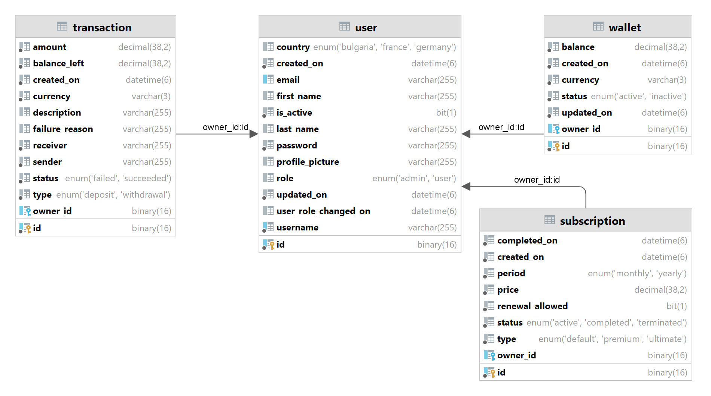

Data Access
The application must support basic functionality involving CRUD (Create, Read, Update, Delete) operations. You must implement repositories for every entity to persist data

Business Logic

Registering a New User
When a new user registers, they need:
- Account Creation: Validate the username to ensure its unique and store the user’s details securely. You must consider persisting user’s sensitive data in a secure way!
- Default Wallet Creation: Automatically create a wallet for the user
- Default Subscription Setup: Assign a free subscription to the user upon registration

Skeleton for the Method:
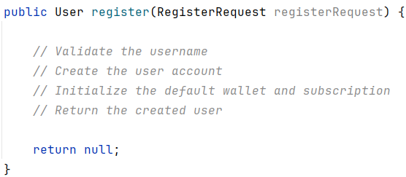
The register method handles the entire flow. It takes a RegisterRequest object (with fields like username, password, and country) and returns a fully initialized User object.

Registration UI
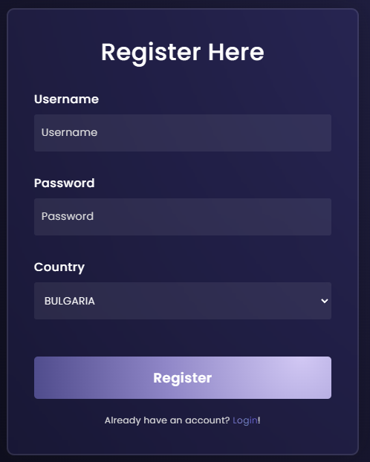

Registration UI - validation constraint violated
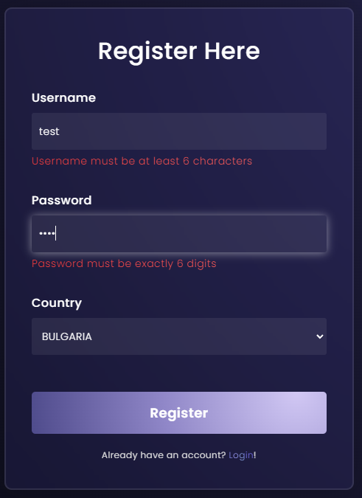

Wallet Creation
Each user is assigned a wallet during registration. The wallet should be initialized with values defined in your configuration properties:
- Initial Balance: €20
- Default Status: ACTIVE
- Currency: Euro (EUR)
This ensures every user starts with a functional financial account that is ready to use.
Skeleton for the Wallet Creation Logic:
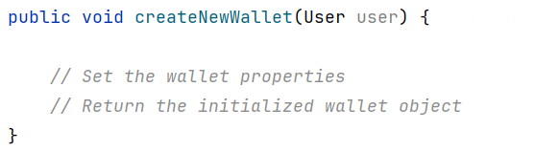

Subscription Creation
Subscriptions provide access to app features. Every user starts with a free default subscription, configured as follows:
- Type: DEFAULT
- Period: From configuration (e.g., MONTHLY)
- Price: €0 (free by default)
- Renewal Eligibility: Renewals are allowed only for monthly subscriptions
Skeleton for Subscription Creation Logic:
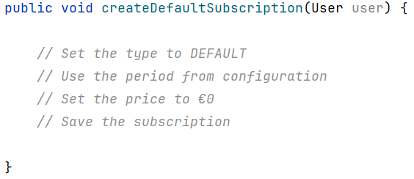

Login
The login functionality validates a user’s credentials and ensures that only authorized users gain access
Steps to Consider:
- Verify the username exists
- Confirm the password matches securely
- Return the logged-in user
Skeleton for the Login Method:
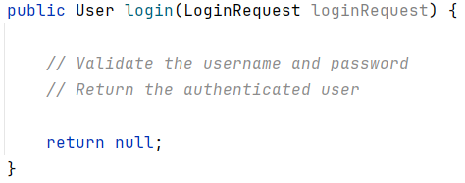

Login UI
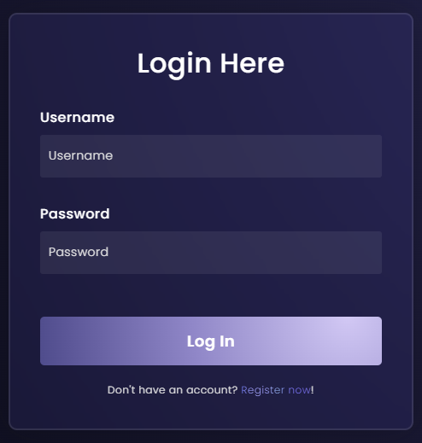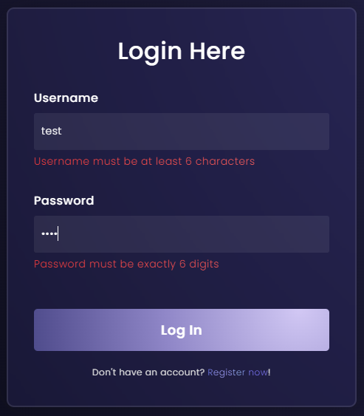
After successful login:
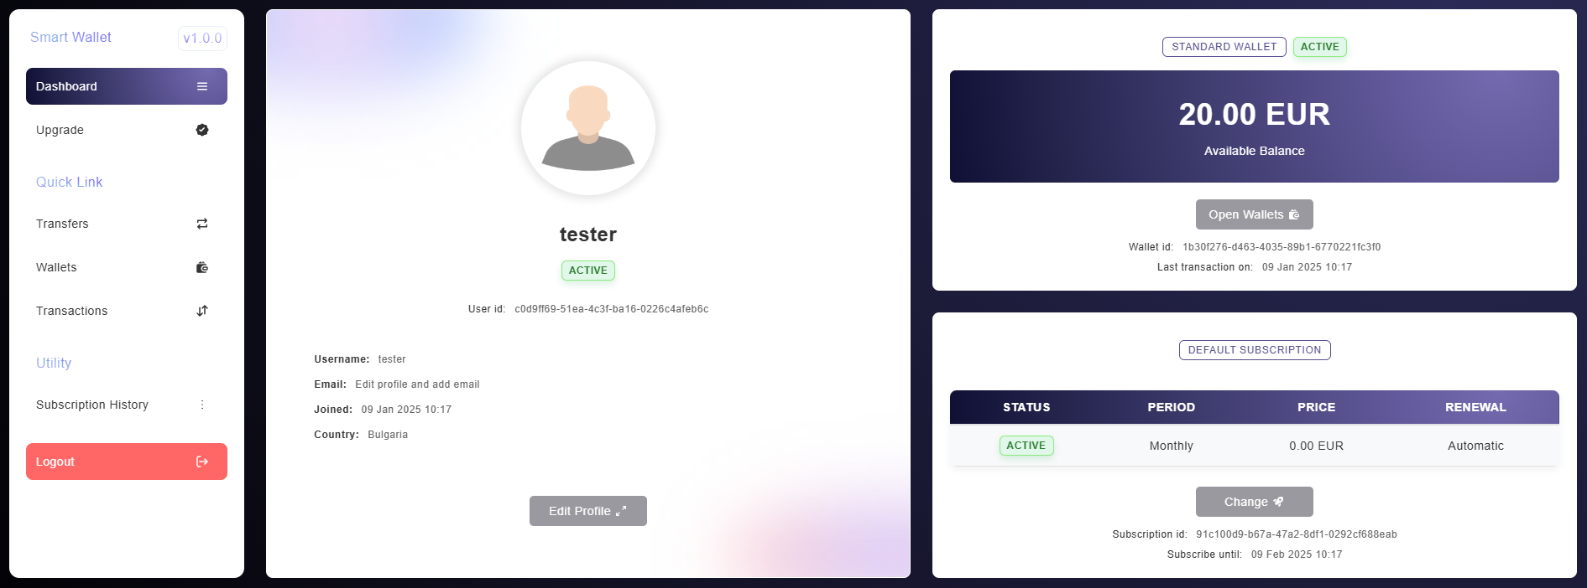

Top-Up: Adding Funds to Wallets
Users can increase their wallet balance by performing a top-up operation.
Steps to Consider:
- Retrieve the wallet using its ID the user wants to top-up
- Verify the wallet is ACTIVE before proceeding, INACTIVE wallets are not eligible for top-up
- Add the top-up amount to the wallet balance
- Record the transaction and save it for auditing purposes

Skeleton for the Method:
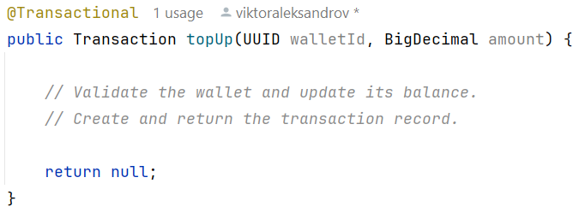
Wallet before top-up:
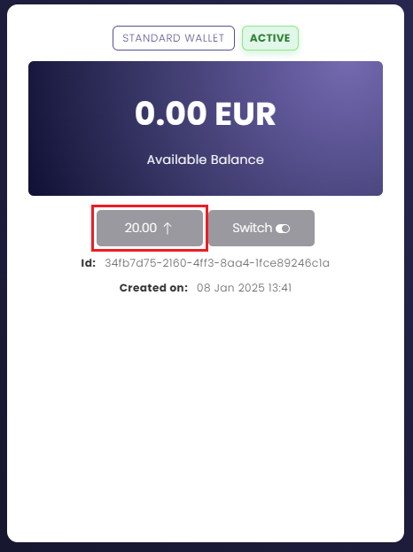

Confirmation of successful top-up:
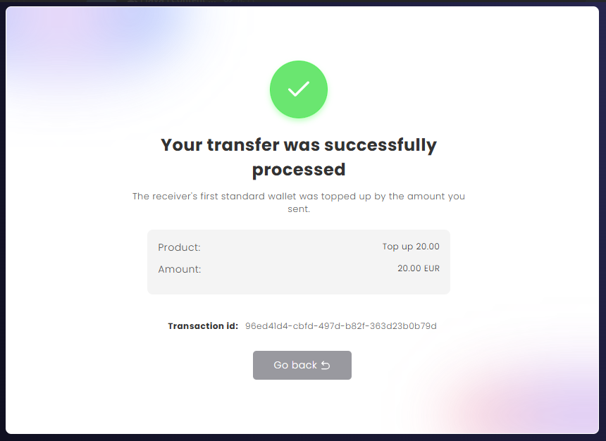
Wallet after top-up:
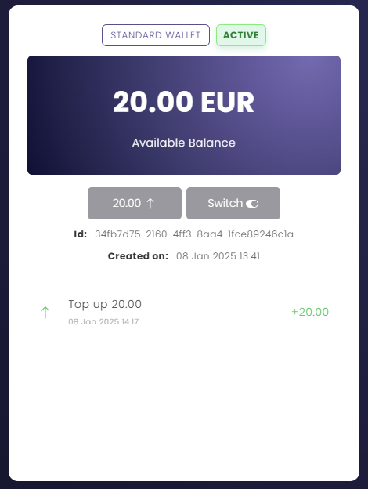

Charge: Deducting Funds from Wallets
A charge represents an outgoing payment from a wallet
Steps to Consider:
- Retrieve the wallet using its ID
- Ensure the wallet is ACTIVE and has sufficient funds
- Deduct the specified amount from the wallet balance
- Record the transaction and save it
Skeleton for the Method:
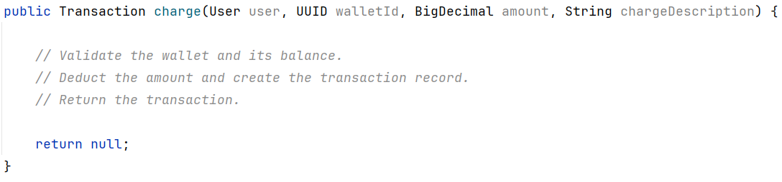
NO MATTER THE CASE - you need always to return a transaction for that charge even if it is a failed or succeeded transaction for tracking purposes.
PREMIUM subscription charge:
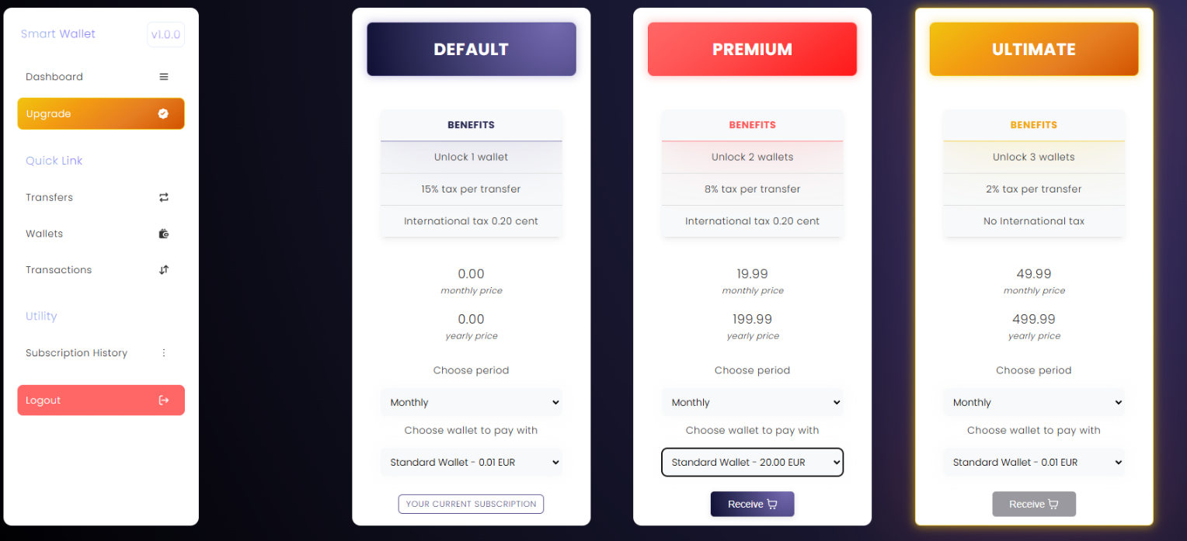

Confirmation of successful transaction:
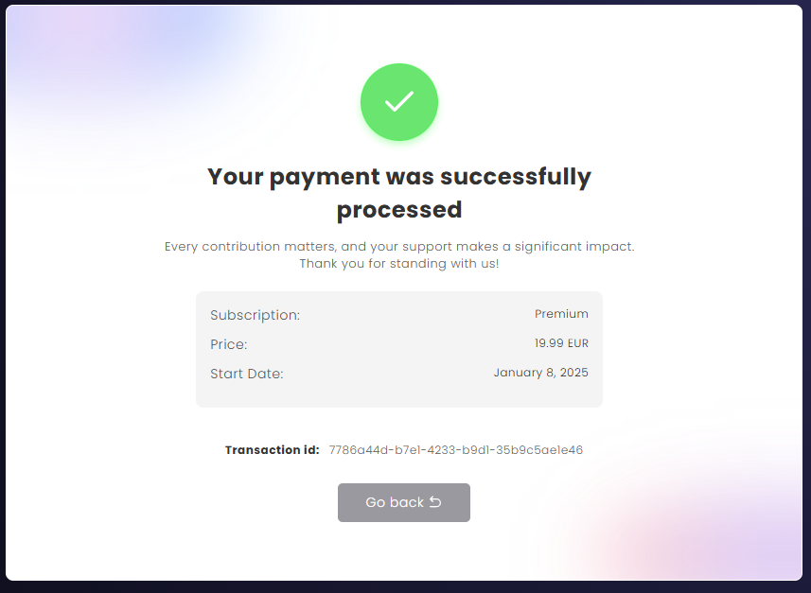
Unsuccessful transaction
