**Introduction**:

In this mode, player will start with **3 health tokens** to represent health condition. Player loses the game when losing all of them. There will also be some **items** to help you to find a way out. Be careful when using them!

Read the cards carefully when you get them.

**Rifle** – An old rifle that can only shoot once.

**Boost** – A special effect to boost your vehicle. Only available once. Only when you are driving.

**Medicine** – Only available once. Restore 1 health. Cannot use during choices (like when you are killed by a choice, you cannot save yourself immediately. You can only use before and after the choice).

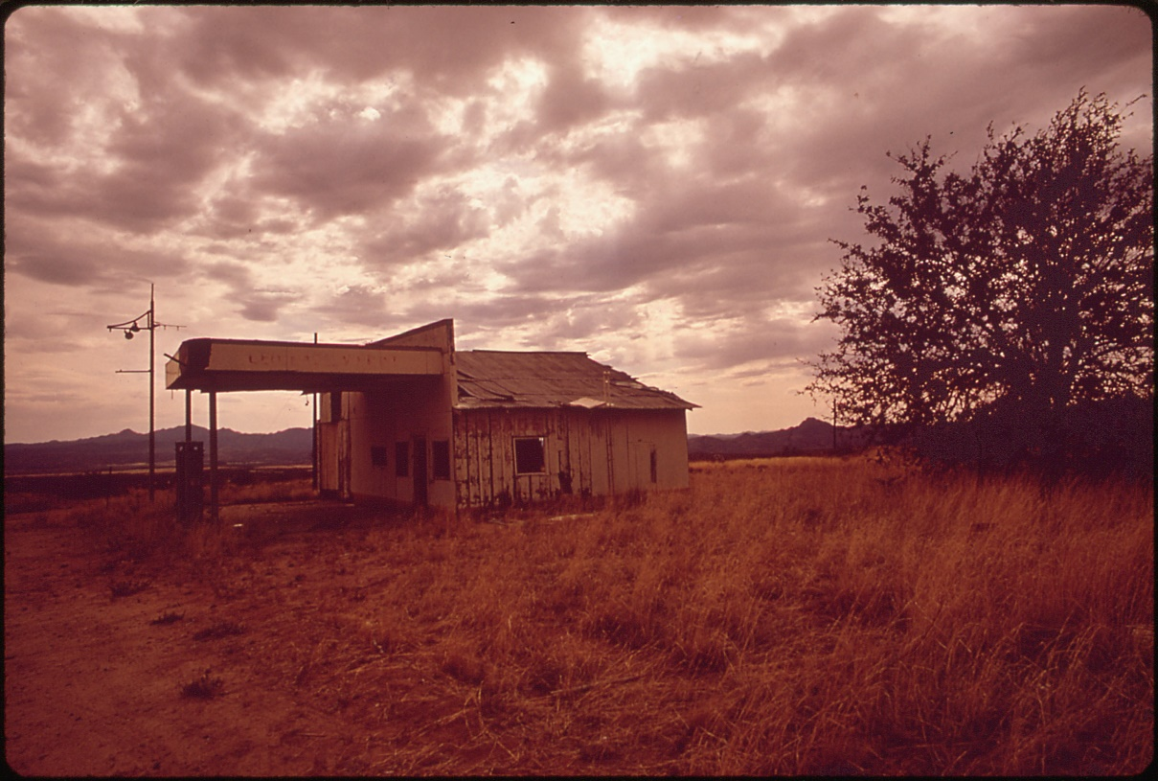

You decided to pick up Sean who lives in the South. You no longer got any messages from your girlfriend. You are very upset that you are not able to pick up both of them, but life has to go on. Sean lives very far away from you, you see a gas station where several zombies are hanging around inside. It seems that it is risky to refill the fuel. **Do you want to refill your fuel?**

Choices:

1. Refill the fuel

After filling your fuel, several zombies attacked you. You were hurt while you were trying to escape. You **lose one health**, but you have a chance to **boost (1 of 3 special card, see card)**.

1. Drive through

Nothing happens

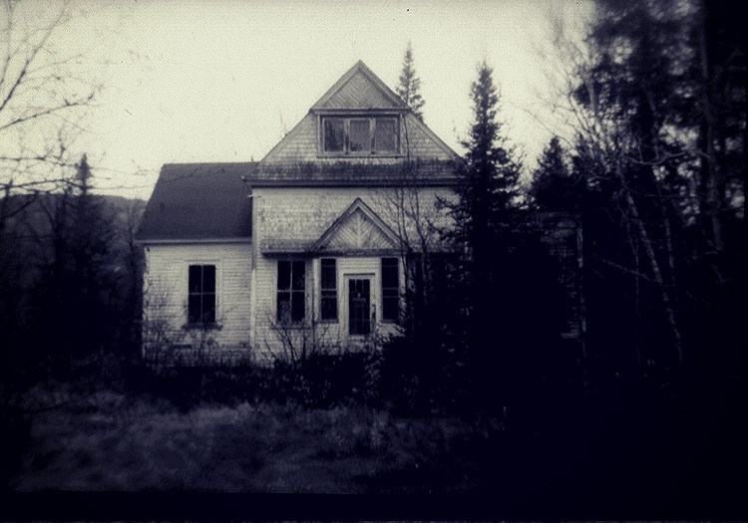

After a day of driving, you arrive at Sean’s house and you find that the door is open. There are some bloods in the yard, and you find that it is so quiet that the only sound is your car engine. You can’t stay here for too long, because the sound would attract the zombies, you have to make a quick decision. **Do you want to enter the house to find Sean?**

Choices

1. Yes

After you enter the door, two zombies in the house somehow attack you and you **lose one health.** Sean rushes into the house from outside and save you. He told you that he was hiding outside the house because the zombies broke into his house in the afternoon, so he could no longer stay inside the house.

1. No

You wait for a few seconds, and when you are about to leave, you hear some voices come from the cellar. You find Sean there and you leave together. Sean tells you that he was hiding outside the house because the zombies broke into in the afternoon.



You and Sean go on your trip. It becomes totally dark outside. You drives through a forest, you both feel sleepy. **What do you want to do?**

Choices:

1. Keep driving

Nothing happens

1. Set campfire in the forest, and take a sleep there.

**You will be bitten while you are asleep, you died.**

1. Set campfire in the forest, and sleep in the car.

**You gain one health**

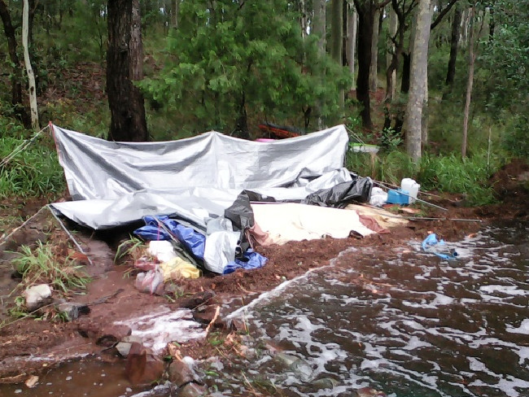

The next morning, you and Sean drive pass a lake and you found a camp that is right next to lake. There are no normal people in the camp, only zombies. Because it was a mess on road, you cannot drive to the camp, if you want to go to the camp, you can only walk over there. There might be some supplies in the camp, but it is also risky to walk on foot to get to the camp (cannot use BOOST). **Do you want to go to the camp or leave right away?**

Choices

1. Go to the camp (very risky)

You find **a Medicine box (intro)** and **a rifle with 1 bullet**. However, a zombie attacks you. You **lose 2 health** while fight. Remember, if your health becomes zero, you died.

1. Leave

Nothing happens

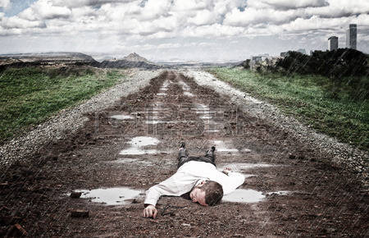

You are about to run out of your gas, and you see a dead body next to the road. You have to two choices, you could either use the boost card, so that you could skip this scene, and nothing would happen; or you could choose to drive normally until the car runs out of gas and stop with the zombie in sight.

Choices

1. Stop

You’ll lose one health because the dead bodies turn to zombie and attack you. You decided to:

**a. use your rifle** - decided to shoot the zombie. You escape the attack and keep going on your trip.

**b.** Fight with bare hand - **you’ll lose one health**.

1. Boost!

You can **skip this scene**, and **lose your boost card**.

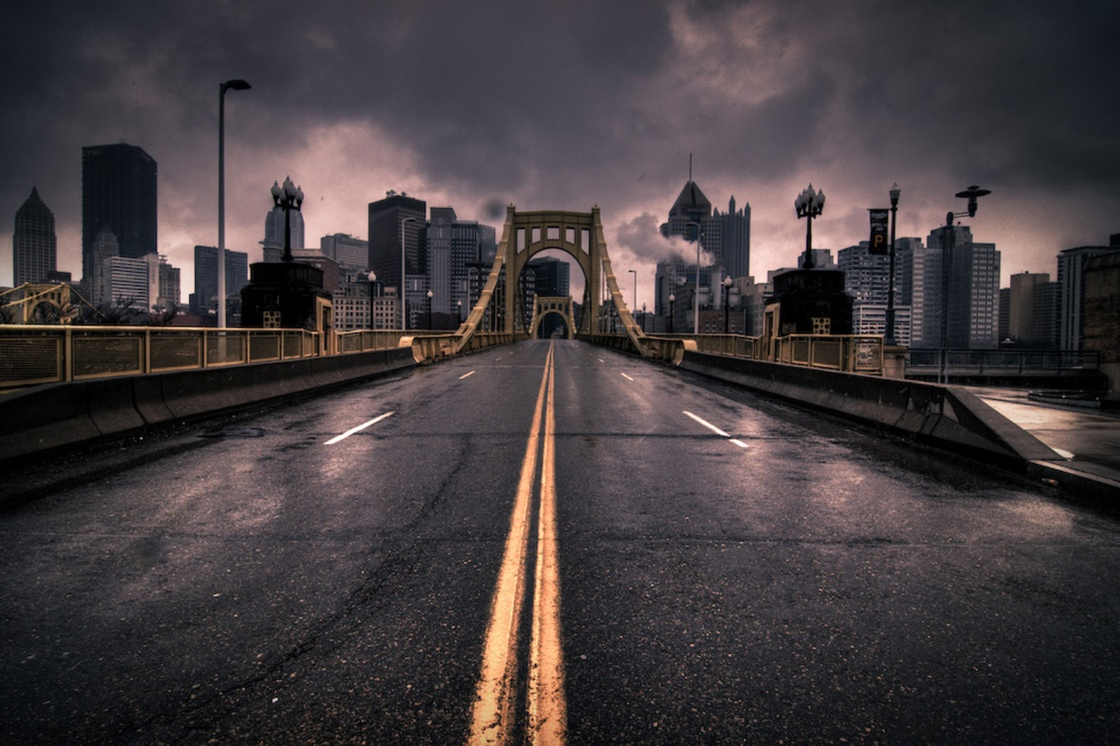

Several hours later, you finally see another city.

Although you cannot see any zombies, you hear several gunshots from further inside the city. On the road that leaves the city, you see several car traces on it.

1. Enter the city
2. Follow the traces

Trace

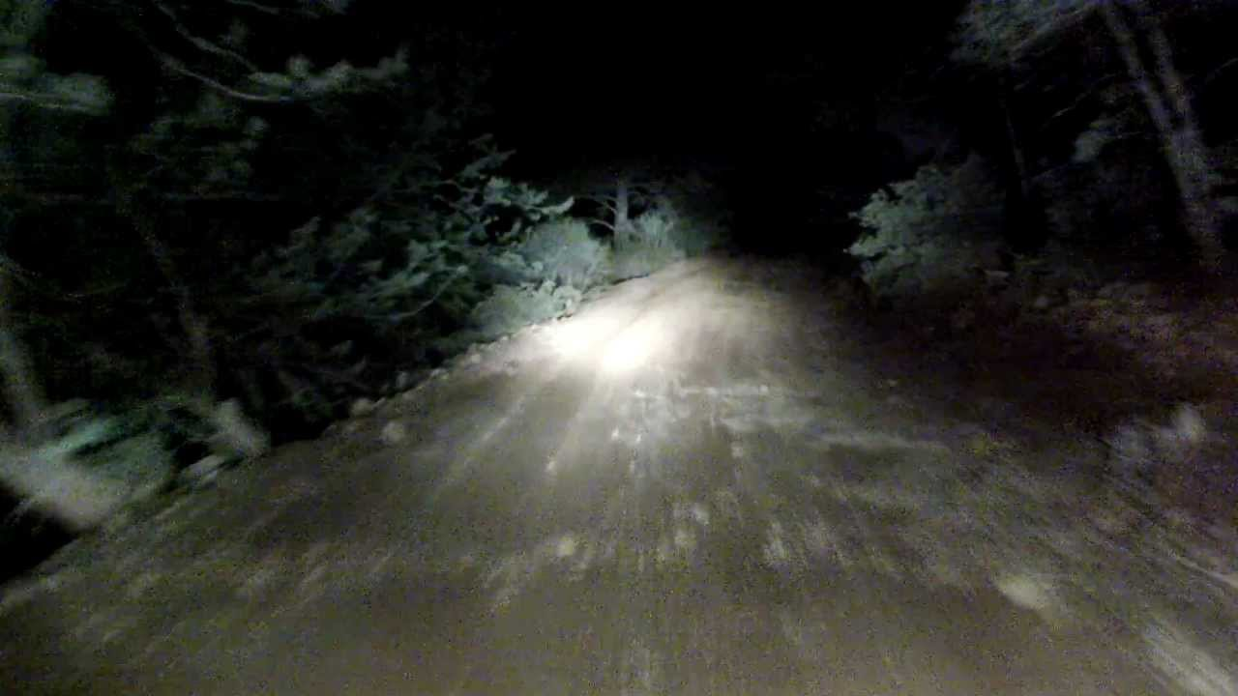

Another night has come. You and your friend walk carefully on the mud road.

Starving and exhausted, but danger still happen on you. Few feet away, a zombie… no, dying person is lying on the ground. He stares at you, keeps closing and opening his mouse. It seems like he knows something.

Choices:

1. Ask him, but he may turn into zombie at any time.

“NEVER… USE… RIFLE… TO ZOMMM……” Then, the man turns into a zombie.

1. Leave him and go away.

However, the man still turns into a zombie.

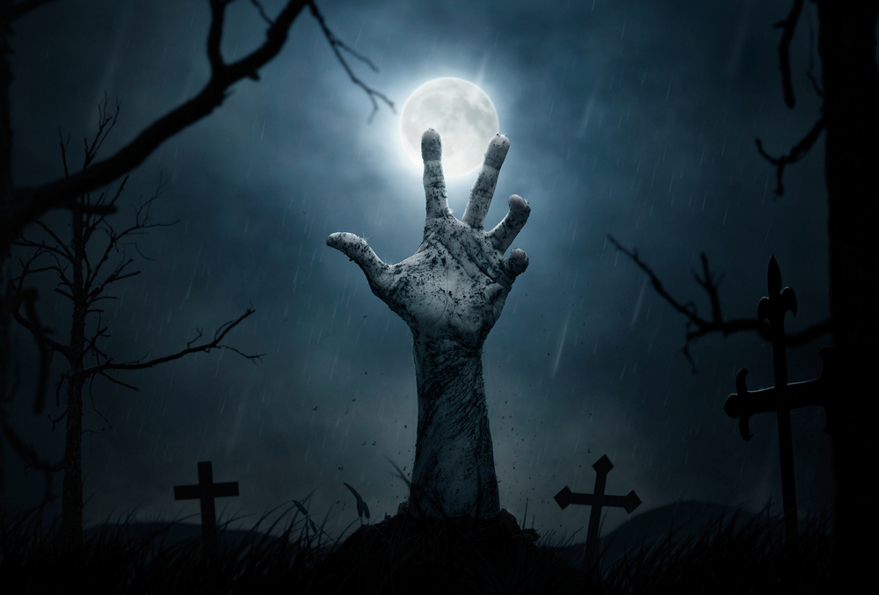

Then, the zombie grabs your friend who has used up his last strength. What will you do now?

Choices:

1. Farewell my friend, I don’t want to die.

**Your friend will die** and you will keep going.

1. SHOOT!

**Discard the rifle** and save your friend.

1. Fight with bare hand.

**Lose one health and keep the rifle bullet**.

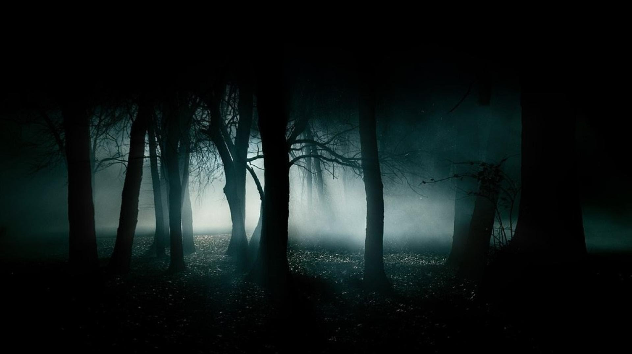

Going deeper and deeper into the woods, the surrounding becomes more and more silent. Suddenly, you hear a sound approaching you rapidly. It is definitely not a zombie, it is a human.

What will you do now?

Choices:

“Who are you?” you turn back and ask

After **you died**, the thief takes away your rifle.

No friendly people will do this. SHOOT him!

You kill the thief. Discard the rifle, **keep going.**

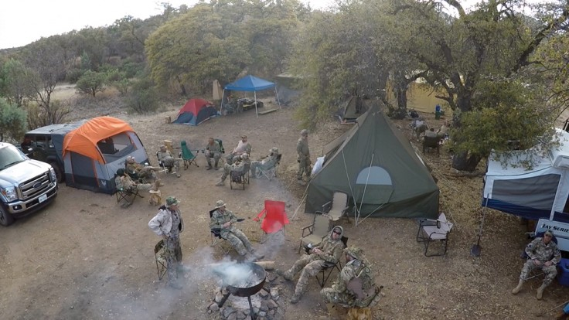

After the echo of gunshot vanished, your find more people are coming. Then, tens of armed soldiers surround you.

“You killed him?” someone asks you, who seems as the leader in between.

You are saved by the militia and welcomed by the general because killing an annoying thief. During the dinner, you meet with the colonels, the general, and his new wife, who was your **girlfriend**.

**You are alive.**

City 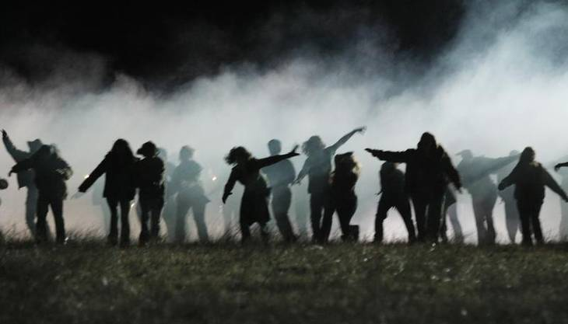

You enter the city with your friend at night. The gunshots stopped, and the zombie once attracted by that sound again back to the street.

Sean can no longer hold on. He falls on another body and cached by a zombie. At the same time, you find that the body beneath Sean is still alive. What will you do?

Choices:

1. Give up Sean and the dying man.

Keep your stuff with you.

1. Fight with bare hand
2. **Lose one health.**
3. Shoot through the dying man’s body

That will kill him but it will not be loud. - Discard the Rifle and leave with your friend.

1. Just shoot

You will be surrounded by hundreds of zombies. You die painfully.

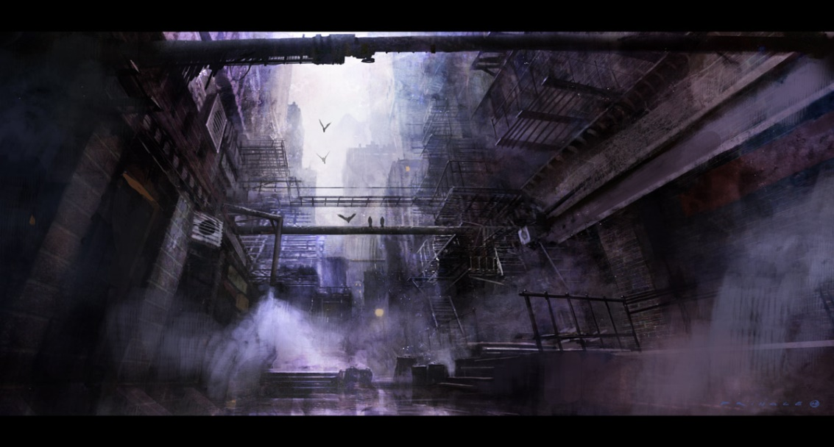

The man dies eventually. No one can save him.

After the escape, you flee through the streets until you notice a dead-end alley where a car engine is sounding. Several bodies are lying around the car.

By the time you are just too hungry to think, but, **will you enter the alley to find some food**?

Choices:

1. Just leave

**You will lose one health**

**because of starvation**

2. Enter the alley.

You find some foods. You gain one health. However, those bodies still turn into zombies.

Fight and run.

**You will lose one health**

BOOST the car!

**Discard the BOOST** and continue.

Shoot!

**Discard the RIFLE** and continue.



You just keep running, breathing and shivering, until falling on the ground and lost consciousness

You get a feel

A feel that some voices are lingering around you

A feel that something warm is in your mouth

Few days later, you find yourself in the camp of “**Survivors Camp**”.

**You are alive!**