**Market Research Report – Student ID Application**

**Initial Problem**

The initial group meeting involved a discussion of our strengths and weaknesses in order to allocate project tasks. Our team consists of one Cell Biologist and two Computer Scientists, resulting in a lack of Bioscience knowledge. Consequently, we decided that conducting any biological studies for our project would need high levels of funding and time, of which we had neither. We therefore agreed to undertake a project in the area of computing. We chose to utilise our expertise in this area as research shows that entrepreneurs are more likely to be successful in areas they are already proficient in (Smarta 2008).

One of the team members was late for the second meeting as a result of queuing at the Job Fair held in the Student’s Union. Their annoyance at this incident inspired us to consider how we may address the problem of queueing within the university setting. We speculated that queuing and ‘frustration’ were interlinked and generally associated with entry to nightclubs, university organised events and events where participants are required to manually providing information during registration procedures.

Queues frequently occur whilst students wait to pay entry for the Newcastle University Student Union’s event, ‘Throwback’. Our initial solution to queuing was to provide students with Near Field Communication (NFC) tags, enabling them to pre pay for events at the Students Union. The tags would pass encrypted information electronically so students could simply swipe their tags for swifter and automated club entry. As a consequence, we could develop a solution to address the problem in question through the use of technology in order to quicken entry processes and reduce, if not eliminate, the related irritation.

**Finding the Products Market Niche**

To investigate if the identified problem needed solving we interviewed the ex-Throwback Manager, asking; ‘what is your current solution to queueing?’ He explained that ‘Throwback’ already has a relatively quick contactless payment system. He also elucidated that queues are beneficial to the business of nightclubs as it helps them to appear popular and thus continue to attract more prospective customers. Furthermore, using the NFC tags as electronic tickets showed few advantages over pre-paid paper tickets, and the tags would be more expensive to replace than paper tickets if lost. Therefore, by using NFC technology within the nightclub business we would ultimately have created more problems than we would have solved. However, this interview did highlight our market niche; efficiently transferring student data, not creating electronic tickets.

Our next focus was to harness the full potential of NFC, as the tags could be pre-loaded with much more information than proof of payment. NFC tags can hold information such as date of birth, email address and home address etc. The tags could be used at careers fairs, fresher’s fair and GP registration during fresher’s week. We then conducted a survey to highlight which activities generate queues and to see if they could realistically be addressed.

We wanted to maintain the use of NFC for two reasons: to remove the chance of human error and to utilise the available technology to provide a greener registration method than that which requires pen and paper. This will not only reduce university costs but also enable them to advertise their steps as a means of ‘going green’. Queueing processes would be significantly quickened as human interaction factors and other variables, such as writing speeds, would be almost entirely removed; students would merely have to tick boxes and scan their phones in a streamlined and efficient process.

Our next task was to find a base to attach the NFC tag to, or a gadget to enable it on. In order to select the most practical option for students, we conducted a survey to see which item they were most likely to remember; their key chain, smart card or phone (all items that could have NFC attached or are NFC enabled).

**Research Objectives**

To confirm our hypothesis that the university setting creates queues and irritation that lead to a gap in the market, we sent out a tailored questionnaire. We used concisely worded, multiple choice, closed questions to ensure a high response rate. We shared the questionnaire via social media platforms that are popular amongst students in order to reach as many possible candidates as we could. There were 118 student participants, studying in the UK and abroad. The study aimed to achieve two things: to show where irritation in relation to queuing stems from and to identify how best to provide access to the NFC tags that we hoped to provide as a means of addressing the problem.

**Research Process**

The questionnaire asked; ‘As a student, have you ever been frustrated by queueing at any of the following events?’ Through previous interviews we had identified where students were most likely to queue; students were then given the option to tick whether these events caused ‘frustration’ or if they were ‘never frustrated’. Listed below were examples of times when students will have been required to share information.

The greatest source of queueing ‘frustration’ was identified as Fresher’s Week. During Fresher’s Week, 61.9 % of student participants were ‘frustrated’ by the queueing systems that they faced. This was closely followed by the percentage of participants ‘frustrated’ from queueing at the Sports and Society Fair and for entrance to university social events Figure 1). As the results showed that only 2% of the participants did not get ‘frustrated’ by queuing, this reinforced our speculation that queues cause ‘frustration’.

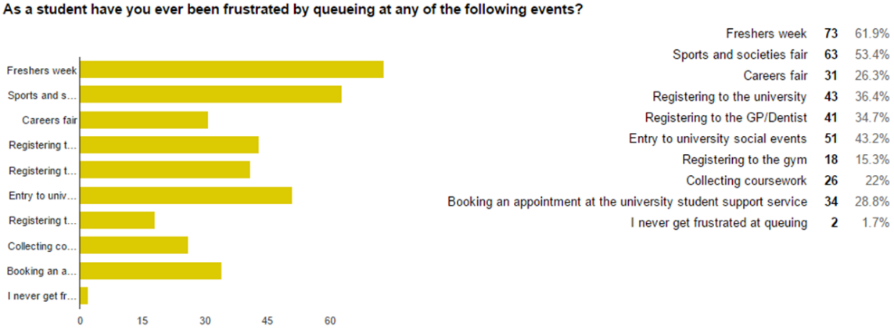

Figure 1. What percentages of students ‘frustrated’ via queueing events.



The questionnaire was also used to find a base for the NFC tags; would it be preferable for them to be incorporated into a smart card, exist as a small plastic tag on a keychain, or to use a mobile phone. The questions asked ‘How often do you forget your smart card/phone/keychain?’ and ‘Which of these items do you have closer to hand?’ was asked, with answer choices of ‘phone’, ‘smart card’ and ‘keychain’. Results showed that not only were students least likely to forget their phone, 69.5 % of students never forget their phone, 90.6% of them had it closer to hand than their keychain or smartcard (figure 2). Therefore, it was clear that phone based NFC technology would be the most convenient option.

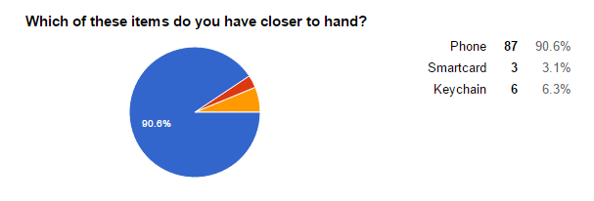

Figure 2. Determining which item students have closest to hand out of their phone, smart card and keychain.

By using phones as a base, an application could be designed which generated a barcode and signals; scanning of the barcode would act in a similar fashion to NFC. This would also mean that students without phone NFC could use the application. We asked students ‘Would you have a problem with sharing information using a tag?’ One common theme emerged that would have been problematic if we had decided to attach the NFC tag to Smart cards; the amount of information shared could not be censored or limited. Data sharing would involve sharing either all of their information or none whatsoever, and the idea of this level of divulgence made many students feel uncomfortable. However, by generating a barcode through a phone application, students could control how much information they shared.

Students were then asked, ‘If it saved time, would you like to electronically share data if you could control what you sent or would you have a problem in doing so?’. In all cases students had no problem with sharing information electronically and said they would prefer to do so if it saved them time. We then reiterated our original idea and decided to use a phone application, as this would give students a lot more flexibility regarding the level of information they were able to share.

**Analysis of Findings**

Events causing ‘frustration’ were generally one off or annual and mostly at the start of the year when the university was overrun with new students and administrative pressures. A solution for these short-term pressures could be a pre-programmed, individual tag that instantly provides the required information in a clear and accessible format. Our product’s value was its ability to remove student irritation. We identified that there is a need for reduced queue time within the university setting as ‘frustrated’ students are, in fact, dissatisfied customers.

To conclude, our research demonstrated what students wanted: to have fewer queues (as queuing is related to increased ‘frustration’). This would be achieved through reducing the factors that contribute to the formation of queues i.e. human interaction and errors within sharing information. As students are frequently required to enter information, queues form and irritation arises. As annoyance and anxiety levels increase, people are much more likely to rush these processes and make mistakes, which in the case of entering information for GP subscription could prove highly problematic.

**Product Overview**

After analysing our findings we decided to develop an application for Apple and Android operation systems/app stores, which will enable students to efficiently transfer data electronically. This application can be used for the one off events where specific data needs to be shared in a short time frame. It also acts as a smart card for smartphone users in situations when students have misplaced their smart card. The students will have to go on to either the Apple App store or Google Play store and download the application. However, after downloading the application, a menu requiring them to sign in using their university credentials will be brought up and only once this stage is completed will the application be fully activated.

This application is not designed to eradicate the smart card, although it has the potential to do so. In practice, removal of the smart card is not feasible, as the university cannot force all students to buy smartphones that have the ability to download applications, display barcodes and produce NFC signals. However, for students with smartphones this is a highly useful application. The application’s home screen will consist of the student’s name, photo, student ID number and university. The basic home screen can be used as an alternative student ID for students without a smart card (Figure 3).

The application will have settings to determine the level of information that will be shared via either barcode or NFC. It will have a default ‘information sharing’ setting which can be configured upon initial application download. However, as our market research revealed that students prefer to have greater control of the information they share than that provided by a ‘default setting’, a settings icon allows the student to tailor the information. Student registration events are an example of when this function is useful, as not all information about a student may be necessary.

Furthermore, if all information is electronically transferred then the issue of poor handwriting is eliminated. This may seem a trivial concept, however, when entering information for GP registration, it is of paramount importance. In the case discussed in Sokol and Hettige’s study (2006) a death was caused by a Doctor’s bad hand writing. This element of human error would instantly be removed, as all of the shared information would be typed and thus legible.

Therefore, the features of our application include: registering student information, student identification, access to buildings and all other functions possessed by a smart card. The benefits of our application include; ensuring the removal of human error, providing a greener alternative to paper registration and also ensuring that students without a smart card can fully function within the university setting.

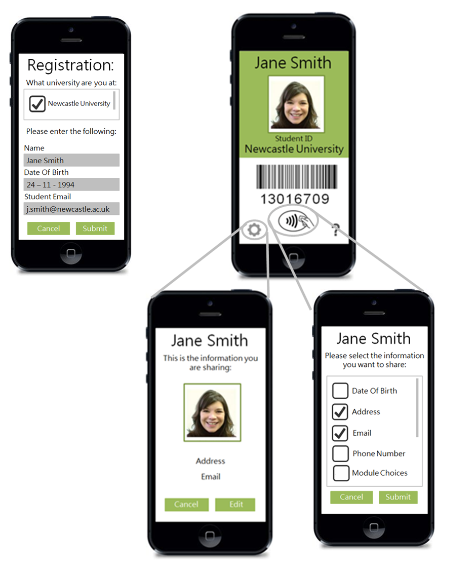

Figure 3. The initial design prototype for our application.

**Is it ‘real’?**

As shown from our market research, the phenomenon of queue-frustrated students is in fact genuine. The market we identified was within universities; our opportunity is that within every academic year, universities are highly overrun with administrative challenges. Our product would remove the severity of this pressure and increase student satisfaction. If students are less ‘frustrated’ with university events and procedures, this will increase the university’s rating for ‘Student Satisfaction’ in university league tables. As universities are in essence businesses this is beneficial; as they will gain more customers and therefore, more students paying their annual fee of nine thousand pounds.

Furthermore, as the subscription is annual, the application can also be used as an electronic smart card. Our concept is scalable to as large as we choose with one of the businesses’ selling points is that the rewards are relatively great compared to the variable costs associated with increasing scalability. However, if this is a great success then it can be sold to more universities.

**Business proposal**

Our business proposition is the development of software that can act as an independent application. The software will allow students to share information efficiently and reducing queue times. Furthermore, it can be used with the same functionality as a smart card when students have misplaced their card or even when their phone is closer to hand. This would enable those without a smart card to still access all university services and domains.

This application would be beneficial for universities, as fewer staff will be needed throughout registration events. It will also reduce the amount of human error which naturally from manually entering data. Passing data electronically could eliminate all registration errors. Therefore, our product will be most ‘valuable’ for universities when they are under administrative pressures requiring information to be shared or when students do not have a working smart card. Not only will the application mean that the university will not have to immediately replace smart cards, in many cases their paperwork load will be reduced and they will have fewer queue-frustrated customers. Therefore, our Unique Selling Points (USPs) are that we propose a greener, more efficient way of transferring student information that eliminates human error.

Our product will solve the problem of queuing as it removes the human element of transactions, an improvement that has been shown by the success of contactless payment methods. We know that our technology is viable as it works in a similar fashion to current applications such as Apple Pay and cards enables with contactless payment designed to reduce the time required to share information.

As our product is both relatively simple and robust (as there is little infrastructure behind it), all services involving students will be automated and impersonal so any problems will be technical. As our application is in-sourced we will have total control of the design and thus any alterations that need to be made can be done in an accurate and timely fashion. This will mean that if there are every any software issues our software team will have complete knowledge of the software and thus will be able to relatively easily remedy the problem.

Furthermore, in terms of an exit strategy as a company we are relatively well prepared. As our application will have relatively low fixed and variable costs, we can just remove it from the Apple app and Google Pay store whenever. The only costs of shutting down the application would be closure of the server and paying the universities the money they had paid for the year’s subscription.

**Potential product vulnerability**

To assess our business idea’s viability, we undertook a critical analysis, looking at our product’s strengths, weaknesses, opportunities and threats to scope its potential. The business’ strengths include the unique, innovative and low-cost service we will provide. Our application provides a mechanism for universities to effectively manage high stress events such as mass registration procedures. Designing the application will be a low cost business, as all of the equipment and material we require can be obtained by utilising free services online.

Our business’s areas of vulnerability include the potential difficulty of integrating this application with existing university IT protocols and the willingness of the university to take on the application. Although universities do no need an infrastructure change, they would be required to provide access to their student information database and in some cases buy additional NFC/barcode readers.

Students cannot access the app independently; they need the universities approval in order to gain access. Even though we have deemed that there is a clear gap in the student market for this type of service from our market research with students, we have not identified a specific need for this by universities. Although the application has clear benefits for universities, they might not outweigh the cost for the educational institutions we hope to gain subscriptions from. By identifying our competitors, we can identify if the business idea will have enough USPs to contend with other businesses.

**Market competitors**

Currently, there are no mobile applications with the same functionality as ours. A similar application in its early stages of release is a student ID application for Norwegian Universities the Student ID App. The application is for the students to prove that they have paid their semester fees to attend the university. The students still need a student card to access buildings, borrow books or other student activities on campus (University of Oslo, 2014). Therefore, the application is not strong competition for the application we will create.

Another application comparable to our business idea is UNiDAYS; this is the most successful student application that provides students with different retailer discounts similar to Student Beans. UNiDAYS has 100,000 - 500,000 downloads on the Google Play store alone (Google Play 2015). The application has a large following with high numbers of students and retailers in their network. Although the application is successful, the features it provides do not compete directly with our service. The application merely offers a verification of student status to allow access to student discounts in stores, online and in restaurants; we hope to develop our application in the future to provide this feature but it is not integral to the structure or service provision of the application. Our main aim is to provide practical services on the university campus. Our application has no direct competition: as there are many apps that provide services for students but not with the same functionality.

The current technology we are using has already been created in many different scenarios, rendering most aspects of our technology and program not patentable as NFC and barcode technology is already in many current handsets and tags. We can copyright the code used to create the application so that the application cannot be exactly reproduced and we can trademark a number of different areas associated with our app: colours, names, logos and any form of representation of the app. This means we cannot fully protect our product, however we can enforce a large amount of copyrighted and trademarked content in order to reduce this. Furthermore, due our pricing strategy, we would aim to be the incumbent firm in the market through creating a monopoly.

**Variable and fixed costs**

The fixed product costs are running a server that will store all of the student information. It is probable that universities will already have a running server which we could extract information from however without contacting each individual university, it is best to assume that this is not the case. Other fixed costs will be staff wages, however as we are staff we can limit wages until the business has made a suitable profit. To publish to the Apple App Store, you must become an Apple Application Developer, which has an annual membership fee of $99 (£67)(Post Office 2015). To publish to the Google Play Store, there is a registration fee of $25 (£17)(Post Office 2015) and then a yearly subscription of between $12-99 (£8-67)(Post Office 2015). This totals the potential start-up costs based on our avenue of publishing at $225 (£151)(Post Office 2015).

Our variable costs are minimal and will only consist of upgrading our technology if the business expands or the software becomes obsolete. The cost of a small business server is £163 (FastHosts 2015), although this could would increase exponentially with the number of university cliental. Furthermore, additional staff would only be needed upon application growth. We would also have no advertising costs as we would directly contact each university asking if they wanted to pay to use our service.

**Financial viability**

Due to the expertise of the team, there will be no start-up costs for staffing; we can produce the application with no initial wage until the project is completed and earning a profit. The software we will use to create the application is provided online for free with Android Studio and the Android SDK (Android Studio 2015). Therefore, creation of this application does not require any external services and can be developed and implemented with the skills our team possess. Two of our team work in the field of Computing Science and can therefore create this application with the resources and knowledge they have. Being experts in the area of our product design reduces potential costs that could be encountered if we required expert advice in design and creation.

With access to personal computers, there will be no initial hardware purchase for the team to develop the product. Furthermore, all team members also have access to Apple and Android phones to test the product on. Failing that, the software provides a mobile simulating environment to test the application. Potential costs depend upon how we choose to publish the application. If publishing as an individual company which universities subscribe to then we will encounter publishing fees.

The potential income received should outweigh the start-up costs and fixed costs as we face minimal costs (table 1). The main source of income will be a subscription charge to the university to provide the service to their students. We will charge £7000 per subscription to universities, with a view to increasing the price to £10000 if the product is successful. Our pricing will depend on the price elasticity of demand for our product. Additional income generated depends on how we choose to publish the application. If we publish the application independently and not integrate it with current apps, then we have the option of placing advertisements as a source of income.

Table 1. The business set up costs and 3 year cash flow per university customer.

|  |  |  |  |  |  |  |  |
| --- | --- | --- | --- | --- | --- | --- | --- |
| Type of Cost | Specific area of cost | | | | | | Total Amount |
| Start-up cost | Publishing application to app stores | | | | | | £ -151.00 |
| Per University | | | | | | | |
| Type of Cost | Year 1 | | Year 2 | | Year 3 | | Total Amount |
| Income | | | | | | | |
| Fee to University | £7,000.00 | | £7,000.00 | | £10,000.00 | | £ 24,000.00 |
| Expenses | |  | | | | | |
| Business Server | £162.00 | £162.00 | | £162.00 | | £ -486.00 | |
|  | | | | | | | |
| Total profit over 3 years (Income – (Expenses + Start-up)) | | | | | | | £ 23, 363.00 |

**Pricing rationale**

As our customers are in fact the universities (who purchase our services primarily for students, our market size is the 160 UK universities (The British Council 2015). Our market strategy would be to initially entice the universities with a month-long free trial. After this they would have to a sign up to a12 month contract. The businesses pricing strategy would initially be to charge a relatively low price to for price penetration into the market. Although longer term, we would look to increase the product’s subscription price for the development of a more exclusive and premium product (depending on its success).

**Business Model Canvas-a breakdown**

Our key partners will be universities who will pay an annual subscription to use our application and services, although our main audience is students as their desire for change in registration procedures is what will incentivise universities to pay application subscription. To demonstrate our value to customers we will show our findings that ques do cause student ‘frustration’ and that we could minimise this. We offer a unique service that will eliminate human error from registration whilst also increasing student satisfaction.

Our customer relations will be automated and impersonal as the only service we offer is the application which requires no discussion. Although we will provide Youtube videos and posters to explain how to operate the application. However, if the universities do encounter problems, we will have a fully functioning website and online correspondence services available to assist them. Although, if the application does expand then call centres will be hired. Our initial costs will be the development of software and putting the application on the market, whereas our revenue will be the annual charge to each university.

**Can we win?**

As our service is an application that is supplied over the internet, provided we have a competent server, the amount of application downloads that we can have is in theory unlimited. As our product tries to target a unique market niche, competition is one of our smaller worries providing we have the correct patent security. We have conducted comprehensive threat analysis and to show our only close competitor is the Norwegian University’s virtual smart card system. Our goal is to reach a point of self-sustainability, i.e. where the business generates enough profit to be run by others. This will be at a point in the future where the software is much more robust and the costs will generally only be fixed costs such as server maintenance and marketing.

**Conclusion-is it worth it?**

As figures above highlight, with minimal start-up and maintenance costs, our business proposition is low risk and has great potential. We have identified our product, its market price, our customers and how to promote it. We have acknowledged that universities will be pressured to purchase the application to maintain student satisfaction. With no other real business contenders, the only barrier the business faces is gaining university subscription. As the application is not be difficult to design and maintain, our fixed and variable costs will be minimal. With few short term costs, any initial sources of revenue can be used to promote the application and repay any loans. Therefore, due to low costs, low maintenance and the perfect target market, this application would be a great business investment.

References

Android Studio. (2015). Download Android Studio and SDK Tools. [ONLINE] Available at: http://developer.android.com/sdk/index.html [Last accessed: 10 December 2015]

FastHosts. (2015). Dedicated Servers. [ONLINE] Available at: <https://www.fasthosts.co.uk/dedicated-servers?source=GooglePPC&gclid=CjwKEAiA-s6zBRDWudDL2Iic4QQSJAA4Od3XhltRk_MmzJPsDQbmbb_o1ZXvKf5-OMqjlsdVl-jcqxoCw-vw_wcB> [Last accessed: 18th December 2015]

Google Play. (2015). UNiDAYS [ONLINE] Available at: https://play.google.com/store/apps/details?id=com.myunidays&hl=en_GB [Last accessed: 10 December 2015]

Post Office. (2015). Exchange Rates. [ONLNE] Available at: http://www.postoffice.co.uk/travel-money/tourist-exchange-rate [Last accessed: 10 December 2015]

Smarta. (2008). How Important is Business Experience? [ONLINE] Available at: http://www.smarta.com/advice/starting-up/starting-your-own-business/how-important-is-business-experience/ [Last accessed: 17 December 2015]

Sokol DK, Hettige S. (2006). Poor handwriting remains a significant problem in medicine. Journal of the Royal Society of Medicine 99:645-646

The British Council. (2015). Universities and colleges. [ONLINE] Available at: http://www.educationuk.org/global/articles/higher-education-universities-colleges/ [Last accessed: 17th December 2015]

University of Oslo. (2014). Digital Student ID [ONILNE] Available at: http://www.fellesstudentsystem.no/studentbevis/ [Last accessed: 10 December 2015]