Set Dressing Postmortem

A top-down, turn-based tactics game with rhythm-based combat emulating films like *John Wick*. My level is intended to be the first in the game, where our hero steps off a subway car and into the sights of a ravenous street gang. The player is introduced to combat mechanics as they use them to defeat said gang and reach the exit.

# Technical Lesson

My technical lesson also doubled as somewhat of a design lesson for this specific challenge. Since the directions specified a level which has elevation (plus the use of ProBuilder), the odds were rather stacked against me for a top-down, 2D game. Then, I had a eureka moment- instead of making true 2D (which would be very ambitious in creating sprites and animations that were fluid and detailed), I could instead use a 3D level and a *shader*!

This helps in a multitude of ways. It makes the game more visually readable, allows me to do more complex lighting effects more easily, and gives me a mathematic level of control over visuals which I would not typically have. It also allows me to use depth and elevation, which otherwise would have been extremely difficult to portray in a truly flat, pixelated environment.

A good example of this concept in a different game is *Project Zomboid*, which uses actual models which look like Picture A, but in gameplay look like Picture B in order to match the pixelated artstyle of the rest of the game while still maintaining fluid animations at infinitely many angles. I wasn’t able to complete the shader by submission, but have the concept down- with only Unity’s render pipeline strangeness in the way.

# Design Lesson

The primary design challenge with the game overall is, the player will only care about their positioning if it is extremely challenging to take on all enemies at once. Thus, the “puzzle” of clearing a level lies in traversing the stage in a way that you’re never overwhelmed while still moving forward. At the same time, I wanted the player’s introduction to their character to be impactful. They need to feel like, for lack of a better term, a badass.

I achieved this through two main devices. Firstly, I staggered the melee enemies throughout the stage- meaning when they all move to attack the player, they will reach them *one at a time* while still giving the impression that they’re moving in mercilessly. Secondly, I used two knocked over benches to serve as a kind of funnel for the enemies toward the player (pictured in Picture C). This means that even if the player screws up a little, they’ll be able to essentially retry it without it immediately getting harder (since enemies behind the currently engaged enemy won’t be able to move past them without going around the bench.

To ensure the player isn’t simply invincible, and get them into the mindset of moving strategically, I placed one gangster in the top-right corner of the map who is armed with a gun. If the player tries to run around the right side of the map, they’ll simply be shot dead- since they are not yet armed in this level. This allows me to control the player’s path to take cover behind the kiosk further without fully restricting them, since an experienced player may be able to dispatch the gunman.

Finally, I used a large point light to emulate sunlight pouring in from the exit in order to guide the player toward their objective.

# Successes and shortcomings

Overall, for a tutorial level I think my stage is successful- however I don’t think it presents an interesting challenge to the player. Instead of the player moving through enemies, the opposite happens- which is far less satisfying. If I could do it over again, I would try to find a way for the player to be more active while still forcing them to think about positioning.

If I had more time, I would fully implement the pixelation shader. It’s simple in concept but ironing out the kinks to get it to look right is rather difficult. Right now, it jitters far too much. This is because I have it essentially “round up” pixel positions- i.e. instead of rendering based on every individual pixel, it’s rendering based on every tenth pixel and filling in the details. It’s a bit frustrating to mess with, but I’m not that unhappy I didn’t have it for my submission, since it essentially has nothing to do with the level design itself.

*PICTURE A*

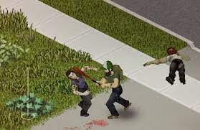

*PICTURE B*

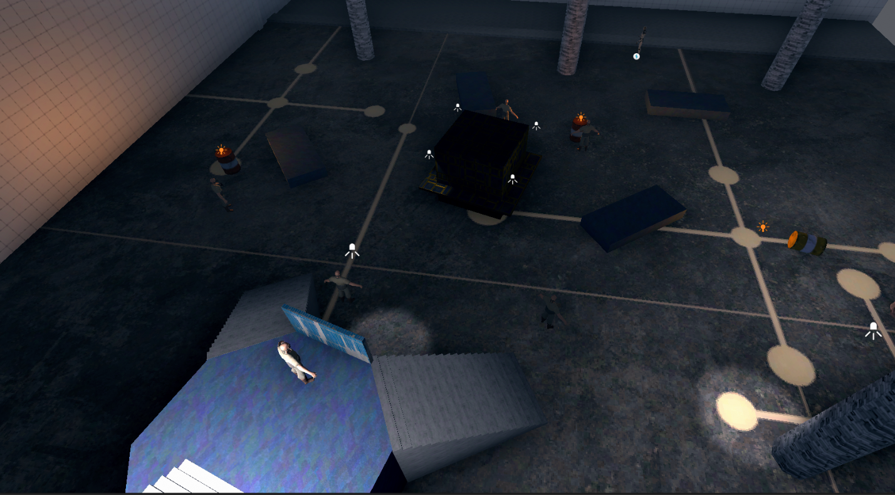

*PICTURE C*