A partitioned hydro-mechanical framework for four-leg reusable launch vehicle landing on a floating barge

Abstract
The vertical landing of a reusable launch vehicle on a floating barge involves two physical systems with markedly different time scales: the wave-frequency motion and radiation memory of the platform, and the short-duration nonlinear contact of the landing mechanism. This paper presents an open partitioned hydro-mechanical framework comprising three numerical blocks. A frequency-domain potential-flow boundary-element model supplies added mass, radiation damping, wave excitation and response operators. A time-domain platform model retains the radiation-memory force and accepts external wave, plume and contact loads. A multibody landing model resolves the vehicle, four landing legs, unilateral footpad contact, friction and load transfer. The blocks exchange deck motion and the resultant contact wrench through explicit interfaces. Three sets of calculations are used to examine the framework. First, a reduced four-contact model is identified from the simultaneous-touchdown experiment reported by Yang et al. and then applied, without further adjustment, to their 1-2-1 and 2-2 touchdown cases. The computed buffer-stroke peaks differ from the digitized tests by no more than 4.0%, whereas the acceleration-peak errors remain 29.2-51.9%, showing that the unpublished flexible mechanism cannot be reconstructed uniquely from the available plots. Second, a locally compiled potential-flow model of a 120 m x 50 m rectangular barge is used to calculate six-degree-of-freedom response amplitude operators and the motion of a landing center and four foot points. For the prescribed frequency and heading grid, the maximum landing-center heave response is 1.128 m/m. A 63-case JONSWAP study gives a maximum P95 landing-center vertical speed of 1.505 m/s at Hs = 3 m, Tp = 10 s and a 90 deg wave heading. Third, a Thies-scale multibody mechanism proxy is coupled to the time-domain platform model. It reproduces sequential contact and returns the leg wrench to the platform, but its contact compliance and one-pass coupling prevent interpretation as a validated full-scale landing-leg model. The results define a reproducible intermediate-fidelity route between prescribed-deck landing simulations and proprietary multibody-hydrodynamic co-simulation.
Keywords: reusable launch vehicle; sea-based landing; floating barge; potential-flow hydrodynamics; radiation memory; multibody contact; landing leg; partitioned simulation

1. Introduction
Landing a reusable first stage downrange can preserve payload performance by avoiding the propellant expenditure associated with a return-to-launch-site maneuver. The recovery platform, however, is not an inertial landing surface. Dynamic positioning can limit low-frequency horizontal drift and heading error, but wave-frequency heave, roll and pitch remain. The velocity of a point on the deck therefore depends on both translation and rotation of the vessel. At touchdown, the four footpads may encounter different deck heights and velocities even when the platform center remains close to its commanded position.
Studies of this problem have tended to treat platform hydrodynamics and landing-mechanism dynamics separately. Nargolkar and Vijayan (2025) combined frequency-domain potential-flow coefficients, a time-domain radiation-memory formulation and an equivalent launch-vehicle structure. Their box-barge and MARMAC-type calculations established a clear route from panel geometry to time-domain response and showed that an offset landing excites platform pitch and vehicle bending. The touchdown interface was represented by equivalent springs, so individual foot contact, friction and sequential compression were not resolved. Wang et al. (2023) considered a different part of the problem. They transferred engine-plume loads from a CFD calculation to a potential-flow platform model in JONSWAP waves and a four-line mooring system. The platform response included wave, mooring and plume effects, but the launch vehicle and landing legs were not retained as dynamic bodies.
The landing mechanism itself has been studied in greater detail for fixed or prescribed moving surfaces. Thies (2022) developed a four-leg multibody model with nonlinear absorbers, friction and inclined-platform cases. Yue et al. (2022) compared a quasi-three-dimensional landing model with scaled drop tests, while Li et al. (2025) included flexible members and a nonlinear liquid-gas absorber. Yang et al. (2026) established a flexible landing-mechanism model and validated it against three drop-test contact sequences before adding prescribed stochastic deck motion. In that extension, the deck motion acted on the vehicle, but the landing loads did not modify the platform response. Xie et al. (2025), although concerned with sea launch rather than recovery, further demonstrated the importance of retaining radiation memory when a short-duration impact acts on a floating structure.
These studies leave a practical modelling gap. A potential-flow solver is well suited to the platform, whereas a multibody contact solver is better suited to the legs. Replacing either solver with a single hand-written model would discard established capability. The more useful approach is to exchange deck kinematics and contact wrenches across a documented interface. Such a model also needs to distinguish between results calculated by the new framework and values used only as validation targets. This distinction is especially important because the published landing papers do not provide complete CAD geometry, member inertia, joint coordinates, absorber curves, contact parameters or random-wave realizations.
The present work develops and tests an open partitioned framework for this purpose. The framework separates frequency-domain platform hydrodynamics, time-domain radiation-memory dynamics and nonlinear multibody contact, while preserving the force and motion exchange between them. The platform pose drives the moving deck in the landing model, and the four foot forces and their moments are returned to the platform equation. The study has three aims: to determine what can be reproduced from the public Yang drop-test record without inventing an unpublished mechanism; to calculate deck-point motion for a parameterized rectangular recovery barge; and to demonstrate the exchange of landing loads between a four-leg multibody model and a radiation-memory platform response. The calculation begins immediately before contact and continues through post-touchdown oscillation. Powered descent guidance, engine control and trajectory optimization are outside the present scope.

2. Coupled numerical framework

2.1 Partitioned hydro-mechanical framework
The numerical arrangement is shown in Figure 1. A panel mesh and hydrodynamic control file are supplied to a locally compiled frequency-domain potential-flow solver. Added mass, radiation damping, hydrostatic restoring coefficients, wave-excitation forces and motion response amplitude operators (RAOs) are passed to external time-domain modules. The same hydrodynamic dataset supports two related calculations. In the first, the complex RAOs are transformed from the platform reference point to the landing center and four foot locations and are combined with a JONSWAP spectrum. In the second, the frequency-dependent radiation coefficients are converted into a time-domain memory force. The resulting deck pose is imposed on the multibody deck; the landing model advances the vehicle and four-leg mechanism and returns the resultant footpad contact wrench.
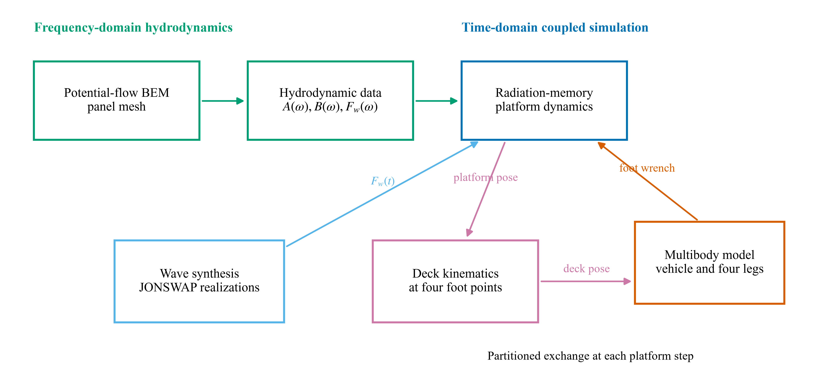
Figure 1. Numerical arrangement of the proposed framework. Frequency-domain hydrodynamics, time-domain platform dynamics and multibody landing dynamics are linked through explicit data and load-transfer interfaces.
This partition keeps the ownership of each physical model explicit. The first block treats linear wave-body interaction by a three-dimensional potential-flow boundary-element method. The second retains the fluid-memory term needed after an impact and advances the platform motion under wave, plume and contact loads. The third handles unilateral contact, friction and the changing constraint state of four independent legs. The landing-mechanism representation can therefore be replaced when measured absorber data or a complete geometric model becomes available without reformulating the hydrodynamic block.

2.2 Frequency-domain hydrodynamics and radiation memory
The hydrodynamic block follows linear potential-flow theory. The fluid is assumed inviscid, incompressible and irrotational, and the wave and body motions are of sufficiently small amplitude for the boundary conditions to be linearized about the mean free surface. The velocity potential therefore satisfies
∇²φ = 0
in the fluid domain. A free-surface Green function satisfies the linearized free-surface, seabed and far-field radiation conditions. Green's theorem then reduces each radiation or diffraction problem to the wetted body surface. In schematic form, the boundary integral equation is
c(P)φ(P) + ∫SB φ(Q) ∂G(P,Q)/∂nQ dSQ = ∫SB G(P,Q) ∂φ(Q)/∂nQ dSQ
The wetted surface is discretized into constant quadrilateral panels. Solving the radiation problems for the six rigid-body modes and the diffraction problem for each wave heading gives the complex pressure field. Integration of that pressure over the body produces the frequency-dependent added-mass matrix A(ω), radiation-damping matrix B(ω) and wave-excitation vector Fwave(ω). The formulation and numerical panel treatment follow the open frequency-domain method documented by Liu (2019).
For a floating body with generalized displacement η, the time-domain equation is written as
(M + A∞) η̈(t) + ∫₀ᵗ K(t - τ) η̇(τ) dτ + Cη̇(t) + Kₕη(t) = Fwave(t) + Fplume(t) + Fcontact(t)
where M is the rigid-body mass matrix, A∞ is the infinite-frequency added mass, C is additional linear damping and Kₕ is the hydrostatic restoring matrix. The right-hand side contains wave, plume and contact loads. The radiation-memory kernel is obtained from the frequency-dependent radiation-damping matrix,
K(t) = (2/π) ∫₀∞ B(ω) cos(ωt) dω
In the time-domain correction used here, the convolution is evaluated through auxiliary sine and cosine states at each hydrodynamic frequency. Trapezoidal frequency weights, including the factor 2/π, are applied to the symmetrized radiation-damping matrices. The auxiliary states satisfy
żc,k = η̇ - ωₖ zs,k; żs,k = ωₖ zc,k
The memory force is assembled by summing the frequency-weighted cosine-state contributions. This form avoids storing the complete velocity history. The coupled ordinary differential equations are advanced with a fourth-order Runge-Kutta method. For the full six-degree-of-freedom development branch, the highest computed added-mass matrix is retained as an estimate of A∞; this approximation is not used to claim high-frequency convergence.

2.3 Rectangular-barge model and deck-point kinematics
The main hydrodynamic case is a rectangular barge 120 m long, 50 m wide and 7 m in draft. The still-water plane is z=0, positive z is upward and the hydrodynamic reference point is the origin. The deck is 3 m above still water. The landing center is at [0,0,3] m, and the four foot sampling points are at [±9,±9,3] m. The center of gravity used in the analytic mass model is [0,0,-2] m. Seawater density is 1025 kg/m³ and gravitational acceleration is 9.80665 m/s².
The wet mesh uses 24 divisions in length, 10 in beam and four in draft. It contains 512 quadrilateral panels and 635 nodes. The waterplane mesh contains 240 panels and 275 nodes. No symmetry boundary is used. Figure 2 distinguishes the wet hydrodynamic mesh, which ends at the still-water plane, from the deck outline and landing points at z=3 m.
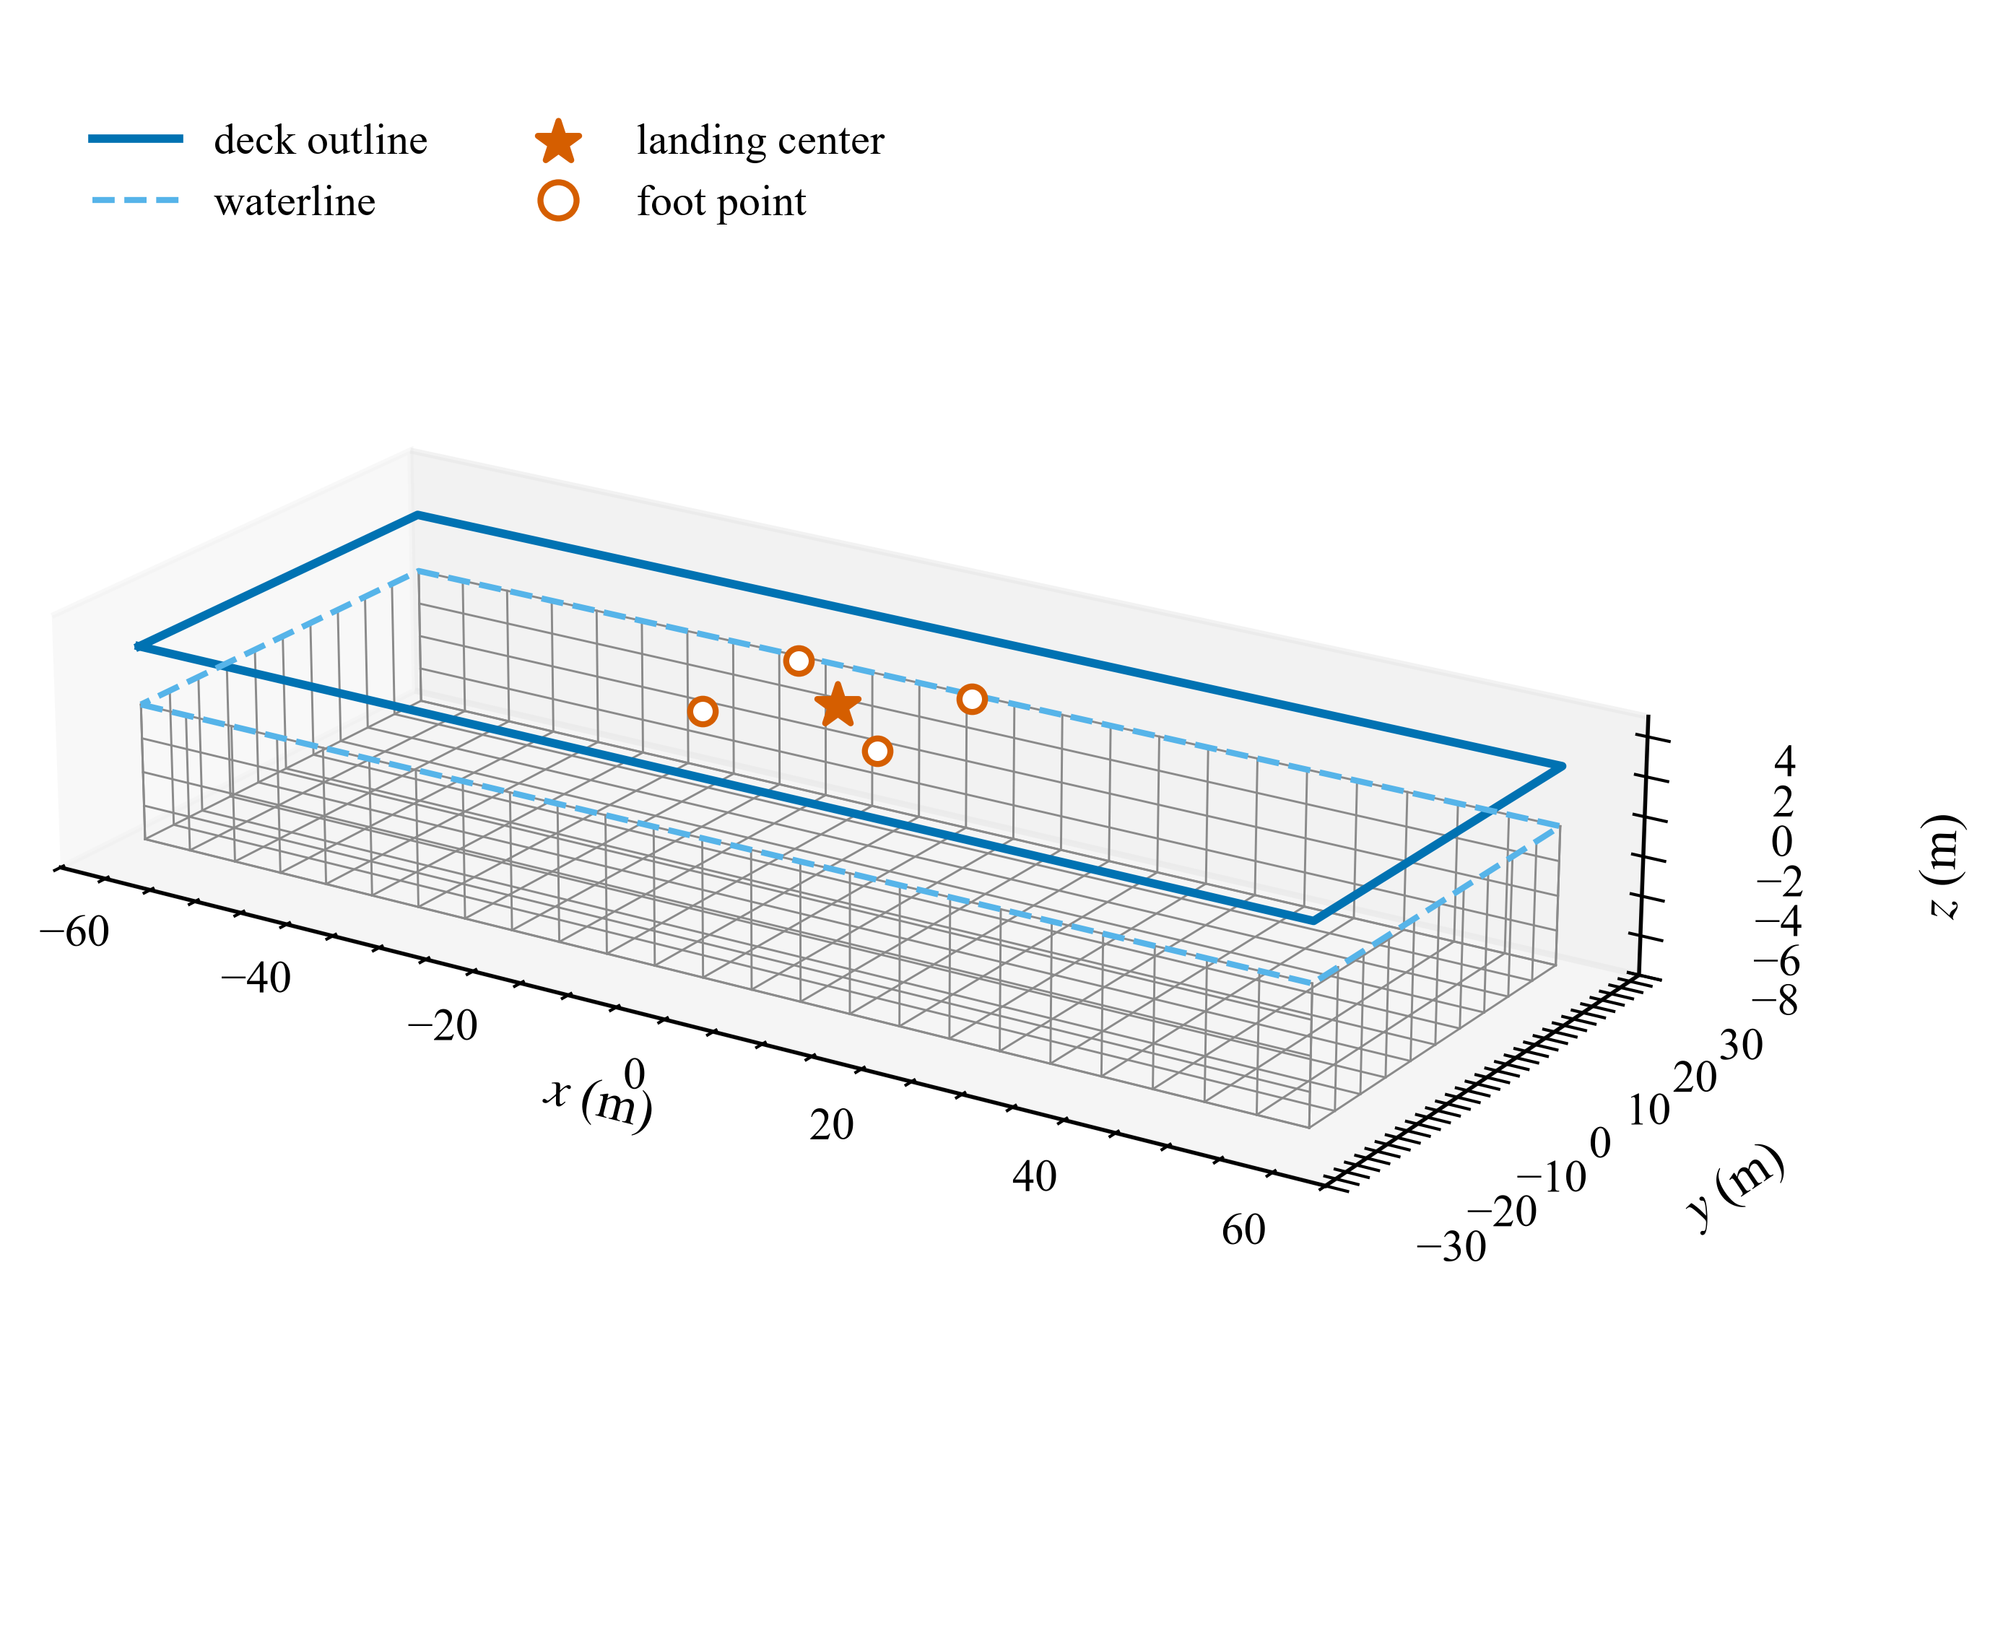
Figure 2. Parameterized 120 m x 50 m rectangular barge. The grey grid is the wetted boundary-element surface; the deck outline and four foot locations are shown only to define the kinematic transformation.
For a deck point r=[x,y,z]ᵀ, the small-angle displacement follows from the platform translation and rotation. In component form,
u_x = η₁ + η₅z - η₆y; u_y = η₂ + η₆x - η₄z; u_z = η₃ + η₄y - η₅x
The complex velocity RAO is iωu. The same operation is applied before stochastic wave synthesis, so that translation and rotation retain their hydrodynamic phase relationship. Four-foot differential motion is therefore calculated from correlated point responses rather than from independently generated time series.

2.4 Irregular-wave synthesis
Nine JONSWAP sea states are formed from Hₛ=1,2,3 m and Tₚ=6,8,10 s, with peak factor γ=3.3. Seven wave headings from 0 to 180 deg are considered. The initial spectral expression is evaluated on the exact discrete Fourier grid and rescaled numerically so that
m₀ = ∫ Sη(ω) dω = Hₛ²/16
The complex deck-point RAOs are interpolated from 0.2-2.0 rad/s to that grid. For each frequency, a single random phase is used across all response channels. This preserves the cross-channel phase implied by the transfer matrix. An inverse real Fourier transform then gives the landing-center displacement and velocity, four foot-point displacement and velocity, platform roll and pitch, and the associated angular rates.
Each sea-state-heading combination is simulated with 100 deterministic seeds beginning at 202600. A realization lasts 600 s with a 0.1 s time step. The recorded quantities are the maximum absolute vertical velocity at each point, the maximum vertical displacement and velocity spans among the four feet, and the maximum platform tilt and tilt rate. Mean, standard deviation, P50, P95, P99 and sample maximum are calculated across seeds. These statistics describe platform motion only. They do not include touchdown timing, landing limits or vehicle feedback.

2.5 Landing models
Two landing models are used because the public validation data and the available multibody geometry support different levels of detail.
The first is a transparent reduced model for comparison with Yang et al. (2026). The vehicle has vertical translation and pitch, and four massless contact points are arranged on a square footprint. The published mass of 5200 kg, touchdown speed of 2 m/s and initial pitch angles of 0 or 3 deg are used directly. A footprint radius of 3.7477 m is derived from the final support margin digitized from Yang et al. Figure 16. Because the vehicle pitch inertia is not reported, it is set to mR² and retained unchanged for all cases.
The compression of foot i is calculated from vehicle translation, pitch and the initial geometric gap. Contact is unilateral. Its vertical force is
Nᵢ = max[0, kzδᵢ + kz2δᵢ² + cc max(δ̇ᵢ, 0) + cr min(δ̇ᵢ, 0)]
when δᵢ>0, and zero otherwise. Separate constant observation ratios map the generalized compression and force to the reported buffer stroke and main-strut load. They are needed because the paper does not give the linkage transmission or the load split among the main and auxiliary members. Six parameters are identified by nonlinear least squares from the simultaneous-touchdown traces only. The asymmetric 1-2-1 and 2-2 cases are then calculated with the same parameters. The equations are integrated by fourth-order Runge-Kutta with a 0.001 s time step over 1.6 s.
The second model is a rigid-body multibody representation based on the 61.288 t vehicle data and tripod dimensions reported by Thies (2022), not on the 5.2 t Yang test article. The vehicle is assigned the published mass and inertia. Four spherical footpads interact with a moving deck through a compliant smooth-contact law. Each leg contains an inclined prismatic main guide, a compression-only translational spring-damper and two diagonal axial braces. The landing footprint radius is 6.926 m. The nominal absorber stiffness and damping are 2.6 MN/m and 1.3 MN s/m, with a 0.42 m reference stroke. A bilinear hard stop is included as a numerical safeguard because no machine-readable hydropneumatic curve is available. The contact law uses a normal stiffness of 100 MN/m, damping of 10 MN s/m, static friction of 0.5 and dynamic friction of 0.4. The exact hinge coordinates, brace mass and inertia, tangential brace separation, footpad mass and hard-stop properties are therefore model assumptions rather than published Thies data.
For generalized multibody coordinates q, the constrained landing dynamics are written as
Mq(q)q̈ + h(q,q̇) = Qg + Qjoint + Qabsorber + Qcontact
where the generalized mass matrix depends on configuration, h contains inertial and constraint terms, and the right-hand side contains gravity, joint, absorber and footpad-contact generalized forces. Unilateral normal force, regularized friction and the compression-only absorber determine the active constraint state of each leg. This formulation allows different feet to contact, separate and re-contact independently as the deck translates and rotates.
The multibody contact step is 0.0005 s and output is sampled every 0.01 s. The calculation runs from 506 to 526 s on the Wang-based event clock, with nominal touchdown at 510 s. Gravity is disabled during the prescribed pre-contact approach so that the specified 5 m/s touchdown speed is not altered by an artificial free-fall interval; gravity is active after first contact. The solver records first contact, lift-off, re-contact, slip, contact impulse, absorber stroke, support-polygon margin and vehicle kinetic energy for each leg.

2.6 Partitioned load exchange
At a platform time step, the radiation-memory solution provides deck translation, rotation and their rates. These variables prescribe the moving deck in the multibody model. The force returned to the platform is the negative of the sum of the foot forces, and the moment is taken about the platform reference point,
Fcontact = -Σᵢ fᵢ; Mcontact = -Σᵢ[(rᵢ - rR) × fᵢ]
The calculation reported here uses a one-pass linear correction in heave, roll and pitch. A Wang-based platform response supplies the wave and plume baseline. The multibody landing calculation is first run on this prescribed motion, after which the resulting vertical foot forces and roll/pitch moments are applied to a second radiation-memory solve. Thus,
η(t) = η_w+p(t) + Δη_c(t)
The method preserves action and reaction in the three returned channels, but it is not a converged strong co-simulation. Horizontal contact forces are recorded by the multibody solver but are not included in this reduced feedback calculation. The repository also contains a six-degree-of-freedom replay branch; its fixed-point convergence has not yet been established and its results are not used below.

3. Numerical verification and comparison data

3.1 Hydrodynamic checks
The rectangular mesh is generated from the case configuration rather than edited manually. Its displaced volume, waterplane area and heave restoring coefficient are checked against closed-form values. The resulting volume is 42,000 m3, the waterplane area is 6,000 m2 and the corresponding mass is 43.05 x 10^6 kg. The heave restoring coefficient is 60.311 MN/m. Panel counts, node counts, wet-surface elevation and waterplane elevation also agree exactly with the parameterized geometry.
The frequency-domain hydrodynamic dataset contains 19 frequencies from 0.2 to 2.0 rad/s, seven headings and six motion RAOs. The point transformation produces five sets of displacement, velocity, rotation and angular-rate RAOs. Tests with pure rigid-body motions verify that all points have the same response in pure heave, while pure roll and pitch give u_z=η₄y and u_z=-η₅x, respectively.
The open-source frequency-domain solver used in this implementation was compiled locally with GNU Fortran. Its HywindSpar certification case agrees with the registered repository benchmark. The Cylinder, DeepCwind and Moonpool cases retain differences from benchmark files created with an older undocumented compiler and library combination. No input or tolerance was changed to suppress those differences. The analytic checks and all barge results are reproducible with the present toolchain, but cross-toolchain identity for every legacy benchmark remains unresolved.

3.2 Yang drop-test data
The Yang paper reports simultaneous, 1-2-1 and 2-2 touchdown tests for a 5.2 t vehicle at 2 m/s. Experimental acceleration, main-strut load and buffer-stroke curves were extracted from a 160 dpi rendering of Figures 9-11. Red dashed pixels were retained inside calibrated axis boxes and written to CSV; gaps in the plotted dashes were not filled in the source data. Contact time and pre-contact baselines were determined by the same scripted procedure for all cases.
Several printed quantities require care. Equation (11) gives H=v/(2g), which is dimensionally inconsistent with the usual free-fall relation v²/(2g). Table 2 also contains an anomalous 1-2-1 test load, and some printed percentage errors do not follow from the tabulated values. These entries are retained in the source register, but the curve comparison does not use them to alter the digitized traces.
For the prescribed-deck part of the Yang model, the published heave and pitch transfer functions are discretized by a bilinear transform. Input samples have variance 1/Δ t, corresponding to a declared unit-intensity continuous white-noise convention, and seed 2026 is used. The source paper gives neither its white-noise normalization nor its seed. The generated time history is therefore a new deterministic realization; only the transfer-function shape can be compared directly.

3.3 Multibody coupling matrix and numerical checks
The multibody-coupling study contains four cases: calm center, wave center, 15 m bow offset and 15 m port offset. All use the same vehicle, mechanism and contact data. For the port-offset case, the contact step is repeated at 0.00025 s and the platform time step at 0.005 s. Contact force, absorber stroke and platform peaks are compared with the base steps. Action-reaction residuals, the no-leg zero-force response and final vehicle kinetic energy are evaluated for every case.
Table 1 summarizes the three numerical levels. Keeping them separate is important: the Yang model assesses what can be identified from a public experiment, the rectangular-barge model assesses wave-induced deck motion, and the Thies-scale multibody model demonstrates contact-load exchange with the platform. They do not describe one particular launch vehicle.
Model level | Principal inputs | Numerical setting | Purpose
Yang reduced landing model | 5.2 t; 2 m/s; 0 or 3 deg pitch; four unilateral contacts | RK4; 0.001 s; 1.6 s | Public drop-test comparison and identifiability
Potential-flow barge model | 120 x 50 x 7 m; 19 frequencies; 7 headings; 5 deck points | Frequency-domain boundary elements; linear RAOs | Platform and deck-point response
Coupled mechanism proxy | 61.288 t; 5 m/s; four tripod legs; Wang-based platform baseline | Multibody step 0.0005 s; platform step 0.01 s; 20 s | Four-leg contact and returned platform wrench

4. Results

4.1 Prescribed-deck filter and drop-test comparison
Figure 3 shows the response of the published deck filters to the declared unit white noise. The first 40 s illustrate the low-frequency character of both motions. The Welch spectra and continuous transfer-function magnitudes are normalized separately, so the comparison concerns spectral shape rather than an unknown absolute source intensity. The dominant frequencies agree. Remaining fluctuations in the Welch estimate follow from the finite 120 s realization.
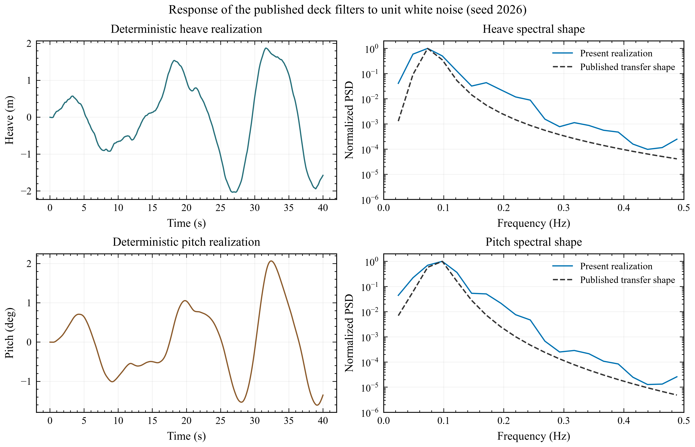
Figure 3. Deterministic heave and pitch realizations generated with seed 2026. Dashed curves show the normalized shapes of the published continuous transfer functions; solid curves show normalized Welch estimates from the present realization.
The parameters identified from simultaneous touchdown were a force observation ratio of 0.4566, a stroke observation ratio of 2.0000, vertical stiffness of 96.55 kN/m per leg, compression damping of 14.52 kN s/m and rebound damping of 192.80 kN s/m. The quadratic stiffness was effectively zero. The stroke observation ratio reached its upper bound, which indicates that the available traces do not determine a unique mechanism transmission. These values are effective parameters of the present reduced model, not parameters reported by Yang et al.
Figure 4 compares the calculation with the digitized tests. Only the simultaneous case contributed to the parameter fit. The asymmetric cases retain the same contact and observation parameters. The model reproduces the simultaneous, 1-2-1 and 2-2 geometric contact patterns and captures the magnitude and decay of buffer stroke. It does not reproduce the high-frequency acceleration peaks, and the 1-2-1 force waveform is poorly correlated with the test.
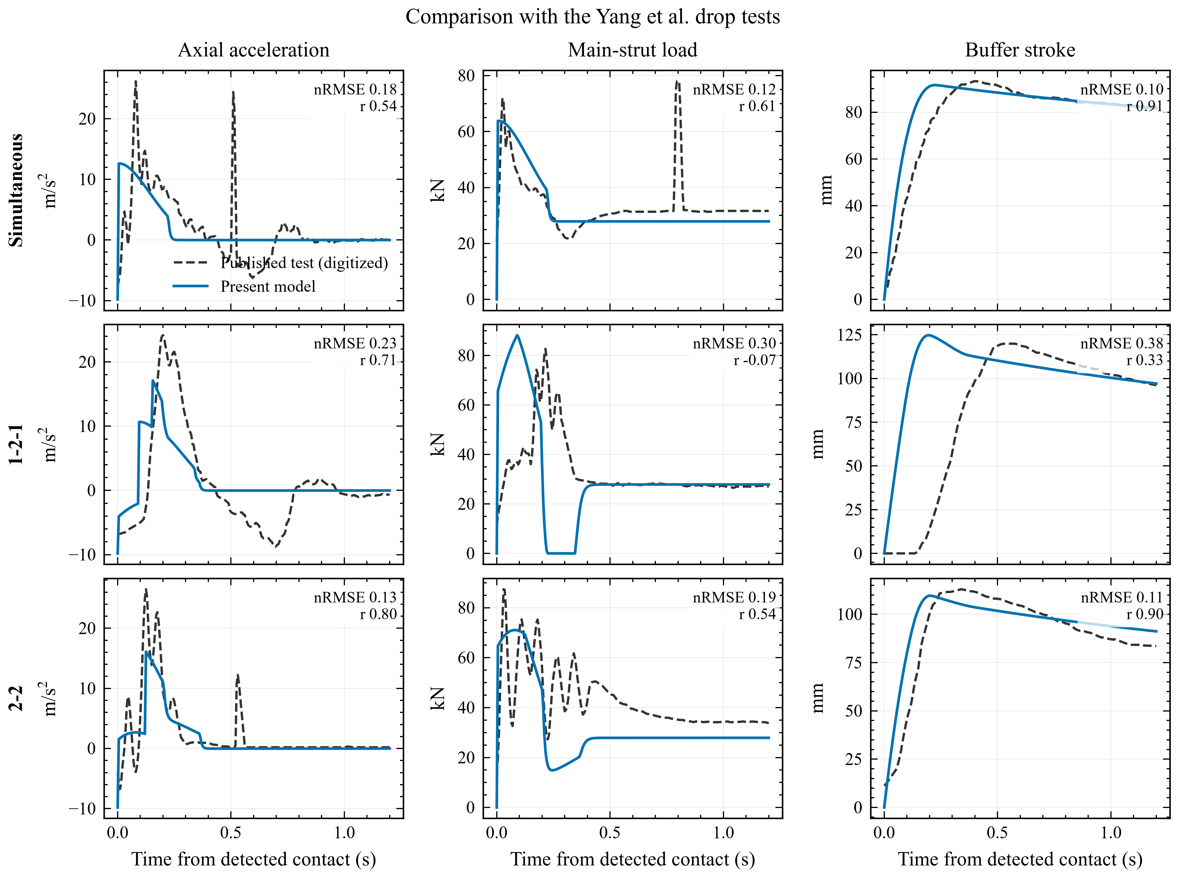
Figure 4. Comparison of the present reduced model with Yang et al. (2026). Grey dashed curves are digitized experimental data; blue solid curves are present calculations. Model parameters were fitted only to simultaneous touchdown.
Case | Response | nRMSE | Correlation | Peak error
Simultaneous | acceleration | 0.181 | 0.537 | 51.9%
Simultaneous | main-strut load | 0.118 | 0.611 | 18.2%
Simultaneous | buffer stroke | 0.101 | 0.911 | 1.7%
1-2-1 | acceleration | 0.232 | 0.707 | 29.2%
1-2-1 | main-strut load | 0.305 | -0.071 | 6.7%
1-2-1 | buffer stroke | 0.377 | 0.333 | 4.0%
2-2 | acceleration | 0.132 | 0.801 | 39.2%
2-2 | main-strut load | 0.192 | 0.543 | 18.7%
2-2 | buffer stroke | 0.106 | 0.899 | 3.0%

The buffer-stroke peak error is no greater than 4.0% in any case. Main-strut peak errors range from 6.7% to 18.7%, while acceleration peak errors range from 29.2% to 51.9%. Peak agreement alone would therefore give an incomplete account of the model. In particular, the negative force correlation for 1-2-1 touchdown shows that the reduced contact law does not represent the measured load sequence. The likely missing contributions are member flexibility, linkage geometry and distributed inertia, all of which are present in the original ADAMS/Abaqus model but are not specified in the paper.

4.2 Hydrodynamic response of the rectangular barge
The landing-center RAOs are shown in Figure 5. Heave remains close to unity at the lowest frequencies and decreases rapidly above 0.8 rad/s. A broad heave amplification is present for beam waves, with a maximum of 1.128 m/m at 0.6 rad/s and 90 deg. Roll is dominated by oblique and beam waves. Its maximum is 6.072 deg/m at 0.8 rad/s and 90 deg. Pitch is largest in head and near-head waves, reaching 1.678 deg/m at 0.6 rad/s and 0 deg. The near-zero roll in head waves and near-zero pitch in beam waves are consistent with the symmetry of the rectangular geometry.
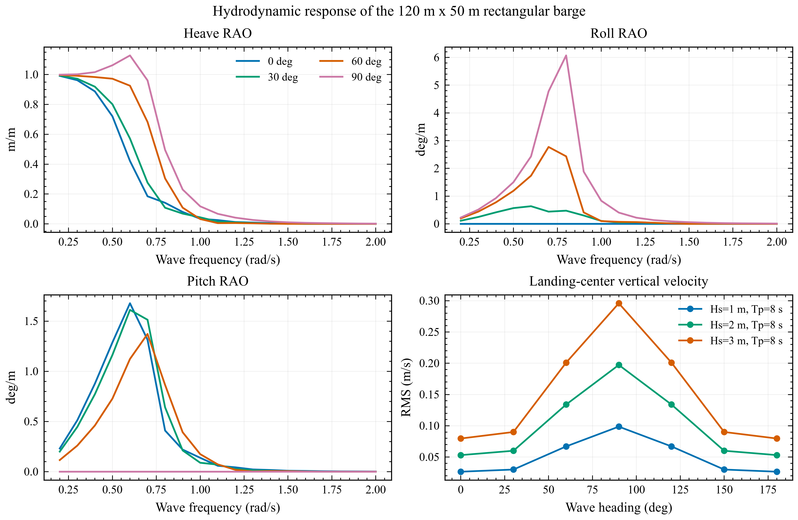
Figure 5. Landing-center potential-flow RAOs and JONSWAP vertical-velocity RMS. All curves are calculated with the locally compiled boundary-element solver and the parameterized mesh in Figure 2.
For Tₚ=8 s, the landing-center vertical-velocity RMS is largest in beam waves and scales linearly with Hₛ, as expected for the linear model. At Hₛ=3 m it reaches 0.296 m/s at 90 deg. This value is an integral spectral measure and should not be confused with the maximum value in a finite time history.
The Nargolkar reproduction cases provide a separate qualitative check on the coupling geometry. For both the box and MARMAC-type barges, a center landing leaves pitch and vehicle transverse motion near numerical zero, whereas the specified offset generates both responses. The result agrees with the physical trend reported by Nargolkar and Vijayan, but it is not used as a pointwise validation because the published paper does not provide complete machine-readable time histories for every coefficient and response.

4.3 Random-wave deck-point response
Figure 6 summarizes the 63 sea-state-heading combinations. The shaded region between P50 and P95 indicates the spread among the 100 phase realizations. All three measures are most sensitive to beam waves. This follows from the large roll RAO in Figure 5 and the 9 m transverse offset of each foot from the landing center.
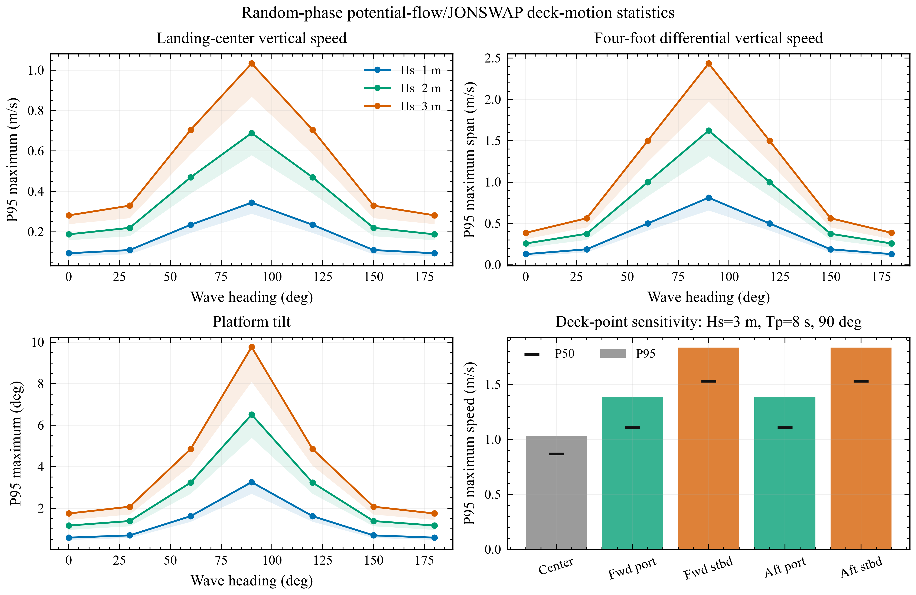
Figure 6. P95 maxima from 100 random-phase realizations for each sea-state-heading combination. Shading spans P50 to P95. The lower-right panel compares the landing center and four foot points for Hₛ=3 m, Tₚ=8 s and 90 deg waves.
The largest P95 landing-center vertical speed in the complete matrix is 1.505 m/s for Hₛ=3 m, Tₚ=10 s and 90 deg waves. At Hₛ=3 m and 90 deg, the corresponding values for Tₚ=6,8 and 10 s are 0.376, 1.033 and 1.505 m/s. The increase with period occurs because the wave spectrum moves towards the barge heave and roll amplification range.
For Hₛ=3 m, Tₚ=8 s and 90 deg waves, the P95 maximum vertical-velocity span among the four feet is 2.435 m/s and the P95 maximum tilt is 9.770 deg. The P95 point speeds are 1.033 m/s at the landing center, 1.384 m/s at both port points and 1.837 m/s at both starboard points. The port-starboard difference does not arise from independent random input. It results from the complex phase between heave and roll in the platform response: the rotational contribution adds to heave on one side and subtracts on the other for a given wave direction. Reversing the beam-wave direction interchanges the sides.
The synthesized spectra satisfy the target m₀=Hₛ²/16 to a maximum relative error below 1.0×10^-15. P95 metrics also scale with Hₛ to within 5.1×10^-16, which provides a direct check on the linear synthesis and transfer implementation.

4.4 Four-leg contact and platform feedback
Figure 7 shows the 15 m port-offset partitioned coupling case. Legs 3 and 4 first contact the deck 0.0295 s before nominal touchdown, followed by legs 1 and 2 at 0.0505 s after it. The first-to-last touchdown interval is 0.080 s. The four legs then undergo lift-off and re-contact before reaching a final four-foot state. The maximum foot-contact force is 2.678 MN and the maximum main-buffer stroke is 46.44 mm.
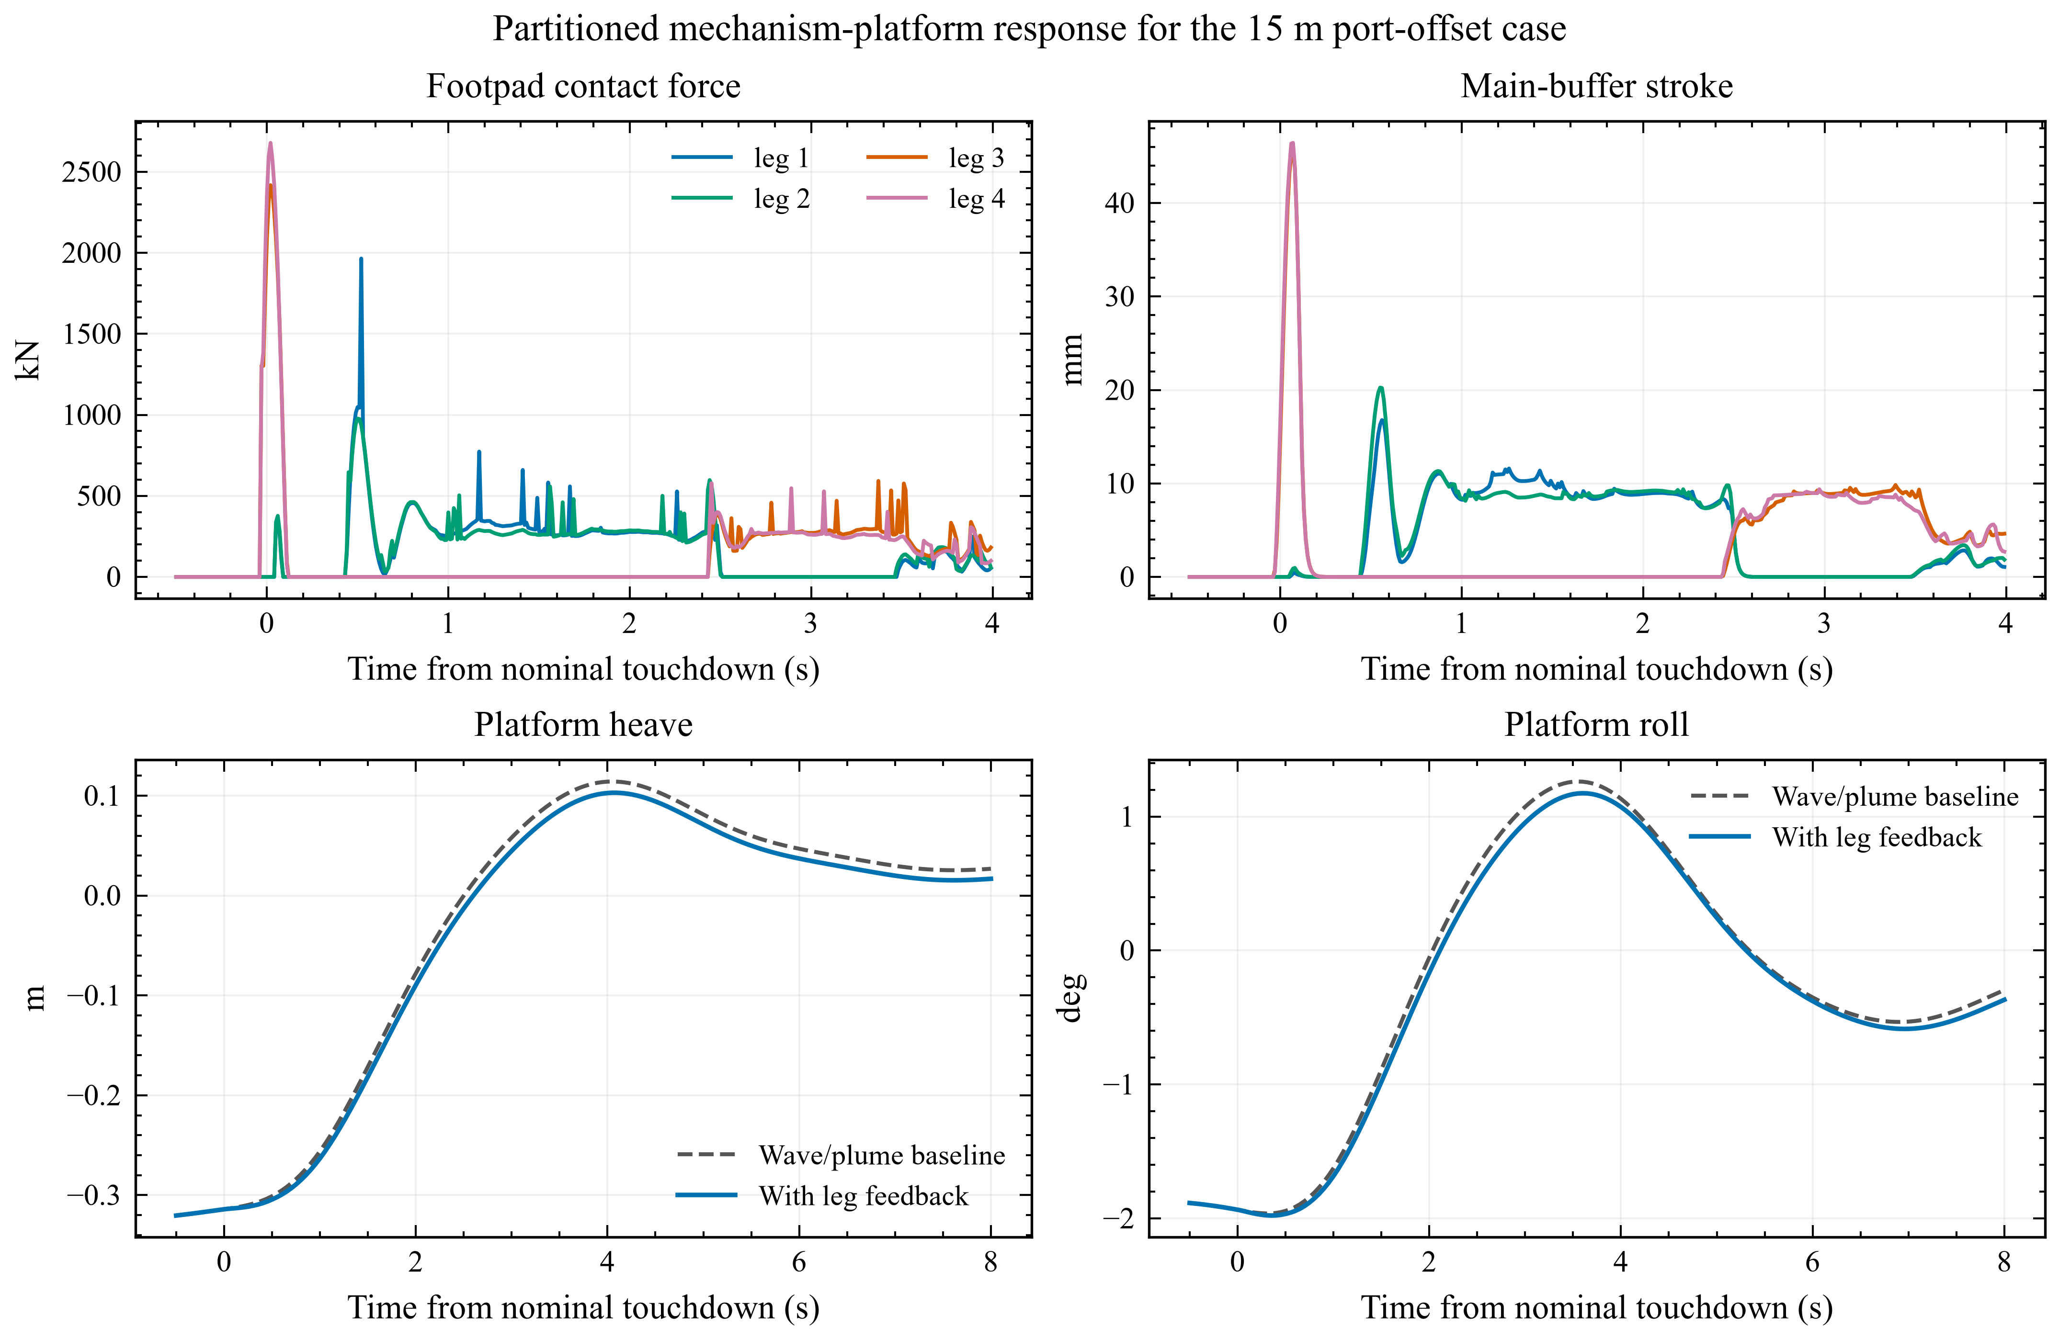
Figure 7. Contact and platform response for the Thies-scale mechanism proxy at a 15 m port offset. The grey dashed platform curves contain the wave and plume baseline; the blue curves include the one-pass correction from the resultant leg wrench.
The leg-induced response has peak magnitudes of 0.0133 m in heave, 0.124 deg in roll and 0.0020 deg in pitch. The roll contribution is much larger than the pitch contribution because the landing is offset in the transverse direction. Halving the multibody and platform time steps changes peak contact force by 0.20%, maximum buffer stroke by 9.08% and the reported platform pitch peak by 0.008%; heave and roll peaks are unchanged to the stored precision. Action-reaction residuals in the returned heave, roll and pitch channels are zero to output precision.
These numerical checks do not establish physical validation of the mechanism. The maximum smooth-contact penetration is 0.148 m, equivalent to 74.1% of the 0.2 m footpad radius. Although the peak force is stable under the selected time-step refinement, that penetration is too large for a full-scale contact interpretation. The contact-force and stroke curves are therefore retained as outputs of the declared proxy, not as predicted loads for a flight vehicle. A credible full-scale calculation requires contact material calibration, the actual footpad geometry and a measured absorber force-stroke-velocity relation.

5. Discussion

5.1 Implications for sea-landing simulation
The calculations show why platform-center motion alone is insufficient for a landing assessment. At the barge center, the vertical response contains heave. At a footpad, roll and pitch add a position-dependent vertical component and velocity. For the beam-wave case examined here, that rotational contribution more than doubles the four-foot differential velocity relative to the center response. A terminal guidance model should therefore receive the predicted pose and velocity of the intended deck target, with a time stamp and uncertainty, rather than only the vessel position.
The same argument applies after touchdown. An eccentric vertical force produces roll or pitch moment immediately, and the radiation-memory force continues after the short contact impulse. The one-pass partitioned result demonstrates this pathway: the returned leg force changes the platform response in the physically expected direction, and a transverse offset predominantly changes roll. A prescribed moving deck cannot reproduce this feedback. Conversely, replacing the landing mechanism with a single vertical spring would suppress the observed sequence of first contact, lift-off and re-contact.
The framework is intentionally modular. The potential-flow block can be rerun for a different hull or platform loading without changing the landing mechanism. A measured absorber curve can replace the present bilinear proxy without changing the hydrodynamic or platform-dynamics formulations. Mooring, dynamic positioning and reduced plume loads can be added to the platform right-hand side. This arrangement is more useful for progressive validation than a monolithic model in which the origin of each load is difficult to trace.

5.2 What the public experiments support
The Yang comparison gives a practical measure of the information contained in a published figure. A simple unilateral model can recover buffer-stroke magnitude and broad contact ordering after fitting one test. It cannot recover structural acceleration or the asymmetric force waveform. The upper-bound observation ratio and the remaining errors show that several combinations of stiffness, damping, geometry and inertia can fit the same limited response. Further optimization against the two asymmetric cases would improve their curves numerically, but it would no longer be a prediction and would conceal the identifiability problem.
For this reason, the dashed curves in Figure 4 are used only as validation targets. They are not included among the present calculated results. The same rule applies to parameters taken from Thies, Wang and Li: their origin is recorded, while the resulting multibody-contact and platform-response histories are generated by the present code. A separate research-integrity document contains the file hashes, figure lineage and unresolved assumptions for each result.

5.3 Limitations and next steps
The hydrodynamic model is linear and assumes small platform motion. Viscous roll damping, green-water effects, slamming and changing wetted surface are outside the potential-flow formulation used here. The rectangular barge is a controlled reference geometry, not a digital model of an operating recovery vessel. Its 9 m foot half-span is a sampling layout and does not represent a named launch vehicle.
The random-wave study is a platform-only screening calculation. It excludes touchdown timing, powered descent, guidance and navigation errors, dynamic-positioning control, wind, current and vehicle feedback. The reported P95 values must not be read as landing success probabilities or allowable sea states. A coupled Monte Carlo study should sample the vehicle state at entry to the terminal landing phase and advance the partitioned platform-contact system through touchdown for each realization.
The multibody branch remains the least certain part of the calculation. CAD-quality joint coordinates, member inertia, footpad compliance and measured absorber data are needed before its loads can be compared with Thies, Yue or Yang on a like-for-like basis. The current large contact penetration is a direct indicator of this deficiency. The next numerical step is to calibrate the contact and absorber model against a public drop test, then repeat time-step and stiffness convergence while monitoring impulse and penetration together. Only after that step should the full six-degree-of-freedom fixed-point exchange be used for quantitative design studies.

6. Conclusions
An open partitioned framework has been developed for coupling frequency-domain potential-flow hydrodynamics, time-domain radiation memory and four-leg multibody contact. The implementation transfers data through machine-readable files and explicit deck-pose and contact-wrench interfaces. The following conclusions are drawn from the present calculations.
- Public Yang drop-test curves are sufficient to identify a reduced unilateral four-contact model and test it on frozen asymmetric cases. Buffer-stroke peaks are reproduced within 4.0%, but the acceleration and asymmetric force histories are not. The missing flexible mechanism cannot be reconstructed uniquely from the published record.
- The locally compiled potential-flow model produces complete platform and deck-point RAOs for the 120 m x 50 m rectangular barge. Analytic displacement, waterplane and hydrostatic checks agree with the parameterized geometry. The maximum landing-center heave RAO on the registered grid is 1.128 m/m.
- Correlated potential-flow/JONSWAP synthesis shows that foot-point motion can differ substantially from center motion because of roll and pitch. Across 63 cases, the largest P95 center vertical speed is 1.505 m/s. For the Hₛ=3 m, Tₚ=8 s beam-wave case, the P95 four-foot vertical-velocity span is 2.435 m/s.
- The coupled mechanism proxy reproduces sequential four-foot contact and returns an eccentric landing wrench to the platform. The 15 m transverse offset produces a larger roll than pitch correction, as expected. The current contact penetration and one-pass feedback, however, preclude interpretation as a validated full-scale landing-leg prediction.
- The framework is ready for progressive replacement of proxy inputs by measured absorber, contact and geometry data. Full six-degree-of-freedom fixed-point coupling and coupled irregular-wave landing statistics should follow only after those mechanism-level data and convergence checks are available.

Data and code availability
Case inputs, panel meshes and hydrodynamic outputs, digitized validation targets, identified-model histories, multibody and platform-response results, random-wave samples, figure scripts and machine-readable audits are included in the accompanying repository. The paper figures are regenerated from these files by a project-local SciencePlots environment. Commercial ADAMS, Abaqus, AQWA and STAR-CCM+ project files were not available and are not represented as reproduced.

References
- Yang, Shaofei; Zhang, Ming; Ruan, Shuang; Lei, Bo. Analysis of Sea-Based Landing Dynamics of Reusable Landing Vehicle Considering Mechanism Flexibility. Journal of Mechanical Strength, 2026, 48(2): 238--250. https://doi.org/10.16356/j.1005-1120.2026.02.006
- Nargolkar, Ishan; Vijayan, Kiran. Coupled Hydrodynamic-Structural Analysis on Reuseable Launch Vehicle Landing on Barge. Proceedings of Meetings on Acoustics, 2025, 57(1): 065002. https://doi.org/10.1121/2.0002061
- Liu, Yingyi. HAMS: A Frequency-Domain Preprocessor for Wave-Structure Interactions - Theory, Development, and Application. Journal of Marine Science and Engineering, 2019, 7(3): 81. https://doi.org/10.3390/jmse7030081
- Thies, Christoph. Investigation of the Landing Dynamics of a Reusable Launch Vehicle and Derivation of Dimension Loading for the Landing Leg. CEAS Space Journal, 2022, 14: 565--576. https://doi.org/10.1007/s12567-022-00456-x
- Yue, Shuai; Lin, Qing; Zheng, Guang; Du, Zhonghua. Modeling and Experimental Validation of Vertical Landing Reusable Launch Vehicle under Symmetric Landing Conditions. Chinese Journal of Aeronautics, 2022, 35(12): 156--172.
- Wang, Zhi; others. Analysis of Ship Coupled Motion Response during Offshore Rocket Recovery. Ship Science and Technology, 2023, 45(10): 35--40. https://doi.org/10.3404/j.issn.1672-7649.2023.10.008
- Xie, C. M.; Yang, J. C.; Cheng, X. M.; Yu, J.; Wang, Z.; Tao, Z. Q.; Lu, Z.; Xiao, F.; Ni, X. Y.. Numerical and Experimental Study on the Motion Response of a Sea-Launch Platform under High Impact Force. China Ocean Engineering, 2025, 39(6): 1016--1027. https://doi.org/10.1007/s13344-025-0078-6
- Wang, Y.; Yu, H.; Xie, J.; Yan, Z.; Tian, B.; Gao, H.. The Impact Modeling and Experimental Verification of a Launch Vehicle with Crushing-Type Landing Gear. Actuators, 2023, 12(8): 307. https://doi.org/10.3390/act12080307
- Li, H.; Xu, W.; Zhao, Y.; Hong, A.; Han, M.; Ji, H.; Sun, C.. Dynamics Modeling and Analysis of a Vertical Landing Mechanism for Reusable Launch Vehicle. Aerospace, 2025, 12(4): 280. https://doi.org/10.3390/aerospace12040280

