Structure Design Documentation (Mk2V16)

Greg Wallace

November 12, 2018

General:

* Radii were made 4mm, and slots were made large enough to be cut with a ¼” end mill (unless impossible)
* All major parts can be made with only one machining operation (after two facing operations)
* Standardized M3x0.5 fasteners (the largest the shop can do easily), except where other requirements supersede (several M1.6, one US thread)
* Structural bolts were all moved to insert into the +z,-z because they have the most extra space.
* Board rails have been slid towards the +z direction to allow the camera to fit
* Excess open space on structural components has been closed in to decrease view from outside space to internal components as per request
* Sil pad dimensions have been changed to 0.3mm thick (compressed)
* +x and -x structure thicknesses increased to limit space between boards
* Several fasteners will need to be custom shortened to ensure they do not stick out further (because they don’t come in the exact length needed). But this should not be difficult.

Separation Switch:

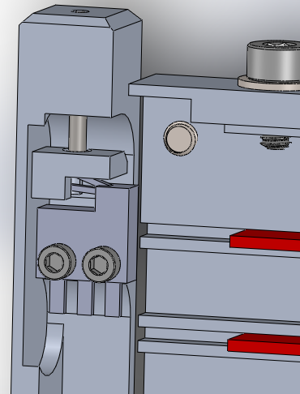 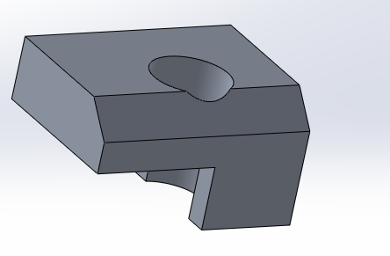 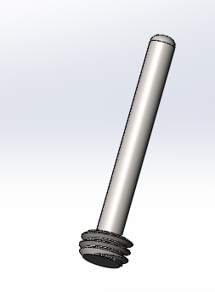

* No longer interferes with the backplane
* Longer throw for easier adjustability (due to leaver actuation)
* Adjustable from outside (until threadlocked)
* Minimal foot surface area removed
* Can’t spin out of position to become unusable (b/c of it’s contact with the -X structure)
* Pin part: turned on a lathe
* Block part: requires operations on two sides (unless chamfer cannot be cut, in which case, 3 sides)

Camera:

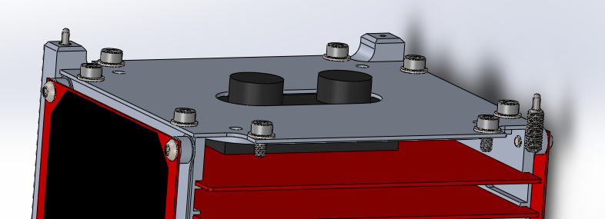

* You have 18.0mm between the bottom (-z) of the last board and the limit for which the camera can stick out. But I suggest trying to keep that smaller.
* The Camera must slide into the structure with a z-direction space of 8.5mm, so while sliding in, it must be shorter than that.

Solar arrays:

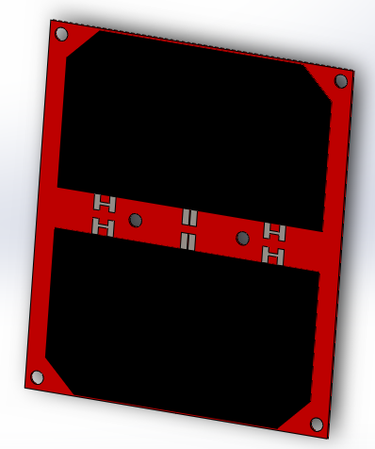 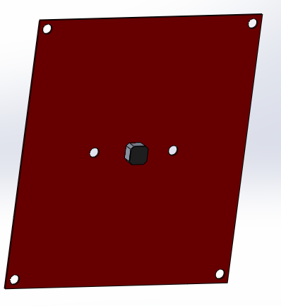

* Cell dimensions have been changed to equal that of Bradley’s models
* The middle holes have been moved to 28mm apart, as per bradley’s request
* Bolt Hole: 84x73, centered in those are two more holes 28mm apart. Button head fasteners are used.
* Overall Dimensions: 90x79
* Back of the solar array:
  + We’ll fit standoffs for heat sink inductors as requested by Bradley, but we cannot do so until dimensions are provided.
  + 64x58 space (centered) in the back of the array for PCB components (as described on the 10.23.18 solar PCB document)
* Note that solar arrays will not necessarily be centered on the side of the structure they are attached.

Boards:

* The Most +z board: On it’s +z side, it must stick out less than 1mm (or else interfere with payload)
* All boards shall have sharp outside corners of at least 1mm radius to ensure fitting

+X

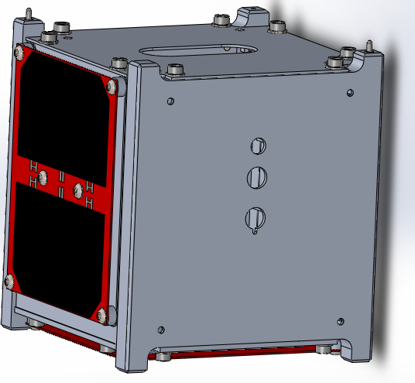 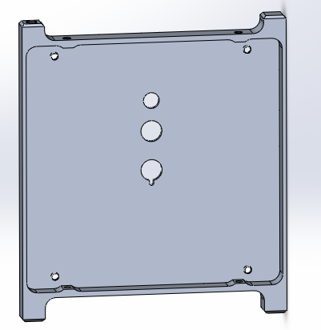

* The holes in the back of the +x structure will be aligned to the backplane and board dimensions as Bradley provided on 11.8-10.18
* The four threaded holes in the corners are currently measured as the same pattern as solar arrays, but aligned at the same height (in the z-direction) as the solar array holes on the -x board.

-X

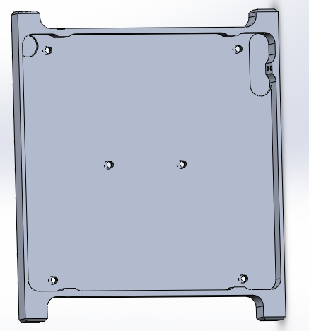

* The solar cell and backplane now share the two middle holes. The bolts for these now thread into the backplane.

+Y, -Y

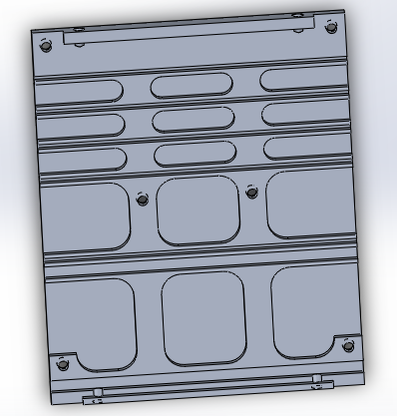

* Parts are exactly the same to improve manufacturability.
* Width was increased to be as wide as possible to limit gaps in the structure. Notice that they cannot be wider than 80mm, else the -Y pane will interfere with the separation switch.
* Extra material was added in the middle to further strengthen it

+Z

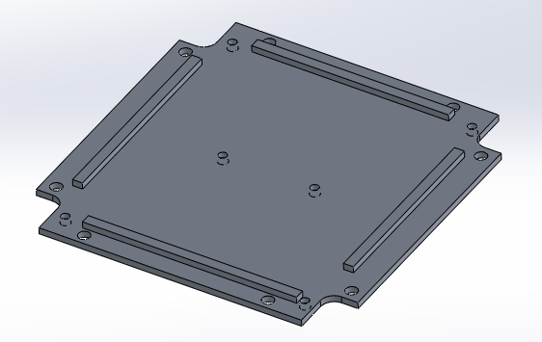

* Allows the option of combining this plate with the Payload.
* Now uses extrusions as stops for the +/-y, +/-x sides to push against

-Z

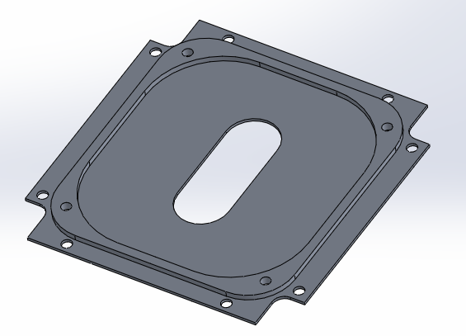

* 70x70 bolt holes for bradley’s use
* Those boards must stick out less than 5.5mm from the -z structure surface. Else, it is not within our boundaries according to the cubesat manual.
* Heads of several bolts will be sticking out of the -z side and must be avoided: include an 8mm diameter cylinder around them. One set of them is 56x93 (X,Y) (the washers for these will need to be clipped), the other is 90x65. They should have the vertical (-z) space such that we can tighten them while the -z board is attached.
* Now uses extrusions as stops for the +/-y, +/-x sides to push against

Magnetorquer Standoffs:

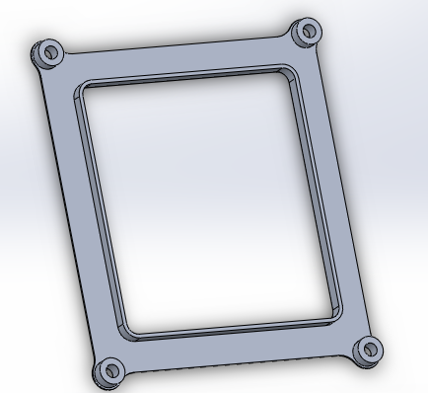

* Bolt holes: 73x84, same as solar arrays
* 3.3mm vertical space for the magnetorquer wire
* Inside limit of magnetorquer wire: 68x62 with 4mm radii at the corners
* Outside limit of magnetorquer wire: 7.8mm offset from the inside limits of the magnetorquer. 8mm may be available on request, but will require slight modification to the bolt standoffs.

Environmental Control:

* There is no room for thermal insulation. If room is needed, it will need to be taken from payload or Bradley.

Assembly:

1. The payload will be fitted in, possibly as part of the +Z side
2. Fit together the +/-Z, +/-Y, and +X structure components
3. To the -X component, bolt on the backplane and solar array, with the magnetorquer assembly underneath.
4. The -X assembly will be slid in, and bolts will attach it to the top/bottom plates
5. Magnetorquers and solar systems will be bolted on last.