Structure Design Documentation:

Mk2V12, September 20, 2018

Greg Wallace

This is a description of why the structural components are designed as they are.

Solar Arrays:

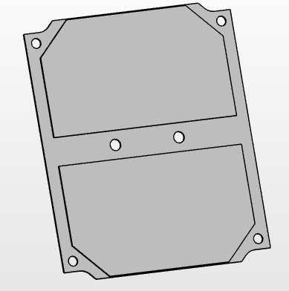 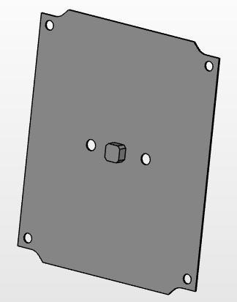

* For simplicity, we have tried to keep the threaded holes for the solar arrays in the exact same pattern on all of the sides which the arrays will be on: left, right, back, bottom. This way, all the solar array panels can be made exactly the same, keeping their design cheaper and simpler.
* This pattern for the holes is: 76mm in the +/-Z direction and 70mm in the +/-Y/X direction. (For the +Z array, these are changed to 76mm in the +/-Y and 70mm in the +/-X, but are in the same shape). In the middle of the arrays are two more holes 24mm apart, lined up parallel to the 70mm hole direction’s line.
* The solar cells were sized off of the outlines on Bradley’s original solar array boards. The distance between the two cells was also based off those. These may not be completely accurate dimensions and should be checked with Bradley.
* Fasteners are M3 sized (standard on our CubeSat). Due to space limitations, we are using very flat heads. Since we are clamping down on a fiberglass plate, we won’t need so much strength in the fastener heads. The threaded holes are 2mm deep into the side panels (left/right). This allows for 4 threads of contact between the bolt and the aluminum: less than is typically recommended 6 for good force distribution, but we don’t expect any high loads on this part. For the same reason we are not using washers (and for space limiations). We use 6 fasteners. 4 are around the edges to ensure the array does not flap around on launch. 2 are in the middle to keep the heat sink of the array touching the structure: This allows the array to keep cool by rejecting heat to the rest of the satellite. These fasteners should not be tightened too tight to prevent damage to the fiberglass array or stripping of the threaded hole in the sidepanel.
* The 2 fasteners in the middle of the backpanel may need to be cut down slightly to ensure they do not stick into the backplane (electrical board) (this would require removing material on the threaded ends to decrease “length” by perhaps 1mm). This is because they do not come in the exact length we desire. Cut them down using a file and be sure to repair the threads with the file once completed: they tend to get slightly out of whack when cut. Then ensure they are clean and fully clear of debris before using.
* The heatsink for an array is centered in the geometric center of the part. Dimensions were provided by Bradley and are probably on github, but I cannot find them.
* The heatsink pad (which goes under the heatsink) was designed with the same outline as the heatsink, but with a thickness of 0.4mm (though it can range from 0.254mm to 0.508mm, which may affect magnetorquer standoff size). We are assuming that the material will be attached via adhesive and that the two nearby bolts will provide enough strength to keep the adhesive from breaking. The material can be found here:

<https://www.digikey.com/catalog/en/partgroup/sil-pad-2000-series/1293?mpart=SP2000-0.015-00-54&vendor=211>

* The cutouts in the 4 corners of the array are to allow structural fasteners to be attached while the array is already attached. The current assembly plan is to connect the structure first and then add the arrays. But this allows us to change things up later if needed.

Main Structural Bolt Holes:

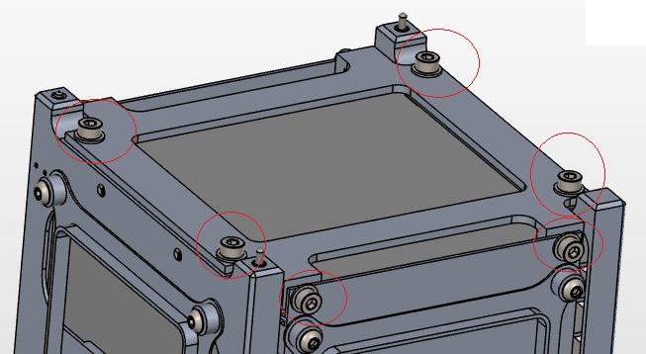

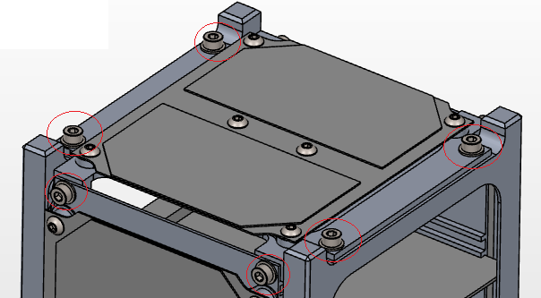

* For simplicity, we have tried to keep the holes between the top/bottom and the front/back in the exact same pattern (which will be attached from the top/bottom directions). Similarly, those between the left/right and top/bottom are of similar pattern (which will be attached from the left/right directions).
* Between the top/bottom and front/back, the pattern is: 90mm in the +/-X direction and 65mm in the +/-Y direction.
* Between the top/bottom and the left/right plates, the pattern is 94mm in the +/-Z direction and 70mm in the +/-X direction.
* Fasteners are M3 sized (standard on our CubeSat). Since we have the vertical space, we are using taller socket-head cap screws: these have the strongest heads. Thread depth in the front/back plates is 5mm, and in the left/right is 4mm (providing 10 and 8 threads of contact with the aluminum respectively). This is greater than the suggested 6 to allow greater factor of safety and the difference in strength between aluminum and the alloy steel fasteners. Most likely, this is not necessary, but we will continue to use it unless it can be shown that it is unnecessary. Since these bolts form the structural backbone of our CubeSat, we are being cautious with these joints and overdesigning them. Washers will be used for each of these bolts to even out the stress in the part, making the joint less likely to fail. There is a fastener of all 4 corners of each side for even forces, decreasing torques, and preventing flapping of the edges during launch. These joints should be torqued to a specific value as calculated using bolted joint analysis.

Mk1 🡪 Mk2

* Previously (See the Mk1 models) the rails were built into the left and right sides. But it was difficult to cut out the slots: they are so small that the head of the milling machine had to stay far from the edges. This also meant that the boards would need to slide through the section of the rails (which are supposed to have more unbroken surfaces). To counteract these, the rails were switched to be on the front/back.

General Design Concerns:

* Number of parts: The rails could be made on their own parts (4 total) and attached via fasteners. But this would making lining them all up on construction more difficult: all joints have some slop in them, so having more parts between vital dimensions makes those dimensions more difficult to maintain. To minimize difficulty in assembling and keep dimensions as needed, fewer parts should be used. For the primary structure, we have only 4 parts: frontpanel, backpanel, top, and bottom. The front and back each have 2 rails, and the front and back are connected by both the top and bottom pieces. So the rails should not be difficult to line up between the front and back pieces.
* Single-sided machining: Designing a part that only needs to be machined on one side (besides facing) makes it easier and faster to construct. The Mk1 model had most of its parts requiring cutting from two sides or more. This made them more expensive. For Mk2 we tried to design parts so they only need to be machined from one side. We didn’t entirely succeed at this, but we gave it a good effort.
* Minimize material removal: Removing material takes time and wastes metal. To Most of the center of the CubeSat and middles of the sides will be open. So by designing flat sides we can use thinner-stock material and save money. In the Mk2, the front and back are 8.5mm thick, the top and bottom are around 9.15 and 7.5 respectively, and the left and right are only 3mm thick.
* Tolerance: No part is perfectly accurate. Higher accuracy takes more time and effort by the machinist making it more expensive. +/-0.1mm is fairly tight. They can get lower but it is difficult. +/-0.5 (for small parts like ours) is fairly cheap. But lower accuracy means parts need to be designed for it, or risk them not fitting together. So, for vital dimensions, +/-0.1 is usually reasonable. But +/-0.5 is cheaper. You just need to make sure that the parts will do their job if all of them are out of spec by the worst-case tolerance in the worst-case positions. There isn’t an easy way to do this. Try seeing if you can make the part fail (dimensionally) by stacking up tolerances in the worst-case directions. Most likely, the machinist will produce a part far more accurate than you asked for: they just don’t want to guarantee it because it takes more work and time.
* Since most of these parts will be milled out, inside dimensions need to have radii (we can’t have a 0mm diameter mill bit). A 1mm radius is difficult to achieve, and cannot be very deep: the spindle of the mill will hit the part. 3+mm radii are more realistic, but larger ones are better. In places where there is plenty of space, we may go up to 10mm radii.
* Volume Limitations: The CubeSat, besides the feet of the rails, must fit in 100mm X 100mm X 100mm. However, there is an extra space between the rails where we may stick out up to 6.5mm. Previous versions (See Mk2V8) presumed a more liberal available space on the left/right/front/back (83mm X 113mm). But Matt Sorgenfrei from NASA Ames pointed out the LP might not accept this, and suggested 83 X 100mm for safety. This requirement would mean fasteners had to be moved more inwards, decreasing the available internal space.
* Slots: since our CubeSat has been designed with slots to slide in the PCBs and Payload Chamber, we must ensure there is enough space for them to move. Because these boards are wider than the space between the cubesat’s primary rails, the boards must be inserted before the back plate of the structure is attached (See “CougSat1 Assembly Process 9.10.18.pdf”). With the internal volume decrease between V8 and V12, the space between slots became more compact. In fact, we wouldn’t have space for the fastener heads on the payload with that system. So to provide more vertical space (+/-Z), the top/bottom plates were adjusted such that their bolts with the left/right are on extrusions. This way when PCBs/Payload are slid in, they have extra vertical space ~6.5mm in the middle (to a width of about 88mm) on the -Z side and ~4.4mm to the same width on the +Z side.
* On threaded holes: Never thread both sides of a joint; they won’t line up properly. Instead, thread the far side and leave the near side as a straight cut that is larger than the bolt diameter (ex: for an M3, use a 4mm hole on the side that the bolt’s head will go on). Also, try to keep 6 threads of contact between the bolt and the far side of the part (3mm for M3x0.5). This will give it maximum strength.

Backpanel (-X):

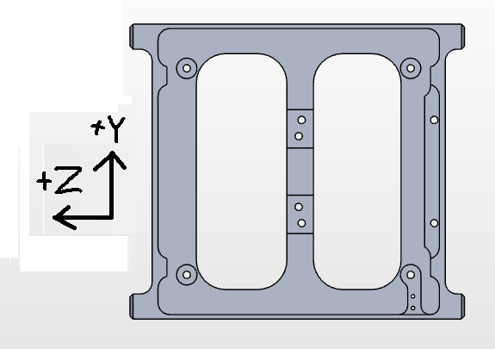 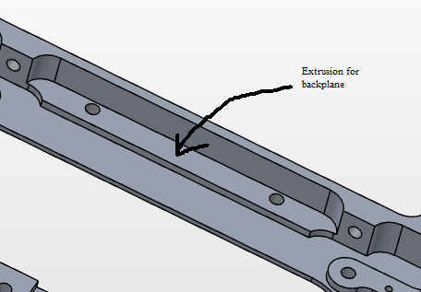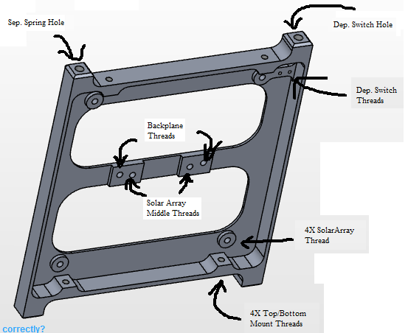

* This part would be made out of a flat piece of stock roughly 100mm X 115mm X 9mm. The features will be cut into it, mostly from the +X side (cutting down into the -X direction) with a milling bit. To assist the milling operation, all radii are 3mm or larger, allowing for 6mm diameter milling bit (almost ¼”). The only exception is in the corners between the solar-array threaded sections and the threaded holes for the to/bottom plates where the space allows up to a 3mm diameter bit (almost 1/8”). Notice how there is some material left all the way around the part in at least 2 directions, providing somewhat of an L-shaped flange around the part. This greatly helps prevent bending of the part: having protrusions in two orthogonal directions provides rigidity from bending in those directions (see: <https://youtu.be/gi-TBlh44gY> ). Since this ‘flange’ extends around the part unbroken, it should be fairly rigid about all three directions.
* Includes two of the CubeSat rails and the structure between them, since this can be machined fairly easily from a single, flat piece of material.
* The rail dimensions are based directly off the requirements of the CubeSat standard.
* One of the feet of the rail on the -Z side has a threaded hole for a separation spring. This will push off against another CubeSat rail foot or against the PPod launcher. The separation spring we are using was directly recommended by the Cubesat Specification Manual.
* The other rail’s foot on the -Z side has a threaded hole to be used by a deployment switch mechanism. For simplicity, the thread will be the same as that of the Separation Spring. A plunger will keep the switch depressed while inside the PPod (it will be pushed on by another CubeSat’s foot or by the PPod). Once our CubeSat is released, it will spring back out, allowing the electronics to start powering on. This thread in the foot of the rail is just to house the plunger piece of the system.
* Next to the deployment switch hole will be two small threaded holes for the actual deployment switch to be attached. Ideally, these holes would not penetrate through the surface of the rail, but they likely will (due to the thinness of the part). This is fine, so long as the bolts themselves do NOT stick out of the rail surface and the surface is smooth. They should be sunk in by a noticeable amount.
* The solar array/magnetorquer system, the top/bottom plates, the deployment switch itself, and the backplane PCB will all be threaded into the backpanel. To ensure these threaded joints are strong enough, at least 1.5mm of extra material was extruded out in sections near each of these threads (where it is already 1mm thick). This provides 2.5mm (5 threads). The top/bottom attachment is 5mm (10 threads) because these are primary structural attachments. This is the purpose of all the extrusions inside the part.
* One of the extrusions, on the -X side with 2 holes, is just a place for the backplane to be clamped against. Otherwise, it would have no method of attaching the -X part of the backplane to the structure (the +X part is held down by two bolts in the middle of the backpanel.

Backplane and Clamp:

* The backplane was modeled off Bradley’s early backplane model by taking physical measurements. So there may be numerical discrepancies between actual design and what we have designed. But the model we designed has tried to be conservative dimensionally, meaning the final design will take up less volume than we have allotted it.
* To fix the backplane to the structure, bolts were originally used in the corners. But these took up space in areas we could not afford. So the current model uses two bolts on the +Z side (in between the 4th and 5th slots, where the batteries will reside) and two bolts on the -Z side where the backplane fiberglass will be allowed to stick out. However, on the -Z side, there wasn’t space for a bolt head without cutting out a slot in the backpanel (and weakening it flexurally). So instead, here the backplane will be clamped down using two bolts and a metal spacer. The bolt heads will push down on a the spacer and their bodies will keep it from moving in the Z/Y directions, and the spacer will push the backplane fiberglass against the backpanel extrusion mentioned in the “Backpanel” section.
* The two +Z fasteners are near the middle to allow them to be on the same extruded pieces of the backpanel as the solar array’s 2 middle bolts.

Frontpanel (+X)

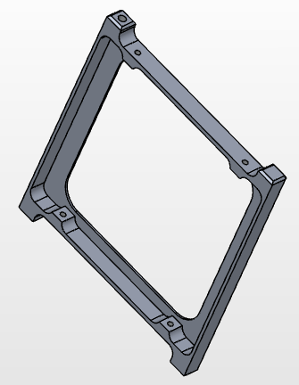 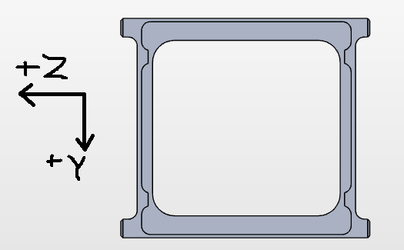

* This is, for the most part, a simplified version of the backpanel. Currently, the only pieces attached to it are the top and bottom plates (4 bolt holes total). So the overall shape is just the rails and some thin connectors between the two rails. Future designs will likely add more bolt holes and pieces, but they are not yet present.
* Like the backpanel, the overall structure is flanged: the cross section has extrusions in two directions, where possible. This helps prevent bending without adding much more material. It is rigid around all 3 directions.
* The rail dimensions are based directly off the requirements of the CubeSat standard.
* There is one hole for a separation spring on the -Z, +Y leg. This thread is the same as those two on the backplane.

Left/Right Side (+/-Y)

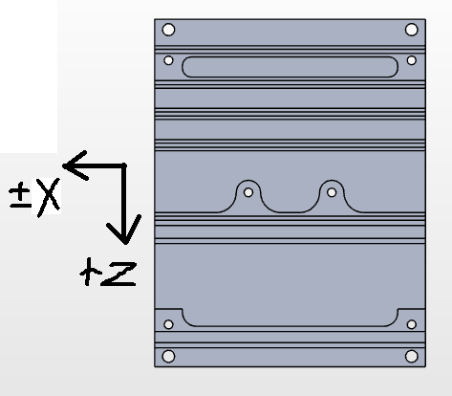 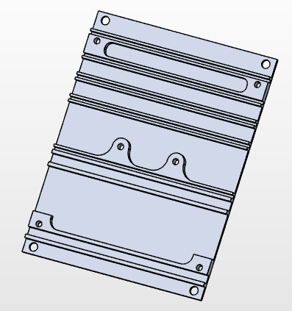

* The left and right are identical, meaning they will be cheaper to have machined (you only need to write the CAM once, and then can make multiple parts the same with it).
* Made thin (3mm) with minimal material removal needed to allow for easy and cheap manufacture.
* Dimensions are mostly simple with minimal tolerance, so we may be able to make these ourselves.
* Adaptable: Can be redesigned so the slots move up or down very easily. The only difficulty is that the bolt holes may need to be kept the same distance between each other, which can interfere with the slots for the boards. The 6 holes (4 corners, 2 middle) for the solar array can be moved around (+/-Z direction), but they must be kept the same distance from one another. Otherwise they will require a uniquely shaped solar array.
* Slots for the boards are standard with 1.2mm of space between them (for a 1.0mm thick board) and the slot rails being 1.0mm thick (we assume this is strong enough, though we have not checked.
* Near the center, one of the slot extrusions acts to hold in both a PCB and one of the payload rails. This one is 1.5mm thick.
* Extrusions are also to allow threaded parts, providing 3mm (6 threads) of attachment.
* Internal radii are kept to a minimum of 2.5mm to allow larger milling bits.
* Note that the structural holes (highest and lowest) for attaching this to the top/bottom are not on extrusions. This is to allow the to/bottom flanges/wings to stick farther in the +/-Y direction and allow greater space for sliding in PCBs/Payload. Assumes the flanges/wings stay 4mm thick.

Bottom (-Z)

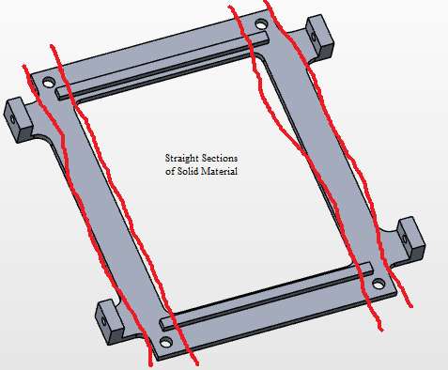 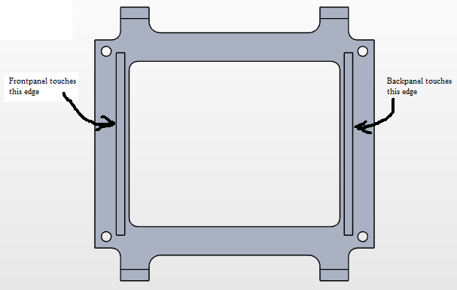

* Since the primary strength of the structure is made of the front and back plates, the bottom piece of the structure is designed to have a straight piece of solid material frontplate’s bolts to the backplate’s bolts. This strengthens it in the +/-X direction, preventing deflection.
* The left/right side pieces are not quite so vital to overall dimensional tolerances so they are not so strictly reinforced.
* As mentioned previously, the threaded holes for attaching to the left/right are on flanges/wings and stuck as far to the +/-Y sides as possible to allow more vertical space for the payload/boards.
* Two extruded rectangles on the +/-X sides will be used to position the front/back pieces of the structure. During assembly, these pieces will be slid up to the structure of the front/back until they are touching. Then the bolts will be attached. This gives a solid margin for keeping the cubesat’s X dimension within spec.

Top (+Z)

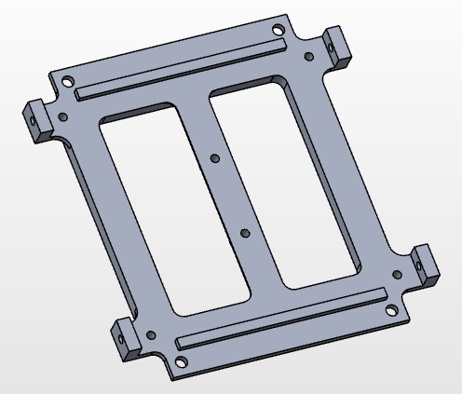 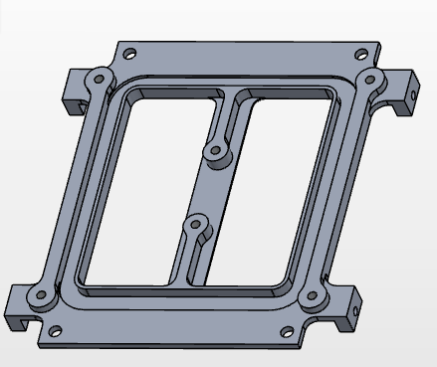

* The “top” panel is slightly more complex than the bottom. It must act as a primary structure between the front and back panels and hold the left and right pieces just as the bottom does. But it also has to hold a magnetorquer and solar array assembly. The amount of space for this is very limited.
* Like the bottom, there is a straight section of solid material between the frontplane and backplane’s bolt holes to help rigidity of the primary structure.
* The -Z side is practically the same as that of the bottom structure.
* Two extruded rectangles on the +/-X side will be used to position the front/back pieces of the structure. During assembly, these pieces will be slid up to the structure of the front/back until they are touching. Then the bolts will be attached. This gives a solid margin for keeping the cubesat’s X dimension within spec.
* Holes are included for the solar array to be attached on the +Z side with extruded space around them for strength. These holes are in the same pattern as those on the other sides of the structure, for simplicity. Since some of these holes are in the middle, a web structure is added to hold them without adding considerable excess material. Between the outer solar array holes there are two risen sections going along the +/-X direction, connecting their own extrudes. These act as strengtheners and were added because of the slots cut out for the magnetorquers.
* Slots are cut in on the +Z side for the magnetorquers to be fit inside. The maximum dimension was set based off how much space the solar array outer bolts’ extruded sections were taking up. The slot was then set arbitrarily at 5mm wide around the whole thing. On the inner edge of this slot, a thin section of material is used to keep the magnetorquer wires from bending inwards.
* In the middle of the part are two threaded holes for the solar array plus a thin piece of material for the heatsink to dispense heat from. Extra material is added in two dimensions to prevent this section from bending, but is not possible right in the middle because that is where the heatsink does.

Magnetorquer Standoffs:

* These are designed to hold a magnetorquer between itself and a solar array. These are intended to provide dimensionally identical space for magnetroquers as those on the top-panel.
* The area for the magnetorquers lies between: 70mm X 76mm (outer dimension) with a radius of 9mm to 60mm X 66mm (inner dimension) and a 4mm radius. Then extruded out 3.4mm. This is symmetrical across all 3 cardinal directions.
* If needed, the inner dimension can be decreased, making the space larger.
* Magnetorquers are installed by wrapping the wire around a magnetorquer-wrapper, glued together, and then pushed off onto the magnetorquer standoff.
* The standoff also provides holes for the solar arrays’ bolts to pass through to keep the solar arrays from moving in and out. For the middle 2 holes, something else is needed.

Heatsink Standoff (“Standoff_3.9mm”):

* For the middle two solar array bolts to hold the array directly against structure, secondary standoffs are needed. These are very simple: just a short tube: OD: 6mm, ID: 3mm, L: 3.9mm.

Other:

* If deflection of the middle of the sidepanels is too high, tabs can be easily added to the edges to prevent them from deflecting outwards, and the boards will prevent them from deflecting inwards.