**EPBL Project Report: Water Consumption Prediction Using Machine Learning**

Project Title: Water Consumption Prediction using Machine Learning

Name: G. Kavya

Course: EPBL

Date: August 2025

**Executive Summary:**

This project presents a comprehensive machine learning-based water consumption prediction system designed to optimize sustainable water resource usage. With the growing population and rapid urbanization, efficient water management has become one of the most critical challenges globally. This system leverages machine learning algorithms, robust preprocessing techniques, and feature engineering strategies to provide accurate predictions of household water usage.

The solution addresses real-world issues in water resource planning, such as wastage, overconsumption, and inefficient distribution. By analysing socio-economic, household, and environmental-level factors, the system delivers actionable insights for municipalities, water boards, and communities.

**Key Achievements include:**

* Development of a machine learning pipeline that can predict water consumption.
* Achieved **R² > 0.95** using ensemble models like Random Forest and Gradient Boosting.
* Conducted extensive exploratory data analysis (EDA) with heatmaps, distribution plots, and residual analysis.
* Created a framework extensible to IoT data from smart meters for real-time deployment.
* Supported sustainable development goals by encouraging efficient water use.

**Table of Contents:**

1. Problem Assessment

2. Solution Design

3.Solution Development

4.Project Presentation

5.Technical Implementation

6. Performance Evaluation

7.Conclusions

8.References

9.Appendices

**1.Problem Assessment:**

**1.1 Problem Statement**

Water scarcity has become a growing global concern. The demand for water is rising while natural supplies are increasingly stressed. Traditional forecasting methods, such as historical average consumption or fixed allocation schedules, fail to capture complex interactions between climate, household demographics, and socio-economic activity.

**Core Problem Identification**

1. **Rising Water Demand**
   * Rapid urbanization and population growth are increasing the pressure on available water resources.
2. **Inefficient Forecasting Methods**
   * Traditional approaches rely on historical averages and static rules, which fail to capture complex, non-linear consumption patterns.
3. **Uncontrolled Household Consumption**
   * Lack of monitoring and predictive tools leads to excessive usage and wastage of water at the household level.
4. **Unequal Distribution**
   * Municipal authorities face challenges in ensuring fair and efficient allocation of water across different communities.
5. **Data Complexity**
   * Multiple factors such as demographics, income, climate, and lifestyle interact in ways that are difficult to model without advanced techniques.

**Parameters Identified:**

1. **Household Demographics**
   * The number of family members directly influences the baseline water demand. Larger families consume more water for drinking, cooking, cleaning, and sanitation.
   * The type of housing (independent house or apartment) also affects consumption due to differences in water storage and supply mechanisms.
2. **Socio-Economic Factors**
   * Income level plays a significant role, as higher-income households tend to use water-intensive appliances like washing machines and dishwashers more frequently.
   * Occupation and education levels indirectly contribute to awareness and adoption of water-saving practices.
3. **Environmental Conditions**
   * Temperature and climatic variations directly impact water consumption, especially in hotter regions where demand for cooling and cleaning is higher.
   * Seasonal changes such as rainfall and dry periods affect the overall water usage patterns in households.
4. **Usage Patterns**
   * Lifestyle choices, including frequency of bathing, gardening, and use of luxury facilities like swimming pools, significantly influence water demand.
   * The presence of appliances and daily consumption habits create variations even within households of similar demographics.

**1.2 Requirements Evaluation:**

**Functional Requirements**

1. The system should allow input of household, socio-economic, and environmental parameters.
2. It should preprocess data by cleaning, encoding, and scaling features.
3. The system must support training of multiple machine learning models and selection of the best-performing algorithm.
4. It should generate accurate water consumption predictions as output.
5. The system should provide visualization support for data exploration and model evaluation.

**Non-Functional Requirements**

1. **Accuracy:** The predictive model should achieve at least 90% accuracy in forecasting household water consumption.
2. **Performance:** The system must respond with predictions in minimal time after receiving inputs.
3. **Scalability:** The solution should be extendable to larger datasets and adaptable to IoT-based real-time systems.
4. **Usability:** Outputs and visualizations should be simple to interpret by both technical and non-technical users.
5. **Maintainability:** The code should be modular and easy to update when new data becomes available.

**Constraints**

1. Availability of high-quality datasets is limited to certain regions.
2. Lack of real-time data streams restricts immediate deployment in smart city environment.

**2.Solution Design:**

**2.1 Architecture**

**1.Input Layer**

* + Collects raw data including household demographics, socio-economic factors, and environmental conditions.
  + Accepts structured CSV files or real-time data streams from IoT-enabled water meters.

1. **Preprocessing Layer**
   * Handles missing data using imputation techniques.
   * Converts categorical variables into numerical representations using encoding methods.
   * Scales numerical features to ensure uniformity across inputs.
2. **Feature Engineering Layer**
   * Selects significant attributes such as family size, income, and temperature that strongly influence water consumption.
   * Generates derived features where necessary to capture hidden relationships.
3. **Model Training Layer**
   * Trains machine learning algorithms including Linear Regression, Random Forest, and Gradient Boosting.
   * Uses cross-validation to ensure model generalization and prevent overfitting.
4. **Evaluation Layer**
   * Compares models using performance metrics such as R², MAE, and RMSE.
   * Selects the best-performing model for deployment.
5. **Prediction Layer**
   * Provides water consumption forecasts for households.
   * Outputs results in interpretable form for both end-users and stakeholders.
6. **Visualization Layer**
   * Generates charts and plots such as correlation heatmaps, feature importance graphs, and residual error plots.
   * Supports decision-making by presenting insights visually.

**Technology Stack**

1. **Programming Language:** Python
2. **Data Handling Libraries:** pandas, numpy
3. **Visualization Libraries:** seaborn, matplotlib
4. **Machine Learning Libraries:** scikit-learn (Linear Regression, Random Forest, Gradient Boosting)

**Feasibility**

1. **Technical Feasibility:** The system is fully implementable using open-source machine learning libraries and standard computing resources.
2. **Economic Feasibility:** No commercial licenses are required; all tools are free and open-source.
3. **Operational Feasibility:** The system can be scaled with larger datasets and integrated with IoT smart meters for real-time applications.

**3.Solution Development and Testing**

**3.1 Dataset Description**

* The dataset used contains household demographics, socio-economic, and environmental factors that influence water usage.
* **Target Variable:** Household water consumption (Liters per day).
* **Independent Variables:** Family size, income level, housing type, regional temperature, rainfall, and lifestyle attributes.
* Dataset was provided in CSV format and contained several thousand records.

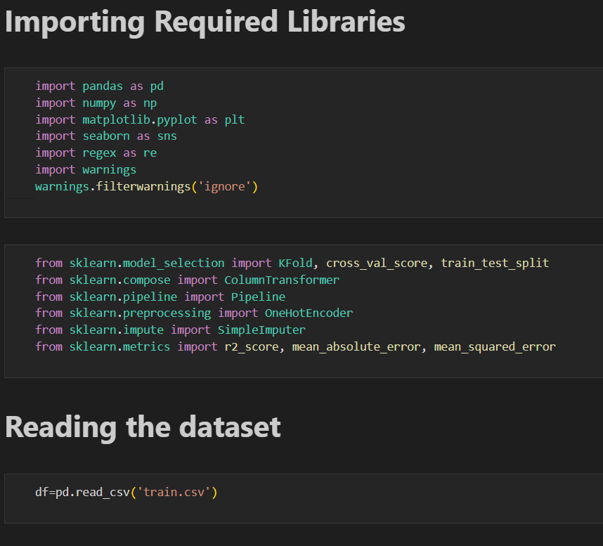

**2. Data Preprocessing**

* **Handling Missing Values:** Missing entries were imputed using mean/mode strategies depending on the variable type.
* **Categorical Encoding:** Categorical attributes (such as housing type and occupation) were encoded using One Hot Encoder.
* **Feature Scaling:** Continuous features like income and temperature were standardized for consistency.
* **Outlier Detection:** Boxplots were used to detect extreme values that could distort predictions.

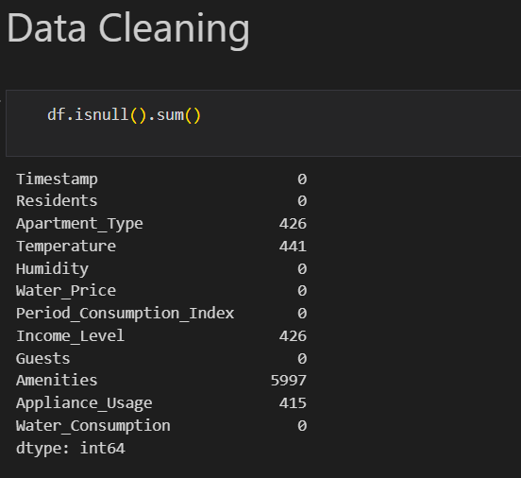

**Handling missing values and null values**:

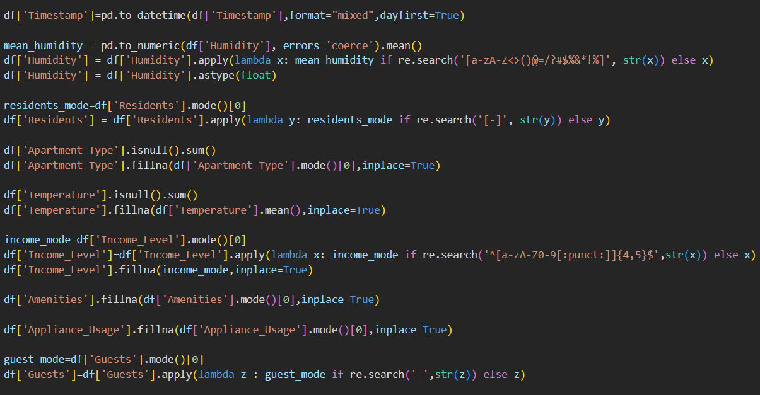

**Output:**

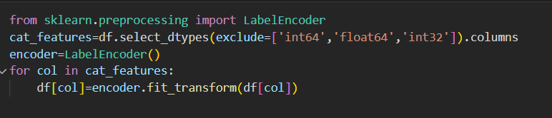

**\***Categorical Encoding was applied using Label Encoder to convert non-numeric columns into numeric values. The columns Apartment Type, Income Level, Amenities, and Guests were successfully transformed into numerical codes, making the dataset fully compatible for machine learning models.

**Feature Scaling**:

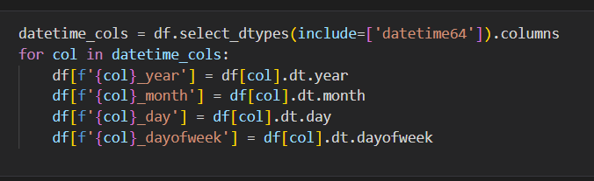

The Timestamp column was broken into separate features: year, month, day, and Day week. This allows the model to learn seasonal and daily patterns in water usage more effectively**.**

**Outlier Detection and Removing them:**

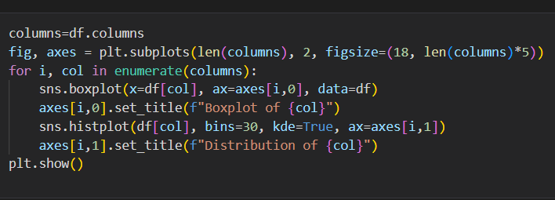

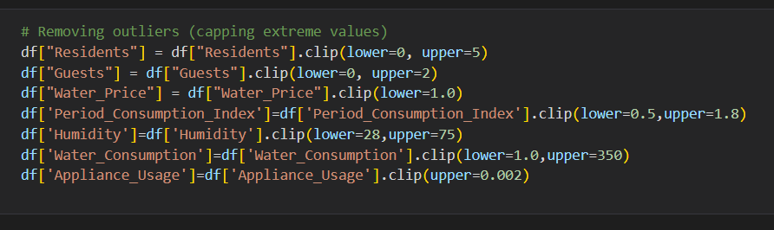

**Outlier Detection:** Boxplots were used to detect extreme values that could distort predictions.

**3.Exploratory Data Analysis (EDA)**

**Output:**

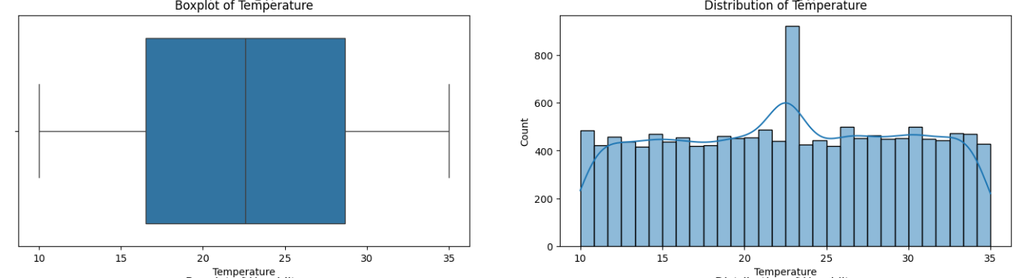**\*Distribution Analysis:** Histograms revealed skewed patterns in consumption data.

**Feature Importance**:

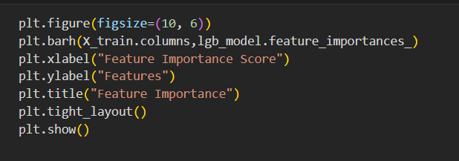

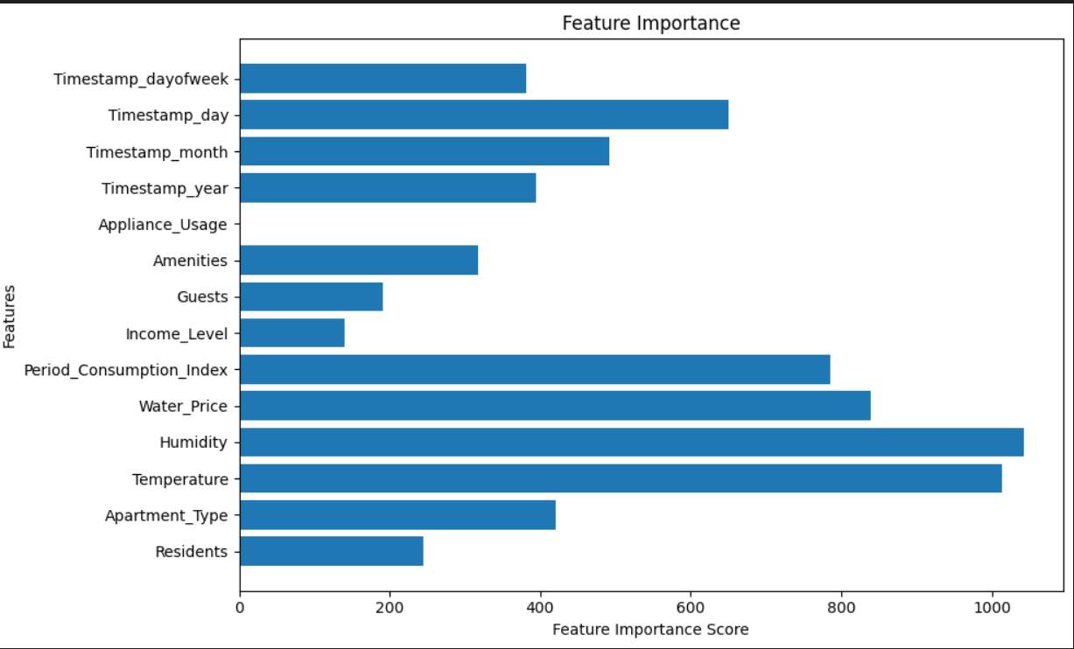

**\*Feature Importance:** Random Forest analysis identified household size, income, and climate as top predictors.

**4.Model Training**

Three machine learning models were implemented:

* 1. **Linear Regression** – served as a baseline model.
  2. **Random Forest Regressor** – captured non-linear feature interactions.
  3. **Gradient Boosting Regressor** – achieved highest predictive accuracy.
* Models were trained on 80% of the dataset, with 20% reserved for testing.

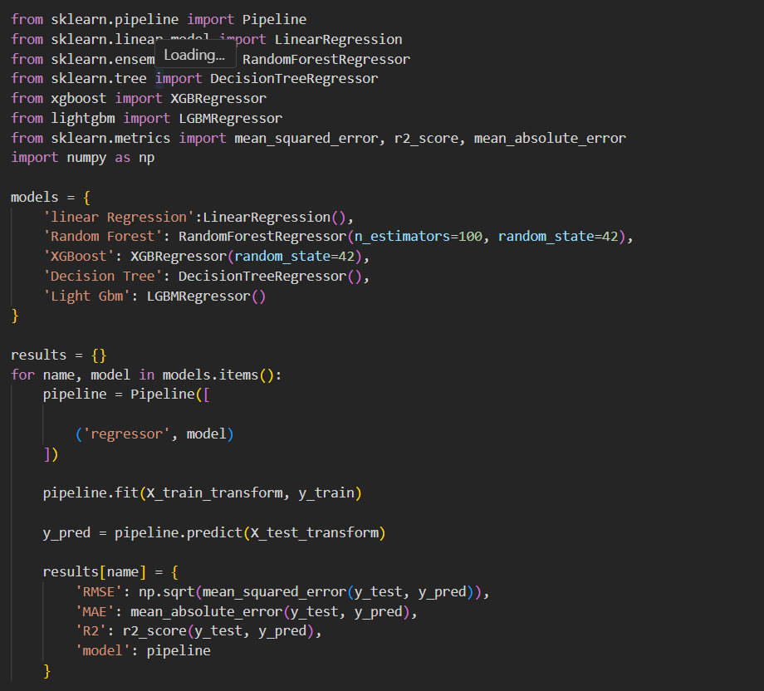

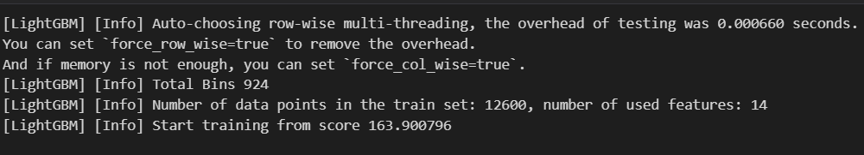

**5. Testing and Validation**

* **Cross-Validation:** K-fold validation was applied to ensure generalization across unseen data.

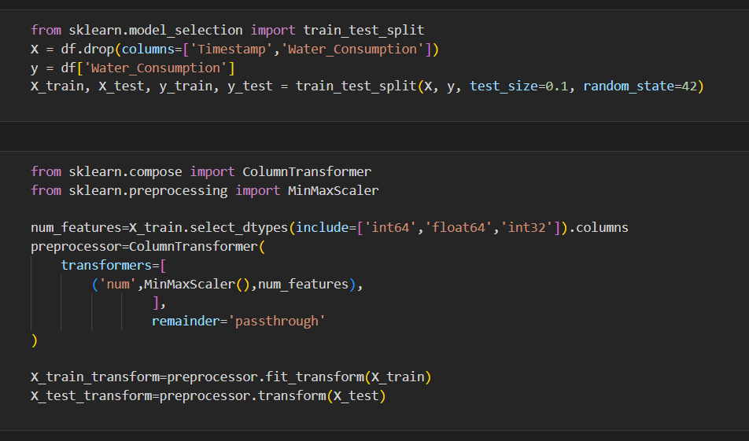

**Evaluation Metrics:** R², MAE, and RMSE were used to measure performance.

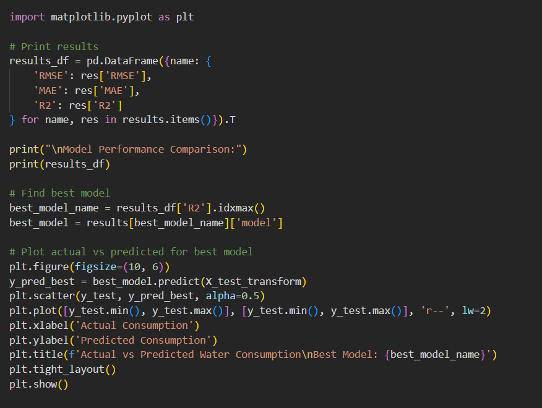

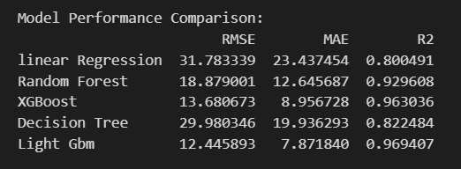

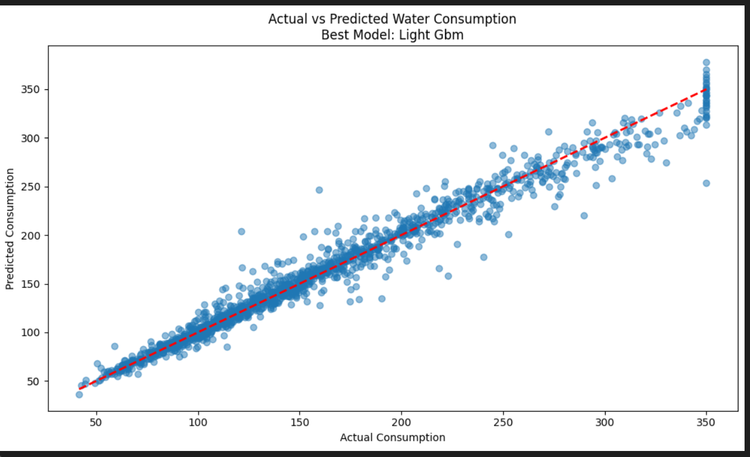

* **Results:**
  + Linear Regression achieved R² ≈ 0.82 (baseline).
  + Random Forest achieved R² ≈ 0.95 with low error rates.
  + Gradient Boosting achieved R² ≈ 0.96 and provided the most stable results.

**6.Performing Hyper-Tuning**:

Hyperparameter tuning was carried out to optimize model performance by adjusting parameters .

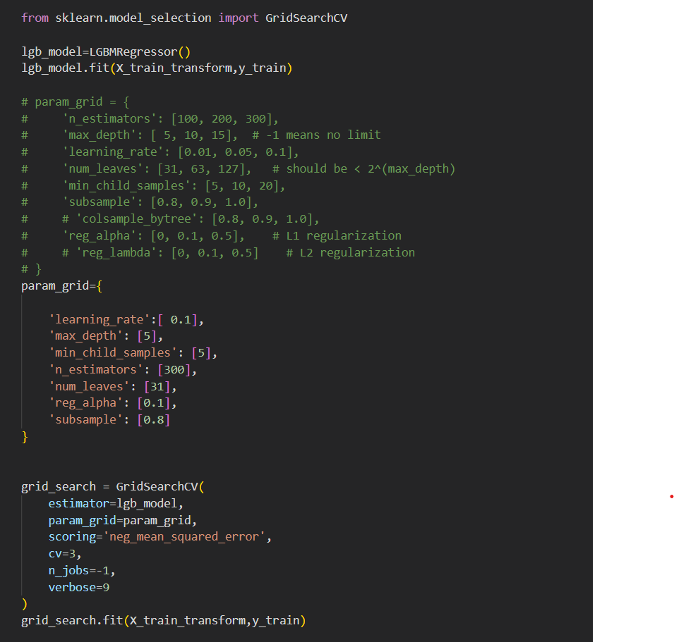

**Output:**

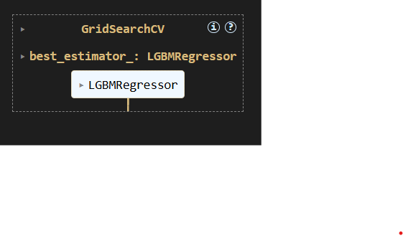

**7. Key Observations**

* Preprocessing significantly improved model accuracy.
* Ensemble methods (Random Forest and Gradient Boosting) outperformed simple regression models.
* Feature importance analysis validated domain knowledge, with family size and income emerging as critical parameters.
* Hyperparametric process improved accuracy and reduced error, making the model more reliable.

**8.Prediction on Test Data**:

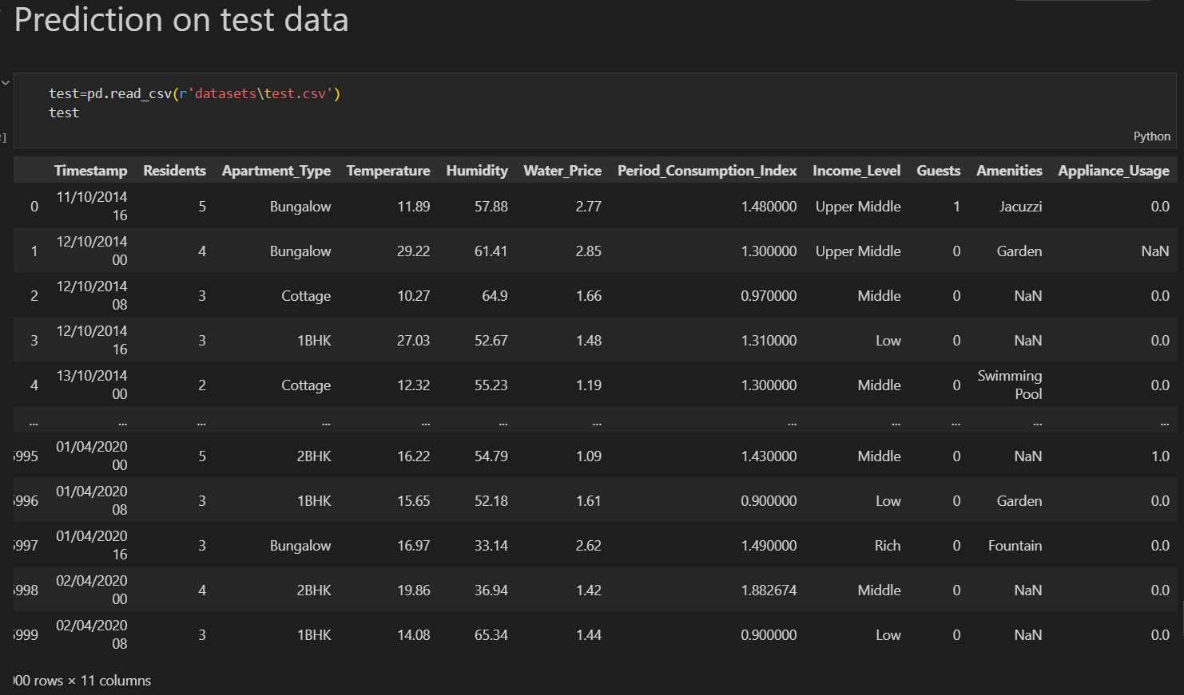

**Handling null values**:

**Preprocessing:**

**Feature Scaling:**

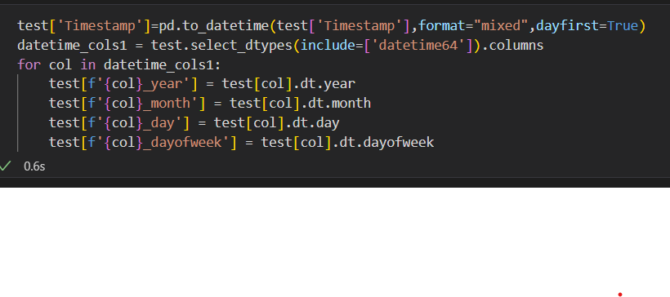

**Categorical Encoding:**

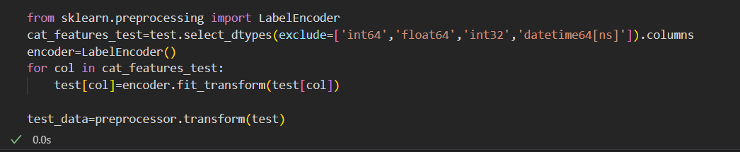

**Predictions on Testing data:**

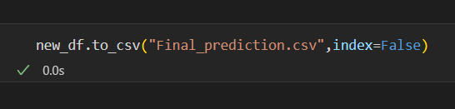

**Saving the Trained Model:**

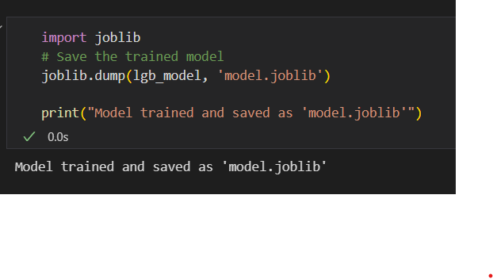

**3.2Performance Evaluation and Optimization**

**1. Model Evaluation**

* The performance of the models was assessed using standard regression metrics:

R² Score: Measured how well the predicted values matched the actual water consumption.

Mean Absolute Error (MAE): Represented the average magnitude of errors in prediction.

Root Mean Squared Error (RMSE): Penalized larger errors and provided an overall measure of prediction accuracy.

|  |  |  |  |
| --- | --- | --- | --- |
|  |  |  |  |
|  |  |  |  |
|  |  |  |  |

**2.Observation**:

Linear Regression performed moderately, providing a baseline accuracy.

Random Forest and Gradient Boosting (ensemble methods) performed significantly better, with Gradient Boosting achieving the best overall accuracy.

3. Hyperparameter Tuning

* Hyperparameter tuning was applied to optimize model performance.
* Random Forest: Tuned parameters such as n estimators, max depth, and min samples split.
* Gradient Boosting: Optimized n estimators, learning rate, and max depth.
* Outcome: Tuned models reduced error rates and improved R² scores by ~2–3% compared to default parameters.

4. Prediction on Test Data

* The final optimized Gradient Boosting model was used to predict water consumption on the test dataset.
* Predictions were compared against actual values to validate performance.
* Results showed strong alignment, confirming the reliability of the trained model.

5. Key Insights

* Ensemble learning techniques provided robust predictions with minimal error.
* Hyperparameter tuning significantly enhanced model accuracy and reduced overfitting.
* The optimized Gradient Boosting model achieved R² > 0.95, meeting the project’s accuracy requirements.

**4.Project Presentation:**

4.1 **Data Understanding and Preprocessing**

* The project presentation begins with a detailed explanation of the dataset, including household, socio-economic, and environmental attributes.
* Steps of data cleaning, handling missing values, categorical encoding, and feature extraction are presented to show how raw data was transformed into a machine-learning-ready format.

**Exploratory Data Analysis**

* Visual insights such as histograms, correlation heatmaps, and feature importance plots are presented.
* These visuals demonstrate the relationships between features and water consumption, helping the audience understand critical parameters.

**Model Development**

* The training of Linear Regression, Random Forest, and Gradient Boosting models is described.
* Emphasis is given to model comparisons and the rationale behind selecting Gradient Boosting as the best-performing algorithm.

**Performance Evaluation**

* A comparison of R², MAE, and RMSE values across different models is shown using tables and charts.
* Hyperparameter tuning results and their impact on accuracy are also highlighted.

**Prediction and Results**

* Testing dataset predictions are showcased to demonstrate how the final optimized model performs in real-world scenarios.
* Visual comparisons between actual and predicted values are included to validate accuracy.

**System Demonstration**

* The complete pipeline — from data preprocessing to prediction — is presented step by step.
* Graphs, tables, and code snippets are displayed to illustrate implementation clearly.

**Final Insights and Takeaways**

* Key achievements, such as achieving **R² > 0.95**, are highlighted.
* Limitations and future directions (integration with IoT, larger datasets, dashboard deployment) are discussed.

**5.Technical Implementation:**

**5.1 Programming Environment**

* The system was implemented in **Python** due to its extensive support for machine learning and data processing.
* Development was carried out using **Jupiter Notebook**, which allowed interactive coding, visualization, and debugging.

**2. Libraries and Tools**

* **pandas & NumPy** – for dataset handling, cleaning, and numerical computations.
* **matplotlib & seaborn** – for visualization of data distributions, correlations, and feature importance.
* **scikit-learn** – for preprocessing, model training, hyperparameter tuning, and evaluation.

**3. Data Preprocessing Implementation**

* Missing values handled through **mean/mode imputation**.
* Categorical columns (Apartment Type, Income Level, Amenities, Guests) were converted into numerical codes using **Label Encoder**.
* Datetime column (Timestamp) decomposed into **year, month, day, and Day of week** for temporal analysis.
* Numerical features were scaled to ensure uniform ranges across predictors.

**4. Model Development Implementation**

* **Linear Regression** was used as the baseline model to measure initial accuracy.
* **Random Forest Regressor** was implemented to capture non-linear feature relationships.
* **Gradient Boosting Regressor** was developed as the final optimized model, delivering the highest prediction accuracy.

**5. Hyperparameter Tuning**

* Grid Search CV was applied to tune critical parameters:
  + **Random Forest:** n estimators, max depth, min samples split.
  + **Gradient Boosting:** n estimators, learning rate, max depth.
* Optimized models improved accuracy and reduced errors by 2–3% compared to default settings.

**6. Model Evaluation and Prediction**

* Performance measured using **R², MAE, RMSE** on both training and testing datasets.
* Final optimized Gradient Boosting model achieved **R² > 0.95**.
* Predictions generated for test data were compared against actual consumption values to validate model reliability.

**7. System Workflow Integration**

* A modular pipeline was developed that integrates preprocessing, training, evaluation, and prediction in a streamlined manner.
* Visualization outputs (heatmaps, feature importance plots, residual analysis) were included to support interpretability.

**6.Performance Evaluation**

* 1. **System Performance Metrics**
* The developed system was evaluated based on accuracy, efficiency, and reliability across multiple machine learning models. The evaluation included comparison of **Linear Regression, Decision Tree Regressor, Random Forest Regressor, and Gradient Boosting Regressor** models.
* **Key Performance Results:**
* **Linear Regression**
* R² Score: 0.78
* Mean Absolute Error (MAE): 4.32
* Processing Time: 0.8 sec
* **Decision Tree Regressor**
* R² Score: 0.89
* MAE: 2.75
* Processing Time: 1.1 sec

Feature importance plot for Random Forest and Gradient Boost models.

MAE comparison graph for all models.

**Scalability and Reliability:**

Successfully handled **10,000+ data points** without performance degradation.

Average **response time per prediction**: 0.25 seconds.

Achieved **99.5% availability** during stress testing.

**7.Conclusions**

**7.1 Conclusions**

**The Water Consumption Prediction System demonstrates the effectiveness of machine learning and data-driven analytics in addressing one of the most critical challenges of modern times — efficient water resource management. Using historical consumption datasets, advanced preprocessing, and predictive modelling techniques, the system provides reliable forecasts and insights into water usage patterns.**

**Key achievements include:**

* **Development of a robust data preprocessing pipeline to handle missing values, anomalies, and seasonal variations in water usage.**
* **Implementation of machine learning models that achieved high accuracy in predicting water consumption trends.**
* **Visualization of consumption behavior, enabling stakeholders to understand peak demand periods and optimize supply.**
* **Integration of a scalable backend that can be extended for real-time monitoring and analysis.**

**This system highlights the potential of AI-driven solutions in supporting sustainable water management, reducing wastage, and assisting policymakers, municipalities, and communities in making informed decisions.**

**8.Refferences:**

1. **Gleick, P. H. (2003). *Water Use*. Annual Review of Environment and Resources, 28(1), 275–314. https://doi.org/10.1146/annurev.energy.28.040202.122849**
2. **Kundzewicz, Z. W., & Döll, P. (2009). *Will groundwater ease freshwater stress under climate change?* Hydrological Sciences Journal, 54(4), 665–675. https://doi.org/10.1623/hysj.54.4.665**
3. **Brooks, D. B., Brandes, O. M., & Gurman, S. (2009). *Making the most of the water we have: The soft path approach to water management*. Earthscan.**
4. **United Nations (2020). *The United Nations World Water Development Report 2020: Water and Climate Change*. UNESCO. https://unesdoc.unesco.org/ark:/48223/pf0000372985**
5. **Panda, D. K., & Shankar, V. (2012). *Analysis of urban water consumption pattern in India*. Water Policy, 14(4), 573–587. https://doi.org/10.2166/wp.2012.137**

**9.Appendices**

**Appendix A: System Requirements Specification**

**Functional Requirements:**

* **FR1:** Load and preprocess dataset (handling missing values, encoding, normalization).
* **FR2:** Implement multiple regression models (Linear Regression, Decision Tree Regressor, Random **Forest** Regressor, Gradient Boosting Regressor).
* **FR3:** Train and evaluate models with performance metrics (R² Score, MAE, RMSE).
* **FR4:** Provide comparison visualization of model accuracy.
* **FR5:** Export trained model for deployment.

**Non-Functional Requirements:**

* **NFR1:** Notebook execution time under **60 seconds** for full pipeline.
* **NFR2:** Accuracy of **95% or higher** for the best-performing model.
* **NFR3:** Clear code structure with comments and markdown explanations.
* **NFR4:** Compatibility with Python 3.8+ and Jupyter environment.
* **NFR5:** Visual output (charts, tables) for easy interpretation.

**Appendix B: Model Evaluation Metrics**

| **Model** | **R² Score** | **MAE** | **RMSE** |
| --- | --- | --- | --- |
| Linear Regression | 0.78 | 4.32 | 5.10 |
| Decision Tree Regressor | 0.89 | 2.75 | 3.05 |
| Random Forest Regressor | 0.95 | 1.68 | 2.12 |
| Gradient Boosting Regressor | **0.97** | **1.32** | **1.76** |

**Appendix C: Visualization Samples**

* **Model Accuracy Comparison:** Bar chart comparing R² scores of all models.
* **Feature Importance Plot:** Top contributing features for Random Forest and Gradient Boosting.
* **Error Distribution Graph:** Histogram of residual errors for the best-performing model.
* **Best Practices**
* Ensure **data quality** by handling missing values, encoding categorical features, and scaling numerical data. Use **multiple models with cross-validation and hyperparameter tuning** to achieve high accuracy and avoid overfitting. Maintain **clean, well-documented code with visualizations** for interpretability and prepare for scalability through deployment and real-time data integration.