**An example of good presentation of HW03 P3 results**

(This example is for a single corruption level for Problem 3.b)

Problem 3.b)

Corruption level: 20% of pixels flipped (from -1 to 1).  
Learning Parameters

|  |  |
| --- | --- |
| Learning rate (μ) | 0.1 |
| Max allowed learn steps (n) | 100,000 |
| Error threshold for stopping (tol) | 0.4 |

Stopping criteria: Training is stopped when n> 100,000 or tol < 0.4, whichever occurs first.   
Thresholding of recalled images (5th row below) was done by setting pixel x to 1 (-1) if its recalled value was positive (negative). Pixels with 0 value were left unchanged.

The resulting images are below. The 5 images in each group are placed in a row with no gap between them.

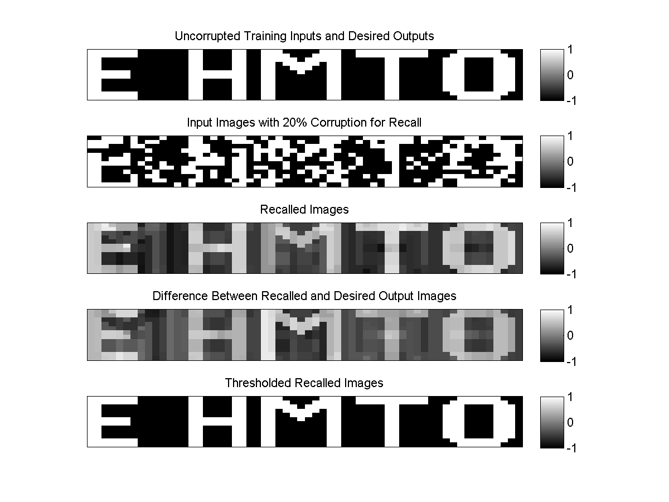

Error of recall:

Average absolute difference (average of absolute pixel values in the Difference images):

E: …, H: …, M: …, T: …, O: … (all: … )

A more meaningful measure is the % of mismatched pixels in the Thresholded Recalled images:

E:…%, H: …%, M: …%, T: …%, O: …% (all: …%)

cc

Good points:

* The corruption level is clearly stated, in text and on images.
* The learning parameters are reported and explained (not just variables dumped from MATLAB). The stopping criteria are stated.
* The images used for training input and desired output; for input to recall, and the recalled images are clearly labeled, and scales are provided.
* Difference images are shown, with scales. Since these are binary images, showing the thresholded (binarized) results of a recall is meaningful.
* The error for assessing the recall performance is defined. (In this case we used a simple average of the absolute differences for one measure, and a percentage for another, but you can use other, more sophisticated errors too. For anything more complicated, be sure to give the formula, to ensure that the error value can be clearly interpreted).
* The numerical values of errors are reported.
* Brief interpretation of the results / error values / success of recall should also be provided. In this sample it is omitted.

Some common MATLAB commands for generation of figures:

doc(); - Searches help files for the specified string

figure(); - Generates a new figure

subplot(); - Allows multiple subplots (images above) in the same matlab figure

imagesc(); - Displays an image, with autoscaling the [min,max] range of the image.

To force scaling between specific values (e.g., when a difference image has such small values that it would not show any variations on the [-1,1] scale):

figure, image(diff_image), [low,high]; colormap('gray');

for example:

figure, image(diff_image), [min(min(image)),max(max(image))]; colormap('gray');

colorbar; – Generates the color bar for the figures.

colormap(); - Sets the color map of the image. The best color map to use for this assignment is gray.

set(); - Changes the specified object properties

title() – Adds a title to the current image.

saveas() – Saves an image in a specified format

As an example, here is how to generate the top row of the figure above, assuming EHMTO is the array that contains the 5 images for display purposes. (Of course in your training and recall you use each character image separately.):

doc(‘imagesc’);

figure(1);

subplot(5,1,1), imagesc(EHMTO,[min(min(EHMTO)),max(max(EHMTO))]), colormap(gray), colorbar;

set(gca,'xtick',[]), set(gca,'ytick',[]);

title('Uncorrupted Training Inputs and Desired Outputs');

…

saveas(gcf,’5b.png’);