# Salesforce App-Owns-Data Embedding Sample

[**SalesforceAppOwnsDataEmbedding**](https://github.com/PowerBiDevCamp/SalesforceAppOwnsDataEmbedding/tree/main/SalesforceAppOwnsDataEmbedding/force-app/main/default/aura/powerBiReportAura) is a sample project which demonstrates how to implement App-Owns-Data embedding with Power BI reports using the [**Salesforce Developer Experience (SFDX)**](https://developer.salesforce.com/developer-centers/developer-experience/) and the [**Salesforce CLI**](https://developer.salesforce.com/tools/sfdxcli). When developing custom software solutions for a Salesforce environment, App-Owns-Data embedding has a big advantage over User-Owns-Data embedding. It does not require creating an Azure AD organizational account and acquiring a Power BI license for each individual user. When developing with the App-Owns-Data embedding model, your Salesforce users remain unknown to Power BI. You have the flexibility to embed reports for any users you want.

## Project Architecture

The architecture of this solution is built on top of an Apex class named [**PowerBiEmbedManager**](https://github.com/PowerBiDevCamp/SalesforceAppOwnsDataEmbedding/blob/main/SalesforceAppOwnsDataEmbedding/force-app/main/default/classes/PowerBiEmbedManager.cls) which is programmed to interact with both Azure AD and the [**Power BI REST API**](https://docs.microsoft.com/en-us/rest/api/power-bi/) as shown in the following diagram.

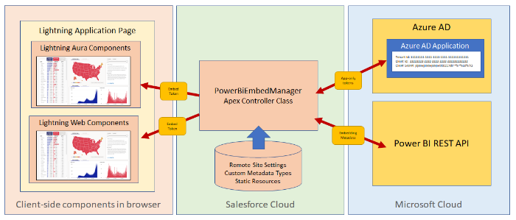

**PowerBiEmbedManager** implements [**Client Credentials Flow**](https://docs.microsoft.com/en-us/azure/active-directory/develop/v2-oauth2-client-creds-grant-flow) when it interacts with Azure AD to acquire an app-only access token. App-only access tokens are important because they makes it possible to call the Power BI REST API under the identity of a service principal instead of calling under the identity of a user. Making calls to the Power BI REST API as service principal is a best practice for developing with App-Owns-Data embedding.

**PowerBiEmbedManager** must call the Power BI REST API for two different reasons. First, it much acquire embedding data such as the Embed Url associated with a specific report ID. Second, **PowerBiEmbedManager** must call the Power BI REST API to generate embed tokens which are required with App-Owns-Data embedding.

**PowerBiEmbedManager** has been designed as a controller class by exposing a public **getEmbeddingDataForReport** method which has been marked with the **AuraEnabled** annotation making it accessible to Lighting Aura components and to Lightning web components. A client-side component can call **getEmbeddingDataForReport** to retrieve the embedding data and the embed token for a specific report.

The **SalesforceAppOwnsDataEmbedding** project contains a Lighting Aura component named [**powerBiReportAura**](https://github.com/PowerBiDevCamp/SalesforceAppOwnsDataEmbedding/tree/main/SalesforceAppOwnsDataEmbedding/force-app/main/default/aura/powerBiReportAura). When you add an instance of the **powerBiReportAura** component to a Lightning application page, you must configure it with the Workspace ID and the Report ID for a specific report in a Power BI workspace. This design makes it possible to add multiple instances of the **powerBiReportAura** component and configure each one to embed a different Power BI report.

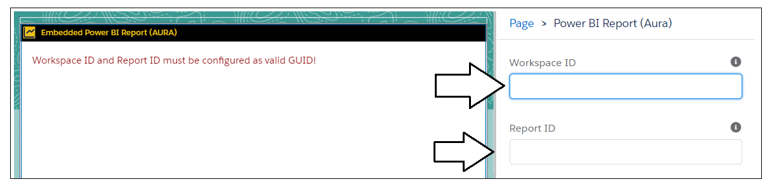

Once you have configured a **powerBiReportAura** component instance with a workspace ID and Report ID, these two configuration valued will be passed as parameters when the component calls **getEmbeddingDataForReport**. The **PowerBiEmbedManager** class responds to this remote function call by returning the embedding data and the embed token which will be used to embed a report in the browser.

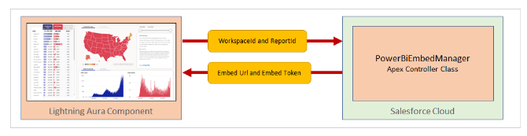

Once the **powerBiReportAura** component has successfully called **getEmbeddingDataForReport**, it has the embedding data and the embed token it needs to embed a report on the hosting web page. In a final step, the **powerBiReportAura** component executes JavaScript code in the browser and uses the [**Power BI JavaScript API**](https://docs.microsoft.com/en-us/javascript/api/overview/powerbi/overview) to implement the report embedding process.

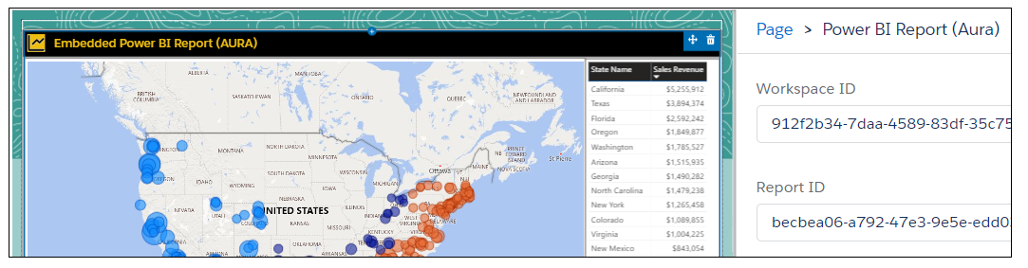

When a Power BI report is embedded on a Web page such as a Lightning application page, it establishes a direct connection back to the Power BI Service. Once the report has loaded, the user can begin to interact with it by setting filters and navigating between pages. As users interact with the report, these interactions are handled by direct communications between the report and the Power BI Service.

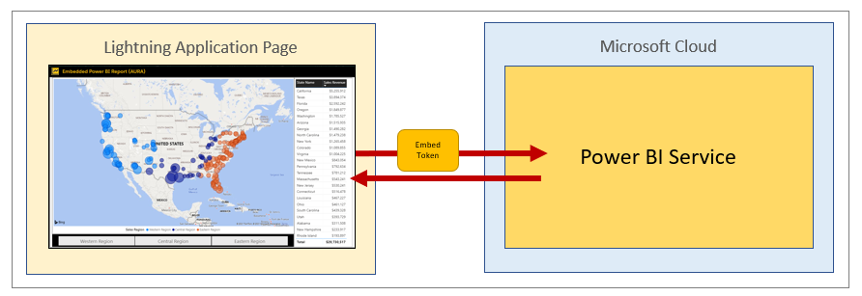

## Setting Up This Sample in a Salesforce Development Environment

In order to setup and run this sample, you need to install the following software.

* [Install Node.JS](https://nodejs.org/en/download/)
* [Install Visual Studio Code](https://code.visualstudio.com/Download)

When you have installed Visual Studio Code, you must install a Visual Studio Code extension the Salesforce Expansion Pack.

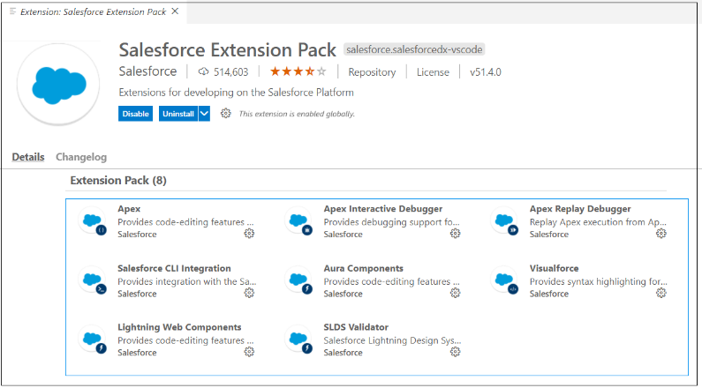

Great blog article in 2017. But so much has changed.

So much has changed.

* Service principal can be used for App-Owns-Data embedding

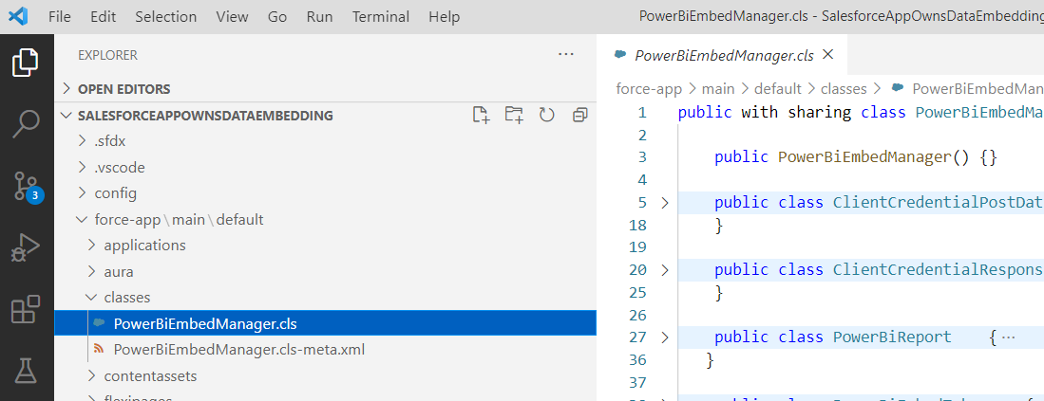

Here is the GitHub repo with the sample code discussed in this article. This code is provided in an SFDX project. This is not an introduction to Salesforce development. It is expect the reader either knows the fundamentals or is willing to learn the fundamentals. Salesforce has done a great job at providing developer material at places such as trailhead.

Here are the Salesforce features

* Apex controller class
* Custom Metadata Type
* Remote Site Settings
* Lightning Aura component
* Lightning Web Component

# Getting Started with the Sample

Create remote site settings

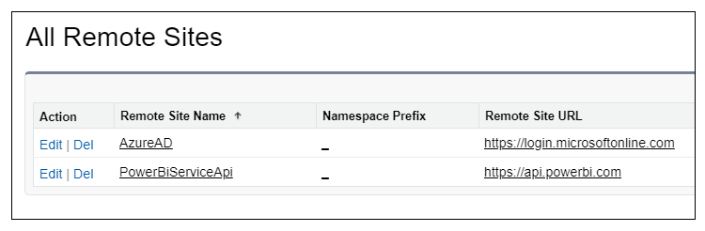

Create Custom Metadata Types with auth settings

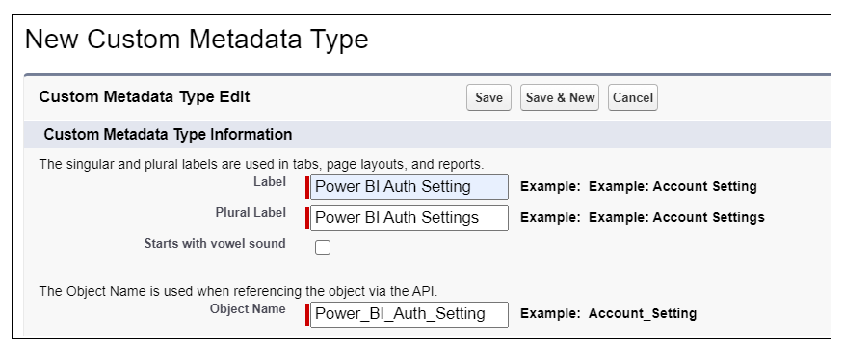

This is placeholder text.

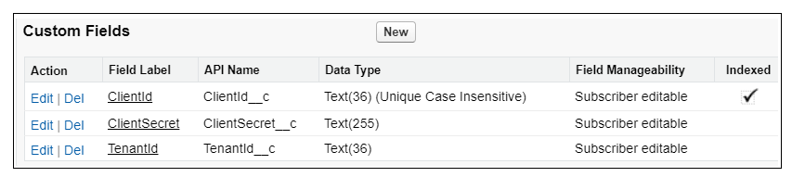

This is placeholder text.

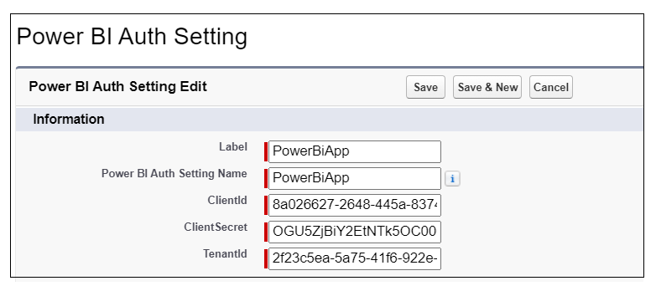

This is placeholder text.

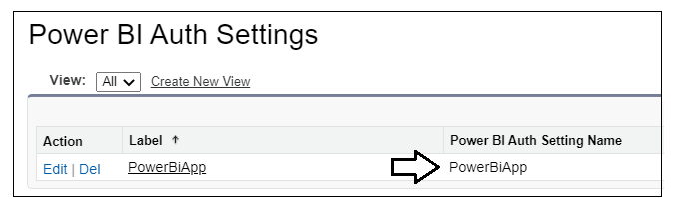

Upload powerbi.js as a Resource

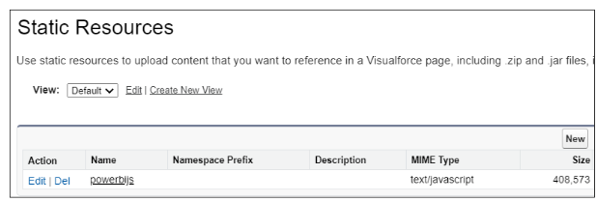

## Salesforce DX Project: Next Steps

Now that you’ve created a Salesforce DX project, what’s next? Here are some documentation resources to get you started.

## How Do You Plan to Deploy Your Changes?

Do you want to deploy a set of changes, or create a self-contained application? Choose a [development model](https://developer.salesforce.com/tools/vscode/en/user-guide/development-models).

**Configure Your Salesforce DX Project**

The **sfdx-project.json** file contains useful configuration information for your project. See [Salesforce DX Project Configuration](https://developer.salesforce.com/docs/atlas.en-us.sfdx_dev.meta/sfdx_dev/sfdx_dev_ws_config.htm) in the *_Salesforce DX Developer Guide_* for details about this file.

**Read All About It**

* [Salesforce Extensions Documentation](https://developer.salesforce.com/tools/vscode/)
* [Salesforce CLI Setup Guide](https://developer.salesforce.com/docs/atlas.en-us.sfdx_setup.meta/sfdx_setup/sfdx_setup_intro.htm)
* [Salesforce DX Developer Guide](https://developer.salesforce.com/docs/atlas.en-us.sfdx_dev.meta/sfdx_dev/sfdx_dev_intro.htm)
* [Salesforce CLI Command Reference](https://developer.salesforce.com/docs/atlas.en-us.sfdx_cli_reference.meta/sfdx_cli_reference/cli_reference.htm)