A PROJECT ON
Courier Service Management
SUBMITTED IN
PARTIAL FULFILLMENT OF THE REQUIREMENT
FOR THE COURSE OF DIPLOMA IN ADVANCED COMPUTING FROM CDAC

SUNBEAM INSTITUTE OF INFORMATION TECHNOLOGY
Hinjawadi
SUBMITTED BY:
Sujay Sanjay Gangan
UNDER THE GUIDENCE OF:
Mr. Snehal Jadhav
Faculty Member
Sunbeam Institute of Information Technology, Pune

ACKNOWLEDGEMENT

A project usually falls short of its expectation unless aided and guided by the right persons at the right time. We avail this opportunity to express our deep sense of gratitude towards Mr. Nitin Kudale (Center Coordinator, SIIT, Pune) and Mr. Yogesh Kolhe (Course Coordinator, SIIT ,Pune) .
We are deeply indebted and grateful to them for their guidance, encouragement and deep concern for our project. Without their critical evaluation and suggestions at every stage of the project, this project could never have reached its present form.
Last but not the least we thank the entire faculty and the staff members of Sunbeam Institute of Information Technology, Pune for their support.

Sujay Sanjay Gangan
0225 PG-DAC
SIIT Pune

CERTIFICATE

This is to certify that the project work under the title ‘Courier Service Management’ is done by Sujay Sanjay Gangan in partial fulfillment of the requirement for award of Diploma in Advanced Computing Course.

Mr. Snehal Jadhav Mr. Yogesh Kolhe
Project Guide Course Co-Coordinator

Date: 03/02/20

INTRODUCTION TO PROJECT

The Courier Service Management System is a comprehensive web-based application developed to automate, streamline, and manage end-to-end courier service operations in a centralized digital environment. In today’s fast-paced logistics industry, courier companies handle a large volume of parcels daily, making manual tracking, coordination, and management inefficient, error-prone, and time-consuming. This project addresses these challenges by providing a modern, technology-driven solution that enhances operational efficiency, accuracy, and transparency.
The primary objective of this system is to replace traditional manual courier handling processes with a centralized, scalable, and efficient digital platform. The system enables seamless management of parcel booking, shipment tracking, hub-to-hub transfers, delivery assignment, and administrative control. By automating these workflows, the application significantly reduces human intervention, minimizes operational delays, and improves customer satisfaction.
From the customer’s perspective, the system offers an intuitive interface that allows users to book courier parcels online, track shipments in real time, and view complete delivery history. Customers receive timely updates on parcel status, ensuring transparency throughout the delivery lifecycle. This real-time tracking capability enhances trust and reliability, which are critical factors in courier and logistics services.
On the operational side, the system provides powerful tools for administrators and staff to manage courier hubs, delivery routes, vehicles, delivery personnel, and parcel statuses effectively. Admin users have centralized control over system configurations, user roles, hub management, and operational monitoring. Staff members can efficiently update shipment progress, manage deliveries, and coordinate hub-to-hub transfers, ensuring smooth and timely parcel movement across locations.
Overall, the Courier Service Management System provides a robust, secure, and scalable digital solution that modernizes courier operations, improves service quality, and supports efficient logistics management in a highly competitive environment.

2.REQUIREMENTS

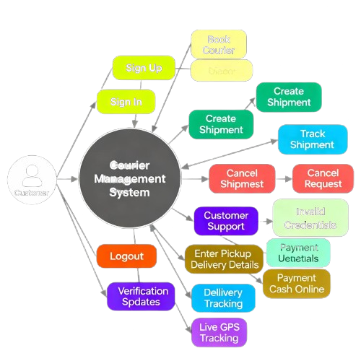

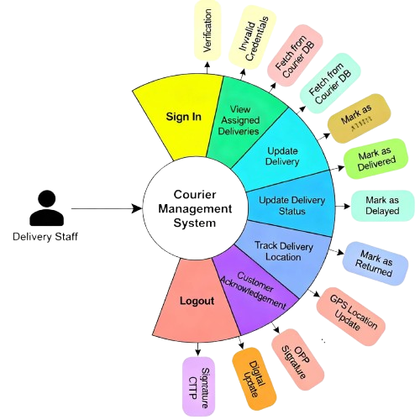

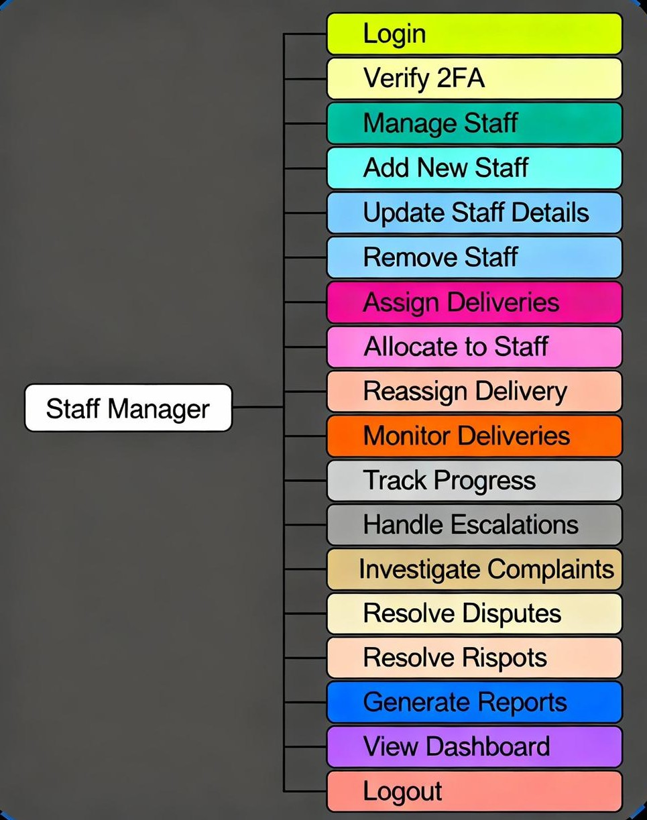

2.1 FUNCTIONAL REQUIREMENTS
The functional requirements describe the core features and operations supported by the Courier Service Management System. These requirements define how different users interact with the system and how courier operations are performed digitally to ensure efficiency, security, and accuracy.

2.1.1 User Roles and Access Control
The system supports multiple user roles, each with clearly defined responsibilities and controlled access rights. A role-based access control (RBAC) mechanism is implemented to restrict system functionalities according to user roles, ensuring data security and operational clarity.
The supported roles include:
- Admin
- Hub Manager
- Delivery Staff
- Customer
Each user can access only those features that are relevant to their responsibilities, preventing unauthorized actions and protecting sensitive operational data.

2.1.2 Customer Module
The Customer Module allows end users to interact with the courier system in a simple and user-friendly manner. It provides all essential features required for booking and tracking courier parcels.
The system allows customers to:
- Register and log in securely to the application
- Book courier parcels by entering sender and receiver details
- Select parcel type, parcel weight, and delivery priority
- Generate a unique tracking ID after successful booking
- Track shipment status in real time using the tracking ID
- View booking history and detailed parcel status updates
This module enhances transparency and improves customer satisfaction by providing real-time visibility of courier deliveries.

2.1.3 Admin Module
The Admin Module provides centralized control over the entire courier management system. Admin users have full access to configure, monitor, and manage system-wide operations.
The system enables the admin to:
- Log in securely using authentication mechanisms
- Manage courier hubs by adding, updating, or deactivating hubs
- Manage vehicles and define delivery routes
- Create, update, and deactivate staff accounts
- Monitor all parcel movements across hubs and cities
- View system-wide analytics, reports, and performance statistics
This module ensures smooth administration, operational oversight, and effective decision-making.

2.1.4 Hub & Delivery Management
This module supports day-to-day operational activities at the hub and delivery level. It ensures efficient coordination between hubs and delivery personnel.
The system allows hub managers to:
- Manage parcels assigned to their respective hubs
- Assign parcels to delivery staff for last-mile delivery
- Track hub-to-hub parcel transfers
- Update parcel status such as In Transit, Out for Delivery, and Delivered
Delivery staff can:
- View assigned delivery tasks
- Update delivery status in real time
- Report delivery completion or issues
This module ensures timely parcel movement and accurate delivery status updates.

2.1.5 Parcel Tracking System
The Parcel Tracking System is a core feature that enables real-time monitoring of courier shipments throughout the delivery lifecycle.
The system provides:
- Automatic generation of a unique tracking ID for each parcel
- Real-time parcel status updates at every delivery stage
- Route-based parcel movement tracking between hubs
- Location-based tracking using city latitude and longitude coordinates
This system improves transparency, reduces customer inquiries, and enables efficient tracking of courier parcels across multiple locations.
2.2 NON-FUNCTIONAL REQUIREMENTS
Non-functional requirements define the quality attributes of the Courier Service Management System. These requirements focus on usability, performance, security, and system constraints to ensure reliable and efficient operation of the application.

2.2.1 Interface Requirements

The system provides a modern, responsive, and user-friendly web interface that ensures smooth interaction across devices and user roles.

The interface requirements include:
- A responsive web interface that works efficiently on desktops, tablets, and mobile devices
- Role-based dashboards customized for Admin, Hub Manager, Delivery Staff, and Customer
- Simple and intuitive navigation for easy access to system features
- Secure authentication pages for login and registration to protect user credentials
The interface design focuses on clarity, accessibility, and ease of use to improve user experience.

2.2.2 Performance Requirements

The system is designed to deliver high performance and reliability under varying workloads.
The performance requirements include:
- Support for multiple concurrent users without system degradation
- Fast parcel search and tracking to provide real-time updates to customers
- Optimized API response times for smooth frontend-backend communication
Efficient database queries and optimized REST APIs ensure quick data retrieval and processing.

2.2.3 Security Requirements

Security is a critical aspect of the Courier Service Management System, as it handles sensitive user and operational data.
The system ensures security through:
- JWT-based authentication for secure and stateless user sessions
- Role-based authorization to restrict access based on user responsibilities
- Secure password encryption using industry-standard hashing algorithms
- Protected REST APIs to prevent unauthorized access and data manipulation
These mechanisms collectively ensure data confidentiality, integrity, and system protection.

2.2.4 Hardware & Software Requirements

- Hardware Requirements
- Minimum 4 GB RAM
- Intel i3 processor or above
- Stable internet connectivity
- Software Requirements
- Frontend: React.js
- Backend: Java, Spring Boot
- Database: MySQL
- Server: Apache Tomcat / Embedded Spring Boot Server
- Cloud Platform: AWS (EC2 for deployment, RDS for database – basic usage)
- Tools: Docker and Jenkins (basic exposure for containerization and CI/CD)
These requirements ensure smooth development, deployment, and scalability of the application.

3. DESIGN

3.1 Database Design

The following table structures depict the database design.

1. User Table
Column Name | Data Type | Description
user_id (PK) | INT | Unique user identifier
name | VARCHAR(100) | Full name
email | VARCHAR(100) | User email (unique)
password | VARCHAR(255) | Encrypted password
role | VARCHAR(30) | Admin / Hub Manager / Delivery Staff / Customer
phone | VARCHAR(15) | Contact number
created_at | TIMESTAMP | Account creation time

2. Customer Table
Column Name | Data Type | Description
customer_id (PK) | INT | Unique customer ID
user_id (FK) | INT | Reference to User table
address | TEXT | Customer address
city | VARCHAR(50) | City name
pincode | VARCHAR(10) | Postal code

3. Hub Table
Column Name | Data Type | Description
hub_id (PK) | INT | Unique hub identifier
hub_name | VARCHAR(100) | Hub name
city | VARCHAR(50) | Hub city
latitude | DOUBLE | City latitude
longitude | DOUBLE | City longitude
status | VARCHAR(20) | Active / Inactive

4. Staff Table
Column Name | Data Type | Description
staff_id (PK) | INT | Unique staff ID
user_id (FK) | INT | Reference to User table
hub_id (FK) | INT | Assigned hub
role | VARCHAR(30) | Hub Manager / Delivery Staff

5. Vehicle Table
Column Name | Data Type | Description
vehicle_id (PK) | INT | Vehicle ID
vehicle_number | VARCHAR(20) | Registration number
vehicle_type | VARCHAR(30) | Bike / Van / Truck
hub_id (FK) | INT | Assigned hub

6. Route Table
Column Name | Data Type | Description
route_id (PK) | INT | Route ID
source_hub_id (FK) | INT | Source hub
destination_hub_id (FK) | INT | Destination hub
distance_km | DOUBLE | Distance

7. Parcel Table
Column Name | Data Type | Description
parcel_id (PK) | INT | Parcel ID
tracking_id | VARCHAR(50) | Unique tracking ID
sender_id (FK) | INT | Customer (sender)
receiver_name | VARCHAR(100) | Receiver name
receiver_address | TEXT | Receiver address
weight | DOUBLE | Parcel weight
parcel_type | VARCHAR(30) | Document / Box
priority | VARCHAR(20) | Normal / Express
status | VARCHAR(30) | Booked / In Transit / Delivered

8. Parcel Movement Table
Column Name | Data Type | Description
movement_id (PK) | INT | Movement record ID
parcel_id (FK) | INT | Parcel reference
hub_id (FK) | INT | Current hub
status | VARCHAR(30) | In Transit / Out for Delivery
timestamp | TIMESTAMP | Update time

9. Delivery Assignment Table
Column Name | Data Type | Description
assignment_id (PK) | INT | Assignment ID
parcel_id (FK) | INT | Parcel reference
staff_id (FK) | INT | Delivery staff
assigned_date | DATE | Assignment date
delivery_status | VARCHAR(30) | Pending / Delivered

E-R Diagram,Dataflow diagram and Class Diagram:

Go to Appendix A

4. CODING STANDARDS IMPLEMENTED

The Courier Service Management System follows well-defined coding standards and best practices to ensure code quality, maintainability, scalability, and readability. Industry-standard Java and web development conventions have been adopted throughout the application.

Java Naming Conventions

Standard Java naming conventions are followed consistently across the project:

- Class names use PascalCase (e.g., ParcelService, UserController)
- Method and variable names use camelCase (e.g., trackParcel(), deliveryStatus)
- Constants use UPPER_CASE with underscores
- Package names are written in lowercase
These conventions improve code readability and maintain uniformity across modules.

Layered Architecture

The application follows a layered architectural pattern, ensuring a clear separation of responsibilities:
- Controller Layer: Handles HTTP requests and responses
- Service Layer: Contains business logic and validations
- Repository Layer: Manages database interactions using JPA/Hibernate
This structure improves maintainability, testing, and scalability of the system.

RESTful API Design

The backend is implemented using RESTful web services, following standard REST principles:
- Proper usage of HTTP methods such as GET, POST, PUT, DELETE
- Resource-oriented API endpoints
- Stateless communication using JSON data format
This design ensures smooth frontend-backend integration and scalability.

Exception Handling

Centralized exception handling is implemented using global exception handlers:
- Common and custom exceptions are handled uniformly
- Meaningful error messages are returned to the client
- Proper HTTP status codes are used for error responses
This approach improves system robustness and simplifies debugging.

Separation of Concerns

Each application component focuses on a specific responsibility:
- Controllers manage request flow
- Services handle business logic
- Repositories manage persistence logic
This clean separation of concerns reduces coupling and improves code clarity.

Meaningful Variable and Method Naming

Descriptive and meaningful names are used for variables, methods, and classes:
- Names reflect the purpose of the component
- Avoidance of ambiguous or short variable names
This practice enhances understandability and reduces maintenance effort.

Code Reusability and Modularization

The codebase is designed to maximize reusability and modularity:
- Common logic is abstracted into reusable services and utilities
- Modular components reduce duplication
- Easy integration of new features without affecting existing code

5. TEST REPORT

Testing was carried out to ensure that the Courier Service Management System functions correctly, reliably, and meets all specified requirements. Both functional and integration testing were performed to validate system behavior and component interaction.

5.1 Functional Testing

Functional testing was conducted to verify that each system feature works according to the defined functional requirements.
SR NO | TEST CASE | EXPECTED RESULT | ACTUAL RESULT
1 | User Login | Successful login | Pass
2 | Parcel Booking | Booking confirmation generated | Pass
3 | Parcel Tracking | Correct parcel status displayed | Pass
4 | Admin Dashboard | All system data loaded correctly | Pass
5 | Delivery Update | Parcel delivery status updated | Pass

All functional test cases executed successfully without any critical defects.

5.2 Integration Testing

Integration testing was performed to verify smooth interaction between different system components and services.

The following integrations were tested:
- Frontend–Backend API integration to ensure correct request and response handling
- Database connectivity to verify successful data storage and retrieval
- Microservice communication to validate seamless interaction between independent services
The system demonstrated stable integration across all components.

6. PROJECT MANAGEMENT RELATED STATISTICS

DATE | WORK PERFORMED | SDLC PHASE | ADDITIONAL NOTES
Jan 10, 2026 | Project allotment and initial requirement discussion | Feasibility Study | Project scope and objectives were discussed with the guide
Jan 12, 2026 | User requirements gathering and analysis | Requirement Analysis | Functional and non-functional requirements identified
Jan 14, 2026 | Initial SRS document preparation and validation | Requirement Analysis (Elicitation) | SRS reviewed and refined based on feedback
Jan 16, 2026 | Design of use cases, ER diagram, class diagram, and UI mockups | Design Phase | Database and system architecture finalized
Jan 18, 2026 | Business logic and microservice design started | Design Phase | Service-level responsibilities defined
Jan 20, 2026 | Backend development started (Spring Boot, APIs) | Implementation | Core services and REST APIs implemented
Jan 22, 2026 | Frontend development started (React.js) | Implementation | UI components and dashboards developed
Jan 24, 2026 | Backend–Frontend integration | Implementation | API integration and data flow testing
Jan 26, 2026 | Unit testing and validation implementation | Testing | Input validations and error handling added
Jan 27, 2026 | Module testing by team members | Testing (Module Testing) | Functional issues identified and resolved
Jan 28, 2026 | System and integration testing | Testing (Integration Testing) | End-to-end workflow tested
Jan 29, 2026 | Bug fixing and optimization | Debugging | Performance and logic issues resolved
Jan 30, 2026 | Deployment and documentation | Deployment | Project prepared for final submission

Appendix A

Entity Relationship Diagram

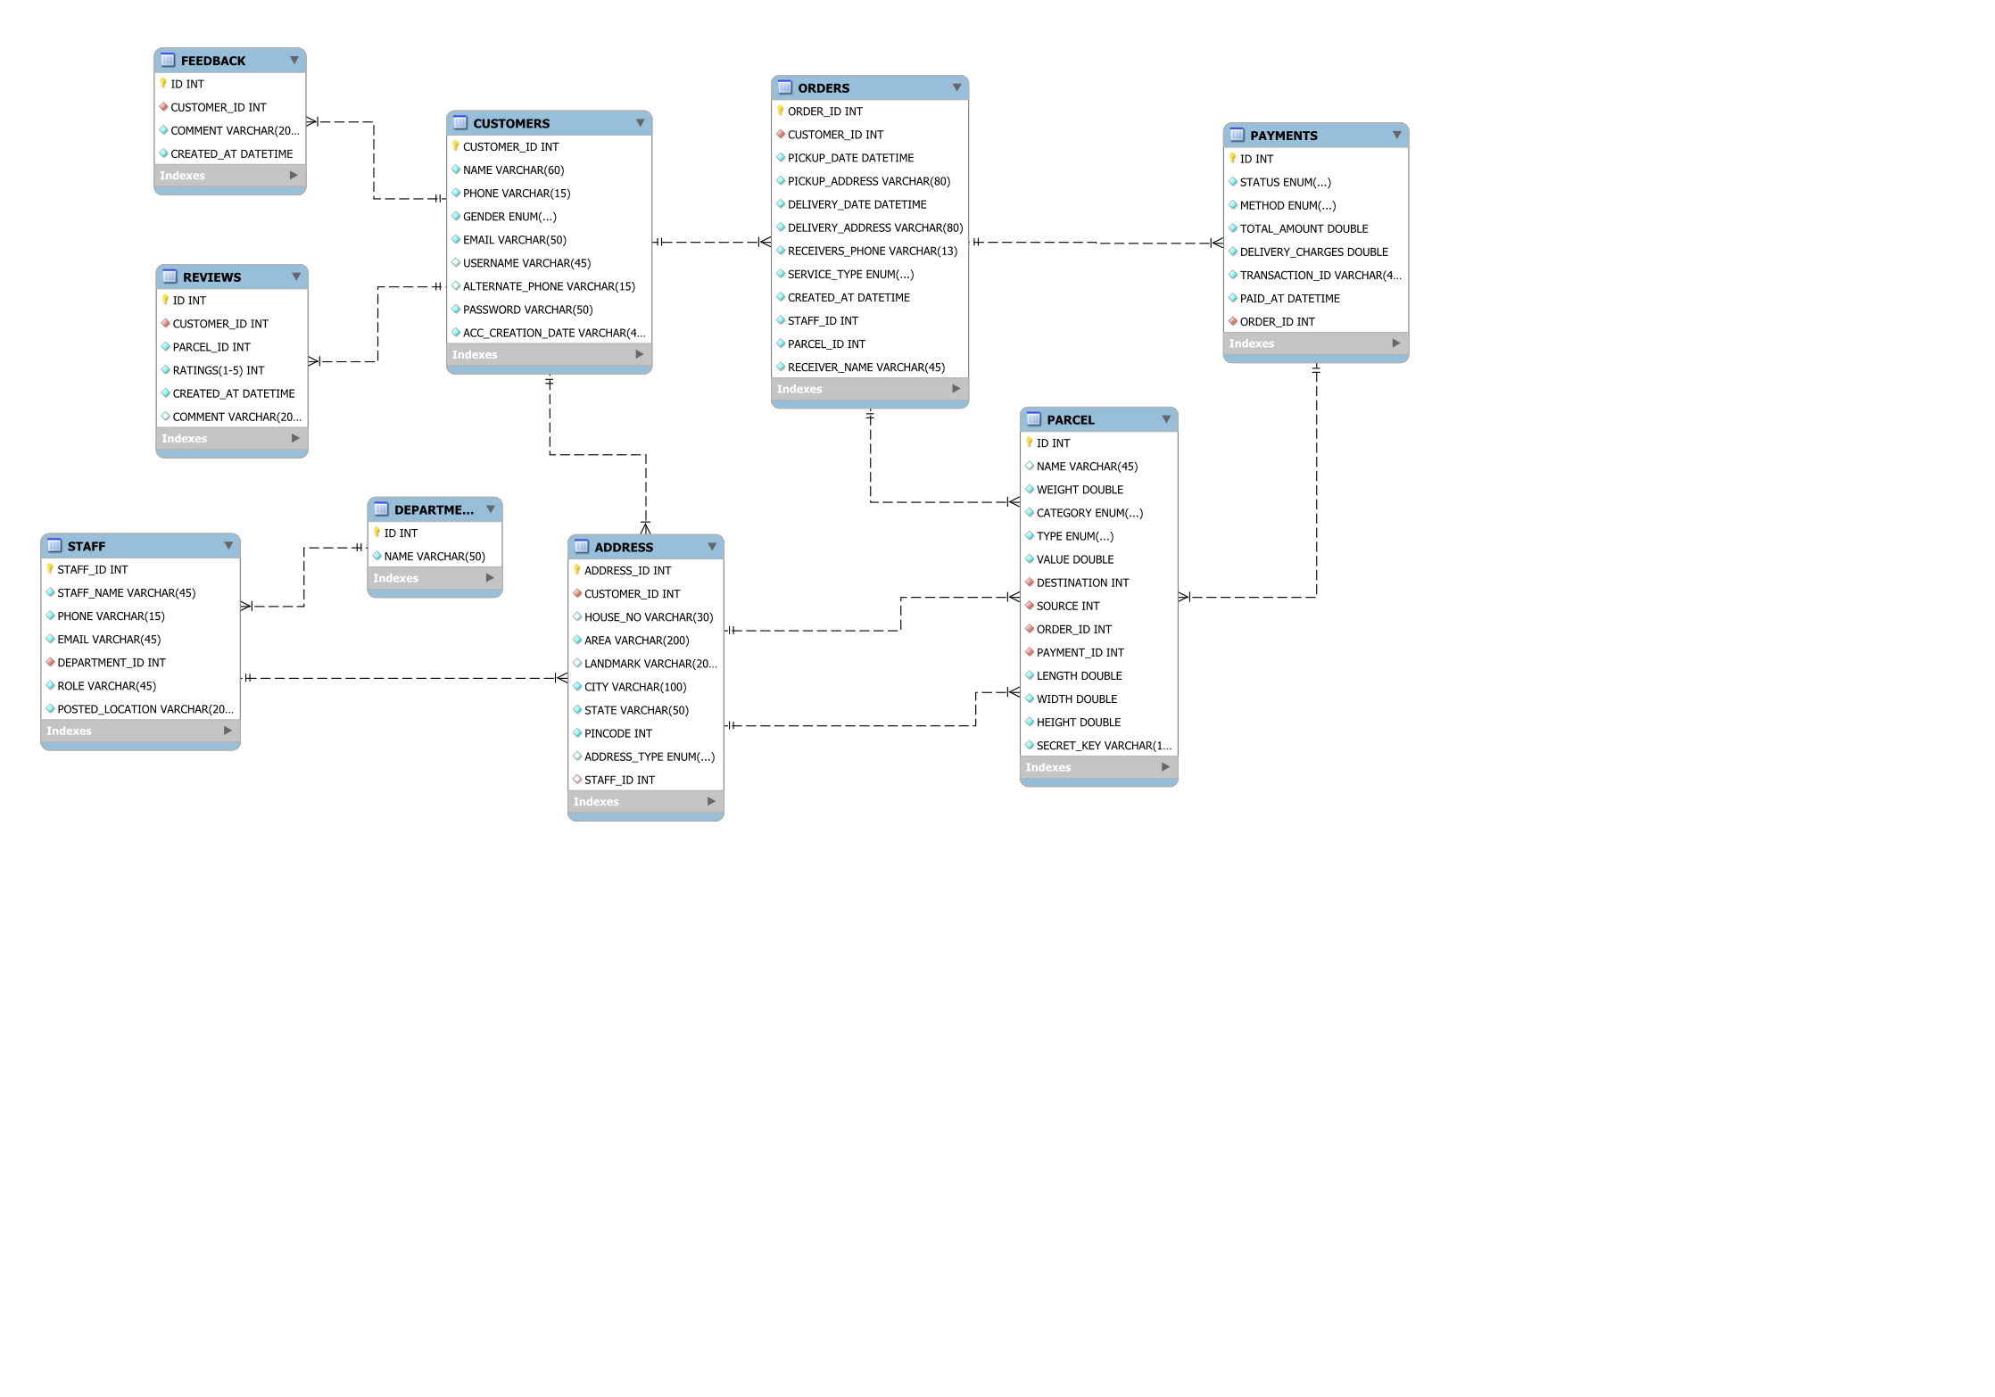

Class Diagram

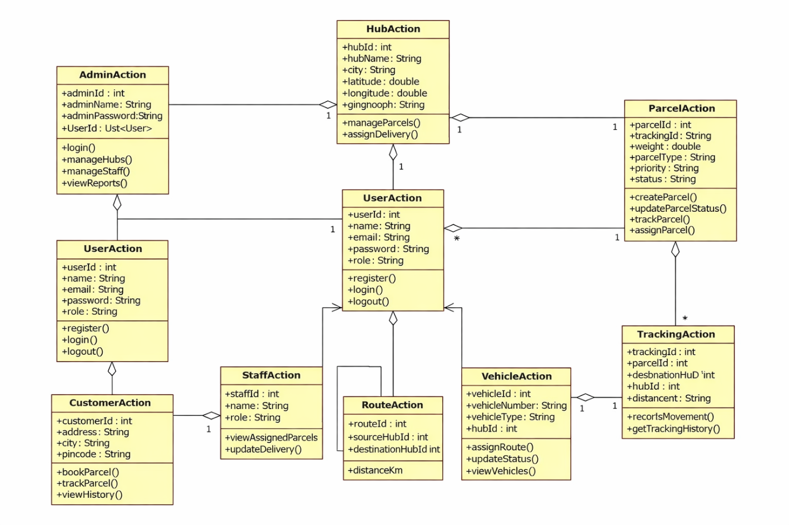

Appendix B

LandingPage:

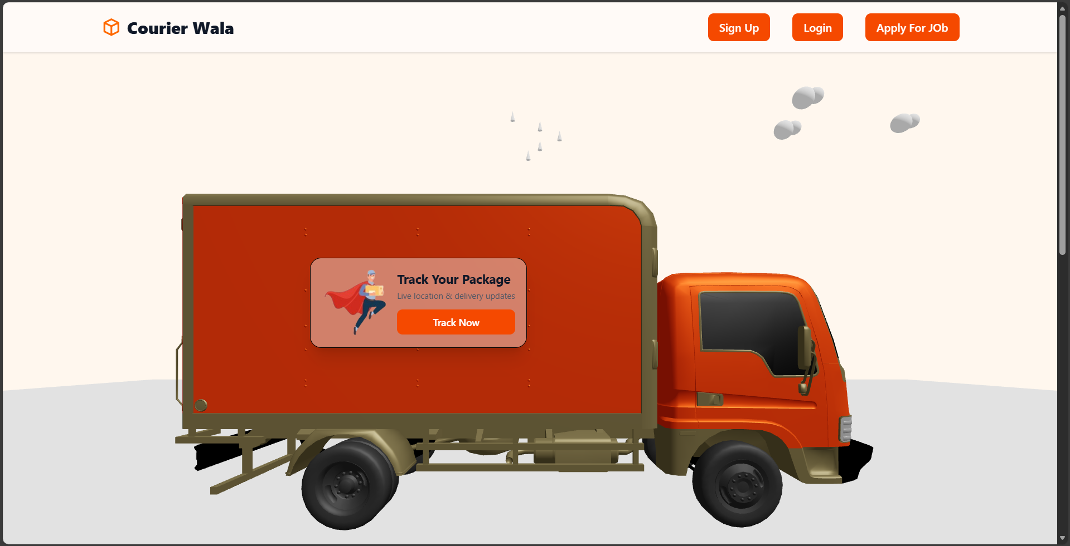

CommonLoginPage: 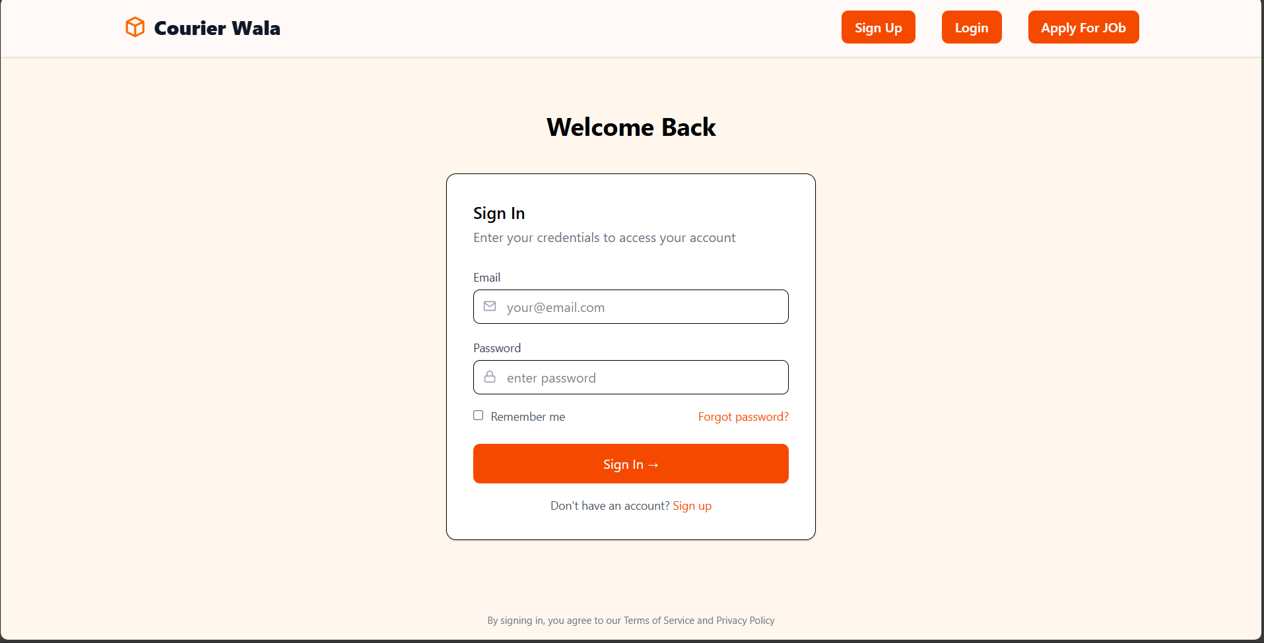

Add New Shipment:
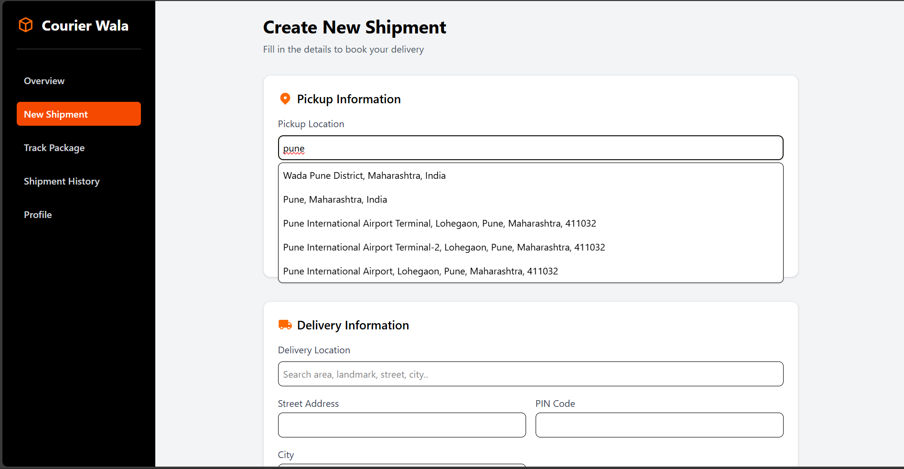

AddHub
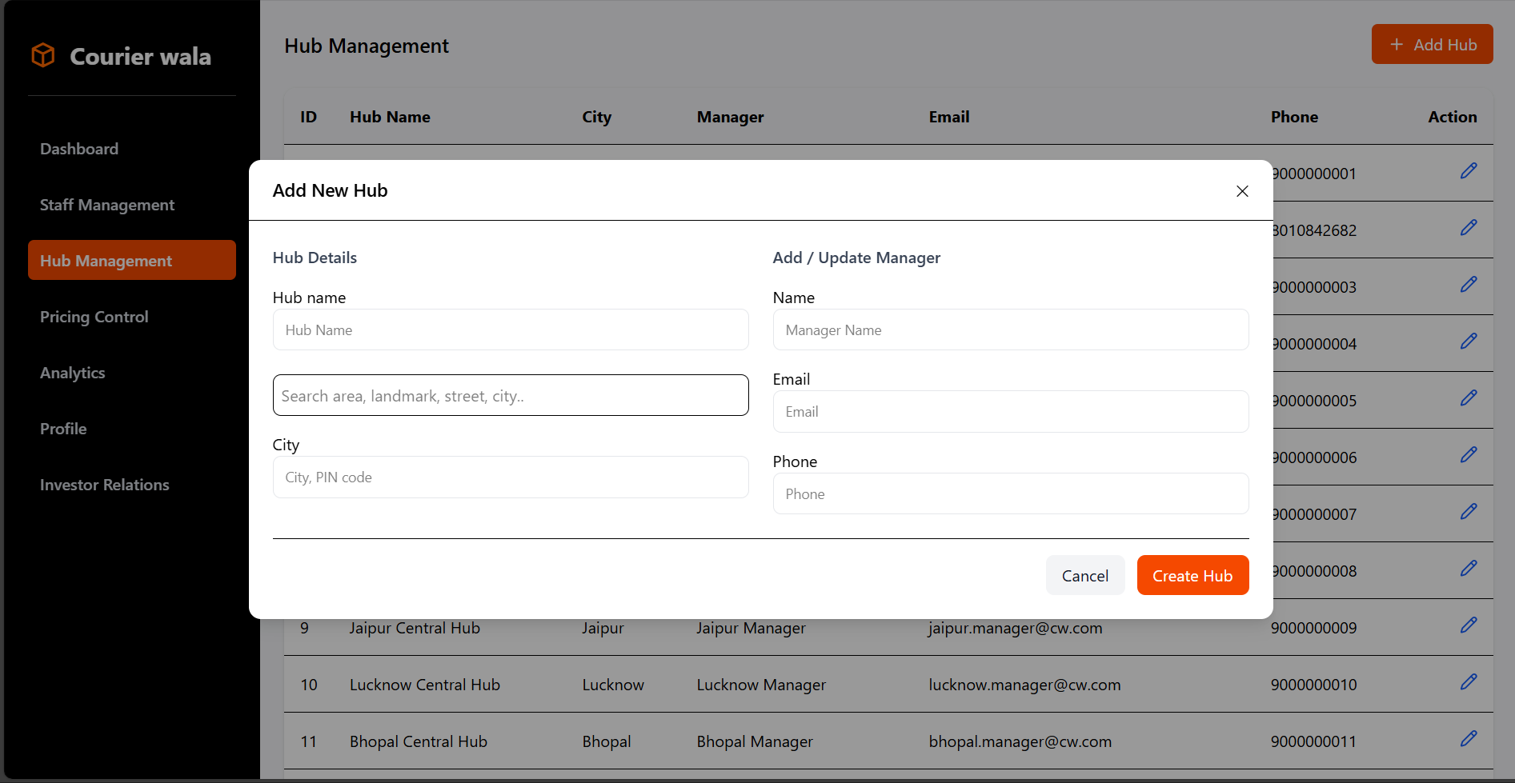

Update Hub and Manager
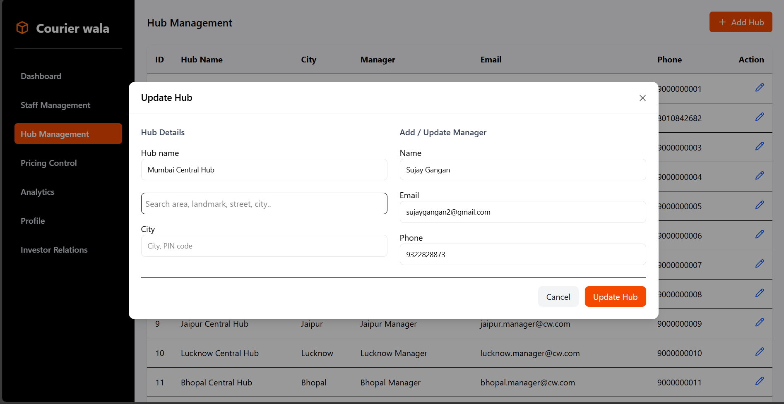

QuickTrackPackage:

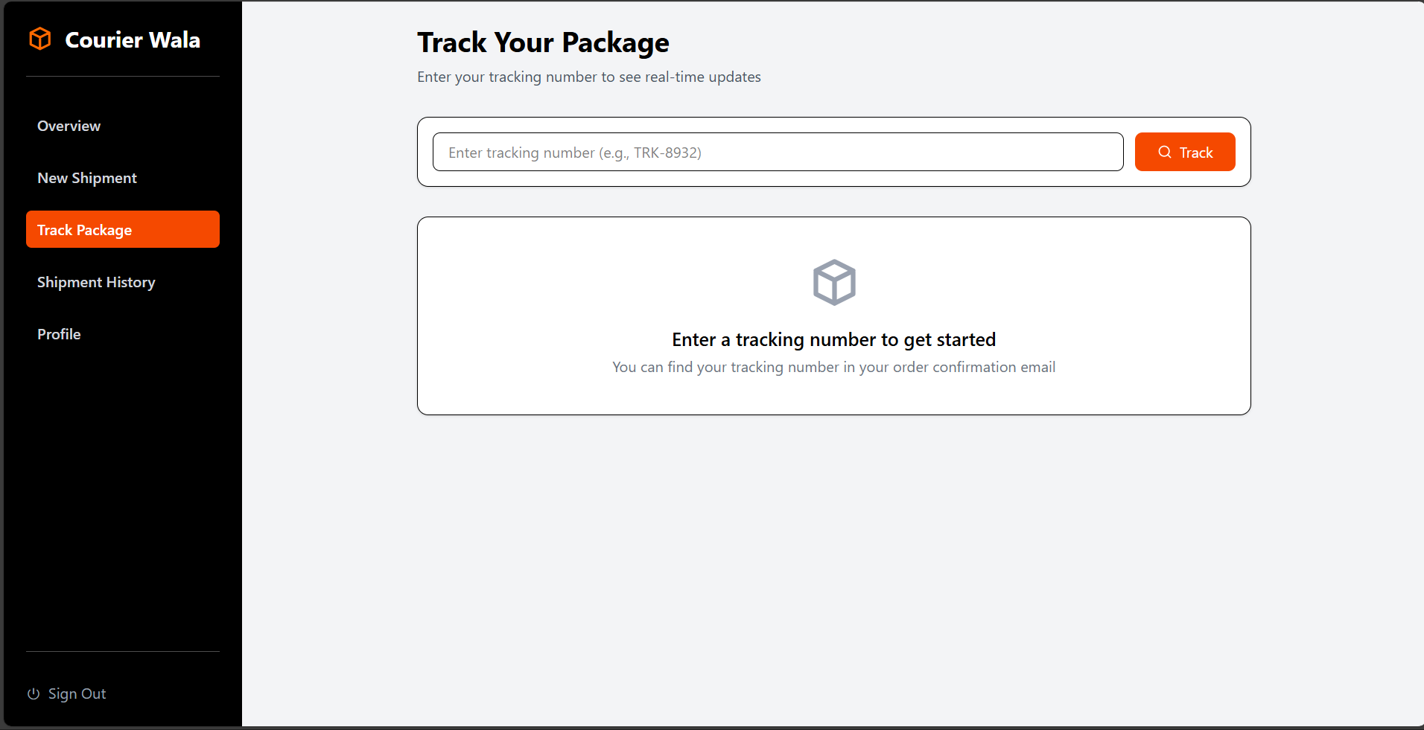

Banking:

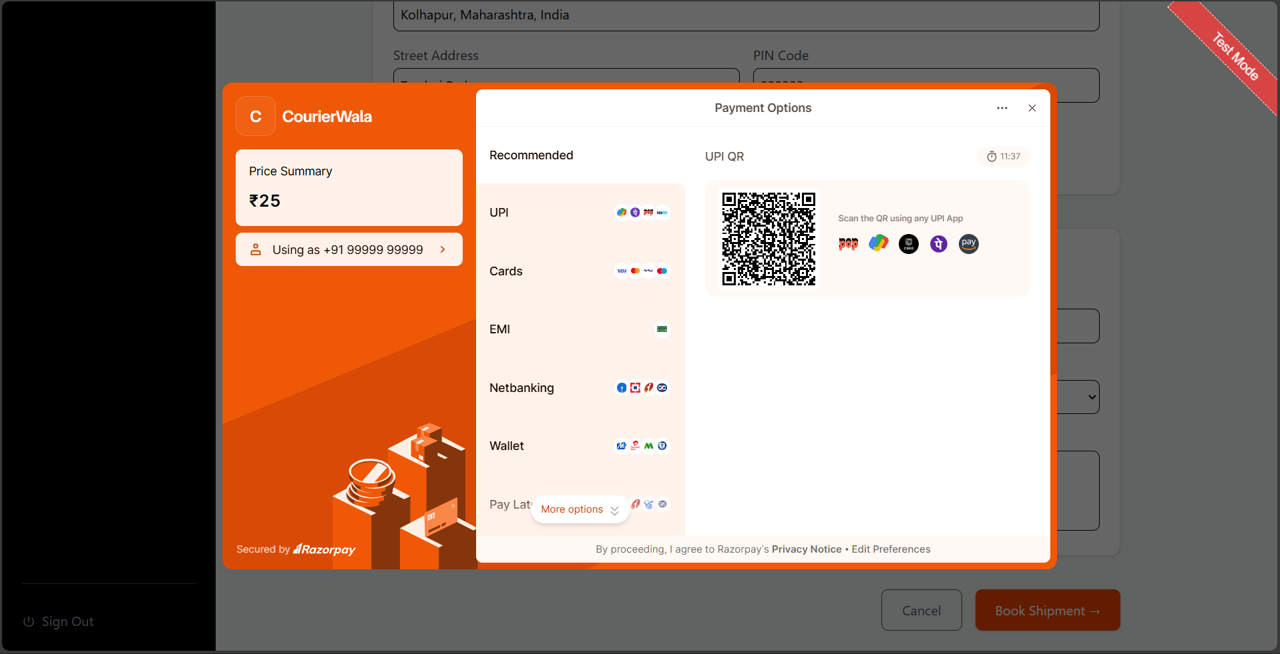

UserProfileDetails:

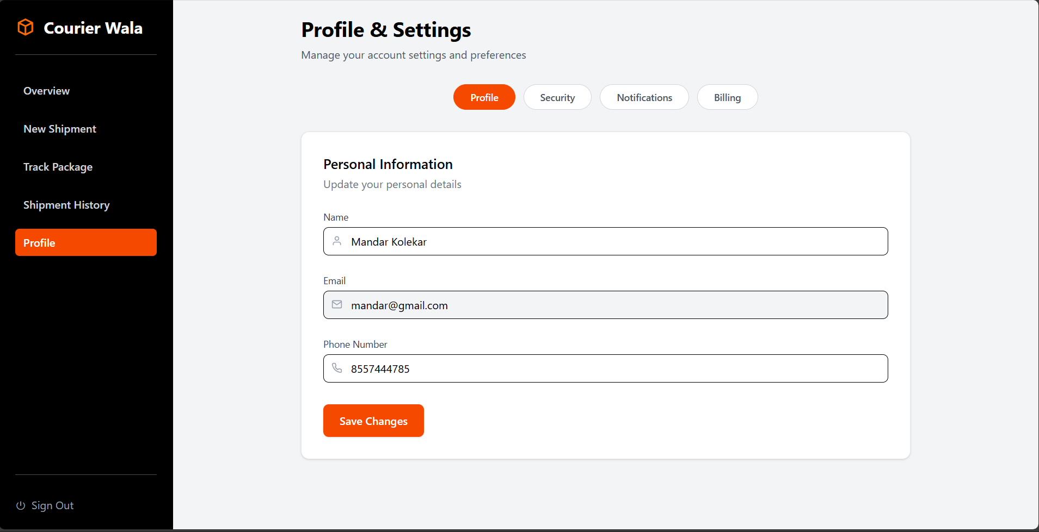

BookingDetails:
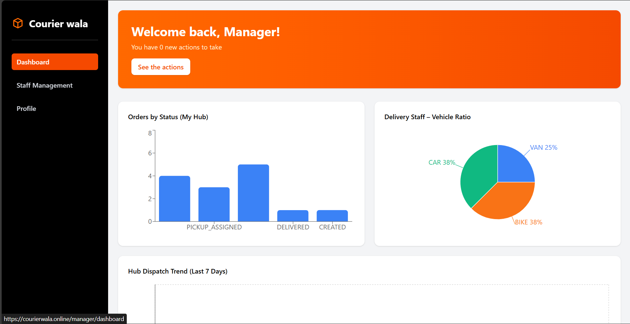

7.REFERENCES:

http://www.google.com

https://www.delhivery.com/

https://docs.spring.io/spring-boot/index.html

https://React.dev

