**Lab03: TRL Line**

**ECEN 452**

**Sambong Jang, 523007383**

**Background:**

TRL calibration is used for measuring network parameters in an accurate manner. DUT (Device Under Test) is usually measured from this technique. However, the error terms generated from this technique must be measured first in order to remove the effects of transition between them. The error terms can be measured from the two error boxes connected to the DUT box. Each calibration condition can be set by connecting it to a reference plane. Detailed description can be shown in the following diagram.

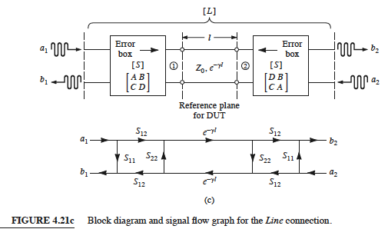

**Figure**

Calculated the error box parameters will be used to measure the S parameters for the DUT at the reference planes.

**Plot:**

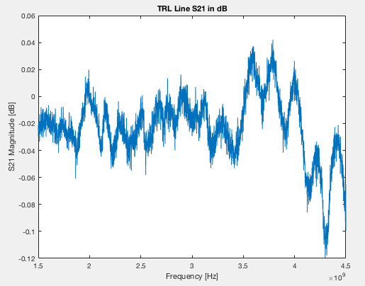

**Figure 1. S21 Magnitude [dB]**

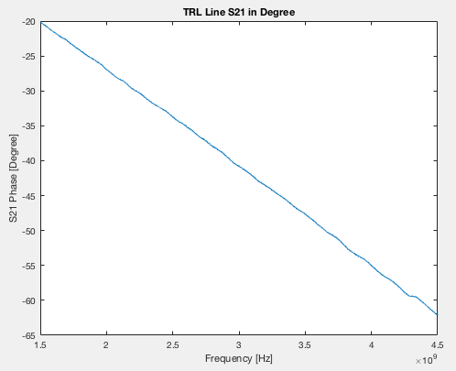

**Figure 2. S21 Phase [Degree]**

**Note:** The slope represents the group delay. It seems it is a straight line, which is hard to obtain in reality. Within a certain range of the bandwidth, the slope is nearly straight.