**Lab5: TRL & Bias Tee**

**ECEN 452**

**Sambong Jang, 523007383**

**Task1: Design of a TRL Calibration Kit**

**Background information:**

TRL Calibration technique is accurate by measuring a single reflection term and two transmission terms and all these values are used to determine the 12 error terms. It is generally known that TRL Calibration is more accurate than SOLT Calibration that uses well-defined short, open, and load.

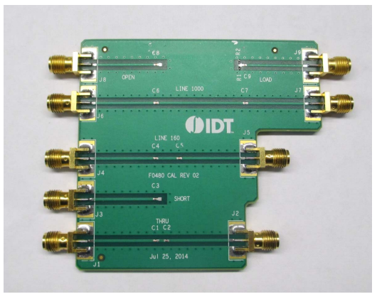

Figure 1. TRL Calibration Kit used for F0480

**Given Data:**

**FR4 has the following features:**

$ε_{r}=4.1$

$Tanδ=0.01$

Thickness = 61 mil = 1.5748 mm

$Z_{0}=50 Ω$

Distance from the reference plane = 15mm

$1GHz≤ f ≤5GHz$

**Calculate the required physical width of the microstrip line**

First calculate A and B given by

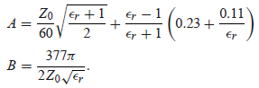

A = 1.486838527

B = 5.849238024

My first guess is that $\frac{W}{d}<2$

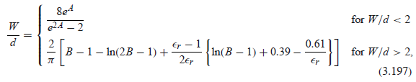

The ratio came out to be

$$\frac{W}{d}=2.014647836>2$$

Thus it should be greater than 2

So again the ratio came out to be

$$\frac{W}{d}=2.01630280>2$$

Which satisfies the condition

Therefore, with the given thickness d = 1.5748mm

W = 3.175273653 mm

**Calculate the design frequency of calibration kit**

$$f_{o}= \frac{f_{L}+f_{H}}{2}=3 GHz$$

Also known as the center frequency

**Calculate the effective dielectric constant**



Using the ratio we obtained from above

$$ε_{e}=3.137885623$$

**Using (2) and (3), calculate the physical length [mm] for a quarter wavelength section of transmission line**

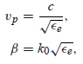

The phase velocity is calculated

$$υ_{P}=169,239,664.3 \left[\frac{m}{s}\right]$$

Where the speed of light is 299,792,458 m/s

1. **When frequency is 5 GHz (Max)**

$$λ_{f_max}=0.0338479329 m$$

Therefore the quarter wave section is 8.461983214 mm

1. **When frequency is 1 GHz (Min)**

$$λ_{f_min}=0.1692396643 m$$

Therefore the quarter wave section is 42.30991608 mm

1. **When frequency is 3 GHz (the design frequency)**

$$λ_{f_design}=0.0564132214 m$$

Therefore the quarter wave section is 56.41322143 mm

**Task2: Design of an RF PIN diode series switch**

**ON State**

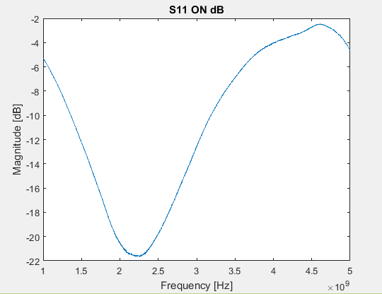

Figure 1. S11 [dB] [ON] vs. Frequency [GHz]

**OFF State**

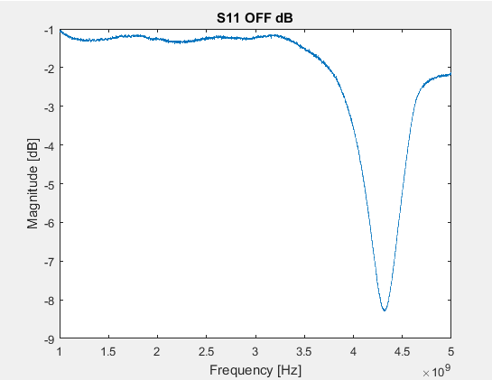

Figure 2. S11 [dB] [OFF] vs. Frequency [GHz]

**Measured Data**

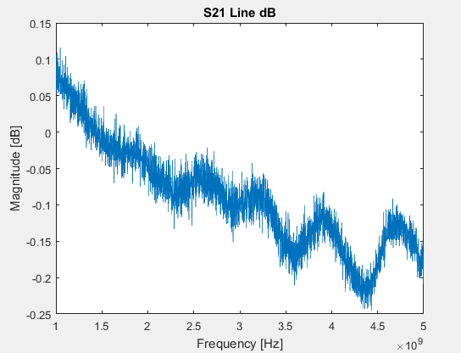

Figure 3. S21 Line [dB] vs. Frequency [GHz]

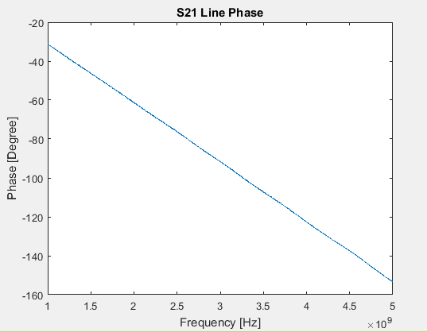

Figure 4. S21 Line phase [Degree] vs. Frequency [GHz]

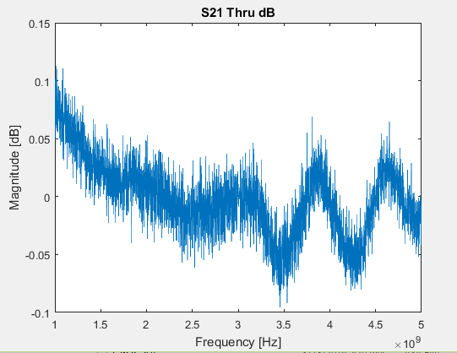

Figure 5. S21 Thru [dB] vs. Frequency [GHz]

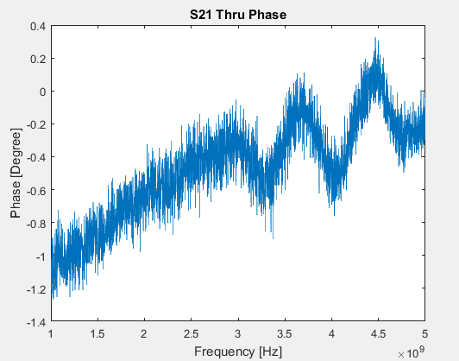

Figure 6. S21 Thru Phase [Degree] vs. Frequency [GHz]