**Lab06:**

**ECEN 452**

**Sambong Jang, 523007383**

**Dr. Huff**

**Given:**

**Characteristic Impedance = 50 ohm**

**Thickness of substrate = 62 mil = 1.5748 mm**

**Dielectric constant of substrate = 4.1**

**Loss tangent of substrate = 0.01**

**Task 1: Synthesis and implementation of a maximally-flat low-pass filter.**

**Given:**

**Cut-off Frequency = 2.5 GHz**

**Minimum attenuation of 10 dB at 3.25 GHz**

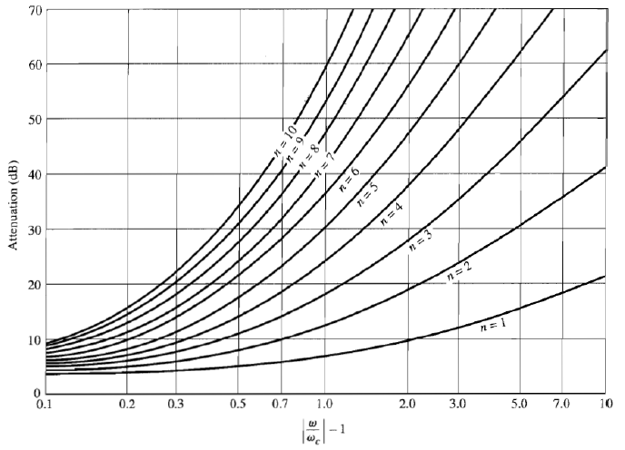

Figure . Attenuation [dB] in terms of frequency

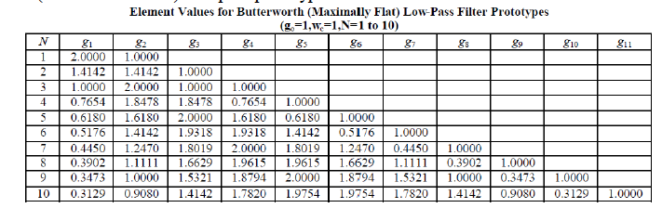

Figure . Element values for Butterworth Low-Pass Filter Prototypes

**Task 2: Synthesis and implementation of an Equi-ripple band-stop filter.**

**Given:**

**Center Frequency = 3 GHz**

**Bandwidth of 2.25 GHz to 3.75 GHz**

**Micro strip line**

**Characteristic Impedance = 50 ohm**

**Thickness of substrate = 62 mil = 1.5748 mm**

**Dielectric Constant = 4.1**

**Loss Tangent = 0.01**

**Calculation:**

Scaled Impedance values of the equivalent open-circuit stubs using the following equation:

$$Z_{s}=\frac{4Z_{0}}{πg_{n}Δ}$$

**Plot:**

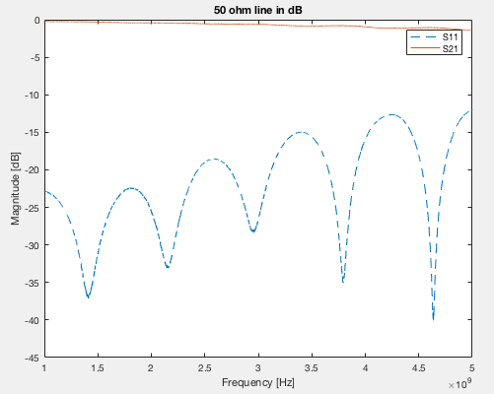

Figure . 50ohm line dB

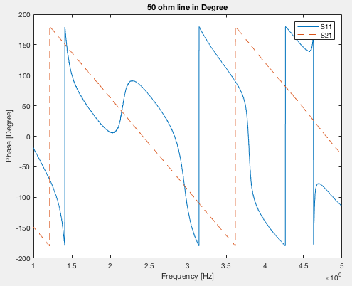

Figure . 50ohm line phase

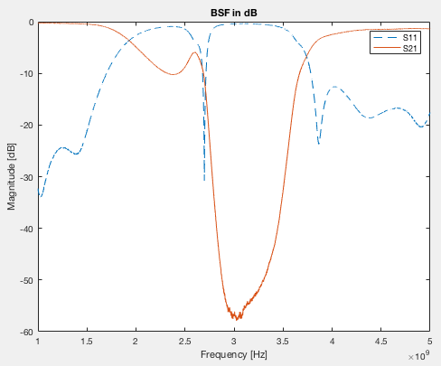

Figure . BSF dB

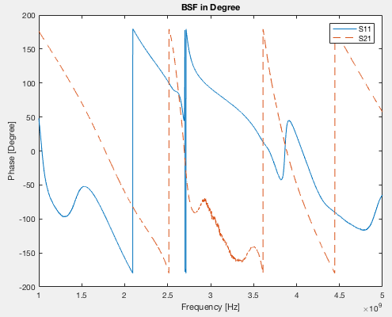

Figure . BSF phase