Lab 5: TRL Calibration Kit and RF PIN Diode Series Switch

1. Design of a TRL calibration kit
   1. For *Z0* = 50 Ω, *w =* 3.12 mm\*
   2. \*

* 1. Simulated using above lengths and width.
  2. Thru has a S21 phase of -.71° at 3 GHz and the Line has a S21 phase of -91.9° at 3 GHz with the length above, it is 89.5.° at 3 GHz with the lline set to 43.925 mm. The length was shortened to decrease the phase. $ε_{eff}={\left(\frac{c}{fl_{line, 2}}\left(\frac{θ}{360}\right)\right)}^{2}={\left(\frac{3 x{10}^{8}m/s}{3x{10}^{9} Hz*.013925 m}\left(\frac{89.5}{360}\right)\right)}^{2}=3.19$ $v=\frac{c}{\sqrt{ε_{eff}}}=\frac{3 x{10}^{8}m/s}{\sqrt{3.19}}=1.68 x {10}^{8} m/s$ $t_{line}=\frac{l_{line,2}\sqrt{ε_{eff}}}{c}=\frac{.043925 m\sqrt{3.19}}{3 x{10}^{8}m/s}=0.262 ns$ $C={\left(2πfX_{c}\right)}^{-1}$
        
        
        
     , done for all frequencies and their given impedance   
     The third order best fit for the capacitance (pF) v. frequency (GHz) is: $y= -0.0012x^{3}+0.0135x^{2}-0.0525x-0.0208$ 
        
     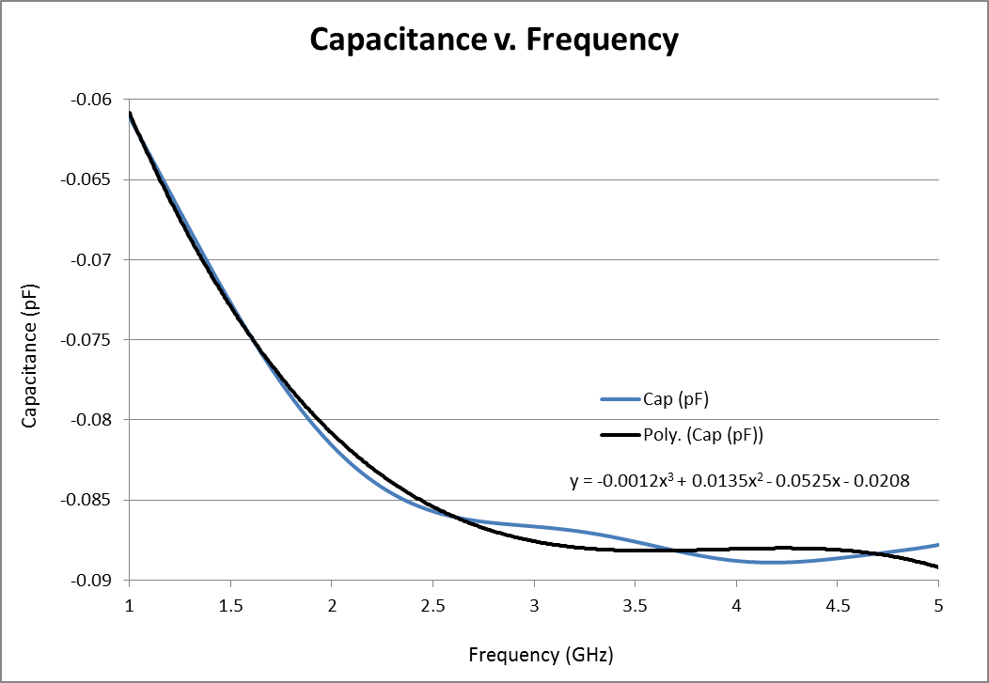
  3. The simulated and measured results line up fairly well. The differences can be accounted for in slight variations of the simulated widths and lengths and the actual widths and lengths of the TRL kit.  
     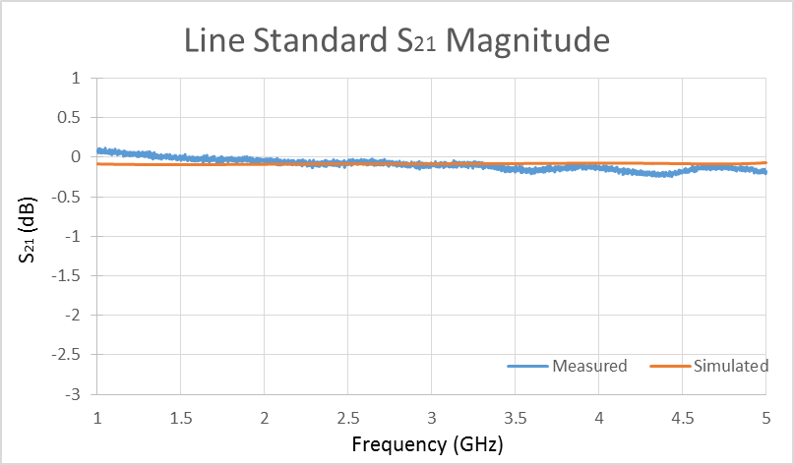 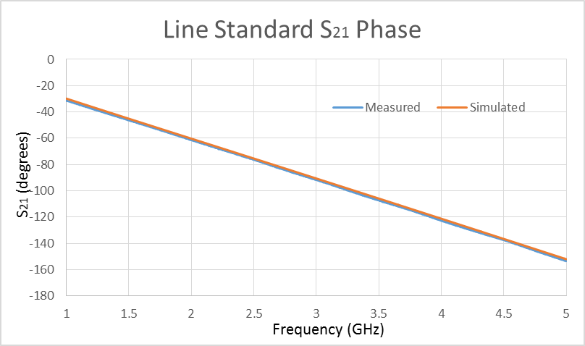  
     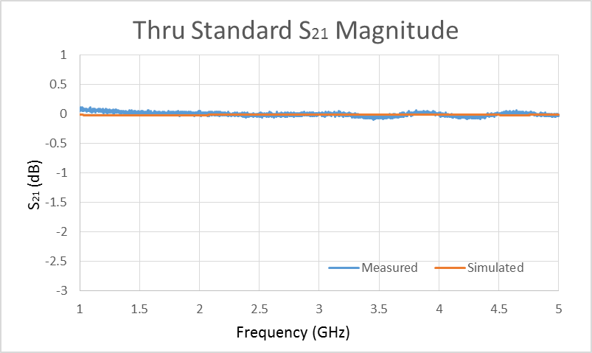 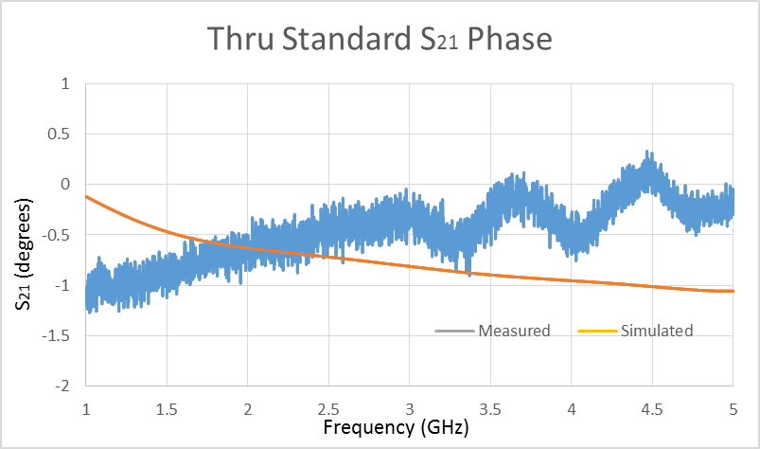

1. Design of an RF PIN diode series switch
   1. For *Z0 =* 50 Ω*, w =* 3.13 mm\*, For *Z0 =* 100 *Ω, w =* 0.746

$l_{{λ_{eff}}/4}=\frac{c}{4f\sqrt{ε_{eff}}}= \frac{3\frac{x{10}^{8}m}{s}}{4*3x{10}^{9} Hz* \sqrt{2.88}}=14.7 mm$\*
   2. After simulations are optimized: $l_{SCG}=18.9 mm$ 
       longer because the frequency was too high $l_{SCB}=18.05 mm$ 
       longer because the frequency was too high
   3. Simulated using above lengths and width.
   4. The simulated and measured results line up fairly well. The differences can be accounted for in slight variations of the simulated widths and lengths and the actual widths and lengths of the PIN diode Switch. This switch could be drastically improved because at the design frequency, 2.5 GHz, the S21 barely gets below -10 dB.  
      