Lab 6: Filter Design

1. Maximally-Flat Low-Pass Filter

The maximally flat low pass filter is a filter that only takes frequencies that are higher than the cut off frequency. By transforming the values of the capacitors and inductors to impedances, the filter can be made out of open circuit stubs. Below are the given impedances with the calculated width or the transmission line used when designing the device.

|  |  |  |  |  |  |  |  |  |  |
| --- | --- | --- | --- | --- | --- | --- | --- | --- | --- |
|  | OC 1 | UE 3 | OC 2 | UE 1 | OC 3 | UE 2 | OC4 | UE 4 | OC 5 |
| Z (Ω) | 181 | 69 | 43 | 112 | 25 | 112 | 43 | 69 | 181 |
| w (mm) | .0842 | 1.759 | 3.962 | 0.539 | 8.396 | 0.539 | 3.962 | 1.759 | .0842 |
| L (mm) | 9.096 | 8.636 | 8.351 | 8.898 | 8.043 | 8.898 | 8.351 | 8.636 | 9.096 |

Design simulated in HFSS  
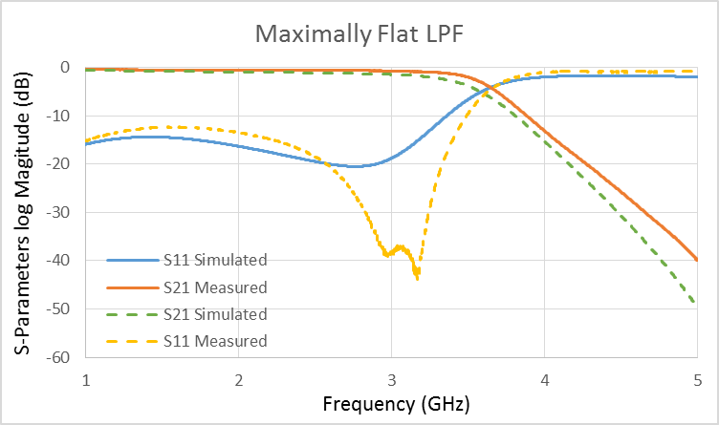

The measured and simulated results line up fairly well. There is a major difference in the S11 parameter form about 2.5 GHz to 3.5 GHz. This dip in the S11 parameter of the measured result is unusual, however, it does not affect the filter’s performance.

1. Tapered Maximally-Flat Low-Pass Filter

This is another way to design the above filter with a similar response. The main difference is that all of the stubs have the same impedance and the length is changed to get the desired response. Below are the given impedances with the calculated width or the transmission line used when building the device.

$$L=\cot^{-1}\left(\frac{2Z_{orginal}}{Z_{new}}\right)\frac{λ_{eff}}{2π}$$

|  |  |  |  |  |  |  |  |  |  |
| --- | --- | --- | --- | --- | --- | --- | --- | --- | --- |
|  | OC 1 | UE 3 | OC 2 | UE 1 | OC 3 | UE 2 | OC 4 | UE 4 | OC 5 |
| Z (Ω) | 89 | 69 | 89 | 112 | 89 | 112 | 89 | 69 | 89 |
| w (mm) | 1.008 | 1.759 | 1.008 | 0.539 | 1.008 | 0.539 | 1.008 | 1.759 | 1.008 |
| L (mm) | 8.407 | 8.636 | 14.551 | 8.898 | 21.84 | 8.898 | 14.551 | 8.636 | 8.407 |

Design simulated in HFSS  
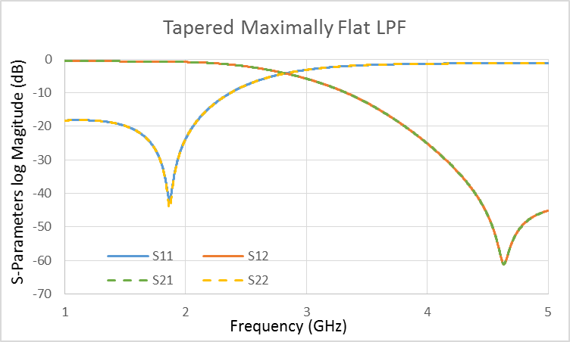

1. Band Stop Filter

The band pass filter is used to attenuate frequencies in a certain range around a selected center frequency. Below are the given impedances with the calculated width or the transmission line used when building the device out of copper tape on FR4.

|  |  |  |  |  |  |  |  |  |  |
| --- | --- | --- | --- | --- | --- | --- | --- | --- | --- |
|  | OC 1 | UE 3 | OC 2 | UE 1 | OC 3 | UE 2 | OC 4 | UE 4 | OC 5 |
| Z (Ω) | 104 | 50 | 75 | 50 | 50 | 50 | 75 | 50 | 104 |
| w (mm) | 0.667 | 3.115 | 1.478 | 3.115 | 3.115 | 3.115 | 1.478 | 3.115 | 0.667 |
| L (mm) | 14.45 | 14.04 | 14.75 | 14.04 | 14.04 | 14.04 | 14.75 | 14.04 | 14.45 |

Design Simulated in HFSS and Built in Lab  
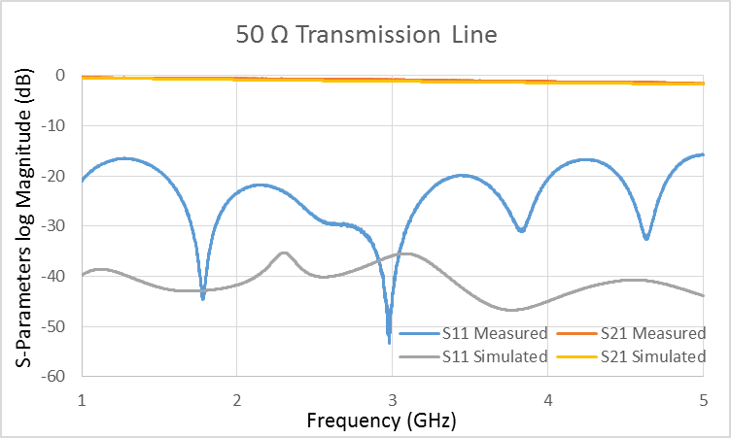 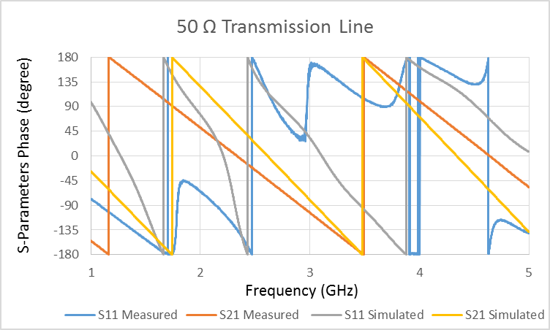  
  
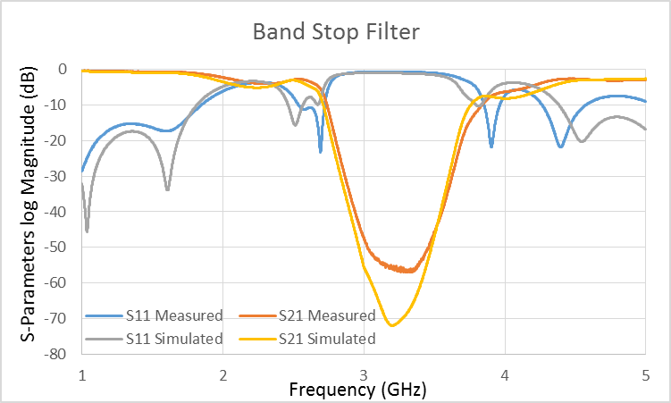 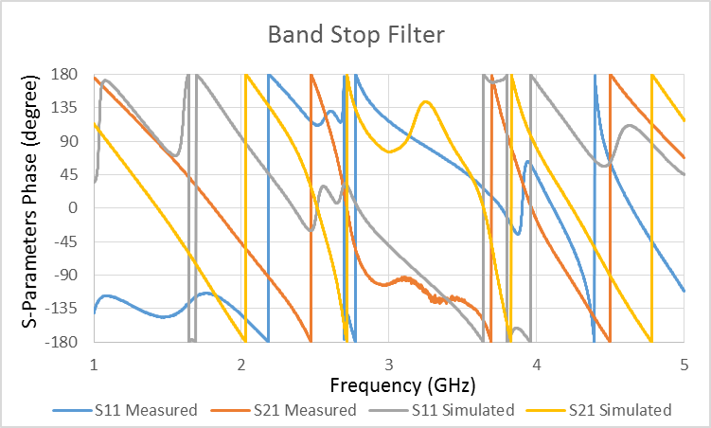

The design operated similarly to the simulated design. Because the device was created by hand, there is some error in both the widths and lengths of the lines in the filter. Here, the stubs were cut too short and therefore the device works at a slightly higher frequency than desired.