Lab 6: Wilkinson Power Divider and Phase Shifter

1. Wilkinson Power Divider  
   The Wilkinson power divider is a 3 port device that equally divides the input power. The device can also be used as a divider by adding the power from the output ports in the input port. Below are the calculated values used for simulation and the results of the simulation.  
   λeff/4=17.3 mm

|  |  |  |  |  |
| --- | --- | --- | --- | --- |
| Parameter | Formula | Z (Ω) | W (mm) | L (mm) |
| Feed | Z0 | 50 | 3.13 | NA |
| Arms | Z0 | 70.71 | 1.68 | 17.3 |
| R | 2Z0 | 100 | NA | NA |

Simulated in HFSS and Measured

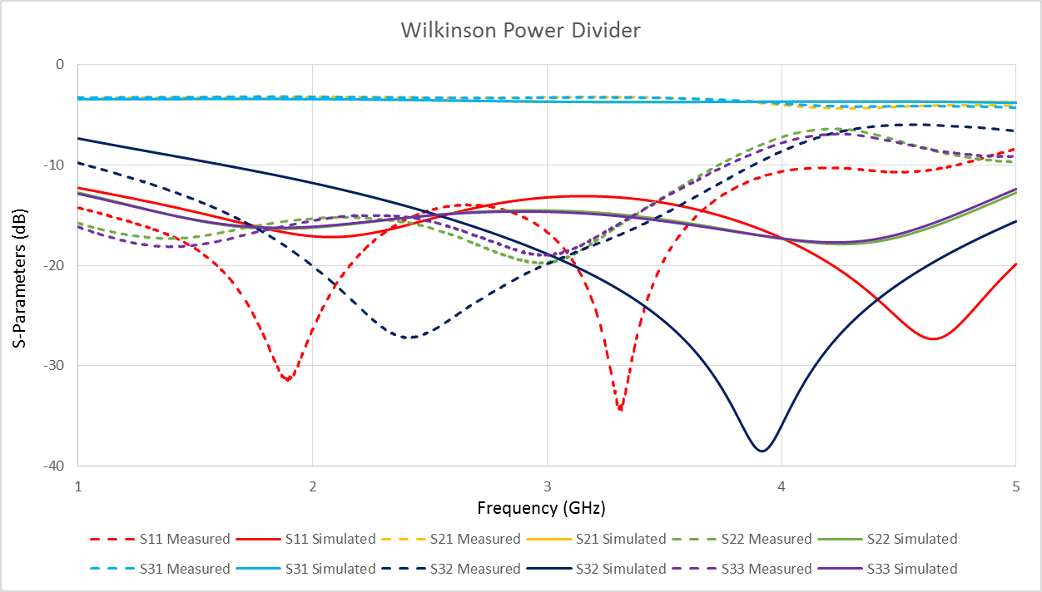

Here the simulated and measured result line up well for the S21 and S31 parameters. The other parameters have varied results for which frequencies the measured and simulated results match. The measured results have more dips in the magnitude at more frequencies. This is a result the line lengths being too long (typically a shift a lower frequency.)

1. Phase Shifter

A Phase Shifter is a device that can change the outputted phase of an input. In this lab, the desired phase shifts are 0°, 90°, and 180°. In lab a 50 Ω line was created for the 0° phase shift. From there, the additional lengths needed to achieve the desired phase shift were calculated using the equation below. The device was tested using the network analyser and the results are shown below.  
Reference Length: 102 mm (length of board)  
Width at 50 Ω : 3.118 mm

Frequency of Operation: 3 GHz

$$l_{90}=l_{0}+{λ_{eff}}/4$$

$$l_{180}=l_{0}+{λ_{eff}}/2$$

|  |  |  |  |  |
| --- | --- | --- | --- | --- |
| Phase Shift (°) | Target Phase (°) | Measured Phase (°) | Ladd (mm) | L (mm) |
| 0 | -434.07 | -435 | 0 | 102 |
| 90 | -524.07 | -506 | 14.036 | 116.036 |
| 180 | -614.07 | -598 | 28.072 | 130.072 |

Measured Results of each part of the Phase Shifter

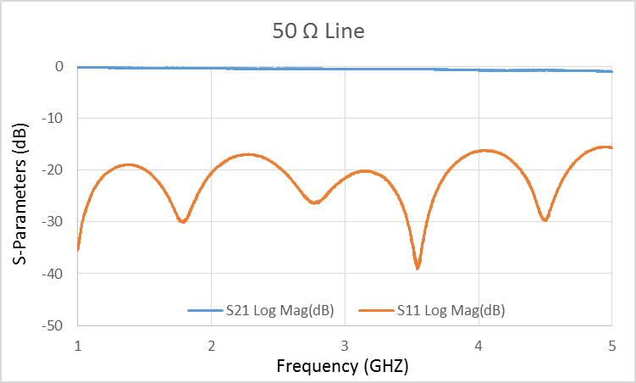 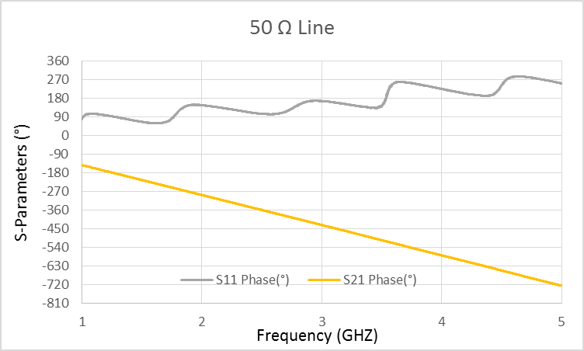

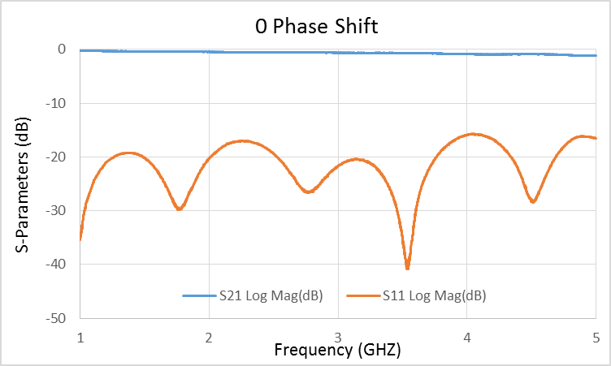 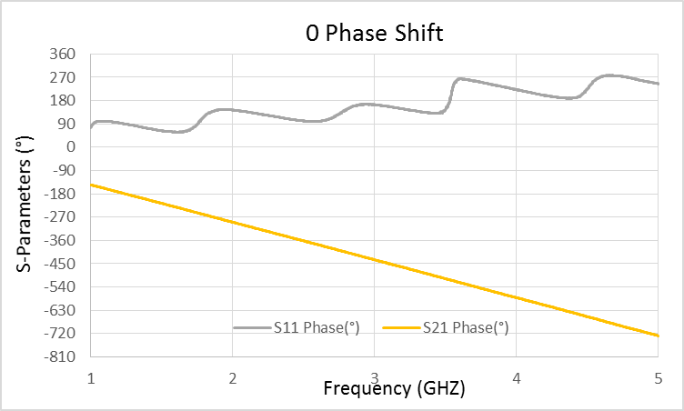

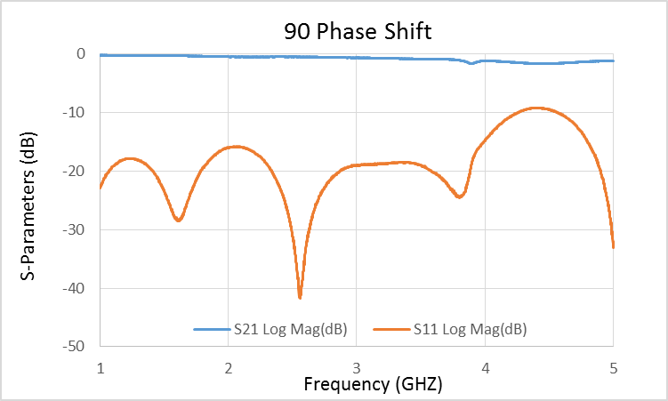 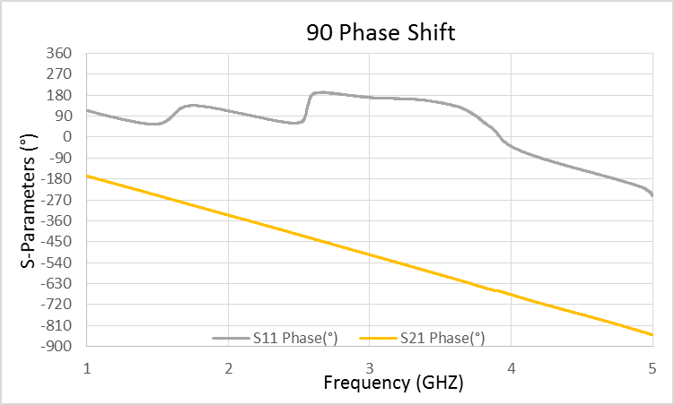

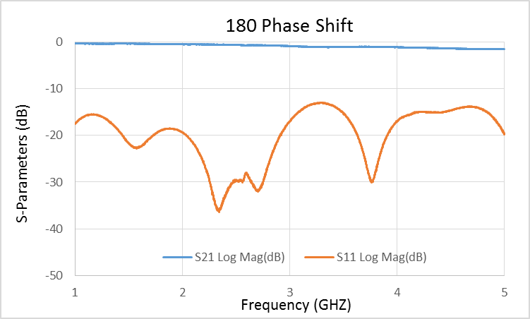 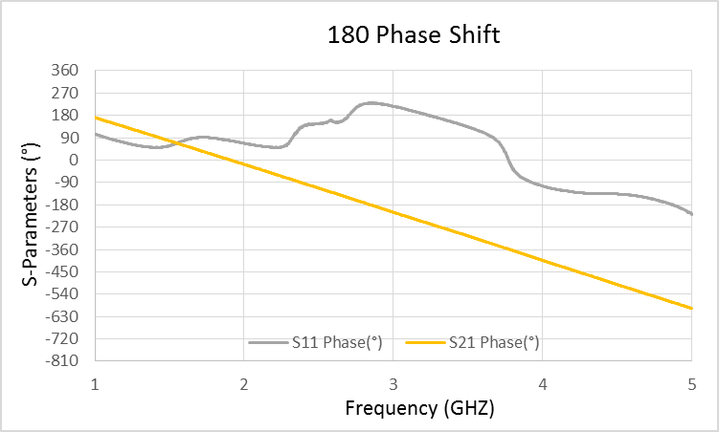

The Phase shifter had problems with the length being too short for both the 90° and 180°. In addition there were problems with attaching/ detaching the copper strips that contribute to the error in the shifts. When the network analyzer unwraps the phase measurement, it did it incorrectly resulting in 360° needed to be added to the phase values. Still, the measured shifts were less than desired which reflects in a phase shift length that is too short.