Lab 8: Four Port Devices

1. Hybrid Coupler  
   The hybrid coupler is a device that equally divides the power into the two output ports with a 90° phase shift. In lab, the device was already fabricated on FR4 with milled copper. The device was tested using the network analyzer and compared to the simulated results. The device works similarly to the simulated results. The biggest difference is there is a shift in the operating frequency of the device from 2.5 GHz (as designed) to about 2.8 GHz (as built). This is a result in the arm lengths of the coupler are too short. In addition, the phase shift of the built device is always higher than the simulated. However both have a phase shift of about 90° at the design frequency of 2.5 GHz. Below are the calculations and the values used in the HFSS simulation, as well as the graphed data.

$$f_{0}=2.5 GHz, Z_{0}=50 Ω, w= 3.128 mm \\ Z_{x}=Z_{0}=50 Ω, w_{x}= 3.128 mm, l_{x}={λ_{eff}}/4=16.88 mm \\ Z_{x}={Z_{0}}/{\sqrt{2}}=35.355 Ω, w_{y}= 5.272 mm, l_{y}={λ_{eff}}/4=16.47 mm$$

|  |  |  |  |
| --- | --- | --- | --- |
|  | Feed Line | Coupler x | Coupler y |
| Z (Ω) | 50 | 50 | 35.355 |
| w (mm) | 3.128 | 3.128 | 5.272 |
| L (mm) | NA | 16.88 | 16.47 |

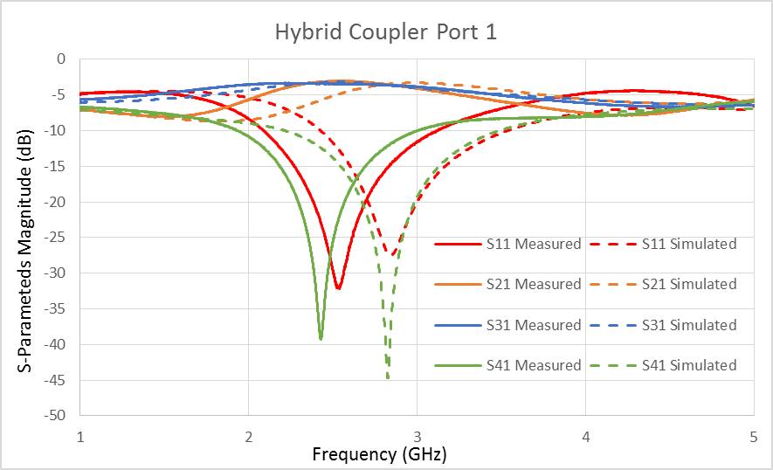 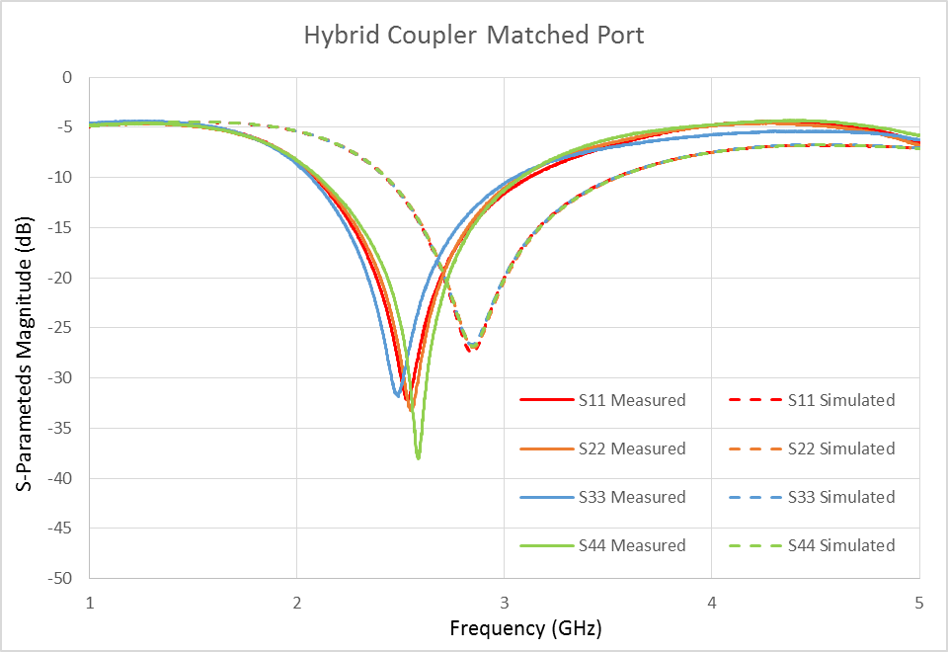

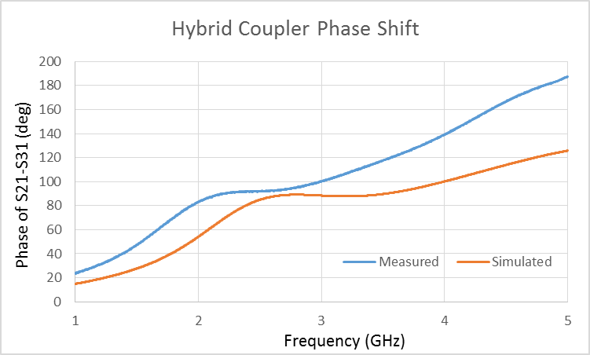

1. Rat Race  
   The Rat Race is another four port coupler that splits the input power in half. In addition, the rat race can have a phase shift of either 90° or 180°. In lab, the device was already fabricated on FR4 with milled copper. The device was tested using the network analyzer and compared to the simulated results. The device works similarly to the simulated results. Below are the calculations and the values used in the HFSS simulation, as well as the graphed data.

$$f_{0}=2.5 GHz, Z_{0}=50 Ω, w= 3.128 mm \\ Z_{RR}={\sqrt{2}Z}_{0}=70.71 Ω, w_{RR}= 1.675 mm, l_{RR}={6λ_{eff}}/4=102.02 mm$$

|  |  |  |
| --- | --- | --- |
|  | Feed Line | RR Circle |
| Z (Ω) | 50 | 70.71 |
| w (mm) | 3.128 | 1.675 |
| L (mm) | NA | 102.02 |

