Lab 9: Patch Antenna

1. The patch antenna is a simple antenna that is linearly polarized. The patch antenna radiates like a monopole antenna. Unlike the dipole antenna, the patch radiates in only one direction because the ground plane reflects all the radiation that would otherwise radiated the opposite direction. The equations below are used to find the dimensions of the patch antenna. In lab these values were found and then constructed out of copper tape on FR4. For simulations, the antenna was feed directly with a coaxial probe. The position was found by moving the probe L/3 from the edge of the patch and refined using simulated data.

$$f_{0}=3 GHz, Z_{0}=50 Ω, h= 1.5748 mm, ε_{r}=4.1 \\ W=\frac{c}{{2f}_{0}}\sqrt{\frac{2}{ε_{eff}+1}}=\frac{3x{10}^{8}m/s}{2*3x{10}^{9}Hz}\sqrt{\frac{2}{4.1+1}}=31.3 mm$$

$$ε_{eff}=\frac{ε_{r}+1}{2}+\frac{ε_{r}-1}{2}{\left(1+12\frac{h}{W}\right)}^{-1/2}=\frac{4.1+1}{2}+\frac{4.1-1}{2}{\left(1+12\frac{1.5748mm}{31.3mm}\right)}^{-1/2}=4.0995$$

$$∆L=0.412h\frac{\left(ε_{eff}+0.3\right)\left(\frac{W}{h}+0.264\right)}{\left(ε_{eff}+0.264\right)\left(\frac{W}{h}+0.8\right)}=0.412*1.5748mm\frac{\left(4.0995+0.3\right)\left(\frac{31.3mm}{1.5748mm}+0.264\right)}{\left(4.0995+0.264\right)\left(\frac{31.3mm}{1.5748mm}+0.8\right)}=7.24mm$$

$$L=\frac{c}{2f_{0}\sqrt{ε_{eff}}}-2∆L=\frac{\frac{3x{10}^{8}m}{s}}{2*3x{10}^{9}Hz\sqrt{4.0995}}-2*7.24 mm=23.25 mm$$

$$L_{probe}=\frac{L}{2}-\frac{L}{3}=\frac{23.25mm}{2}-\frac{23.25mm}{3}=3.875 mm (from center)$$

|  |  |  |
| --- | --- | --- |
|  | Calculated | Simulated |
| L (mm) | 23.25 | 23.64 |
| W (mm) | 31.3 | 31.3 |
| probe (mm) | 3.875 | 5.4 |

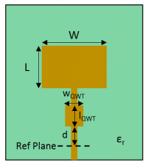In lab, a 50 Ω microstrip transmission line was used to feed the antenna with a quarter wave transform used to match the antenna. The antenna was feed first with an unmatched to find the input impedance. Then a Smith chart was used to find how far away from the reference point (15 mm) the transform needed to be

$$\overline{Z_{in}}=1.236-j1.27$$

$$\overline{Z_{L}}=0.345, Z_{L}=50Ω*.345=17.25Ω$$

$$Z_{λ/4}=\sqrt{Z_{L}Z_{0}}=\sqrt{17.25Ω*50Ω}=29.37Ω$$

$$l=17.496 mm (found from the Smith Chart)$$

$$d=l+l_{ref}-l_{λ/4}=17.496mm+15mm-13.5mm=19mm$$

$$w_{λ/4}=6.76 mm, l_{λ/4}=13.5 mm$$

Below are the results for both the simulated and measured results for each of the patch antennas with the alternate matching a feed structures.

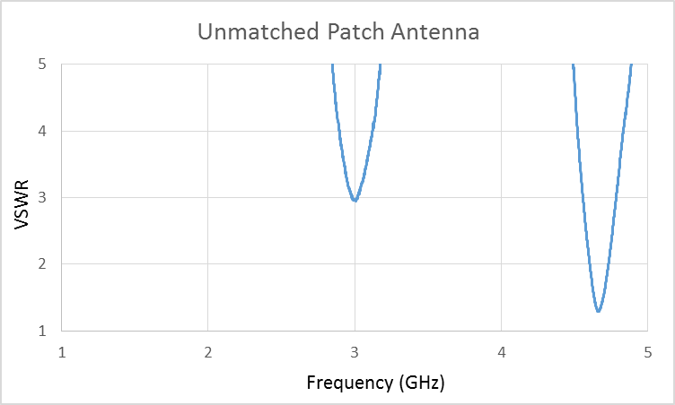 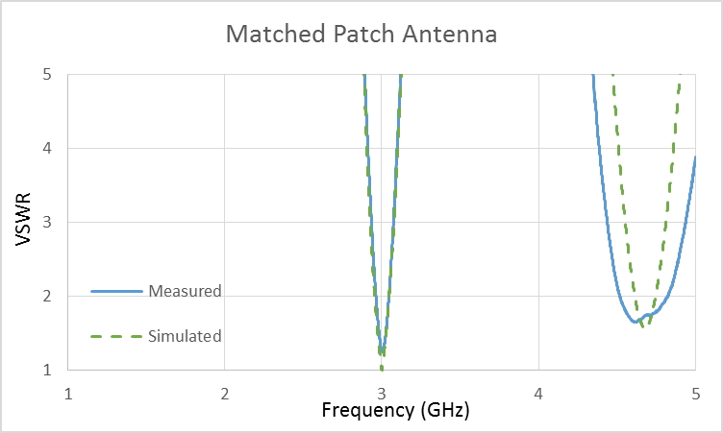

At 3 GHz, the simulated patch had a final impedance or 50.35+j0.75 and a VSWR of 1.017, while the measured patch had a final impedance of 60.592-j7.998 and a VSWR of 1.272. Both the simulated and measured patches are well matched and operate at the appropriate frequency.