Contents

Table 1 Source data 2

Table 1a Data analysis with 1st visit to hosptial as reference day 1 2

Table 1b Disease co-morbidities cartesion product 2

Table 1c Pre and post analysis with index date 3

Table 1d Disease trajectory creation 4

Table 1e Sentence of disease and medicine 4

Table 2 Interactive table before and after example 1 4

Table 2a Interactive table before and after example 2 5

Figure 1: Interactive visualization 1 5

Figure 1a: Interactive visualization 2 6

Figure 2: Disease trajectory for reference disease Madhumeha 6

Figure 2a: Medicine trajectory for reference disease Madhumeha 6

Figure 3: Circular view of co morbidities Amlapitta and Vaatvyadhi - Greedhrasee 7

Figure 3a: Circular view of co morbidities Dhanwanaristham and Vaatvyadhi - Greedhrasee 7

Figure 3b Reference disease and medicine window 7

Figure 3c Representation of time points, count of unique diseases, medicines 8

Figure 4: Diseases – summary view 10

Figure 4a: Diseases – summary view by season 10

Figure 5 Word embedding representation 11

# Table 1 Source data

|  |  |
| --- | --- |
| Example 1 | Example 2 |
|  |  |

# Table 1a Data analysis with 1st visit to hosptial as reference day 1

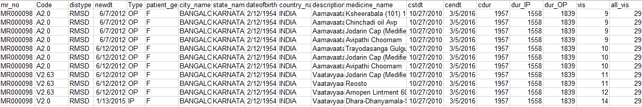

# Table 1b Disease co-morbidities cartesion product

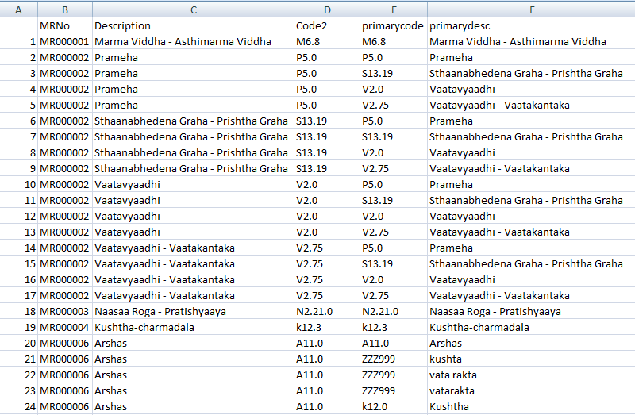

# Table 1c Pre and post analysis with index date

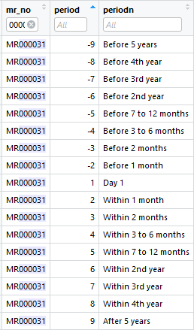

# Table 1d Disease trajectory creation

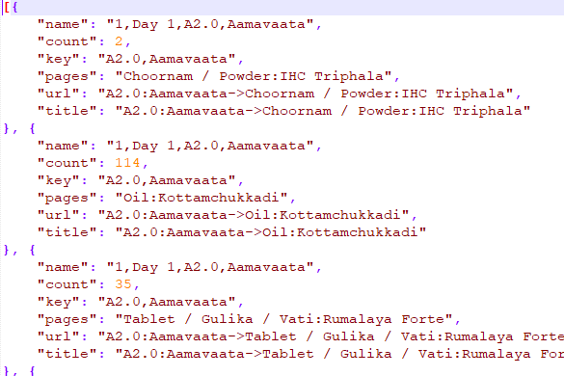

# Table 1e Sentence of disease and medicine

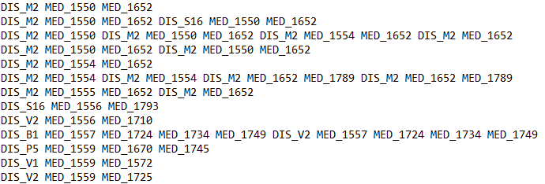

Link to before and after table: <https://public.tableau.com/views/085_dis_1st_time_refCal_NodesEdges/Sheet1?:display_count=y&:origin=viz_share_link>

# Table 2 Interactive table before and after example 1

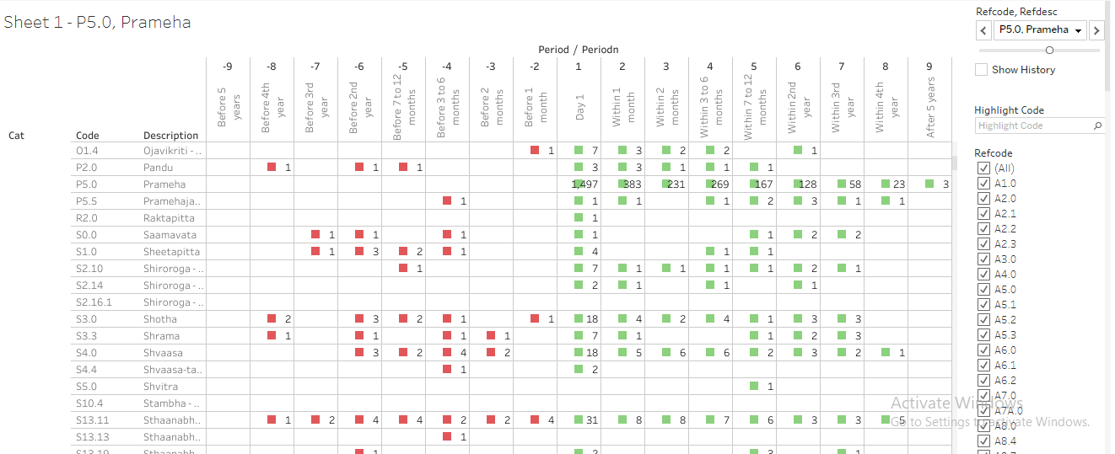

# Table 2a Interactive table before and after example 2

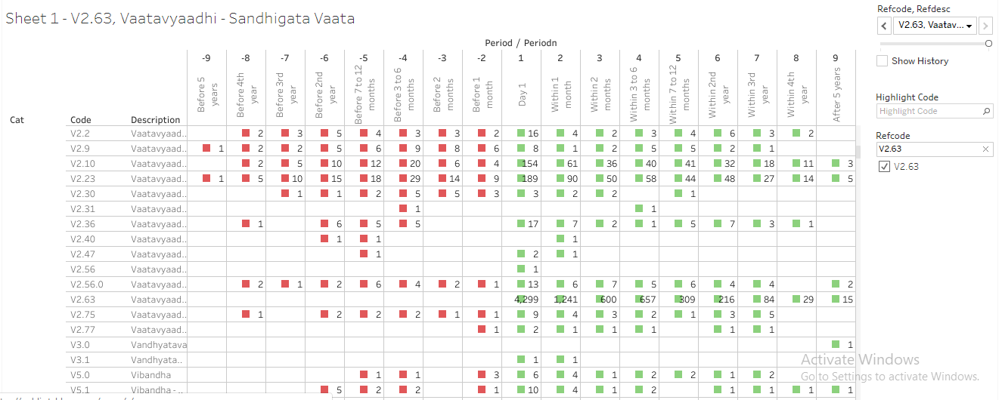

# Figure 1: Interactive visualization 1

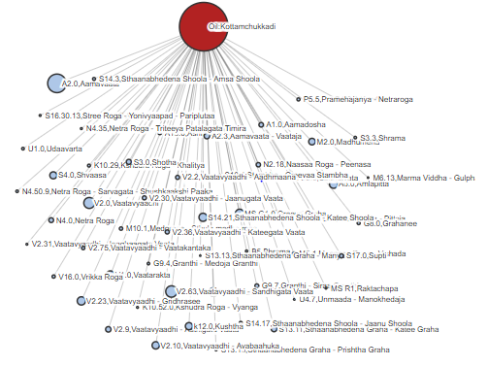

# Figure 1a: Interactive visualization 2

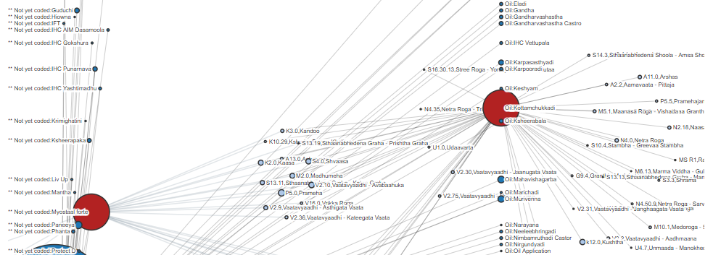

# Figure 2: Disease trajectory for reference disease Madhumeha

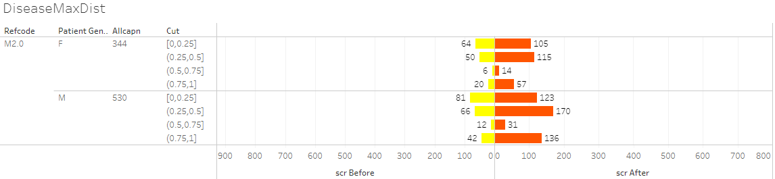

Link for medical visual:

<https://public.tableau.com/views/DistanceMeasuresTimePeriod-086prgm/DiseaseMaxDist?:display_count=y&:origin=viz_share_link>

# Figure 2a: Medicine trajectory for reference disease Madhumeha

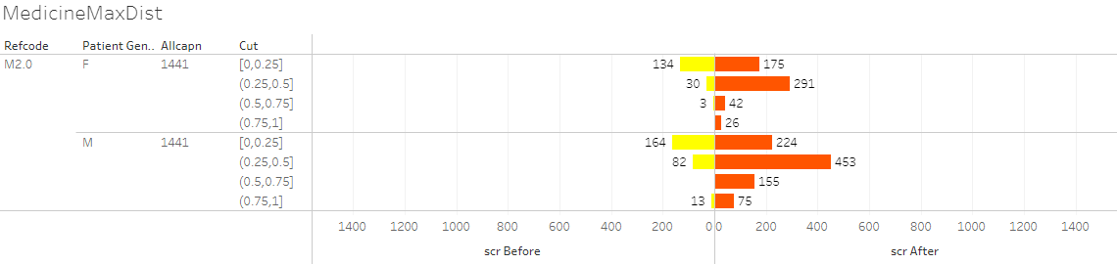

Link for medicine visual:

<https://public.tableau.com/views/DistanceMeasures/DiseaseMaxDist?:display_count=y&:origin=viz_share_link>

# Figure 3: Circular view of co morbidities Amlapitta and Vaatvyadhi - Greedhrasee

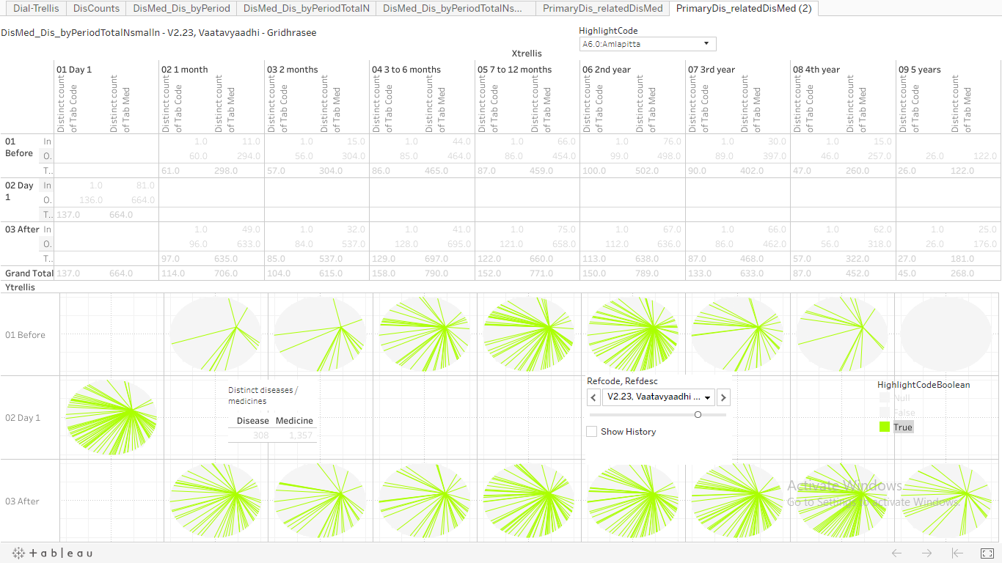

# Figure 3a: Circular view of co morbidities Dhanwanaristham and Vaatvyadhi - Greedhrasee

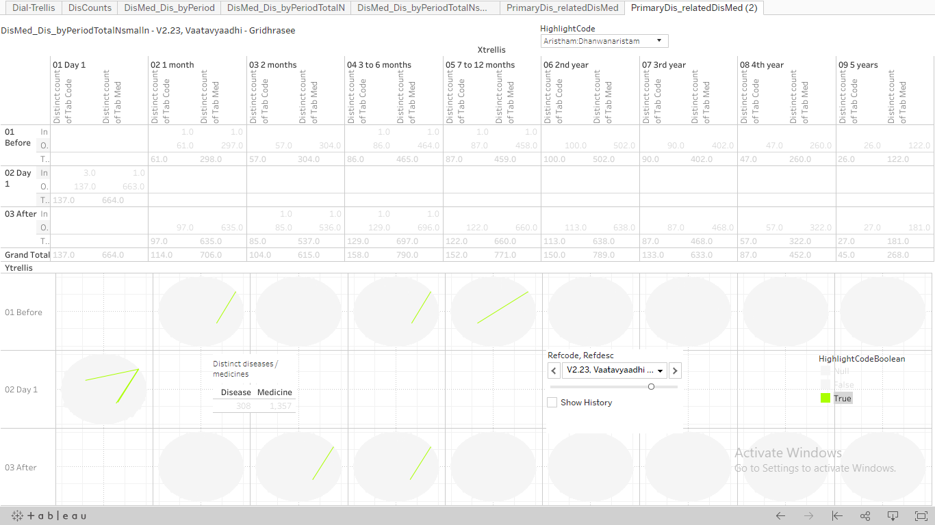

# Figure 3b Reference disease and medicine window

|  |  |
| --- | --- |
| Reference disease window | Reference disease or medicine window |
|  |  |

# Figure 3c Representation of time points, count of unique diseases, medicines

Time points (1)



|  |  |
| --- | --- |
| Count of distinct  number of diseases (2) | Count of distinct  number of medicines (3) |
|  |  |

|  |  |
| --- | --- |
| Example on day 1 (4) |  |
| Example in before period (5) |  |
| Example in after period (6) |  |

**Figure 3d Total diseases, medicines for the underlying combination**

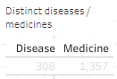

**Figure 3e Representation of each circle**

|  |  |
| --- | --- |
| The green colored spokes going from point of origin are different treatments prescribed (1) |  |
| Hovering tooltip (2) |  |

Link for circular co-morbidity visual:

<https://public.tableau.com/views/085_dis_count_edges_3rd_byPeriod02try/PrimaryDis_relatedDisMed2?:display_count=y&:origin=viz_share_link>

# Figure 4: Diseases – summary view

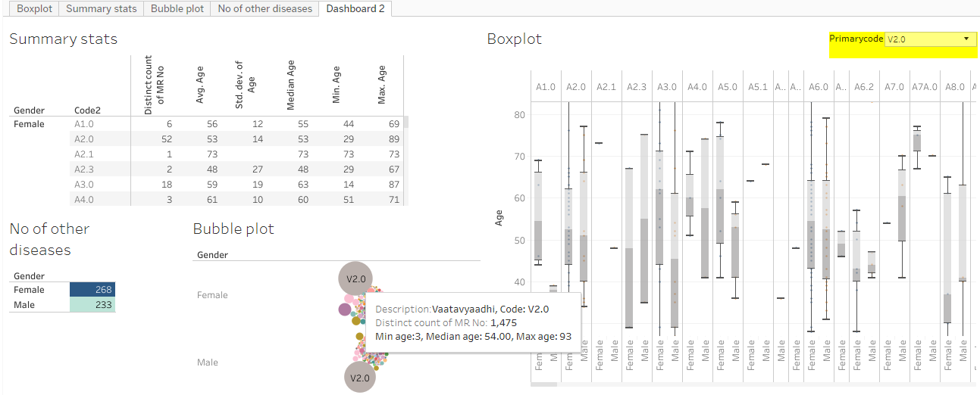

Link to the disease summary view:

<https://public.tableau.com/views/Primary_disease_and_all_other_diseases/Dashboard2?:display_count=y&:origin=viz_share_link>

# Figure 4a: Diseases – summary view by season

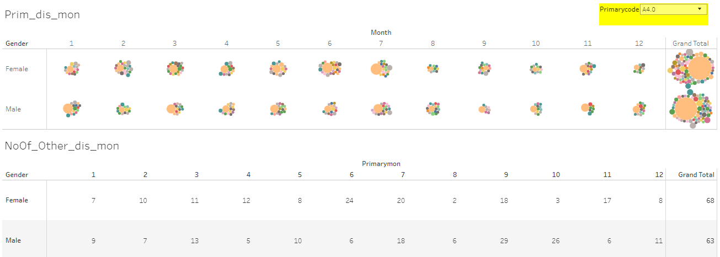

Link to the disease summary view by season:

<https://public.tableau.com/views/PrimDis_otherDis_ByMonth/Dashboard1?:display_count=y&:origin=viz_share_link>

# Figure 5 Word embedding representation

