Contents

Table 1 Source data 2

Table 1a Screenshot – analysis snapshot 1 3

# Table 1 Source data

|  |  |
| --- | --- |
| Example 1 | Example 2 |
|  |  |

# Table 1a Screenshot – analysis snapshot 1

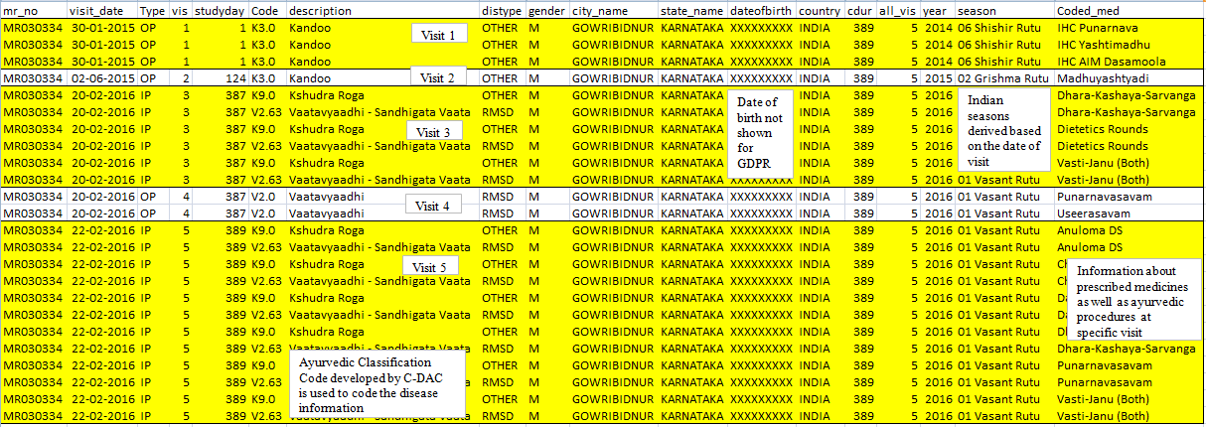

Extraction#

Source datasets:

1. STATE_MASTER
2. COUNTRY_MASTER
3. CITY
4. STATE
5. PATIENT_DETAILS
6. PATIENT_REGISTRATION
7. MRD_DIAGNOSIS
8. PATIENT_PRESCRIPTION
9. PATIENT_MEDICINE_PRESCRIPTIONS
10. IP_PRESCRIPTION
11. SERVICES_PRESCRIBED
12. SERVICES
13. MEDICINE_SALES_VIEW

**Original Data**

Visit data of patient in PDF format

#



**Snapshot 5**

Medicinal trajectory

**Snapshot 4**

Disease trajectory

**Snapshot 3**

* Pre and post analysis of disease data using day 1 as reference day for each disease
* Understanding pre and post intervention and medical conditions of the patient.

**Snapshot 2**

* Data extract, per patient, of different disease combination
* Understand the relationship between different conditions
* Analyze and understand co-morbidities

**Snapshot 1**

* 1st hospital visit as a reference day 1
* Information extracted include:
  + Patient ID
  + Disease code
  + Disease type
  + Date of visit
  + Visit type (IP, OP)
  + Gender
  + City
  + State
  + Date of birth
  + Country
  + Description of disease
  + Medicine name
  + Start date
  + End date
  + Total duration
  + In Patient duration
  + Outpatient duration
  + Visit number
  + Total number of visits