Plotting and Color

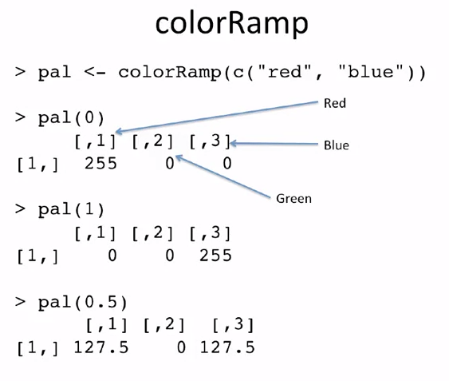

# Defaults are ugly!

* 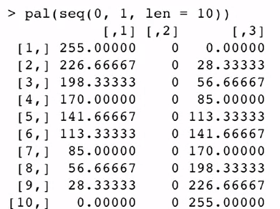col 1 – black
* col 2 – red
* col 3 – green
* col 4 – cyan
* col 5 – magenta

**grDevices Package**

take palettes of colors and mix between them

* 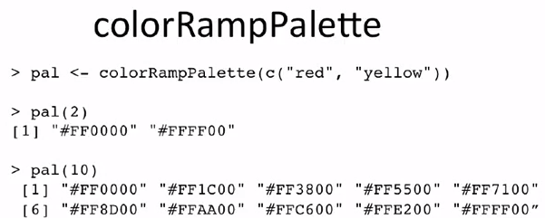colorRamp()
* colorRampPalette()

**RcolorBrewer Package**

* Sequential – light to dark
* Diverging – Categorical (random) pastel/bold
* 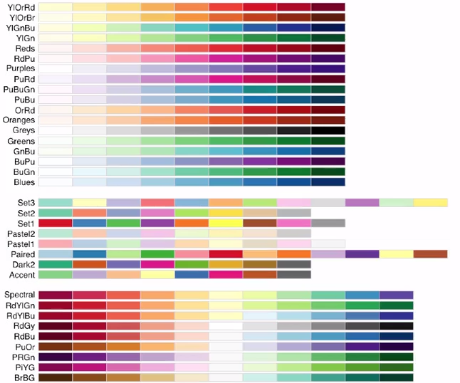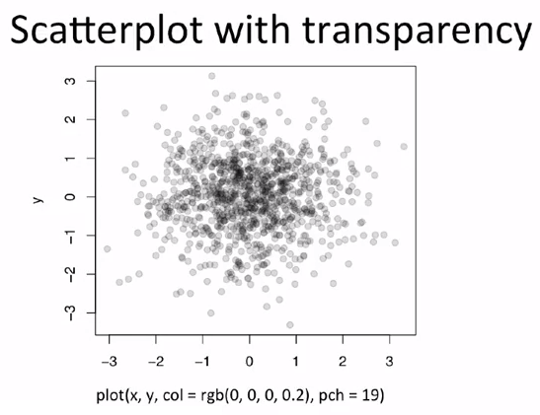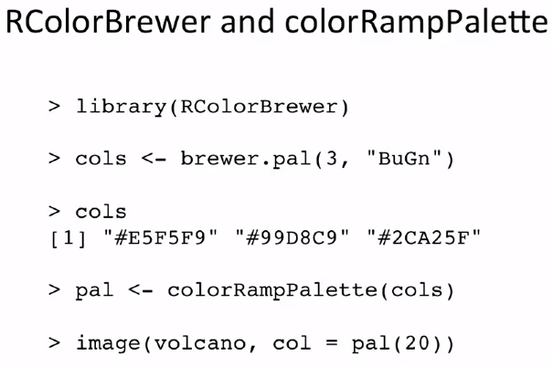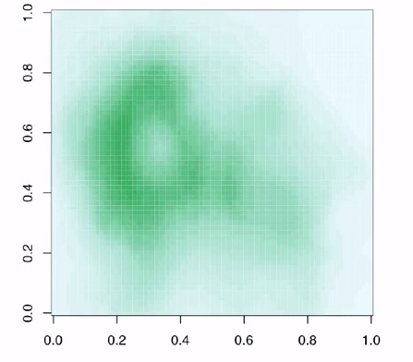Qualitative