STORYBOARD
Full Name: Courtney Rodney
Assignment #2
ID#: 2307682
Class: Web Programming
Class Time: Thursday 6:00pm - 7:50pm
Teacher: Sirisha Badhika
Module Code: CIT2011
Hosting Link: https://ia-2-psi.vercel.app/Index.html
I used VERCEL.
My credits with Netlify were used up and could not direct to the page.
GitHub Link: https://github.com/Court-Codes111/IA_2.git

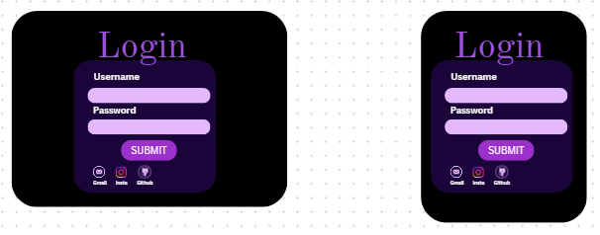
DESKTOP MOBILE

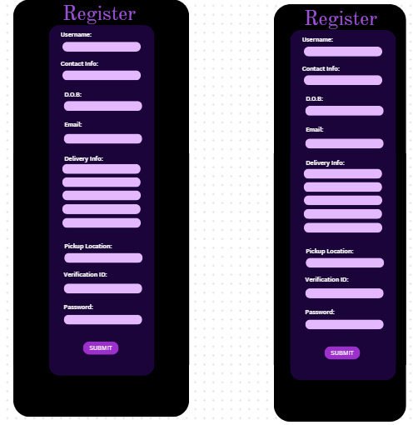

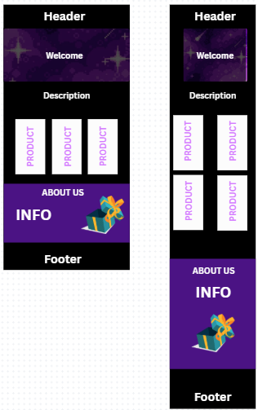

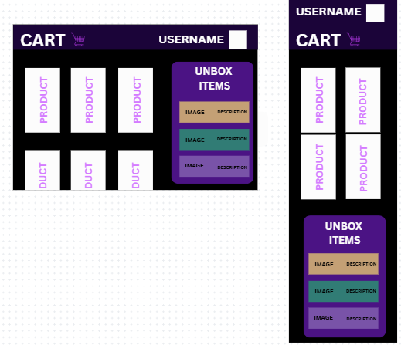

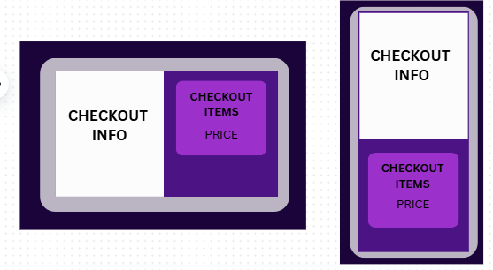

FUNCTIONS AND PURPOSES
- Checkout Script
loadOrderSummary()
- Purpose: Loads and displays the order summary from cart data in localStorage.

placeOrder()
- Purpose: Processes order placement, clears cart, and redirects to homepage.

- Cart Script
displaycart()
- Purpose: Displays all items in the cart from localStorage.

clearCart()
- Purpose: Clears entire cart after user confirmation.

removeFromCart(index)
- Purpose: Removes a specific item from the cart by index.

showPurchases()
- Purpose: Displays purchase history with unboxed items.

purchase(TierName)
- Purpose: Gives a rabdom item when purchasing/unboxing a box.

proceedToCheckout()
- Purpose: Redirects user to checkout page.

- Homepage Script
addToCart(tier, company, image)
- Purpose: Adds product to cart and saves to localStorage.

purchase(TierName, CompanyName, elementId)
- Purpose: Direct purchase from homepage with random unboxing.

- Login Script
checkLogin()
- Purpose: Validates user credentials against stored users.

- Registration Script
valid()
- Purpose: Validates password requirements (uppercase + 3 numbers).

storedata()
- Purpose: Stores user registration data in localStorage.

Business Description
Humble Box is an online mystery box e-commerce platform that offers curated surprise packages from various companies. Customers can purchase different tiered boxes containing random items, creating an exciting unboxing experience where the contents remain a mystery until purchase.

Logo
A purple Ace of Clubs playing card, representing gambling and high-stakes thrill of unboxing mystery items.

Slogan
"Where curiosity meets excitement or tears"
This clever tagline captures the thrill and uncertainty of mystery box purchases, acknowledging both the potential for amazing discoveries and disappointing results.

Mission Statement
To provide an engaging and thrilling shopping experience where customers can discover unique, valuable items through tiered mystery boxes, offering both entertainment and potential value through surprise unboxing.

Vision Statement
To become the premier destination for mystery box enthusiasts, creating memorable unboxing experiences through curated partnerships with diverse companies and maintaining the excitement of discovery.

Core Value Proposition
Tiered Mystery Boxes: Three distinct price points (Basic $50, Pro $100, Epic $250).
Company Variety: Partnerships with multiple.
Surprise Element: Every box contains random items worth at least half the purchase value.
Limited Availability: Each box is a one-time purchase item per customer.

Unique Selling Points
1. Themed Unboxing: Different companies offer unique item categories.
2. Special Features:
- 5% of boxes include riddles as clues.
- "Golden Ticket" chances for grand prizes or full refunds.
3. Jamaican Focus: Several partner companies are Jamaican brands, suggesting regional specialization.
4. Gamified Experience: The thrill of uncertainty and potential for high-value discoveries.

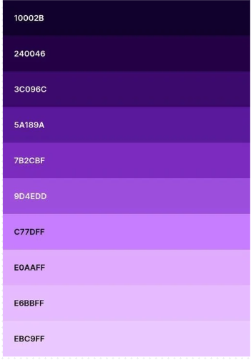
Color Palette Analysis
Primary Colors Used:
-Deep Purples (240046, 3C096C, 5A189A, 782GBF, 904EDD)
-Light Purples/Lavenders (C770FF, E0AAFF, E68BFF, EBC9FF)
- Black (10002B - which is actually a very dark purple/black)

Psychology of Purple in Web Design & Marketing:
1. Luxury & Premium Quality
- Purple has historically been associated with royalty, nobility, and luxury.
- Perfect for positioning Humble Box as a premium mystery box service.
- Creates perception of high-value items and exclusive experiences.

2. Mystery & Creativity
- Purple evokes feelings of mystery, imagination, and the unknown.
- Ideal for a mystery box business where contents are secret.
- Encourages creative thinking and wonder about what might be inside.

Marketing Justification
This palette effectively:
- Builds anticipation through mysterious dark tones.
- Suggests value through royal, premium associations.
- Creates emotional connection through creative, imaginative qualities.
- Maintains sophistication while still being approachable and fun.


Icons

width: 100px;
height: 100px;

Font Families
- 'Lucida Handwriting', cursive (headers, navigation, tier labels)
- 'Times New Roman', serif (intro overlay, product descriptions)
- 'Poppins', sans-serif (header paragraphs)
- 'monospace', sans-serif (product titles)
- 'Segoe Print', serif (footer content)
- 'Comic Sans MS', sans-serif (about section info)

Font Weights:
- 200 (head section h1)
- 300, 400, 500, 600, 700, 900 (various elements)
- 500 (about section h2)
- 600 (navigation links)
- 700 (overlay text, header elements)
- 900 (statement sections, tier labels)

Font Sizes
- 14px (footer copyright)
- 16px (footer links and contact info)
- 18px (header paragraphs, mobile about section)
- 20px (statement lists, tier details, form labels)
- 25px (navigation links, mobile responsive)
- 32px (header h2, mobile statement sections)
- 35px (overlay text, about section h1)
- 40px (head section, statement paragraphs)
- 100px (overlay h1)

TARGET AUDIENCE
The intended audience for Humble Box is primarily mystery and surprise enthusiasts, including young adults, collectors, and gamers, who are drawn to experiential shopping, the thrill of discovery, and the potential of acquiring unique, high-value, or limited-edition items from a variety of themes, with a particular appeal to those interested in Jamaican products and brands.
Reference
W3Schools. (n.d.). HTML tutorial. W3Schools Online Web Tutorials. Retrieved November 15, 2025, from https://www.w3schools.com/html/
Pinterest. (n.d.). Pinterest. Retrieved November 15, 2025, from https://www.pinterest.com/

Canva. (n.d.). Canva. Retrieved November 15, 2025, from https://www.canva.com/

