Screenshot of the three objects in motion.

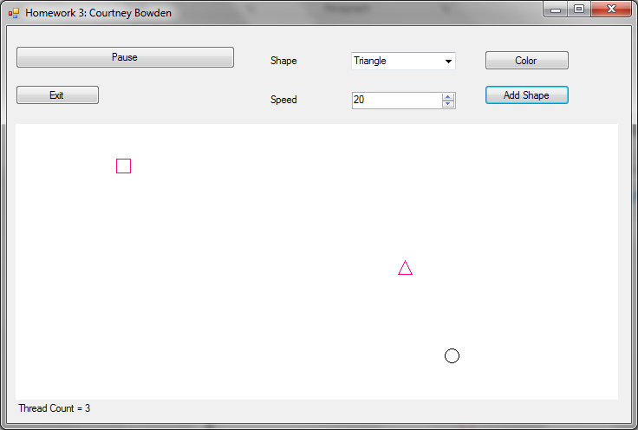

Screenshot of color dialog that pops up.

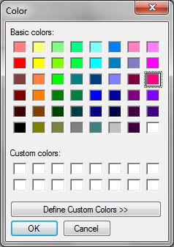

Screenshot of what happens when you add 50 objects.

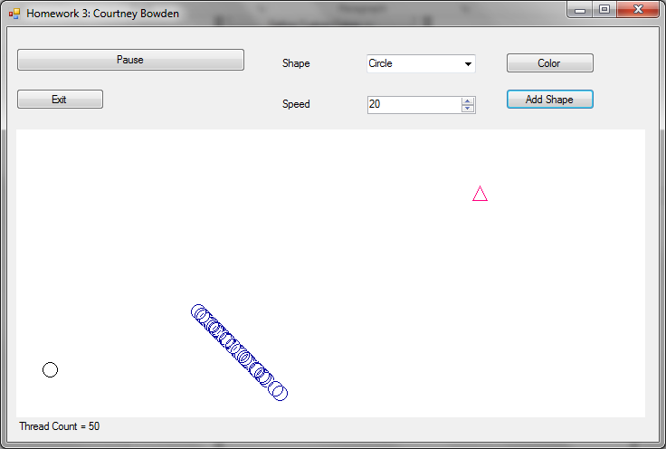

Screenshot of message box that prevents you from exceeding 50 objects. \*\*I got 150 to work but it drains system resources and slows everything down.

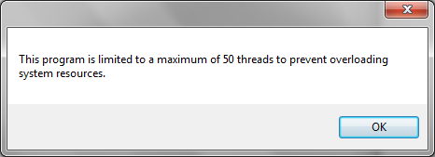

Screenshot of when application starts with pause/resume button disabled because there are no active threads.

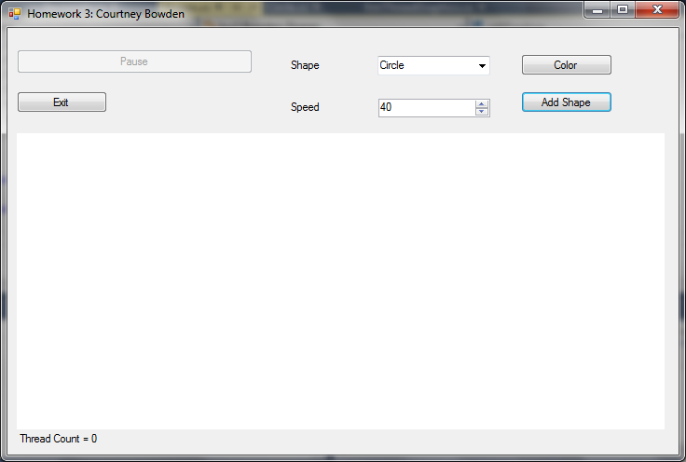

Screenshot taken after first object added. The pause/resume button is active.

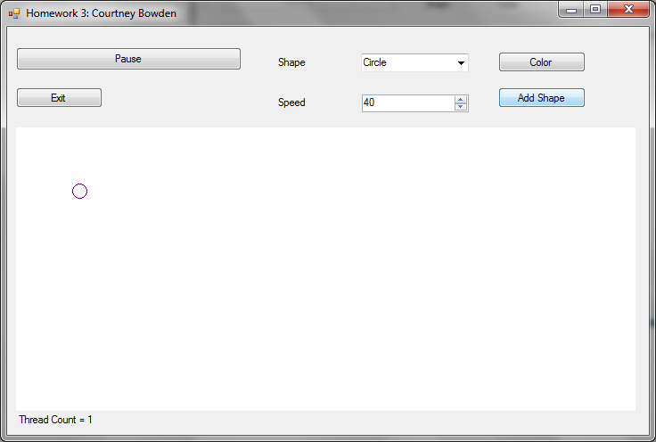

Screenshot after pausing. The pause/resume button now says resume.

