Screenshot of the data in the datagrid.

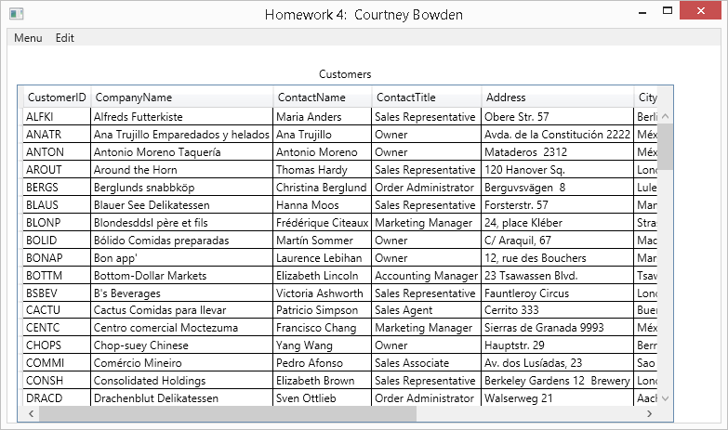

This screenshot show the adding of a new record.

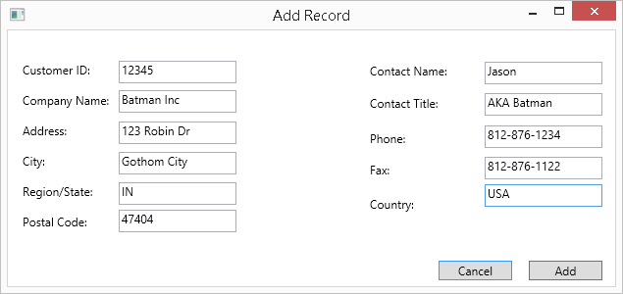

This screenshot show that Customer 12345 has been added.

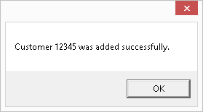

This screenshot shows that Customer 12345 is now in the datagrid.

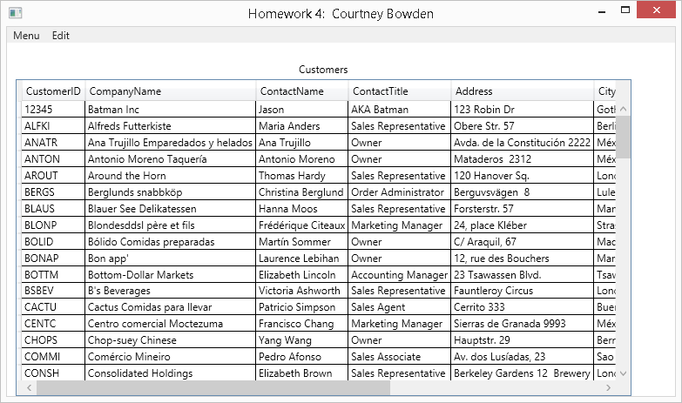

Screenshot of the Edit Record.

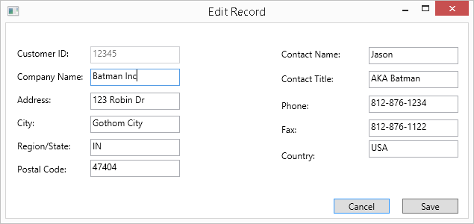

Screenshot of the Edit Record has been successful.

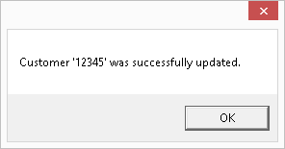

Screenshot of Record being deleted.

