Reduced growth due to belowground sink limitation is not fully explained by reduced photosynthesis

Courtney E. Campany1, Belinda E. Medlyn1 and Remko A. Duursma1

1 Hawkesbury Institute for the Environment, Western Sydney University, Locked Bag 1797, Penrith, NSW, Australia

Corresponding author: C.E. Campany, email: [courtneycampany@gmail.com](mailto:courtneycampany@gmail.com), telephone: +61 02 4570 1421, fax: +61 02 4570 1103

Running Head: Sink limitation and reduced seedling growth

# Abstract

Sink limitation is known to reduce plant growth, but it is not known how plant carbon (C) balance is affected, limiting our ability to predict growth under sink-limited conditions. We manipulated soil volume to impose sink limitation of growth in *Eucalyptus tereticornis* seedlings. Seedlings were grown in the field in containers of different sizes and planted flush to the soil alongside freely-rooted (Free) seedlings. Container volume negatively affected aboveground growth throughout the experiment, and light saturated rates of leaf photosynthesis were consistently lower in seedlings in containers (-26 %) compared to Free seedlings. Significant reductions in photosynthetic capacity in containerized seedlings was related to both reduced leaf nitrogen content and starch accumulation, indicating direct effects of sink limitation on photosynthetic down regulation. After 120 days, harvested biomass of Free seedlings was on average 84 % higher than seedlings in containers, but biomass distribution in leaves, stems and roots was not different. However, the reduction in net leaf photosynthesis over the growth period was insufficient to explain the reduction in growth, so that we also observed an apparent reduction in whole-plant C use efficiency (CUE) with container size. Our results show that sink limitation affects plant growth through feedbacks to both photosynthesis and CUE. Mass balance approaches to predicting plant growth under sink-limited conditions need to incorporate both of these feedbacks.

## Keywords

photosynthesis, plant growth, sink regulation, carbon allocation, soil volume

# Introduction

The source-sink limitation paradigm for plant growth argues that growth may be limited either by source activity, i.e. the amount of carbon (C) that the plants are able to take up through photosynthesis, or by sink strength, i.e. the amount of carbon that the plants are able to utilize in growth. This debate over how rates of photosynthesis affect plant growth or to what degree these rates are instead controlled by growth has existed for decades (Sweet and Wareing 1966, Körner 2015). To be able to predict plant growth responses to environmental change, we need models that can account for both source and sink limitation.

Most current models of plant growth are based on the physical principle of mass balance: C entering the plant through net photosynthesis must be balanced by C allocation to growth and storage and C losses including respiration, root exudation, volatile organic compounds and tissue turnover. Plant growth is thus predicted as the outcome of the processes of photosynthesis, C allocation and C loss. It is easy to see how source-limited growth can be implemented in such models: increasing source activity increases photosynthetic C uptake, flowing through to increased growth. It is less easy to know how to implement sink limitation of growth in such models, because it requires that we know whether, and how, sink limitation influences the contributing processes of photosynthesis, C allocation and C loss. It has been suggested that sink limitation affects the C balance by causing a down-regulation of photosynthetic rate, possibly mediated by carbohydrate accumulation (Arp 1991, Paul and Foyer 2001, Ainsworth et al. 2004, Ronchi et al. 2006, Nebauer et al. 2011), but there is also evidence that photosynthesis and growth can become strongly decoupled under sink limitation (Muller et al. 2011, Leuzinger et al. 2013), suggesting that other processes must also be affected.

In the absence of a good understanding of the effects of sink limitation on physiological processes, most attempts to model sink limitation of growth to date have done so by abandoning the principle of mass balance (Fatichi et al. 2014). This approach is unsatisfactory because mechanistic models should obey the laws of physics. Growth models must take into account several simultaneous processes affecting the C balance at any given time (Fourcaud et al. 2008), thus incomplete modelling approaches often lead to unaccounted-for C. Our goal in this paper was to investigate how the C balance of plants is modified by sink limitation, by experimentally imposing a sink limitation to growth.

In previous studies, the sink limitation of growth has been explored by manipulations of both C source and C sink activity. Examples of experimental approaches that manipulate C source activity include elevated atmospheric CO2 concentration and partial defoliation experiments. Elevated CO2 causes an increase in leaf-level photosynthetic rate, *A*n (Drake et al. 1997, Ainsworth and Rogers 2007). This increased photosynthetic uptake is often observed to drive an increase in plant biomass production (Norby et al. 2005). Evidence from a wide range of elevated CO2 experiments, however, also reveals that even with an average photosynthetic enhancement of over 30 %, the biomass growth rate only increases by around 10 % (Kirschbaum 2011). This implies that other process of tree C balance must be affected, which has been noted in CO2 manipulation studies that attempt to close the C budget (Wang et al. 1998, Hamilton et al. 2002, Schäfer et al. 2003).

In partial defoliation experiments, source activity is decreased by a reduction of photosynthesizing leaf area. In these experiments, compensatory increases in *A*n of the remaining foliage are commonly found, and have been attributed to several processes including indirect effects on resource availability, such as increased stomatal conductance (Layne and Flore 1995) or enhanced leaf nutrient status (Turnbull et al. 2007, Pinkard et al. 2011), or more direct effects of modified sink-source balance such as, reduction in end-product inhibition (Iglesias et al. 2002, Zhou and Quebedeaux 2003, Handa et al. 2005), enhanced biochemical activity (Ovaska, Sari, et al. 1993, Layne and Flore 1995, Pinkard et al. 2011), and regulatory sugar signaling (Eyles et al. 2013). Similar to elevated CO2 experiments, these increases in *A*n in defoliation experiments do not increase tree growth (Ovaska, Walls, et al. 1993, Markkola et al. 2004, Palacio et al. 2012). As these studies do not attempt to scale the degree of compensatory response in leaf C gain to the entire canopy, the overall affect of source manipulation on tree C balance and growth is still unclear.

Alternatively, sink limitation can be investigated by manipulating plant tissue C sinks, for example by fruit removal or phloem girdling. In these studies, down regulation of *A*n is often observed, and typically correlates with carbohydrate accumulation resulting from reduced tissue sink strength (Iglesias et al. 2002, Urban and Alphonsout 2007, Haouari et al. 2013). However, reductions in *A*n have also been attributed to biochemical limitations prior to carbohydrate accumulation (Nebauer et al. 2011), irreversible photo-oxidative damage (Duan et al. 2008) and stomatal limitation (Li et al. 2005). Similar to C source manipulations, it is still unclear whether these impacts on *A*n can fully explain the resulting impacts on growth.

Yet another experimental approach is to reduce belowground C sink strength in tree seedlings by manipulating container size and thus rooting volume (Arp 1991, NeSmith and Duval 1998, Poorter, Bühler, et al. 2012). Inadequate rooting volume can decrease C sink strength by progressively restricting root growth in growing plants (Thomas and Strain 1991). In a comprehensive meta-analysis, Poorter *et al.* (2012) demonstrated a large effect of container size on plant biomass accumulation. Photosynthetic down-regulation is generally observed in these studies (e.g. Arp 1991, McConnaughay and Bazzaz 1991, Gunderson and Wullschleger 1994, Sage 1994, Maina et al. 2002, Ronchi et al. 2006). Poorter *et al.* (2012) examined the components of relative growth rate and found the unit leaf rate to be most strongly affected by rooting volume. As unit leaf rate is correlated with *A*n, they concluded that down-regulation of *A*n may best explain the effects of container size on biomass growth. However, they were unable to determine the physiological mechanism driving the downregulation of *A*n, nor to test whether the reduction in *A*n could explain the observed reduction in growth.

Our goal in this paper was to impose a sink limitation of growth, by manipulating container size and thus rooting volume, and to examine how the C balance of the plants was affected. We grew *Eucalyptus tereticornis* seedlings in a range of container sizes in field conditions, using freely-rooted seedlings as a control for the container size treatments. Seedlings were maintained under well-watered conditions in order to isolate the effect of restricted soil volume from that of low water availability. We tracked leaf-level gas exchange, leaf carbohydrate accumulation and seedling allometry over the course of 4 months. We drove a simple whole-plant photosynthesis model with measured leaf gas exchange and interpolated leaf area data to estimated net canopy C uptake over the experimental period, and compared the result with total seedling biomass. We anticipated that both photosynthesis and growth would be reduced under belowground sink limitation. The principal questions that we addressed were: 1) can we identify the main physiological processes that best explain the down-regulation of photosynthesis?, and 2) does this down-regulation fully explain the observed response of growth, or are other components of the C balance also affected?

# Materials and Methods

## Experimental design

This experiment was located at the Hawkesbury Forest Experiment site in Richmond, NSW, Australia. Plots were located in an open cover paddock that was converted from native pasture grasses. Top soils are an alluvial formation of low-fertility sandy loam soils (380 and 108 mg kg-1 total N and phosphorus respectively) with low organic matter (0.7 %) and low water holding capacity. At this site a soil hard layer exists at ~1.0 m with a transition to heavy clay soils.

Forty-nine *Eucalyptus tereticornis* seedlings, 20 weeks old and approximately 40 cm tall in tube stock, were nursery seed grown from a single local Cumberland plain (western Sydney) cohort. Six additional seedlings were harvested before planting to measure initial leaf area and dry mass of leaves, stems and roots. Six container volumes were used ranging from 5 L to 35 L, with a 22.5 cm diameter, and lengths ranging from 15 to 100 cm. Containers were constructed of PVC pipe capped at the bottom end and were filled with local top soil. Soil in each container was packed to achieve a target soil bulk density that matched local soil conditions of 1.7 g cm-3. An Imidacloprid (BAYER CropScience) insecticide tablet was planted 5 cm below the roots of each seedling. Containers were planted flush with the soil surface inside metal sleeves, designed to minimize excess air space between the container and outside soil while also allowing for container removal. This allowed for soil temperatures in containers to reflect conditions of naturally planted (Free) seedlings. Each experimental block (n=7) contained a complete replicate set of six container volumes as well as one Free seedling, with 1 m2 spacing. For each Free seedling, used as the control, a 1 m2 subplot was excavated to the hard layer and replaced with the same soil used in each container. A border of root exclusion material was buried 0.25 m deep and extended 0.25 m above the ground surface around each subplot to exclude local vegetation, which was further kept out by periodic weeding. Roots of Free seedlings were allowed to grow unrestricted below the root exclusion border.

Plants were watered weekly or when needed to maintain soil moisture at field capacity (13-15 %). Drain systems were built into each container to prevent pooling of water before root expansion, from reduced root uptake, or from large rainfall events. Pooling of water could lead to an anaerobic environment around the root that could hinder the uptake of water through reduced root conductance (Poorter et al. 2009), an undesired experimental artefact. A compartment in the bottom of each container, containing gravel covered by root exclusion mesh, was used to collect excess water. For small containers (5, 10, and 15 l) a simple bottom plug was used to drain excess water from the compartment. For larger containers, plastic tubing (6 mm diameter) was inset into the gravel layer and extended through the top of the container and a lysimeter pump was then used to suction excess water, through the tubing, as needed. Each container was inspected after every watering and rainfall event to determine if pooling had occurred.

## Growth and morphology metrics

Seedlings were planted in summer (January 21st 2013) and stem height, diameter at 15 cm and leaf count were measured weekly thereafter. After four months, a full biomass harvest was completed and the experiment ended (May 21st 2013). Dry mass of leaves, stems, roots and total leaf area (LI-3100C Area Meter; LI-COR, Lincoln, NE, USA) were measured for each seedling. Mean individual leaf area for each harvested seedling was calculated by dividing total measured leaf area by total leaf count of only fully expanded leaves. Mean individual leaf area was then used to interpolate total seedling leaf area through time with weekly leaf counts. Root mass was collected by removing the roots system and passing soil from each container through a 1 mm sieve, washing, separating into fine and coarse roots (<2 mm and >2 mm diameter, respectively) and then drying to a constant mass. Roots of seedlings in containers were not considered pot bound, as matted roots along the soil-container interface were not observed. Roots from the Free seedlings were collected by excavating each 1 m2 subplot to the hard layer and keeping only roots within the subplot. For each seedling, a sub-sample of washed fine roots was analyzed for root length using WhinoRhizo software (Regent Instruments Inc., Quebec, QC, Canada). Specific root length (SRL) is reported as the root length divided by the dry mass of each sub-sample (m g-1). Fine root length density (FRLD) for seedlings in containers is reported as the total fine root length divided by the volume of each container (m dm-3).

## Photosynthetic parameters

Leaf gas exchange measurements were performed fortnightly at saturating light (*A*sat) and saturating light and [CO2] (*A*max) on new fully expanded leaves. Measurements were initiated only after sufficient new leaf growth occurred (March 5th, 2013), approximately 6 weeks following planting, and continued until the biomass harvest. Leaf gas exchange was measured with a standard leaf chamber (2 x 3 cm) equipped with blue-red light emitting diodes using a portable gas exchange system (LI-6400, LI-COR, Lincoln, NE, USA). *A*sat measurements were made at PPFD of 1800 mol m-1 s-1 and [CO2] of 400 l l-1 and *A*max with [CO2] of 1600 l l-1 and PPFD of 1800 mol m-1 s-1. This choice of light level to achieve light saturation is consistent with other studies on *Eucalyptus* species (Kallarackal and Somen 1997, Pinkard et al. 1998, Crous et al. 2013, Drake et al. 2014). These measurements were conducted during midday (10:00-14:00 h) with leaf temperature maintained at 25 °C. After CO2 and water vapour flux values stabilized in the leaf chamber, net CO2 assimilation rate and stomatal conductance (*g*s) were logged 5 times and averaged for both *A*sat and *A*max.

Photosynthetic CO2 response (ACi) curves were measured at 25 °C on a random subset of each container size (n=3) after new leaves were first produced (March 13-14th, 2013) and prior to the final harvest (May 14-15th, 2013). Each ACi curve was started at the reference [CO2] of 400 l l-1 and then consisted of 12 additional steps from [CO2] of 50 to 1800 l-1 at 25 °C at saturating light. From these curves, the maximum rate of Rubisco carboxylation (*V*cmax) and the maximum rate of electron transport for RuBP regeneration under saturating light (*J*max) were quantified using the biochemical model of Farquhar et al. (1980) and fit with the 'plantecophys' package (Duursma 2015) in R (R Development Core Team 2016).

Leaf dark respiration rates (*R*) were measured on each seedling on the same dates as ACi curves. Freshly detached leaves were collected at least 1 hour after sundown and placed inside a conifer chamber attached to the Licor 6400. Measurements were taken at a reference [CO2] of 400 l l-1 while leaf temperature was maintained at current ambient conditions (11.5-13.4 °C). *R* was logged 5 times for each leaf after CO2 and water vapour flux values stabilized in the conifer chamber. Reported values of *R* are standardized rates at 25 °C using a *Q*10 value (1.86) developed for these seedlings in a separate experiment. Leaf area and dry mass were recorded for each leaf during gas exchange campaigns.

## Leaf water potential

Predawn (pd) and midday (l) leaf water potentials were measured for each seedling using a PMS 1505D pressure chamber (PMS Instruments, Albany, OR, USA) on fully expanded leaves during the same time period as ACi and *R*. Leaves were detached and immediately stored inside foil-covered bags before water potential measurements were performed. pd was measured before sunrise and l at 13:00 h (± 30 min). These measurements were used as a measure of static water stress on the seedlings (Sellin 1999) and to ensure that the bulk soil water availability was high enough for plants to avoid water stress as they became larger and roots filled the soil volume.

## Leaf, root and soil chemistry

Each leaf used in gas exchange measurements and subsamples of harvested roots were oven dried at 60 °C to a constant mass and ball milled for analysis of nitrogen (N) content, 13C, and total non-structural carbohydrates (TNC). Pre-planting soil samples (n=6) and subsamples of soil from each container following harvest were passed through a 1 mm sieve to remove organic material, air dried at 40 °C for 72 h and ball milled for analysis of N. Nitrogen concentrations of leaf and soil samples were determined using a Carlo Erba CE1110 elemental analyzer and the percentage of N in samples was calculated by comparison with certified standards. Leaf 13C was analyzed with an Delta V Advantage coupled to a Flash HT and Conflo IV isotope ratio mass spectrometer. Leaf samples were flash combusted at 1000°C to convert to CO2, feed to the mass spectrometer and isotopic signatures are reported relative to the standard Vienna Pee Dee Belemnite scale.

Leaf total non-structural carbohydrate (TNC) concentration was analyzed on dried and milled leaf samples using a total starch assay kit (Megazyme International, Wicklow, Ireland) and includes the starch and soluble sugar concentrations (mg g-1). Starch was quantified using a thermostable -amylase and amyloglucosidase assay (McCleary et al. 1997) and soluble sugars were determined following the anthrone method (Ebell 1969). Exact methods of the TNC assay used in this study are fully described in Mitchell et al. (2013). TNC-free specific leaf area (SLAf, m2 kg-1) for leaves sampled during gas exchange campaigns, was calculated by first subtracting the TNC content from individual dry leaf mass before dividing leaf area by leaf mass. Similarly, TNC-free leaf N concentration (Nf, %) was calculated on all gas exchange leaves from leaf mass without TNC content.

## Modelled net seedling C uptake

The daily total net C gain of seedlings (*G*), is given by

(1)

where *L* is modelled total plant leaf area (m2), is a self-shading parameter and *P*day is the net daily C assimilation per unit leaf area (g C m-2).

*P* was predicted by using a coupled photosynthesis - stomatal conductance model (Farquhar et al. 1980, Medlyn et al. 2011) with the 'plantecophys' package (Duursma 2015) in R with the mean photosynthetic parameters (*J*max, *V*cmax, *g*1 and *R*dark) for each treatment and meteorological data from an onsite weather station. Values of *J*max and *V*cmax are mean estimates from ACi curves over two measurement periods (explained above). The *g*1 parameter was generated by fitting the optimal stomatal conductance model from (Medlyn et al. 2011) to observed *g*s values. *R*dark was was estimated using Eq. (2) from Atkin et al. (2005), which was parameterized with a mean reference empirical measurement for each treatment, a Q10 value of 1.86, a reference air temperature for each treatment and air temperatures at each time step.

(2)

Methods of the coupled leaf gas exchange model are also described in Duursma *et al.* (2014). Combined with the meteorological parameters; PPFD, air temperature, and relative humidity, at 15 min intervals, net leaf photosynthesis rates (mol CO2 m-2 s-1) were then predicted for each soil volume treatment. *P*day was calculated by converting predicted rates to mass C gain over 15 min time steps (g m-2) and then summed for 24 h. This resulted in 120 unique values of *P* for each soil volume treatment, one value for each day of the experiment. Thus, each daily time step for model runs included a value of *P*day that represented both treatment specific photosynthetic parameters and meteorological constraints across the duration of the experiment.

It was further necessary to calculate a self-shading parameter () when scaling leaf *A*n with total plant leaf area. This was accomplished by utilizing 61 previously digitized *Eucalyptus* seedlings, covering 5 total species which include *E. tereticornis*, from Duursma *et al.* (2012) to run in 'YplantQMC' package (Duursma 2014) in R to build a 3D plant structure based on digitized metrics of plant allometry and crown structure. Using the same treatment specific physiological parameters listed above, 'YplantQMC' outputs total *A*n, using total leaf area, for seedlings assuming self-shading as well as for a full sun large horizontal leaf. The ratio of total *A*n with self-shading to horizontal leaf was then used to calculate for each of the 61 digitized seedlings, independently for each of the seven soil volume treatments. Next, the linear relationship between and total leaf area was determined across digitized seedlings, within each treatment. For the growth model, was then predicted for each daily time step using the previous days cumulative leaf area and this value was then applied to *P*.

We used modelled C gain to test the hypothesis that the effects of belowground sink limitation on rates of leaf photosynthesis were sufficient to accurately predict overall seedling biomass production after 120 days. Cumulative net leaf C gain for each treatment was equal to the sum of each value of *P* over 120 days and final seedling C was assumed to equal half of the final dry mass for observed seedlings. We then compared seedling C use efficiency (CUE) across treatments, as the proportion of modelled cumulative net leaf C gain allocated to observed seedling biomass.

## Data analysis

Differences in measured parameters with soil volume were analysed by mixed-effects models in R with individual containers and experimental blocks as random effects and soil volume treatment as a categorical fixed effect with seven levels. Tukey's post-hoc tests were performed in conjunction with ANOVA to determine which specific paired comparisons among soil volume treatments were different. A linear mixed effect model of *A*mass and leaf chemistry was performed using the 'nlme' package (Pinheiro et al. 2015) in R. Explained variance (*R*2) of mixed models were computed as in Nakagawa and Schielzeth (2013), in which the marginal *R*2 represents variance explained by fixed factors and the conditional *R*2 by both fixed and random factors. Tests of allometric relationships between log-transformed biomass components were implemented using standardized major axis regression in the 'smatr' package in R (Warton et al. 2012). All tests of statistical significance were conducted at an level of 0.05.

# Results

## Growth and morphology

Plant height, diameter and leaf area diverged between container volumes soon after start of the experiment (Figure 1a-c). First to diverge was seedling leaf area, which significantly differed among soil volumes (*P* < 0.029) from the 5th week of the experiment. Significant differences were then observed in both height (8th week) and then diameter (9th week) among soil volumes (*P* < 0.045 & 0.035, respectively). The large reductions in height gain and total leaf area in smaller compared to larger containers continued throughout the experiment. In this field study, colder temperatures and reductions in total PPFD per day (Figure 2) likely slowed the growth of seedlings in the final weeks of the experiment. Seedlings maintained diameter growth throughout the experiment, although growth was marginal in smaller soil volumes in the final month. Final seedling height significantly increased with increasing soil volume (*P* < 0.001). Increases in both final stem diameter and cumulative leaf area (both *P* < 0.001) were found with increasing soil volume. We did not find a continuous effect of container size; rather, plant size was similar among smaller containers, and differences were driven mainly by the largest container and the Free seedling treatments.

Total seedling biomass at harvest was significantly different across container volumes (*P* < 0.001) and between container treatments and Free seedlings (*P* < 0.001, Table 1). Total seedling leaf area at harvest was significantly different between container treatments and Free seedlings (*P* < 0.001, Table 1). On average, both harvested biomass and total leaf area of Free seedlings was >80 % higher than that of seedlings in containers. Plant biomass was positively correlated with total leaf area across all treatments (*R*2 = 0.97, *P* < 0.001). Differences in biomass partitioning to leaves, stems and roots were not different across soil volumes after variation in seedling biomass across treatments was accounted for in the analysis (Figure 3a,b). The final harvest root:shoot biomass ratio was conserved across all treatments, with a slightly higher shoot than root mass ( = 0.90, 95 % CI = [0.85,1.12]). The ratio of leaf to fine root mass was also not different between treatments (Figure 3c).

Overall, SRL was higher in seedlings in containers compared to Free seedlings but only in some of the container size treatments (Table 1, *P* = 0.009). Fine root length density was significantly higher in the two smallest container sizes and was the lowest in the largest container size (Table 1, *P* < 0.001). Over the duration of the experiment SLAf was higher in Free seedlings, but was not different across container sizes (Table 1, *P* < 0.001) and this pattern was evident beginning in the first gas exchange measurement campaign (*P* < 0.001).

## Leaf and root chemistry

Leaf Nf was significantly higher in Free seedlings and the largest container volume compared to the smaller container volumes at the onset of gas exchange measurements (6th week, *P* < 0.001). Throughout the remainder of the experiment the smallest container volume had significantly lower leaf Nf than other soil volumes, while Free seedlings maintained the highest leaf Nf (Table 2, *P* < 0.001). Leaf starch content in the smallest container was ca. double that of Free seedlings (*P* = 0.039), while leaf soluble sugars did not differ across treatments throughout the experiment (Table 2). Differences in leaf starch between the Free seedling and the smallest container were evident during the first gas exchange campaign (*P* = 0.001). Root N was higher in Free seedlings compared to seedlings in containers but only for some of the container size treatments (Table 2).

## Gas exchange and photosynthetic parameters

At the first measurement campaign, both *A*sat and *A*max were significantly higher in the Free seedling treatment compared to seedlings in containers (both *P* < 0.001). Across all measurement campaigns, mean *A*sat and *A*max (Table 3) were consistently higher in Free seedlings than in containers (26 % and 29 %, respectively). The relationship between leaf starch and leaf Nf on a mass basis was marginally significant (*P* = 0.058), but *A*max on a mass basis (*A*mass) was correlated with both leaf Nf and leaf starch (both *P* < 0.001). We used predictions from the linear mixed effect model equation to visualize these relationships of *A*mass to either leaf Nf or leaf starch at multiple bin levels (n=5) of the co-variate parameter (Figure 4). Across all measurement campaigns and treatments *A*mass was higher when leaf Nf was also higher, usually associated with low levels of leaf starch (Figure 4a). *A*mass was also lower when leaf starch was high as higher leaf Nf often did not coincide with high leaf starch (Figure 4b).

Both *J*max and *V*cmax were significantly higher in Free seedlings (30 % and 26 %, respectively) than container-grown seedlings with little variation between container volume treatments (Table 3). Overall, the *J*max / *V*cmax ratio was conserved across all treatments (1.6±0.02). Leaf dark respiration rates were not significantly different across soil volumes (Table 3). The *g*1 parameter, generated for each seedling from the Medlyn *et al.* (2011) optimal stomatal conductance model, was lowest in the Free seedling treatment and was marginally different across soil volume treatments (Table 3).

Neither pd nor l were different across treatments, with mean values of -0.27 and -1.2 MPa across all seedlings, respectively. Although *g*s in Free seedlings was generally higher than those in containers (Table 3, *P* < 0.001), the mean rates for all seedlings were high at 0.37 mol m-2 s-1 and did not change throughout the course of the experiment. Additionally, leaf 13C at final harvest was not different across treatments (Table 2). Combined, these indices provide strong evidence that water stress was not apparent on these seedlings throughout the experiment. Soil N at harvest was not different across soil volumes (mean of .045 %), with minimal decreases from pre-planting values (mean of = .049 %). This similarity indicates that nutrient leaching from Free seedlings or from draining of containers following natural rainfall events did not differ between treatments.

## Whole-plant C balance

Modelled cumulative net leaf C gain over 120 days varied three-fold across containers sizes (Table 1). The Free seedling control had five-fold greater modelled total C gain than the average of container treatments (213.6 - 42.7±8.2 g C). For seedlings in containers, an average of 67 ±0.01 % of modelled C gain was not allocated to observed biomass, compared to 59.2 % for the Free seedling control. Consequently, the estimated CUE of containerized seedlings was lower than the Free seedling control (Figure 5). As a result, the observed reductions in leaf *A*n with decreasing soil volume when integrated across the 120 day experiment were not large enough to explain the reduction in observed seedling biomass across the container size treatments.

# Discussion

This study utilized a novel field design to manipulate belowground sink limitation and physically restrict *Eucalyptus tereticornis* seedling growth. Our goal was to identify how sink limitation of growth modified the C balance of seedlings. We found a strong reduction of growth in containerized plants. Leaf *A*sat was also reduced, but reductions in net leaf photosynthesis rates were insufficient to fully explain the reduction in growth, implying that components such as non-leaf respiratory losses were also likely affected.

## Changes in growth and physiology under sink limitation

Soon after seedlings became established, both height and diameter growth were negatively affected by decreasing soil volume. Low growth rates led to large reductions in biomass in small containers, compared to freely rooted seedlings. We analyzed the relationship between biomass growth and soil volume and found an increase of 34 % with a doubling of container volume, close to the 43 % reported in the meta-analysis by Poorter *et al.* (2012). These growth reductions were expected, as the impedance of root growth can cause reductions in overall plant growth and activity (McConnaughay and Bazzaz 1991, Young et al. 1997). It has been shown that roots subjected to environmental stress may send inhibitory signals to the shoots that affect *g*s, cell expansion, cell division and the rate of leaf appearance (Passioura 2002). Here, we observed a large divergence in leaf area between seedlings in containers and Free seedlings through time, with the eventual cessation of new leaf growth in seedlings in small containers.

Decreases in *A*sat occurred simultaneously with reductions of height, diameter and leaf area of seedlings in containers throughout the duration of the experiment. This observation initially suggests that sink limitation may be driving the down regulation of photosynthesis, and thus growth. However, there are several possible mechanisms that can explain reduced *A*sat in small containers including increased soil temperatures, reduced water availability or nutrient content, or reduced sink strength (Poorter, Bühler, et al. 2012). It was therefore necessary to examine each of these factors to determine the mechanism by which the induced belowground sink limitation triggered photosynthetic down regulation. In this study, the impacts of increasing soil temperatures with decreasing container sizes was controlled by burying of all containers flush to the soil surface.

With high rates of *g*s, non-limiting leaf water potential (pd), and consistent leaf 13C across soil volume treatments, there was little evidence that water stress caused the reduction in *A*sat. This finding is consistent with other container size studies without drought treatments. For example, reduced *A*max in cotton seedlings grown at elevated CO2 was attributed to sink-limited feedback inhibition from inadequate rooting volume, not decreased *g*s (Thomas and Strain 1991). Similarly, severe reductions in leaf photosynthesis in coffee plants were not attributed to impacts of container size on leaf water potentials or *g*s (Ronchi et al. 2006). It is thus likely that reductions in *A*at of well-watered seedlings observed in our study of *E. tereticornis* seedlings are not the result of limiting soil moisture availability.

With respect to nutrient availability, reductions in *A*mass were positively correlated with decreases in leaf Nf and leaf Nf was considerably reduced for seedlings in containers. Since reductions in leaf Nf were detected with TNC-free leaf mass, TNC dilution of leaf N was accounted for in all seedlings. It is possible that either physical root restriction or decreased supply reduced seedling N uptake in small containers. Overall, root N in Free seedlings was ~15 % higher than containerized seedlings at the end of the experiment. Unrestricted mycorrhizal recruitment could have facilitated the increases in leaf Nf in Free seedlings, but this effect is unknown. Soil N also declined evenly across all treatments, providing no clear evidence for decreased supply between Free seedlings and seedlings in containers. In these already low fertility soils, it is possible that seedlings in containers simply grew into increasing N limitation which negatively affected belowground sink strength. Although no clear feedback could be determined between the soil N pool and decreases in leaf Nf, the effects of belowground sink limitation on *A*sat of seedlings in containers was evident throughout the experiment.

As both rooting space and resources were finite in containers, the inability of seedlings to maintain the capacity of the belowground C sink resulted in the buildup of C assimilate in leaves. The feedback inhibition of *A*n from starch accumulation has been proposed, yet it is still not known whether there is a starch threshold that triggers the down-regulation process (Nebauer et al. 2011). Here, declines in *A*mass were correlated with higher starch content throughout the experiment. These results agree with a study on a deciduous conifer by Equiza *et al.* (2006) where photosynthetic downregulation from reduced sink strength was correlated with starch content. As starch content in leaves of plants grown in the smallest containers was nearly double that of Free seedlings in our study, this suggests the response of *A*sat to sink inhibition was regulated by this accumulation, as hypothesized. Overall, it is likely that both nutrient limitation and reduced sink strength played a role in observed photosynthetic down regulation, but future studies are needed to identify the specific mechanisms which prompted these feedbacks.

## Biomass partitioning under sink limitation

As biomass partitioning is likely controlled by the source and sink strength of all organs (Poorter, Niklas, et al. 2012), it was important to determine which tissue components were most affected by the container size treatments. It was necessary to distinguish if growth was affected beyond ontogenetic constraints, by correcting for size, as biomass distribution is strongly size-dependent (Gould 1966, Lleonart et al. 2000). In this study, there was no significant difference in root, leaf, or stem biomass partitioning with reduced soil volume compared to Free seedlings, once ontogenetic drift was taken into account (Figure 3a,b). A conserved ratio of fine root mass to leaf mass was observed across all treatments, suggesting that seedlings maintained homeostasis with biomass partitioning instead of a functional partitioning response to optimize limiting soil resources.

The lack of detected shifts in partitioning to fine roots provides evidence against an optimal foraging strategy for seedlings in containers. Root exudation may have increased with reduced rooting volumes to facilitate N uptake in favor of increasing partitioning to root biomass. The sensitivity of roots to their own exudates near obstructions may also prevent further growth (Semchenko et al. 2008). Here, we found that fine root length density was highest in smallest containers suggesting that root restriction likely occurred as simple function of available rooting space. Additionally, physical restriction of root proliferation could have impacted root development and morphology prior to shifts in mass partitioning. Although plants in containers have been shown to have different root morphology to field grown plants (NeSmith and Duval 1998), increases in specific root length were detected in only one of the the soil volume treatments. The poor soil quality used in our experiment and root restriction, however, likely decreased the capacity of this morphological response to increase N uptake.

## Do reductions in photosynthesis explain reductions in seedling growth?

We use a simple approach to estimate cumulative seedling C gain with measured reductions in leaf photosynthetic parameters, via soil volume effects. Although reductions in both *A*max and biomass were correlated among treatments, as hypothesized by Poorter *et al.* (2012), we provide evidence that the negative effects of sink limitation on *A*n do not fully explain reduced seedling growth. As estimated whole-plant C use efficiency was decreased in containerized seedlings, this suggests that other components of the C balance were affected. These results are especially noteworthy for process-based growth models that parameterize CUE, tissue respiration and C allocation as fixed processes. For example, classical approaches in tree growth and production modelling are often driven by inputs of C assimilation and processes such as respiration are considered proportional to biomass (Le Roux et al. 2001) or growth rate (Tjoelker et al. 1999). It is possible these results represent an initial overestimation of *A*n, however, the robust empirical based methods used to generate photosynthetic parameters (*J*max, *V*cmax, *R*dark and *g*1) make this unlikely. Instead, our results indicate a need to evaluate how oversimplified representations of processes other than *A*n affect models which distinguish the fate of assimilate C within a plant. Doing so will provide valuable input to future models as assimilate allocation is a key component in C-balance driven plant growth models (Lacointe 2000).

Focusing only on empirical results in this study points to *A*n driving reductions in seedling growth. Modelling cumulative net seedling C gain, however, suggests that other components of the C balance, beyond *A*n, are required to explain the observed seedling biomass response to sink manipulation. This finding is noteworthy, as partial accounting of the different mechanisms involved in plant C balance can lead to erroneous conclusions (Valentini et al. 2000). For example, the fraction of photosynthate used in respiration is known to vary depending on species and local environmental conditions (Lambers et al. 2008), yet is often considered a static parameter in process based growth models. Thus, we agree with conclusions from Valentine and Mäkelä (2005) that the problem with predicting tree growth is a problem in forecasting the assimilation and allocation of C and other constituents. Future empirical and modelling studies should focus on how feedbacks from sink activity affect both rates of *A*n and the fate of C allocated at the whole plant level to growth, respiration, exudation and C storage. However, the degree to which these mechanisms regulate the C available for growth will undoubtedly shift across different species and environmental conditions.

## Conclusions

With a unique field-based design we detected a massive effect of container volume on seedling growth, when compared with naturally planted seedlings. This finding is important as manipulations of plants grown in containers are often used to draw conclusions about growth and physiological principles, but how these results actually reflect field-grown plants is seldom studied. As seedlings maintained a conservative partitioning strategy, aboveground biomass was restricted in coordination with root restriction from limited soil volume. Photosynthesis was affected by both reduced nutrient uptake and the buildup of starch, both potential mechanism for downregulation of *A*n. Our combined empirical and modeling approach shows that when non-photosynthetic parameters were kept constant, changes in *A*n were not able to fully predict changes in growth, an important distinction often missed in studies that manipulate source/sink activity. It has been suggested that tissue sink activity strongly feedbacks onto source activity, causing growth to control *A*n through the demand for C (Körner 2013, 2015). Our results imply that testing this hypothesis requires accurate modelling of C mass balance before addressing this debate.

# Acknowledgements

We thank Burhan Amiji for his outstanding technical assistance. We would like to thank the many Hawkesbury Institute for the Environment staff and students who helped during the experimental harvest.

# Tables

**Table 1**. Responses of plant characteristics of *Eucalyptus tereticornis* seedlings to soil volume treatments, including modelled cumulative net leaf carbon gain. Empirical values reflect the mean (± 1 standard error) for each treatment. Seedling mass, leaf area, SRL, and fine root length density (FRLD) values are from final harvest. Values of SLAf, leaf starch, leaf sugars and leaf Nf represent overall means across measurement campaigns (n=6). Values for FRLD were only calculated for seedlings in containers as Free seedlings had potentially unlimited soil volume to exploit. For empirical values, different letters represent significant differences between treatments. The volume effect *P* value represents the overall difference between seedlings with soil volume restriction and the control seedlings, except for FRLD which represents only differences between seedlings in containers.

|  |  |  |  |  |  |  |
| --- | --- | --- | --- | --- | --- | --- |
| **Volume (L)** | **Seedling mass (g)** | **Leaf area (m2)** | **SLAf (m2 kg-1)** | **SRL (m g-1)** | **FRLD (m dm-3)** | **Total Net C Gain (g)** |
| 5 | 14.8 (1.82) a | 0.02 (0.004) a | 11.8 (0.32) a | 73.0 (6.73) ab | 36.4 (5.68) bc | 23.1 |
| 10 | 20.0 (2.38) ab | 0.03 (0.003) a | 11.7 (0.31) a | 99.6 (8.70) b | 45.9 (8.68) c | 28.8 |
| 15 | 25.4 (2.49) ab | 0.05 (0.006) a | 12.7 (0.48) a | 74.6 (6.98) ab | 20.9 (1.51) ab | 43.2 |
| 20 | 23.4 (1.63) ab | 0.04 (0.004) a | 11.8 (0.37) a | 85.8 (7.37) ab | 23.0 (3.09) ab | 34.8 |
| 25 | 30.4 (5.49) ab | 0.06 (0.010) a | 12.4 (0.40) a | 82.5 (15.02) ab | 24.7 (7.58) ab | 46.2 |
| 35 | 52.2 (9.55) b | 0.11 (0.024) a | 13.5 (0.46) ab | 63.1 (6.47) a | 13.3 (1.98) a | 79.9 |
| Free | 174.5 (18.02) c | 0.47 (0.055) b | 15.1 (0.47) b | 50.9 (5.00) a |  | 213.6 |
| Volume Effect (P value) | 0.001 | 0.001 | 0.001 | 0.009 | 0.001 | NA |

**Table 2**. Responses of leaf and root chemistry of *Eucalyptus tereticornis* seedlings to soil volume treatments. Each value reflects the mean (± 1 standard error) for each treatment. Values of leaf starch, leaf sugars and leaf Nf represent overall means across measurement campaigns (n=6). Leaf 13C and root N values are from final harvest. Different letters represent significant differences between treatments. The volume effect P value represents the overall difference between seedlings with soil volume restriction and the control seedlings.

|  |  |  |  |  |  |
| --- | --- | --- | --- | --- | --- |
| **Volume (L)** | **Leaf Starch (%)** | **Leaf Sugars (%)** | **Leaf Nf (%)** | **Leaf 13C (‰)** | **Root N (%)** |
| 5 | 12.7 (0.97) b | 6.4 (0.28) a | 1.3 (0.03) a | -30.1 (0.26) a | 0.78 (0.04) ab |
| 10 | 9.4 (0.75) ab | 6.7 (0.25) a | 1.5 (0.04) ab | -30.2 (0.25) a | 0.75 (0.02) a |
| 15 | 7.3 (0.73) a | 7.2 (0.28) a | 1.6 (0.07) ab | -30.3 (0.36) a | 0.71 (0.02) a |
| 20 | 9.5 (0.88) ab | 6.6 (0.26) a | 1.7 (0.06) ab | -29.7 (0.28) a | 0.76 (0.04) a |
| 25 | 9.8 (0.71) ab | 6.9 (0.24) a | 1.6 (0.07) ab | -29.7 (0.25) a | 0.74 (0.02) a |
| 35 | 9.8 (0.65) ab | 6.8 (0.22) a | 1.8 (0.08) b | -30.6 (0.38) a | 0.77 (0.03) ab |
| Free | 6.8 (0.65) a | 7.4 (0.25) a | 2.7 (0.09) c | -30.0 (0.34) a | 0.90 (0.03) b |
| Volume Effect (P value) | 0.029 | 0.125 | 0.001 | 0.372 | 0.017 |

**Table 3**. Responses of leaf level gas exchange parameters of *Eucalyptus tereticornis* seedlings to soil volume treatments. Each value reflects the mean (± 1 standard error) for each treatment. *A*max, *A*sat, *R*dark and *g*s are each measured at 25 °C. Values of *A*max, *A*sat, *g*s and *g*1 represent overall means across measurement campaigns (n=6). R, *J*max and *V*cmax values are means of two measurement campaigns at beginning and end of gas exchange measurements. Different letters represent significant differences between treatments. The volume effect *P* value represents the overall difference between seedlings with soil volume restriction and the control seedlings.

|  |  |  |  |  |  |  |  |
| --- | --- | --- | --- | --- | --- | --- | --- |
| **Volume (L)** | ***A*max (mol m-2 s-1)** | ***A*sat (mol m-2 s-1)** | ***R*dark (mol m-2 s-1)** | ***J*max (mol m-2 s-1)** | ***V*cmax (mol m-2 s-1)** | ***g*s (mol m-2 s-1)** | ***g*1** |
| 5 | 21.2 (0.9) a | 14.0 (0.8) a | 0.61 (0.04) a | 104.5 (3.3) a | 63.3 (2.5) a | 0.30 (0.009) a | 5.1 (0.14) bc |
| 10 | 22.3 (1.4) ab | 15.4 (1.0) ab | 0.79 (0.06) a | 116.5 (7.5) a | 69.4 (4.7) a | 0.36 (0.009) ab | 5.4 (0.10) cd |
| 15 | 23.3 (1.2) ab | 16.9 (0.9) b | 0.70 (0.05) a | 125.4 (7.8) a | 80.8 (5.1) ab | 0.42 (0.010) ab | 5.8 (0.14) d |
| 20 | 26.1 (0.7) b | 17.4 (0.5) b | 0.73 (0.11) a | 131.5 (8.6) a | 82.1 (4.7) ab | 0.37 (0.011) ab | 4.9 (0.12) ac |
| 25 | 23.9 (0.9) ab | 15.6 (0.5) ab | 0.53 (0.13) a | 132.8 (13.1) a | 79.0 (8.7) a | 0.30 (0.009) a | 4.5 (0.14) a |
| 35 | 25.0 (1.0) ab | 16.0 (0.6) ab | 0.61 (0.04) a | 127.2 (6.1) a | 82.4 (3.6) a | 0.31 (0.011) a | 4.4 (0.15) a |
| Free | 33.1 (0.7) c | 21.4 (0.3) c | 0.64 (0.07) a | 169.0 (8.2) b | 100.4 (3.3) b | 0.44 (0.011) b | 4.5 (0.14) ab |
| Volume Effect (P value) | 0.001 | 0.001 | 0.269 | 0.004 | 0.005 | 0.007 | 0.001 |

# Figures

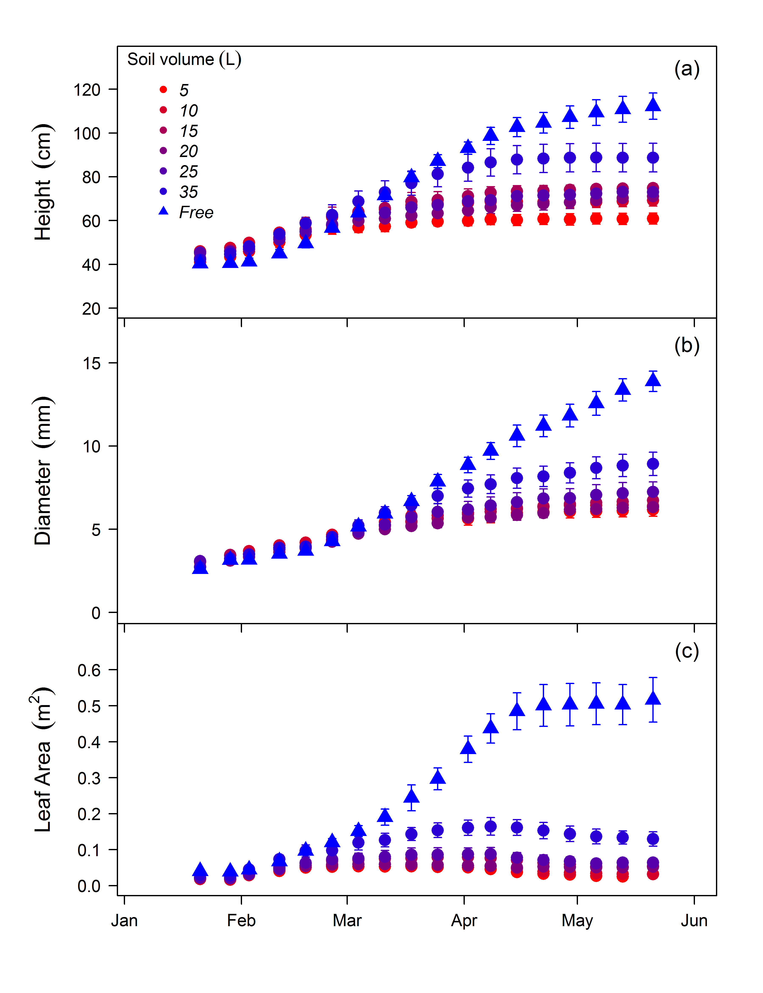 **Figure 1**. Seedling growth over the duration of the experiment was strongly reduced in containerized seedlings compared to freely rooted seedlings. Height growth (a), diameter growth (b), and seedling leaf area estimated from leaf counts (c) measured weekly on *Eucalyptus tereticornis* seedlings across the experiment duration in 2013. Shown are soil volume treatment means ± standard error.  
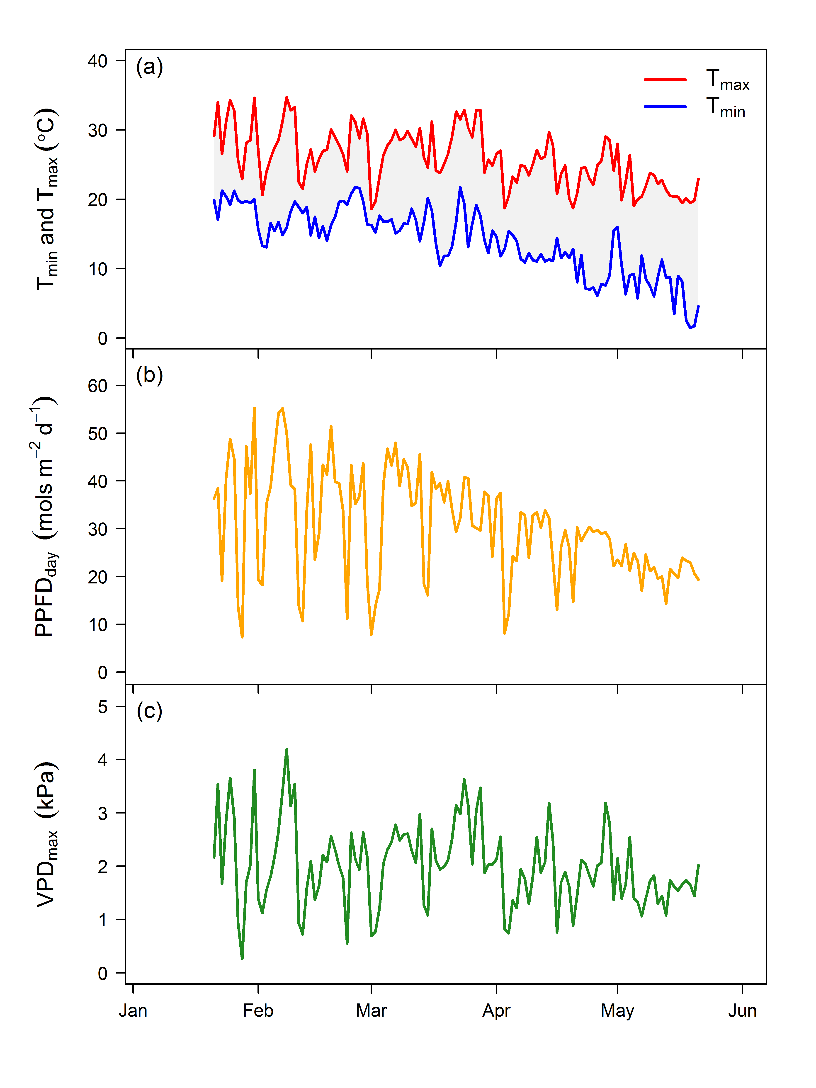 **Figure 2**. Environmental drivers over the course of the experiment. Daily maximum and minimum temperature (a), total daily PPFD (b), and daily maximum vapour pressure deficit (c) in 2013.  
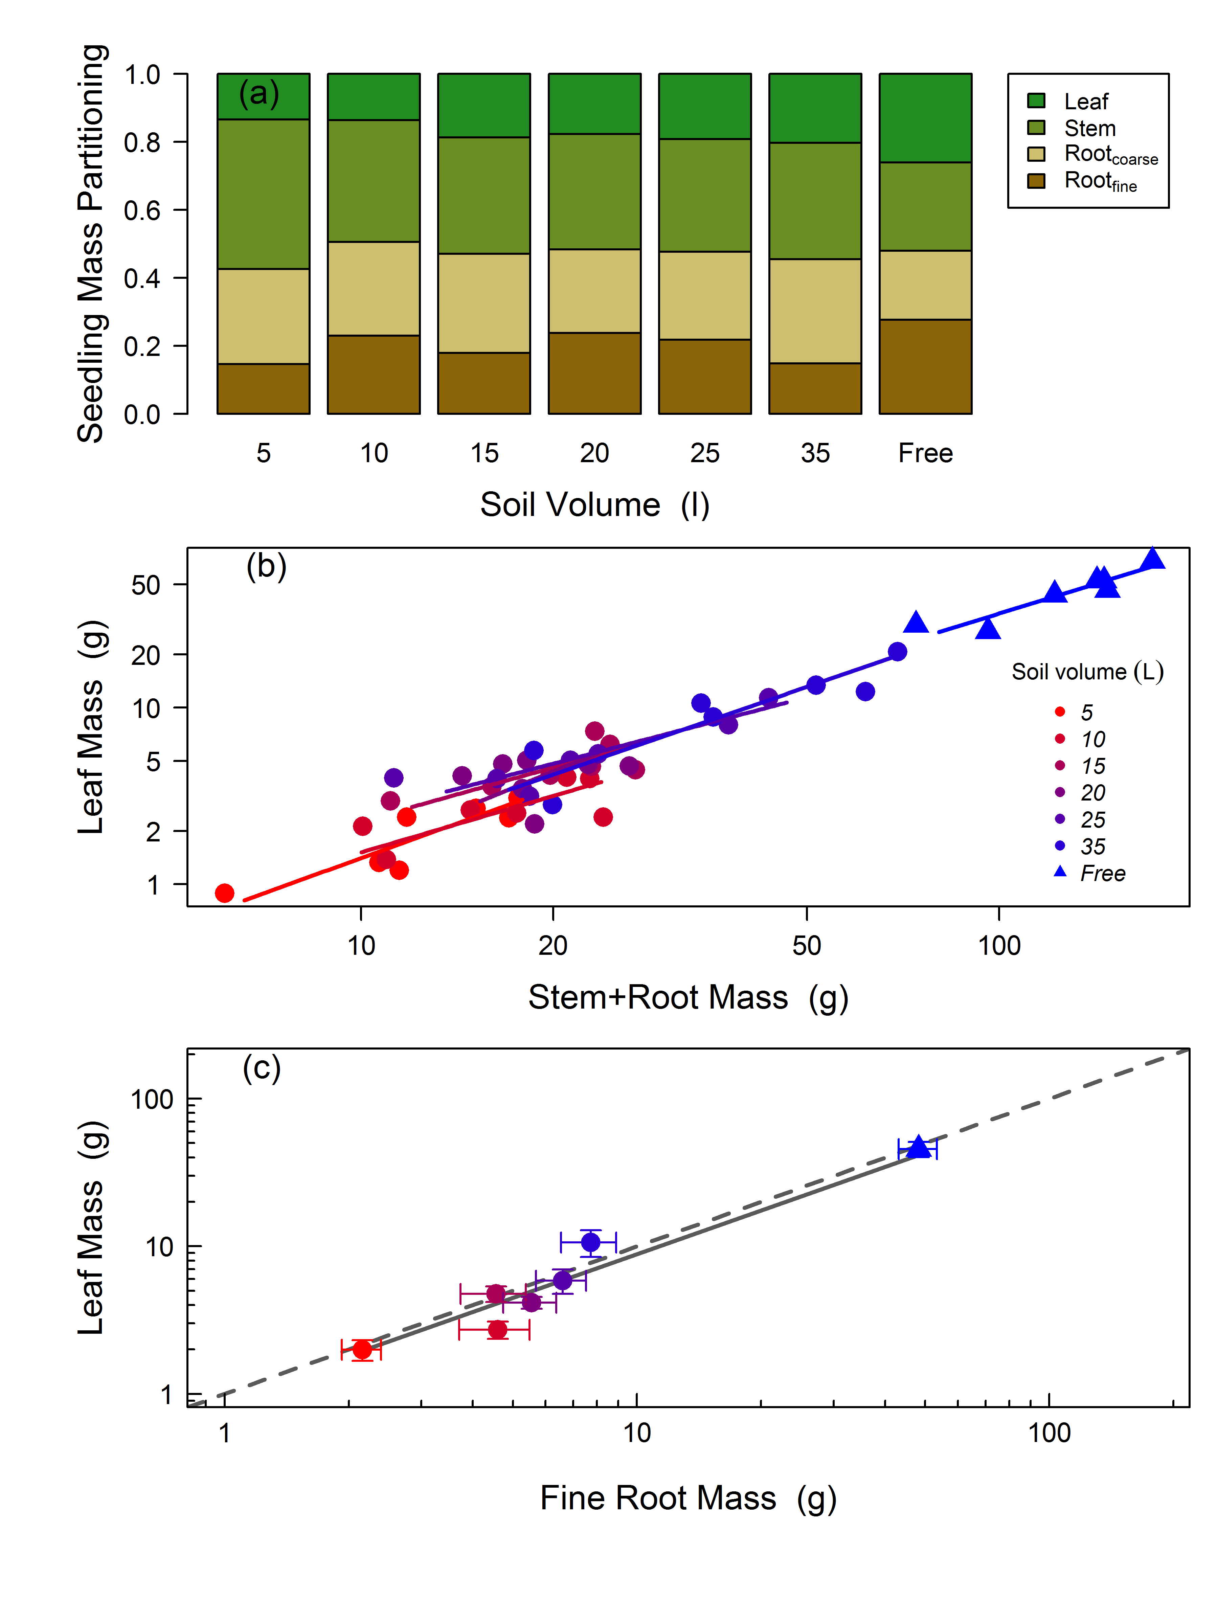 **Figure 3**. Biomass partitioning at final harvest did not respond strongly to soil volume treatment. (a) Relative partitioning to leaves, stems, and roots at the final harvest, shown as treatment means (standard errors omitted for clarity). (b) Bi-variate relationships between mass partitioning to leaves and stems + roots. Each symbol is a plant. Lines represent standardized major axis fitting of the log-transformed allometric relationships of leaf mass fraction by treatment. (c) Total plant leaf mass as a function of fine root biomass with ± standard error. The dashed line is a 1:1 line and the solid line represents the significant log-log model fit (*R*2 = 0.82) with equation: log(x) = -0.36 + 0.983 * log(y).  
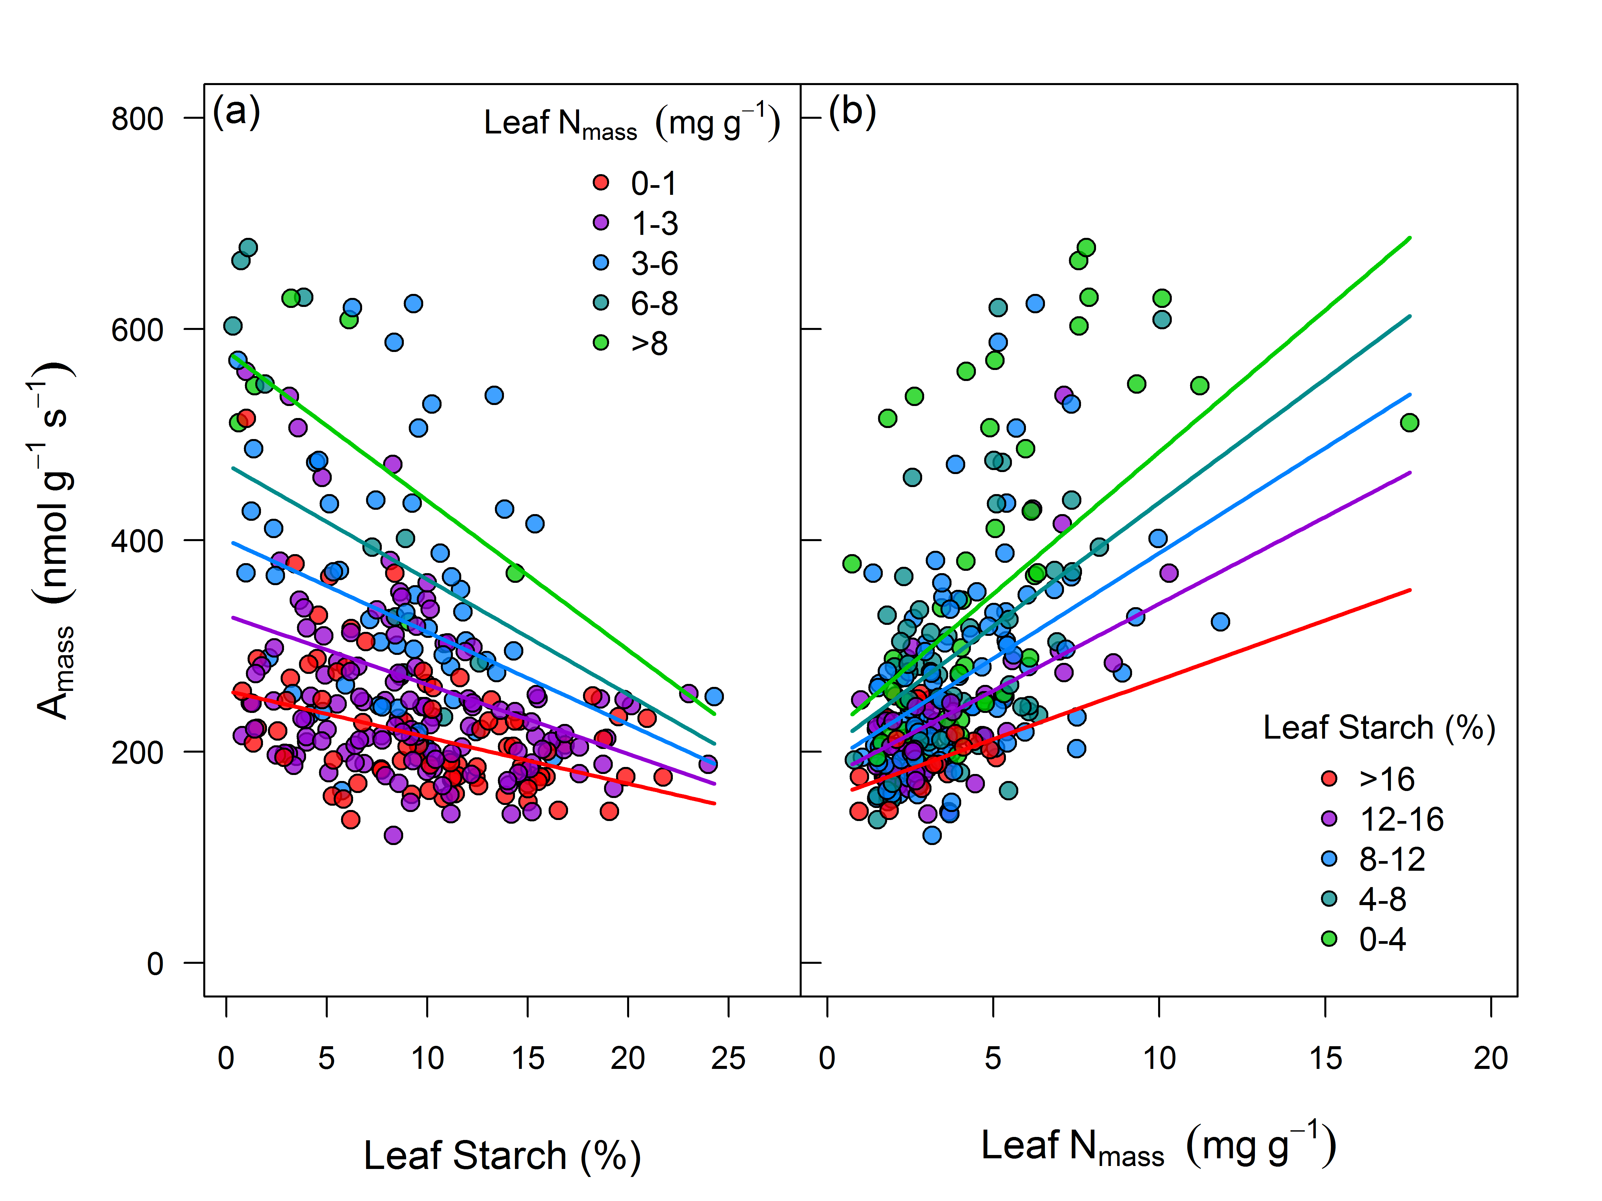 **Figure 4**. Photosynthetic capacity on a leaf mass basis (Amass, measured at saturating light and [CO2]) was correlated to both leaf starch and nitrogen content. (a) Amass was negatively related to leaf starch (shown as percentage of dry mass), in particular for leaves with higher nitrogen content (Nmass). (b) Amass was positively related to Nmass (expressed as N per unit mass after subtracting TNC content). In both panels, each symbol is an individual measurement of Amass (data across all campaigns are shown). Colors represent bins levels (n = 5) of both leaf starch and nitrogen grouped from low to high. Lines represents predictions, for each bin level, from the linear mixed effects model equation of Amass as a function of starch and nitrogen. The marginal *R*2 (fixed effects only) was 0.37 and the conditional *R*2 (fixed and random effects) was 0.48 for the complete model. The equation for the full model is y = - 221.96 + 28.58(N) - 3.31(Starch) - 0.87(N*Starch).  
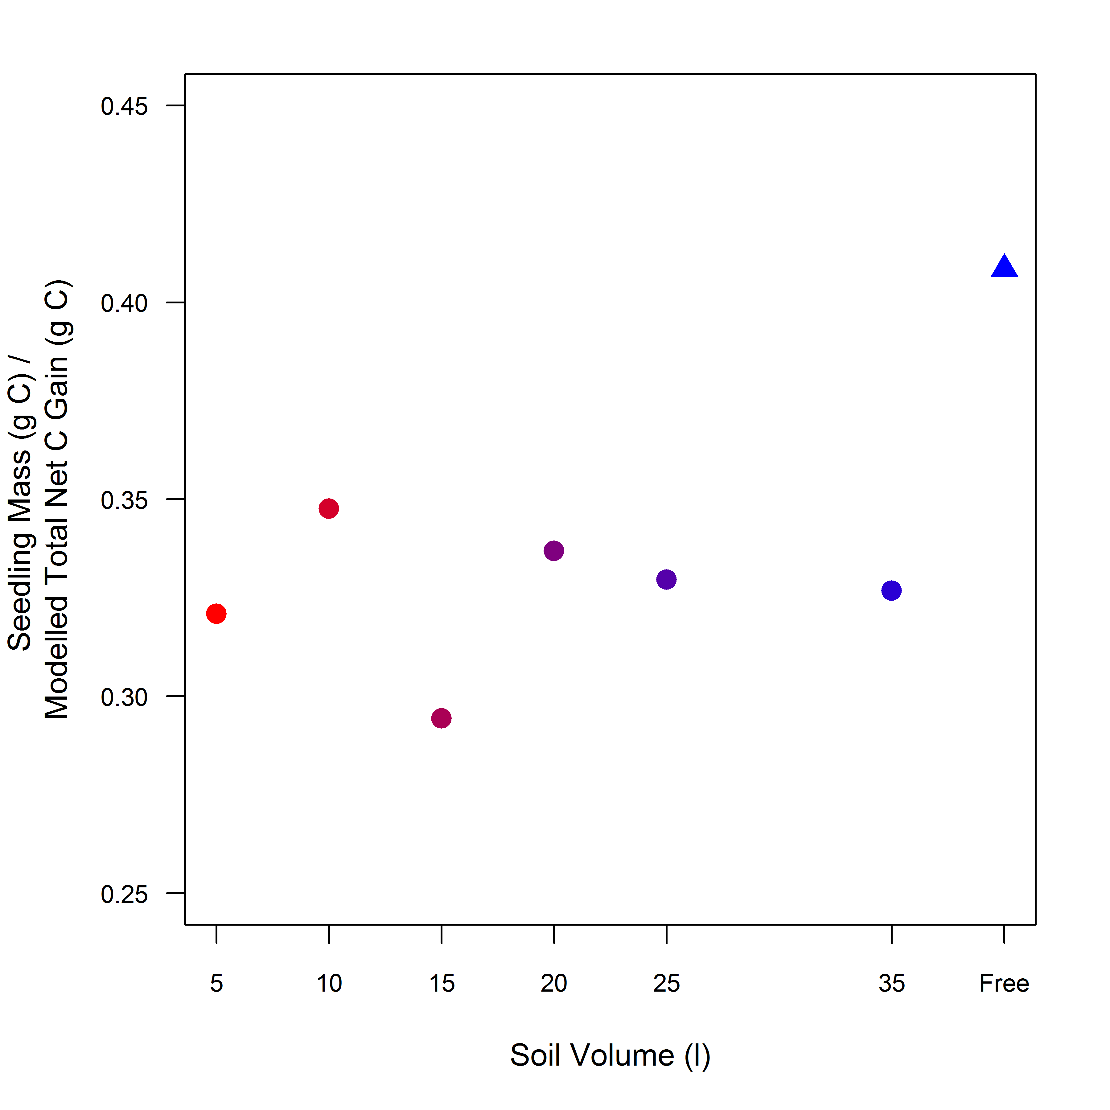 **Figure 5**. The final biomass attained per unit total photosynthesis over the duration of the experiment. Note the higher ratio for the freely rooted seedlings compared to the containerized seedlings, indicating a higher carbon-use efficiency. Shown are treatment means, as the model scaling instantaneous leaf photosynthesis to total plant photosynthesis was run once for every treatment.

# References

Ainsworth EA, Rogers A (2007) The response of photosynthesis and stomatal conductance to rising [CO2]: mechanisms and environmental interactions. Plant, Cell & Environment 30:258–270.

Ainsworth EA, Rogers A, Nelson R, Long SP (2004) Testing the ‘source–sink’ hypothesis of down-regulation of photosynthesis in elevated [CO2] in the field with single gene substitutions in Glycine max. Agricultural and Forest Meteorology 122:85–94.

Arp WJ (1991) Effects of source-sink relations on photosynthetic acclimation to elevated CO2. Plant, Cell & Environment 14:869–875.

Atkin OK, Bruhn D, Tjoelker MG (2005) Response of plant respiration to changes in temperature: Mechanisms and consequences of variations in q10 values and acclimation. In: Plant respiration. Springer, pp 95–135.

Crous KY, Quentin AG, Lin Y-S, Medlyn BE, Williams DG, Barton CVM, Ellsworth DS (2013) Photosynthesis of temperate *Eucalyptus globulus* trees outside their native range has limited adjustment to elevated CO2 and climate warming. Global Change Biology 19:3790–3807.

Drake JE, Aspinwall MJ, Pfautsch S, Rymer PD, Reich PB, Smith RA, Crous KY, Tissue DT, Ghannoum O, Tjoelker MG (2014) The capacity to cope with climate warming declines from temperate to tropical latitudes in two widely distributed *Eucalyptus* species. Global Change Biology 21:459–472.

Drake BG, Gonzàlez-Meler MA, Long SP (1997) More efficient plants: a consequence of rising atmospheric CO2? Annual Review of Plant Biology 48:609–639.

Duan W, Fan PG, Wang LJ, Li WD, Yan ST, Li SH (2008) Photosynthetic response to low sink demand after fruit removal in relation to photoinhibition and photoprotection in peach trees. Tree Physiology 28:123–132.

Duursma R (2014) YplantQMC: Plant architectural analysis with Yplant and QuasiMC. <http://www.remkoduursma.com/yplantqmc, https://www.bitbucket.org/remkoduursma/yplantqmc/>

Duursma RA (2015) Plantecophys - An R Package for Analysing and Modelling Leaf Gas Exchange Data. PLoS ONE 10:e0143346.

Duursma RA, Barton CVM, Lin Y-S, Medlyn BE, Eamus D, Tissue DT, Ellsworth DS, McMurtrie RE (2014) The peaked response of transpiration rate to vapour pressure deficit in field conditions can be explained by the temperature optimum of photosynthesis. Agricultural and Forest Meteorology 189:2–10.

Duursma RA, Falster DS, Valladares F, Sterck FJ, Pearcy RW, Lusk CH, Sendall KM, Nordenstahl M, Houter NC, Atwell BJ, Others (2012) Light interception efficiency explained by two simple variables: a test using a diversity of small-to medium-sized woody plants. New Phytologist 193:397–408.

Ebell LF (1969) Variation in total soluble sugars of conifer tissues with method of analysis. Phytochemistry 8:227–233.

Equiza MA, Day ME, Jagels R, Li X (2006) Photosynthetic downregulation in the conifer *Metasequoia glyptostroboides* growing under continuous light: the significance of carbohydrate sinks and paleoecophysiological implications. Botany 84:1453–1461.

Eyles A, Pinkard EA, Davies NW, Corkrey R, Churchill K, O’Grady AP, Sands P, Mohammed C (2013) Whole-plant versus leaf-level regulation of photosynthetic responses after partial defoliation in *Eucalyptus globulus* saplings. Journal of Experimental Botany 64:1625–1636.

Farquhar GD, Caemmerer S von von, Berry JA (1980) A biochemical model of photosynthetic CO2 assimilation in leaves of C3 species. Planta 149:78–90.

Fatichi S, Leuzinger S, Körner C (2014) Moving beyond photosynthesis: from carbon source to sink-driven vegetation modeling. New Phytologist 201:1086–1095.

Fourcaud T, Zhang X, Stokes A, Lambers H, Körner C (2008) Plant growth modelling and applications: the increasing importance of plant architecture in growth models. Annals of Botany 101:1053–1063.

Gould SJ (1966) Allometry and size in ontogeny and phylogeny. Biological Reviews 41:587–640.

Gunderson CA, Wullschleger SD (1994) Photosynthetic acclimation in trees to rising atmospheric CO2: a broader perspective. Photosynthesis Research 39:369–388.

Hamilton JG, DeLucia EH, George K, Naidu SL, Finzi AC, Schlesinger WH (2002) Forest carbon balance under elevated CO2. Oecologia 131:250–260.

Handa IT, Körner C, Hättenschwiler S (2005) A test of the treeline carbon limitation hypothesis by in situ CO2 enrichment and defoliation. Ecology 86:1288–1300.

Haouari A, Van Labeke M-C, Steppe K, Mariem FB, Braham M, Chaieb M (2013) Fruit thinning affects photosynthetic activity, carbohydrate levels, and shoot and fruit development of olive trees grown under semiarid conditions. Functional Plant Biology 40:1179–1186.

Iglesias DJ, Lliso I, Tadeo FR, Talon M (2002) Regulation of photosynthesis through source: sink imbalance in citrus is mediated by carbohydrate content in leaves. Physiologia Plantarum 116:563–572.

Kallarackal J, Somen CK (1997) An ecophysiological evaluation of the suitability of *Eucalyptus grandis* for planting in the tropics. Forest Ecology and Management 95:53–61.

Kirschbaum MUF (2011) Does enhanced photosynthesis enhance growth? Lessons learned from CO2 enrichment studies. Plant Physiology 155:117–124.

Körner C (2013) Growth controls photosynthesis–mostly. Nova Acta Leopoldina 114:273–283.

Körner C (2015) Paradigm shift in plant growth control. Current Opinion in Plant Biology 25:107–114.

Lacointe A (2000) Carbon allocation among tree organs: a review of basic processes and representation in functional-structural tree models. Annals of Forest Science 57:521–533.

Lambers H, Chapin FS, Pons TL (2008) Plant physiological ecology, 2nd edn. Springer, New York.

Layne DR, Flore JA (1995) End-product inhibition of photosynthesis in *Prunus cerasus* L. in response to whole-plant source-sink manipulation. Journal of the American Society for Horticultural Science 120:583–599.

Le Roux X, Lacointe A, Escobar-Gutiérrez A, Le Dizès S (2001) Carbon-based models of individual tree growth: a critical appraisal. Annals of Forest Science 58:469–506.

Leuzinger S, Manusch C, Bugmann H, Wolf A (2013) A sink-limited growth model improves biomass estimation along boreal and alpine tree lines. Global Ecology and Biogeography 22:924–932.

Li WD, Li SH, Yang SH, Yang JM, Zheng XB, Li XD, Yao HM (2005) Photosynthesis in response to sink-source manipulations during different phenological stages of fruit development in peach trees: regulation by stomatal aperture and leaf temperature. Journal of Horticultural Science & Biotechnology 80:481–487.

Lleonart J, Salat J, Torres GJ (2000) Removing allometric effects of body size in morphological analysis. Journal of Theoretical Biology 205:85–93.

Maina GG, Brown JS, Gersani M (2002) Intra-plant versus inter-plant root competition in beans: avoidance, resource matching or tragedy of the commons. Plant Ecology 160:235–247.

Markkola A, Kuikka K, Rautio P, Härmä E, Roitto M, Tuomi J (2004) Defoliation increases carbon limitation in ectomycorrhizal symbiosis of *Betula pubescens*. Oecologia 140:234–240.

McCleary BV, Gibson TS, Mugford DC (1997) Measurement of total starch in cereal products by amyloglucosidase--amylase method: Collaborative study. Journal of AOAC International 80:571–579.

McConnaughay KDM, Bazzaz FA (1991) Is physical space a soil resource? Ecology 72:94–103.

Medlyn BE, Duursma RA, Eamus D, Ellsworth DS, Prentice IC, Barton CVM, Crous KY, Angelis P de, Freeman M, Wingate L (2011) Reconciling the optimal and empirical approaches to modelling stomatal conductance. Global Change Biology 17:2134–2144.

Mitchell PJ, O’Grady AP, Tissue DT, White DA, Ottenschlaeger ML, Pinkard EA (2013) Drought response strategies define the relative contributions of hydraulic dysfunction and carbohydrate depletion during tree mortality. New Phytologist 197:862–872.

Muller B, Pantin F, Génard M, Turc O, Freixes S, Piques M, Gibon Y (2011) Water deficits uncouple growth from photosynthesis, increase C content, and modify the relationships between C and growth in sink organs. Journal of Experimental Botany 62:1715–1729.

Nakagawa S, Schielzeth H (2013) A general and simple method for obtaining R2 from generalized linear mixed-effects models. Methods in Ecology and Evolution 4:133–142.

Nebauer SG, Renau-Morata B, Guardiola JL, Molina R-V (2011) Photosynthesis down-regulation precedes carbohydrate accumulation under sink limitation in Citrus. Tree Physiology 31:169–177.

NeSmith DS, Duval JR (1998) The effect of container size. HortTechnology 8:495–498.

Norby RJ, DeLucia EH, Gielen B, Calfapietra C, Giardina CP, King JS, Ledford J, McCarthy HR, Moore DJP, Ceulemans R, Others (2005) Forest response to elevated CO2 is conserved across a broad range of productivity. Proceedings of the National Academy of Sciences of the United States of America 102:18052–18056.

Ovaska J, Sari R, Rintamäki E, Vapaavuori E (1993) Combined effects of partial defoliation and nutrient availability on cloned *Betula pendula* saplings II. Changes in net photosynthesis and related biochemical properties. Journal of Experimental Botany 44:1395–1402.

Ovaska J, Walls M, Vapaavuori E (1993) Combined effects of partial defoliation and nutrient availability on cloned *Betula pendula* saplings I. Changes in growth, partitioning and nitrogen uptake. Journal of Experimental Botany 44:1385–1393.

Palacio S, Hernández R, Maestro-Martínez M, Camarero JJ (2012) Fast replenishment of initial carbon stores after defoliation by the pine processionary moth and its relationship to the re-growth ability of trees. Trees 26:1627–1640.

Passioura JB (2002) Soil conditions and plant growth. Plant, Cell & Environment 25:311–318.

Paul MJ, Foyer CH (2001) Sink regulation of photosynthesis. Journal of Experimental Botany 52:1383–1400.

Pinheiro J, Bates D, DebRoy S, Sarkar D, R Core Team (2015) {nlme}: Linear and nonlinear mixed effects models. <http://cran.r-project.org/package=nlme>

Pinkard EA, Beadle CL, Davidson NJ, Battaglia M (1998) Photosynthetic responses of *Eucalyptus nitens* (Deane and Maiden) Maiden to green pruning. Trees 12:119–129.

Pinkard EA, Eyles A, O’Grady AP (2011) Are gas exchange responses to resource limitation and defoliation linked to source: sink relationships? Plant, Cell & Environment 34:1652–1665.

Poorter H, Bühler J, Dusschoten D van, Climent J, Postma JA (2012) Pot size matters: a meta-analysis of the effects of rooting volume on plant growth. Functional Plant Biology 39:839–850.

Poorter H, Niinemets Ü, Poorter L, Wright IJ, Villar R (2009) Causes and consequences of variation in leaf mass per area (LMA): a meta-analysis. New Phytologist 182:565–588.

Poorter H, Niklas KJ, Reich PB, Oleksyn J, Poot P, Mommer L (2012) Biomass allocation to leaves, stems and roots: meta-analyses of interspecific variation and environmental control. New Phytologist 193:30–50.

R Development Core Team R (2016) R: A language and environment for statistical computing Team RDC (ed). 1:409. <http://www.r-project.org>

Ronchi CP, DaMatta FM, Batista KD, Moraes GABK, Loureiro ME, Ducatti C (2006) Growth and photosynthetic down-regulation in *Coffea arabica* in response to restricted root volume. Functional Plant Biology 33:1013–1023.

Sage RF (1994) Acclimation of photosynthesis to increasing atmospheric CO2: the gas exchange perspective. Photosynthesis Research 39:351–368.

Schäfer KVR, Oren R, Ellsworth DS, Lai C-T, Herrick JD, Finzi AC, Richter DD, Katul GG (2003) Exposure to an enriched CO2 atmosphere alters carbon assimilation and allocation in a pine forest ecosystem. Global Change Biology 9:1378–1400.

Sellin A (1999) Does pre-dawn water potential reflect conditions of equilibrium in plant and soil water status? Acta Oecologica 20:51–59.

Semchenko M, Zobel K, Heinemeyer A, Hutchings MJ (2008) Foraging for space and avoidance of physical obstructions by plant roots: a comparative study of grasses from contrasting habitats. New Phytologist 179:1162–1170.

Sweet GB, Wareing PF (1966) Role of plant growth in regulating photosynthesis. Nature 210:77–79.

Thomas RB, Strain BR (1991) Root restriction as a factor in photosynthetic acclimation of cotton seedlings grown in elevated carbon dioxide. Plant Physiology 96:627–634.

Tjoelker M, Oleksyn J, Reich PB, Others (1999) Acclimation of respiration to temperature and CO2 in seedlings of boreal tree species in relation to plant size and relative growth rate. Global Change Biology 5:679–691.

Turnbull TL, Adams MA, Warren CR (2007) Increased photosynthesis following partial defoliation of field-grown *Eucalyptus globulus* seedlings is not caused by increased leaf nitrogen. Tree Physiology 27:1481–1492.

Urban L, Alphonsout L (2007) Girdling decreases photosynthetic electron fluxes and induces sustained photoprotection in mango leaves. Tree Physiology 27:345–352.

Valentine HT, Mäkelä A (2005) Bridging process-based and empirical approaches to modeling tree growth. Tree Physiology 25:769–779.

Valentini R, Matteucci G, Dolman AJ, Schulze E-D, Rebmann C, Moors EJ, Granier A, Gross P, Jensen NO, Pilegaard K, Others (2000) Respiration as the main determinant of carbon balance in European forests. Nature 404:861–865.

Wang YP, Rey A, Jarvis PG (1998) Carbon balance of young birch trees grown in ambient and elevated atmospheric CO2 concentrations. Global Change Biology 4:797–807.

Warton DI, Duursma RA, Falster DS, Taskinen S (2012) smatr 3–an R package for estimation and inference about allometric lines. Methods in Ecology and Evolution 3:257–259.

Young IM, Montagu K, Conroy J, Bengough AG (1997) Mechanical impedance of root growth directly reduces leaf elongation rates of cereals. New Phytologist 135:613–619.

Zhou R, Quebedeaux B (2003) Changes in photosynthesis and carbohydrate metabolism in mature apple leaves in response to whole plant source-sink manipulation. Journal of the American Society for Horticultural Science 128:113–119.