tablesfigures

Court Campany

December 7, 2015

# List of Tables

**Table 1**.Responses of plant and leaf characteristics of *Eucalyptus tereticornis* seedlings to soil volume treatments. Each value reflects the mean(standard error) for each treatment. Seedling mass and leaf 13C values are from final harvest. Values of leaf starch, sugars, nitrogen and SLA represent overall means across measurement campaigns (n=6). Different letters represent significant differences between treatments. The volume effect P value represents the overall difference between seedlings with soil volume restriction and the control seedlings.

**Table 2**. Responses of root characteristics of *Eucalyptus tereticornis* seedlings to soil volume treatments. Each value reflects the mean(standard error) for each treatment. All values are from the final harvest. Values for FRLD are only calculated for seedlings in containers as free seedlings have potentially unlimited soil volume to exploit. Different letters represent significant differences between treatments. The volume effect P value represents the overall difference between seedlings with soil volume restriction and the control seedlings, except for FRLD which represents only differences between seedlings in containers.

**Table 3**. Responses of leaf level gas exchange parameters of *Eucalyptus tereticornis* seedlings to soil volume treatments. Each value reflects the mean(standard error) for each treatment. Amax, R and gs are each measured at 25 °C. Values of Amax, gs and g1 represent overall means across measurement campaigns (n=6). R, Jmax and Vcmax values are means of two measurement campaigns at beginning and end of gas exchange measurements. Different letters represent significant differences between treatments. The volume effect P value represents the overall difference between seedlings with soil volume restriction and the control seedlings.

**Table S1**. Seedling growth model default parameters.

# List of Figures

**Figure 1**. Soil volume treatment means ± standard error of height growth (a), diameter growth (b), and interpolated seedling leaf area (c) measured weekly of *Eucalyptus tereticornis* seedlings across the experiment duration in 2013.

**Figure 2**. Daily maximum and minimum temperature (a), total daily PPFD (b), and daily maximum vapour pressure deficit (c) across the experiment duration in 2013.

**Figure 3**. Soil volume treatment means of biomass partitioning to leaves, stems, and roots at harvest (a), bi-variate relationships between mass allocation to leaves and stems + roots (b) and leaf mass as a function of fine root biomass with ± standard error (c). For (b) lines represent standardized major axis fitting of the log-transformed allometric relationships of leaf mass fraction by treatment. For (c) the dashed line is the 1:1 relationship and the solid line represents the significant log-log model fit (R2 = 0.82) with equation: log(x) = 0.983(log(y)) - 0.036.

**Figure 4**. Soil volume treatment means ± standard error, across all measurement campaigns (n = 6), of light saturated rates of photosynthesis at 25°C. Different letters represent significant differences between treatments.

**Figure 5**. Photosynthetic capacity, on a leaf mass basis, as a function of accumulation of leaf starch (a) and leaf nitrogen content without TNC (b). Colors represent bins levels (n = 5) of both leaf starch and nitrogen grouped from low to high. Lines represents predictions, for each bin level, from the linear mixed effects model equation of Amass as a function of starch and nitrogen. The marginal R2 (fixed effects only) was 0.37 and the conditional R2 (fixed and random effects) was 0.48 for the complete model.

**Figure 6**. Total carbon mass for harvested and modeled seedlings versus predicted total carbon gain after 120 days (a) and reductions in final seedling carbon mass, both modeled and observed, as a function of the reduction in leaf photosynthesis across treatments (b). For (a) the dashed 1:1 identifies the difference between net total leaf carbon gain and gross seedling production. For (b) both seedling carbon mass and daily carbon assimilation were first scaled to the free seedling control.

**Figure S1**. Sensitivity testing of seedling growth model to different carbon allocation strategies including; constraints of leaf mass fraction to treatment specific final harvest values (a) and increases in respiration of non-leaf tissue components by 50 % (b). Open and filled symbols represent default model and harvest values, while shaded symbols represent model sensitivity to each scenario by soil volume treatment. Both seedling carbon mass and daily carbon assimilation were first scaled to the free seedling control.

# Tables

**Table 1**.Responses of plant and leaf characteristics of *Eucalyptus tereticornis* seedlings to soil volume treatments. Each value reflects the mean (± 1 standard error) for each treatment. Seedling mass and leaf 13C values are from final harvest. Values of leaf starch, sugars, nitrogen and SLA represent overall means across measurement campaigns (n=6). Different letters represent significant differences between treatments. The volume effect P value represents the overall difference between seedlings with soil volume restriction and the control seedlings.

|  |  |  |  |  |  |  |
| --- | --- | --- | --- | --- | --- | --- |
| **Volume (L)** | **Seedling mass (g)** | **SLATNC-free (m2 kg-1)** | **Leaf Starch (%)** | **Leaf Sugars (%)** | **Leaf NitrogenTNC-free (%)** | **Leaf d13C (‰)** |
| 5 | 14.8 (1.82) a | 11.8 (0.32) a | 12.7 (0.97) b | 6.4 (0.28) a | 1.3 (0.03) a | -30.1 (0.26) a |
| 10 | 20.0 (2.38) ab | 11.7 (0.31) a | 9.4 (0.75) ab | 6.7 (0.25) a | 1.5 (0.04) ab | -30.2 (0.25) a |
| 15 | 25.4 (2.49) ab | 12.7 (0.48) a | 7.3 (0.73) a | 7.2 (0.28) a | 1.6 (0.07) ab | -30.3 (0.36) a |
| 20 | 23.4 (1.63) ab | 11.8 (0.37) a | 9.5 (0.88) ab | 6.6 (0.26) a | 1.7 (0.06) ab | -29.7 (0.28) a |
| 25 | 30.4 (5.49) ab | 12.4 (0.40) a | 9.8 (0.71) ab | 6.9 (0.24) a | 1.6 (0.07) ab | -29.7 (0.25) a |
| 35 | 52.2 (9.55) b | 13.5 (0.46) ab | 9.8 (0.65) ab | 6.8 (0.22) a | 1.8 (0.08) b | -30.6 (0.38) a |
| Free | 174.5 (18.02) c | 15.1 (0.47) b | 6.8 (0.65) a | 7.4 (0.25) a | 2.7 (0.09) c | -30.0 (0.34) a |
| Volume Effect (P value) | 0.001 | 0.001 | 0.029 | 0.125 | 0.001 | 0.372 |

**Table 2**. Responses of root characteristics of *Eucalyptus tereticornis* seedlings to soil volume treatments. Each value reflects the mean (± 1 standard error) for each treatment. All values are from the final harvest. Values for FRLD were only calculated for seedlings in containers as free seedlings had potentially unlimited soil volume to exploit. Different letters represent significant differences between treatments. The volume effect P value represents the overall difference between seedlings with soil volume restriction and the control seedlings, except for FRLD which represents only differences between seedlings in containers.

|  |  |  |  |
| --- | --- | --- | --- |
| **Volume (L)** | **Root Nitrogen (%)** | **SRL (m g-1)** | **FRLD (m dm-3)** |
| 5 | 0.78 (0.04) ab | 73.0 (6.73) ab | 36.4 (5.68) bc |
| 10 | 0.75 (0.02) a | 99.6 (8.70) b | 45.9 (8.68) c |
| 15 | 0.71 (0.02) a | 74.6 (6.98) ab | 20.9 (1.51) ab |
| 20 | 0.76 (0.04) a | 85.8 (7.37) ab | 23.0 (3.09) ab |
| 25 | 0.74 (0.02) a | 82.5 (15.02) ab | 24.7 (7.58) ab |
| 35 | 0.77 (0.03) ab | 63.1 (6.47) a | 13.3 (1.98) a |
| Free | 0.90 (0.03) b | 50.9 (5.00) a |  |
| Volume Effect (P value) | 0.017 | 0.009 | 0.001 |

**Table 3**. Responses of leaf level gas exchange parameters of *Eucalyptus tereticornis* seedlings to soil volume treatments. Each value reflects the mean (± 1 standard error) for each treatment. Amax, R and gs are each measured at 25 °C. Values of Amax, gs and g1 represent overall means across measurement campaigns (n=6). R, Jmax and Vcmax values are means of two measurement campaigns at beginning and end of gas exchange measurements. Different letters represent significant differences between treatments. The volume effect P value represents the overall difference between seedlings with soil volume restriction and the control seedlings.

|  |  |  |  |  |  |  |
| --- | --- | --- | --- | --- | --- | --- |
| **Volume (L)** | **Amax (mol m-2 s-1)** | **R (mol m-2 s-1)** | **Jmax** | **Vcmax** | **gs (mol m-2 s-1)** | **g1** |
| 5 | 21.2 (0.9) a | 0.61 (0.04) a | 104.5 (3.3) a | 63.3 (2.5) a | 0.30 (0.009) a | 5.1 (0.14) bc |
| 10 | 22.3 (1.4) ab | 0.79 (0.06) a | 116.5 (7.5) a | 69.4 (4.7) a | 0.36 (0.009) ab | 5.4 (0.10) cd |
| 15 | 23.3 (1.2) ab | 0.70 (0.05) a | 125.4 (7.8) a | 80.8 (5.1) ab | 0.42 (0.010) ab | 5.8 (0.14) d |
| 20 | 26.1 (0.7) b | 0.73 (0.11) a | 131.5 (8.6) a | 82.1 (4.7) ab | 0.37 (0.011) ab | 4.9 (0.12) ac |
| 25 | 23.9 (0.9) ab | 0.53 (0.13) a | 132.8 (13.1) a | 79.0 (8.7) a | 0.30 (0.009) a | 4.5 (0.14) a |
| 35 | 25.0 (1.0) ab | 0.61 (0.04) a | 127.2 (6.1) a | 82.4 (3.6) a | 0.31 (0.011) a | 4.4 (0.15) a |
| Free | 33.1 (0.7) c | 0.64 (0.07) a | 169.0 (8.2) b | 100.4 (3.3) b | 0.44 (0.011) b | 4.5 (0.14) ab |
| Volume Effect (P value) | 0.001 | 0.269 | 0.004 | 0.005 | 0.007 | 0.001 |

# Figures

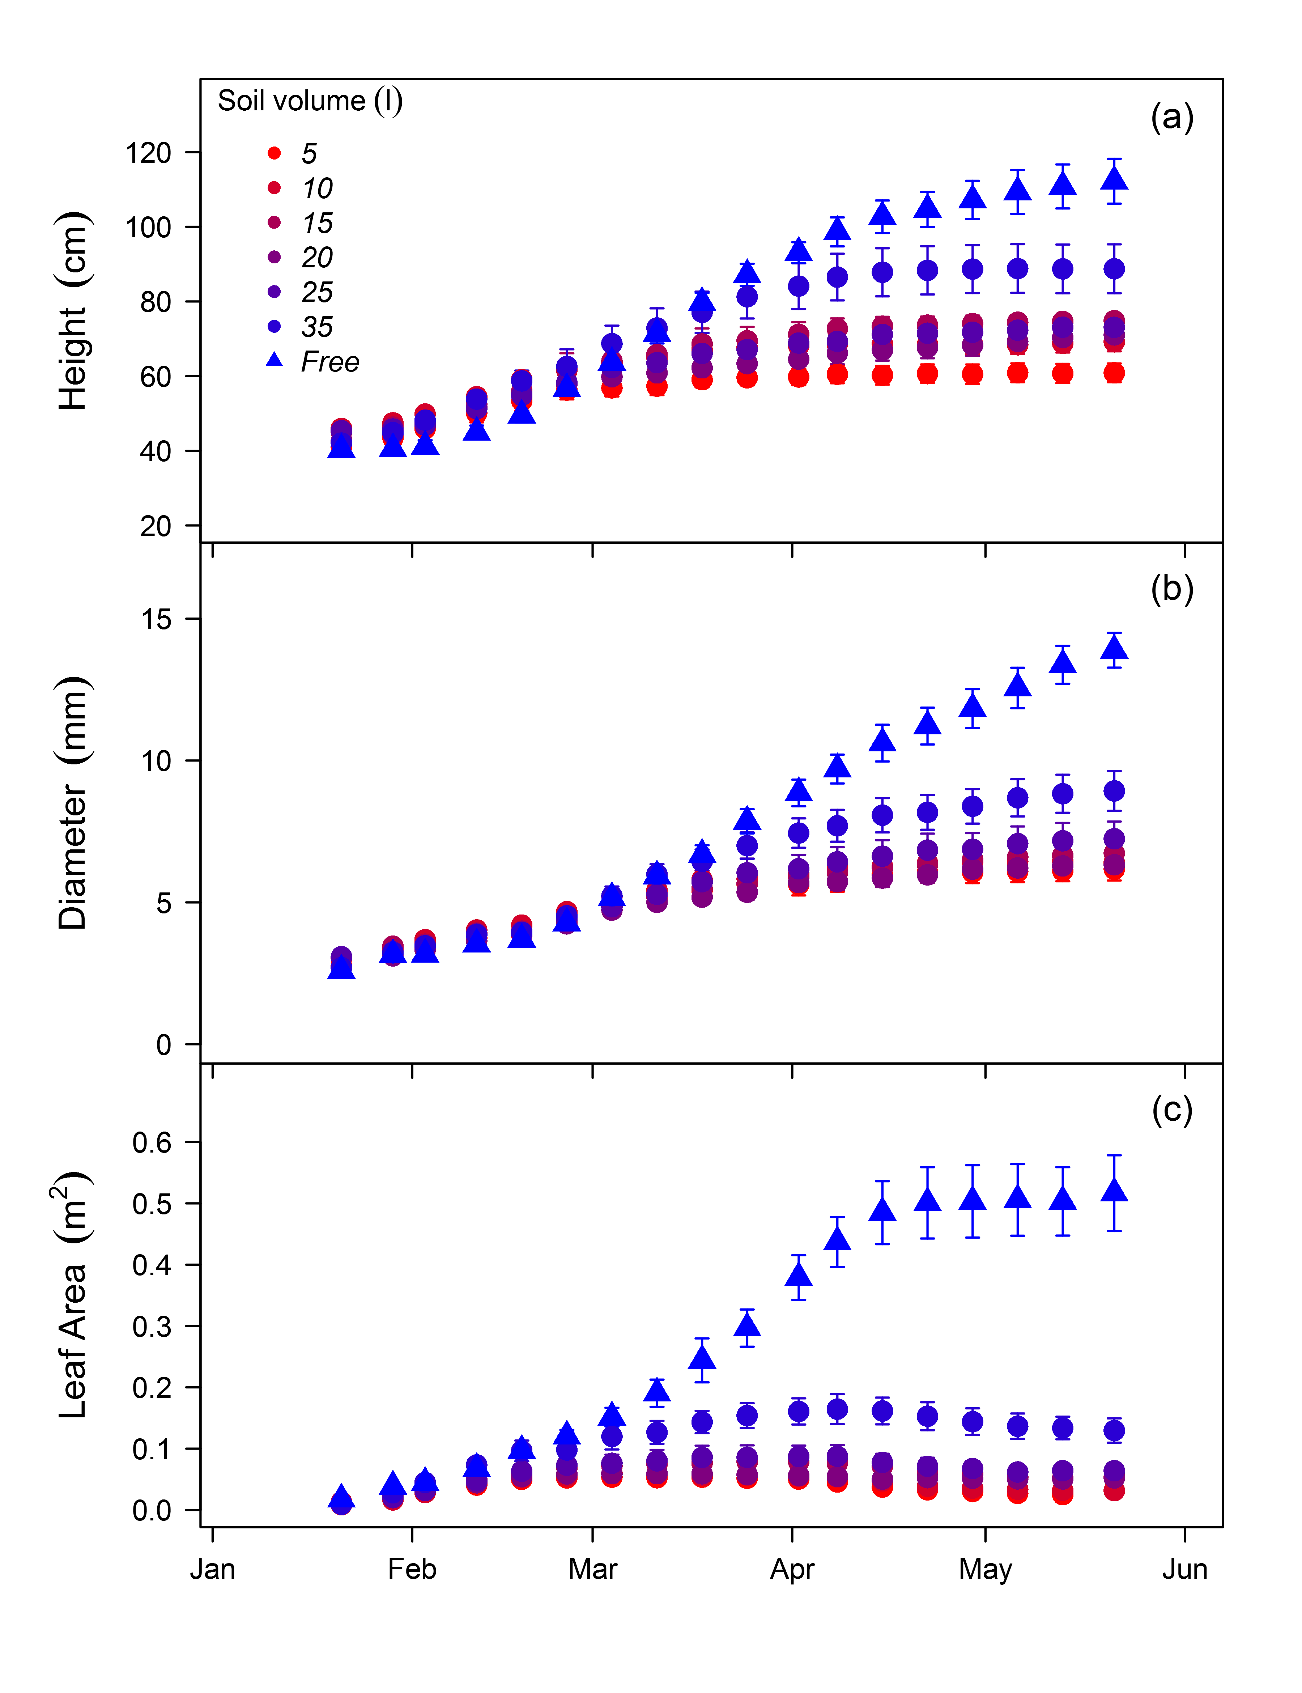

**Figure 1**.

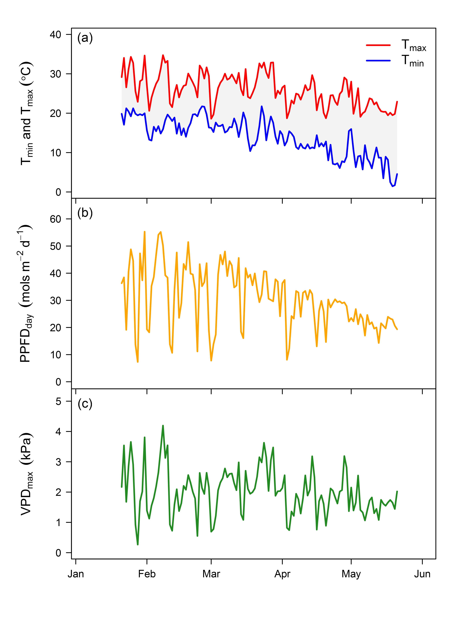

**Figure 2**.

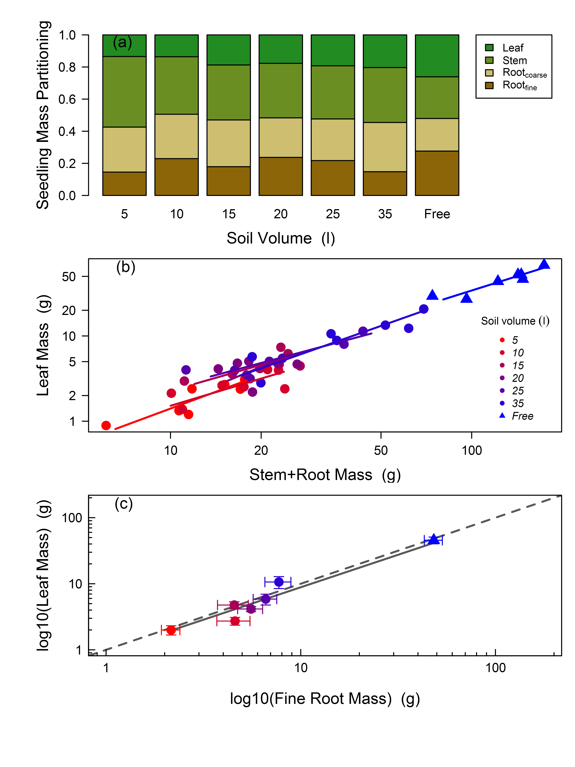

**Figure 3**.

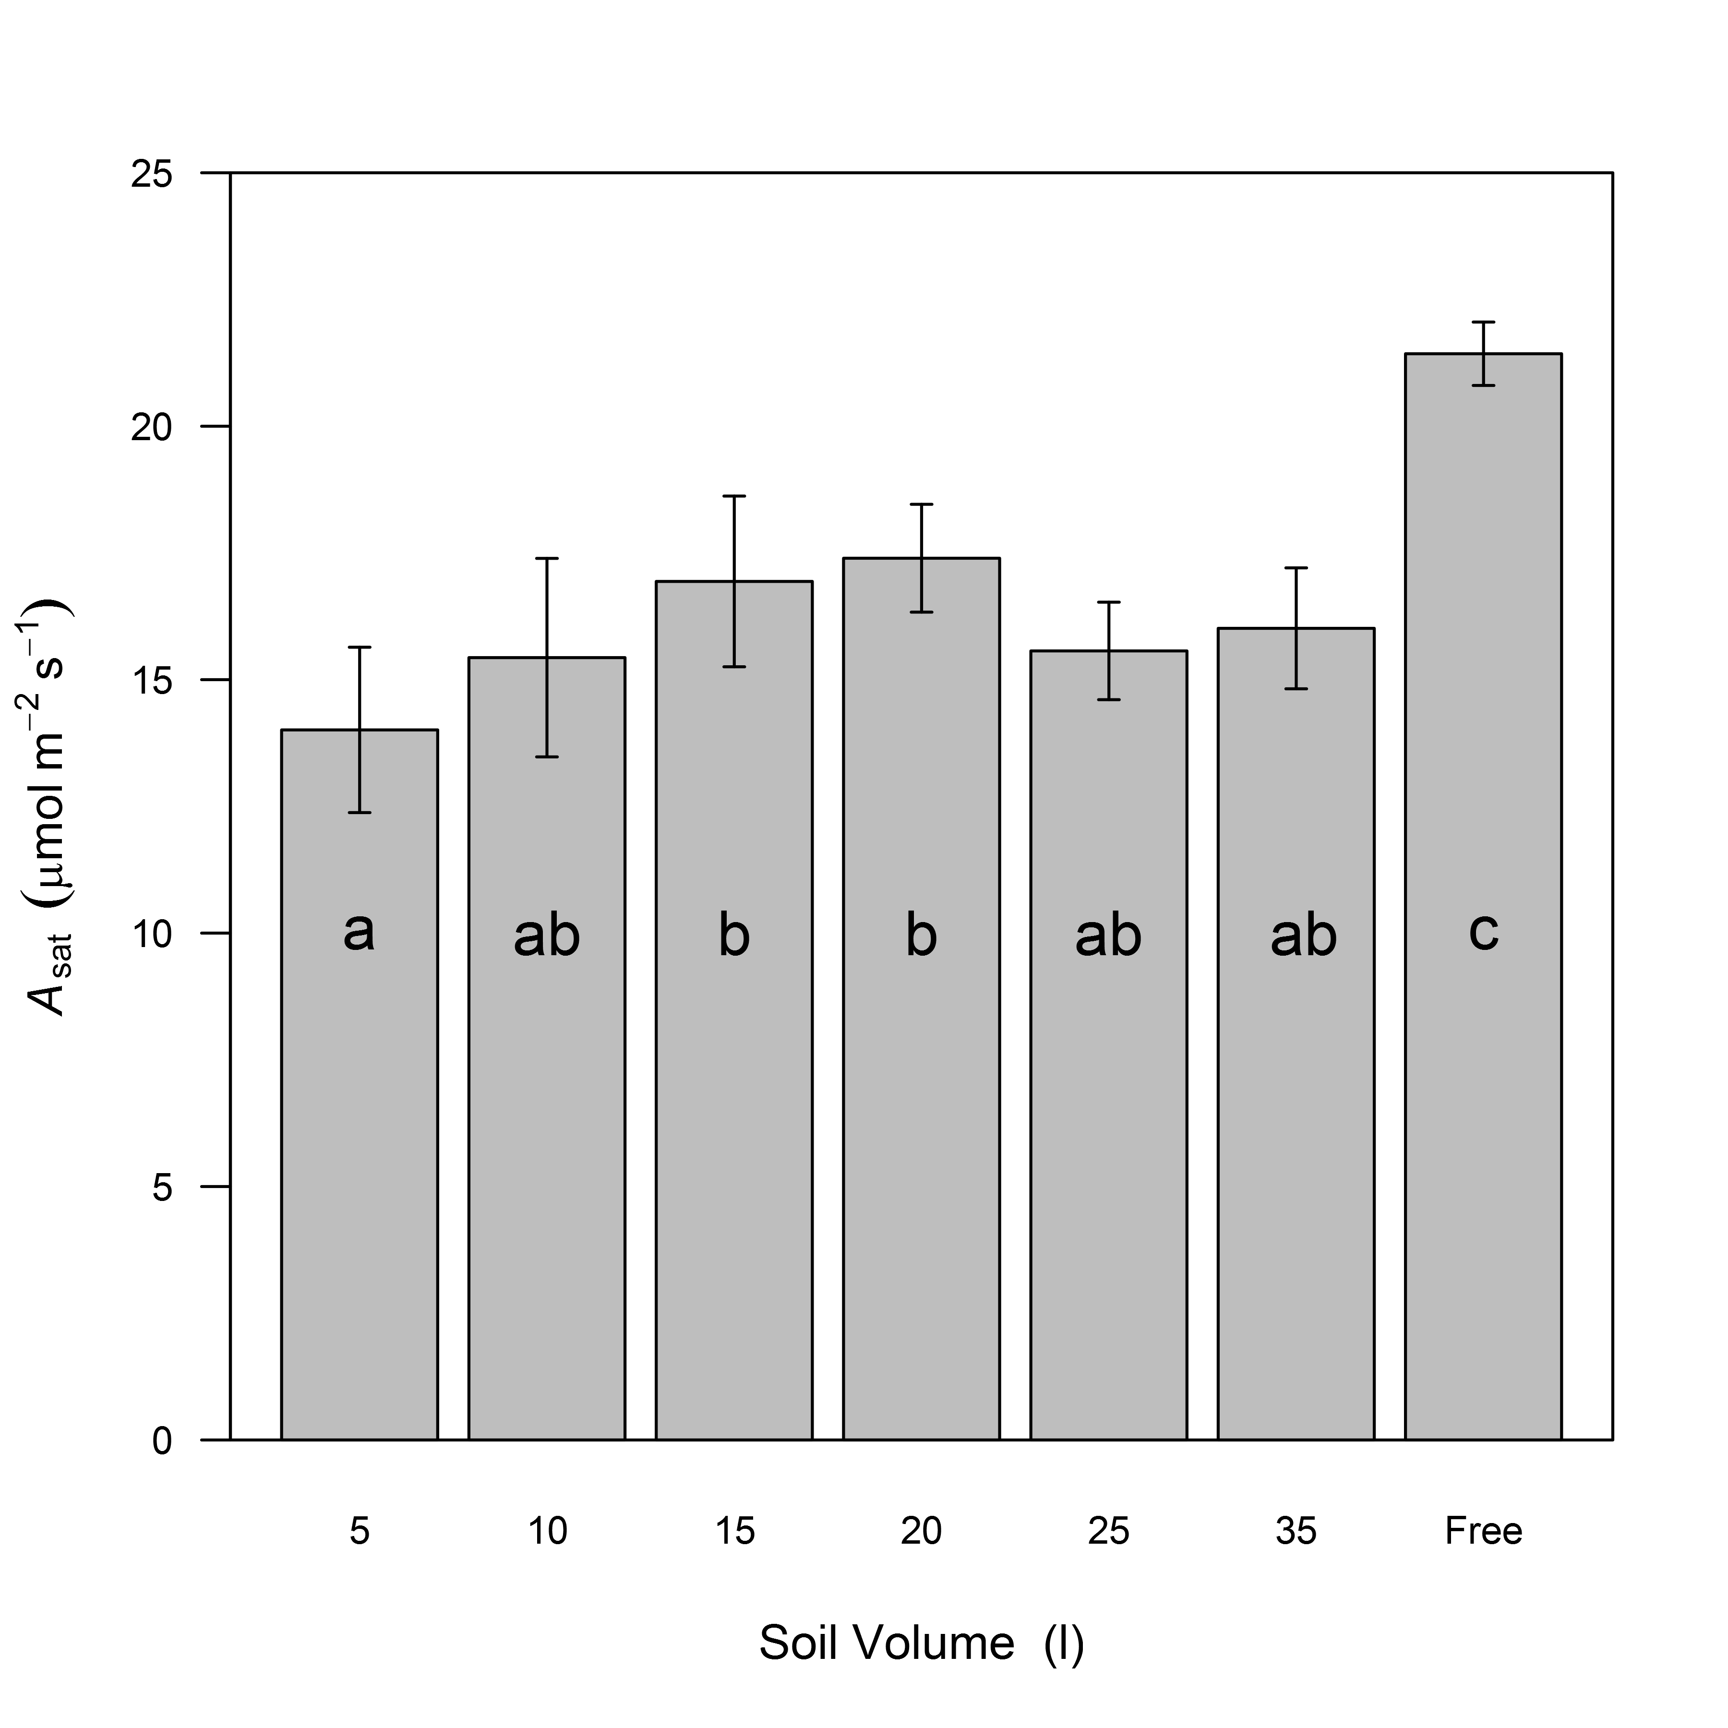

**Figure 4**.

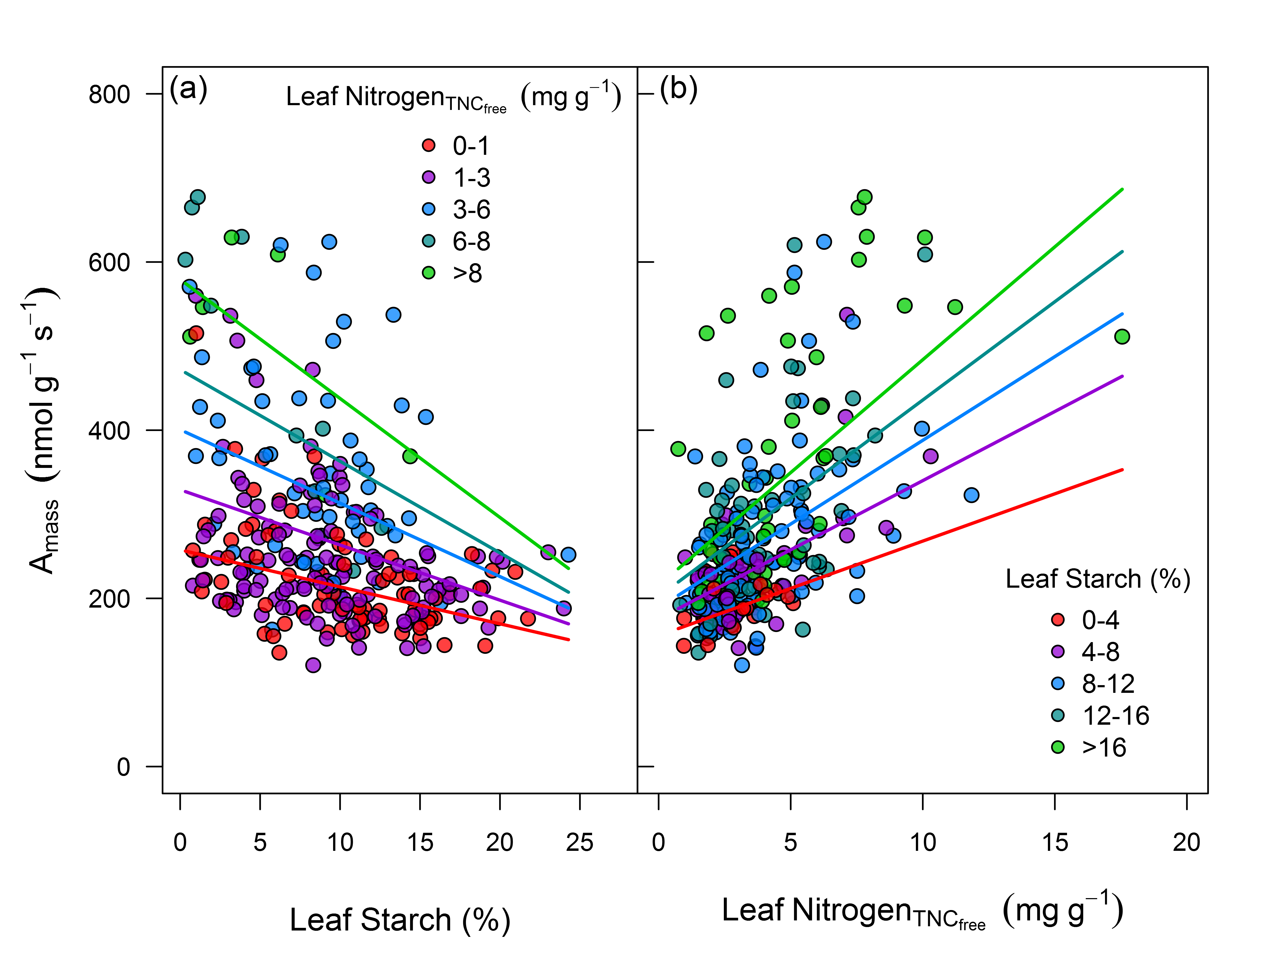

**Figure 5**.

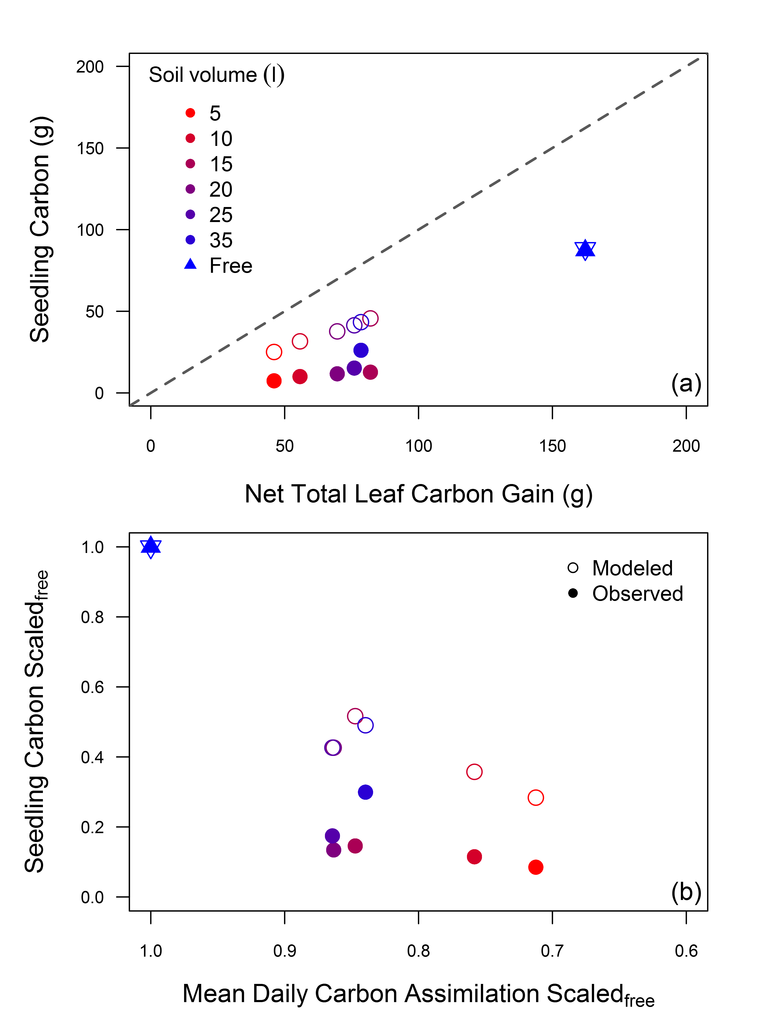

**Figure 6**.

# Supporting Information

**Table S1**.Seedling growth model default parameters.

|  |  |  |  |  |
| --- | --- | --- | --- | --- |
| **Variable** | **Description** | **Default.Value** | **Units** | **Source** |
| Leaf areai | initial leaf area | 0.035 | m2 | this study |
| Leaf massi | initial leaf mass | 3.45 | g | this study |
| Stem massi | initial stem mass | 1.51 | g | this study |
| Root massi | initial root mass | 0.99 | g | this study |
| c | biomass conversion efficiency | 0.65 | g C g mass-1 | Mäkelä (1997) |
| Rcoarse root | coarse root respiration | 0.00124 | g C g root-1 d-1 | Marden et al. (2008) |
| Rfine root | fine root respiration | 0.01037 | g C g root-1 d-1 | Ryan et al. (2010) |
| Rstem | stem respiration | 0.00187 | g C g stem-1 d-1 | Drake et al. (unpublished) |
| Cday | daily leaf carbon assimilation | 5.4 - 7.6 | g C m-2 d-1 | this study |
|  | leaf or root turnover | 1 | yr-1 | theoretical |

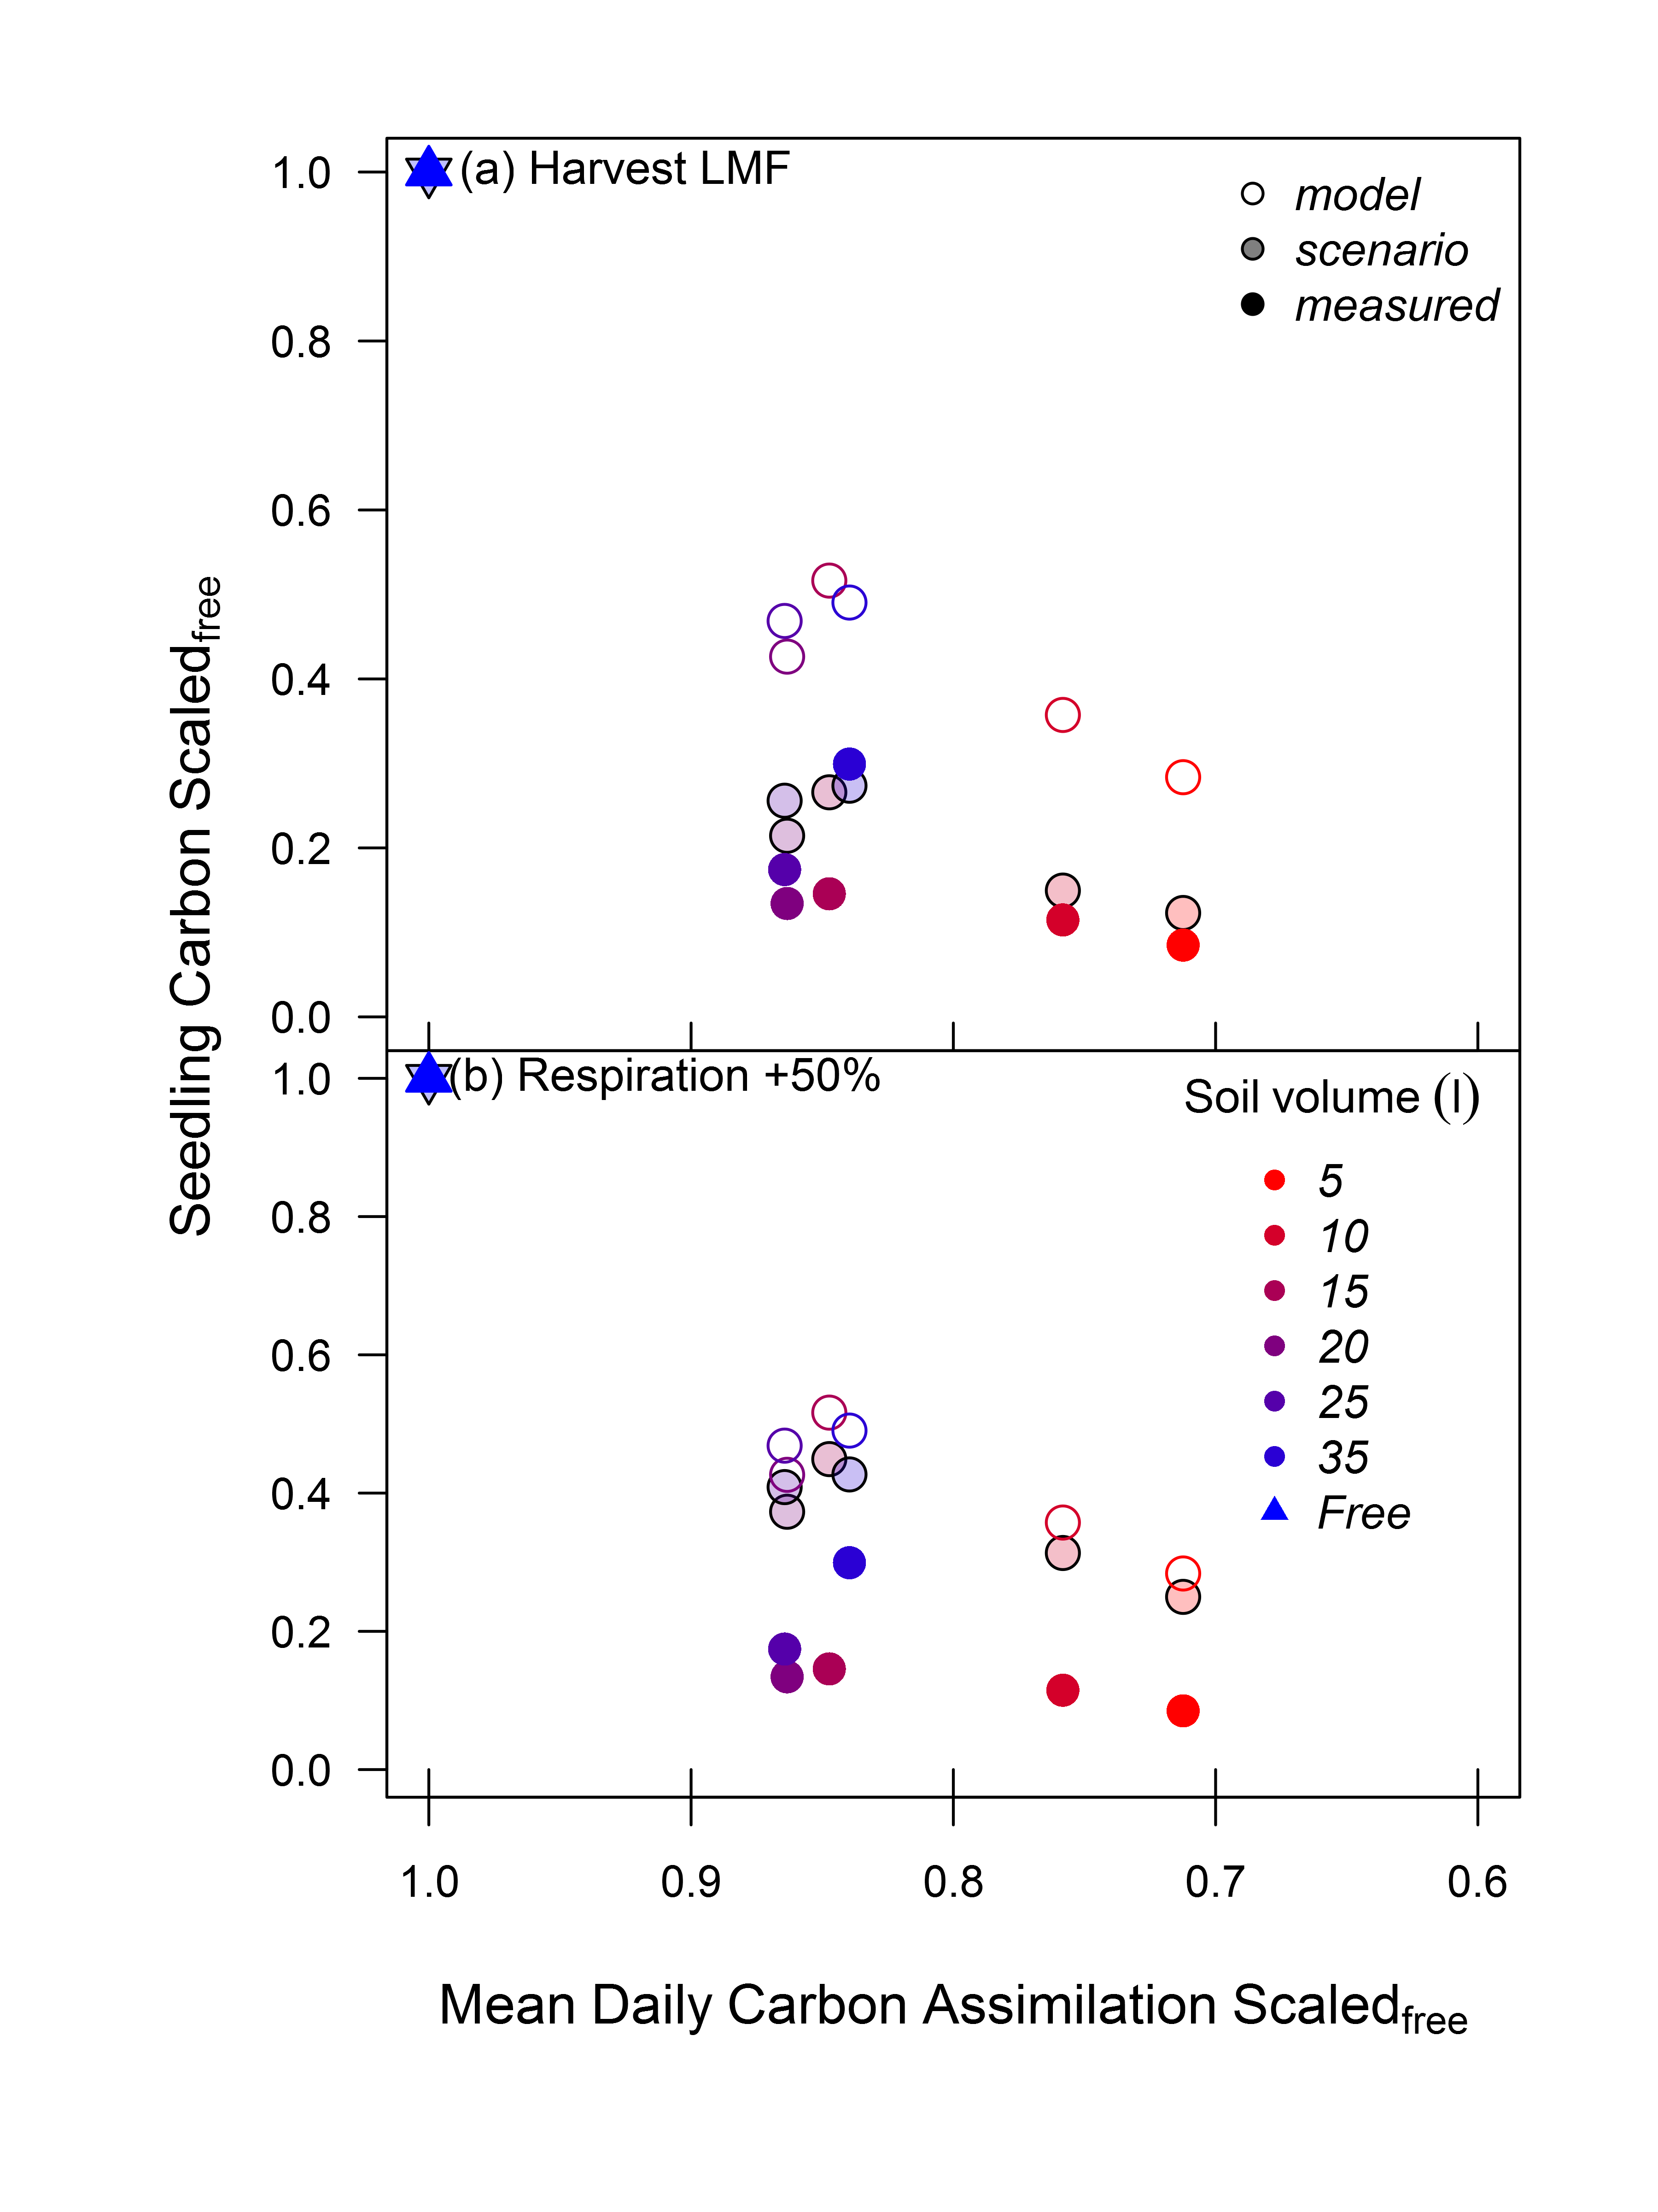

**Figure S1**.