Chapter 2  
Belowground sink limitation alters growth and carbon balance of *Eucalyptus* seedlings

# 2.1 Abstract

Interpreting limitations to plant growth requires understanding of the balance between carbon (C) source and sink activity. This study used manipulations of soil volume to test how growth is coupled to physiology, C allocation, and sink activity in *Eucalyptus tereticornis* seedlings. We grew individual seedlings in a large range of container sizes and planted containers flush to the soil alongside naturally sown (free) seedlings. We developed a seedling growth model that utilized leaf photosynthesis rates (*An*) to allocate daily C uptake towards mass growth of stems, leaves and roots. Reduced soil volume was expected to induce rapid negative effects on growth and physiology compared to free seedlings. It was hypothesized that the soil volume effect would be largest in the smallest containers, negatively impacting mass partitioning belowground. An accumulation of leaf non-structural carbohydrates, resulting from reduced belowground sink strength, was expected to correlate to reductions in photosynthetic capacity. We observed a negative effect of container volume on aboveground growth soon after the experiment started. Although growth was consistently different across soil volumes, dry mass partitioning to leaves, stems and roots was unchanged after 120 days. Photosynthetic capacity was significantly reduced in containers compared to free seedlings, and was related to both leaf nitrogen content and starch accumulation. We then asked whether the observed reductions in *An* explained the observed differences in seedling biomass. We found that although belowground sink limitation resulted in down regulation of *An*, these reductions were not large enough to explain observed growth responses. Thus, as *An* and growth were not tightly coordinated, excess photosynthetic C not attributed to biomass resulted in seedlings with soil volume restriction. These results highlight the need to further utilize mass balance approaches when evaluating plant C allocation and confirm that important feedbacks exist between belowground sink strength and leaf C uptake.

# 2.2 Introduction

Understanding plant growth and its relationship to C assimilation requires knowledge of the mass balance that must be achieved between C uptake and subsequent allocation to growth, storage, and respiration. As woody plants have highly integrated systems of competing carbohydrate sinks (Kozlowski 1992), growth should principally depend on the allocation of photosynthate among different tissues and organs. At long enough time scales leaf photosynthesis (*An*) and respiratory losses together determine net C balance and will correlate to plant growth. At shorter temporal scales, however, growth can instead be mediated by tissue C storage pools. This has led to the current debate on how strongly plant growth is controlled by either source or sink activity. Consequently, plant growth cannot always be simply determined by *An*, making it complex to understand and challenging to model (Fourcaud et al. 2008). Despite a wealth of studies, large uncertainties still remain regarding the coordination of C supply and growth of woody species.

In woody species, the coordination of *An* and growth has been studied with manipulations of C source activity. Examples included elevated CO2 experiments, for example FACE (reviewed in Ainsworth and Long 2005), and partial defoliation experiments. Elevated CO2 has been shown to increase *An* (Drake et al. 1997, Ainsworth and Rogers 2007) and across four FACE experiments this resulted in a stimulation of 23 % in forest biomass production (Norby et al. 2005). Evidence from a wide range of elevated CO2 experiments, however, also reveals that even with an average photosynthetic enhancement of over 30 %, the biomass growth rate only increases by around 10 % (Kirschbaum 2011). In partial defoliation experiments, increases in *An* of the remaining foliage are commonly shown, yet are attributed to various mechanisms, including reduction in end product inhibition (Iglesias et al. 2002, Zhou and Quebedeaux 2003, Handa et al. 2005), enhanced biochemical activity (Ovaska, Sari, et al. 1993, Layne and Flore 1995), increased stomatal conductance (Layne and Flore 1995), enhanced leaf nutrient status (Turnbull et al. 2007) and regulatory sugar signaling (Eyles et al. 2013). However, increases in *An* in defoliation experiments did not always produce increased growth due to reductions in meristem sink strength (Palacio et al. 2012), C limitation to mycorrhizal colonization (Markkola et al. 2004), or an overall decrease in whole plant C gain (Ovaska, Walls, et al. 1993). These manipulations of C source activity expose unresolved issues with how changes in *An* do not always infer similar responses in growth.

Alternatively, manipulating plant tissue C sinks is often used to investigate the correlation of *An* and growth. This is because metabolic signaling networks, relaying information on C and N status of different tissues, can regulate photosynthetic activity (Paul and Foyer 2001). If sink inhibition of *An* occurs, a close coordination between declines in *An* and growth should be expected. Whether photosynthetic down regulation is evident in woody species has been tested through fruit removal, phloem girdling and low temperatures at high elevations. In these studies, down regulation of *An* was frequently correlated to carbohydrate accumulation resulting from reduced tissue sink strength (Hoch et al. 2002, Iglesias et al. 2002, Urban and Alphonsout 2007, Haouari et al. 2013). However, reductions in *An* were also attributed to biochemical limitations prior to carbohydrate accumulation (Nebauer et al. 2011), irreversible photo-oxidative damage (Duan et al. 2008) and stomatal limitation (Li et al. 2005). These mixed results are not surprising as we still know little about the balance between assimilation, storage and growth across temporal scales in plants (Smith and Stitt 2007). As these manipulations likely impact source as well as sink activity simultaneously, affect water transport, are very extreme, or are specific to the occurrence of large fruiting sinks, they tell us little about source-sink coordination in typical growing conditions for woody species.

An alternative experimental approach is to reduce belowground C sink strength in tree seedlings by manipulating rooting volume, by varying the container size (Arp 1991, NeSmith and Duval 1998, Poorter, Bühler, et al. 2012). Possible advantages of this approach are that it allows a large range of treatment levels, can be easily compared to naturally planted seedlings and may mimic natural conditions as seedlings compete for space or reach bedrock. Seedlings undergo many physiological and morphological changes in response to rooting volume, including biomass partitioning, *An*, water relations, nutrient uptake and respiration (NeSmith and Duval 1998, Poorter, Bühler, et al. 2012 and references therein). Inadequate rooting volume may decrease C sink strength by progressively restricting root growth in growing plants (Thomas and Strain 1991). Container size studies frequently exhibit photosynthetic down-regulation, likely as a result of sink limitation (Arp 1991, McConnaughay and Bazzaz 1991, Gunderson and Wullschleger 1994, Sage 1994, Maina et al. 2002, Ronchi et al. 2006). A meta-analysis by Poorter et al. (2012) concluded that *An* is the process likely to be the strongest affected by pot size and may best explain the effects on biomass seen in the large number of studies where containers are used. This conclusion arises because plants grown in small containers are shown to accumulate leaf starch while having lower C exchange and assimilate export rates (Robbins and Pharr 1988). However, evidence in support for a trade-off between C storage and growth in trees is, to date, inconclusive (Palacio et al. 2014). Based on these previous studies, using container size as a sink-strength manipulation can be used to empirically test the extent to which growth and *An* are coordinated.

This study utilizes a novel field design to investigate the coordination between growth and *An* in *Eucalyptus tereticornis* Sm. seedlings, by manipulating container size and thus rooting volume. Seedlings were maintained under well watered conditions in order to isolate the effect of restricted soil volume. We used freely-rooted seedlings as a control for the container size treatments. Empirical results were combined with a simple plant growth model to simulate seedling growth with a C mass balance approach, which was then compared to observed harvested seedling mass. The model used whole-plant C gain, scaled from instantaneous rates of leaf *An*, to quantify seedling dry mass production over the 120 day experiment.

Our hypotheses were as follows:  
1). The manipulations of container size were expected to induce a belowground sink limitation compared to free seedlings. We hypothesized that declines in seedling growth would be largest in the smallest containers.

2). As the finite pool of rooting volume and soil nutrients will decline faster in trees growing in small containers, we expected reductions in partitioning to fine root mass relative to tree size with decreasing container size.

3). Reduced sink strength was expected to lead to accumulation of leaf non-structural carbohydrates, and a resulting down regulation of A. We therefore expected a correlation between carbohydrate accumulation and photosynthetic capacity as a function of soil volume.

4). Last, observed seedling mass was expected to correspond to growth model mass predicted from a simple C balance model taking into account measured rates of photosynthesis.

# 2.3 Materials and Methods

## 2.3.1 Experimental design

This experiment was located at the Hawkesbury Forest Experiment site in Richmond, NSW, Australia. Plots were located in an open cover paddock that was converted from native pasture grasses. Top soils at this site are an alluvial formation of low-fertility sandy loam soils (380 and 108 mg kg-1 total N and phosphorus respectively) with low organic matter (0.7 %) and low water holding capacity. At this site a soil hard layer exists at ~1.0 m with a transition to heavy clay soils. The climate for the region is classified as sub-humid temperate.

*Eucalyptus tereticornis* seedlings, 20 weeks old and approximately 40 cm tall in tube stock, were chosen from a single local Cumberland plain cohort. Six additional seedlings were harvested before planting to measure initial leaf area and dry mass of leaves, stems and roots. Previous container experiments have confirmed that species with tap roots (similar to *E. tereticornis*) use the center of the container as the medium for thick roots leaving the periphery of the soil as the most active sites for fine root proliferation (Biran and Eliassaf 1980a, 1980b). By using a species with tap root growth and manipulations of container length rather than width, we believed that a more realistic test of growth inhibition through constrained soil volume would be achieved.

Six container volumes were used ranging from 5 L to 35 L, with a 22.5 cm diameter, and lengths ranging from 15 to 100 cm. Containers were constructed of PVC pipe and were filled with local top soil (described above). Soil in each container was packed to achieve a target soil bulk density that matched local soil conditions of 1.7 g cm-3. A Imidacloprid (BAYER CropScience) insecticide tablet was planted 5 cm below the roots of each seedling. Containers were planted flush with the soil surface inside metal sleeves, designed to minimize excess air space between the container and outside soil while also allowing for container removal. This allowed for soil temperatures in containers to reflect conditions of naturally planted ('free') seedlings. Each experimental block (n=7) contained a complete replicate set of six container volumes as well as one free seedling, with 1 m2 spacing. For each free seedling, used as the control, a 1 m2 subplot was excavated to the hard layer and replaced with the same soil used in each container. A border of root exclusion material was buried 0.25 m deep and extended 0.25 m above the ground surface around each subplot to exclude local vegetation.

Plants were watered weekly or when needed to maintain soil moisture at field capacity (13-15 %). Drain systems were built into each pot to prevent pooling of water throughout the experiment. Pooling of water could lead to an anaerobic environment around the root that could hinder the uptake of water through reduced root conductance (Poorter et al. 2009), an undesired experimental artifact. A collection compartment in the bottom of containers, containing gravel covered by root exclusion mesh, was used to collect excess water for 20, 25, and 35 l containers. Plastic tubing (6 mm diameter) was inset into the gravel layer and extended through the top of the container. A lysimeter pump was then used to suction excess water, through the tubing, as needed. For small containers (5, 10, and 15 L) a simple bottom plug was used to drain excess water from the gravel compartment. Each containers was inspected after every rainfall event to determine if pooling had occurred.

## 2.3.2 Growth and morphology metrics

Seedlings were planted in summer (January 21st 2013) and stem height, diameter at 15 cm and leaf count were measured weekly thereafter. Once the growth rate of individual plants had significantly declined a full biomass harvest was completed and the experiment ended (May 21st 2013). Dry mass of leaves, stems, roots and total leaf area (LI-3100C Area Meter; LI-COR, Lincoln, NE, USA) were measured for each seedling. Mean individual leaf area for each harvested seedling was calculated by dividing total measured leaf area by total leaf count of only fully expanded leaves. Mean individual leaf area was then used to interpolate total seedling leaf area through time with weekly leaf counts. Root mass was collected by removing the roots system and passing soil from each container through a 1 mm sieve, washing, separating into fine and coarse roots (<2 mm and >2 mm diameter, respectively) and then drying to a constant mass. Roots of seedlings in containers were not considered pot bound, as clusters of roots along the soil-container interface were not observed. Roots from the free seedlings were collected by excavating each 1 m2 subplot to the hard layer and keeping only roots within the subplot. For each seedling, a sub-sample of washed fine roots was analyzed for root length using WhinoRhizo software (Regent Instruments Inc., Quebec, QC, Canada). Specific root length (SRL) is reported as the root length divided by the dry mass of each sub-sample (m g-1). Fine root length density (FRLD) for seedlings in containers is reported as the total fine root length divided by the volume of each container (m dm-3).

## 2.3.3 Photosynthetic parameters

Leaf gas exchange measurements were performed fortnightly at saturating light (Asat) and saturating light and [CO2] (Amax) on new fully expanded leaves. Measurements were initiated only after sufficient new leaf growth occurred (March 05th, 2013), approximately 6 weeks following planting, and continued until the biomass harvest. Leaf level gas exchange was measured with a standard leaf chamber (2 x 3 cm) equipped with blue-red light emitting diodes using a portable gas exchange system (LI-6400, LI-COR, Lincoln, NE, USA). Asat measurements were made at PPFD of 1800 mol m-1 s-1 and [CO2] of 400 l l-1 and Amax with [CO2] of 1600 l l-1 and PPFD of 1800 mol photons m-1 s-1. This choice of light level to achieve light saturation is consistent with other studies on *Eucalyptus* species (Kallarackal and Somen 1997, Pinkard et al. 1998, Crous et al. 2013, Drake et al. 2014). These measurements were conducted during midday (10:00-14:00 h) with leaf temperature maintained at 25 °C. After CO2 and water vapor flux values stabilized in the leaf chamber, net CO2 assimilation rate and stomatal conductance (gs) were logged 5 times and averaged for both Asat and Amax.

Photosynthetic CO2 response (ACi) curves were measured at 25 °C on a random subset of each container size (n=3) after new leaves were first produced (March 13-14th, 2013) and prior to the final harvest (May 14-15th, 2013). Each ACi curve was started at the reference [CO2] of 400 l l-1 and then consisted of 12 additional steps from [CO2] of 50 to 1800 l-1 at 25 °C at saturating light (above). From these curves the photosynthetic parameters, Jmax and Vcmax, were quantified using the biochemical model of (Farquhar et al. 1980) and fit with the 'plantecophys' package (Duursma 2015) in R (R Development Core Team 2011).

Leaf dark respiration rates (R) was measured on each seedling during the same dates as ACi curves. Freshly detached leaves were collected at least 1 hour after sundown and placed inside a conifer chamber attached to the Licor 6400. Measurements were taken at a reference [CO2] of 400 l l-1 while leaf temperature was maintained at current ambient conditions. Reported values of R are standardized rates at 25 °C using a Q10 value (1.86) developed for these seedlings in a separate experiment (Drake et al. unpublished). Leaf area and dry mass were recorded for each leaf during gas exchange campaigns.

## 2.3.4 Leaf water potential

Predawn (pd) and midday (l) leaf water potentials were measured for each seedling using a PMS 1505D pressure chamber (PMS Instruments, Albany, OR, USA) on fully expanded leaves during the same time period as ACi and R. Leaves were detached and immediately stored inside foil covered bags before water potential measurements were performed. pd was measured before sunrise and l at midday 13:00-14:30 h. These measurements were used as a measure of static water stress on the seedlings (Sellin 1999) and to ensure that the bulk soil water availability was high enough for plants to avoid water stress as they became larger and roots filled the soil volume.

## 2.3.5 Leaf, root and soil chemistry

Leaves used in each gas exchange measurements and subsamples of harvested roots were dried to a constant mass and milled for analysis of N content, 13C, and total non-structural carbohydrates (TNC). Pre-planting soil samples (n=6) and subsamples of soil from each container following harvest were sieved to remove organic material, air dried and milled for analysis of N. Nitrogen concentrations of leaf and soil samples were determined using a Carlo Erba CE1110 elemental analyzer with thermal conductivity and mass spectromic detection (of N2 and CO2). The percentage of N in the sample was calculated by comparison with certified standards. Leaf 13C was analyzed with an Delta V Advantage coupled to a Flash HT and Conflo IV isotope ratio mass spectrometer. Leaf samples were flash combusted at 1000°C to convert to CO2, feed to the mass spectrometer and isotopic signatures are reported relative to the standard Vienna Pee Dee Belemnite scale.

Leaf total non-structural carbohydrate (TNC) concentration was analyzed on dried and milled leaf samples using a total starch assay kit (Megazyme International, Wicklow, Ireland) and includes the starch and soluble sugar concentrations (mg g-1). Starch was quantified using a thermostable -amylase and amyloglucosidase assay (McCleary et al. 1997) and soluble sugars were determined following the anthrone method (Ebell 1969). Complete methods of the TNC assay are described in (Mitchell et al. 2013). TNC-free specific leaf area (SLAf, m2 kg-1) for leaves sampled during gas exchange campaigns, were calculated by first subtracting the TNC content from individual dry leaf mass before dividing leaf area by leaf mass or the leaf N content. Similarly, TNC-free leaf N (Nf, %) was calculated on all gas exchange leaves from leaf mass without TNC and leaf N content.

## 2.3.6 Seedling growth model

We developed a simple seedling growth model that utilized leaf *An* rates to allocate daily C assimilate towards biomass production of stems, leaves, fine roots and coarse roots. The model begins with mean initial tissue component biomass (leafi, stemi and rooti) and a starting leaf area (LAi) measured prior to planting. The initial biomass of roots was divided evenly between fine and coarse roots. The daily net biomass production of seedlings (Pi) is then given by

(1)

where L is total plant leaf area (m2), Cday,i is the predicted daily carbon assimilation (g C g mass-1 d-1), s is a self shading parameter (explained below), c is a biomass conversion efficiency parameter (g C g mass-1) and R is the mass based total respiration of all tissue components (g C d-1). Total respiration was calculated as

(2)

where Rc is published or local tissue respiration rates of fine roots, coarse roots or stems (Table 2.S3, g C g mass-1 d-1) and Mc is the standing biomass of each component (g). Rleaf is represented in the calculation of Cday (described below). The change in individual component biomass (Mc), here solved on a daily time step, is given by

(3)

where Ac is the component specific biomass partitioning to whole plant biomass (%) and c is component specific turnover rate (yr-1). Because we did not observe branch turnover, stem was assumed to equal 0. Total seedling biomass, per time step, was then equal to the sum of all biomass components; leaves, stems, fine roots and coarse roots.

Cday was predicted by using a coupled photosynthesis - stomatal conductance model (Farquhar et al. 1980, Medlyn et al. 2011) with the 'plantecophys' package in R with the mean photosynthetic parameters (Jmax, Vcmax, R and g1) for each treatment and meteorological data from an onsite weather station. Jmax and Vcmax were estimated from ACi curves (explained above), R was empirically measured and the g1 parameter was generated by fitting the optimal stomatal conductance model from (Medlyn et al. 2011) with observed gs values. Methods of the coupled leaf gas exchange model are described in Duursma et al (2014). Combined with the meteorological parameters; PPFD, air temperature, and relative humidity, at 15 min intervals, leaf *A* rates (mol CO2 m-2 s-1) were then predicted for each soil volume treatment. Cday was calculated by converting predicted rates to mass C gain over 15 min time steps (g m-2) and then summed for 24 h. This resulted in 120 unique values of Cday for each soil volume treatment, one value for each day of the experiment. Thus, each daily time step for model runs included a value of Cday that represented both treatment specific photosynthetic parameters and meteorological constraints across the duration of the experiment.

It was further necessary to calculate a self-shading parameter (s) when scaling leaf *An* with total plant leaf area. This was accomplished by utilizing 61 previously digitized *Eucalyptus* seedlings, covering 5 total species which include *E. tereticornis*, from Duursma et al. (2012) to run in 'YplantQMC' package (Duursma) in R to build a 3D plant structure based on digitized metrics of plant allometry and crown structure. Inputting the same treatment specific physiological parameters listed above, 'YplantQMC' outputs total *An*, using total leaf area, for seedlings assuming self-shading as well as for a full sun large horizontal leaf. The ratio of total *An* with self-shading to horizontal leaf was then used to calculate s for each of the 61 digitized seedlings, independently for each of the seven soil volume treatments. Next, the linear relationship between s and total leaf area was determined across digitized seedlings, within each treatment. For the growth model, s was then predicted for each daily time step using the previous days cumulative leaf area and this value was then applied to Cday,i. All default parameters used in model simulations are reported in Table 2.S3.

We then utilized this model to test the hypothesis that the effects of belowground sink limitation on rates of leaf *An* where sufficient to accurately predict overall seedling biomass production after 120 days. Each model run utilized changes in *An* and leaf mass fraction (LMF), with values of stem and root respiration rates, to generate total seedling mass and leaf area after 120 days. Cumulative net leaf C gain for each treatment was equal to the sum of each value of Cday,i over 120 days and final seedling C was assumed to equal half of the final mass for both modeled and observed seedlings.

First, a default model was fitted with mean photosynthetic parameters from the free seedlings and then optimized to produce a LMF which correctly predicted both the leaf mass and total biomass of the harvested free seedling (Mfree). This optimized LMF was then used to constrain model runs with soil volume treatment specific Cday, while keeping tissue respiration and turnover parameters constant, to determine if changes in leaf *An* alone could predict biomass of seedlings in containers (Mpots). Next, model sensitivity to different C allocation scenarios, including observed treatment specific LMF and up-regulation of non-leaf tissue respiration by 50 % of default values (MS1 and MS2, respectively), was used to improve model biomass predictions compared to measured harvest biomass. For all cases, seedling biomass production was compared between model output and harvested seedlings with treatment specific mean Cday by first scaling values to the free seedling control.

## 2.3.7 Data analysis

Differences in experimental parameters with soil volume were analysed by mixed-effects models in R with individual containers and experimental blocks as random effects and soil volume treatment as a categorical fixed effect with seven levels. Tukey's post-hoc tests were performed in conjunction with ANOVA to determine which specific paired comparisons among soil volume treatments were different. A linear mixed effect model of Amax and leaf chemistry was performed using the 'nlme' package (Pinheiro et al. 2015) in R. Explained variance (R2) of mixed models were computed as in (Nakagawa and Schielzeth 2013). Tests of allometric relationships between log-transformed biomass components were implemented using standardized major axis regression in the 'smatr' package in R (Warton et al. 2012). All tests of statistical significance were conducted at an alpha level of 0.05.

# 2.4 Results

## 2.4.1 Growth and morphology

Plant height, diameter and leaf area diverged between container volumes soon after start of the experiment (Figure 2.1a-c). First, seedling leaf area significantly diverged between soil volumes (P < 0.029) during the 5th week of the experiment. Following this period both height (8th) week) and then diameter (9th week) significantly deviated across soil volumes (P < 0.045 & 0.035, respectively). The large reductions in height gain and total leaf area in smaller compared to larger containers continued throughout the experiment. In this field study, colder temperatures and reductions in total PPFD per day (Figure 2.2) likely slowed the growth of seedlings in the final weeks of the experiment. Seedlings maintained diameter growth throughout the experiment, although marginal with smaller soil volumes in the final month. Final seedling height significantly increased with increasing soil volume (P < 0.001). Increases in both final stem diameter (P < 0.001) and cumulative leaf area (both P < 0.001) were found with increasing soil volume and these differences were driven mainly by the largest container and the free seedling treatments.  
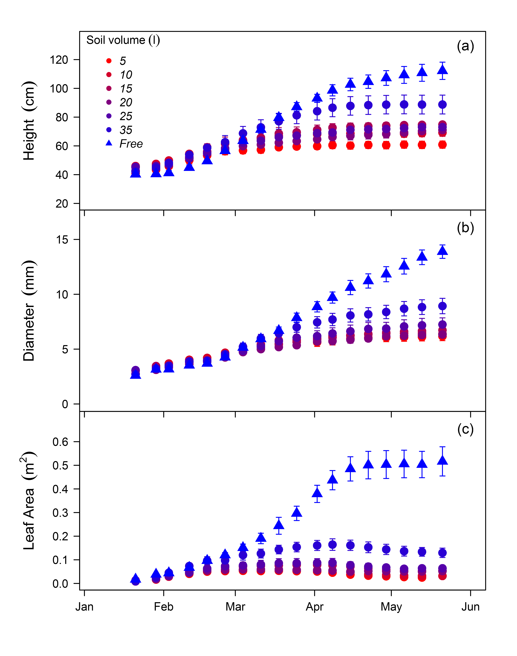  
**Figure 2.1**. Soil volume treatment means ± standard error of height growth (a), diameter growth (b), and interpolated seedling leaf area (c) measured weekly of *Eucalyptus tereticornis* seedlings across the experiment duration in 2013.  
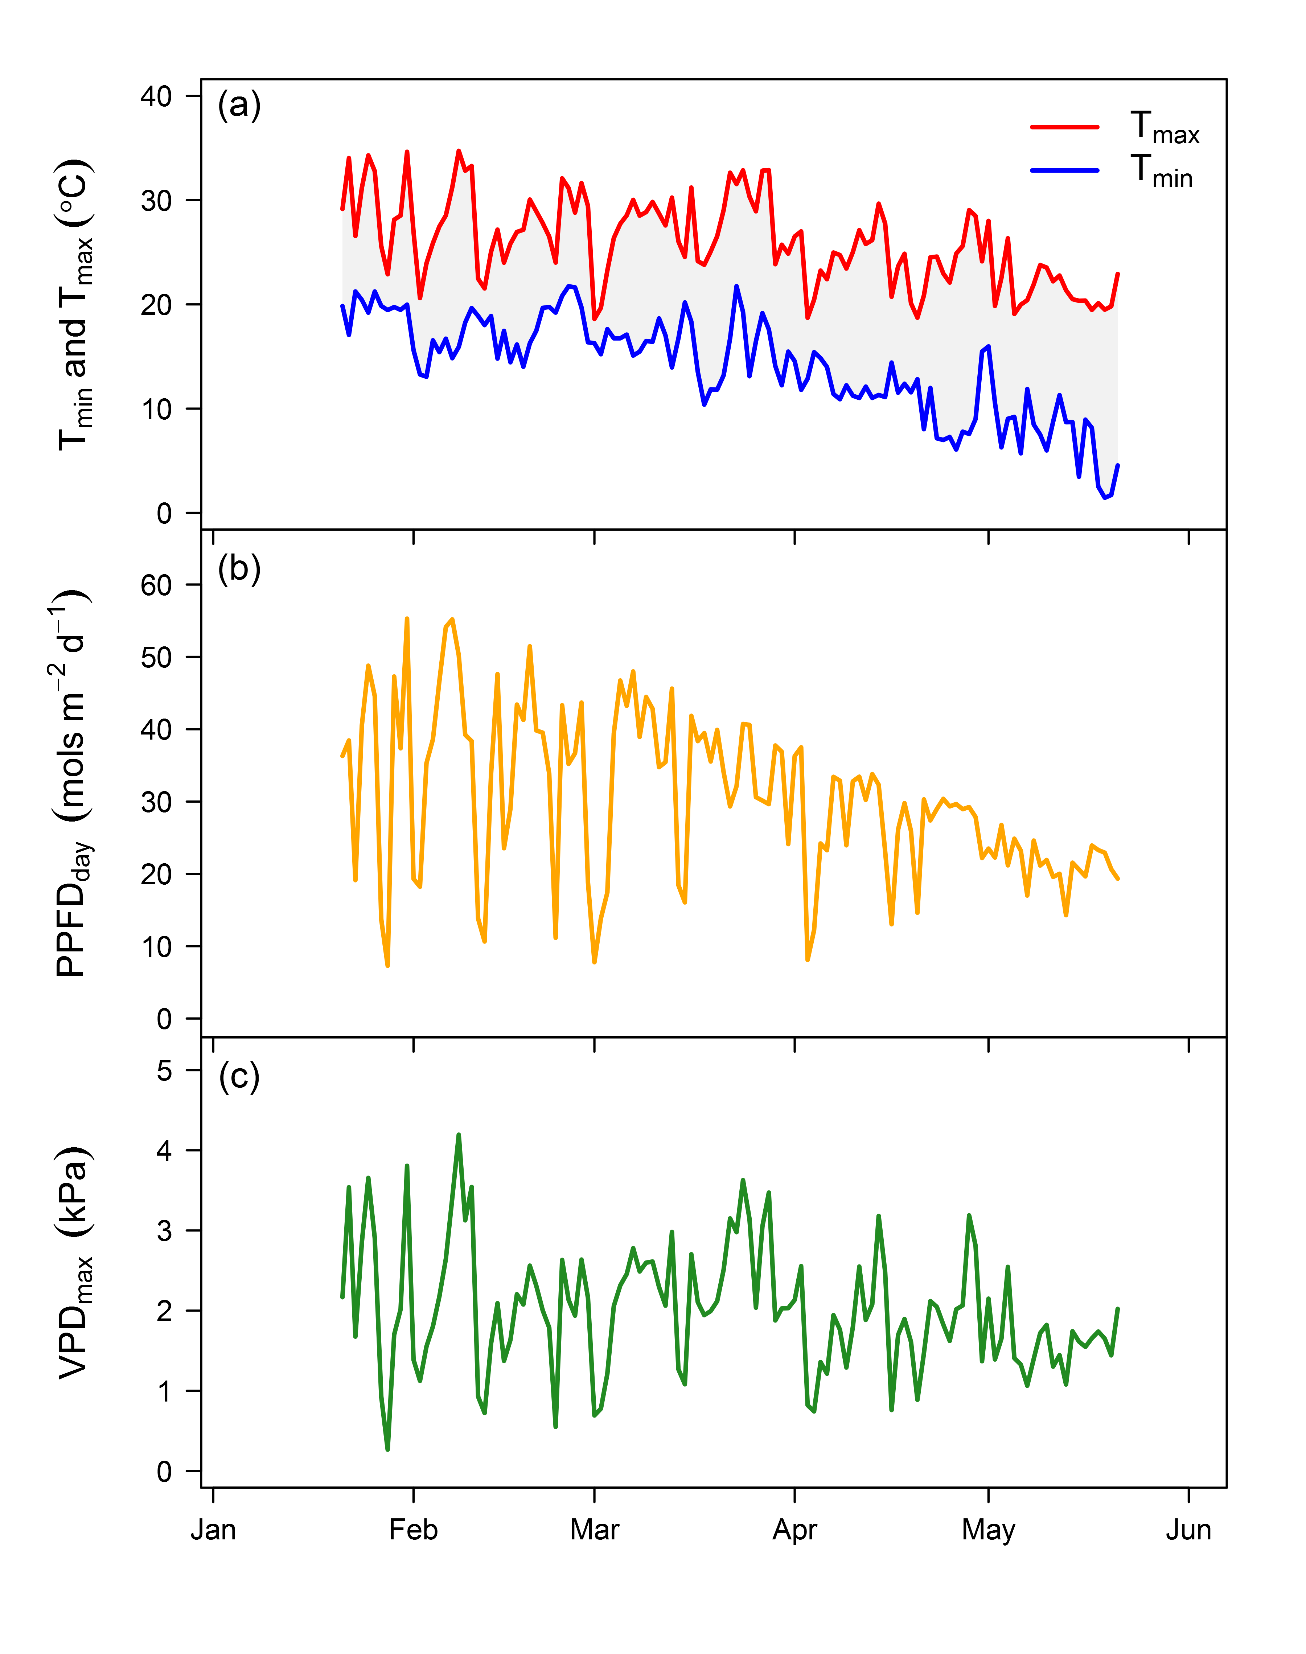  
**Figure 2.2**. Daily maximum and minimum temperature (a), total daily PPFD (b), and daily maximum vapour pressure deficit (c) across the experiment duration in 2013.

Total seedling biomass at harvest was significantly different across container volumes (P < 0.001) and between container treatments and free seedlings (P < 0.001, Table 2.1). On average, harvested biomass of free seedlings was 84% higher than seedlings in containers. Plant biomass was positively correlated with total leaf area across all treatments (R2 = 0.97, P < 0.001). Differences in biomass partitioning to leaves, stems and roots were not different across soil volumes after variation in seedling biomass across treatments was factored in the analysis (Figure 2.3a,b). Across all treatments, the final harvest root:shoot biomass ratio was conserved in these seedlings which exhibited a slightly higher shoot than root mass ( = 0.904, 95% CI = [0.846,1.119]) and a near identical ratio of leaf to fine root mass (Figure 2.3c).

**Table 2.1**.Responses of plant and leaf characteristics of *Eucalyptus tereticornis* seedlings to soil volume treatments. Each value reflects the mean (± 1 standard error) for each treatment. Seedling mass and leaf 13C values are from final harvest. Values of leaf starch, sugars, nitrogen and SLA represent overall means across measurement campaigns (n=6). Different letters represent significant differences between treatments. The volume effect P value represents the overall difference between seedlings with soil volume restriction and the control seedlings.

|  |  |  |  |  |  |  |
| --- | --- | --- | --- | --- | --- | --- |
| **Volume (L)** | **Seedling mass (g)** | **SLATNC-free (m2 kg-1)** | **Leaf Starch (%)** | **Leaf Sugars (%)** | **Leaf NitrogenTNC-free (%)** | **Leaf d13C (‰)** |
| 5 | 14.8 (1.82) a | 11.8 (0.32) a | 12.7 (0.97) b | 6.4 (0.28) a | 1.3 (0.03) a | -30.1 (0.26) a |
| 10 | 20.0 (2.38) ab | 11.7 (0.31) a | 9.4 (0.75) ab | 6.7 (0.25) a | 1.5 (0.04) ab | -30.2 (0.25) a |
| 15 | 25.4 (2.49) ab | 12.7 (0.48) a | 7.3 (0.73) a | 7.2 (0.28) a | 1.6 (0.07) ab | -30.3 (0.36) a |
| 20 | 23.4 (1.63) ab | 11.8 (0.37) a | 9.5 (0.88) ab | 6.6 (0.26) a | 1.7 (0.06) ab | -29.7 (0.28) a |
| 25 | 30.4 (5.49) ab | 12.4 (0.40) a | 9.8 (0.71) ab | 6.9 (0.24) a | 1.6 (0.07) ab | -29.7 (0.25) a |
| 35 | 52.2 (9.55) b | 13.5 (0.46) ab | 9.8 (0.65) ab | 6.8 (0.22) a | 1.8 (0.08) b | -30.6 (0.38) a |
| Free | 174.5 (18.02) c | 15.1 (0.47) b | 6.8 (0.65) a | 7.4 (0.25) a | 2.7 (0.09) c | -30.0 (0.34) a |
| Volume Effect (P value) | 0.001 | 0.001 | 0.029 | 0.125 | 0.001 | 0.372 |

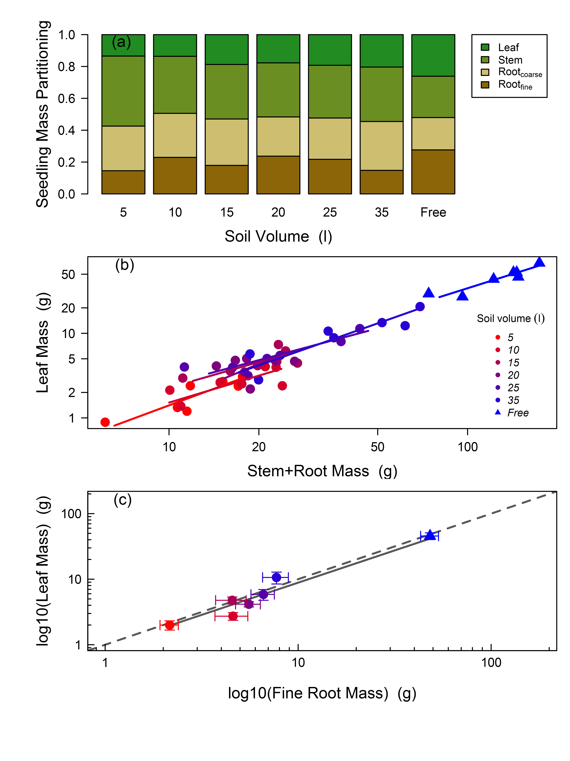  
  
**Figure 2.3**. Soil volume treatment means of biomass partitioning to leaves, stems, and roots at harvest (a), bi-variate relationships between mass allocation to leaves and stems + roots (b) and leaf mass as a function of fine root biomass with ± standard error (c). For (b) lines represent standardized major axis fitting of the log-transformed allometric relationships of leaf mass fraction by treatment. For (c) the dashed line is the 1:1 relationship and the solid line represents the significant log-log model fit (R2 = 0.82) with equation: log(x) = 0.983(log(y)) - 0.036.

Overall, SRL was higher in seedlings in containers compared to free seedlings but only in some of the container size treatments (Table 2.2, P = 0.009). Fine root length density was significantly higher in the two smallest container sizes and was the lowest in the largest container size (Table 2.2, P < 0.001). Over the duration of the experiment SLAf was higher in free seedlings, but was not different across containers sizes (Table 2.1, P < 0.001) and this pattern was evident beginning in the first gas exchange measurement campaign (P < 0.001).

**Table 2.2**. Responses of root characteristics of *Eucalyptus tereticornis* seedlings to soil volume treatments. Each value reflects the mean (± 1 standard error) for each treatment. All values are from the final harvest. Values for FRLD were only calculated for seedlings in containers as free seedlings had potentially unlimited soil volume to exploit. Different letters represent significant differences between treatments. The volume effect P value represents the overall difference between seedlings with soil volume restriction and the control seedlings, except for FRLD which represents only differences between seedlings in containers.

|  |  |  |  |
| --- | --- | --- | --- |
| **Volume (L)** | **Root Nitrogen (%)** | **SRL (m g-1)** | **FRLD (m dm-3)** |
| 5 | 0.78 (0.04) ab | 73.0 (6.73) ab | 36.4 (5.68) bc |
| 10 | 0.75 (0.02) a | 99.6 (8.70) b | 45.9 (8.68) c |
| 15 | 0.71 (0.02) a | 74.6 (6.98) ab | 20.9 (1.51) ab |
| 20 | 0.76 (0.04) a | 85.8 (7.37) ab | 23.0 (3.09) ab |
| 25 | 0.74 (0.02) a | 82.5 (15.02) ab | 24.7 (7.58) ab |
| 35 | 0.77 (0.03) ab | 63.1 (6.47) a | 13.3 (1.98) a |
| Free | 0.90 (0.03) b | 50.9 (5.00) a |  |
| Volume Effect (P value) | 0.017 | 0.009 | 0.001 |

## 2.4.2 Leaf and root chemistry

Leaf Nf was significantly higher in free seedlings and the largest container volume compared to the smaller container volumes at the onset of gas exchange measurements (6th week, P < 0.001). Throughout the remainder of the experiment the smallest container volume had a significant reduction in leaf Nf compared to other soil volumes, while free seedlings maintained the highest leaf Nf (Table 2.1, P < 0.001). Leaf starch content in the smallest container was ca. double that of free seedlings (P = 0.039), while leaf soluble sugars did not differ across treatments throughout the experiment (Table 2.1). Differences in leaf starch between the free seedling and the smallest container were evident during the first gas exchange campaign (P = 0.001). Root N was higher in free seedlings compared to seedlings in containers but only for some of the container size treatments (Table 2.2).

## 2.4.3 Gas exchange and photosynthetic parameters

At the first measurement campaign, both Asat and Amax were significantly higher in the free seedling treatment compared to seedlings in containers (both P < 0.001). Across all measurement campaigns mean Asat (Figure 2.4) and Amax (Table 2.3) were consistently higher in free seedlings than in containers (26 % and 29 %, respectively). The relationships between photosynthetic capacity, leaf starch and leaf N on a mass basis was marginally significant (P = 0.058), but Amax on a mass basis was highly correlated to both leaf N content and leaf starch (both P < 0.001). We used predictions from the linear mixed effect model equation to visualize these relationship of Amax to either leaf N content or leaf starch at multiple bin levels (n=5) of the co-variate parameter (Figure 2.5). Across all measurement campaigns and treatments Amax was higher when leaf N was also higher, usually associated with low levels of leaf starch (Figure 2.5a). Amax was also lower when leaf starch was high as higher leaf N often did not coincide with high leaf starch (Figure 2.5b). Overall, Amax was positively correlated with final harvest biomass across all seedlings (P < 0.001).  
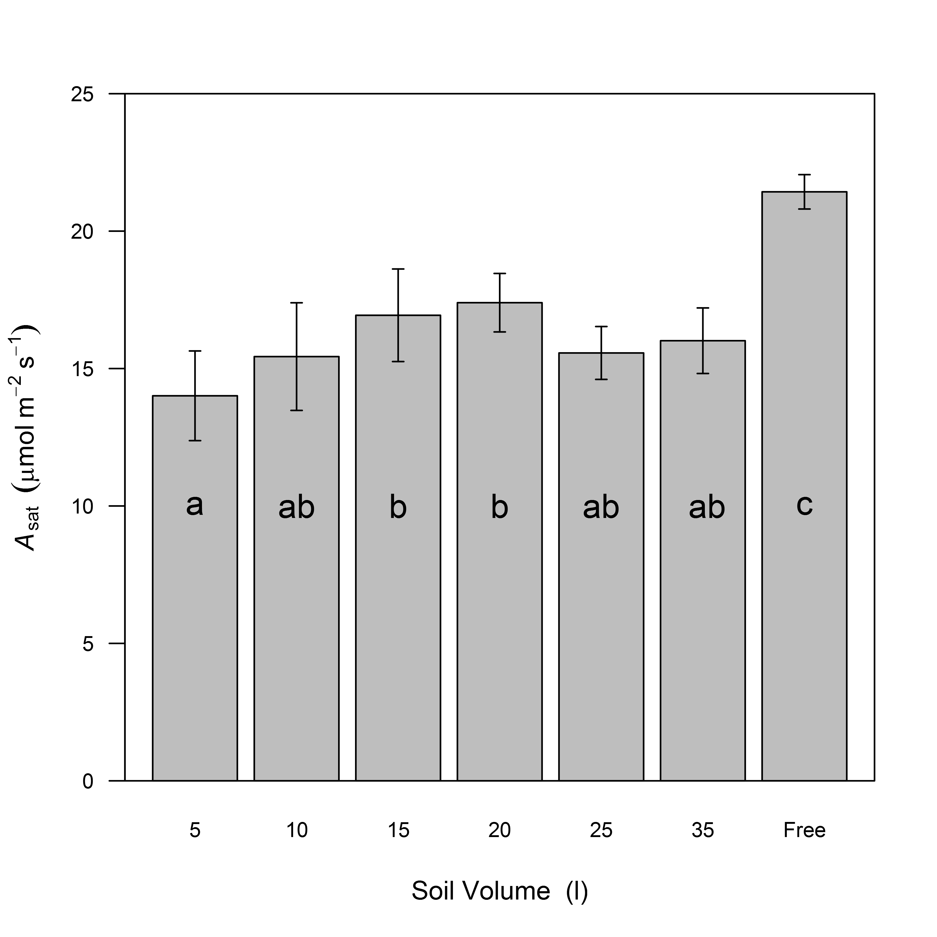  
**Figure 2.4**. Soil volume treatment means ± standard error, across all measurement campaigns (n = 6), of light saturated rates of photosynthesis at 25°C. Different letters represent significant differences between treatments.

**Table 2.3**. Responses of leaf level gas exchange parameters of *Eucalyptus tereticornis* seedlings to soil volume treatments. Each value reflects the mean (± 1 standard error) for each treatment. Amax, R and gs are each measured at 25 °C. Values of Amax, gs and g1 represent overall means across measurement campaigns (n=6). R, Jmax and Vcmax values are means of two measurement campaigns at beginning and end of gas exchange measurements. Different letters represent significant differences between treatments. The volume effect P value represents the overall difference between seedlings with soil volume restriction and the control seedlings.

|  |  |  |  |  |  |  |
| --- | --- | --- | --- | --- | --- | --- |
| **Volume (L)** | **Amax (mol m-2 s-1)** | **R (mol m-2 s-1)** | **Jmax** | **Vcmax** | **gs (mol m-2 s-1)** | **g1** |
| 5 | 21.2 (0.9) a | 0.61 (0.04) a | 104.5 (3.3) a | 63.3 (2.5) a | 0.30 (0.009) a | 5.1 (0.14) bc |
| 10 | 22.3 (1.4) ab | 0.79 (0.06) a | 116.5 (7.5) a | 69.4 (4.7) a | 0.36 (0.009) ab | 5.4 (0.10) cd |
| 15 | 23.3 (1.2) ab | 0.70 (0.05) a | 125.4 (7.8) a | 80.8 (5.1) ab | 0.42 (0.010) ab | 5.8 (0.14) d |
| 20 | 26.1 (0.7) b | 0.73 (0.11) a | 131.5 (8.6) a | 82.1 (4.7) ab | 0.37 (0.011) ab | 4.9 (0.12) ac |
| 25 | 23.9 (0.9) ab | 0.53 (0.13) a | 132.8 (13.1) a | 79.0 (8.7) a | 0.30 (0.009) a | 4.5 (0.14) a |
| 35 | 25.0 (1.0) ab | 0.61 (0.04) a | 127.2 (6.1) a | 82.4 (3.6) a | 0.31 (0.011) a | 4.4 (0.15) a |
| Free | 33.1 (0.7) c | 0.64 (0.07) a | 169.0 (8.2) b | 100.4 (3.3) b | 0.44 (0.011) b | 4.5 (0.14) ab |
| Volume Effect (P value) | 0.001 | 0.269 | 0.004 | 0.005 | 0.007 | 0.001 |

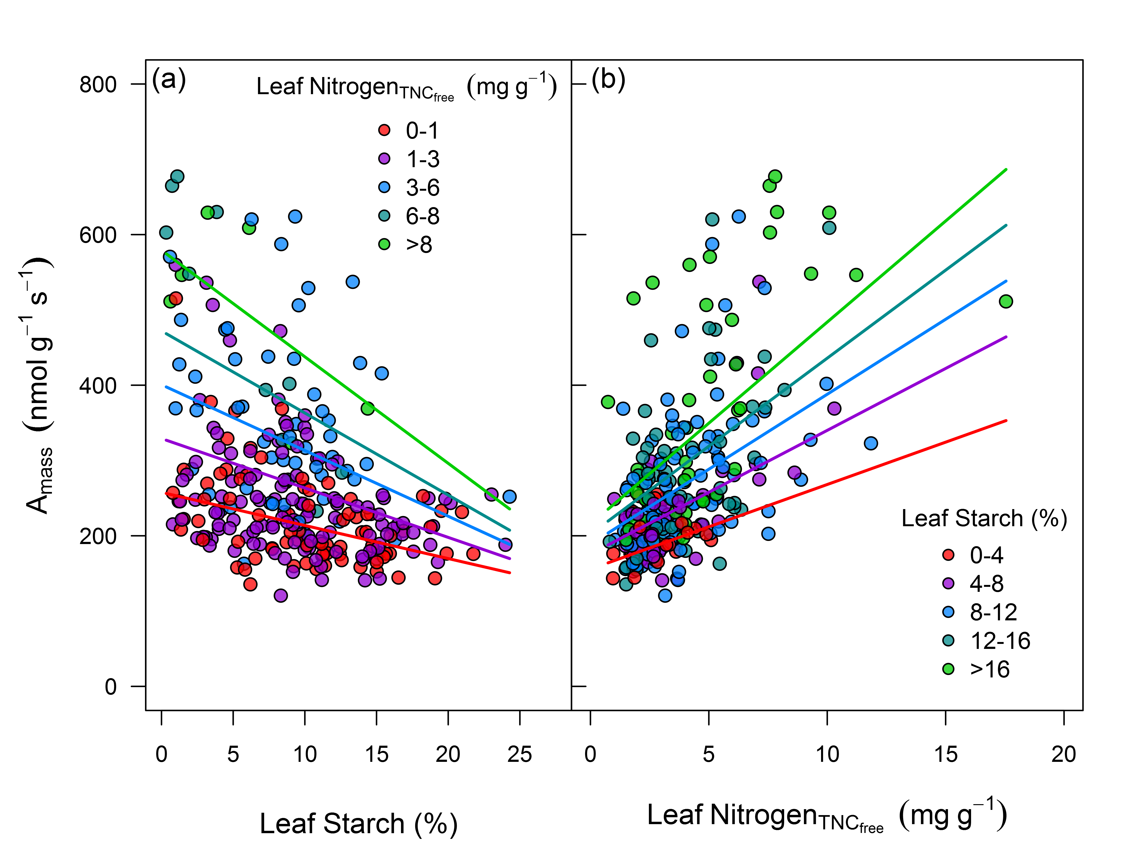  
**Figure 2.5**. Photosynthetic capacity, on a leaf mass basis, as a function of accumulation of leaf starch (a) and leaf nitrogen content without TNC (b). Colors represent bins levels (n = 5) of both leaf starch and nitrogen grouped from low to high. Lines represents predictions, for each bin level, from the linear mixed effects model equation of Amass as a function of starch and nitrogen. The marginal R2 (fixed effects only) was 0.37 and the conditional R2 (fixed and random effects) was 0.48 for the complete model.

Both Jmax and Vcmax were significantly higher in free seedlings (30 % and 26 %, respectively) than container-grown seedlings with little variation between container volume treatments (Table 2.2). Leaf dark respiration rates were not significantly different across soil volumes (Table 2.2). The g1 parameter, generated for each seedling from the Medlyn et al (2011) optimal stomatal conductance model, was lowest in the free seedling treatment and was marginally different across soil volume treatments (Table 2.2).

Neither pd nor l were different across treatments, with mean values of -0.27 and -1.2 MPa across all seedlings, respectively. Although gs in free seedlings was generally higher than those in containers (Table 2.2, P < 0.001), the mean rates for all seedlings were high at 0.37 mol m-2 s-1 and did not change throughout the course of the experiment. Additionally, leaf 13C at final harvest was not different across treatments (Table 2.1). Combined these indices provide strong evidence that water stress was not apparent on these seedlings throughout the experiment. Soil N at harvest was not different across soil volumes ( = 4.5 %), with minimal decreases from pre-planting value ( = 4.9 %). This indicates that nutrient leaching from free seedlings or from draining of containers following natural rainfall events did not differ between treatments.

## 2.4.4 Modelling seedling biomass

The default model Mfree, successfully optimized a LMF (21.6 %) which then allowed the model to predict mean harvest total biomass of free seedlings within 1.2 %. Using this optimized LMF, the total biomass of modeled seedlings for each soil volume treatment (Mpots) were on average 23±2.4 g C more than measured seedling biomass when compared against predicted total net leaf C gain (Figure 2.6a). Thus, seedling C mass was overestimated by an average of 50±8.7 % in modeled seedlings across the soil volume treatments (Figure 2.6b). As a result, the observed reductions in leaf *A* with decreasing soil volume when integrated across the 120 day experiment were not large enough to explain the reduction in observed seedling biomass across the container size treatments.  
  
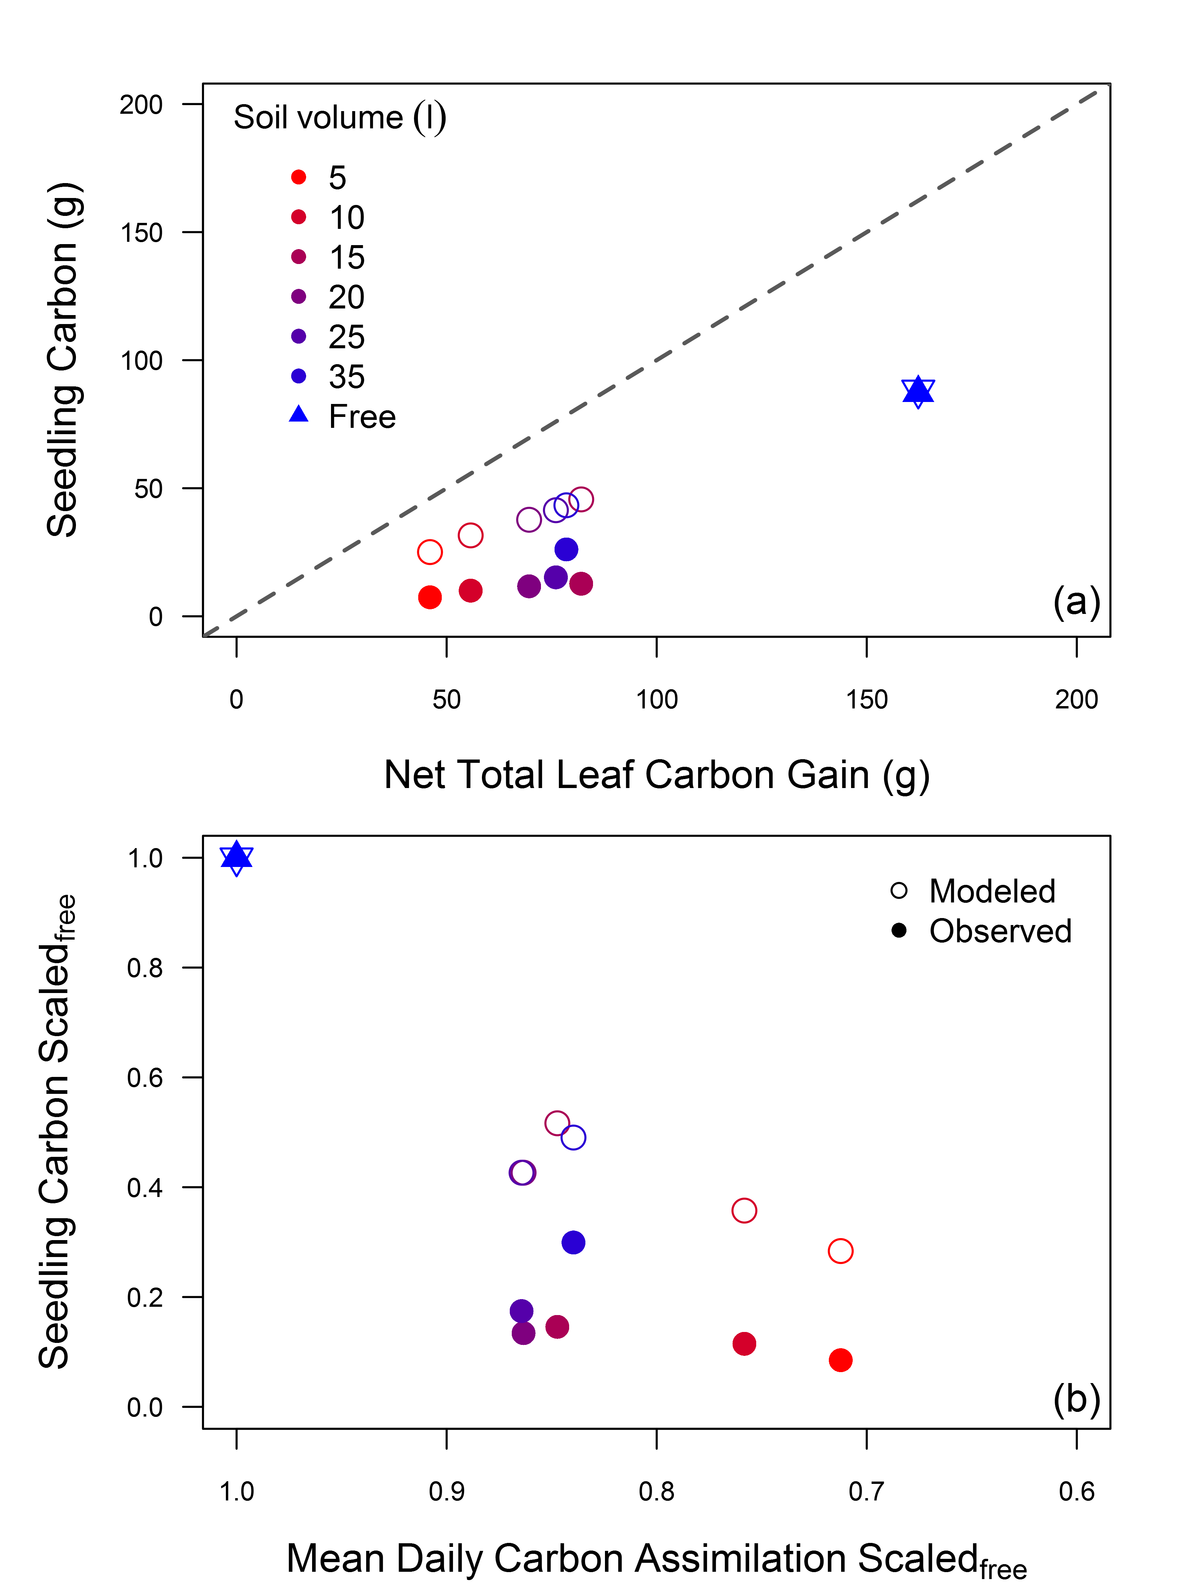  
  
  
**Figure 2.6**. Total carbon mass for harvested and modeled seedlings versus predicted total carbon gain after 120 days (a) and reductions in final seedling carbon mass, both modeled and observed, as a function of the reduction in leaf photosynthesis across treatments (b). For (a) the dashed 1:1 identifies the difference between net total leaf carbon gain and gross seedling production. For (b) both seedling carbon mass and daily carbon assimilation were first scaled to the free seedling control.

Next, we performed a series of model simulations to test possible C allocation scenarios to account for the over predictions of seedling C mass. Testing the sensitivity of the model to observed treatment-specific LMF from the final harvest (MS1), which were each lower than the optimized LMF value (see Figure 2.3a), improved model predictions of seedling C mass but still overestimated seedling total C by 32±11.1 % (Figure 2.S1a). Using harvest values of LMF, however, does not capture the observed increase in leaf turnover of seedlings in small containers (Figure 2.1c). Thus, the use of harvest LMF values for seedlings in containers in MS1 likely underestimates daily C allocation to leaves over the final months of the experiment. Increases of 50 % in non-leaf tissue respiration (MS2) improved biomass estimates slightly but overestimated mass C by an average of 46±9.3 % in seedlings with soil volume restriction (Figure 2.S1b). With MS2, non-tissue respiration rates would need to be increased by ca. 250% in order for mass balance to be achieved.

# 2.5 Discussion

This study utilized a simple but novel field design to manipulate belowground sink limitation and physically restrict *Eucalyptus tereticornis* seedling biomass production. We addressed questions regarding the coordination of *An* and growth by complementing empirical results with a C mass balance model. We found that reductions in leaf *An* across container sizes, when integrated across the 120 day experiment, were alone insufficient to account for observed reductions in total plant biomass production.

## 2.5.1 Reductions in growth and physiology under sink limitation

Soon after seedlings became established both height and diameter growth were negatively affected by decreasing soil volume. This led to the large reductions in biomass in small containers, compared to freely rooted seedlings. We analyzed the relationship between biomass growth and soil volume and found an increase of 34 % with a doubling of container volume, consistent with the meta-analysis of Poorter, Bühler, et al. (2012). These growth reductions were expected, as the impedance of root growth can cause reductions in overall plant growth and activity (McConnaughay and Bazzaz 1991, Young et al. 1997). It has been shown that roots subjected to environmental stress may send inhibitory signals to the shoots that affect gs, cell expansion, cell division and the rate of leaf appearance (Passioura 2002). Here, this was evident in a large divergence in leaf area between seedlings in containers and free seedlings through time, with the eventual cessation of new leaf growth in seedlings in small containers.

Decreases in Asat occurred at the same time as reductions in height and diameter of seedlings in containers. This initially suggests a strong link between growth and an apparent down regulation of *An*. However, there are several possible mechanisms that can explain reduced *An* in small containers including nutrient content, water or reduced sink strength (Poorter, Bühler, et al. 2012). It was therefore necessary to examine each of these factors to determine if the induced belowground sink limitation actually triggered photosynthetic down regulation.

With high rates of gs, non-limiting leaf water potential and consistent leaf 13C across soil volume treatments there was little evidence that water stress caused the reduction in *An*. This finding is consistent with other container size studies without drought treatments. For example, reduced Amax in cotton seedlings grown at elevated CO2 was attributed to sink-limited feedback inhibition from inadequate rooting volume, not decreased gs (Thomas and Strain 1991). Additionally, severe reductions in *An* in coffee plants were not attributed to impacts of container size on leaf water potentials or gs (Ronchi et al. 2006). It is likely that reductions in *An* of well-watered seedlings observed in our study of *E.tereticornis* seedlings was instead the result of limiting soil nutrients or space restriction on belowground sink strength.

Here, reductions in *An* were positively correlated with decreases in leaf N and leaf N was considerably reduced for seedlings in containers. As leaf N reductions were detected with TNC-free leaf mass, this suggests that physical root restriction or decreased supply likely affected seedling N uptake instead of TNC dilution in leaves in the smallest containers. Root N at the end of the experiment was on average higher in free seedlings but not consistently higher than every container volume treatment. Unrestricted mycorrhizal recruitment could have instead facilitated the increases in leaf N in free seedlings, but this effect is unknown. Combined with the fact that soil N declined evenly across all treatments, there was no clear mechanism present to identify changes in root N uptake between free seedlings and seedlings in containers. In these already low quality soils, it is possible that seedlings in containers simply grew into increasing N limitation which negatively affected belowground sink strength. Although no clear feedback could be determined between the available soil N pool and decreases in leaf N, the effects of belowground sink limitation on *An* of seedlings in containers was evident throughout the experiment.

As both rooting space and resources were finite in containers, the inability of seedlings to maintain the capacity of the belowground C sink resulted in the buildup of C assimilate in leaves. The feedback inhibition of *An* from starch accumulation has been proposed, yet it is still not known whether there is a starch threshold that triggers the down-regulation process (Nebauer et al. 2011). Here, declines in Amax were correlated with higher starch content throughout the experiment. This agrees with a study on a deciduous conifer by Equiza et al. (2006) where photosynthetic downregulation from reduced sink strength was correlated with starch content. As starch content in leaves of plants grown in the smallest containers was nearly double that of free seedlings in our study, this suggests the response of *An* to sink inhibition was regulated by this accumulation, as hypothesized.

## 2.5.2 Biomass partitioning under sink limitation

As biomass partitioning is likely controlled by the source and sink strength of all organs (Poorter, Niklas, et al. 2012), it was important to determine which tissue components were most affected by the container size treatments. It was necessary to distinguish if growth was affected beyond ontogenetic constraints, by correcting for size, as biomass distribution is strongly size-dependent (Gould 1966, Lleonart et al. 2000). In this study, there was no significant difference in root, leaf, or stem biomass partitioning with reduced soil volume compared to free seedlings, outside of ontogenetic drift (Figure 2.3a,b). This is a surprising result as shifts in partitioning have been noted specifically for nutrient limitation (McConnaughay and Coleman 1999, and references therein). Surprisingly, a constant ratio of fine root mass to leaf mass was observed across all treatments suggesting a functional partitioning response to optimize resource gain did not occur.

As partitioning to fine roots did not change this provides evidence against an optimal foraging strategy for seedlings in containers. This could be because lateral root development is affected by inanimate obstacles and avoiding growth towards container walls could improve the efficiency of resource allocation (Falik et al. 2005). The sensitivity of roots to their own exudates near obstructions may prevent further growth (Semchenko et al. 2008). Here, we show that FRLD was highest in smallest containers suggesting that root restriction likely occurred as simple function of available rooting space. Additionally, physical restriction of root proliferation could have impacted root development and morphology prior to shifts in mass partitioning. Here, increases in SRL where detected in several of the soil volume treatments. This is not surprising as plants in containers have been shown to have different root morphology to field grown plants (NeSmith and Duval 1998). The poor soil quality used in our experiment and root restriction, however, likely decreased the capacity of this morphological response to increase N uptake.

## 2.5.3 Do reductions in photosynthesis explain reductions in seedling growth?

Our model used a simple approach to drive seedling growth with measured reductions in leaf *An*, via soil volume effects, while treating C use efficiency, respiration and C allocation as fixed processes. Contrary to expectation, the model consistently overestimated seedling growth in containers when parameterized with an optimized LMF for free seedlings. Although reductions in Amax and biomass were strongly correlated among treatments, as hypothesized by Poorter et al. (2012), we provide evidence that the negative effects of sink limitation on *An* do not fully explain reduced seedling growth. These findings are important as this model reflects classical approaches in tree growth and production modelling that are driven by inputs of C assimilation and processes such as respiration are considered proportional to biomass (Le Roux et al. 2001) or growth rate (Tjoelker et al. 1999). It is possible that the overestimation of growth was due to an initial overestimation of *An*, however, the robust empirical based methods used to generate photosynthetic parameters (Jmax, Vcmax, R and g1) make this unlikely. Instead, our results indicate a need to evaluate how oversimplified representations of processes other than *An* affect models which distinguish the fate of assimilate C within a plant. Doing so will provide valuable input to future models as assimilate allocation is a key component in carbon-balance driven plant growth models (Lacointe 2000). To address this issue, we utilized the flexibility of this model to test plausible fates of the pool of simulated non-biomass C unaccounted for with observed mass balance. Similar to Lohier et al. (2014) we manipulated processes contributing to modeled seedling C mass balance, including changes to leaf C allocation or non-leaf tissue respiration, to quantitatively test their respective influences on model predictions.

Using measured LMF from the harvest, instead of the optimized seedling control (MS1), improved biomass predictions and provided insight into how sink limitation can impact leaf C allocation beyond *An*. The sensitivity of the model to shifts in LMF could represent leaf loss throughout the experiment that could not be explicitly quantified in this field study. As TNC accumulation can lead to accelerated leaf senescence (Paul and Foyer 2001), this could explain the observed decline in total leaf area of seedlings in small containers. Future empirical and modelling studies should focus on how feedbacks from sink activity affect both rates of *An* and the fate of C allocated to growth, respiration and C storage in leaves. It will be the interactions between these two components that will determine the total C gain available for plant growth.

Increasing rates of non-leaf respiration (MS2) improved biomass predictions but to a far lesser extent than changes to leaf C allocation. We also show that very large increases in non-leaf respiration rates would have been required to accurately predict observed seedling biomass. Although the fraction of photosynthate used in respiration is known to vary among species and is sensitive to changes in growth rates (Lambers et al. 2008), results from MS2 highlight a lack of knowledge regarding how respiration rates of individual tissues, within a single plant, maybe be differentially affected by environmental change. This is noteworthy, as C balance is a delicate equilibrium between fluxes of *An* and respiration, partial accounting of C dynamics can easily lead to erroneous conclusions (Valentini et al. 2000). These results infer that using fixed rates of respiration in models likely underestimates plant responses to sink limitation. Thus, we agree with Delucia et al. (2007) that it is likely inappropriate to assume that respiration is a constant fraction of gross primary production in models. Our findings reveal that a combination of different mechanisms, beyond *An*, are likely at play in driving the observed seedling biomass response to sink manipulation. However, the degree to which these mechanisms will regulate growth will undoubtedly shift across different experimental manipulations and plant species.

## 2.5.4 Conclusions

With a novel field-based design we detected a massive effect of container volume on seedling growth, not between containers but with naturally planted seedlings. This is important as manipulations of plants grown in containers are often used to draw conclusions about growth and physiological principles, but how these results actually reflect field-grown plants has seldom been studied. Although biomass partitioning was conserved, our empirical and model results suggest that the amount of photosynthate allocated to non-biomass pools such as TNC or respiration were likely altered by sink inhibition. The debate over how rates of photosynthesis affect plant growth or to what degree these rates are instead controlled by growth has existed for decades (Sweet and Wareing 1966). Our combined empirical and modeling approach shows that when non-photosynthesis parameters were kept constant changes in *An* were not able to fully to predict changes in growth, an important distinction often missed in studies that manipulate source/sink activity. Körner (2013) suggests that it is the norm for sink activity to feedback onto source activity, causing growth to control *An* through the demand for C. Although this may be true, our results infer that quantifying the fate of assimilated C into known pools of growth, storage and C loss are needed prior to addressing this debate. Our modelling results agree with conclusions from Valentine and Mäkelä (2005) where the problem with predicting tree growth is a problem in forecasting the assimilation and allocation of C and other constituents. The approach used here has the flexibility to account for multiple drivers of C allocation and provides an avenue to address future questions regarding the impact of environmental change on plant growth.

# 2.6 Supporting Information

**Table 2.S1**.Seedling growth model default parameters.

|  |  |  |  |  |
| --- | --- | --- | --- | --- |
| **Variable** | **Description** | **Default.Value** | **Units** | **Source** |
| Leaf areai | initial leaf area | 0.035 | m2 | this study |
| Leaf massi | initial leaf mass | 3.45 | g | this study |
| Stem massi | initial stem mass | 1.51 | g | this study |
| Root massi | initial root mass | 0.99 | g | this study |
| c | biomass conversion efficiency | 0.65 | g C g mass-1 | Mäkelä (1997) |
| Rcoarse root | coarse root respiration | 0.00124 | g C g root-1 d-1 | Marden et al. (2008) |
| Rfine root | fine root respiration | 0.01037 | g C g root-1 d-1 | Ryan et al. (2010) |
| Rstem | stem respiration | 0.00187 | g C g stem-1 d-1 | Drake et al. (unpublished) |
| Cday | daily leaf carbon assimilation | 5.4 - 7.6 | g C m-2 d-1 | this study |
|  | leaf or root turnover | 1 | yr-1 | theoretical |

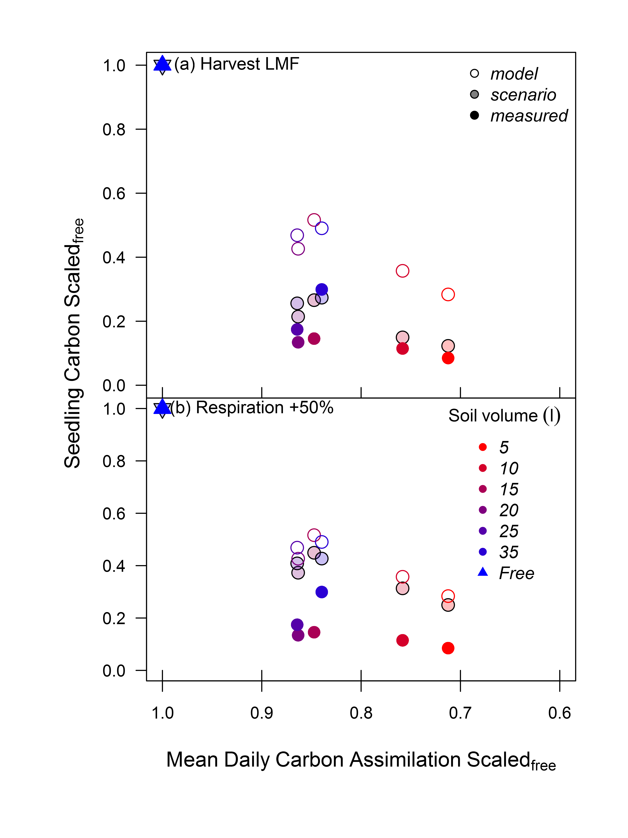  
  
  
**Figure 2.S1**. Sensitivity testing of seedling growth model to different carbon allocation strategies including; constraints of leaf mass fraction to treatment specific final harvest values (a) and increases in respiration of non-leaf tissue components by 50 % (b). Open and filled symbols represent default model and harvest values, while shaded symbols represent model sensitivity to each scenario by soil volume treatment. Both seedling carbon mass and daily carbon assimilation were first scaled to the free seedling control.

# References

Ainsworth EA, Long SP (2005) What have we learned from 15 years of free-air CO_2 enrichment (FACE)? A meta-analytic review of the responses of photosynthesis, canopy properties and plant production to rising CO2. New Phytologist 165:351–372.

Ainsworth EA, Rogers A (2007) The response of photosynthesis and stomatal conductance to rising [CO_2]: mechanisms and environmental interactions. Plant, cell & environment 30:258–270.

Arp WJ (1991) Effects of source-sink relations on photosynthetic acclimation to elevated CO_2. Plant, Cell & Environment 14:869–875.

Biran I, Eliassaf A (1980a) The effect of container size and aeration conditions on growth of roots and canopy of woody plants. Scientia Horticulturae 12:385–394.

Biran I, Eliassaf A (1980b) The effect of container shape on the development of roots and canopy of woody plants. Scientia Horticulturae 12:183–193.

Crous KY, Quentin AG, Lin Y-S, Medlyn BE, Williams DG, Barton CVM, Ellsworth DS (2013) Photosynthesis of temperate *Eucalyptus globulus* trees outside their native range has limited adjustment to elevated CO_2 and climate warming. Global change biology 19:3790–3807.

DeLucia E, Drake JE, Thomas RB, Gonzalez-Meler M (2007) Forest carbon use efficiency: is respiration a constant fraction of gross primary production? Global Change Biology 13:1157–1167.

Drake JE, Aspinwall MJ, Pfautsch S, Rymer PD, Reich PB, Smith RA, Crous KY, Tissue DT, Ghannoum O, Tjoelker MG (2014) The capacity to cope with climate warming declines from temperate to tropical latitudes in two widely distributed *Eucalyptus* species. Global change biology 21:459–472.

Drake BG, Gonzàlez-Meler MA, Long SP (1997) More efficient plants: a consequence of rising atmospheric CO_2? Annual review of plant biology 48:609–639.

Duan W, Fan PG, Wang LJ, Li WD, Yan ST, Li SH (2008) Photosynthetic response to low sink demand after fruit removal in relation to photoinhibition and photoprotection in peach trees. Tree physiology 28:123–132.

Duursma RA (2015) Plantecophys - An R Package for Analysing and Modelling Leaf Gas Exchange Data. PLoS ONE 10

Duursma R YplantQMC: Plant architectural analysis with Yplant and QuasiMC. <http://www.remkoduursma.com/yplantqmc, https://www.bitbucket.org/remkoduursma/yplantqmc/>

Duursma RA, Barton CVM, Lin Y-S, Medlyn BE, Eamus D, Tissue DT, Ellsworth DS, McMurtrie RE (2014) The peaked response of transpiration rate to vapour pressure deficit in field conditions can be explained by the temperature optimum of photosynthesis. Agricultural and Forest Meteorology 189:2–10.

Duursma RA, Falster DS, Valladares F, Sterck FJ, Pearcy RW, Lusk CH, Sendall KM, Nordenstahl M, Houter NC, Atwell BJ, Others (2012) Light interception efficiency explained by two simple variables: a test using a diversity of small-to medium-sized woody plants. New Phytologist 193:397–408.

Ebell LF (1969) Variation in total soluble sugars of conifer tissues with method of analysis. Phytochemistry 8:227–233.

Equiza MA, Day ME, Jagels R, Li X (2006) Photosynthetic downregulation in the conifer *Metasequoia glyptostroboides* growing under continuous light: the significance of carbohydrate sinks and paleoecophysiological implications. Botany 84:1453–1461.

Eyles A, Pinkard EA, Davies NW, Corkrey R, Churchill K, O’Grady AP, Sands P, Mohammed C (2013) Whole-plant versus leaf-level regulation of photosynthetic responses after partial defoliation in *Eucalyptus globulus* saplings. Journal of experimental botany 64:1625–1636.

Falik O, Reides P, Gersani M, Novoplansky A (2005) Root navigation by self inhibition. Plant, Cell & Environment 28:562–569.

Farquhar GD, Caemmerer S von von, Berry JA (1980) A biochemical model of photosynthetic CO_2 assimilation in leaves of C3 species. Planta 149:78–90.

Fourcaud T, Zhang X, Stokes A, Lambers H, Körner C (2008) Plant growth modelling and applications: the increasing importance of plant architecture in growth models. Annals of Botany 101:1053–1063.

Gould SJ (1966) Allometry and size in ontogeny and phylogeny. Biol Rev 41:587–640.

Gunderson CA, Wullschleger SD (1994) Photosynthetic acclimation in trees to rising atmospheric CO_2: a broader perspective. Photosynthesis research 39:369–388.

Handa IT, Körner C, Hättenschwiler S (2005) A test of the treeline carbon limitation hypothesis by in situ CO_2 enrichment and defoliation. Ecology 86:1288–1300.

Haouari A, Van Labeke M-C, Steppe K, Mariem FB, Braham M, Chaieb M (2013) Fruit thinning affects photosynthetic activity, carbohydrate levels, and shoot and fruit development of olive trees grown under semiarid conditions. Functional Plant Biology 40:1179–1186.

Hoch G, Popp M, Körner C (2002) Altitudinal increase of mobile carbon pools in *Pinus cembra* suggests sink limitation of growth at the Swiss treeline. Oikos 98:361–374.

Iglesias DJ, Lliso I, Tadeo FR, Talon M (2002) Regulation of photosynthesis through source: sink imbalance in citrus is mediated by carbohydrate content in leaves. Physiologia Plantarum 116:563–572.

Kallarackal J, Somen CK (1997) An ecophysiological evaluation of the suitability of *Eucalyptus grandis* for planting in the tropics. Forest Ecology and Management 95:53–61.

Kirschbaum MUF (2011) Does enhanced photosynthesis enhance growth? Lessons learned from CO_2 enrichment studies. Plant Physiology 155:117–124.

Kozlowski TT (1992) Carbohydrate sources and sinks in woody plants. The Botanical Review 58:107–222.

Körner C (2013) Growth controls photosynthesis–mostly. Nova Acta Leopoldina 114:273–283.

Lacointe A (2000) Carbon allocation among tree organs: a review of basic processes and representation in functional-structural tree models. Annals of Forest Science 57:521–533.

Lambers H, Chapin FS, Pons TL (2008) Plant physiological ecology, 2nd edn. Springer New York, New York.

Layne DR, Flore JA (1995) End-product inhibition of photosynthesis in *Prunus cerasus* L. in response to whole-plant source-sink manipulation. Journal of the American Society for Horticultural Science 120:583–599.

Le Roux X, Lacointe A, Escobar-Gutiérrez A, Le Dizès S (2001) Carbon-based models of individual tree growth: a critical appraisal. Annals of Forest Science 58:469–506.

Li WD, Li SH, Yang SH, Yang JM, Zheng XB, Li XD, Yao HM (2005) Photosynthesis in response to sink-source manipulations during different phenological stages of fruit development in peach trees: regulation by stomatal aperture and leaf temperature. Journal of horticultural science & biotechnology 80:481–487.

Lleonart J, Salat J, Torres GJ (2000) Removing allometric effects of body size in morphological analysis. Journal of Theoretical Biology 205:85–93.

Lohier T, Jabot F, Meziane D, Shipley B, Reich PB, Deffuant G (2014) Explaining ontogenetic shifts in root–shoot scaling with transient dynamics. Annals of botany 114:513–524.

Maina GG, Brown JS, Gersani M (2002) Intra-plant versus inter-plant root competition in beans: avoidance, resource matching or tragedy of the commons. Plant Ecology 160:235–247.

Markkola A, Kuikka K, Rautio P, Härmä E, Roitto M, Tuomi J (2004) Defoliation increases carbon limitation in ectomycorrhizal symbiosis of Betula pubescens. Oecologia 140:234–240.

McCleary BV, Gibson TS, Mugford DC (1997) Measurement of total starch in cereal products by amyloglucosidase--amylase method: Collaborative study. Journal of AOAC International 80:571–579.

McConnaughay KDM, Bazzaz FA (1991) Is physical space a soil resource? Ecology:94–103.

McConnaughay KDM, Coleman JS (1999) Biomass allocation in plants: ontogeny or optimality? A test along three resource gradients. Ecology 80:2581–2593.

Medlyn BE, Duursma RA, Eamus D, Ellsworth DS, Prentice IC, Barton CVM, Crous KY, Angelis P de, Freeman M, Wingate L (2011) Reconciling the optimal and empirical approaches to modelling stomatal conductance. Global Change Biology 17:2134–2144.

Mitchell PJ, O’Grady AP, Tissue DT, White DA, Ottenschlaeger ML, Pinkard EA (2013) Drought response strategies define the relative contributions of hydraulic dysfunction and carbohydrate depletion during tree mortality. New Phytologist 197:862–872.

Nakagawa S, Schielzeth H (2013) Methods in Ecology and Evolution 4:133–142.

Nebauer SG, Renau-Morata B, Guardiola JL, Molina R-V (2011) Photosynthesis down-regulation precedes carbohydrate accumulation under sink limitation in Citrus. Tree Physiology 31:169–177.

NeSmith DS, Duval JR (1998) The effect of container size. HortTechnology 8:495–498.

Norby RJ, DeLucia EH, Gielen B, Calfapietra C, Giardina CP, King JS, Ledford J, McCarthy HR, Moore DJP, Ceulemans R, Others (2005) Forest response to elevated CO_2 is conserved across a broad range of productivity. Proceedings of the National Academy of Sciences of the United States of America 102:18052–18056.

Ovaska J, Sari R, Rintamäki E, Vapaavuori E (1993) Combined effects of partial defoliation and nutrient availability on cloned *Betula pendula* saplings II. Changes in net photosynthesis and related biochemical properties. Journal of Experimental Botany 44:1395–1402.

Ovaska J, Walls M, Vapaavuori E (1993) Combined effects of partial defoliation and nutrient availability on cloned *Betula pendula* saplings I. Changes in growth, partitioning and nitrogen uptake. Journal of Experimental Botany 44:1385–1393.

Palacio S, Hernández R, Maestro-Martínez M, Camarero JJ (2012) Fast replenishment of initial carbon stores after defoliation by the pine processionary moth and its relationship to the re-growth ability of trees. Trees 26:1627–1640.

Palacio S, Hoch G, Sala A, Körner C, Millard P (2014) Does carbon storage limit tree growth? New Phytologist 201:1096–1100.

Passioura JB (2002) Soil conditions and plant growth. Plant, cell & environment 25:311–318.

Paul MJ, Foyer CH (2001) Sink regulation of photosynthesis. Journal of experimental botany 52:1383–1400.

Pinheiro J, Bates D, DebRoy S, Sarkar D, R Core Team (2015) nlme: Linear and Nonlinear Mixed Effects Models. R package version 3.1-122. <http://cran.r-project.org/package=nlme>

Pinkard EA, Beadle CL, Davidson NJ, Battaglia M (1998) Photosynthetic responses of *Eucalyptus nitens* (Deane and Maiden) Maiden to green pruning. Trees 12:119–129.

Poorter H, Bühler J, Dusschoten D van, Climent J, Postma JA (2012) Pot size matters: a meta-analysis of the effects of rooting volume on plant growth. Functional Plant Biology 39:839–850.

Poorter H, Niinemets Ü, Poorter L, Wright IJ, Villar R (2009) Causes and consequences of variation in leaf mass per area (LMA): a meta-analysis. New Phytologist 182:565–588.

Poorter H, Niklas KJ, Reich PB, Oleksyn J, Poot P, Mommer L (2012) Biomass allocation to leaves, stems and roots: meta-analyses of interspecific variation and environmental control. New Phytologist 193:30–50.

R Development Core Team R (2011) R: A Language and Environment for Statistical Computing Team RDC (ed). 1:409. <http://www.r-project.org>

Robbins NS, Pharr DM (1988) Effect of restricted root growth on carbohydrate metabolism and whole plant growth of Cucumis sativus L. Plant physiology 87:409–413.

Ronchi CP, DaMatta FM, Batista KD, Moraes GABK, Loureiro ME, Ducatti C (2006) Growth and photosynthetic down-regulation in *Coffea arabica* in response to restricted root volume. Functional Plant Biology 33:1013–1023.

Sage RF (1994) Acclimation of photosynthesis to increasing atmospheric CO_2: the gas exchange perspective. Photosynthesis research 39:351–368.

Sellin A (1999) Does pre-dawn water potential reflect conditions of equilibrium in plant and soil water status? Acta Oecologica 20:51–59.

Semchenko M, Zobel K, Heinemeyer A, Hutchings MJ (2008) Foraging for space and avoidance of physical obstructions by plant roots: a comparative study of grasses from contrasting habitats. New Phytologist 179:1162–1170.

Smith AM, Stitt M (2007) Coordination of carbon supply and plant growth. Plant, cell & environment 30:1126–1149.

Sweet GB, Wareing PF (1966) Role of plant growth in regulating photosynthesis. Nature 210:77–79.

Thomas RB, Strain BR (1991) Root restriction as a factor in photosynthetic acclimation of cotton seedlings grown in elevated carbon dioxide. Plant Physiology 96:627–634.

Tjoelker M, Oleksyn J, Reich PB, Others (1999) Acclimation of respiration to temperature and CO_2 in seedlings of boreal tree species in relation to plant size and relative growth rate. Global Change Biology 5:679–691.

Turnbull TL, Adams MA, Warren CR (2007) Increased photosynthesis following partial defoliation of field-grown *Eucalyptus globulus* seedlings is not caused by increased leaf nitrogen. Tree Physiology 27:1481–1492.

Urban L, Alphonsout L (2007) Girdling decreases photosynthetic electron fluxes and induces sustained photoprotection in mango leaves. Tree Physiology 27:345–352.

Valentine HT, Mäkelä A (2005) Bridging process-based and empirical approaches to modeling tree growth. Tree Physiology 25:769–779.

Valentini R, Matteucci G, Dolman AJ, Schulze E-D, Rebmann C, Moors EJ, Granier A, Gross P, Jensen NO, Pilegaard K, Others (2000) Respiration as the main determinant of carbon balance in European forests. Nature 404:861–865.

Warton DI, Duursma RA, Falster DS, Taskinen S (2012) smatr 3–an R package for estimation and inference about allometric lines. Methods in Ecology and Evolution 3:257–259.

Young IM, Montagu K, Conroy J, Bengough AG (1997) Mechanical impedance of root growth directly reduces leaf elongation rates of cereals. New Phytologist 135:613–619.

Zhou R, Quebedeaux B (2003) Changes in photosynthesis and carbohydrate metabolism in mature apple leaves in response to whole plant source-sink manipulation. Journal of the American Society for Horticultural Science 128:113–119.