Untitled

Court Campany

December 7, 2015

# List of Tables

**Table 1**. Final harvest C mass of above and belowground tissues, cumulative aboveground tree C uptake () and specific leaf area (SLA). Each value represents the mean (± 1 standard error) for each treatment combination. Units for C mass and are g C, while SLA are cm2 g-1. For each variable, different letters represent significant differences between treatments from the overall model which includes CO2 * drought interactions. P values represent overall differences of CO2 or drought main effects and the CO2 * drought interaction.

# List of Figures

**Figure 1**. Conceptual diagram depicting the major components of C flow among plant components including; uptake via photosynthesis, allocation to component tissues, tissue respiration and root exudation. Net aboveground C uptake (), shown in the shaded box, represents the flux of C measured within each WTC. With the WTC experimental design, total belowground C allocation (TBCA) is measured as the residual between and total aboveground C mass.

**Figure 2**. Whole tree C mass as a function of cumulative aboveground C flux for each WTC tree. Values of cumulative aboveground net C flux were measured over the final eleven months of the experiment. Whole tree C mass represents the sum of bole, branch, leaf and root C mass from allometric estimates over the same time period. The dotted line is the 1:1 relationship and the solid line represents the significant overall linear model fit from the equation y = 0.56x + 878.2 (R2 = 0.86).

**Figure 3**. Estimated canopy leaf area for each WTC tree over the final eleven months of the experiment (April 2008 to March 2009). Estimates are based on height growth, litterfall rates and two leaf area estimates following Barton et al. [-@barton2012effects]. Color and line type distinguish the treatment combination for each WTC.

**Figure 4**. Treatment means of cumulative aboveground C flux as a function of mean daily canopy leaf area over the final eleven months of the experiment. The solid line represents the significant overall linear model fit (R2 = 0.77) from the equation: y = 611.9x + 2791.2. Separate 95% confidence intervals are shown for linear regression between and mean leaf area for aCa and eCa treatments.

**Figure 5**. Treatment means of C mass fractions of leaves (a), stems (branches+boles) (c) and roots (e) as a function of tree size, via whole tree C mass. Treatment means of C allocation to leaves (b) and stems (d) as a function of cumulative aboveground net C flux. Root C allocation could not be estimated as root turnover was not known. Values for C mass fractions are calculated from final harvest biomass totals. Values for C allocation are estimated from cumulative total aboveground net C flux over the final eleven months of the experiment. Solid lines represent overall linear model fit for leaf, stem and root mass fractions (R2 = 0.53, 0.26 and 0.01, respectively), as well as leaf and stem C allocation (R2 = 0.39, 0.01, respectively).

**Figure 6**. Cumulative aboveground net C flux and additive C allocation to individual tree components from 15 April 2008 to 16 March 2009. Each panel represents mean values for each treatment combination (n=3). Both aboveground net C flux and tissue C allocation where set to 0 on 15 April 2008 in order to track the allocation of C in daily time steps. Root C mass, predicted from the logarithmic relationship between above and belowground mass partitioning of pre-planting seedlings and harvested trees, is shown on the last date.

**Figure 7**. Treatment means ± 1 standard error of cumulative aboveground net C flux, TBCA, and the residual belowground C flux (). Values of cumulative aboveground net C flux were measured over the final eleven months of the experiment. Values for TBCA are the residual between the cumulative C flux and total C mass aboveground estimated from allometric surveys over the same time period. Values for were calculated as the residual between TBCA and root C mass predicted on the last date of the eleven month period.

**Figure 8**. Total belowground C allocation as a function of cumulative aboveground net C flux across the final eleven months of the experiment. Carbon mass aboveground was estimated from allometric surveys, interpolated on a daily time scale and then subtracted from the aboveground net C flux to quantify TBCA. Individual lines represent treatment means, with color and line type distinguishing treatment combinations. The dotted line represents a theoretical investment of 50 % of aboveground net C flux towards TBCA.

**Figure S1**. Root mass as a function of shoot mass in *Eucalyptus saligna* for potted seedlings harvested before planting of WTC trees (n=17) and WTC trees harvested after 2 years (n=12). Potted seedlings were grown in 25 l pots inside each WTC, while chamber [CO2] treatments conditions were maintained. The solid line represents the significant log-log model fit (R2 = 0.98) from the equation: log(x) = 0.77(log(y)) + 0.43.

**Figure S2**. Cumulative aboveground net C flux and additive C allocation of individual tree components from 2008-4-15 and 2009-3-16. Panels represent each individual WTC. Both aboveground net C flux and tissue C allocation where set to 0 on 2008-4-15 in order to track the allocation of C in daily time steps. Total root C mass, predicted from the log relationship between above and belowground mass partitioning of pre-planting seedlings and harvested trees, is shown on the last date.

# Tables

**Table 1**. Final harvest C mass of above and belowground tissues, cumulative aboveground tree C uptake () and specific leaf area (SLA). Each value represents the mean (± 1 standard error) for each treatment combination. Units for C mass and are g C, while SLA are cm2 g-1. For each variable, different letters represent significant differences between treatments from the overall model which includes CO2 * drought interactions. P values represent overall differences of CO2 or drought main effects and the CO2 * drought interaction.

|  |  |  |  |  |  |  |  |
| --- | --- | --- | --- | --- | --- | --- | --- |
| **Treatment** | **Bole** | **Branch** | **Leaf** | **Litter** | **Root** | **Fc,T** | **SLA** |
| aCO2-dry | 5231.8 (687.0) b | 2799.2 (628.3) a | 2642.8 (370.7) a | 1129.8 (336.0) a | 3052.9 (500.2) a | 19394.2 (2169.5) a | 83.2 (3.3) a |
| aCO2-wet | 7785.1 (267.1) ab | 3154.6 (687.1) a | 3254.2 (393.5) a | 1043.1 (47.3) a | 3677.4 (316.8) a | 23556.5 (1689.0) a | 87.9 (2.8) a |
| eCO2-dry | 4080.5 (682.5) a | 1926.0 (369.4) a | 2232.1 (235.4) a | 889.4 (82.6) a | 2518.7 (481.6) a | 14620.7 (3456.2) a | 70.6 (3.6) a |
| eCO2-wet | 4026.3 (783.3) a | 1856.8 (474.5) a | 2358.3 (473.6) a | 919.0 (244.3) a | 2213.9 (705.8) a | 15197.9 (3253.5) a | 81.8 (6.1) a |
| CO2 effect (P) | 0.005 | 0.086 | 0.122 | 0.417 | 0.091 | 0.044 | 0.053 |
| Drought effect (P) | 0.085 | 0.803 | 0.358 | 0.897 | 0.766 | 0.413 | 0.089 |
| CO2 * Drought (P) | 0.075 | 0.712 | 0.539 | 0.792 | 0.397 | 0.532 | 0.454 |

# Figures

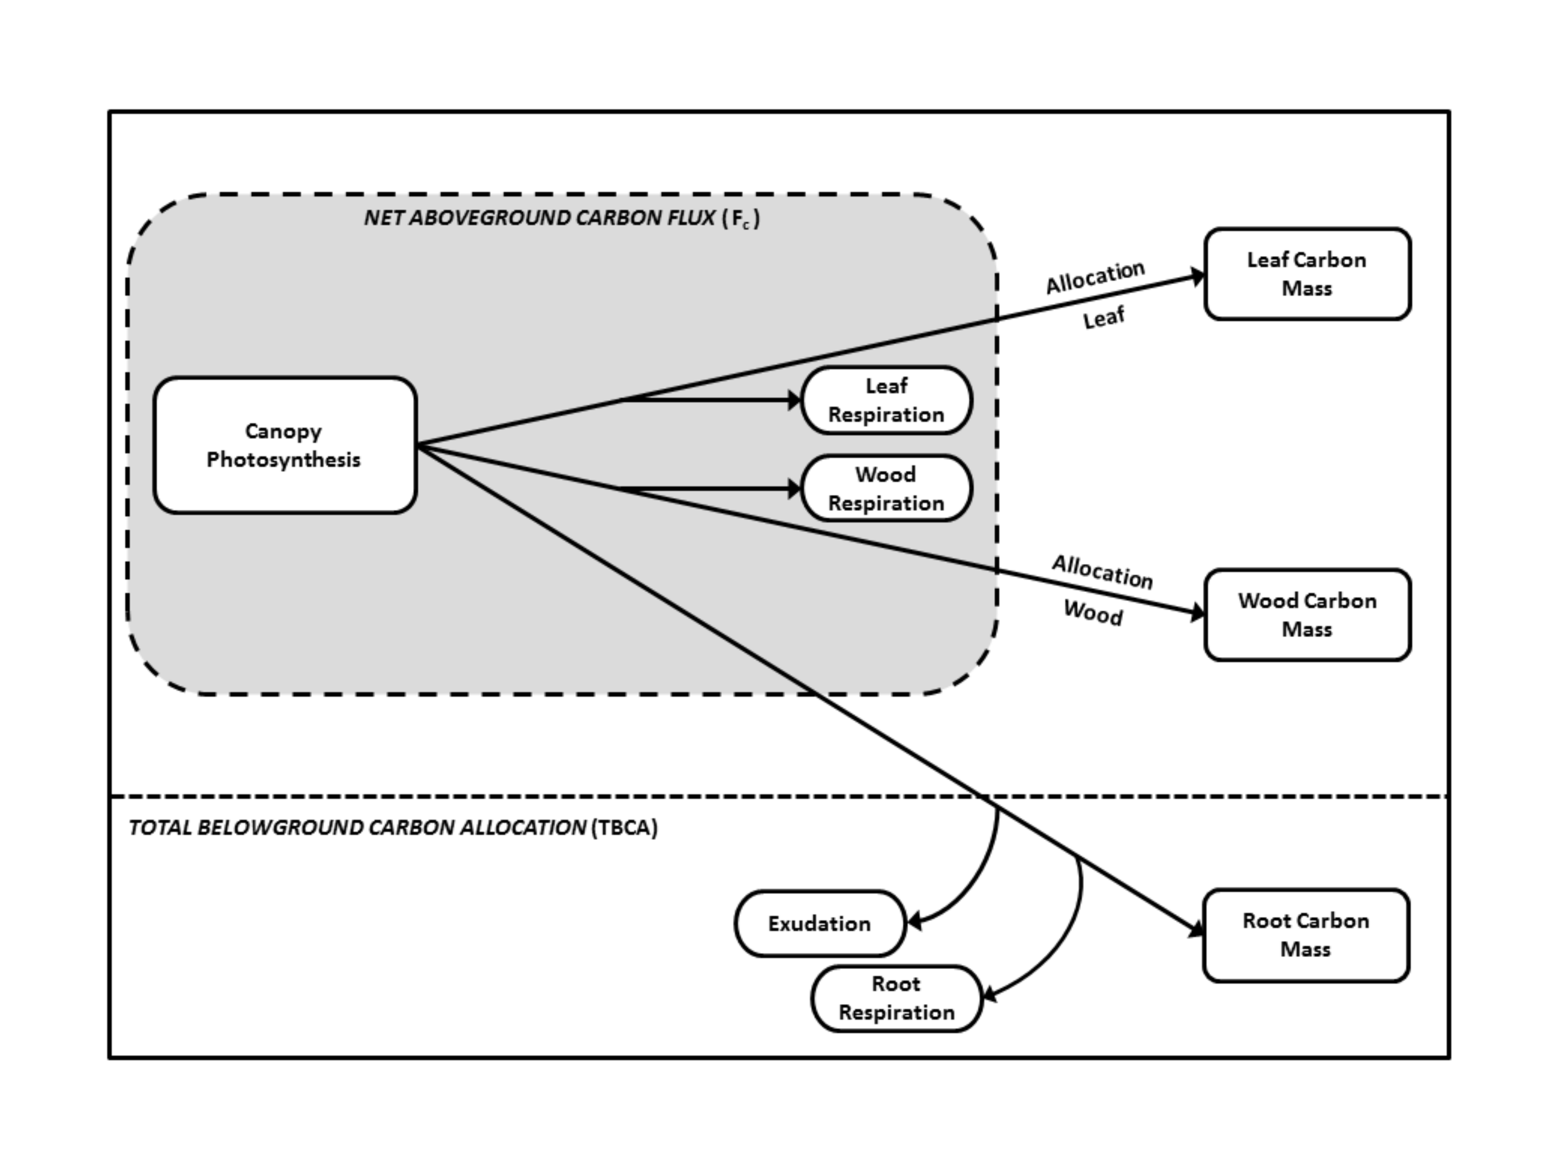  
**Figure 1**.

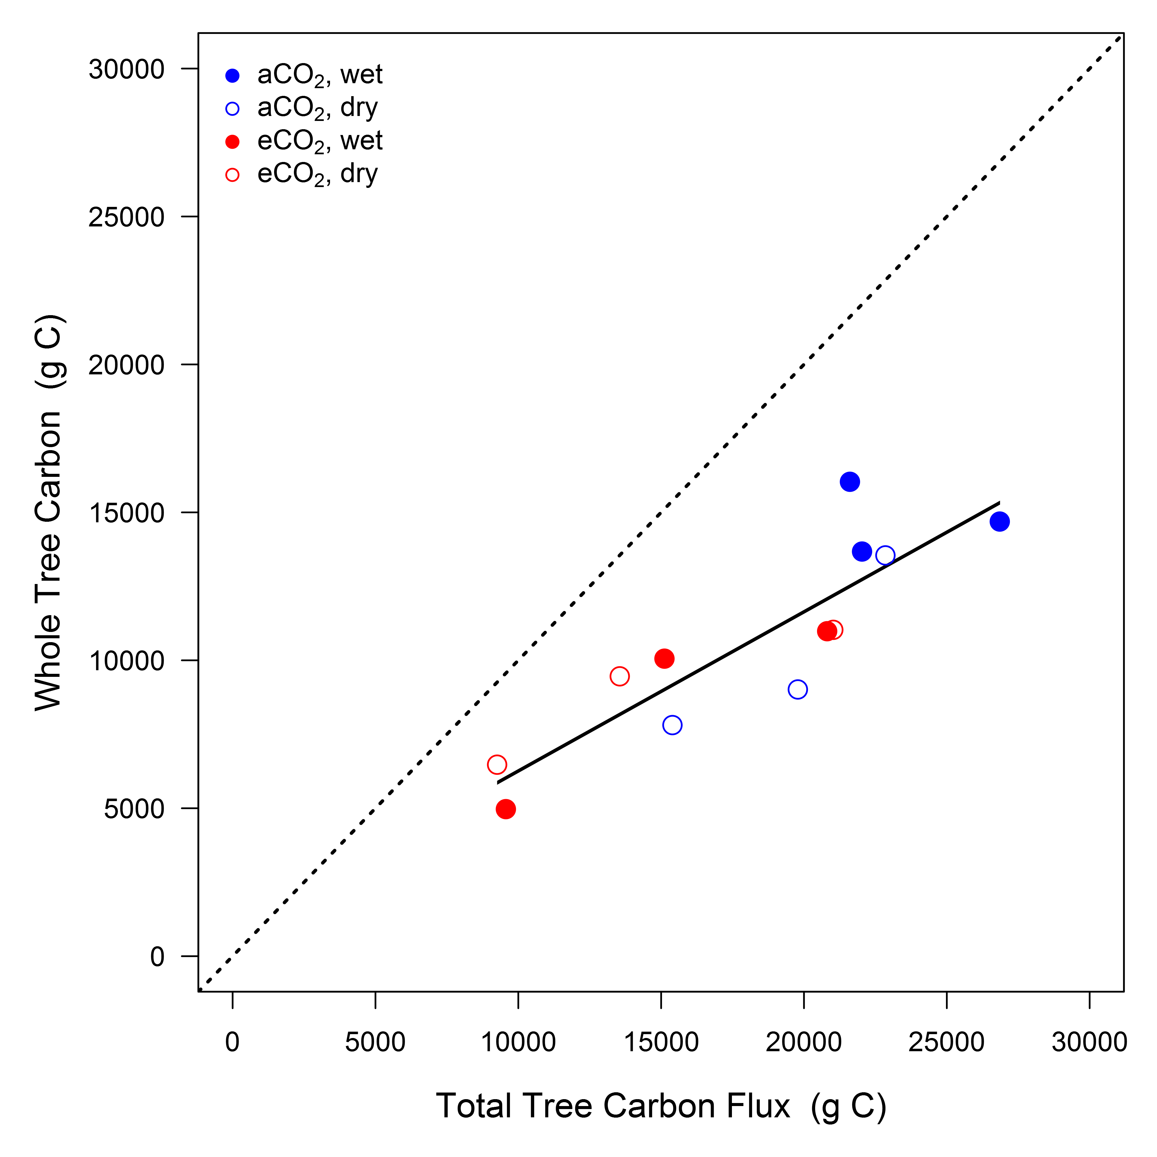  
**Figure 2**.

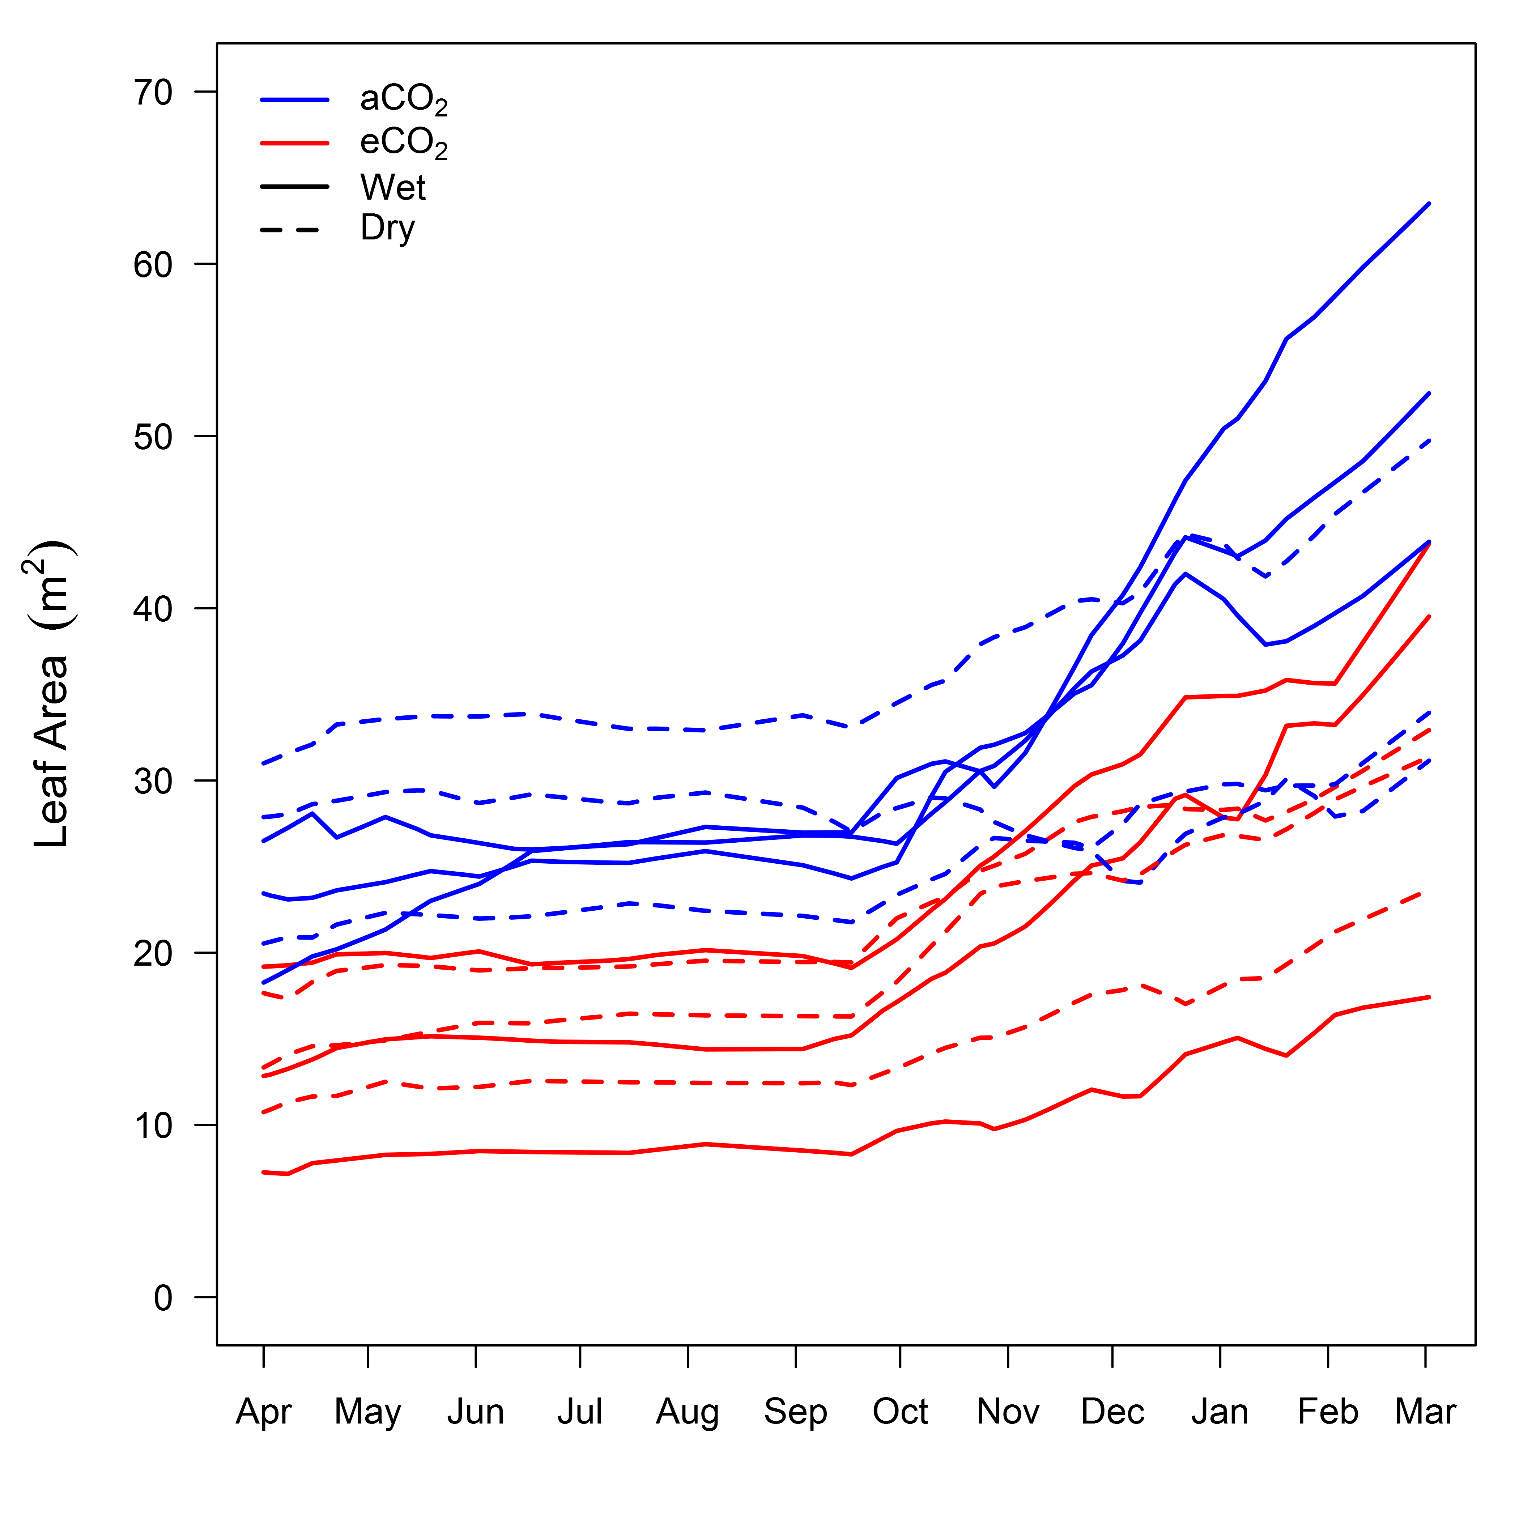  
**Figure 3**.

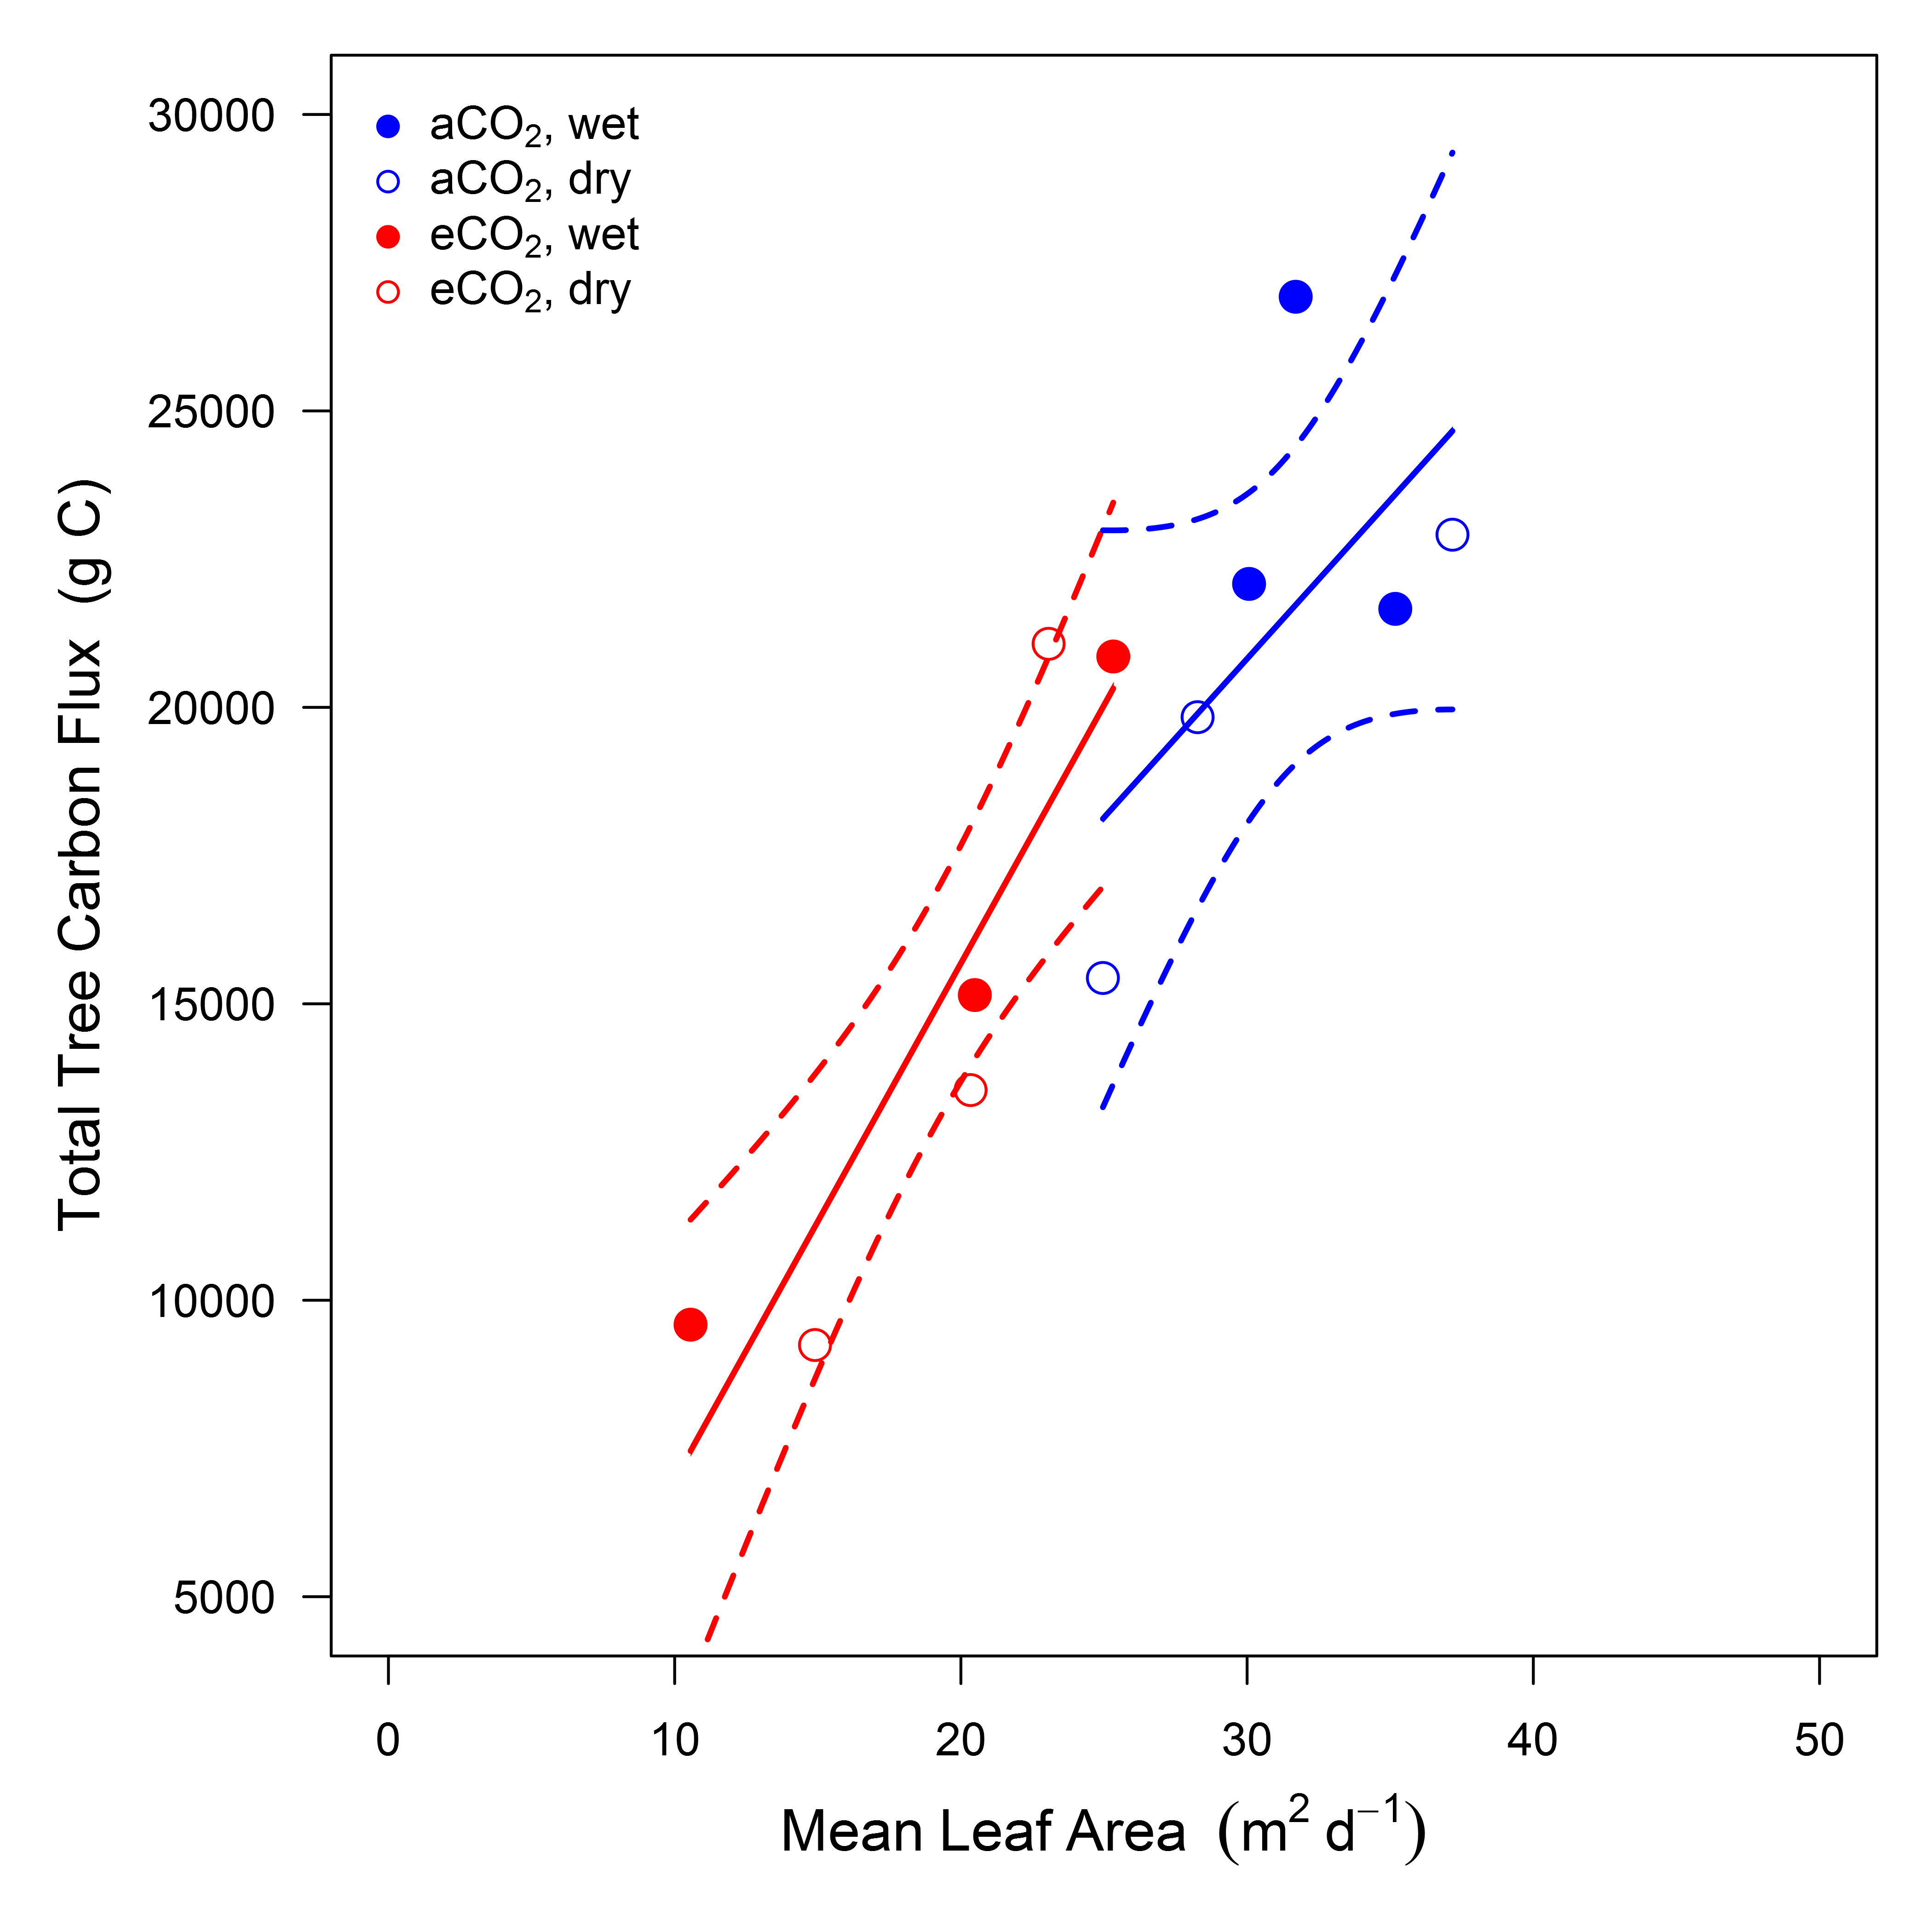  
**Figure 4**.

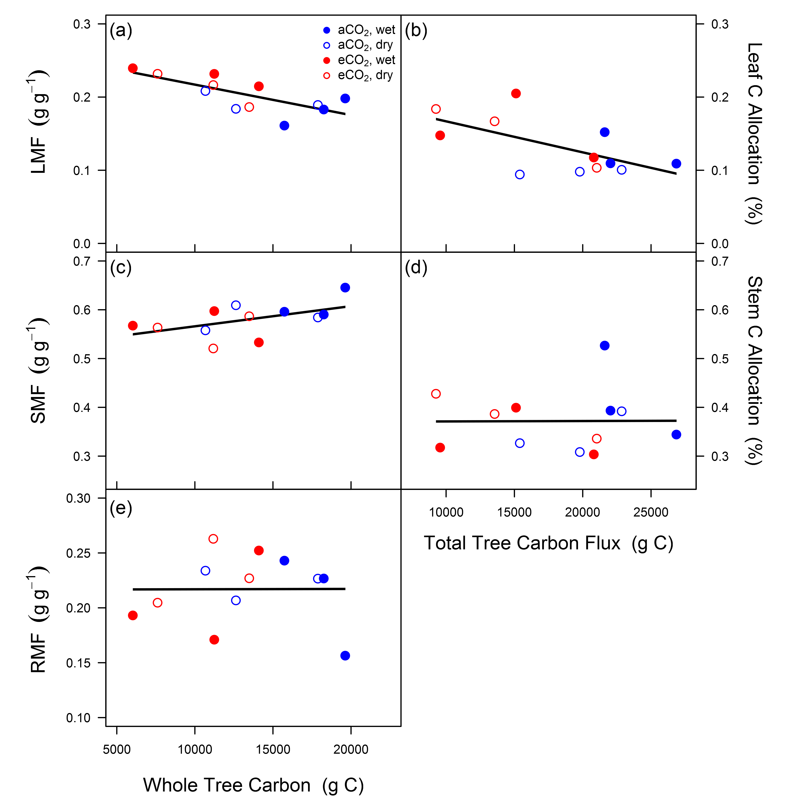  
**Figure 5**.

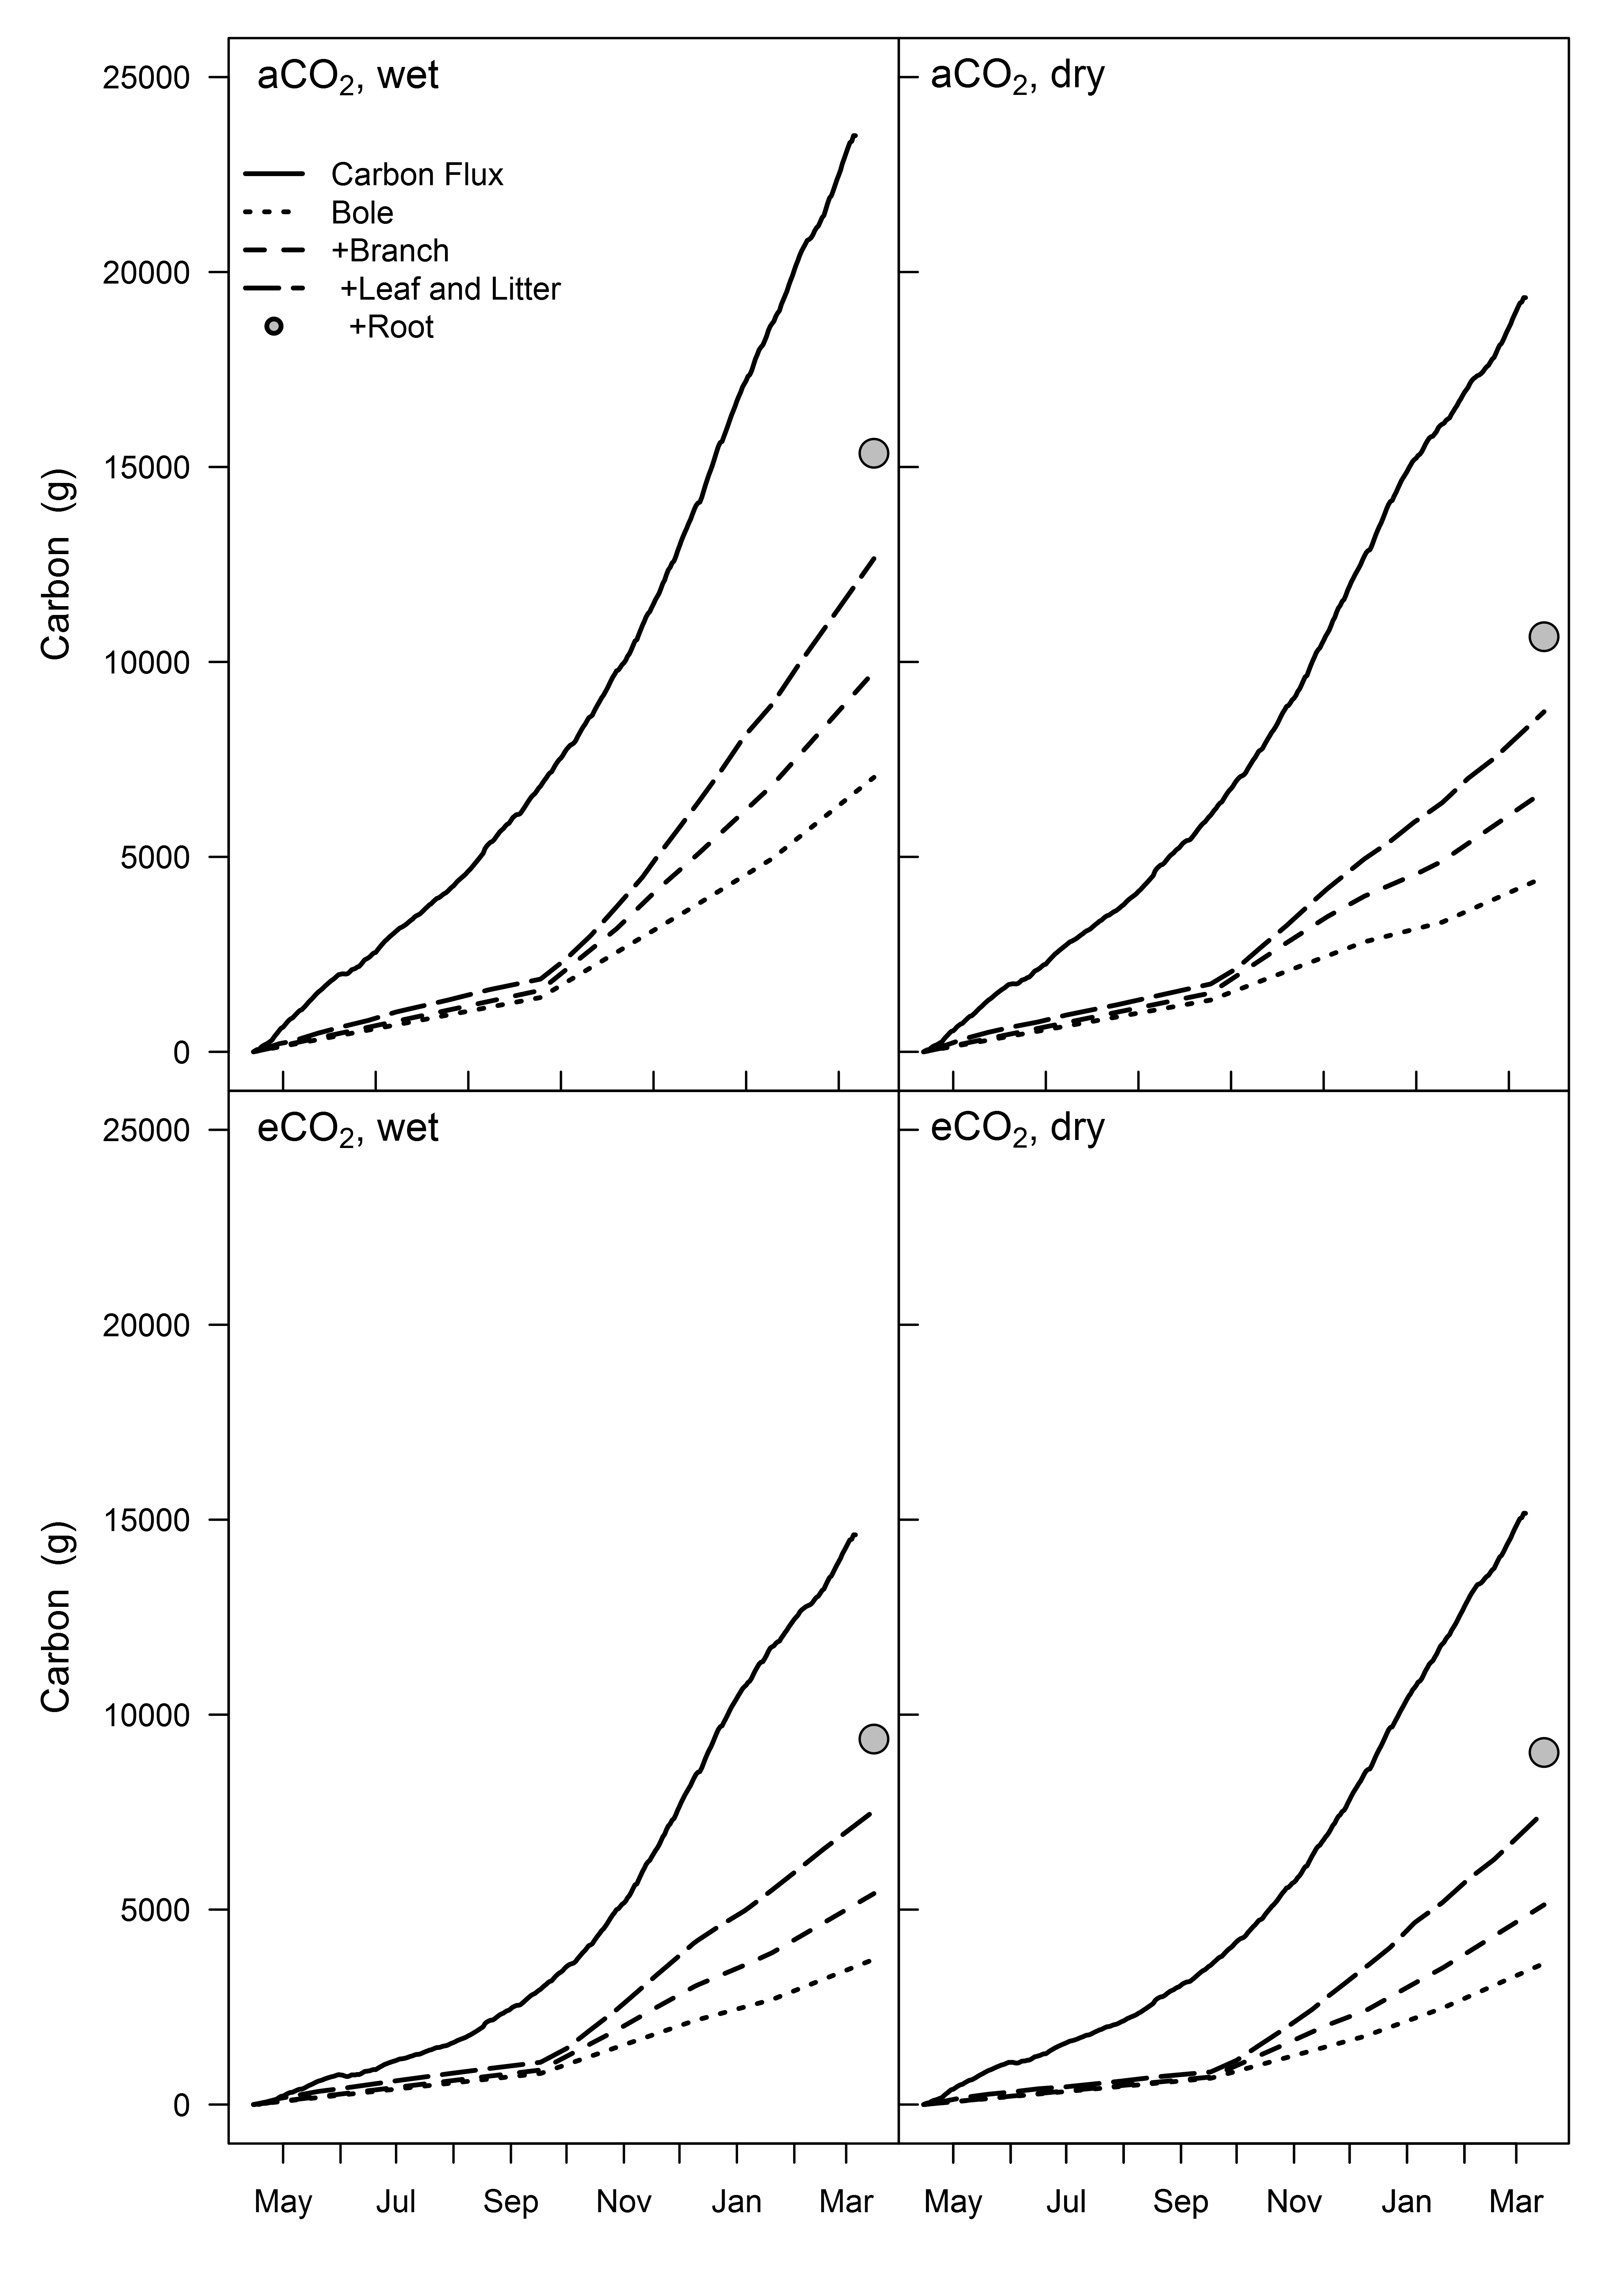  
**Figure 6**.

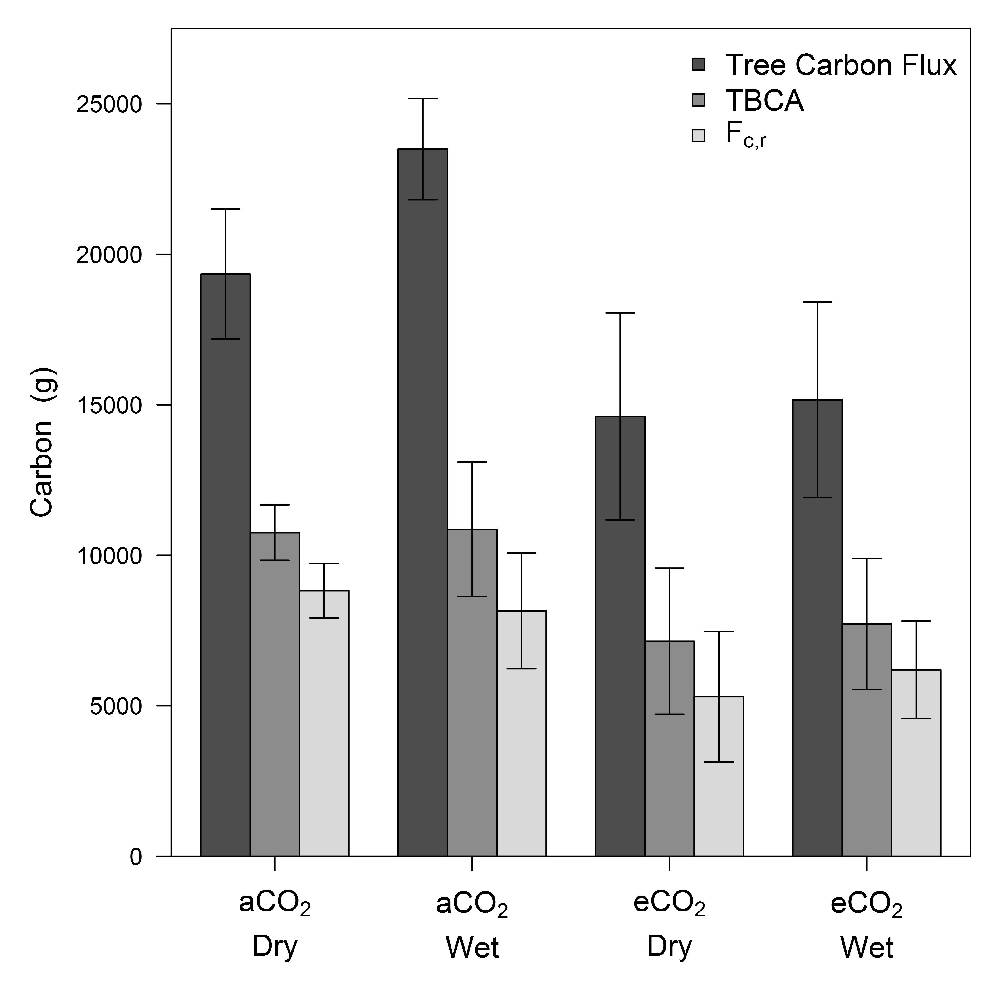  
**Figure 7**.

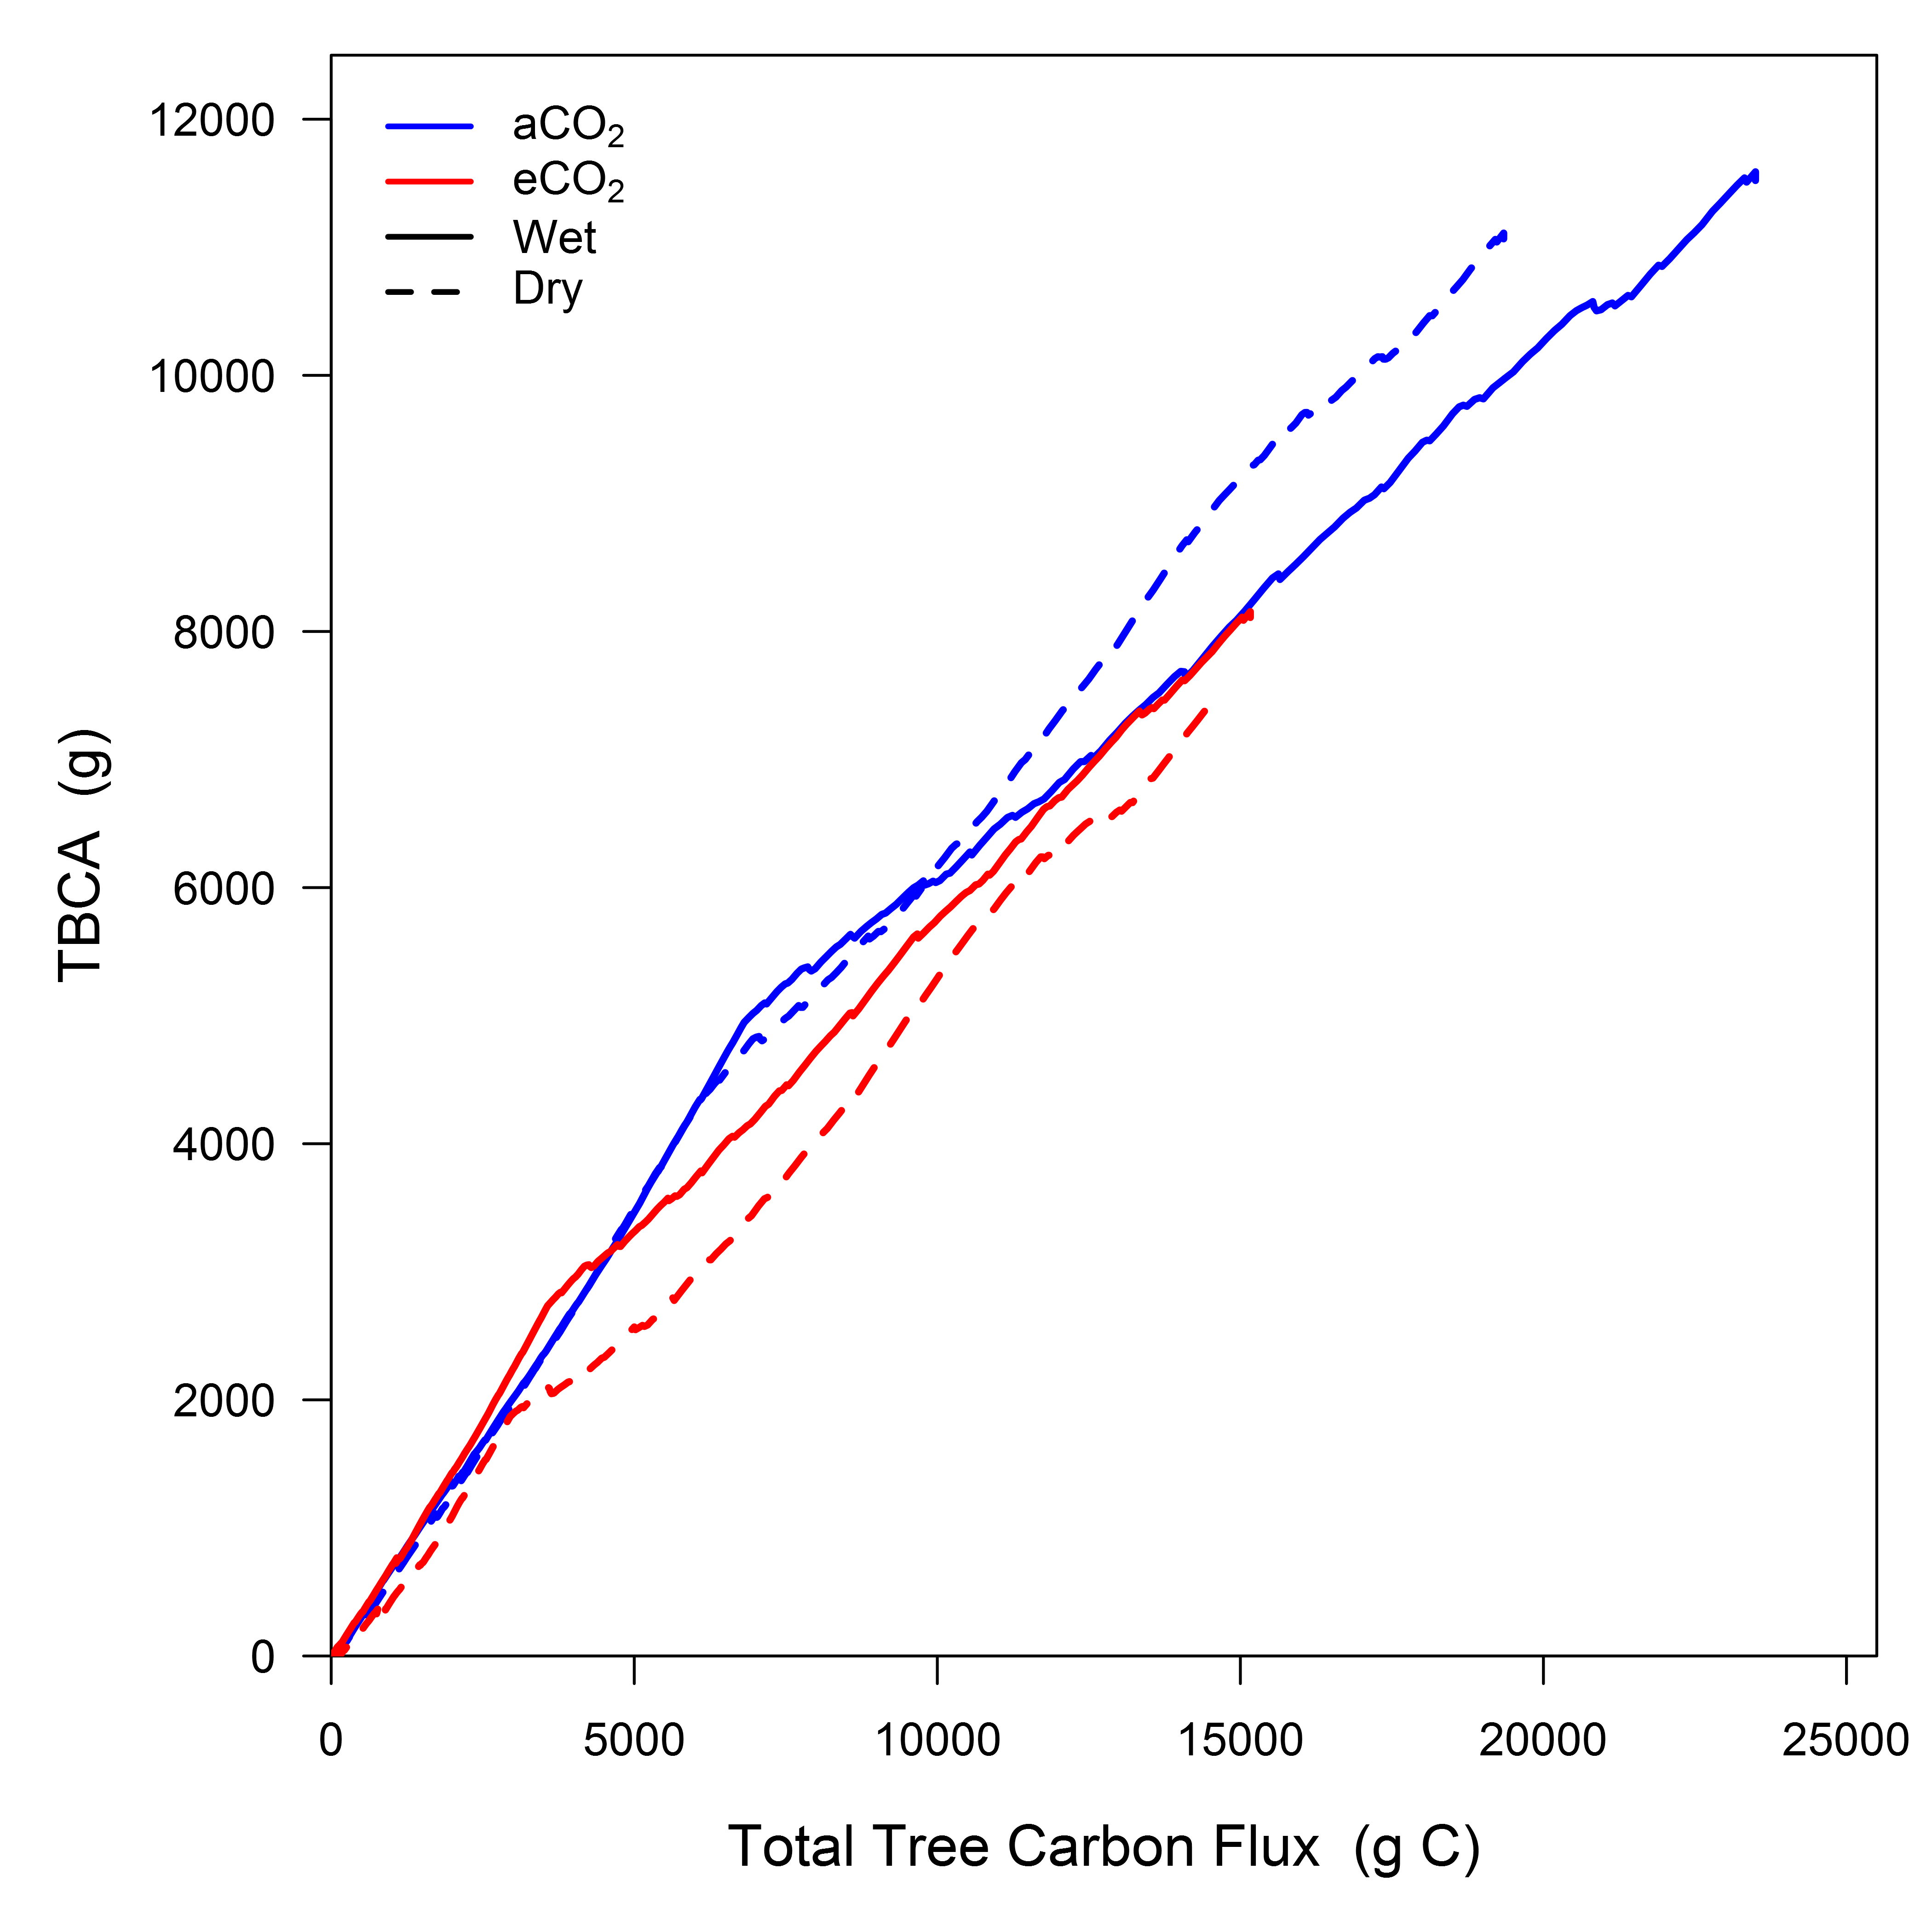  
**Figure 8**.

# Supporting Information

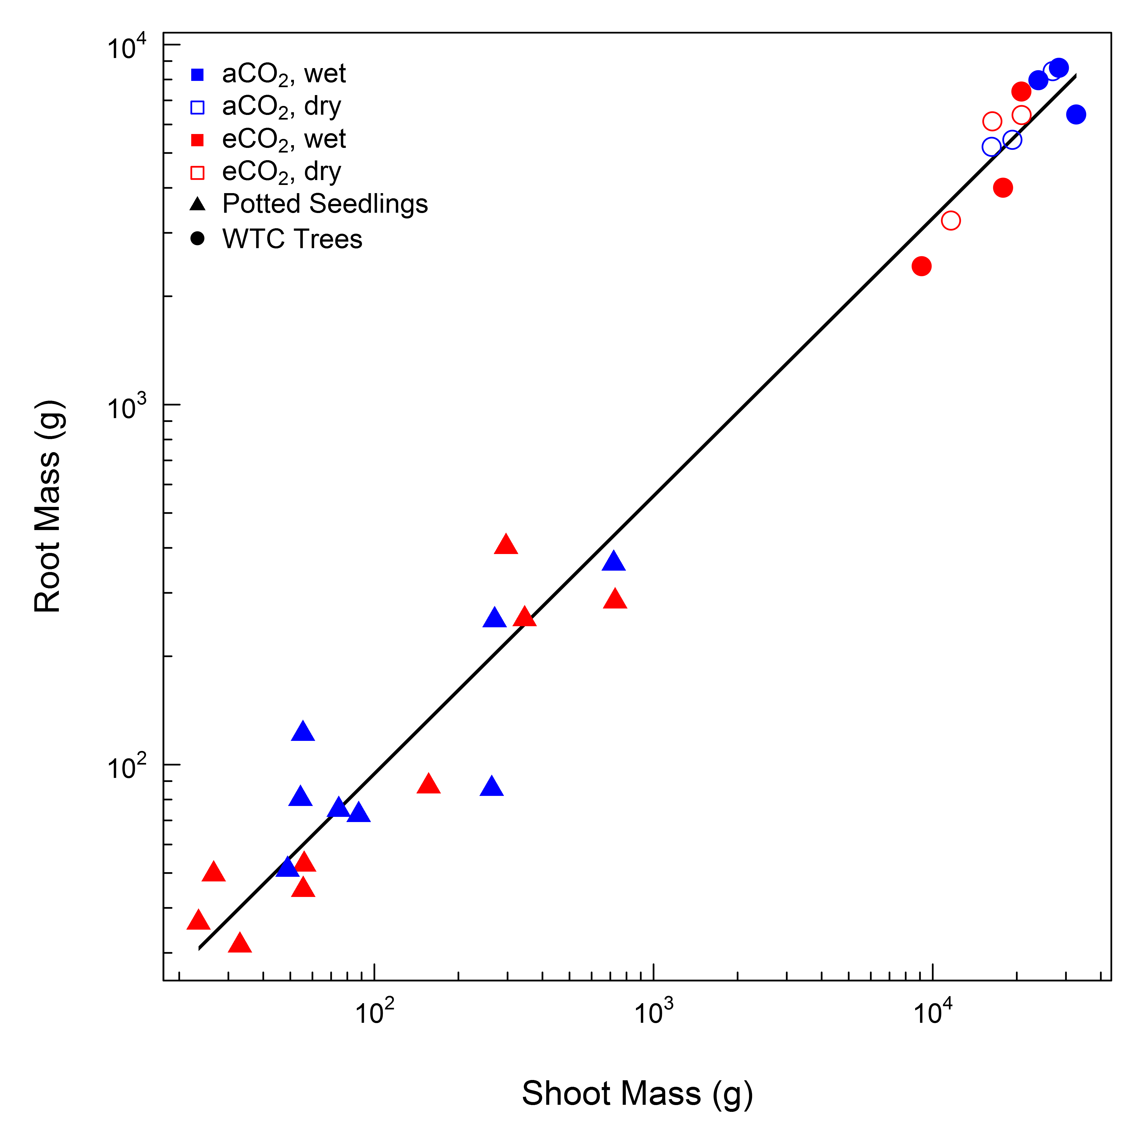  
**Figure S1**.

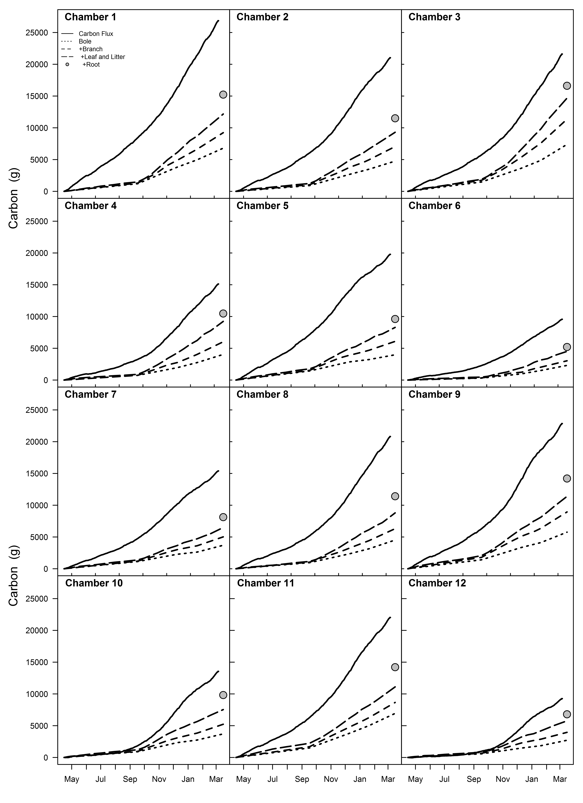  
**Figure S2**.