Elevated atmospheric [CO2] and drought alters carbon allocation patterns in *Eucalyptus saligna*.

Courtney E. Campany1, Mark Tjoelker1, Craig Barton1, Remko A. Duursma1.

1 Hawkesbury Institute for the Environment, University of Western Sydney, Locked Bag 1797, Penrith, NSW, Australia

*Corresponding author*: Courtney Campany E: [courtneycampany@gmail.com](mailto:courtneycampany@gmail.com)

# Abstract

# Key Words

# Introduction

Carbon allocation is the proportional share of biomass production invested in the growth of foliage, fine roots and woody components per unit time (Mäkelä 2012). Carbon allocation controls the flow of photosynthate between respiration and biomass production, and between short and long-lived above and belowground tissues (Epron et al. 2012). This distribution of new C among different pools and processes is an important factor in ecosystem biogeochemical and hydrological cycling (Warren et al. 2012), yet our knowledge of how environmental change impacts this distribution is incomplete. Understanding allocation is vital, as partitioning among plant organs and their feedback processes determines the growth rates of plant components (Friedlingstein et al. 1999, Lacointe 2000).

Over-simplified models generally assume that a fixed fraction of assimilation is allocated to each organ (Franklin et al. 2012). Consequently, predictions of C partitioning among tree components under climate change are still unreliable (Palmroth et al. 2006), and the representation of C allocation is rudimentary compared to A in applied forest models (Friedlingstein et al. 1999, Franklin et al. 2012). For example, soil-vegetation-atmosphere transfer models are yet to incorporate a mechanistically based scheme for C allocation (Epron et al. 2012). The deficiency of large-scale models in their allocation components seems not to be due to a lack of empirical evidence, but rather to the difficulty in defining principles that are valid under a wide range of conditions (Franklin et al. 2012). Thus, accurate modeling of forest ecosystem metabolism and predictions of the effects of global change on C cycling is still hindered (Friedlingstein et al. 1999, landsberg2003modelling; Litton et al. 2007, Epron et al. 2012).

In a resource saturated environment a plant maximizes its growth rate by allocating new C to leaves to increase C acquisition (Monsi and Saeki 2005). However, environmental stresses such as water, nutrient and light availability may cause plants to invest in roots for belowground resources and stem elongation for increased light harvesting (Friedlingstein et al. 1999). These interactions are part of a dynamic system: as the tree grows, or sink activities are altered, the fate of assimilate can shift through time. As a result, there is need to empirically measure patterns of tree C allocation under resource limitation in order to more accurately model forest C balance.

With rising atmospheric [CO2], forest C allocation has drawn particular interest due to its potential effect on C sequestration and the global C balance (Franklin et al. 2012). Increasing [CO2] has been shown to stimulate net primary production and belowground C allocation, but the flux to belowground increased twice as much as aboveground productivity, as reviewed across four forested free-air CO2 enrichment experiments (Palmroth et al. 2006). Additionally, understanding the impacts of global climate change on forests requires investigation of various global change factors to tease apart multifaceted relationships (Rustad 2008). In particular, as drought can limit plant productivity understanding potential interactions with the growth-stimulating effects of increasing [CO2] requires further attention (Duursma et al. 2011).

*TBCA* introduce some intro stuff from palmroth papers Allocation of C belowground remains one of the most difficult components of tree C budgets to calculate. In forest ecosystems, the flux of C belowground has been shown to be equal or greater than aboveground production (Law et al. 1999), yet the controls of this belowground flux are poorly understood (Raich and Nadelhoffer 1989, Giardina et al. 2005). As trees allocate such a large portion of production belowground, the difficulty in accurately measuring this allocation has limited our understanding of C cycling (Giardina and Ryan 2002). Consequently, modeling attempts to describe the response of belowground C allocation to global change often assume that responses of aboveground tissues represent those of belowground tissues (Giardina et al. 2005). These issues with both measuring and modeling tree C allocation elucidate a vital need to utilize a model experimental system which couples continuous measurements of assimilation and respiratory fluxes with the ability to track growth above and belowground.

The whole-tree chambers (WTC), located at the Hawkesbury Forest Experiment, were designed to allow continuous measurement of whole-tree net CO2 and water fluxes, allowing A, respiration and transpiration to be calculated using a mass balance approach (Medhurst et al. 2006, Barton et al. 2010). Generally, measuring canopy A is difficult as variation in photosynthetic capacity exists within the canopy in response to the environment, requiring leaf measurements and models to upscale to the canopy (Ryan et al. 2010). The WTC, however, can resolve net aboveground C gain (canopy A minus respiration of foliage and aboveground woody components, Figure 1.) at high temporal resolution, while controlling temperature and air humidity at ambient conditions. Belowground C flow, including root allocation, respiration and exudation, can then be estimated as the residual between net aboveground C gain and production of aboveground components. As a result, this experimental system provides a unique opportunity to validate models that scale from leaf gas exchange to the tree canopy with measurements of the response of whole-tree CO2 fluxes and biomass production to global change manipulations (Barton et al. 2010).

The objective of this study was to determine the response of C allocation among foliage, aboveground woody components and roots of a native Australian tree species to changes in both atmospheric [CO2] and altered water availability. Specifically we tested whether cumulative net aboveground C gain (Figure 1.) was correlated to whole tree biomass increment, as a function of tree size affected by drought and elevated CO2. Overall, the effects of drought and elevated CO2were expected to alter the fixed partitioning of C among biomass components from ambient conditions, which are commonly used in applied forest C models. Additionally, increased gross primary productivity in elevated [CO2] treatments was hypoethesized to be the result of increased C allocation to roots, as similarly reported by Palmroth et al. (2006). Increases in C allocation to roots are also expected with drought treatments to reduce water limitation (Meier and Leuschner 2008), yet the interactive effects between the two treatments are still unknown.

# Methods

## Whole tree chamber experimental design

From April 2007 Eucalyptus saligna Sm. seedlings were grown in 12 whole tree chambers (WTC) at the Hawkesbury Forest Experiment in Richmond, Australia. One seedling per WTC (10 m high) was grown for 2 years and chamber conditions tracked outside air temperature and humidity. This multifactor experiment design included CO2 × drought treatments with three replicates of in each of four treatments. Six chambers were kept at ambient atmospheric CO2 concentrations (ca. 380 ppm) and six were maintained at elevated levels of +240 ppm above ambient. Through October 2008 all trees were watered with 10 mm of water every 3 days. Next half of the chambers were subjected to drought treatments by completely withholding water, lasting through mid-February 2009. A final destructive harvest was completed in March 2009. Detailed descriptions of chamber design and operation are provided in Barton el al. (2010).

## Tree chamber gas exchange

Floors installed above the soil surface permitted the chambers to functions as cuvettes and allowed for whole tree fluxes of CO2 and water to be monitored once trees were ca. 3.5 m in height. High resolution CO2 flux data at 14 min intervals (Fs) were then available for the final year of the experiment. For expression of chamber CO2 fluxes on a canopy basis, through time, leaf area was estimated leaf counting in April 2008 and from the final harvest in March 2009. Canopy leaf area was interpolated through time height growth and litter fall rates, assuming that total cumulative leaf area followed and allometric relationship with tree height (Barton et al. 2010).

## Allometric Tree Growth and Carbon Allocation

Tree height was measured bi-weekly. Stem diameters were recorded monthly throughout the experimentmeasured at regular intervals along the main bole and split stems. Tree diameters at 65cm above the ground were used as the standard diameter because none of the trees had forks at this height. Canopy layers (5 in total) were set from the floor height and extended through the top of the canopy. For the final harvest all plant mass is reported by canopy layer including leaf, twig, branch, and buds.

## Bole Carbon

Tree heights and diameters measured along the stem made throughout the duration of the HFE-I was used to determine the volume of the main stem from base to tip. Individual volume units were constructed as concentric cylinders in between measurements of stem diameter. This approach assumed stem taper was accounted in the differences between volume sizes across stem sections. The last section which includes the top of the tree was calculated as a cone with a tip radius of .001 cm. Tree heights and diameters measured along the stem made throughout the duration of the HFE-I was used to determine the volume of the main stem from base to tip. Individual volume units were constructed as concentric cylinders in between measurements of stem diameter. This approach assumed stem taper was accounted in the differences between volume sizes across stem sections. The last section which includes the top of the tree was calculated as a cone with a tip radius of .001 cm. The volume below the standard diameter (65 cm) was calculated separately to interpolate taper into this section of the main stem. Using the height of the tree and the diameter at 65cm the diameters at 30cm and at base were modelled by extending the length of the pre-existing cone. This resulted in two stem sections for the base of each tree with taper assumed as previously stated. All volume units were summed, including split stems, to calculate total tree volume.

During the final experimental harvest 1~cm stem sections were cut at regular intervals along the main stem to determine stem density. Wood density was calculated as dry weight / fresh volume (kg m-3), and was measured separately for bark and stem wood. Fresh volume (cm3) was determined for each section through water displacement. Diameters with and without bark were measured and then stem sections were oven dried to a constant mass. For every tree bark and stem wood density were constructed for every stem section.

Whole tree stem mass was calculated for approximately monthly for every tree coordinating with stem height and diameter measurements. Stem wood mass and bark mass were calculated as volume multiplied by density for each volume unit, including a ratio parameter which corrects for the diameter proportion of bark:wood for each individual tree. Bark mass and wood mass were then summed for all volume units for every tree. Bole wood carbon was assumed to be 50% of mass, and this conversion was performed on all other subsequent plant dry mass components. Dry mass conversions by canopy layer were calculated oven drying sampled branches to a constant mass and water content was assumed to be constant within canopy layers.

## Branch and Twig Carbon

Branch mass (>1.0 cm diameter) and twig mass (<1.0 cm diameter) were estimated through time using separate equations. Branch diameter measurements were taken 5cm from their individual insertion points. During the final harvest 5 subset branches per canopy layer (n=5), covering a range of diameters, were sampled to obtain detailed measurements of architecture, allometry, and for dry mass determination. For each sampled branch the number of second order branches and composite twig mass was recorded. Basal area and length of each sample branch was determined and used to calculate the total branch volume. 5 cm was added back to each branch length in order to represent the entire branch volume. A volume shape factor, from Makela et al. (1997), was applied to each branch volume to designate each branch as an intermediate shape between a volumetric cone and a cylinder ($\phi\textsubscript{b}$, 0.75). Dry mass conversions by canopy layer were calculated oven drying sampled branches to a constant mass and water content was assumed to be constant within canopy layers. In order to estimate branch mass through time branch density ($\rho\textsubscript{b}$) was estimated for each canopy layer. Due to the thin layer of bark in branches a seperate density parameter for bark was not created. Using the dry mass and volume of each sample branch, branch density was calculated as:

(1) $$_b =

where Mb is the dry mass, Hb is the length, and $\alpha~\phi\textsubscript{b}$ is the basal area.

During the final year of the experiment branch diameter and length for each stem were collected across seven dates, including forked stems. To obtain branch mass, volume was first calculated with all individual branches for each sample period as outlined above. We assumed that branch density did not change through time and calculated branch mass at each time point~(i) as:

During the final harvest dry matter content of all twigs were recorded for each branch subset per canopy layer. Since allometric measurements were only recorded for branches, twig mass through time was estimated via the relationship between

First, the number of second order branches was estimated for each branch according to branch length (r2 = 0.91, p < 0.001). The dry mass of twigs was then estimated from the number of second order branches for each measured branch. Separate equations were developed for twig mass for branches with less than 20 (r2 = 0.61, p < 0.001) or greater than 20 second order branches (r2 = 0.72, p < 0.001). Twig mass is reported as the sum of all modelled twigs for each tree through time.

As twigs were not empirically measured through time (no allometry for branches less than 1cm) linear model equations were constructed from parameters within the detailed subset branch harvest.

## Leaf Carbon and Area

Total leaf area and mass were measured for each of the five canopy layers for each WTC at the final harvest. The relationship between cumulative tree leaf mass and leaf area was used to predict leaf mass through time for each WTC. An additional leaf census was conducted in April 2008 and the development of leaf area through the final harvest was estimated based on height growth and litterfall. For April 2008, estimates of standing leaf area were obtained from total leaf counts for each tree, multiplied by tree-specific mean leaf size (based on a sub-sample). For March 2008, foliage biomass for each canopy layer was multiplied by canopy layer specific mean specific leaf area, and summed to obtain total standing leaf area.

For the model leaf growth was assumed to coincide with height growth, so that no leaf growth occurs when height growth has ceased. We also make the assumption that total produced leaf area (i.e. standing leaf area plus that produced by litter fall) follows an allometric relationship with tree height such that:

where $A_{L,T}$ is the total 'potential' leaf area, a and b are tree specific coefficinets and H is tree height~(m). Then standing leaf area at time t are obitained from tree height at time t and cumulative litterfall:

where L(t) is the litterfall rate () at time t. Leaf litter was collected from the chambers bi-weekly, oven-dried and weighed. To convert to area-based litter fall rates, estimates of specific leaf area were obtained from data collected at the final harvest. Averages for each chamber were obtained by weighing SLA of each of the 5 layers by their foliage mass fraction. Litter was assumed to be produced by all canopy layers, and that SLA did not change between the two sampling dates. This latter assumption is known to be false (see Figure 3), but is difficult to account for. Specifically, estimates of SLA were uncertain in April 2008 because of small sample sizes. Estimates of cumulative leaf area lost were linearly interpolated between dates.

## Root Carbon

Dry root mass was calculated as a total standing crop from soil excavation during the final harvest. Root carbon was calculated for both fine roots (<2 mm diameter) and coarse roots (>2 mm diameter). Five replicate root cores (10 cm2 diameter) were taken from within each chamber at sequential depths of 0-15 cm, 15-30 cm, and 30-70 cm. The average of all five cumulative cores (0-70 cm) were taken and root mass was scaled to chamber floor area (325 cm2) to calculate standing crop of each root component.

## Above and belowgrount chamber CO2 flux

Chamber flux measurements were calculated as an hourly time step generated from the average of the raw 14 min (mol hour-1) from each chamber. Missing CO2 flux data was gap filled r with SOLO (self-organizing linear output map) (see Abramowitz et al. 2005). This is a neural network, a self-fitting model that predicts the flux as a function of PAR, Tair, VPD and day of year. The flux per unit leaf area was fitted with SOLO and converted back to the total flux. For this analysis diurnal CO2 chamber fluxes, between sunrise and sunset, were converted to grams of carbon per chamber flux area (10 m2). The daily cumulative sum of the chamber carbon flux was generated of the last year of the experiment to compare with carbon allocation of plant components.

Soil respiration (g CO2 m2 h-1) over the analyses period was measured monthly from two soil collars measured by an IRGA (Vaisala) and static chambers (). Both soil collars were averaged and one measurement per static chamber was recorded for each WTC. It is assumed that measurements taken between the two methods are similar, which allows for a more integrated respiration flux to me estimated over the final year of the experiment.

## TBCA

As the installation of floors into each WTC seperated the aboveground carbon uptake from the soil carbon efflux total belowground carbon allocation (TBCA) was then calculated as:

where F[c,t] is the gross primary productivity (g C) of the each tree aboveground minus respirtaion of leaves, stems and branches and M[ab,t] is the total standing crop biomass (g C) of stems, branches, leaves and cumulative leaf litterfall at the final harvest. As the final standing crop of fine and coarse roots were excaavted, TBCA can be further broken down into the total final carbon mass of roots (Mr) and the residual belowground carbon flux which includes; root respiration, soil respiration, root turnover and root exudation (F[s,r]). The use of aboveground allometry to interpolate M[ab,t] through time combined with Fs allowed TBCA to be estimated daily over the final year of the experiment while F[s,r] was calculated following the final harvest.

## Data analysis

# Results

# Discussion

# List of Tables

# Tables

# List of Figures

# Figures

**Figure 1**. 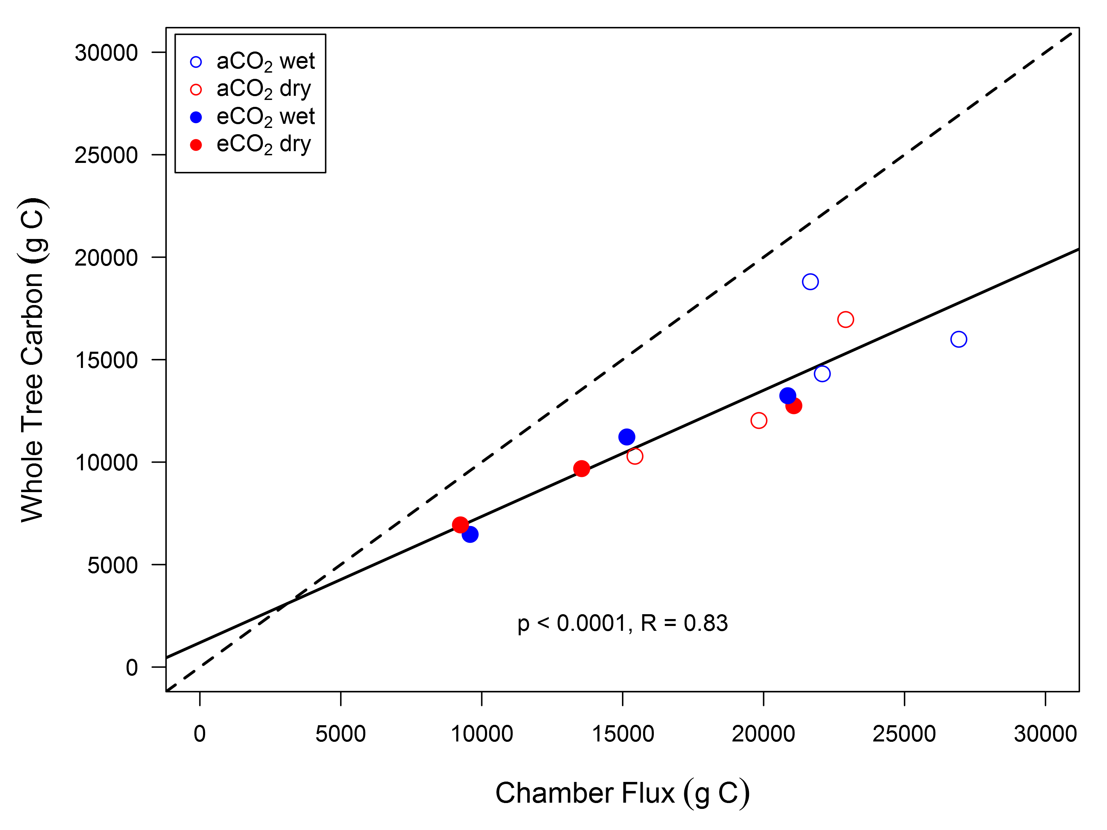

**Figure 3**. 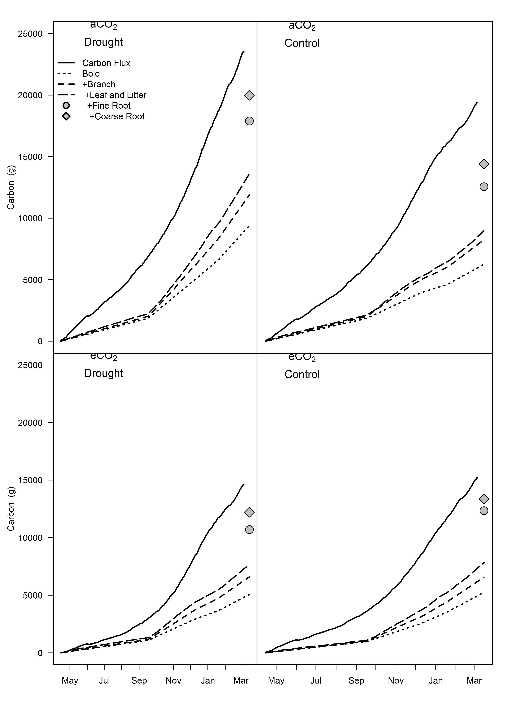

**Figure 3**. 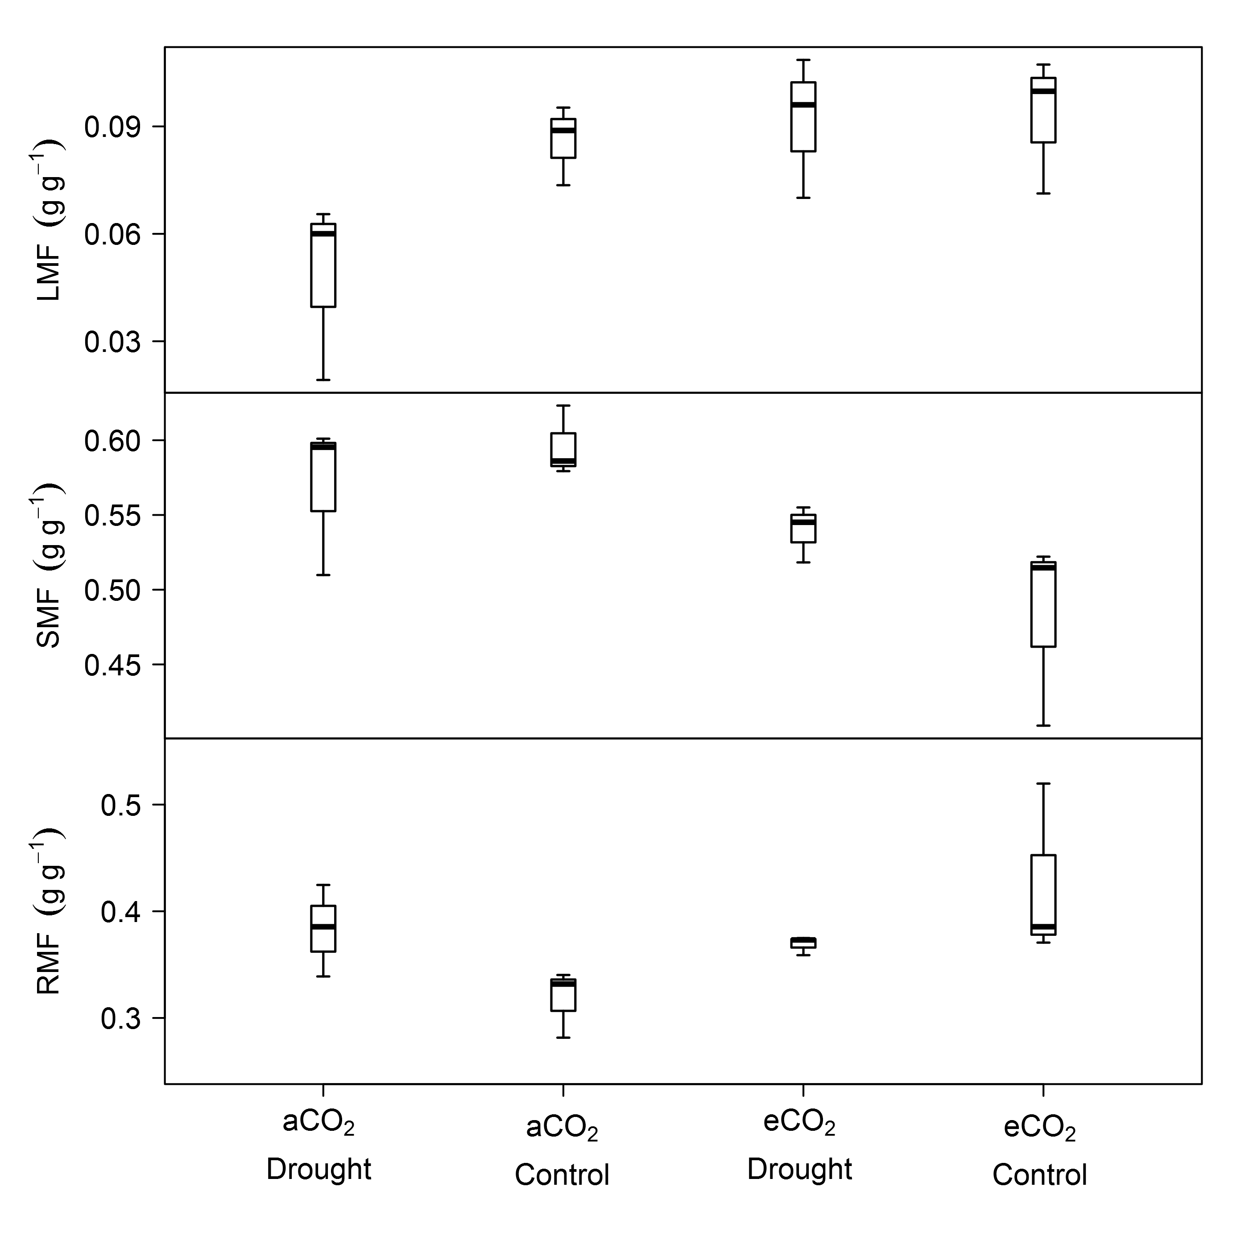

# References

Barton CVM, Ellsworth DS, Medlyn BE, Duursma RA, Tissue DT, Adams MA, Eamus D, Conroy JP, McMurtrie RE, Parsby J, Others (2010) Whole-tree chambers for elevated atmospheric CO 2 experimentation and tree scale flux measurements in south-eastern Australia: The Hawkesbury Forest Experiment. Agricultural and Forest Meteorology 150:941–951.

Duursma RA, Barton CVM, Eamus D, Medlyn BE, Ellsworth DS, Forster MA, Tissue DT, Linder S, McMurtrie RE (2011) Rooting depth explains [CO2] $∖$ times drought interaction in Eucalyptus saligna. Tree physiology:tpr030.

Epron D, Nouvellon Y, Ryan MG (2012) Introduction to the invited issue on carbon allocation of trees and forests. Tree physiology 32:639–643.

Franklin O, Johansson J, Dewar RC, Dieckmann U, McMurtrie RE, Brännström Å, Dybzinski R (2012) Modeling carbon allocation in trees: a search for principles. Tree Physiology:tpr138.

Friedlingstein P, Joel G, Field CB, Fung IY (1999) Toward an allocation scheme for global terrestrial carbon models. Global Change Biology 5:755–770.

Giardina CP, Ryan MG (2002) Total belowground carbon allocation in a fast-growing Eucalyptus plantation estimated using a carbon balance approach. Ecosystems 5:487–499.

Giardina CP, Coleman MD, Hancock JE, King JS, Lilleskov EA, Loya WM, Pregitzer KS, Ryan MG, Trettin CC (2005) The response of belowground carbon allocation in forests to global change. In: Tree species effects on soils: Implications for global change. Springer, pp 119–154.

Lacointe A (2000) Carbon allocation among tree organs: a review of basic processes and representation in functional-structural tree models. Annals of Forest Science 57:521–533.

Law BE, Ryan MG, Anthoni PM (1999) Seasonal and annual respiration of a ponderosa pine ecosystem. Global Change Biology 5:169–182.

Litton CM, Raich JW, Ryan MG (2007) Carbon allocation in forest ecosystems. Global Change Biology 13:2089–2109.

Mäkelä A (1997) A carbon balance model of growth and self-pruning in trees based on structural relationships. Forest Science 43:7–24.

Mäkelä A (2012) On guiding principles for carbon allocation in eco-physiological growth models. Tree physiology 32:644–647.

Medhurst J, Parsby J, Linder S, Wallin G, Ceschia E, Slaney M (2006) A whole-tree chamber system for examining tree-level physiological responses of field-grown trees to environmental variation and climate change. Plant, cell & environment 29:1853–1869.

Monsi M, Saeki T (2005) On the factor light in plant communities and its importance for matter production. Annals of Botany 95:549–567.

Palmroth S, Oren R, McCarthy HR, Johnsen KH, Finzi AC, Butnor JR, Ryan MG, Schlesinger WH (2006) Aboveground sink strength in forests controls the allocation of carbon below ground and its [CO2]-induced enhancement. Proceedings of the National Academy of Sciences 103:19362–19367.

Raich JW, Nadelhoffer KJ (1989) Belowground carbon allocation in forest ecosystems: global trends. Ecology 70:1346–1354.

Rustad LE (2008) The response of terrestrial ecosystems to global climate change: towards an integrated approach. Science of the Total Environment 404:222–235.

Ryan MG, Stape JL, Binkley D, Fonseca S, Loos RA, Takahashi EN, Silva CR, Silva SR, Hakamada RE, Ferreira JM, Others (2010) Factors controlling Eucalyptus productivity: How water availability and stand structure alter production and carbon allocation. Forest ecology and management 259:1695–1703.

Warren JM, Iversen CM, Garten CT, Norby RJ, Childs J, Brice D, Evans RM, Gu L, Thornton P, Weston DJ (2012) Timing and magnitude of C partitioning through a young loblolly pine (Pinus taeda L.) stand using 13C labeling and shade treatments. Tree physiology 32:799–813.