Rapid response of mesophyll conductance to light availability allows shade leaves to take advantage of sunflecks

Courtney E. Campany1, Mark Tjoelker1, Susanne von Caemmerer2, Remko A. Duursma1.

1 Hawkesbury Institute for the Environment, Western Sydney University, Locked Bag 1797, Penrith, NSW, Australia  
2 ARC Centre of Excellence for Translational Photosynthesis, Plant Science Division, Research School of Biology, The Australian National University, Canberra, ACT, Australia

Author for Correspondence:  
*Courtney Campany*  
*Tel: +61(0)432391114*  
*Email:* [*courtneycampany@gmail.com*](mailto:courtneycampany@gmail.com)

|count | answer|count2 |answer2 | |:-----------------------------|------:|:------------------------------------|:------------------------| |Total word count (main body): | 5535|No. of Figures: |6 (all in color) | |Summary: | 219|No of Tables: |2 | |Introduction: | 1207|No. of Supporting Information files: |6 (5 Figures, 1 Methods) | |Materials and Methods: | 1847| | | |Results: | 1102| | | |Discussion: | 1359| | | |Acknowledgements: | 20| | |

# Summary

* Light gradients within tree canopies play a major role in the distribution of plant resources that define leaf photosynthetic capacity. A lack of empirical data relating photosynthesis to leaf physiological behavior within tree canopies, however, impedes our ability to assess the contribution of shade leaves to canopy carbon gain.
* To investigate the CO2 diffusion pathway of sun and shade leaves, leaf gas exchange was coupled with online carbon isotope discrimination to measure net leaf photosynthesis (*An*), stomatal conductance (gs) and mesophyll conductance (gm) in *Eucalyptus tereticornis* trees grown in climate controlled whole tree chambers.
* Compared to sun leaves, shade leaves had lower A, gm, leaf nitrogen and photosynthetic biochemical parameters (Vcmax and Jmax), but gs was similar. When light intensity was increased for shade leaves both gs and gm increased, leading to increases in A greater than sun leaves.
* Here we show that dynamic physiological responses of shade leaves to altered light environments has important implications for upscaling leaf level measurements and predicting whole canopy carbon gain. We argue that the up-regulation of gm over short time intervals with light enables shade leaves to respond quickly to sunflecks, possibly representing a new mechanism underpinning leaf gas exchange responses to light.

## Key words

leaf optimal behavior, mesophyll conductance, photosynthesis, shade, stomatal conductance,

# Introduction

Light availability is one of the most important environmental drivers of leaf carbon (C) uptake in trees. Predicting C uptake of forests usually involves upscaling leaf level measurements to assess whole canopy function. Due to the costs and limitations of efficient light harvesting, plants cannot expose all leaves to full sun (Niinemets, 2010), making simple upscaling based on solar irradiance problematic. Incident photosynthetic photon flux density (PPFD) declines exponentially with cumulative leaf area index, creating a steep light gradient from the canopy top to bottom (Monsi & Saeki, 2005). Consequently, structural and functional properties of leaves are modified to efficiently use light (Vogelman *et al.*, 1996; Niinemets & Valladares, 2004), as changing irradiance strongly affects rates of leaf photosynthesis (*An*) (Evans, 1995). To estimate whole canopy C gain it is thus necessary to account for the non-linear response of *An* to light by distinguishing between shaded and sunlit leaves (De Pury & Farquhar, 1997; Linderson *et al.*, 2012).

The distribution of resources required for *An*, including leaf nitrogen (N) and supply of water, are also partially defined by canopy light gradients. As *An* has a saturating response with light and maximum rates depend in part on N-rich photosynthetic machinery, it has been argued that leaf N should be proportional to PPFD along the canopy light gradient to maximize canopy C gain at a given total canopy N (Field, 1983; Field & Mooney, 1986; Peltoniemi *et al.*, 2012; Buckley *et al.*, 2013). Changes in chlorophyll per unit N, chlorophyll a:b ratios, electron transport capacity per unit chlorophyll and ratios of electron transport capacity to Rubisco activity can also occur in response to changes in irradiance (Evans & Poorter, 2001). Sun leaves frequently experience greater water limitations in the upper canopy, despite effective vascular systems developed for high radiation loads and transpiration (Sellin *et al.*, 2008; Niinemets, 2012). Higher rates of *An* and stomatal conductance (gs) can only be sustained if the leaf specific hydraulic conductance (Kl) is also large enough to avoid low leaf water potentials (Hubbard *et al.*, 2001). Optimal photosynthetic N investment in the upper canopy will be ineffective in enhancing *An* if water supply is insufficient (Niinemets, 2012; Peltoniemi *et al.*, 2012), thus Kl should also be higher in the upper canopy to supply sunlit leaves with sufficient water (Sellin & Kupper, 2007 ; Sellin *et al.*, 2008; Burgess *et al.*).

Rates of photosynthesis in C3 plants are limited by the [CO2] available for fixation by Rubisco within the chloroplast and this [CO2] is a function of the drawdown of CO2 from the atmosphere to the site of carboxylation (Warren, 2008). This drawdown consists of multiple resistance pathways to CO2 diffusion which include CO2 diffusion from the atmosphere through stomata (stomatal conductance, gs) and then from these intercellular air spaces into the chloroplast (mesophyll conductance, gm). Based on optimal theory, regulation of gs within a tree canopy should act to efficiently utilize available supplies of light, N and water to maximize *An* (Peltoniemi *et al.*, 2012). This is because stomata are hypothesized to exhibit an optimal behaviour to maximize C gain while simultaneously minimizing water loss through transpiration (Cowan & Farquhar, 1977). Mesophyll conductance can also impose limitations on *An* as large gs (Warren, 2008; Ubierna & Marshall, 2011), reducing the efficiency of leaf N use in *An* (Niinemets, 2007) if gm constrains CO2 supply to the chloroplast. Part of the variation in photosynthetic capacity between sun and shade leaves has been proposed to be due to differences in gm (Piel *et al.*, 2002; Warren *et al.*, 2007), yet the trade-offs that constrain this diffusion pathway are yet to be explicitly quantified. Stomatal and mesophyll conductance should not be considered independent of each other (Griffiths & Helliker, 2013), but a lack of empirical data currently hinders our ability to interpreting their coupled responses to *An* across sun and shade leaves.

Additionally, accounting for short term light fluctuations within a canopy, via sunflecks, makes assessing shade leaf behaviour difficult. How shade leaves utilize sunflecks for short term C gain depends on the combined response time of gs and gm and the underlying photosynthetic biochemistry acclimated to a low light environment (Pearcy, 1990; Tausz *et al.*, 2005). The utilization of sunflecks is first limited by delayed responses of stomata opening, which may take minutes, effectively limiting the maximum assimilation rate that can be achieved (Pearcy, 1990; Vico *et al.*, 2011; Way & Pearcy, 2012). Mesophyll conductance has been shown to respond to environmental factors (e.g. CO2, temperature or vapor pressure deficit) at timescales of minutes, possibly faster than gs (Flexas *et al.*, 2008 and references therein), yet short term response to light availability are unclear. For example, gm was found to be independent of light intensity in wheat leaves (Tazoe *et al.*, 2009) but was responsive to light in tobacco (Flexas *et al.*, 2007). Anatomical parameters which regulate gm with changing irradiance such as chloroplast surface area (Terashima *et al.*, 2006) and mesophyll thickness (Boardman, 1977; terashima2001sun; Hanba *et al.*, 2002) are also unlikely to adjust during short light fluctuations. The physiological behaviour of shade leaves to maximize C gain must be assessed as both a degree of acclimation to local irradiance and as a potential response to transitory light availability.

Climate warming may also affect the physiological behaviour of leaves within a canopy. This is because leaves can be exposed to different heat, water and high light stresses as temperature and vapour pressure deficit (VPD) vary with canopy light availability (Baldocchi *et al.*, 2002; Niinemets & Valladares, 2004; Niinemets, 2007). How these stresses affect the diffusion of CO2, through either gs or gm, will have implications for upscaling *An* for sun and shade leaves. Additionally, light saturated rates of *An* are limited by the maximum rate of Rubisco carboxylation (Vcmax) or the maximum rate of photosynthetic electron transport (Jmax) across a range of temperatures, yet their temperature dependencies are not the same (Farquhar *et al.*, 1980; Medlyn *et al.*, 2002). How these parameters are differentially affected by warming may impact constraints of N distribution and leaf photosynthetic capacity across light gradients. The impacts of warming on plant physiological processes are vast, yet differentiating their impacts on leaf physiology within a canopy will be essential to evaluate whole tree responses to a changing climate.

In this study we use *Eucalyptus tereticornis* trees, planted in climate controlled whole tree chambers with ambient and elevated temperature (ambient +3°C) treatments, to empirically test whether the distribution of nitrogen and water supply and leaf physiological behaviour result in higher photosynthetic capacity in sun leaves compared to shade leaves. As leaves which developed in the shade were expected to have lower biochemical photosynthetic capacity, we then predicted that sunfleck simulations would not increase *An* to rates similar to sun leaves. We further predicted that climate warming would decrease gs and leaf C gain in sun leaves during summer months, as increased evaporation demand from higher temperatures lead to stomatal closure.

# Materials and Methods

## Whole tree chamber experimental design

Twelve *Eucalyptus tereticornis* Sm. seedlings, chosen from a single local Cumberland plain cohort, were planted in March 2013 into 12 whole-tree chambers (WTC) at the Hawkesbury Forest Experiment site near Richmond, NSW, Australia. Each chamber has a height of 9 m and seedlings were grown for 15 months. A detailed description of the WTC operation and design is available in Barton et al. (2010). Six chambers were set to match outside ambient air temperatures (AT) while the remaining 6 experienced an elevated air temperature treatment of +3°C (ET, Figure S1). Trees grew quickly and developed large canopies, with height growth reaching the top of the WTCs over the experiment duration. Trees were watered weekly with 70 L from March 2013 to November 2013. From October 2013 to the end of the experiment trees were watered every 15 days with the mean monthly rainfall amount for Richmond, NSW. In February 2013 half of the chambers (3 each of AT and ET) were subjected to a drought treatment by withholding watering. Due to a limited range of data for the drought treatment only well-watered trees are reported, which reduces the sample size of WTC (n=6 to n=3) for the final 3 months of the experiment.

Before seedlings were planted into each chamber they were maintained under well-watered conditions in 25 L pots and kept inside each chamber. This allowed for seedlings to gain sufficient size before planting while also allowing them to acclimate to chamber temperature treatments. Seedlings were planted into each chamber after mean seedling height reached ca. 100 cm. The top soils at this site, used in both pots and chambers, are an alluvial formation of low-fertility sandy loam soils (380 and 108 mg kg-1 total N and phosphorus respectively) with low organic matter (0.7 %) and low water holding capacity. A root exclusion barrier extended from chamber walls to the hard layer (ca. 1 m) and roots were allowed to grow freely below the barrier. Leaf gas exchange measurements were initiated in October 2013 when trees had both ample height growth and canopy development for realistic canopy light gradients to be measured. At this point, trees under AT treatment had a mean diameter of 28.2±1.1 mm, height of 348±15.1 cm and an leaf area of 3.9±0.1 m2. For ET treatments, trees had a mean diameter of 34.1±2.1 mm, height of 418.3±23.1 cm and an leaf area of 6.2±0.2 m2. Leaf area was calculated based on complete leaf counts and mean leaf size from a subsample.

## Leaf gas exchange, online carbon isotope discrimination and mesophyll conductance

Leaf gas exchange measurements were performed six times, beginning in October 2013 and monthly from December 2013 to April 2014. Measurements were taken on a representative sun and shade leaf for each tree during each measurement campaign. The newest fully expanded leaf from the branch apex was chosen for gas exchange measurements and sun leaves were measured in the upper third of the canopy. Here, shade leaves are defined as inner-canopy leaves developing on secondary branches in a low light environment. Shade leaves were always measured in the lower canopy, but leaves were sampled on subsequent higher branches across measurement campaigns to minimize confounding effects of leaf age. As shade leaves most likely developed slower this assured that older leaves in the bottom canopy were avoided.

Prior to gas exchange measurements photosynthetic photon flux density (PPFD) was recorded as a point measurement at the individual leaf level and a spatially averaged measurement at the canopy position for each selected leaf. A hand-held quantum sensor (LI-COR, Lincoln, NE, USA) was used to record leaf level PPFD to ensure that chosen leaves were positioned in the desired light environment, either full sun or full shade. A ceptometer (AccuPAR LP-80, Decagon Devices, Pullman, USA) was then used to measure a spatially averaged PPFD at the canopy height of each chosen leaf type. Each ceptometer reading integrated an array of 80 sensors over a total length of 84 cm. Five ceptometer readings were recorded at different locations within the canopy, but at the same height and close to each selected leaf. The mean of these readings was assumed to represent the local light environment of sun and shade leaves for each tree. All measurements of PPFD and gas exchange were performed on sunny days between 10:00-14:30 h.

Synchronized gas exchange and C isotope discrimination measurements were made similarly as described in Tazoe et al. (2011) and Evans & von Caemmerer (2013). Leaf level gas exchange was measured with a standard (2 x 3 cm) leaf cuvette using a portable gas exchange system (LI-6400XT, LI-COR, Lincoln, NE, USA). This system was coupled with a tunable diode laser (TDL; TGA100,Campbell Scientific, Inc., Logan, UT, USA) for concurrent measurements of online C isotope discrimination. The CO2 in the leaf cuvette was set at ambient atmospheric [CO2] (400 ppm) with a flow rate of 200 mol s-1. Two identical gas exchanges systems were run simultaneously, one in each of a randomly chosen WTC for each temperature treatment. Leaf temperatures were controlled at the current AT or ET WTC air temperature. PPFD in the cuvette was set to match the individual light environment of each leaf type (explained above). Periods of high irradiance were simulated for shade leaves by increasing the leaf cuvette PPFD (LI-COR red/blue light source) to match the light environment of the full sun leaf in the same tree. The maximum sunfleck response of shade leaves was then recorded once CO2 and water vapour fluxes re-stabilized in the leaf cuvette (ca. 25 min).

Once CO2 and water vapour flux values were stable for each leaf measurement, the sample and reference gas lines were diverted to the TDL via T-junctions inserted into the reference gas tube and match valve outlet of the LI-6400XT. The gas streams were dried by passing through napion gas dryers in the respective gas lines, and then 12CO2 and 13CO2 concentrations were measured for each gas stream by the TDL. Reference, sample and two calibration gases were run on alternating 80 s loops (20 s each), one for each AT and ET leaf at a matched canopy position, for a total of 12 min. This allowed for 4-5 measurements per leaf and data were averaged over the last 10 s of reference line and samples line gas streams for calculations. The two calibration gases were drawn from compressed air tanks (330 and 740 ppm CO2) in order to correct for gain drift of the TDL on each measurement cycle. Photosynthesis, gs, transpiration, VPD and intercellular [CO2] (Ci) were auto-logged every 15 s for each gas exchange system over the 12 min interval.

Mesophyll conductance was calculated from carbon isotope discrimination with equations and fractionation factors as presented in Evans & von Caemmerer (2013), including the ternary corrections proposed by Farquhar & Cernusak (2012), such that:

(1)

$$Δ_{o}=Δ_{i}−Δ_{gm}−Δ_{e}−Δ_{f}$$

where o is the observed discrimination and i, gm , e and f are the contributions to fractionation if Ci = Cc, gm, respiration and photorespiration, respectively. For this study, the CO2 compensation point ($Γ_{*}$) and respiration during the day (Rd) parameters originally derived for tobacco plants (Von Caemmerer *et al.*, 1994) were replaced with parameters derived for *Eucalyptus globulus* from Crous et al. (2012) when calculating gm. Full descriptions of the carbon isotope discrimination equations, with ternary corrections, are presented in Supporting Information Methods S1. The variation in o between sun and shade leaves and the simulated sunfleck where compared as a function of Ci:Ca. Once gm was calculated the chloroplast CO2 partial pressure (Cc) and the drawdown of CO2 from the intercellular air spaces to the site of carboxylation were estimated from the relationship between gm to the leaf photosynthesis rate (*An*) by:

(2)

## Biochemical parameters of photosynthesis

Photosynthetic CO2 response (ACi) curves were measured at 25 °C for one sun and shade leaf for each WTC prior to the initiation of the drought treatment. Each ACi curve began at the reference [CO2] of 400 l l-1 and then consisted of 12 additional steps from [CO2] of 50 to 1800 l l-1 at 25 °C at saturating light (1800 mols m-1 s-1).

From these curves the photosynthetic parameters, Jmax and Vcmax, were quantified using the biochemical model of (Farquhar *et al.*, 1980) and fit with the 'plantecophys' package (Duursma, 2015) in R (R Development Core Team, 2011) using default parameters.

As gm was known

An alternate non-rectangular hyperbola version of the biochemical model of (Farquhar *et al.*, 1980), accounting for gm, was used to quantify chloroplastic Jmax and Vcmax (Ethier & Livingston, 2004). All ACi curves were fit with the 'plantecophys' package (Duursma, 2015) in R (R Development Core Team, 2011) using default parameters and treatment specific measured gm. Conventional ACi curves, fitted without gm, are provided for reference in Supporting Information (Figure S3).

We also simulated ACc curves to determine if treatment differences in Jmax and Vcmax where instead the result of differences in gm. Comparison of ACc curves (Figure S3) and ACi curves revealed similar differences between sun and shade leaves.

## Leaf chemistry and hydraulic parameters

Following gas exchange measurements each leaf was collected, measured for leaf water potential (explained below), scanned for leaf area, dried and weighed. These leaves were then milled and analyzed for leaf N content and 13C. Leaf samples were analysed on a Delta V Advantage coupled to a Flash HT and Conflo IV (Thermo Fisher Scientific, Bremen, Germany) in dual-reactor setup. Samples were flash combusted at 1000°C and converted to CO2 and N2 and then subjected to stable isotope ratio mass spectrometry. Leaf N is reported on an area basis (Na, g m-2) and isotopic signatures of dry matter are reported relative to standard Vienna Pee Dee Belemnite.

Predawn () and midday () leaf water potentials (MPa) were measured for sun and shade leaves during each gas exchange campaign using a PMS 1505D pressure chamber (PMS Instruments, Albany, OR, USA). The leaf closest to the leaf used for gas exchange was sampled for measurement of . Predawn leaf water potential was measured before sunrise on the same day as gas exchange measurements. Leaves used for gas exchange were immediately sampled for once measurements were completed. All leaves were detached and immediately stored inside foil covered bags before water potential measurements were performed. Leaf water potential and transpiration (E, mmol-2 m-2 s-1) from gas exchange were then used to calculate leaf-specific hydraulic conductance (Kl, mmol m-2 s-1 MPa) with the equation:

(3)

$$K_{L}=\frac{E_{L}}{Ψ_{pd} −Ψ_{L}}$$

Leaf level instantaneous transpiration efficiency (ITE) was calculated as *An* divided by E. The g1 parameter was estimated from ITE to VPD response curves by fitting a rearranged optimal gs model for ITE (Medlyn *et al.*, 2011) using non-linear regression (see Duursma *et al.*, 2013). Small values of g1 indicate that transpiration is costly in C terms and plants are then likely to exhibit conservative water use, whereas large values imply a lower C construction cost and decreased water-use efficiency (Lin *et al.*, 2015).

## Data analysis

Differences in experimental parameters to either the warming treatment or leaf type were analysed by mixed-effects models in R (R Development Core Team, 2011) with WTC as a random effect. Explained variance (R2) of mixed models were computed as in (Nakagawa & Schielzeth, 2013), in which the marginal R2 represents variance explained by fixed factors and the conditional R2 by both fixed and random factors. Confidence intervals (95 %) of mixed effect linear models were generated using bootstrapping methods with 999 simulations, using the bootMer function in the 'lme4' package (Bates *et al.*, 2015). For non-linear relationships, confidence intervals were estimated by fitting a generalized additive model to the data with the 'mgcv' package, using WTC as a random effect. All tests of statistical significance were conducted at an of 0.05.

# Results

## Leaf resource distribution

Across six measurement campaigns over the 7 month period PPFD was reduced on average by >75% in the shade (Figure 1). Leaf-specific hydraulic conductance (Kl) was similar across sun and shade leaves (Table 1). This was because neither leaf water potentials ( $Ψ_{pd}$ and $Ψ_{L}$, Table 1) nor transpiration rates (E, Table 2) differed between leaf types. Leaf Na was approximately 20% higher in sun leaves compared to shade leaves (Table 1). Leaf mass per area (LMA) was not different between leaf types (Table 1). No effect of the warming treatment was detected with PPFD, , , Kl, E, Na or LMA either within or across leaf types (P > 0.05).

## Photosynthetic capacity and leaf photosynthesis rates

The photosynthetic parameters Jmax and Vcmax were higher in sun compared to shade leaves (Table 1), as estimated from ACi curves (Figure 2a). Within leaf types, no effect of the warming treatment was detected on either parameter. Among the sampled leaves, Vcmax was positively related to leaf Na across leaf types and temperature treatments (P = 0.01, Figure 2b).

Mean *An* was significantly higher in sun compared to shade leaves (+23%), when measured at their local light environment (Table 2). Additionally, leaf Na was positively related to *An* across gas exchange campaigns and leaf types measured under ambient light and temperature conditions (P < 0.001, Figure 2c). Following an increase in light intensity to match high-light conditions, *An* of shade leaves increased to values significantly greater than sun leaves at high light (P < 0.001, Table 2). No effect of the warming treatment was detected on *An* of sun leaves measured at high light or shade leaves at either low or high light. Photosynthesis within leaf types and treatments was similar through time and across the range of leaf temperatures measured (Figure S4a).

## Stomatal conductance and leaf water-use efficiency

On average, gs was 18% higher in shade compared to sun leaves under their local light environment (Table 2). Photosynthesis was positively correlated with gs in all leaves measured under high light conditions, however, gs and *An* were not correlated in shade leaves under low light (Figure 3a). Following increased PPFD, gs of shade leaves was significantly greater than both shade leaves at low light and sun leaves, pooled across all measurement dates (Figure 4a). No effect of the warming treatment was detected on gs within or across leaf types. Stomatal conductance within leaf types and treatments was similar through time and across the range of leaf temperatures measured (Figure S5b).

Measured under ambient light and temperature, leaf ITE was significantly greater in sun leaves than in shade leaves at low light (+21%, P = 0.001). Following an increase in PPFD to high-light conditions, ITE of shade leaves did not differ from shade leaves at low light and was therefore significantly lower than sun leaves (P < 0.001). Instantaneous transpiration efficiency in sun leaves was reduced in the warming treatment, but no warming effect was detected in shade leaves measured at low or high light (Table 2). The mean estimated g1 for sun leaves was 1.51±0.11 and for shade leaves with low and high light was 2.59±0.12 and 2.74±0.04. For all leaf types and light treatments there was a strong response of ITE to VPD and individual data points broadly corresponded to response curves from the optimal ITE model with a g1 value for each leaf type and treatment (Figure 5a). Within leaf types and light treatments the response of VPD to leaf temperature was similar across all measurement campaigns (Figure S5a).

Bulk-leaf 13C, as an index of integrated water-use efficiency (Marshall *et al.*, 2007), was significantly lower in shade leaves compared to sun leaves by ca. 2‰ (Table 1). No effects of the warming treatment on leaf 13C were detected. Leaf 13C and Na were positively correlated for all leaves (P<0.001, Figure 5b), with less negative 13C (higher water-use efficiency) and higher N investment in sun leaves.

## Leaf carbon isotope discrimination and mesophyll conductance

The observed carbon isotope discrimination ($Δ_{o}$) measured during photosynthesis was positively correlated with Ci:Ca for all leaf types (P < 0.001), with larger o detected for sun leaves and shade leaves at high light than shade leaves at low light (Figure S2). Carbon isotope discrimination associated with gm accounted for the majority of $Δ_{o}$ (69.7±0.4%) and varied little across measurement temperatures, leaf types, or warming treatments. The remainder consists of the contributions of gs, respiration and photorespiration to discrimination.

Mean gm was higher in sun compared to shade leaves (+27%) under their local light environment (P < 0.001). Following the increase in PPFD from low to high light on the same leaf, gm values of shade leaves increased on average 55% after approximately 25 min (Figure 6). These measured values of gm for shade leaves at high light were also equivalent or greater than those of sun leaves (Table 2). Proportional increases in gm were matched by proportional increases in *An* from low to high light in shade leaves (Figure 4b,c). Photosynthesis scaled positively with increases in gm for all leaves, with similar intercepts but different slopes between leaf type and light treatment (P = 0.0186). The large increases in gm in shade leaves under high light likely resulted in the highest rates of *An* (Figure 3b). No differences in gm were detected with the warming treatment within leaf types. Mesophyll conductance did not vary across measurements campaigns within leaf types and light treatments (Figure S4b), but a weak negative relationship with increasing leaf temperature was detected with sun and shade leaves under their local light environment (P = 0.001 & 0.04, respectively).

## Variation in intercellular and chloroplastic CO2 concentrations

Higher rates of gs in shade leaves under low and high light led to significant increases in Ci compared to sun leaves (Figure 7a). The chloroplast CO2 partial pressure was comparable between shade leaves when measured at both low and high light conditions (Figure 7c). In sun leaves Cc was significantly lower than shade leaves, consistent with a lower Ci. The drawdown of CO2 from intercellular spaces to the chloroplast, Ci-Cc, measures the coordination between gm and *An* (Von Caemmerer & Evans, 2014). This drawdown was similar between sun and shade leaves measured at their local light environment and increased marginally in shade leaves at high light (Figure 7c). This was the result of the proportional relationship between gm and *An* across all leaves. The CO2 drawdown from Ca to Ci and Ci to Cc were both relatively stable across the range of temperatures measured and gas exchange campaigns (Figure S5c and S4c, respectively).

# Discussion

Here we show that *An* in leaves within canopies of *Eucalyptus tereticornis* are limited by their local light environment, however, shade leaves increased rates of leaf C gain exceeding sun leaves when light availability increased. Although shade leaves in lower light environments exhibited relatively high gs and Ci, it was concomitant increases in gm under periods of high light availability that allowed for this up-regulation of *An*. Although we know shade leaves experience transient periods of sun and shade (Pearcy, 1990), a lack of empirical data within tree canopies currently impedes our ability to predict whole canopy C gain. These findings offer new insights into how aspects of leaf physiology may be optimized differently in sun and shade leaves and reveal how the total leaf CO2 conductance pathway should be accounted for when testing optimizations of canopy C uptake in future studies. Additionally, with measurements recorded across a large natural range of air temperatures only minimal effects a +3 °C warming treatment were detected on leaf physiology.

## Resource distribution and photosynthetic capacity

The allocation of Na constrains *An* and is thus a key trait in determining the relative contribution of individual leaves to canopy C gain. Decreasing light availability should decrease the investment into photosynthetic enzyme within a canopy (Mooney & Gulmon, 1979). As a result, acclimation of photosynthetic capacity to irradiance is typically reflected in the key photosynthetic biochemical parameters Vcmax and Jmax (Farquhar *et al.*, 1980). Our data agree with these conventional conclusions as the distribution of Na, both measures of photosynthetic capacity and *An* were all reduced in shade leaves. Leaf mass per area, however, was not different between sun and shade leaves. This could be due to leaf formation under comparative light conditions or possible unmeasured differences in total non-structural carbohydrates contents between leaf types.

Photosynthesis is also limited by the ability to supply water to the upper canopy. Ultimately, the ability of tree hydraulic architecture to supply water to foliage across increasing pathlengths affects productivity and survival (Sellin *et al.*, 2008). Using a two-leaf model, Peltoniemi et al. (2012) theorizes that optimal N distribution will be proportional to light distribution only if Kl is also optimally distributed. In this study, variation in leaf N distribution and *An* rates were not associated with subsequent changes in Kl between sun and shade leaves. Thus, no direct relationship between water supply and N distribution or *An* within the canopy were detected.

Unexpected higher rates of gs in shade leaves compared to sun leaves led to decreased ITE in shade leaves throughout the experiment. From a canopy perspective this pattern in water-use efficiency initially appears to be detrimental to C gain as *An* in sun leaves was characterized by low rates of gs and low Ci. Consistently lower leaf 13C in shade leaves also suggests that observed higher Ci and Cc in shade leaves was likely prevalent long term. Relative to the differences in *An* between leaf types, higher rates of gs in shade leaves appear to exhibit inefficient water use. As whole canopy C gain integrates the efficiency of all leaves, this begs the question of why shade leaves maintained a lower ITE compared to sun leaves.

## Physiological behaviour of sun and shade leaves

The pattern of inefficient water use in shade leaves is important as we hypothesized that gs and *An* would be proportional across sun and shade leaves. In sun leaves, *An* and gs were strongly correlated, exhibiting behaviour broadly consistent with optimal stomatal theory. However, lower rates of *An* in shade leaves were not coupled with decreases in gs, leading to the observed decreases in ITE. This is significant as optimal stomatal regulation to balance C gain with water loss has been reported across a wide range of ecosystems and plant functional types; however, empirical data is often collected only on sun leaves (e.g. Prentice *et al.*, 2014; Lin *et al.*, 2015). As a result, the often used economic framework of balancing costs of using water versus N allocation to predict *An* (Wright *et al.*, 2003) may break down when considering all leaves within a tree canopy.

It is possible that reducing stomatal response time, by sustaining higher gs, is a strategy to take advantage of high light quickly in shade leaves (Tausz *et al.*, 2005). Evidence from this study supports this hypothesis, as shade leaves increased *An* equivalent or even outperforming sun leaves under identical light intensity. Transpiration-induced cooling in shade leaves, by keeping stomata open, has also been suggested as an effective strategy to reduce sunfleck induced thermal load (Schymanski *et al.*, 2013). This is because rapid increases in leaf temperature with sunflecks have been shown to inhibit C gain (Leakey *et al.*, 2003). However, this response likely occurs at very high air temperatures and may not explain the observed gs in shade leaves across the large natural range of temperatures included in this study. How prevalent each of these strategies are within tree canopies is still unknown, as empirical studies assessing photosynthetic responses to sunflecks generally focus on seedlings (Küppers & Schneider, 1993; Pepin & Livingston, 1997; Leakey *et al.*, 2002) and understory plants, often in deep shade (Chazdon & Pearcy, 1991; Allen & Pearcy, 2000; Brantley & Young, 2009). Thus, our findings highlight a critical need for empirical measurements of shade leaves under dynamic light environments in order to accurately scale C gain from leaf to canopy (see De Pury & Farquhar, 1997).

We found that *An* and gm scaled positively across leaf types and, unexpectedly, increased proportionately after leaf stability (~25 min) when light intensity was increased in shade leaves. Research has suggested that aquaporins can facilitate increases in the CO2 permeability of the cell membranes resulting in rapid modulation of gm (Hanba *et al.*, 2004; Heinen *et al.*, 2009; Li *et al.*, 2014). This provides a potential explanation for the observed increases in gm, but the impacts of aquaporins on gm are yet to be tested in leaves of tree species. Our findings support a growing wealth of evidence that gm is highly variable and can respond to environmental variables (Flexas *et al.*, 2008). Here we provide empirical data showing gm not only varies within a canopy but the up-regulation of gm plays a critical role in the photosynthetic response of shade leaves to sunflecks.

If shade leaves "lie in wait" for sunflecks, then perhaps we should consider an alternate leaf economic strategy to maximize C gain, beyond conventional trade-offs associated with canopy resource distribution. This is because the role of gs in regulating photosynthetic induction impacts the capacity of a leaf to utilize sunflecks (Way & Pearcy, 2012). If the valuation of sunflecks as a C resource is large enough, then costs of sub-optimal stomatal behaviour could be offset over the leaf lifespan or across the entire canopy when considering both sun and shade leaf types. For example, the potential C gain in leaves where sunflecks constitute a large proportion of total daily PFFD may be large enough to tolerate decreases in ITE. However, accounting for the heterogeneous nature of light within a canopy remains a current challenge for empirical and modelling studies. Thus, models which predict leaf photosynthesis from N distribution within a canopy will be incomplete unless inclusion of canopy light extinction and the integration of sunflecks on shade leaves are included (De Pury & Farquhar, 1997).

## Conclusions

Here we show that dynamic physiological responses of shade leaves to altered light environments has important implications for upscaling leaf level measurements to the canopy. Although resource allocation constrains leaf photosynthetic capacity it is the physiological behaviour of individual leaves which actually determine C gain. These findings suggest that current theories of leaf optimal behaviour should be extended to include dynamic light environments, which will have important implications for process-based models that predict canopy C gain from rates of leaf photosynthesis. Furthermore, the dynamic nature of gm cannot be simply parameterized in tree growth models and possibly should be excluded until it can be represented properly. Additional empirical data, across multiple tree species, are needed to determine both the mechanisms and the capacity of gm to opportunistically increase CO2 drawdown. To improve our ability to predict whole canopy C gain, future research should prioritize the incorporation of both sun and shade leaf physiology, which may be optimized differently.

# Tables

**Table 1**. *Eucalyptus tereticornis* leaf morphological and physiological traits between full sun and shade leaves under ambient and elevated temperature treatments. Leaf mass per area, Na, 13C, pd, l and Kl values represent treatment mean (± 1 standard error) across measurement campaigns (n=6). Values of Vcmax and Jmax are treatment mean (± 1 standard error) from ACi curves measured in each chamber at saturating light. Units of LMA and Leaf Narea are g m2, Kl is mmol m-2 s-1 MPa, WP is MPa and 13C is ‰. Different letters represent significant differences between leaf type and temperature treatments. The P value represents the overall effect between each unique combination of leaf type and temperature treatment for each trait.

|  |  |  |  |  |  |  |  |  |  |
| --- | --- | --- | --- | --- | --- | --- | --- | --- | --- |
| **Leaf** | **Temperature** | **LMA** | **Na** | **Vcmax** | **Jmax** | **K** | **WPpre** | **WPmid** | **13c** |
| Sun | AT | 114.1 (4.5) a | 2.63 (0.08) b | 96.3 (5.9) b | 146.1 (11.2) c | 1.69 (0.18) a | -0.32 (0.03) a | -1.60 (0.10) a | -28.1 (0.18) b |
|  | ET | 109.9 (4.8) a | 2.60 (0.09) b | 84.8 (10.5) b | 130.3 (11.6) bc | 1.79 (0.15) a | -0.32 (0.02) a | -1.70 (0.09) a | -28.3 (0.17) b |
| Shade | AT | 118.3 (4.4) a | 2.13 (0.07) a | 84.0 (3.5) ab | 112.7 (5.2) ab | 1.70 (0.13) a | -0.27 (0.02) a | -1.50 (0.09) a | -29.9 (0.17) a |
|  | ET | 113.1 (4.3) a | 1.88 (0.06) a | 66.8 (5.0) a | 95.6 (5.9) a | 1.78 (0.14) a | -0.30 (0.02) a | -1.60 (0.11) a | -30.4 (0.22) a |
| P value |  | 0.781 | 0.001 | 0.028 | 0.002 | 0.973 | 0.3486 | 0.6385 | 0.001 |

**Table 2**. *Eucalyptus tereticornis* leaf gas exchange parameters for sun and shade leaves under ambient and elevated temperature treatments. Each value reflects the mean (± 1 standard error) for each treatment across gas exchange campaigns (n=6). Units for *An* and E are mol m-2 s-1, for gs are mol m-2 s-1, for gm are mol m-2 s-1 bar-1 and for VPD is kPa. Different letters represent significant differences between leaf type, light environment and temperature treatments. The P value represents the overall effect between each unique combination of leaf type, light environment and temperature treatment for each parameter.

|  |  |  |  |  |  |  |  |  |  |  |
| --- | --- | --- | --- | --- | --- | --- | --- | --- | --- | --- |
| **Leaf** | **Light** | **Temperature** | ***An*** | **gs** | **gm** | **ITE** | **E** | **VPD** | **Ci** | **Cc** |
| Sun | High | AT | 13.5 (0.3) b | 0.122 (0.005) a | 0.163 (0.005) c | 8.26 (0.48) b | 1.78 (0.07) a | 1.60 (0.04) ab | 179.8 ( 3.2) a | 92.2 ( 2.9) a |
|  |  | ET | 13.1 (0.3) b | 0.123 (0.005) a | 0.153 (0.007) bc | 6.57 (0.39) ab | 2.21 (0.09) a | 1.90 (0.05) b | 187.9 ( 2.9) a | 92.2 ( 2.8) a |
| Shade | Low | AT | 10.4 (0.1) a | 0.150 (0.005) a | 0.117 (0.004) ab | 6.24 (0.50) a | 1.93 (0.07) a | 1.40 (0.04) a | 255.4 ( 3.8) b | 160.0 ( 4.1) c |
|  |  | ET | 10.0 (0.1) a | 0.146 (0.005) a | 0.116 (0.004) a | 5.43 (0.51) a | 2.23 (0.09) a | 1.60 (0.05) a | 253.8 ( 4.1) b | 160.3 ( 3.5) bc |
|  | High | AT | 18.1 (0.3) c | 0.255 (0.007) b | 0.184 (0.003) c | 5.85 (0.33) a | 3.42 (0.12) b | 1.40 (0.04) a | 237.4 ( 2.2) b | 137.4 ( 1.9) b |
|  |  | ET | 16.7 (0.2) c | 0.246 (0.009) b | 0.177 (0.003) c | 5.02 (0.35) a | 3.81 (0.15) b | 1.70 (0.04) ab | 238.1 ( 3.2) b | 141.7 ( 2.8) bc |
| P value |  |  | 0.001 | 0.001 | 0.001 | 0.001 | 0.001 | 0.005 | 0.001 | 0.001 |

# Figures

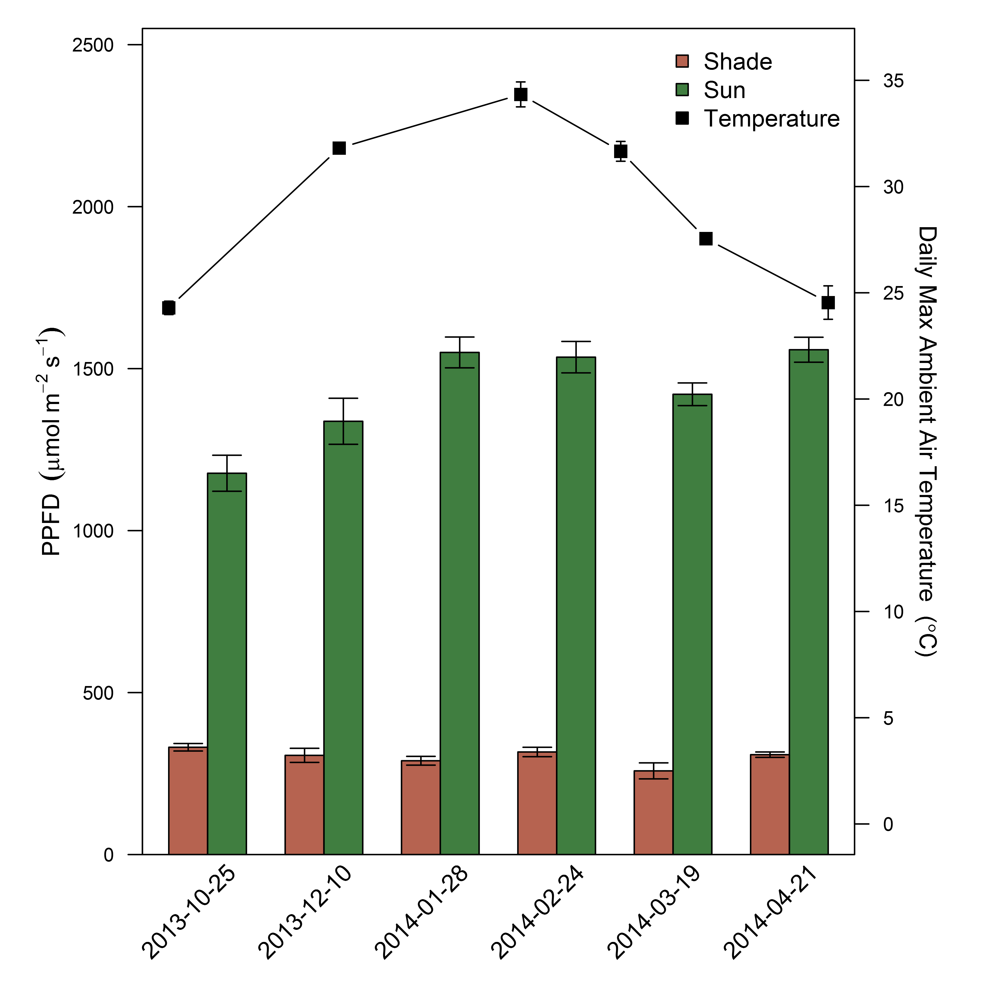  
**Figure 1**. Bars represent the local light environment for sun and shade leaves during six gas exchange campaigns from October 2013 to April 2014. Means ± 1 standard error represent integrated PPFD, measured with a ceptometer, at the canopy height of each selected leaf. Each date represents the starting date for each measurement campaign. Points represent the mean (± 1 standard error) daily maximum air temperature during each campaign period.

# {r acicurves, fig.width=8, fig.height=10, warning=FALSE,echo=FALSE,dev="png", dpi=600, dev.args=list(type="cairo")} # source("master_scripts/aci_vcmaxnitro.R") #  
  
 **Figure 2**. (a) ACi curves for sun and shade leaves at elevated (ET) and ambient (AT) temperature treatments. ACi curves were measured once on all trees, in February 2014, at 25°C and at saturating light (1800 mols m-1 s-1). (b) The relationship between Vcmax and mean leaf Na for each chamber, including sun leaves and shade leaves at low light. (c) The relationship between *An* and leaf Na for sun and shade leaves measured under their ambient light and temperature conditions. For (b,c) the dashed line represents the significant linear model fit for all leaves, with a marginal and conditional R2 of 0.28 and 0.35 for (b) and 0.24 and 0.33 for (c).  
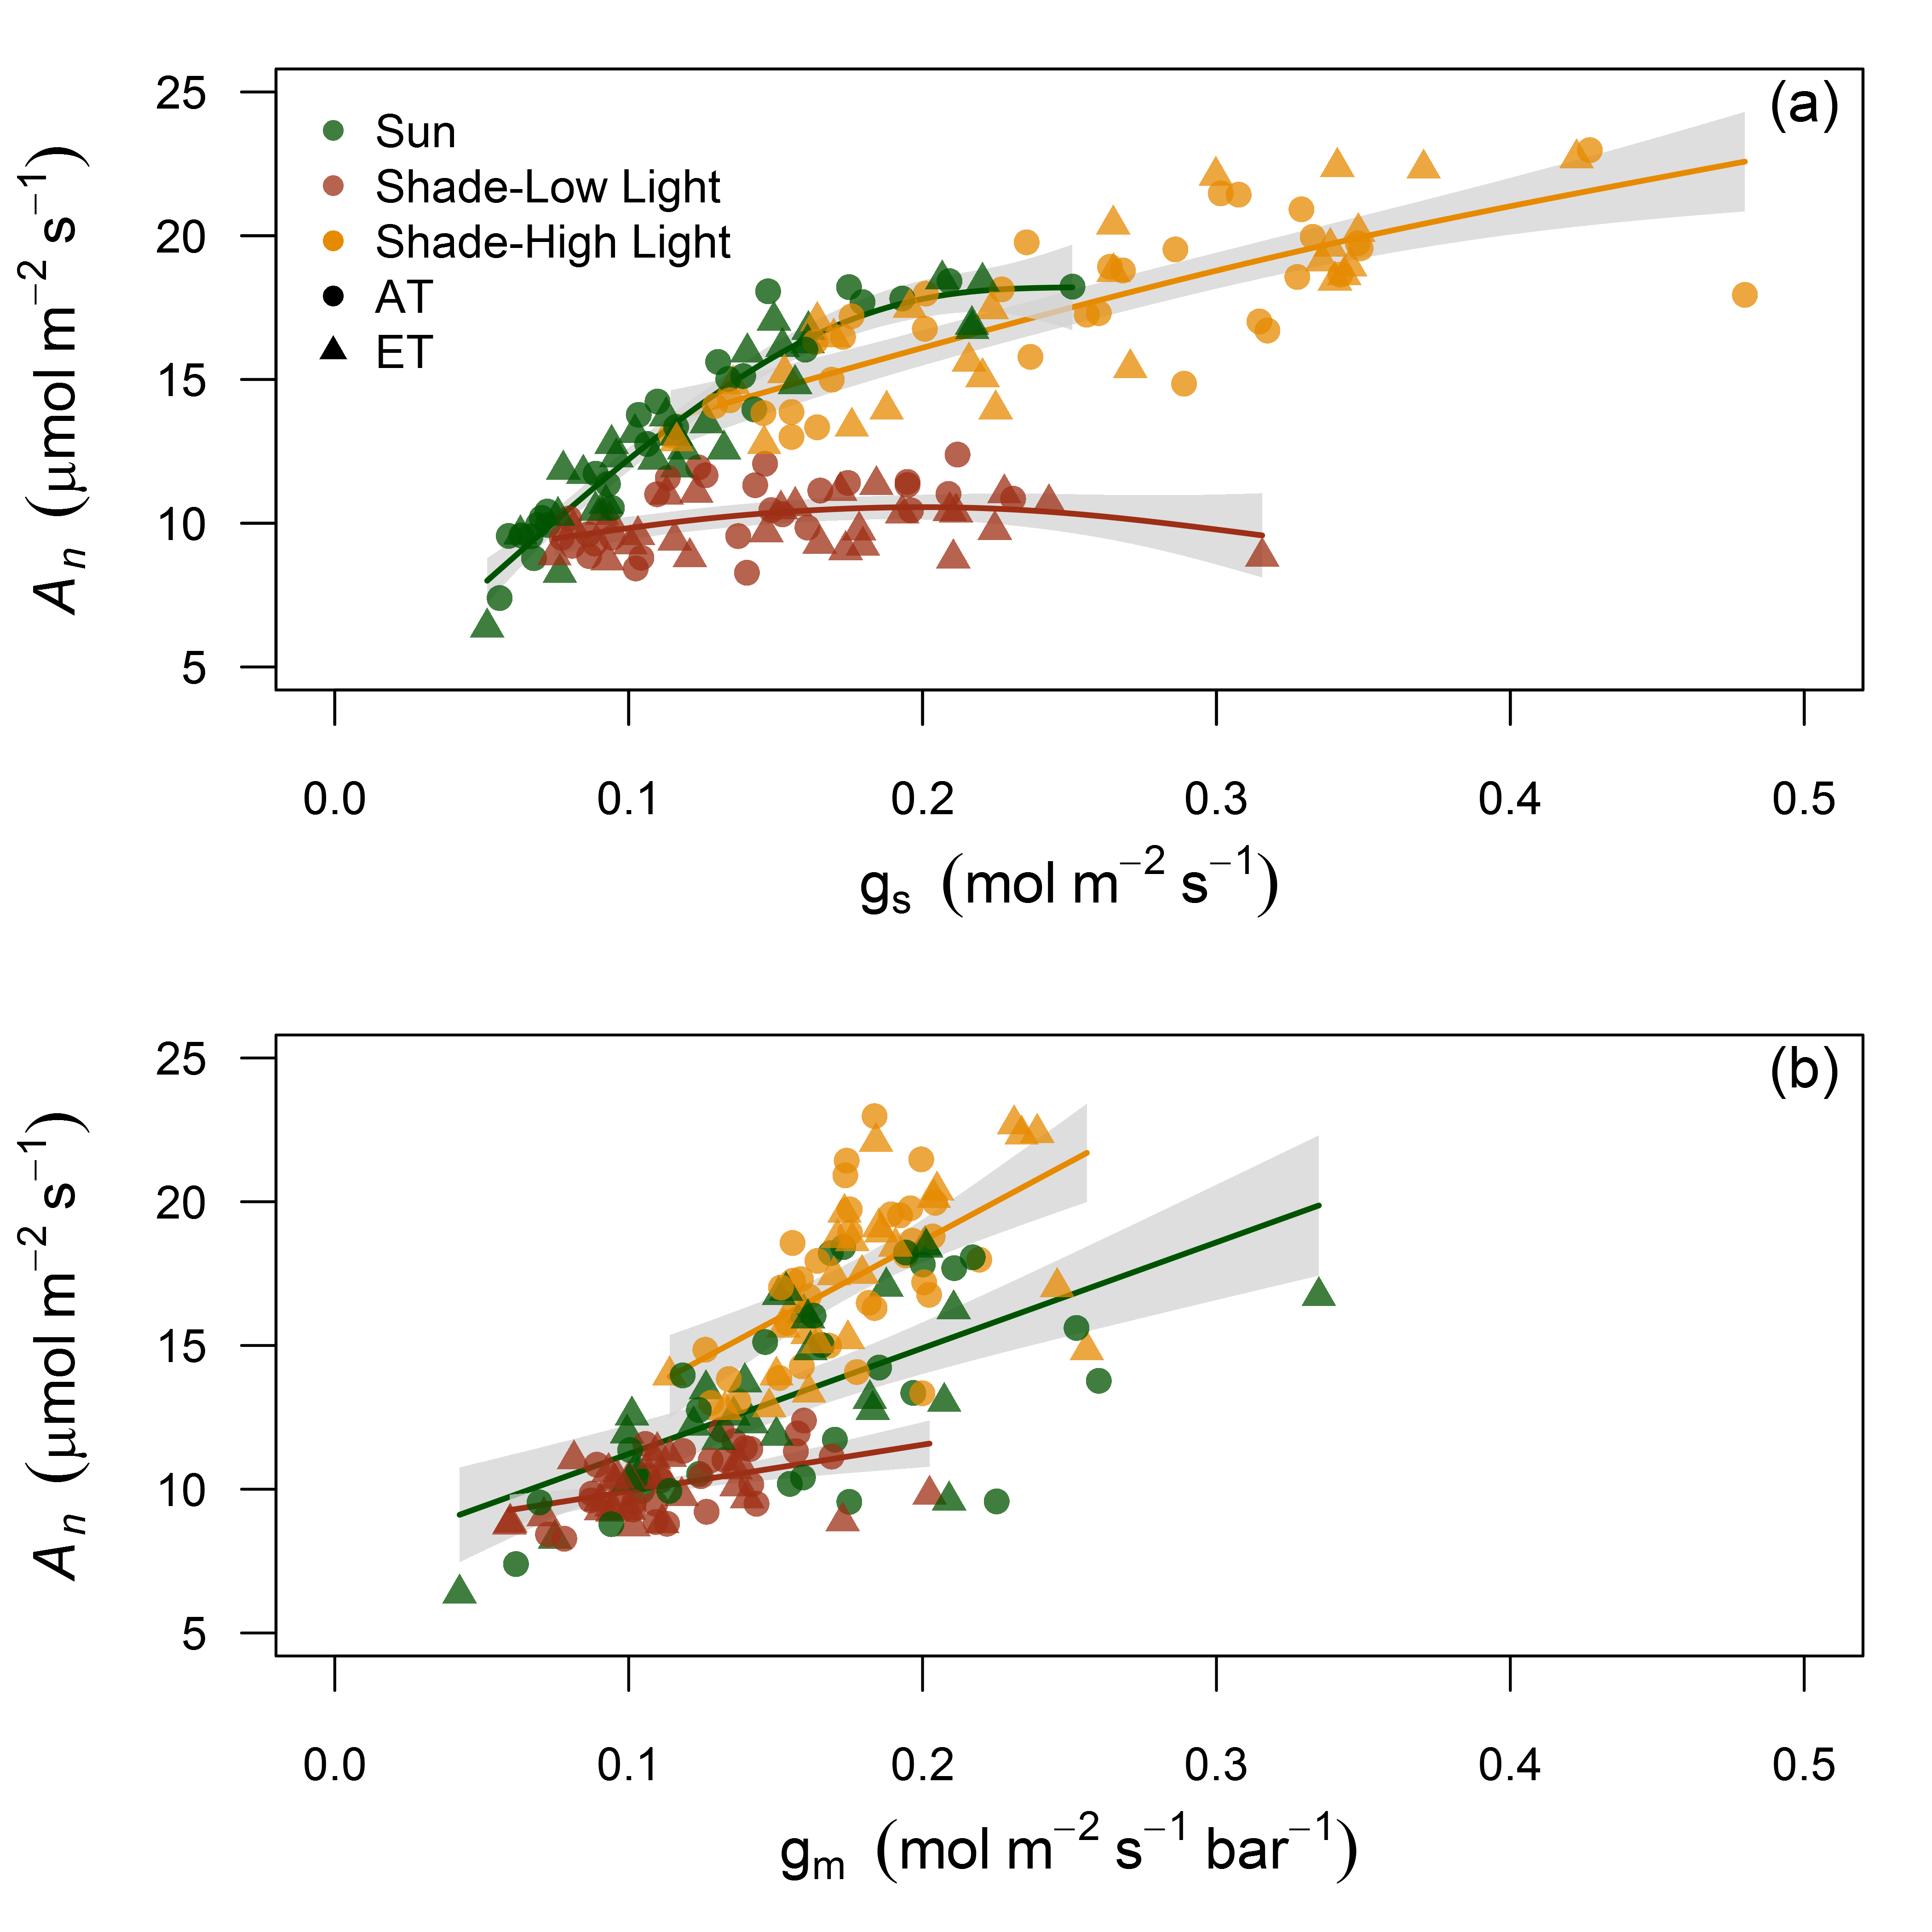  
**Figure 3**. The relationship between *An* to gs (a) and gm (b) for sun leaves measured at high light and shade leaves measured at both low and high light under their respective elevated and ambient temperature treatments. Lines represent either smoothed regressions from a generalized additive model fit (a) or linear model fits (b). Grey areas are 95% confidence intervals for the mean.  
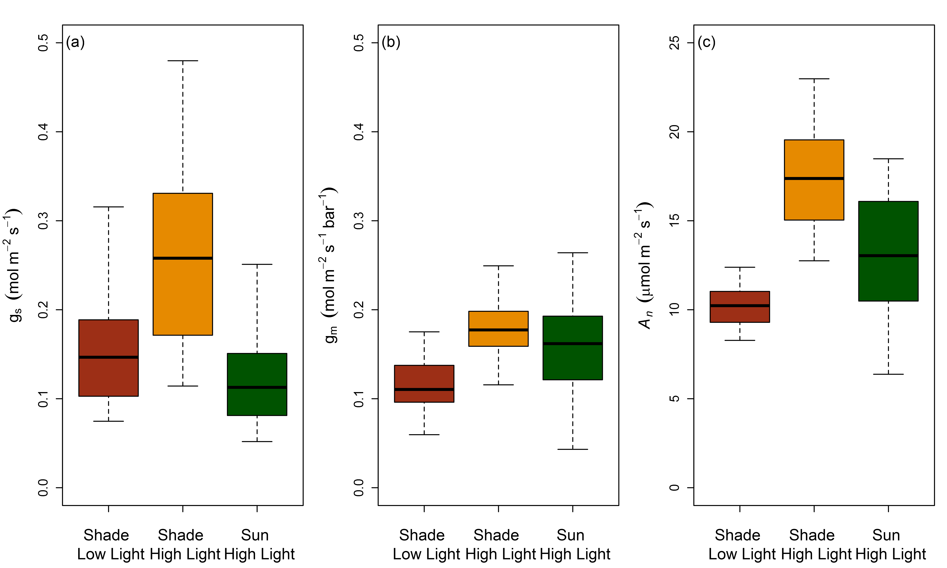  
**Figure 4**. Box plots of measured gs (a), gm (b) and *An* (c) of sun leaves and shade leaves at both low and high light pooled across six measurement dates.  
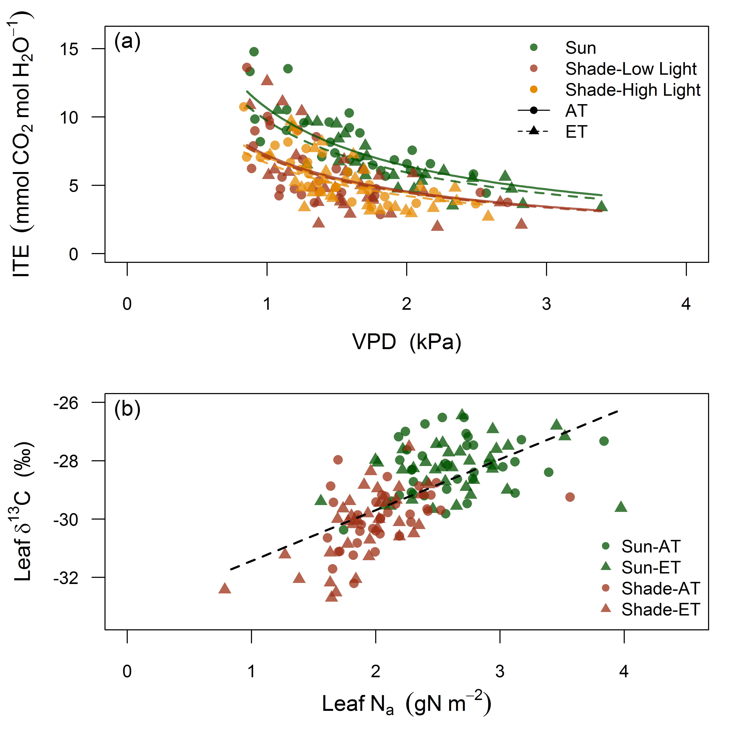  
**Figure 5**. (a) The relationship between instantaneous transpiration efficiency (ITE) and VPD for sun leaves and shade leaves at both low and high light with elevated and ambient temperature treatments. (b) The relationship between leaf 13C and leaf Na for sun leaves at high light and shade leaves at low light. For (a) VPD is the leaf to air pressure difference inside the gas exchange cuvette and lines represent predictions from the optimal ITE model with a g1 value for each leaf type and treatment. For (b) the dashed line represents the significant linear model fit across all leaves with a marginal and conditional R2 of 0.41 and 0.45, respectively.  
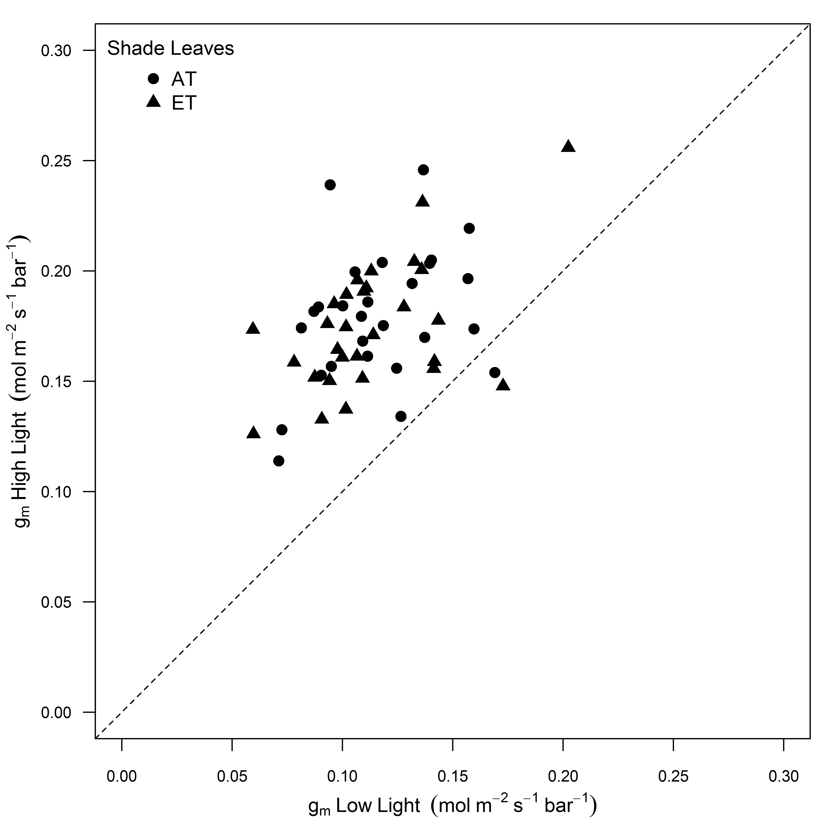  
**Figure 6**. The change in measured gm for individual shade leaves following an increase in PPFD to match the light environment of full sun leaves in the same tree. Measurements of gm were recorded once CO2 and water vapour fluxes were stable in the leaf cuvette, which took approximately 25 minutes after light intensity was increased. The dashed line is the 1:1 relationship.

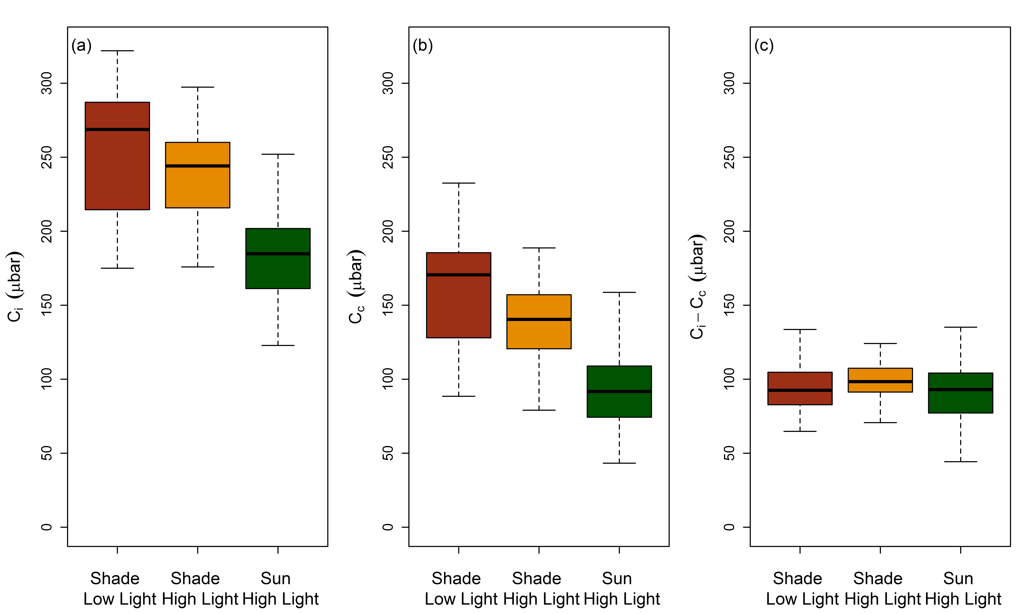  
**Figure 7**. Boxplots of (a) intercellular CO2 concentration (Ci), (b) CO2 concentration in the chloroplasts (Cc) and (c) CO2 drawdown from substomatal cavities to sites of carboxylation of sun leaves and shade leaves at both low and high light (Ci-Cc).

### Acknowledgements

We thank Craig Barton and Burhan Amiji for maintaining the Whole Tree Chambers experiment and for their outstanding technical assistance.

### Author Contributions

CC contributed to the design of the research, data analysis, collection, interpretation and writing the manuscript. MT contributed to the design of the research, interpretation and writing the manuscript. SC contributed to the design of the research, performance of the research and interpretation. RD contributed to the design of the research, data analysis, interpretation and writing the manuscript.

# Supporting Information

## Figures

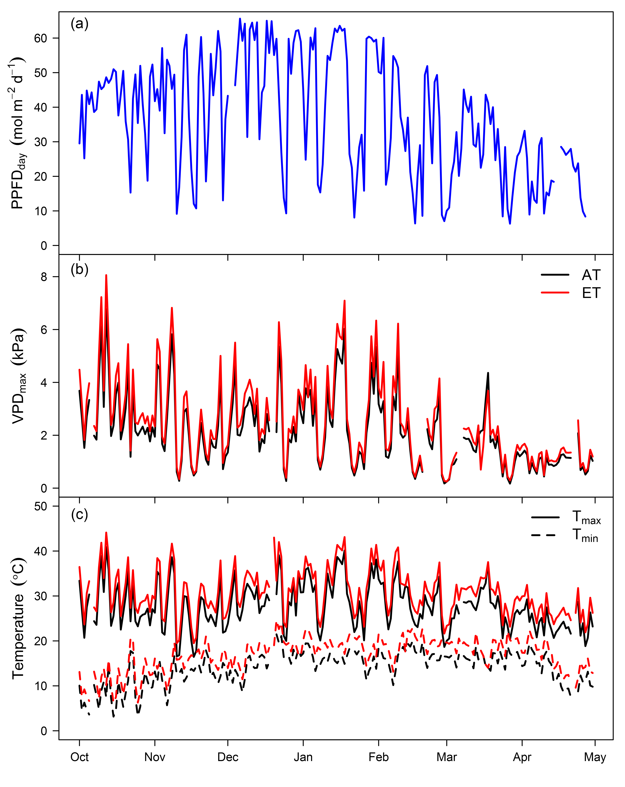  
**Figure S1**. Daily maximum and minimum temperature (a), daily maximum VPD (b) and total daily PPFD (c) for each chamber across the experiment duration.  
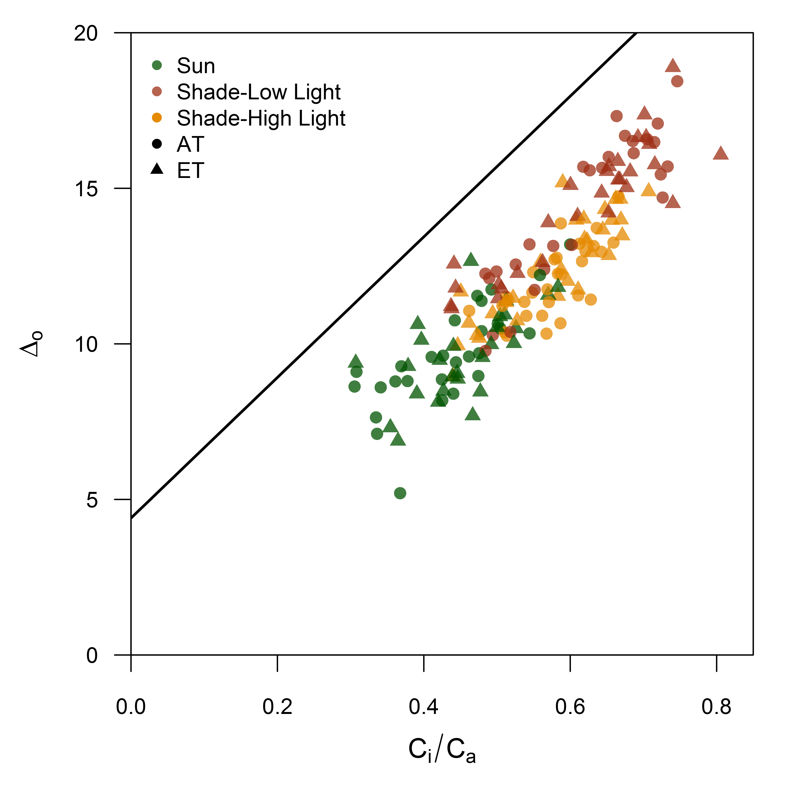  
**Figure S2**. Relationship between the observed discrimination of 13CO2 measured during photosynthesis () and measured Ci/Ca for sun leaves measured at high light and shade leaves measured at both low and high light. The solid line represents the theoretical line for C3 plants from Evans et al. (1986).  
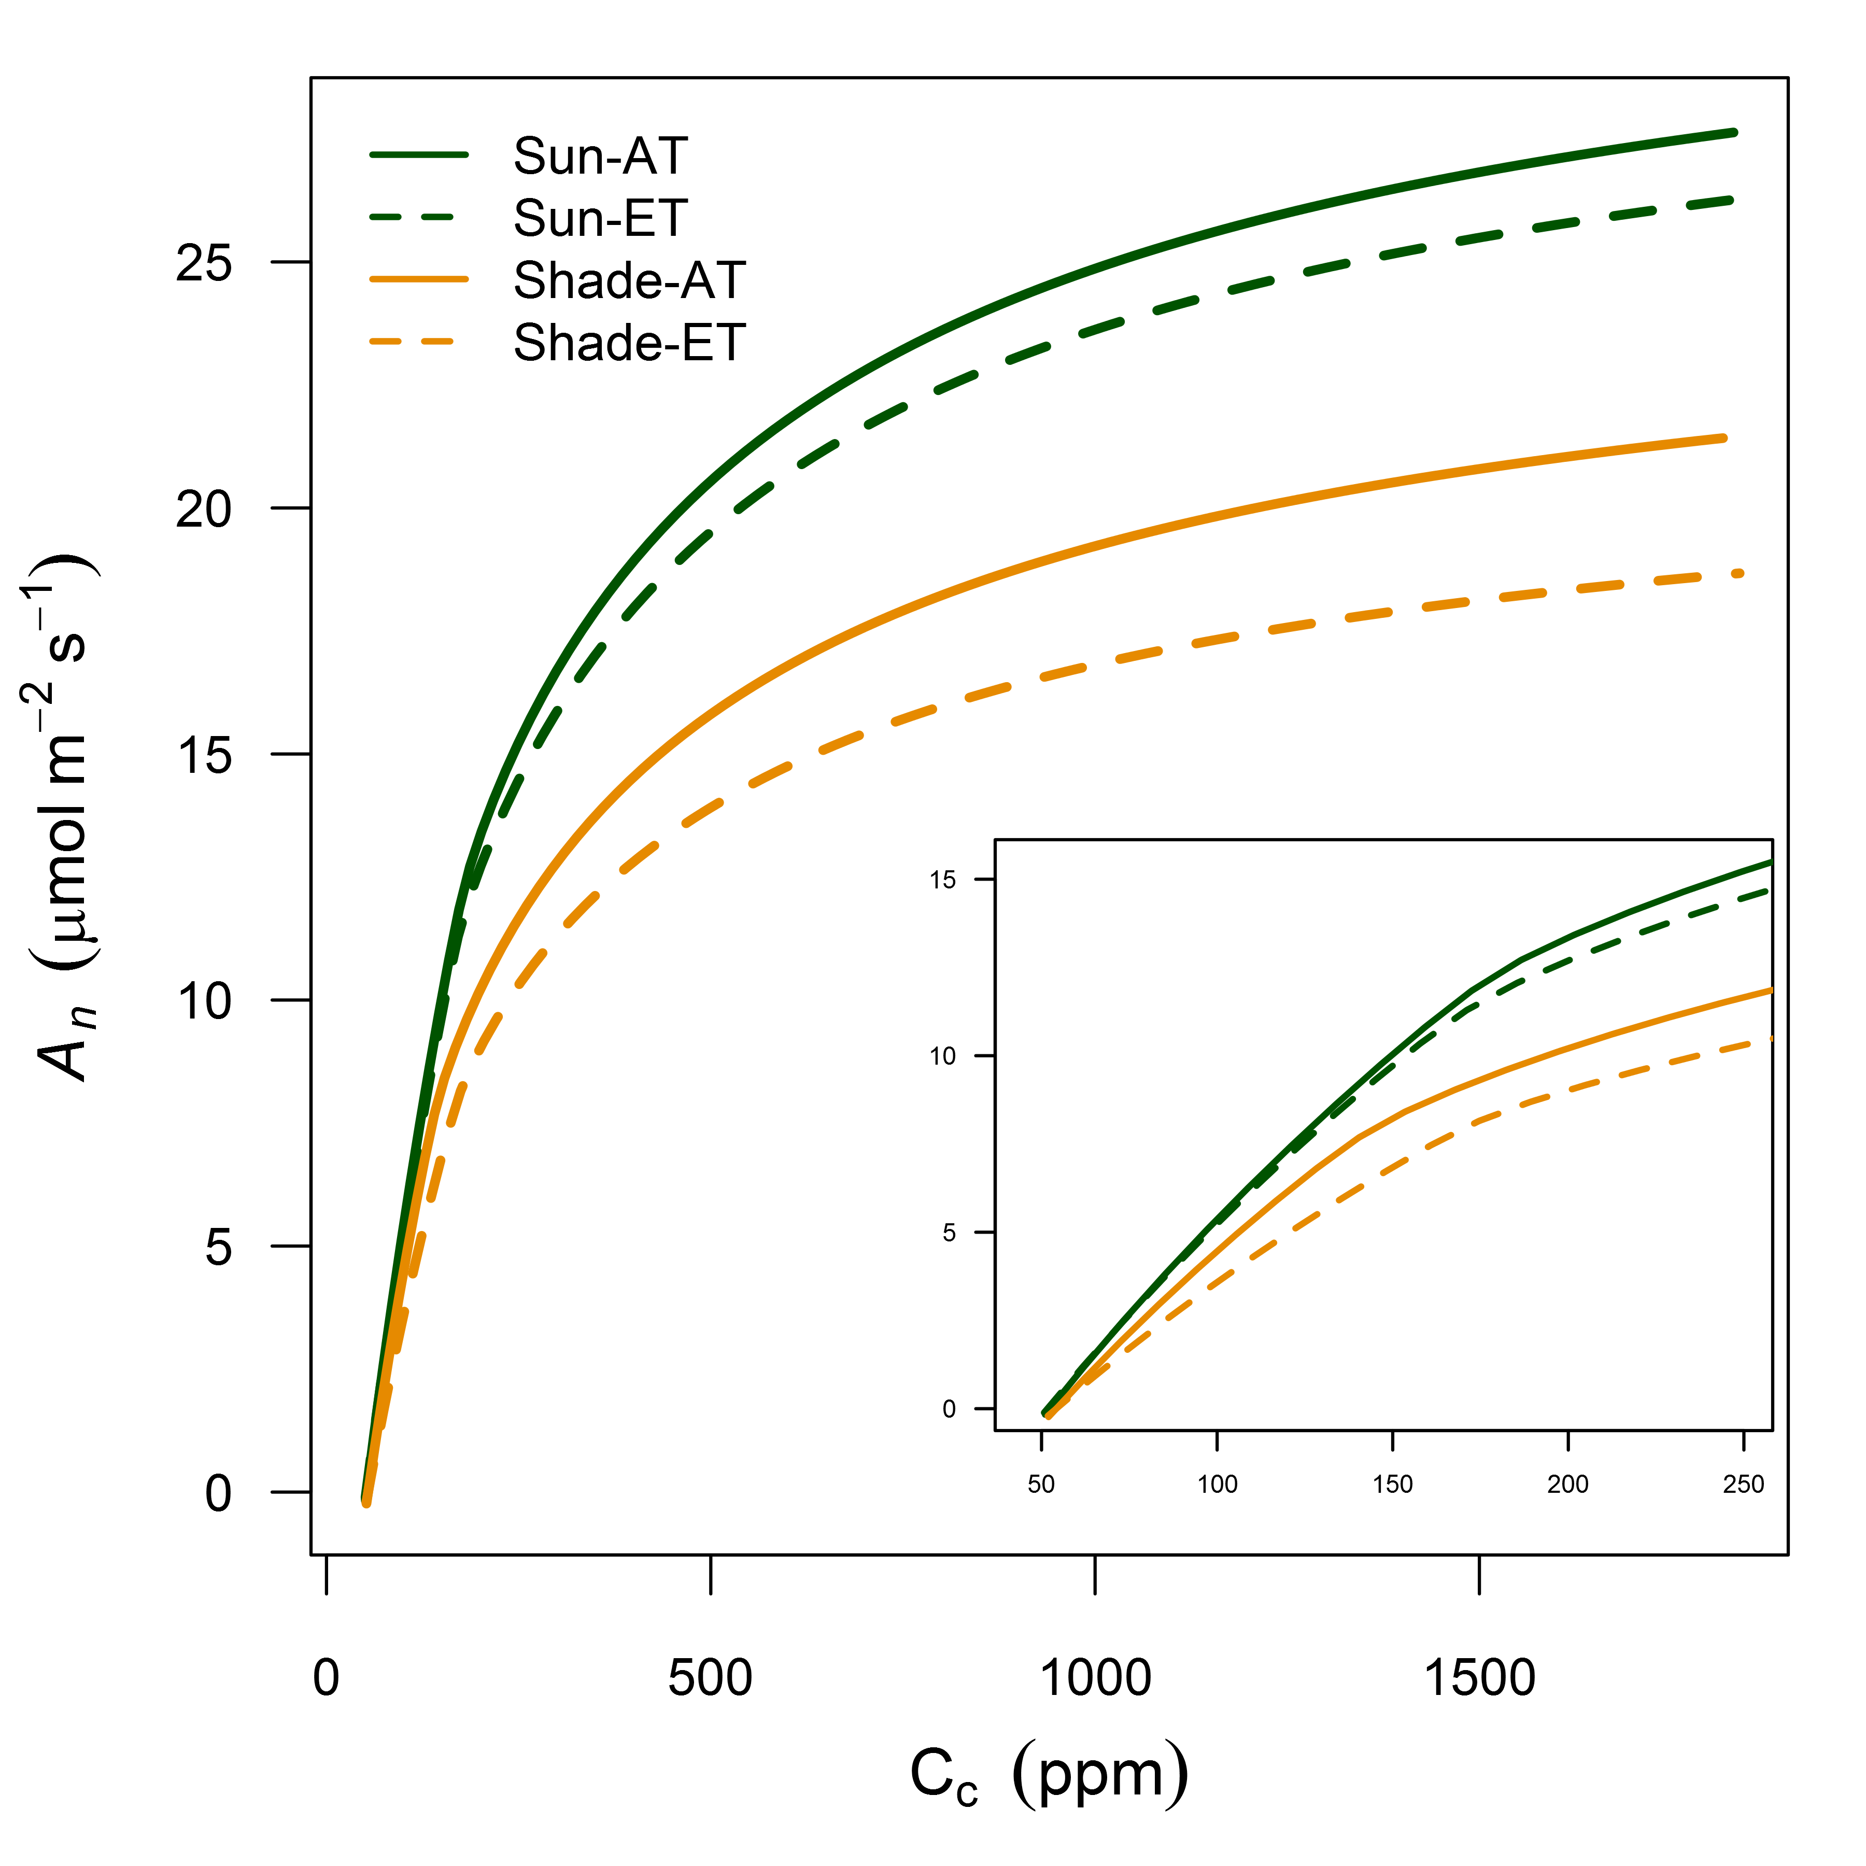  
**Figure S3**. Photosynthetic CO2 response (ACc) curves for sun and shade leaves at elevated and ambient temperature treatments. Cc values were predicted with gm and curves represent chloroplastic photosynthetic parameters at 25°C and saturating light (1800 mols m-1 s-1).  
  
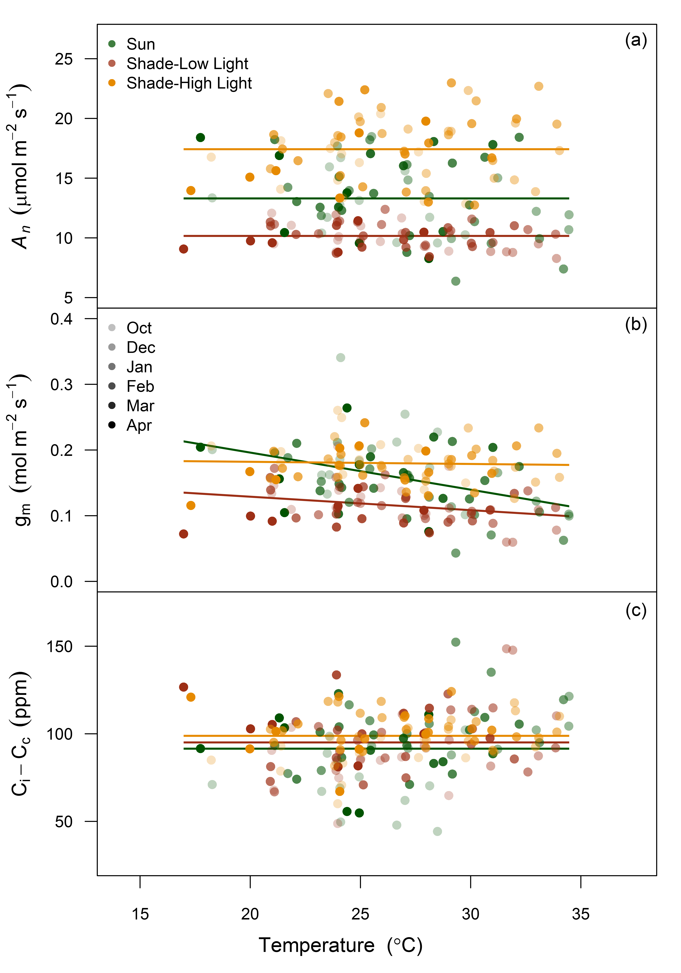  
**Figure S4**. Response of *An* (a), gm (b) and Ci-Cc to leaf temperature for sun leaves and shade leaves at low and high light. Shaded symbols represents each monthly measurement campaign. Solid lines, colored by leaf and light type, are fitted line for the relationship with each parameter and leaf temperature across all measurement campaigns. All parameters with no relationship are fitted with zero slope and the overall mean value for each treatment combination. Weak negative relationships with gm and increasing leaf temperature were detected with sun and shade leaves under their local light environment (R2 = 0.16 and 0.08, respectively).  
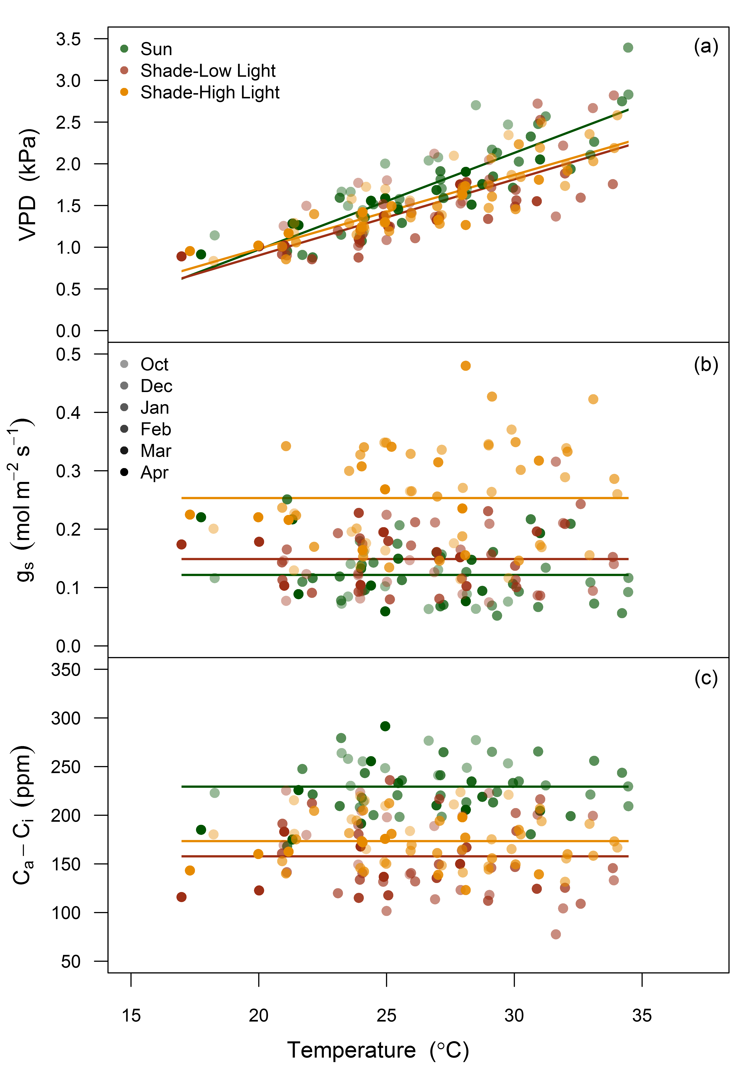  
**Figure S5**. Response of VPD (a), gs (b) and Ca-Ci to leaf temperature for sun leaves and shade leaves at low and high light. Shaded symbols represents each monthly measurement campaign. Solid lines, colored by leaf and light type, are fitted line for the relationship with each parameter and leaf temperature across all measurement campaigns. All parameters with no relationship are fitted with zero slope and the overall mean value for each treatment combination. Leaf VPD inside the gas exchange cuvette was positively correlated with increasing leaf temperature for sun leaves and shade leaves at low and high light (R2 = 0.73, 0.58 and 0.72, respectively).

## Methods S1

### Description of the calculation of gm from carbon isotope discrimination during C3 photosynthesis

Using online C isotope discrimination measurements, the difference between the observed discrimination and what is predicted for light saturated gas exchange is proportional to gm (Griffiths & Helliker, 2013). First, leaf C isotope discrimination was calculated by comparing the isotopic composition of the reference gas entering the leaf cuvette (13Ce) with the sample gas (13Co) such that:

(1)

where Rs is the isotopic ratio of the sample and Rstnd is the isotopic ratio of the standard Vienna Pee Dee Belemnite (VPDP). Next, the observed discrimination (o) is calculated from Evans et al. (1986):

(2)

where:

(3)

and is the ratio of the CO2 entering the well mixed leaf cuvette to the CO2 draw down in the gas stream by the leaf.

Second, C isotope discrimination during C3 photosynthesis () is the resultant discrimination from CO2 diffusion from the atmosphere to the site of carboxylation, consisting of a series of fractionation steps described in Evans et al. (1986). In this experiment, a modified form of this equation presented in Evans & Von Caemmerer (2013) with ternary effect corrections by Farquhar & Cernusak (2012) was used such that:

(4)

where o is the observed discrimination and i, gm , e and f are the contributions to fractionation if Ci = Cc, gm, respiration and photorespiration, respectively. The equations for each are as follows:

(5)

(6)

(7)

(8)

where the different fractionation factors include; diffusion through water (ai, 1.8‰), Rubisco carboxylation (b, 29‰), the photorespiratory fractionation (f, 16.2‰) and the combined fractionation through the boundary layer and the stomata (a'). a' is defined by:

(9)

where Cs is the CO2 partial pressure at the leaf surface, ab is the fractionation from boundary layer diffusion (2.9‰) and a is the fractionation due to diffusion in air (4.4‰) (Evans *et al.*, 1986). Ca and Ci are the atmospheric and intercellular partial pressures and is the compensation point in the absence of mitochondrial respiration in the light (Rd). In this experiment both and Rd were derived using a standard Arrhenius function with parameters for *Eucalyptus globulus* from Crous et al. (2012). The ternary effect corrections (t) are described by:

(10)

where E denotes the transpiration rate and is the total conductance to CO2 diffusion to both the boundary layer and stomatal conductance.

The gm can then be calculated as:

(11)

Here, gm is expressed in units of mol m-2 s-1 bar-1 to be consistent with Evans & Von Caemmerer (2013). As the pressure term is nearly equal to unity, suitable comparisons between gm and gs can be made.

# References

Allen MT**,** Pearcy RW. **2000**. Stomatal behavior and photosynthetic performance under dynamic light regimes in a seasonally dry tropical rain forest. *Oecologia* **122**: 470–478.

Baldocchi DD**,** Wilson KB**,** Gu L. **2002**. How the environment, canopy structure and canopy physiological functioning influence carbon, water and energy fluxes of a temperate broad-leaved deciduous forest—an assessment with the biophysical model CANOAK. *Tree Physiology* **22**: 1065–1077.

Barton CVM**,** Ellsworth DS**,** Medlyn BE**,** Duursma RA**,** Tissue DT**,** Adams MA**,** Eamus D**,** Conroy JP**,** McMurtrie RE**,** Parsby J ***et al.*** **2010**. Whole-tree chambers for elevated atmospheric CO2 experimentation and tree scale flux measurements in south-eastern Australia: The Hawkesbury Forest Experiment. *Agricultural and Forest Meteorology* **150**: 941–951.

Bates D**,** Maechler M**,** Bolker B**,** Walker S. **2015**. Fitting linear mixed-effects models using lme4. *Journal of Statistical Software* **67**: 1–48.

Boardman NK. **1977**. Comparative photosynthesis of sun and shade plants. *Annual Review of Plant Physiology* **28**: 355–377.

Brantley ST**,** Young DR. **2009**. Contribution of sunflecks is minimal in expanding shrub thickets compared to temperate forest. *Ecology* **90**: 1021–1029.

Buckley TN**,** Cescatti A**,** Farquhar GD. **2013**. What does optimization theory actually predict about crown profiles of photosynthetic capacity when models incorporate greater realism? *Plant, Cell & Environment* **36**: 1547–1563.

Burgess SSO**,** Pittermann J**,** Dawson TE.

Chazdon RL**,** Pearcy RW. **1991**. The importance of sunflecks for forest understory plants. *Bioscience* **41**: 760–766.

Cowan IR**,** Farquhar GD. **1977**. Stomatal function in relation to leaf metabolism and environment. Symposia of the society for experimental biology.471–505.

Crous KY**,** Zaragoza-Castells J**,** Ellsworth DS**,** Duursma RA**,** Loew M**,** Tissue DT**,** Atkin OK. **2012**. Light inhibition of leaf respiration in field-grown *Eucalyptus saligna* in whole-tree chambers under elevated atmospheric CO2 and summer drought. *Plant, Cell & Environment* **35**: 966–981.

De Pury DGG**,** Farquhar GD. **1997**. Simple scaling of photosynthesis from leaves to canopies without the errors of big-leaf models. *Plant Cell and Environment* **20**: 537–557.

Duursma RA. **2015**. Plantecophys - An R Package for Analysing and Modelling Leaf Gas Exchange Data. *PLoS ONE* **10**.

Duursma RA**,** Payton P**,** Bange MP**,** Broughton KJ**,** Smith RA**,** Medlyn BE**,** Tissue DT. **2013**. Near-optimal response of instantaneous transpiration efficiency to vapour pressure deficit, temperature and [CO2] in cotton (*Gossypium hirsutum* L.). *Agricultural and Forest Meteorology* **168**: 168–176.

Ethier GJ**,** Livingston NJ. **2004**. On the need to incorporate sensitivity to CO2 transfer conductance into the Farquhar–von Caemmerer–Berry leaf photosynthesis model. *Plant, Cell & Environment* **27**: 137–153.

Evans JR. **1995**. Carbon fixation profiles do reflect light absorption profiles in leaves. *Functional Plant Biology* **22**: 865–873.

Evans J**,** Poorter H. **2001**. Photosynthetic acclimation of plants to growth irradiance: the relative importance of specific leaf area and nitrogen partitioning in maximizing carbon gain. *Plant, Cell & Environment* **24**: 755–767.

Evans JR**,** Von Caemmerer S. **2013**. Temperature response of carbon isotope discrimination and mesophyll conductance in tobacco. *Plant, Cell & Environment* **36**: 745–756.

Evans JR**,** Sharkey TD**,** Berry JA**,** Farquhar GD. **1986**. Carbon isotope discrimination measured concurrently with gas exchange to investigate CO2 diffusion in leaves of higher plants. *Functional Plant Biology* **13**: 281–292.

Farquhar GD**,** Cernusak LA. **2012**. Ternary effects on the gas exchange of isotopologues of carbon dioxide. *Plant, Cell & Environment* **35**: 1221–1231.

Farquhar GD**,** Caemmerer S von von**,** Berry JA. **1980**. A biochemical model of photosynthetic CO2 assimilation in leaves of C3 species. *Planta* **149**: 78–90.

Field C. **1983**. Allocating leaf nitrogen for the maximization of carbon gain: leaf age as a control on the allocation program. *Oecologia* **56**: 341–347.

Field CH**,** Mooney HA. **1986**. Photosynthesis–nitrogen relationship in wild plants. On the economy of plant form and function: Proceedings of the sixth maria moors cabot symposium. Cambridge University Press, 25–55.

Flexas J**,** Diaz-Espejo A**,** Galmes J**,** Kaldenhoff R**,** Medrano H**,** Ribas-Carbó M. **2007**. Rapid variations of mesophyll conductance in response to changes in CO2 concentration around leaves. *Plant, Cell & Environment* **30**: 1284–1298.

Flexas J**,** Ribas-Carbó M**,** Diaz-Espejo A**,** Galmes J**,** Medrano H. **2008**. Mesophyll conductance to CO2: current knowledge and future prospects. *Plant, Cell & Environment* **31**: 602–621.

Griffiths H**,** Helliker BR. **2013**. Mesophyll conductance: internal insights of leaf carbon exchange. *Plant, Cell & Environment* **36**: 733–735.

Hanba YT**,** Kogami H**,** Terashima I. **2002**. The effect of growth irradiance on leaf anatomy and photosynthesis in *Acer* species differing in light demand. *Plant, Cell & Environment* **25**: 1021–1030.

Hanba YT**,** Shibasaka M**,** Hayashi Y**,** Hayakawa T**,** Kasamo K**,** Terashima I**,** Katsuhara M. **2004**. Overexpression of the barley aquaporin HvPIP2; 1 increases internal CO2 conductance and CO2 assimilation in the leaves of transgenic rice plants. *Plant and Cell Physiology* **45**: 521–529.

Heinen RB**,** Ye Q**,** Chaumont F. **2009**. Role of aquaporins in leaf physiology. *Journal of Experimental Botany* **60**: 2971–2985.

Hubbard RM**,** Ryan MG**,** Stiller V**,** Sperry JS. **2001**. Stomatal conductance and photosynthesis vary linearly with plant hydraulic conductance in ponderosa pine. *Plant, Cell & Environment* **24**: 113–121.

Küppers M**,** Schneider H. **1993**. Leaf gas exchange of beech (*Fagus sylvatica* L.) seedlings in lightflecks: effects of fleck length and leaf temperature in leaves grown in deep and partial shade. *Trees* **7**: 160–168.

Leakey ADB**,** Press MC**,** Scholes JD. **2003**. High-temperature inhibition of photosynthesis is greater under sunflecks than uniform irradiance in a tropical rain forest tree seedling. *Plant, Cell & Environment* **26**: 1681–1690.

Leakey ADB**,** Press MC**,** Scholes JD**,** Watling JR. **2002**. Relative enhancement of photosynthesis and growth at elevated CO2 is greater under sunflecks than uniform irradiance in a tropical rain forest tree seedling. *Plant, Cell & Environment* **25**: 1701–1714.

Li G**,** Santoni V**,** Maurel C. **2014**. Plant aquaporins: roles in plant physiology. *Biochimica et Biophysica Acta (BBA)-General Subjects* **1840**: 1574–1582.

Lin Y-S**,** Medlyn BE**,** Duursma RA**,** Prentice IC**,** Wang H**,** Baig S**,** Eamus D**,** Dios VR de**,** Mitchell P**,** Ellsworth DS ***et al.*** **2015**. Optimal stomatal behaviour around the world. *Nature Climate Change* **5**: 459–464.

Linderson M-L**,** Mikkelsen TN**,** Ibrom A**,** Lindroth A**,** Ro-Poulsen H**,** Pilegaard K. **2012**. Up-scaling of water use efficiency from leaf to canopy as based on leaf gas exchange relationships and the modeled in-canopy light distribution. *Agricultural and Forest Meteorology* **152**: 201–211.

Marshall JD**,** Brooks JR**,** Lajtha K. **2007**. Sources of variation in the stable isotopic composition of plants. Stable isotopes in ecology and environmental science. Oxford, UK: Blackwell Publishing Chichester, 22–60.

Medlyn BE**,** Dreyer E**,** Ellsworth D**,** Forstreuter M**,** Harley PC**,** Kirschbaum MUF**,** Le Roux X**,** Montpied P**,** Strassemeyer J**,** Walcroft A ***et al.*** **2002**. Temperature response of parameters of a biochemically based model of photosynthesis. II. A review of experimental data. *Plant, Cell & Environment* **25**: 1167–1179.

Medlyn BE**,** Duursma RA**,** Eamus D**,** Ellsworth DS**,** Prentice IC**,** Barton CVM**,** Crous KY**,** Angelis P de**,** Freeman M**,** Wingate L. **2011**. Reconciling the optimal and empirical approaches to modelling stomatal conductance. *Global Change Biology* **17**: 2134–2144.

Monsi M**,** Saeki T. **2005**. On the factor light in plant communities and its importance for matter production. *Annals of Botany* **95**: 549–567.

Mooney HA**,** Gulmon SL. **1979**. Environmental and evolutionary constraints on the photosynthetic characteristics of higher plants. Topics in plant population biology. columbia university press, new york. New York: Columbia University Press,.

Nakagawa S**,** Schielzeth H. **2013**. A general and simple method for obtaining R2 from generalized linear mixed-effects models. *Methods in Ecology and Evolution* **4**: 133–142.

Niinemets Ü. **2007**. Photosynthesis and resource distribution through plant canopies. *Plant, Cell & Environment* **30**: 1052–1071.

Niinemets Ü. **2010**. A review of light interception in plant stands from leaf to canopy in different plant functional types and in species with varying shade tolerance. *Ecological Research* **25**: 693–714.

Niinemets Ü. **2012**. Optimization of foliage photosynthetic capacity in tree canopies: towards identifying missing constraints. *Tree Physiology* **32**: 505–509.

Niinemets Ü**,** Valladares F. **2004**. Photosynthetic acclimation to simultaneous and interacting environmental stresses along natural light gradients: optimality and constraints. *Plant Biology* **6**: 254–268.

Pearcy RW. **1990**. Sunflecks and photosynthesis in plant canopies. *Annual Review of Plant Biology* **41**: 421–453.

Peltoniemi MS**,** Duursma RA**,** Medlyn BE. **2012**. Co-optimal distribution of leaf nitrogen and hydraulic conductance in plant canopies. *Tree Physiology* **32**: 510–519.

Pepin S**,** Livingston NJ. **1997**. Rates of stomatal opening in conifer seedlings in relation to air temperature and daily carbon gain. *Plant, Cell & Environment* **20**: 1462–1472.

Piel C**,** Frak E**,** Le Roux X**,** Genty B. **2002**. Effect of local irradiance on CO2 transfer conductance of mesophyll in walnut. *Journal of Experimental Botany* **53**: 2423–2430.

Prentice IC**,** Dong N**,** Gleason SM**,** Maire V**,** Wright IJ. **2014**. Balancing the costs of carbon gain and water transport: testing a new theoretical framework for plant functional ecology. *Ecology Letters* **17**: 82–91.

R Development Core Team R. **2011**. R: A language and environment for statistical computing (RDC Team, Ed.). **1**: 409.

Schymanski SJ**,** Or D**,** Zwieniecki MA. **2013**. Stomatal control and leaf thermal and hydraulic capacitances under rapid environmental fluctuations. *PloS ONE* **8**: e54231.

Sellin A**,** Kupper P. **2007**. Effects of enhanced hydraulic supply for foliage on stomatal responses in little-leaf linden (*Tilia cordata* Mill.). *European Journal of Forest Research* **126**: 241–251.

Sellin A**,** Õunapuu E**,** Kupper P. **2008**. Effects of light intensity and duration on leaf hydraulic conductance and distribution of resistance in shoots of silver birch (*Betula pendula*). *Physiologia Plantarum* **134**: 412–420.

Tausz M**,** Warren CR**,** Adams MA. **2005**. Dynamic light use and protection from excess light in upper canopy and coppice leaves of *Nothofagus cunninghamii* in an old growth, cool temperate rainforest in Victoria, Australia. *New Phytologist* **165**: 143–156.

Tazoe Y**,** Von Caemmerer S**,** Badger MR**,** Evans JR. **2009**. Light and CO2 do not affect the mesophyll conductance to CO2 diffusion in wheat leaves. *Journal of Experimental Botany* **60**: 2291–2301.

Tazoe Y**,** Von Caemmerer S**,** Estavillo GM**,** Evans JR. **2011**. Using tunable diode laser spectroscopy to measure carbon isotope discrimination and mesophyll conductance to CO2 diffusion dynamically at different CO2 concentrations. *Plant, Cell & Environment* **34**: 580–591.

Terashima I**,** Hanba YT**,** Tazoe Y**,** Vyas P**,** Yano S. **2006**. Irradiance and phenotype: comparative eco-development of sun and shade leaves in relation to photosynthetic CO2 diffusion. *Journal of Experimental Botany* **57**: 343–354.

Ubierna N**,** Marshall JD. **2011**. Estimation of canopy average mesophyll conductance using $δ^{13}$ C of phloem contents. *Plant, Cell & Environment* **34**: 1521–1535.

Vico G**,** Manzoni S**,** Palmroth S**,** Katul G. **2011**. Effects of stomatal delays on the economics of leaf gas exchange under intermittent light regimes. *New Phytologist* **192**: 640–652.

Vogelman TC**,** Nishio JN**,** Smith WK. **1996**. Leaves and light capture: light propagation and gradients of carbon fixation within leaves. *Trends in Plant Science* **1**: 65–70.

Von Caemmerer S**,** Evans JR. **2014**. Temperature responses of mesophyll conductance differ greatly between species. *Plant, Cell & Environment* **38**: 629–637.

Von Caemmerer S**,** Evans JR**,** Hudson GS**,** Andrews TJ. **1994**. The kinetics of ribulose-1, 5-bisphosphate carboxylase/oxygenase in vivo inferred from measurements of photosynthesis in leaves of transgenic tobacco. *Planta* **195**: 88–97.

Warren CR. **2008**. Stand aside stomata, another actor deserves centre stage: the forgotten role of the internal conductance to CO2 transfer. *Journal of Experimental Botany* **59**: 1475–1487.

Warren CR**,** Löw M**,** Matyssek R**,** Tausz M. **2007**. Internal conductance to CO2 transfer of adult *Fagus sylvatica*: variation between sun and shade leaves and due to free-air ozone fumigation. *Environmental and Experimental Botany* **59**: 130–138.

Way DA**,** Pearcy RW. **2012**. Sunflecks in trees and forests: from photosynthetic physiology to global change biology. *Tree Physiology* **32**: 1066–1081.

Wright IJ**,** Reich PB**,** Westoby M. **2003**. Least-cost input mixtures of water and nitrogen for photosynthesis. *The American Naturalist* **161**: 98–111.