Do shade leaves lying in wait? How instantaneous responses of mesophyll conductance to light availability in shade leaves impacts optimal canopy carbon gain

Courtney E. Campany1, Belinda Medlyn1, Mark Tjoelker1, Susanne von Caemmerer2, Remko A. Duursma1.

1 Hawkesbury Institute for the Environment, University of Western Sydney, Locked Bag 1797, Penrith, NSW, Australia

2 Plant Science Division, Research School of Biology, The Australian National University, Canberra, ACT, Australia

*Corresponding author*: Courtney Campany E: [courtneycampany@gmail.com](mailto:courtneycampany@gmail.com)

# Summary

* overview
* method
* big result
* implication

# Introduction

The need to understand and predict carbon uptake in forest ecosystems is crucially important for assessing the impacts of a changing climate. Specifically, this involves accurate upscaling of leaf level measurements to predict whole canopy function. Due to the costs and limitations of efficient light harvesting plants cannot expose all leaves to full sun (Niinemets, 2010), making simple upscaling problematic. Incident PPFD declines exponentially with increasing leaf area index, creating a steep light gradient from the canopy top to bottom (Monsi & Saeki, 2005), and photosynthesis (A) increases with irradiance from shade to sun until biochemical limitation occurs (Evans, 1995). Consequently, leaves modify structural and functional properties to efficiently intercept variable light and enhance photosynthetic capacity (Vogelman *et al.*, 1996; Niinemets & Valladares, 2004). To estimate whole canopy carbon gain it is thus necessary to account for the non-linear response of photosynthesis to light by distinguishing between shaded and sunlit leaves (De Pury & Farquhar, 1997; Linderson *et al.*, 2012).

The distribution of resources required for A, including nitrogen (N) and water, are also partially defined by canopy light gradients. As A has a saturating response with light and a dependence on N, leaf N should be distributed in the upper canopy to maximize canopy carbon gain (Field, 1983; Field & Mooney, 1986; Peltoniemi *et al.*, 2012). This can lead to changes in chlorophyll per unit N, chlorophyll a:b ratios, electron transport capacity per unit chlorophyll, and ratios of electron transport capacity to Rubisco activity across leaf types (Evans & Poorter, 2001). Sun leaves also experience greater water limitations in the upper canopy, despite effective vascular systems developed for high radiation loads and transpiration (Sellin *et al.*, 2008; Niinemets, 2012). Higher rates of A and stomatal conductance (gs) can only be sustained if the hydraulic conductance (K) is also large enough to avoid low leaf water potentials (Hubbard *et al.*, 2001). Optimal photosynthetic N investment in the upper canopy will be wasted if photosynthetic capacity exceeds hydraulic supply (Niinemets, 2012), thus K should also be higher in the upper canopy to supply sunlit leaves with sufficient water (Burgess *et al.*, 2006; Sellin & Kupper, 2007 ; Sellin *et al.*, 2008).

These theoretical distributions of N and water regulate leaf physiological traits that constrain A differently for sun and shade leaves. The balance between the costs and energetic benefits of these leaf traits affecting photosynthetic capacity create trade-offs impacting canopy carbon gain (Givnish, 1988). During A, CO2 diffuses from the atmosphere through stomata (gs), intercellular air space and into the chloroplast for fixation by Rubisco (mesophyll conductance, gm) (Tazoe *et al.*, 2011) and trade-offs exists that constrain each of these diffusion pathways. For optimal leaf carbon gain these pathways should act to minimize the resistance to CO2 diffusion while also limiting the intrinsic energy, water and construction costs which diminish the carbon return from A. As these processes should not be considered independent of each other and must be integrated with hydraulic constraints (Griffiths *et al.*, 2013) predicting their behaviour within canopies remains difficult.

First, gs should be efficiently distributed within a canopy to utilize supplies of light, N and water to maximize A (Peltoniemi *et al.*, 2012). • This is because stomata are hypothesized to exhibit an optimal behaviour to maximize carbon gain while simultaneously minimizing water loss through transpiration (Cowan & Farquhar, 1977). Second, variation in photosynthetic capacity between sun and shade leaves has also been hypothesized to be due to differences in gm (Duursma & Marshall, 2006). Mesophyll conductance can impose limitations on A as large as those associated with gs (Warren, 2008; Ubierna & Marshall, 2011)and these limitations can reduce the efficiency of N use in A (Niinemets, 2007). Interpreting the coupled responses of both gs and gm to A across sun and shade leaves has major implications for predicting canopy carbon gain, but empirical measurements across tree canopies are still lacking.

Additionally, assessing shade leaf behaviour is made difficult with accounting of short term light fluctuations within a canopy, via sunflecks. How shade leaves utilize sunflecks for short term carbon gain depends on the combined response time of gs and gm and the underlying photosynthetic biochemistry acclimated to a low light environment (Pearcy, 1990). For example, at short timescales the utilization of sunflecks is limited by the slow response of stomatal opening, effectively limiting the maximum assimilation rate that can be achieved (Way & Pearcy, 2012). Mesophyll conductance has been shown to respond to environmental factors across both long and rapid time scales, possibly faster than gs (Flexas *et al.*, 2008). However, anatomical parameters which regulate gm with changing irradiance such as chloroplast surface area (Terashima *et al.*, 2006) and mesophyll thickness (Boardman, 1977) are not likely adaptable during short light fluctuations. The physiological behaviour of shade leaves to maximize carbon gain must be assessed as both a degree of acclimation to local irradiance and as a potential response to transitory light availability.

Climate warming may also potentially affect the physiological behaviour of leaves within a canopy. This is because leaves can be exposed to different heat, water and high light stresses as temperature and vapour pressure deficit (VPD) scale positively with canopy light availability (Baldocchi *et al.*, 2002; Niinemets & Valladares, 2004; Niinemets, 2007). How these stresses affect the diffusion of CO2, through either gs or gm will have implications for upscaling A for sun and shade leaves. Additionally, light saturated rates of A are limited by the maximum rate of Rubisco carboxylation (Vcmax) or the maximum rate of photosynthetic electron transport (Jmax) across a range of temperatures, yet their temperature dependencies are not the same (Farquhar *et al.*, 1980; Medlyn *et al.*, 2002). How these parameters are differentially affected by warming may impact constraints of N distribution and leaf photosynthetic capacity across light gradients. The impacts of warming on plant physiological processes are obviously vast, yet differentiating their impacts on leaf physiology within a canopy will be essential for evaluating whole tree responses to a changing climate.

In this study we use *Eucalyptus tereticornis* Sm. trees, planted in climate controlled whole tree chambers with ambient and elevated temperature (+3°C) treatments, to empirically evaluate the distribution of resources and leaf physiological behaviour of sun and shade leaves. 1. If whole tree canopies are optimized for carbon gain, then leaf N, K and photosynthetic capacity were predicted to be higher in full sun leaves. 2. Under comparable leaf VPD, gs and A should exhibit theoretical optimal behaviour across both sun and shade leaves, while gm was predicted to scale positively with photosynthetic capacity. 3. As shade leaves are constrained by their underlying biochemistry and slow physiological responses, increases in A following sunfleck simulations were not expected to reach levels of full sun leaves. 4. The effects of climate warming was predicted to be greater in sun than shade leaves, seen as increases in stomatal closure and reductions in leaf carbon gain during summer months.

# Materials and Methods

## Whole tree chamber experimental design

Twelve *Eucalyptus tereticornis* seedlings, chosen from a single local Cumberland plain cohort, were planted in March 2013 into 12 whole-tree chambers (WTC) at the Hawkesbury Forest Experiment site near Richmond, NSW, Australia. Each chamber has a maximum height of 10 m and seedlings were grown for 15 months. A detailed description of the WTC operation and design is available in (Barton *et al.*, 2010). Six chambers were set to match outside ambient air temperatures (AT) while the remaining 6 experienced a constant elevated air temperature treatment (ET, 3°C). The CO2 concentration inside the chamber was set to match outside air, tracking diurnal changes. Due to the temperature treatment air humidity was not explicitly controlled. Trees were watered with 70 l weekly from March 2013 to November 2013. From December 2013 to final harvest trees were watered fortnightly with mean monthly (100 yr) rainfall amount. In February 2013 half of the chambers (3 each of AT and ET) were subjected to a drought treatment by withholding watering. Due to a limited range of data for the drought treatment only well-watered trees are reported here.

Before seedlings were planted into each chamber they were maintained under well watered conditions in 35 l pots and kept inside each chamber. This allowed for seedlings to gain sufficient biomass before planting while also allowing them to acclimate to chamber temperature treatments. Seedlings were planted into each chamber after mean seedling height reached 100 cm. After 2 months, floors were installed 45 cm from the soil surface. This enabled chamber fluxes of CO2 and H2O from the whole tree canopy to be monitored. Gas exchange measurements were initiated in October 2013 when trees had both ample height growth and canopy development for realistic canopy light gradients to be measured. At this point, trees had a mean height of 34±15.1 and 418±323.1 cm and an estimated leaf area of 3.9±0.1 and 6.2±0.2 m2 for ambient and elevated temperature treatments, respectively.

## Leaf gas exchange, online carbon isotope discrimination and mesophyll conductance

Leaf gas exchange measurements were performed monthly through to the final harvest. Measurements were taken on a representative sun and shade leaf for each tree during each measurement campaign. The youngest fully expanded leaf from the stem apex was chosen for gas exchange measurements and sun leaves were measured in the upper third of the canopy. In order to minimize any confounding effects of leaf age, shade leaves were measured first in the lower canopy then gradually higher during each campaign. As shade leaves most likely developed slower this assured that older leaves that exist in the lower canopy were avoided. The nearest leaf on each branch was sampled for measurement of predawn leaf water potential. All leaves were selected and flagged 24 hours prior to initiation of measurements.

Prior to gas exchange measurements photosynthetic photon flux density (PPFD) was recorded at the individual leaf level and at the canopy position for each selected leaf. A hand-held photosynthetically available radiation meter was used to record leaf level PPFD to ensure that chosen leaves were positioned in the desired light environment, either full sun or full shade. A ceptometer (AccuPAR LP-80, Decagon Devices, Pullman, USA) was then used to measure 1 m integrated PPFD at the canopy height of each chosen leaf type. Five ceptometer readings were recorded within the canopy at random locations of the height of each selected leaf. The mean of these readings was assumed to represent the overall leaf light environment of representative full sun and shade leaves for each tree. All measurements of PPFD and gas exchange were performed on full sun days between 10:00-14:30 h.

Leaf level gas exchange was measured with a standard 6 cm2 leaf chamber using a portable gas exchange system (LI-6400, LI-COR, Lincoln, NE, USA). This system was coupled with a tunable diode laser (TDL;TGA100,Campbell Scientific, Inc., Logan, UT, USA) for concurrent measurements of online carbon isotope discrimination. The CO2 in the leaf chamber was set at ambient atmospheric [CO2] (400 ppm) with a flow rate of 200 mols s-1. Two identical gas exchanges systems were run simultaneously, one in each of a randomly chosen WTC for each temperature treatment. This paired design allowed for direct leaf comparisons to be made with simultaneous measurements of similar leaf types. Leaf temperatures were controlled at the current ambient or +3°C chamber air temperature. PPFD in the chamber was set to match the individual light environment of each leaf type (explained above). Sun flecks were then simulated for shade leaves by increasing the chamber PPFD to the light environment of the full sun leaf in the same tree. When shade leaves were exposed to high light they were allowed enough time to equilibrate with chamber conditions until stable (ca. 25 min).

Once the chamber environment for leaves was stable the sample and reference gas lines were diverted to the TDL via T-junctions inserted into the reference gas tube and match valve outlet. These gases were dried by passing through napion gas dryers in the respective gas lines, and then 12CO2 and 13CO2 concentrations were measured for each gas by the TDL. Reference, sample and 2 calibration gases were run on alternating 80 s loops (20 s each), one for each paired leaf, for a total of 12 min. This allowed for 4-5 measurements per leaf and data were averaged over the last 10 s of reference and samples gases for calculations. The two calibration gases were drawn from compressed air tanks (330 and 740 ppm CO2) in order to correct for gain drift of the TDLAS on each measurement cycle. Net CO2 assimilation rate, gs, transpiration, and intercellular [CO2] were auto logged every 15 s for each gas exchange system over the same 12 min interval.

Using online C isotope discrimination measurements, the difference between the observed discrimination and what is predicted for light saturated gas exchange is proportional to gm (Griffiths & Helliker, 2013). First, leaf discrimination was calculated by comparing the isotopic composition of the reference gas entering the chamber (13Ce) with the sample gas (13Co) such that:

where Rs is the isotopic ratio of the sample and Rstnd is the isotopic ratio of the standard Vienna Pee Dee Belemnite. Next, the observed discrimination (obs) is calculated from (Evans *et al.*, 1986):

where:

is the ratio of the CO2 entering the well mixed leaf chamber to the CO2 draw down by the leaf.

Second, leaf 13CO2 during C3 photosynthesis (13C) is the resultant discrimination from CO2 diffusion from the atmosphere to the site of carboxylation, consisting or a series of fractionation steps described in (Evans *et al.*, 1986). In this experiment, a modified form of this equation presented in (Tazoe *et al.*, 2011) with ternary effect corrections by (Farquhar & Cernusak, 2012) was used such that:

where:

E denotes the transpiration rate and is the total conductance to CO2 diffusion to both the boundary layer and stomatal conductance (von Caemmerer 1981). Ca and Ci are the atmospheric and intercellular partial pressures and is the compensation point in the absence of mitochondrial respiration in the light (Rd). In this experiment both and Rd were derived using a standard Arrhenius function with parameters for *Eucalyptus globulis* from (Crous *et al.*, 2012). The different fractionation factors include; diffusion through water (ai, 1.8‰), Rubisco carboxylation (b, 29‰), the photorespiratory fractionation (f, 16.2‰) and the combined fractionation through the boundary layer and the stomata (a'). a' is defined by:

where Cs is the CO2 partial pressure at the leaf surface, a~b (2.9‰) is the fractionation from boundary layer diffusion and a is the fractionation due to diffusion in air~(4.4‰) (Evans *et al.*, 1986). The CO2 diffusion from the intercellular airspace to the chloroplast, gm, is given by its relationship to the CO2 assimilation rate (A) by:

where Cc is the chloroplast CO2 partial pressure. Examples of this approach to measure gas exchange and carbon isotope discrimination are presented in (Evans & Von Caemmerer, 2013). Once gm was calculated Cc and the drawdown of CO2 from the intercellular arispaces to the site of carboxylation were then estimated using eq. 7.

Photosynthetic CO2 response (ACi) curves were developed at 25°C for one sun and shade leaf for each chamber prior to the initiation of the drought treatment. Each ACi curve began at the reference [CO2] of 400 l l-1 and then consisted of 12 additional steps from [CO2] of 50 to 1800 l l-1 at 25°C at saturating light (1800 mols m-1 s-1). From these curves the photosynthetic parameters, Jmax and Vcmax, were quantified using the biochemical model of (Farquhar *et al.*, 1980).

## Leaf chemistry and hydraulic parameters

Following gas exchange measurements each leaf was collected, measured for leaf water potential (explained below), scanned for leaf area, dried to constant mass and then weighed. These leaves were then milled and analyzed for leaf N content and 13C. Leaf samples were analysed on a Delta V Advantage coupled to a Flash HT and Conflo IV (Thermo Fisher Scientific, Bremen, Germany) in dual-reactor setup. Samples were flash combusted at 1000°C and converted to CO2 and N2 and then subjected to stable isotope ratio mass spectrometry. Isotopic signatures are reported relative to the VPDP scale.

Predawn () and midday () leaf water potentials were measured for sun and shade leaves during each gas exchange campaign using a PMS 1505D pressure chamber (PMS Instruments, Albany, OR, USA). Predawn leaf water potential on selected leaves for each chamber was measured before sunrise on the same day as gas exchange measurements. Leaves used for gas exchange were immediately sampled for once measurements were completed. All leaves were detached and immediately stored inside foil covered bags before water potential measurements were performed. Leaf water potential and transpiration (E) from gas exchange were then used to calculate leaf specific hydraulic conductance (K) through the equation:

where the term Hpwg represents the gravitational potential assumed to be minimal in this experiment due to small tree size (Whitehead, 1998). Leaf level instantaneous transpiration efficiency (ITE) was calculated as leaf photosynthesis divided by leaf transpiration. The g1 parameter was estimated from ITE to VPD response curves by fitting a rearranged optimal stomatal conductance model for ITE (Medlyn *et al.*, 2012) using non-linear resgression, where K=0.5 (see Duursma *et al.*, 2013).

## Data analysis

Differences in experimental parameters to either the warming treatment or leaf type were analysed by one-way analysis of variance in R (R Development Core Team, 2011) with chambers as random effects. Mixed model ANOVAs of A max and leaf chemistry were performed using the nlme package (Pinheiro *et al.*, 2015) in R and r2 values of mixed models were computed as in (Nakagawa & Schielzeth, 2013). Confidence intervals (95 %) of mixed effect linear models of leaf photosynthesis as a functions of different physiological parameters were generated using bootstrapping methods with 999 simulations in the lme4 package (Bates *et al.*, 2013) in R. For non-linear mixed models models confidence intervals were estimated by fitting a generalized additive model to the data with the mgcv package in R. Results were considered significant at P≤0.05.

# Results

## Sun and Shade leaf resource distribution

Across all measurement campaigns 1m canopy integrated PPFD was significantly different between sun and shade leaves (P<0.001) and PPFD was reduced by 78% in the shade (Figure 1). The distribution of H2O, via K, was not different across sun and shade leaves (Table 1). This was the result of neither , (Table 1) nor E (Table 2) differing between leaf types. Leaf N, on an area basis, was significantly higher in sun leaves than in shade leaves (p<0.001) by ca. 20% (Table1). No effect of the warming treatment was detected with PPFD, , , K, E or Narea either within or across leaf types.

## Leaf photosynthesis rates and photosynthetic capacity

Mean leaf photosynthesis rates were significantly higher in sun compared to shade leaves (+23%), under their local light environoment (P<0.001, Table 2). Following an increase in available light, A of shade leaves was significantly greater than both shade leaves at low light and sun leaves (P<0.001). No effect of the warming treatment was detected on rates of A of sun leaves or shade leaves at low or high light. Photosynthesis across all leaf types and treatments did not vary according across the leaf temperatures measured in this study or time of year (Figure S1a).

The photsynthetic parameters Jmax and Vcmax were both significantly higher in sun than shade leaves (p<0.001 & p=0.02, respectively), as evident from ACi curves from each chamber (Figure 2a). No effect of the warming treatment was detected on either parameter (Table 1). Within individual chambers Vcmax was postively related to leaf Narea across leaf types and temperature treatments (P =0.01, Figure 2b). Additionally, leaf Narea was postively related to A across gas exchange campaigns and leaf types (P<0.001, Figure 2c). As Vcmax is condisdered implicit with gm (results below) with conventional ACi curves, a ACc curves were also simulated to determine if treatment differences in ACi parameters where instead the result of differences in gm. When accounting for the effect of gm, photosynthetic capacity was still greater in sun leaves than shade leaves (Figure S2)

## Leaf water use efficiency

Leaf ITE was significantly greater in sun leaves than in shade leaves (P=0.001, Table 2). Following an increase in available light, ITE of shade leaves did not differ from shade leaves at low light and was still significantly lower than sun leaves (P<0.001). ITE in sun leaves was reduced in the warming treatment (P=0.021) but no effect was noted in shade leaves with low or high light. For all leaf types and light treatments there was a strong response of ITE to VPD, and individual data points broadly corresponded to response curves from the optimal ITE model (Figure 3a). The mean estimated g1 for sun leaves was 1.51±0.11 and for shade leaves with low and high light was 2.59±0.12 and 2.74±0.04. Across leaf types and light treatments the response of VPD to leaf temperature was similar across all measurement campaigns (Figure S2a)

Leaf 13C significantly decreased from sun leaves to shade leaves by ca. 2‰ (p<0.001, Table 1). Within leaf types no affects of the warming treatment on leaf 13C were detected. Leaf 13C and Narea were postively correlated for all leaves (P<0.001, Figure 3b).

leaf 13C with leaf N and what this stands for

## Stomatal conductance, mesophyll conductance and CO2 drawdown

Mean gs was significantly higher in shade compared to sun leaves (+18%), under their local light environment (P=0.004, Table2). Following an increase in available light, gs of shade leaves was significantly greater than both shade leaves at low light and sun leaves (P<0.001, Figure 4a). In sun leaves, gs and A showed optimal behavior with diminishing rates of A with highest values of gs (Figure 5a). However, in shade leaves this relationship was clearly uncoupled. With increased light availability, both increases in A and gs in shade leaves extened the realtionship of A and gs seen in sun leaves.

Mean gm was significantly higher in sun compared to shade leaves (+27%), under their local light environment (P=<0.001, Table2). Following an increase in available light, gs of shade leaves was significantly greater than both shade leaves at low light and sun leaves (P<0.001, Figure 4b). Relationships between gm and A were nearly proportional within leaf types and light treatments (Figure 4b,c). Photosynthesis scaled postively with increases in gm for all leaves and the large increases in gm in shade leaves in high light resulted in the highest rates of A (Figure 5b). No differences in gs nor gm were detected with the warming treatment within leaf types or light treatments. Additionally, neither gs nor gm varied significantly across measurements campaigns (Figures S1b and S2b, respectively) and only a slight negative relationship was detected with gm and increasing leaf temperature.

The combination of a non-limiting supply of leaf K and more open stomata lead to a significant increase in Ci in shade compared to sun leaves (Figure 6a). As increases in A in shade leaves were associated with higher rates of gs the Ci was similar than under low light but still greater than sun leaves. As the drop in CO2 for intecellular spaces to the cholorplast, Ci-Cc, measures the coordiation between gm and A (CAEMMERER & Evans, 2014) an increase in this drawdown was detected in shade leaves at high light (Figure 6c). This was a direct result of the increase in gm and its subsequent direct effect on A, when compared to both sun and shade leaves that are acclimated to their local light environment. CO2 drawdown from Ca to Ci and Ci to Cc were both relatively stable acorss the range of temperatures measured and gas exchange campaigns (Figure S2c and S1c, respectively).

## delta contrib, deltav cica

The difference between 13Ce and 13Co was mostly accounted for by discrimination associated with mesophyll conductance (85%) compared to contributions from respiration and photorespiration.

# Discussion

photosynthetic capacity: Mesophyll conductance asymmetrically affects key photosynthetic parameters and an assumption of infinite mesophyll conductance leads to underestimation of the maximum carboxylation rate Vcmax, maximum electron transport rate Jmax (Sun *et al.*, 2014).

# Tables

|  |  |  |  |  |  |  |  |  |
| --- | --- | --- | --- | --- | --- | --- | --- | --- |
| **Leaf** | **Temperature** | **LMA** | **Narea** | **Vcmax** | **Jmax** | **Leaf K** | **WP_pre** | **WP_mid** |
| Sun | Ambient | 114.1 (4.5) | 2.63 (0.08) | 96.0 (6.7) | 141.6 (7.5) | 1.69 (0.18) | -0.32 (0.03) | -1.60 (0.10) |
| Sun | Elevated | 109.9 (4.8) | 2.60 (0.09) | 95.5 (6.6) | 148.3 (11.8) | 1.79 (0.15) | -0.32 (0.02) | -1.70 (0.09) |
| Shade | Ambient | 118.3 (4.4) | 2.13 (0.07) | 73.3 (6.4) | 102.1 (6.9) | 1.70 (0.13) | -0.27 (0.02) | -1.50 (0.09) |
| Shade | Elevated | 113.1 (4.3) | 1.88 (0.06) | 77.6 (4.9) | 106.2 (6.5) | 1.78 (0.14) | -0.30 (0.02) | -1.60 (0.11) |

**Table 1.** Canopy resouce distribution among sun and shade leaves under elevated and ambient termperatures

|  |  |  |  |  |  |  |  |  |
| --- | --- | --- | --- | --- | --- | --- | --- | --- |
| **Leaf** | **Temperature** | **Light** | **Photosynthesis** | **gs** | **gm** | **Ci** | **Transpiration** | **VPD** |
| Sun | Elevated | High | 13.1 (0.3) | 0.123 (0.005) | 0.153 (0.007) | 187.9 (2.9) | 2.21 (0.09) | 1.90 (0.05) |
| Sun | Ambient | High | 13.5 (0.3) | 0.122 (0.005) | 0.163 (0.005) | 179.8 (3.2) | 1.78 (0.07) | 1.60 (0.04) |
| Shade | Ambient | Low | 10.4 (0.1) | 0.150 (0.005) | 0.117 (0.004) | 255.4 (3.8) | 1.93 (0.07) | 1.40 (0.04) |
| Shade | Elevated | Low | 10.0 (0.1) | 0.146 (0.005) | 0.116 (0.004) | 253.8 (4.1) | 2.23 (0.09) | 1.60 (0.05) |
| Shade | Ambient | High | 18.1 (0.3) | 0.255 (0.007) | 0.184 (0.003) | 237.4 (2.2) | 3.42 (0.12) | 1.40 (0.04) |
| Shade | Elevated | High | 16.7 (0.2) | 0.246 (0.009) | 0.177 (0.003) | 238.1 (3.2) | 3.81 (0.15) | 1.70 (0.04) |

**Table 2.** Mean gas exchange parameters across leaf types with light and temperature treatments

# Figures

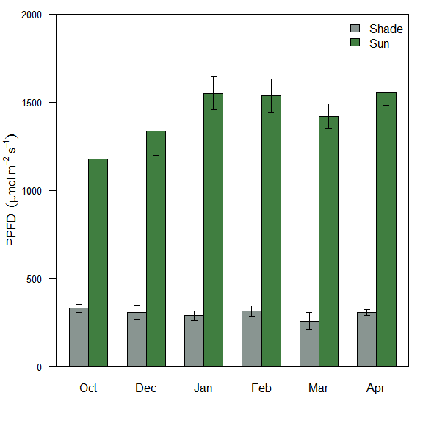

**Figure 1**. Local light environment for sun and shade leaves for each gas exchange campaign. Means with standard errors represent 1 m integrated PPFD (n=5), measured with a ceptometer, at the canopy height of each selected leaf.

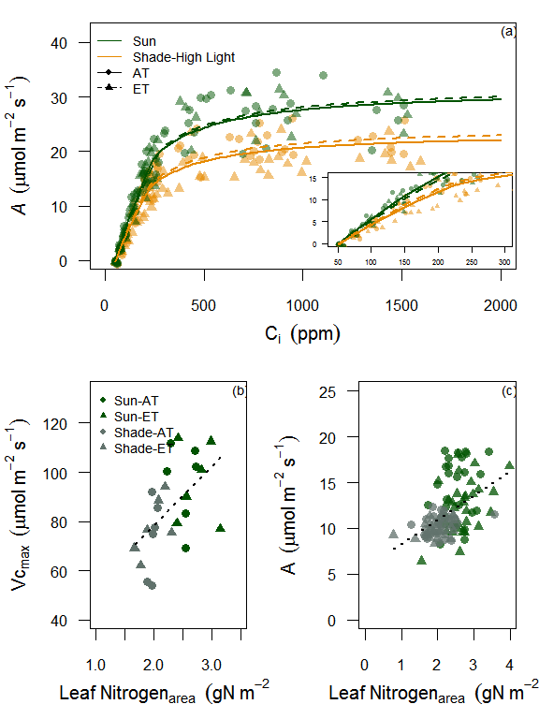

**Figure 2**. (a) Photosynthetic CO2 response (ACi) curves for sun and shade leaves at elevated (ET) and ambient (AT) temperature treatments. ACi curves were developed once for all trees, before the initiation of the drought treatment, at 25°C and at saturating light (1800 mols m-1 s-1). (b) The relationship between Vcmax and mean leaf nitrogenarea for each chamber, including sun leaves and shade leaves at low light. (c) the relationship between For (b,c) the dashed line represents the significant linear model fit for all leaves with a marginal and conditional r2 of 0.28 and 0.35 for (b), and 0.24 and 0.33 for (c).

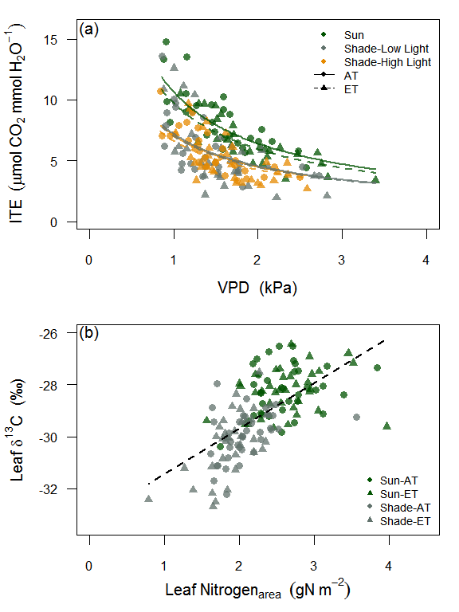

**Figure 3**. (a) Response of instantaneous water use efficiency (ITE) to leaf vapor pressure deficit (VPD) for sun leaves and shade leaves at both low and high light with elevated and ambient temperature treatments. (b) The relationship between leaf 13C and leaf nitrogenarea for sun leaves and shade leaves at low light. For (a) VPD is the leaf to air pressure difference inside the gas exchange cuvette and lines represent predictions from the optimal ITE model with a g1 value for each leaf type and treatment. For (b) the dashed line represents the significant linear model fit for all leaves with a marginal and conditional r2 of 0.41 and 0.45, respectively.

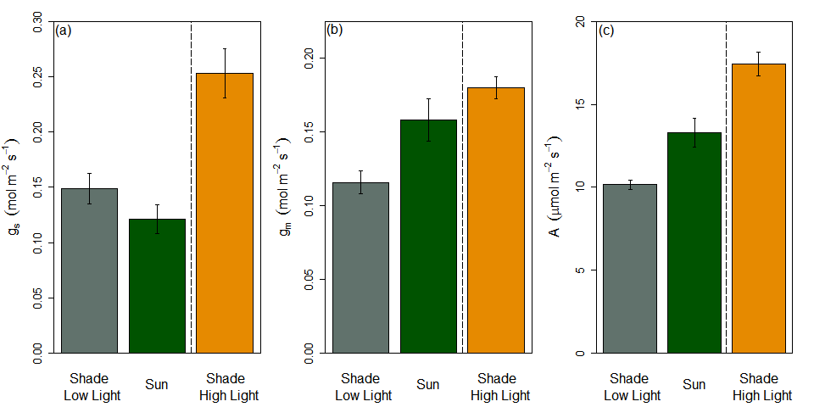

**Figure 4**. The mean stomatal conductance (a), mesophyll conductance (b) and photosynthesis rate (c) of sun leaves and shade leaves at both low and high light with standard errors.

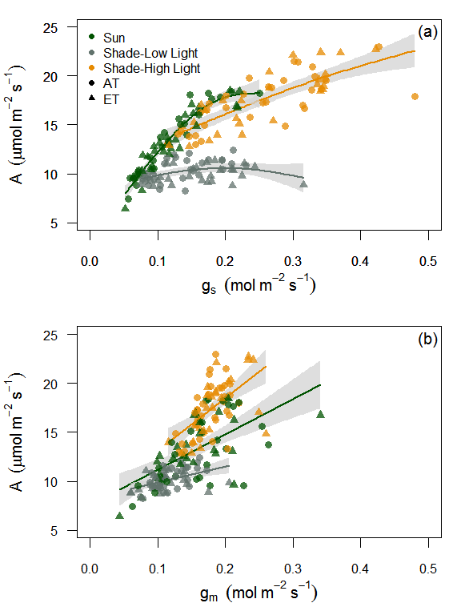 **Figure 5**. The response of leaf photosynthesis rates to stomatal conductance (a) and mesophyll conductance (b) for sun leaves and shade leaves at both low and high light with elevated and ambient temperature treatments. The response of shade leaf physiology to high light was recorded once both photosynthesis and stomatal conductance were stable in the gas exchange leaf cuvette (ca. 25min). Lines represent either smoothed regressions from a generalized additive model fit (a) or linear model fits (b). Grey areas are approximately 95% confidence intervals from the mean.

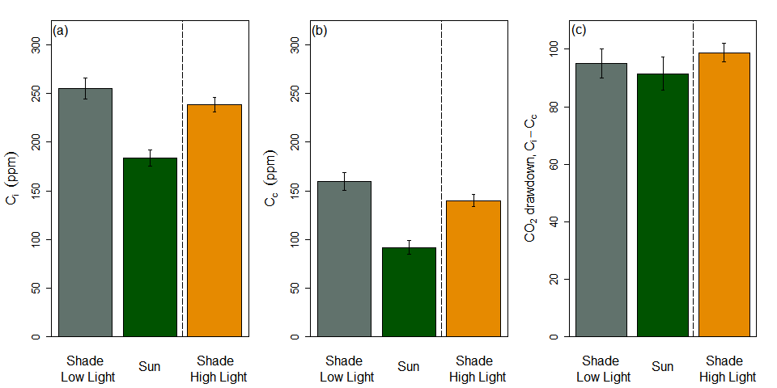

**Figure 6**. The mean intercellular CO2 concentration (a), CO2 concentration in the chloroplasts (b) and CO2 drawdown from substomatal cavities to sites of carboxylation of sun leaves and shade leaves at both low and high light with standard errors.

# Supporting Information

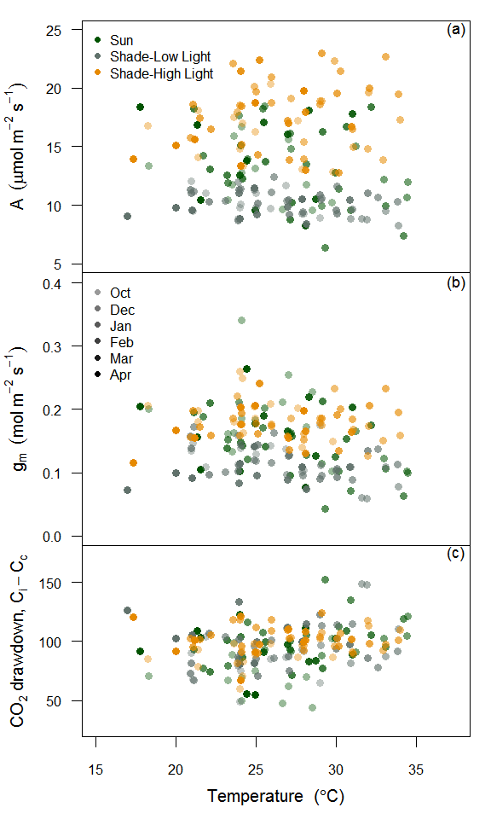 **Figure S1**. Reponse of photosynthesis (a), mesophyll conductance (b) and Ci-Cc to leaf temperature for sun leaves and shade leaves at low and high light. Shaded symbols represents each monthyl measurement campaign.

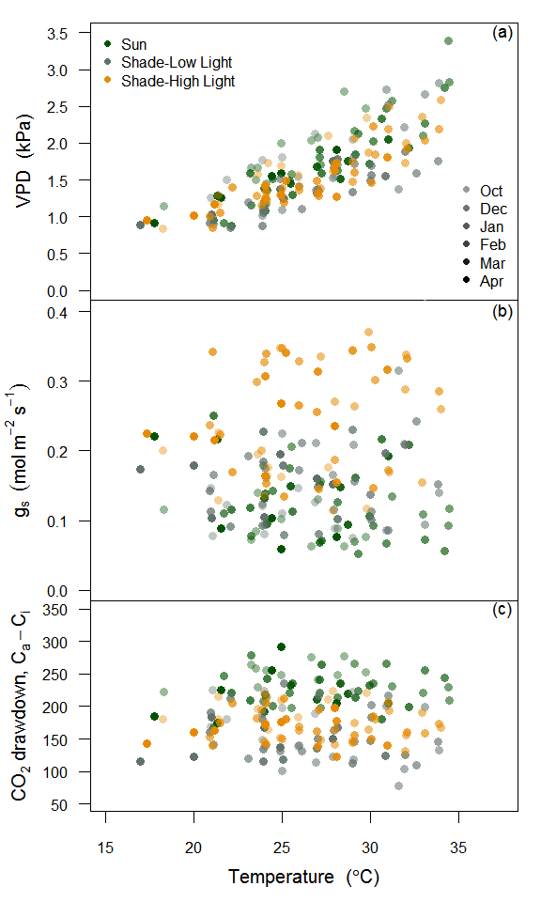 **Figure S2**. Reponse of vapor pressure deficit (a), stomatal conductance (b) and Ca-Ci to leaf temperature for sun leaves and shade leaves at low and high light. Shaded symbols represents each monthyl measurement campaign.

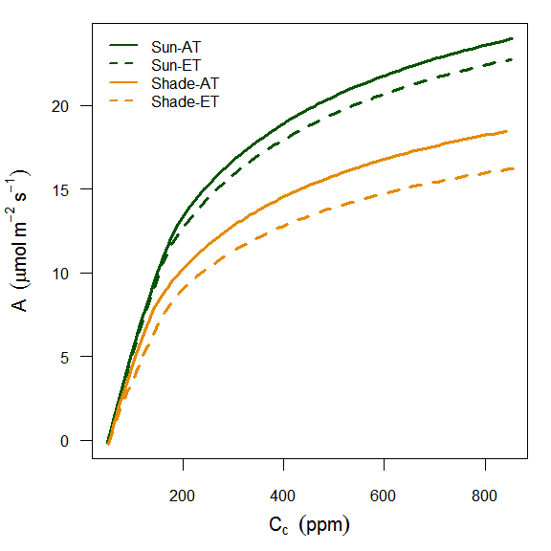

**Figure S3**. Photosynthetic CO2 response (ACc) curves for sun and shade leaves at elevated and ambient temperature treatments. Cc values were predicited with mesophyll conductance, thus curves represent chloroplastic photosynthetic parameters at 25°C and at saturating light (1800 mols m-1 s-1).

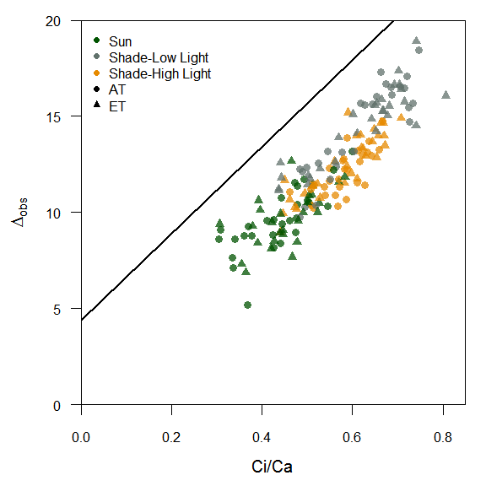

**Figure S4**. Relationship between the observed discrimination of 13CO2 and measured Ci/Ca for sun leaves and shade leaves at both low and high light. The solid line represents the the theortical line for C3 plants from (Evans *et al.*, 1986).

# References

Baldocchi DD**,** Wilson KB**,** Gu L. **2002**. How the environment, canopy structure and canopy physiological functioning influence carbon, water and energy fluxes of a temperate broad-leaved deciduous forest—an assessment with the biophysical model CANOAK. *Tree Physiology* **22**: 1065–1077.

Barton CVM**,** Ellsworth DS**,** Medlyn BE**,** Duursma RA**,** Tissue DT**,** Adams MA**,** Eamus D**,** Conroy JP**,** McMurtrie RE**,** Parsby J***et al.*** **2010**. Whole-tree chambers for elevated atmospheric CO 2 experimentation and tree scale flux measurements in south-eastern Australia: The Hawkesbury Forest Experiment. *Agricultural and Forest Meteorology* **150**: 941–951.

Bates D**,** Maechler M**,** Bolker B**,** Walker S. **2013**. lme4: Linear mixed-effects models using Eigen and S4. *R package version* **1**.

Boardman N. **1977**. Comparative photosynthesis of sun and shade plants. *Annual review of plant physiology* **28**: 355–377.

Burgess SSO**,** Pittermann J**,** Dawson TE. **2006**. Hydraulic efficiency and safety of branch xylem increases with height in Sequoia sempervirens (D. Don) crowns. *Plant, Cell & Environment* **29**: 229–239.

CAEMMERER S**,** Evans JR. **2014**. Temperature responses of mesophyll conductance differ greatly between species. *Plant, cell & environment*.

Cowan IR**,** Farquhar GD. **1977**. Stomatal function in relation to leaf metabolism and environment. Symposia of the society for experimental biology.471–505.

Crous KY**,** ZARAGOZA-CASTELLS J**,** Ellsworth DS**,** Duursma RA**,** Loew M**,** Tissue DT**,** Atkin OK. **2012**. Light inhibition of leaf respiration in field-grown Eucalyptus saligna in whole-tree chambers under elevated atmospheric CO2 and summer drought. *Plant, cell & environment* **35**: 966–981.

De Pury DGG**,** Farquhar GD. **1997**. Simple scaling of photosynthesis from leaves to canopies without the errors of big-leaf models. *Plant Cell and Environment* **20**: 537–557.

Duursma RA**,** Marshall JD. **2006**. Vertical canopy gradients in 13C correspond with leaf nitrogen content in a mixed-species conifer forest. *Trees* **20**: 496–506.

Duursma RA**,** Payton P**,** Bange MP**,** Broughton KJ**,** Smith RA**,** Medlyn BE**,** Tissue DT. **2013**. Near-optimal response of instantaneous transpiration efficiency to vapour pressure deficit, temperature and [CO 2] in cotton (Gossypium hirsutum L.). *Agricultural and forest meteorology* **168**: 168–176.

Evans JR. **1995**. Carbon fixation profiles do reflect light absorption profiles in leaves. *Functional Plant Biology* **22**: 865–873.

Evans J**,** Poorter H. **2001**. Photosynthetic acclimation of plants to growth irradiance: the relative importance of specific leaf area and nitrogen partitioning in maximizing carbon gain. *Plant, Cell & Environment* **24**: 755–767.

Evans JR**,** Von Caemmerer S. **2013**. Temperature response of carbon isotope discrimination and mesophyll conductance in tobacco. *Plant, cell & environment* **36**: 745–756.

Evans JR**,** Sharkey TD**,** Berry JA**,** Farquhar GD. **1986**. Carbon isotope discrimination measured concurrently with gas exchange to investigate CO2 diffusion in leaves of higher plants. *Functional Plant Biology* **13**: 281–292.

Farquhar GD**,** Cernusak LA. **2012**. Ternary effects on the gas exchange of isotopologues of carbon dioxide. *Plant, Cell & Environment* **35**: 1221–1231.

Farquhar GD**,** Caemmerer S von von**,** Berry JA. **1980**. A biochemical model of photosynthetic CO2 assimilation in leaves of C3 species. *Planta* **149**: 78–90.

Field C. **1983**. Allocating leaf nitrogen for the maximization of carbon gain: leaf age as a control on the allocation program. *Oecologia* **56**: 341–347.

Field CH**,** Mooney HA. **1986**. Photosynthesis–nitrogen relationship in wild plants. On the economy of plant form and function: Proceedings of the sixth maria moors cabot symposium,‘ evolutionary constraints on primary productivity, adaptive patterns of energy capture in plants,’ harvard forest, august 1983.

Flexas J**,** RIBAS-CARBÓ M**,** DIAZ-ESPEJO A**,** GalmES J**,** Medrano H. **2008**. Mesophyll conductance to CO2: current knowledge and future prospects. *Plant, Cell & Environment* **31**: 602–621.

Givnish TJ. **1988**. Adaptation to sun and shade: a whole-plant perspective. *Functional Plant Biology* **15**: 63–92.

Griffiths H**,** Helliker BR. **2013**. Mesophyll conductance: internal insights of leaf carbon exchange. *Plant, cell & environment* **36**: 733–735.

Griffiths H**,** Weller G**,** Toy LFM**,** Dennis RJ. **2013**. You’re so vein: bundle sheath physiology, phylogeny and evolution in C3 and C4 plants. *Plant, Cell & Environment* **36**: 249–261.

Hubbard RM**,** Ryan MG**,** Stiller V**,** Sperry JS. **2001**. Stomatal conductance and photosynthesis vary linearly with plant hydraulic conductance in ponderosa pine. *Plant, Cell & Environment* **24**: 113–121.

Linderson M-L**,** Mikkelsen TN**,** Ibrom A**,** Lindroth A**,** Ro-Poulsen H**,** Pilegaard K. **2012**. Up-scaling of water use efficiency from leaf to canopy as based on leaf gas exchange relationships and the modeled in-canopy light distribution. *Agricultural and Forest Meteorology* **152**: 201–211.

Medlyn BE**,** Dreyer E**,** Ellsworth D**,** Forstreuter M**,** Harley PC**,** Kirschbaum MUF**,** Le Roux X**,** Montpied P**,** Strassemeyer J**,** Walcroft A***et al.*** **2002**. Temperature response of parameters of a biochemically based model of photosynthesis. II. A review of experimental data. *Plant, Cell & Environment* **25**: 1167–1179.

Medlyn BE**,** Duursma RA**,** Eamus D**,** Ellsworth DS**,** Colin Prentice I**,** Barton CVM**,** Crous KY**,** Angelis P**,** Freeman M**,** Wingate L. **2012**. Reconciling the optimal and empirical approaches to modelling stomatal conductance. *Global Change Biology* **18**: 3476.

Monsi M**,** Saeki T. **2005**. On the factor light in plant communities and its importance for matter production. *Annals of Botany* **95**: 549–567.

Nakagawa S**,** Schielzeth H. **2013**. A general and simple method for obtaining R2 from generalized linear mixed-effects models. *Methods in Ecology and Evolution* **4**: 133–142.

Niinemets U. **2007**. Photosynthesis and resource distribution through plant canopies. *Plant, Cell & Environment* **30**: 1052–1071.

Niinemets Ü. **2010**. A review of light interception in plant stands from leaf to canopy in different plant functional types and in species with varying shade tolerance. *Ecological Research* **25**: 693–714.

Niinemets Ü. **2012**. Optimization of foliage photosynthetic capacity in tree canopies: towards identifying missing constraints. *Tree physiology* **32**: 505–509.

Niinemets Ü**,** Valladares F. **2004**. Photosynthetic acclimation to simultaneous and interacting environmental stresses along natural light gradients: optimality and constraints. *Plant Biology* **6**: 254–268.

Pearcy RW. **1990**. Sunflecks and photosynthesis in plant canopies. *Annual review of plant biology* **41**: 421–453.

Peltoniemi MS**,** Duursma RA**,** Medlyn BE. **2012**. Co-optimal distribution of leaf nitrogen and hydraulic conductance in plant canopies. *Tree physiology*: tps023.

Pinheiro J**,** Bates D**,** DebRoy S**,** Sarkar D**,** R Core Team. **2015**. *{nlme}: Linear and Nonlinear Mixed Effects Models*.

R Development Core Team R. **2011**. R: A Language and Environment for Statistical Computing (RDC Team, Ed.). *R foundation for statistical computing* **1**: 409.

Sellin A**,** Kupper P. **2007**. Effects of enhanced hydraulic supply for foliage on stomatal responses in little-leaf linden (Tilia cordata Mill.). *European Journal of Forest Research* **126**: 241–251.

Sellin A**,** Õunapuu E**,** Kupper P. **2008**. Effects of light intensity and duration on leaf hydraulic conductance and distribution of resistance in shoots of silver birch (Betula pendula). *Physiologia Plantarum* **134**: 412–420.

Sun Y**,** Gu L**,** Dickinson RE**,** Pallardy SG**,** Baker J**,** Cao Y**,** DaMatta FM**,** Dong X**,** Ellsworth D**,** Van Goethem D***et al.*** **2014**. Asymmetrical effects of mesophyll conductance on fundamental photosynthetic parameters and their relationships estimated from leaf gas exchange measurements. *Plant, cell & environment* **37**: 978–994.

Tazoe Y**,** Von Caemmerer S**,** Estavillo GM**,** Evans JR. **2011**. Using tunable diode laser spectroscopy to measure carbon isotope discrimination and mesophyll conductance to CO2 diffusion dynamically at different CO2 concentrations. *Plant, Cell & Environment* **34**: 580–591.

Terashima I**,** Hanba YT**,** Tazoe Y**,** Vyas P**,** Yano S. **2006**. Irradiance and phenotype: comparative eco-development of sun and shade leaves in relation to photosynthetic CO2 diffusion. *Journal of Experimental Botany* **57**: 343–354.

Ubierna N**,** Marshall JD. **2011**. Estimation of canopy average mesophyll conductance using 13C of phloem contents. *Plant, cell & environment* **34**: 1521–1535.

Vogelman TC**,** Nishio JN**,** Smith WK. **1996**. Leaves and light capture: light propagation and gradients of carbon fixation within leaves. *Trends in Plant Science* **1**: 65–70.

Warren CR. **2008**. Stand aside stomata, another actor deserves centre stage: the forgotten role of the internal conductance to CO2 transfer. *Journal of Experimental Botany* **59**: 1475–1487.

Way DA**,** Pearcy RW. **2012**. Sunflecks in trees and forests: from photosynthetic physiology to global change biology. *Tree Physiology* **32**: 1066–1081.

Whitehead D. **1998**. Regulation of stomatal conductance and transpiration in forest canopies. *Tree Physiology* **18**: 633–644.