Adaptability of ecophysiological traits define how plant lineages make a living in shaded environments

Courtney E. Campany1, coauthors1 and James E. Watkins Jr. 1

1 Department of Biology, Colgate University, Hamilton, NY, USA

Corresponding author: C.E. Campany, email: [courtneycampany@gmail.com](mailto:courtneycampany@gmail.com),

Running Head: Ecophysiology of herbaceous plant lineages

# Abstract

/

Key Words:

# Introduction

Our understanding of the ecophysiology of ferns and lycophytes is limited. However, recent studies have shown that these two groups possess an unusual set of functional traits that likely influence their ecology (Brodribb, Watkins, Pinterman, Franks, campany). For example, Watkins has demonstrated that the gametophyte generations of many tropical ferns are markedly desiccation-tolerant, with tolerance being closely linked to ecological preference. In seed plants, desiccation tolerance has been essentially lost from vegetative tissues. Additional work on ferns indicates a tight link between carbon and nitrogen relations with species distribution (Watkins 2005). Work on fern hydraulics is in its early stages; however, a study on tropical ferns suggests that ferns have a significantly more resistive vascular system than seed plants. A recent study on temperate species proposes that ferns are more similar to gymnosperms in their hydraulic properties (Watkins).

A primary controlling factor in fern hydraulics is stomatal function. A series of elegeant studies have shown that stomatal control of ferns and lycophytes differs fundamentally from seed plants. Evidence on fern and lycophyte stomata indicates that these groups have inefficient stomatal systems, likely possessing a hydropassive mechanism which influences stomatal opening and closing (many cites). Specifically, unlike seed plants, fern and lycophyte stomata fail to close in response to abscisic acid (ABA) addition (many cites). Additionally, recent evidence also suggests that co-occuring tropical ferns and lycophytes optimize thier ecophysiology differently (Campany). Consequently, the evolution or adaptation of physiolgoical traits may impact the differential distribution of ferns,lycophytes and seed plants to eath other.

Studies that examine the comparative physiology of ferns and lycophytes to seed plants are rare. Therefore, it is difficult to derive widely applicable hypotheses of the ecophysiological behavior of these groups. From the limited number of present studies, ferns and lycophytes appear to have lower photosynthetic rates than seed plants (cite). This would suggest that non-seed plants may be at a competitive disadvantage when growing alongside seed plants. However, none of these studies have systematically compared the physiology of these groups when growing in similar habitats.

The goal of the current study is to examine the comparative physiology of a number of temperate ferns and lycophytes to angiosperms. We specifically examined several physiological parameters in comparison between co-occurring ferns, lycophytes and angiosperm in identical closed canopy habitats. In a pairwise camoparison, we also evaluated the potential of fern and angiosperm species to adapt to open-light habitats. Given increasing evidence of inefficient stomatal functions in non-seed plants, we hypothesized that ferns and lycophytes would have lower photosynthetic rates and stomatal conductance values in comparison to the nearby angiosperms. This, in turn, would impact aspects of leaf anatomy (stomatal density), nutrient relations (N and P), and water use efficiency. We speculate that the differences in physiological function also affect the ecology of lycophytes in a manner that prevents them from establishing in full sun environments.

# Methods

## Study site and species

This study was conducted at two sites in upstate New York, USA. Data for most species were gathered at the Edmund Niles Huyck Preserve (ENHP), characterized by mixed hardwood hemlock forests along the Helderberg escarpment in the foothills of the Catskill mountain range. Data from the second site were gathered at a forested natural area on the campus of Colgate University in Hamilton, New York, situated in the foothills surrounding the Chenango Valley. Forests at the Colgate University site are younger, but consist of a similar species richness and composition as ENHP.

We examined a series of fern, lycophyte, and angiosperm species at both sites (Table 1). The main focus of this work was to examine ferns relative to light-analogous angiosperms. To accomplish this, we selected a fern species and then located the nearest neighboring angiosperm growing in similar habitat conditions. Surveyed angiosperm taxa were always herbaceous and similar in size and stature to the neighboring fern species. At the ENHP, we sampled across two distinct habitats: understory low-light areas (closed) and open canopy high-light areas (open). At the Colgate University site, additional low-light fern and lycophyte species were surveyed.

## Physiological Measurements

To generate comparative physiological data, we followed two procedures. First, we generated a series of detailed light response curves for a select number of species from each plant group (fern = 5, angiosperm = 5, lycophytes = 3). Light response curves were conducted for five individuals of each species. Next, to increase our comparative sample size, we surveyed light saturated rates of photosynthesis (An) and stomatal conductance (gs) for additional species at the ENHP. All gas exchange parameters were generated using the LiCor 6400 XT Photosynthesis System (LiCor Biosciences, Lincoln, NE USA).

Light response curves were conducted by decreasing the light intensity in the 2x3 cm gas exchange cuvette in small step changes. For each light response curve, The CO2 in the leaf cuvette was set to a flow rate of 300 mol s-1 and at ambient atmospheric [CO2] (400 ppm). Temperature was not explictly controlled in the leaf cuvette. Cuvette leaf temperatures ranged from 27-30 °C and leaf vapor pressure deficit (VPD) averaged 1.37±0.40 kPa. Initial light measurements were made using the built-in quantum sensor to determine typical ambient light levels. These measurements were used to generate light response curves using appropriate light levels for high-light and low-light species separately. The light levels were not identical for each species, with several points being added or subtracted with each run. Broadly, light response curves followed the same template for high light or low light species. For high light species, light levels started at a PPFD of 1500 mol m-1 s-1 and then consisted of 16 additional steps to O mol m-1 s-1. For low light species, light response curves started at a PPFD of 500 mol m-1 s-1, followed by 13 additional steps to O mol m-1 s-1. Light response data for each curves was fit to a non-rectangular hyperbola model (Equation 6 in Lobo *et al.* (2013)). The light compensation point (LCP) was calculated as the PPFD at which the net photosynthetic rate equalled zero from the linear phase of each light response curve. Quantum yeild () was calculated as the initial slope of the assimilation rate and mitochondrial respiration in the light (Rd) at the step change where PPFD was 0 mol m-1 s-1.

From these light response curves, we also developed an understanding of the levels at which low-light and high-light species reached light saturated photosynthetic rates. As a result, additional survey measurments were conducted at at a PPFD of 1200 mol m-1 s-1 for high-light species and 600 mol m-1 s-1 for low-light species. All other cuvette parameters were identical to those used for the light response curves. Leaf-level instantaneous water use efficiency (WUE) was calculated as An divided by transpiration from gas exchange measurements.

## Foliar chemistry

Foliar tissue was sampled following gas exchange measurements for all species at ENHP and used for nutrient analyses. Samples were dried to a constant mass and ground using a Wig-L-Bug (Sigma-Aldrich, St. Louis, USA). Carbon and nitrogen analyses were measured using a Costech Analytical Elemental Analyzer (Valencia, USA), with the percentage of carbon and nitrogen in samples calculated by comparison with certified standards. Foliar phosphorus concentrations were determined using an ash digestion process (D’Angelo *et al.*, 2001) preceded by color development and absorbance measurement on an Astoria Paciﬁc colorimetric autoanalyzer (Clackamas, Oregon, USA).

## Stomatal anatomy

Stomatal density (SD) was measured by directly counting stomata on the abaxial leaf surface under 40x magnification with a field of view of 0.622 mm2. Stomatal density was calculated from 8 non-overlapping foliar regions for five individuals of each species.

## Statistial analyses

Principal component analysis, utilizing the ‘vegan’ package (Oksanen *et al.*, 2019), was used to explore how measured functional traits were distributed and co-varied among plant groups and canopy type. Linear mixed-effect models responses were used to test responses of functional traits to caetgorial fixed effects of plant group and canopy habitat. To test broad differnces in plant groups, species nested within canopy habitats were treated as random effects. To test differences between habitat types (ferns and angiosperms only) species was treated as a fixed effect. Explained variance (R2) of mixed models were computed as in Nakagawa & Schielzeth (2013), in which the marginal R2 represents variance explained by fixed factors and the conditional R2 by both fixed and random factors. Tukey’s post-hoc test were performed in conjunction with ANOVA to determine which mean values of functional traits were different among plant groups and canopy habitats with the ‘multcomp’ package (Hothorn *et al.*, 2008). T-tests were performed to test for differences between functional traits across canopy habitats within angioperm and fern plant groups. For bivariate trait relationships, responses of dependent variables were analysed with linear mixed-effect models, with species as a random effect and plant group and/or canopy type as categorical fixed effects. Differences in slopes of the relationship of bivariate traits by habitat were tested by calculating estimated marginal means and computing pairwise comparisons with the ‘emmeans’ package (Lenth, 2019). All tests of statistical significance were conducted at an α level of 0.05. All analyses were performed with R 3.5.1 (R Core Team, 2018).

# Results

## Ecophysiology among plant lineages and habitats

We first explored how each of 10 measured functional traits varied and were distributed among co-occuring ferns, angiosperms and lycophytes in closed habitats. In total, 52.9 % of the trait variation was accounted for in two dimensions, encompassing different resource economics, physiology and anatomy of the surveryed taxa. Interestingly, there was minimal overlap among component scores for angiosperms species compared to spore-bearing ferns and lycophytes (Figure 1). Specifically, angiosperms species were associated with gas exchange, anatomical and stoichiometric functional traits related to optimizing carboxylation. In contrast, lycophytes and fern species were most associated with physiological traits related to maintaining postive carbon balance.

Next, we explored how the same suite of 10 functional traits were distributed among open and closed habitats, in both angiosperms and ferns. In total, 55.9 % of the trait variation was accounted for in two dimensions. Component scores for angiosperms and fern species broadly diverged across open and closed canopy habitats, however, associations with physiological traits in open habitats were stronger for angiosperms (Figure 2). Specifically, angiosperms appear more plastic in their ability to upregulate traits related to photosynthetic gas exchange with increased light availability. Overall, these diverging relationships with measured functional traits suggest a highly variable in situ ecophysiology for coexisting angiosperm, fern and lycophyte taxa. This is evident in broad differences in mean values of ecophyioslogical traits across the three plant lineages and among habitat types (Table 2).

## Light response curve parameters

Overall, ferns and angiosperms had similar across open and closed habitats. Quantum yields were also equivalent within angiosperm and fern species groups between open and closed habitats. Shifts in Rd between open and closed habitats differed for angiosperms and ferns (habitat x plant group, *P* < 0.001). Specifically, Rd in angiosperms was 80.6 % greater in open compared to closed habitats (t=-4.197, *P* = 0.001). Alternatively, Rd in ferns was 44.0 % greater in low-light compared to open habitats (t=-2.97, *P* = 0.006). Similarly, shifts in LCP between open and closed habitats differed for angiosperms and ferns (habitats x plant group, *P* < 0.001). Specifically, the LCP in angiosperms was 79.2 % greater in open compared to closed habitats (t=-3.5998, *P* = 0.005). Alternatively, the LCP in ferns was 39.7 % greater in closed compared to open habitats (t=2.1814, *P* = 0.040).

In closed canopy environments,the LCP in ferns were equivalent to lycophytes, while both plant groups were marginally higher than angiosperms (*P* = 0.061). Photosynthetic quantum was similar between each plant group, but lycophytes and ferns were broadly higher than angiosperms. Ferns and lycophytes had equavalent respiration rates, while both groups were higher than angiosperms (*P* = 0.0178)

## Leaf gas exchange

Overall, fern and angiosperm species in open habitats had higher An than comparable species in low-light habitats (*P* <- 0.0001). Specifically, fern species in high-light habitats had 40.6 % greater An than in low-light habitats(*P* < 0.0001, t=-4.72), while angiosperm species had 60 % higher An (*P* < 0.0001, t=-6.97). Ferns and angiosperms growing in low-light habitats had similar An, however, in open habitats angiosperms had 42.6% higher rates of An than ferns (canopy x plant group, *P* = 0.043). Neither ferns nor angiosperms species differed in WUE across the two light environments. Across all habitats, the WUE was also statistically similar for ferns and angiosperms.

Overall, ferns and angiosperms in open habitats had 64.2% higher gs than comparable species in low-light habitats (*P* = 0.002). Specifically, fern species in high-light habitats had 50.7 % greater gs than in low-light habitats(*P* < 0.0001, t=-4.72), while angiosperm species had 66.9 % higher gs (*P* < 0.0001, t=-4.157). Across both habitat types, angiosperm species had a 60% higher gs than fern species (*P* = 0.011).

In closed canopy environments, variation in gas exchange parameters was largely due to individual species variation instead of functional differences between all three plant groups. No differences between An were detected between between the three plant groups, with a majority of the variation associated with the random effect of individual species. Stomatal conductance in angiosperms was higher than in ferns and lycophytes **P* = 0.001). Water-use efficiency was 47 % higher in lycophytes than ferns and angiosperms (*P* = 0.005), while ferns and angiosperms where statiscally similar.

## Stoichiometry (##can use pairwise for specific p values: see leaf P below)

Ferns and angiosperms species in open light environments had marginally lower foliar nitrogen content compared to similar species in growing in closed light environments (-17.2 %, *P* = 0.072), with a large proportion of variation attributed to individual species differences. Neither ferns nor angiosperms species differed in their CN ratios across the two light environments. Across all habitats, the CN ratio of ferns was 20 % higher than in angiosperms (*P* = 0.0325). No differences in foliar P content were detected between open and closed canopies for either ferns or angiosperms. Across all habitats, foliar P content was 22.1 % higher in angiosperms than in ferns (*P* = 0.034). Neither ferns nor angiosperms species differed in their NP ratios across the two light environments. Across all habitats, the NP ratio was statistically similar for ferns and angiosperms.

Across closed canopy habitats, Lycophytes have 45% lower foliar nitrogen content than ferns and angiosperms, which do not statistically differ (*P* < 0.001). Conseqently, Lycophytes had significantly higher CN ratios than ferns and angiosperms (*P* < 0.001). Lycophytes also had 24% lower foliar phosphorous content than angiosperms (*P* = .026), while ferns were simiilar to both groups. The NP ratios were not statistically different across angiosperms, ferns and lycophytes in closed canopies habitats.

## Stomatal anatomy

Overall, no differences where detected in stomatal densities between species growing open canopy and closed canopy habitats. Specifically, differences in stomatal densities were not detected for either fern nor angiosperms species between the two habitats. However, in both open and closed environments, ferns had significantly lower stomatal densities than analogous angiosperms (*P* < 0.001).

In closed canopy environments, no differenes in stomatal density were detected among species of ferns, angiosperms and lycophytes. Variation in stomatal denisty in the shade was largely due to individual species variation.

## Bivariate relationships between functional traits

The relationship between An and foliar nitrogen content depended on both plant group and canopy type (canopy x plant group, *P* = 0.028). Specifically, the postive slopes of the relationship between An and N differed for ferns and angiosperms in open canopys, while no relationship beween An and N was found for either group in closed canopies (Figure 6).

No relationships…..

# Discussion

## Comparative ecophysiology in the shade

## Differential adaption to open habitats

## Functional ecology of lycophytes

## Ecophysiological trait variation in seed plants

## Summary

# Acknowledgements

We thank

# Tables

**Table 1**. Surveyed species of angiosperms, ferns and lycophytes across both open canopy high-light and closed canopy low-ligh habitats.

|  |  |  |  |
| --- | --- | --- | --- |
| **Species** | **Plant Lineage** | **Collection Site** | **Canopy** |
| Ageratina altissima (L.) King & H. Rob. | Angiosperm | Huyck_Preserve | Closed |
| Arisaema triphyllum (L.) Schott | Angiosperm | Huyck_Preserve | Closed |
| Eupatorium purpureum L. | Angiosperm | Huyck_Preserve | Open |
| Eurybia divaricata (Aster divaricatus) (L.) G.L. Nesom | Angiosperm | Huyck_Preserve | Closed |
| Impatiens pallida Nutt. | Angiosperm | Huyck_Preserve | Closed |
| Lysimachia ciliata L. | Angiosperm | Huyck_Preserve | Open |
| Rumex acetosella L. | Angiosperm | Huyck_Preserve | Open |
| Tussilago farfara L. | Angiosperm | Huyck_Preserve | Open |
| Urtica dioica L. | Angiosperm | Huyck_Preserve | Closed |
| Viola sp. | Angiosperm | Huyck_Preserve | Closed |
| Adiantum pedatumL. | Fern | Huyck_Preserve | Closed |
| Athyrium filix-femina(L.) Mertens | Fern | Huyck_Preserve | Open |
| Botrychium dissectumSpreng. | Fern | Colgate_University | Closed |
| Botrychium multifidum(Gmel.) Rupr. | Fern | Colgate_University | Closed |
| Dennstaedtia punctilobula(Michx.) T. Moore | Fern | Huyck_Preserve | Open |
| Deparia acrostichoides(Sw.) M. Kato | Fern | Huyck_Preserve | Closed |
| Dryopteris cristata(L.) Gray | Fern | Huyck_Preserve | Closed |
| Dryopteris intermedia(Muhl. Ex Willd.) Gray | Fern | Huyck_Preserve | Closed |
| Dryopteris marginalis(L.) Gray | Fern | Huyck_Preserve | Closed |
| Onoclea sensibilis L. | Fern | Huyck_Preserve | Open |
| Osmundastrum cinnamomeumL. | Fern | Huyck_Preserve | Open |
| Osmunda claytoniana L. | Fern | Huyck_Preserve | Closed |
| Phegopteris connectilis(Michaux) Watt | Fern | Huyck_Preserve | Closed |
| Polystichum acrostichoides(Michx.) Schott | Fern | Huyck_Preserve | Closed |
| Pteridium aquilinum(L.) Kuhn | Fern | Huyck_Preserve | Closed |
| Thelypteris noveboracensis(L.) Nieuwland | Fern | Huyck_Preserve | Closed |
| Dendrolycopodium dendroideum(Michx.) A. Haines | Lycophyte | Huyck_Preserve | Closed |
| Dendrolycopodium obscurum(L.) A. Haines | Lycophyte | Colgate_University | Closed |
| Diphasiastrum complanatum (L.) Holub | Lycophyte | Colgate_University | Closed |
| Diphasiastrum digitatum (Dill. Ex A. Braun) Holub | Lycophyte | Huyck_Preserve | Closed |
| Lycopodium clavatum L. | Lycophyte | Huyck_Preserve/Colgate_University | Closed |
| Spinulum annotinum (L.) Haines | Lycophyte | Colgate_University | Closed |

**Table 2**. Pooled ecophysiological traits for different plant lineages in open light and closed habitats. Each value reflects the mean (± 1 standard error) for each treatment.

|  |  |  |  |  |  |  |  |  |  |  |  |
| --- | --- | --- | --- | --- | --- | --- | --- | --- | --- | --- | --- |
| **Plant Lineage** | **Canopy** | ***A*n (mol m-2 s-1)** | ***g*s (mol m-2 s-1)** | **Foliar Nitrogen (%)** | **Foliar Phosphorus (%)** | **N:P** | **WUE** | **SD (mm-2)** | **(mol CO2 mol photons-1)** | ***R*d (mol m-2 s-1)** | **LCP (mol~m-2~s-1)** |
| Angiosperm | Closed | 5.1 (0.21) | 0.10 (0.011) | 3.0 (0.14) | 0.26 (0.014) | 13.3 (1.27) | 4.5 (0.34) | 29.2 (1.89) | 0.055 (0.0052) | 0.14 (0.022) | 2.5 (0.41) |
|  | Open | 13.1 (1.12) | 0.30 (0.046) | 2.4 (0.19) | 0.22 (0.007) | 11.6 (1.03) | 4.4 (0.18) | 32.5 (3.17) | 0.067 (0.0034) | 0.77 (0.146) | 13.0 (2.83) |
| Fern | Closed | 4.5 (0.30) | 0.06 (0.004) | 3.0 (0.10) | 0.21 (0.008) | 13.8 (0.71) | 4.8 (0.28) | 14.3 (1.26) | 87.729 (87.6545) | 0.46 (0.056) | 7.1 (1.11) |
|  | Open | 7.5 (0.58) | 0.11 (0.013) | 2.5 (0.09) | 0.17 (0.012) | 15.0 (0.86) | 5.5 (0.47) | 15.2 (1.96) | 0.062 (0.0015) | 0.26 (0.039) | 4.3 (0.67) |
| Lycophyte | Closed | 3.6 (0.20) | 0.02 (0.002) | 1.6 (0.07) | 0.20 (0.023) | 10.8 (0.89) | 8.8 (0.75) | 24.9 (3.04) | 0.085 (0.0088) | 0.48 (0.085) | 7.1 (1.27) |

# Figures

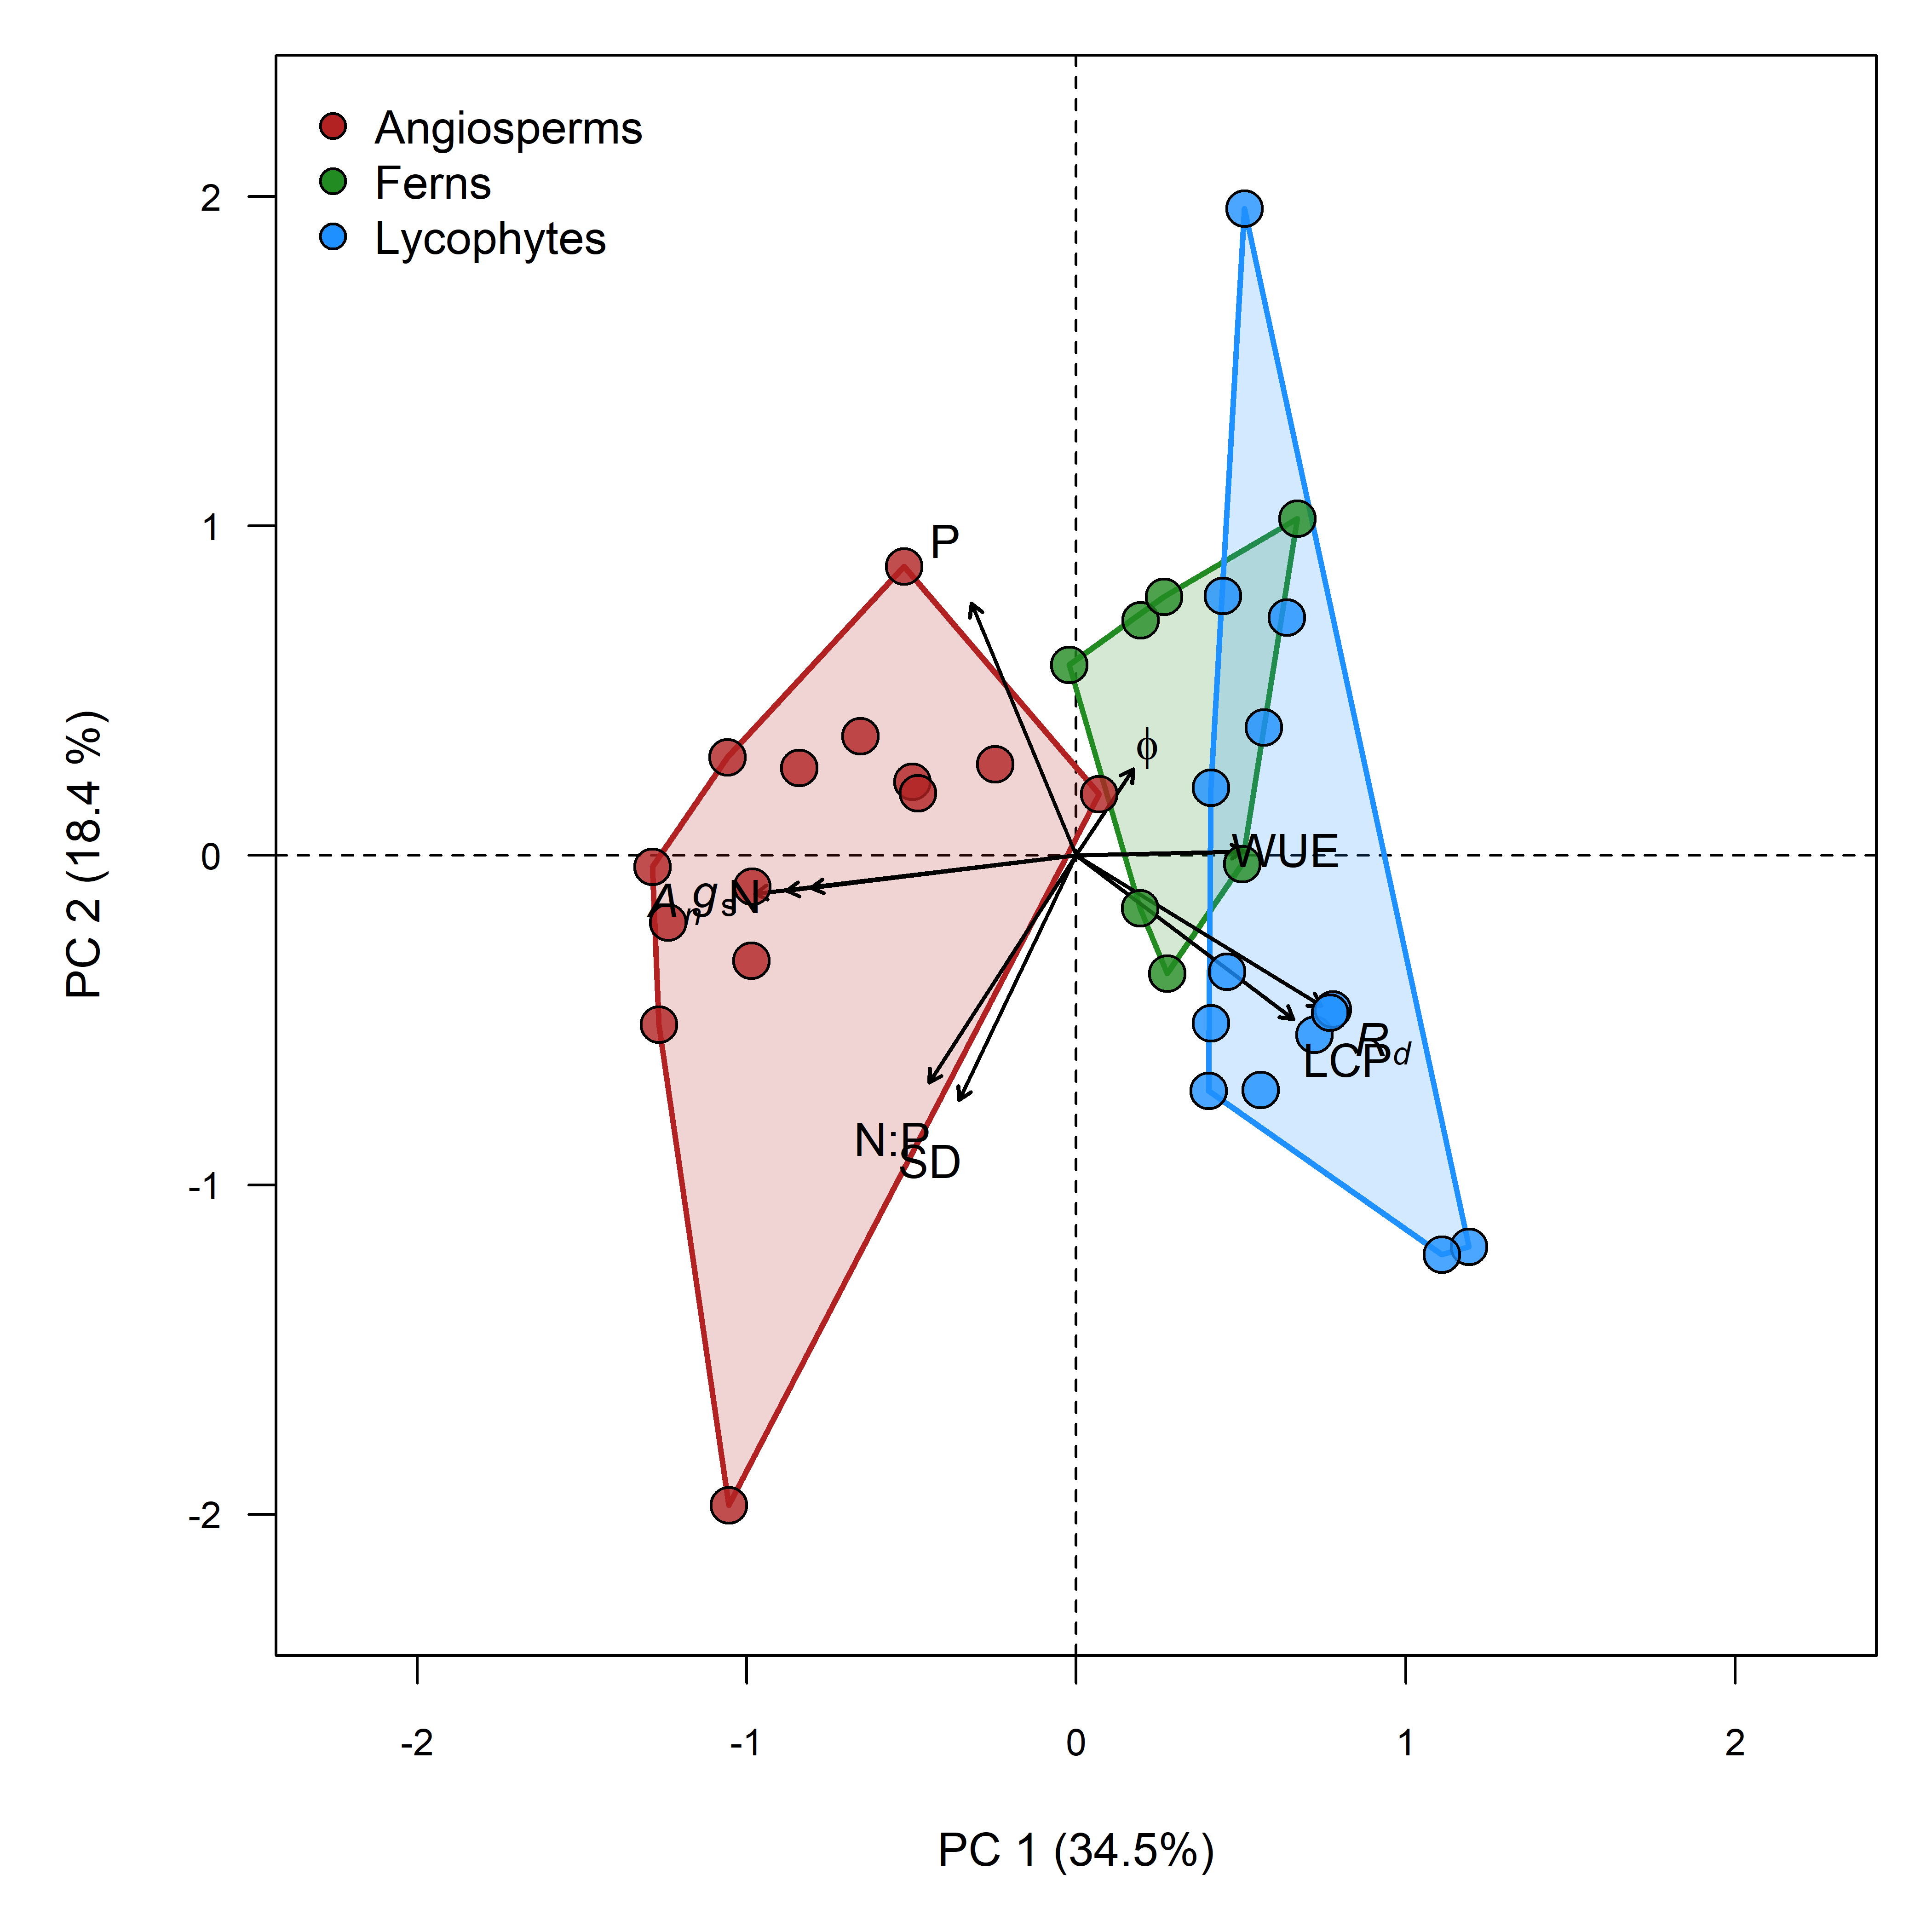 **Figure 1**. Redundancy analysis of measured functional traits across con-occuring similar statured angiosperm, fern and lycophyte species in shaded habitats. With the 10 measured variables, 52.9 % of the trait variation was accounted for in two dimensions. Variables include net photosynthesis (An), stomatal conductance (gs), instantaneous water use efficiency (WUE), stomatal density (SD), the light compensation point (LCP), quantum yield (), dark respiration (Rd), foliar nitrogen (N) and phosphorus (P) content and the leaf nitrogen to phosphorus ratio (N:P).

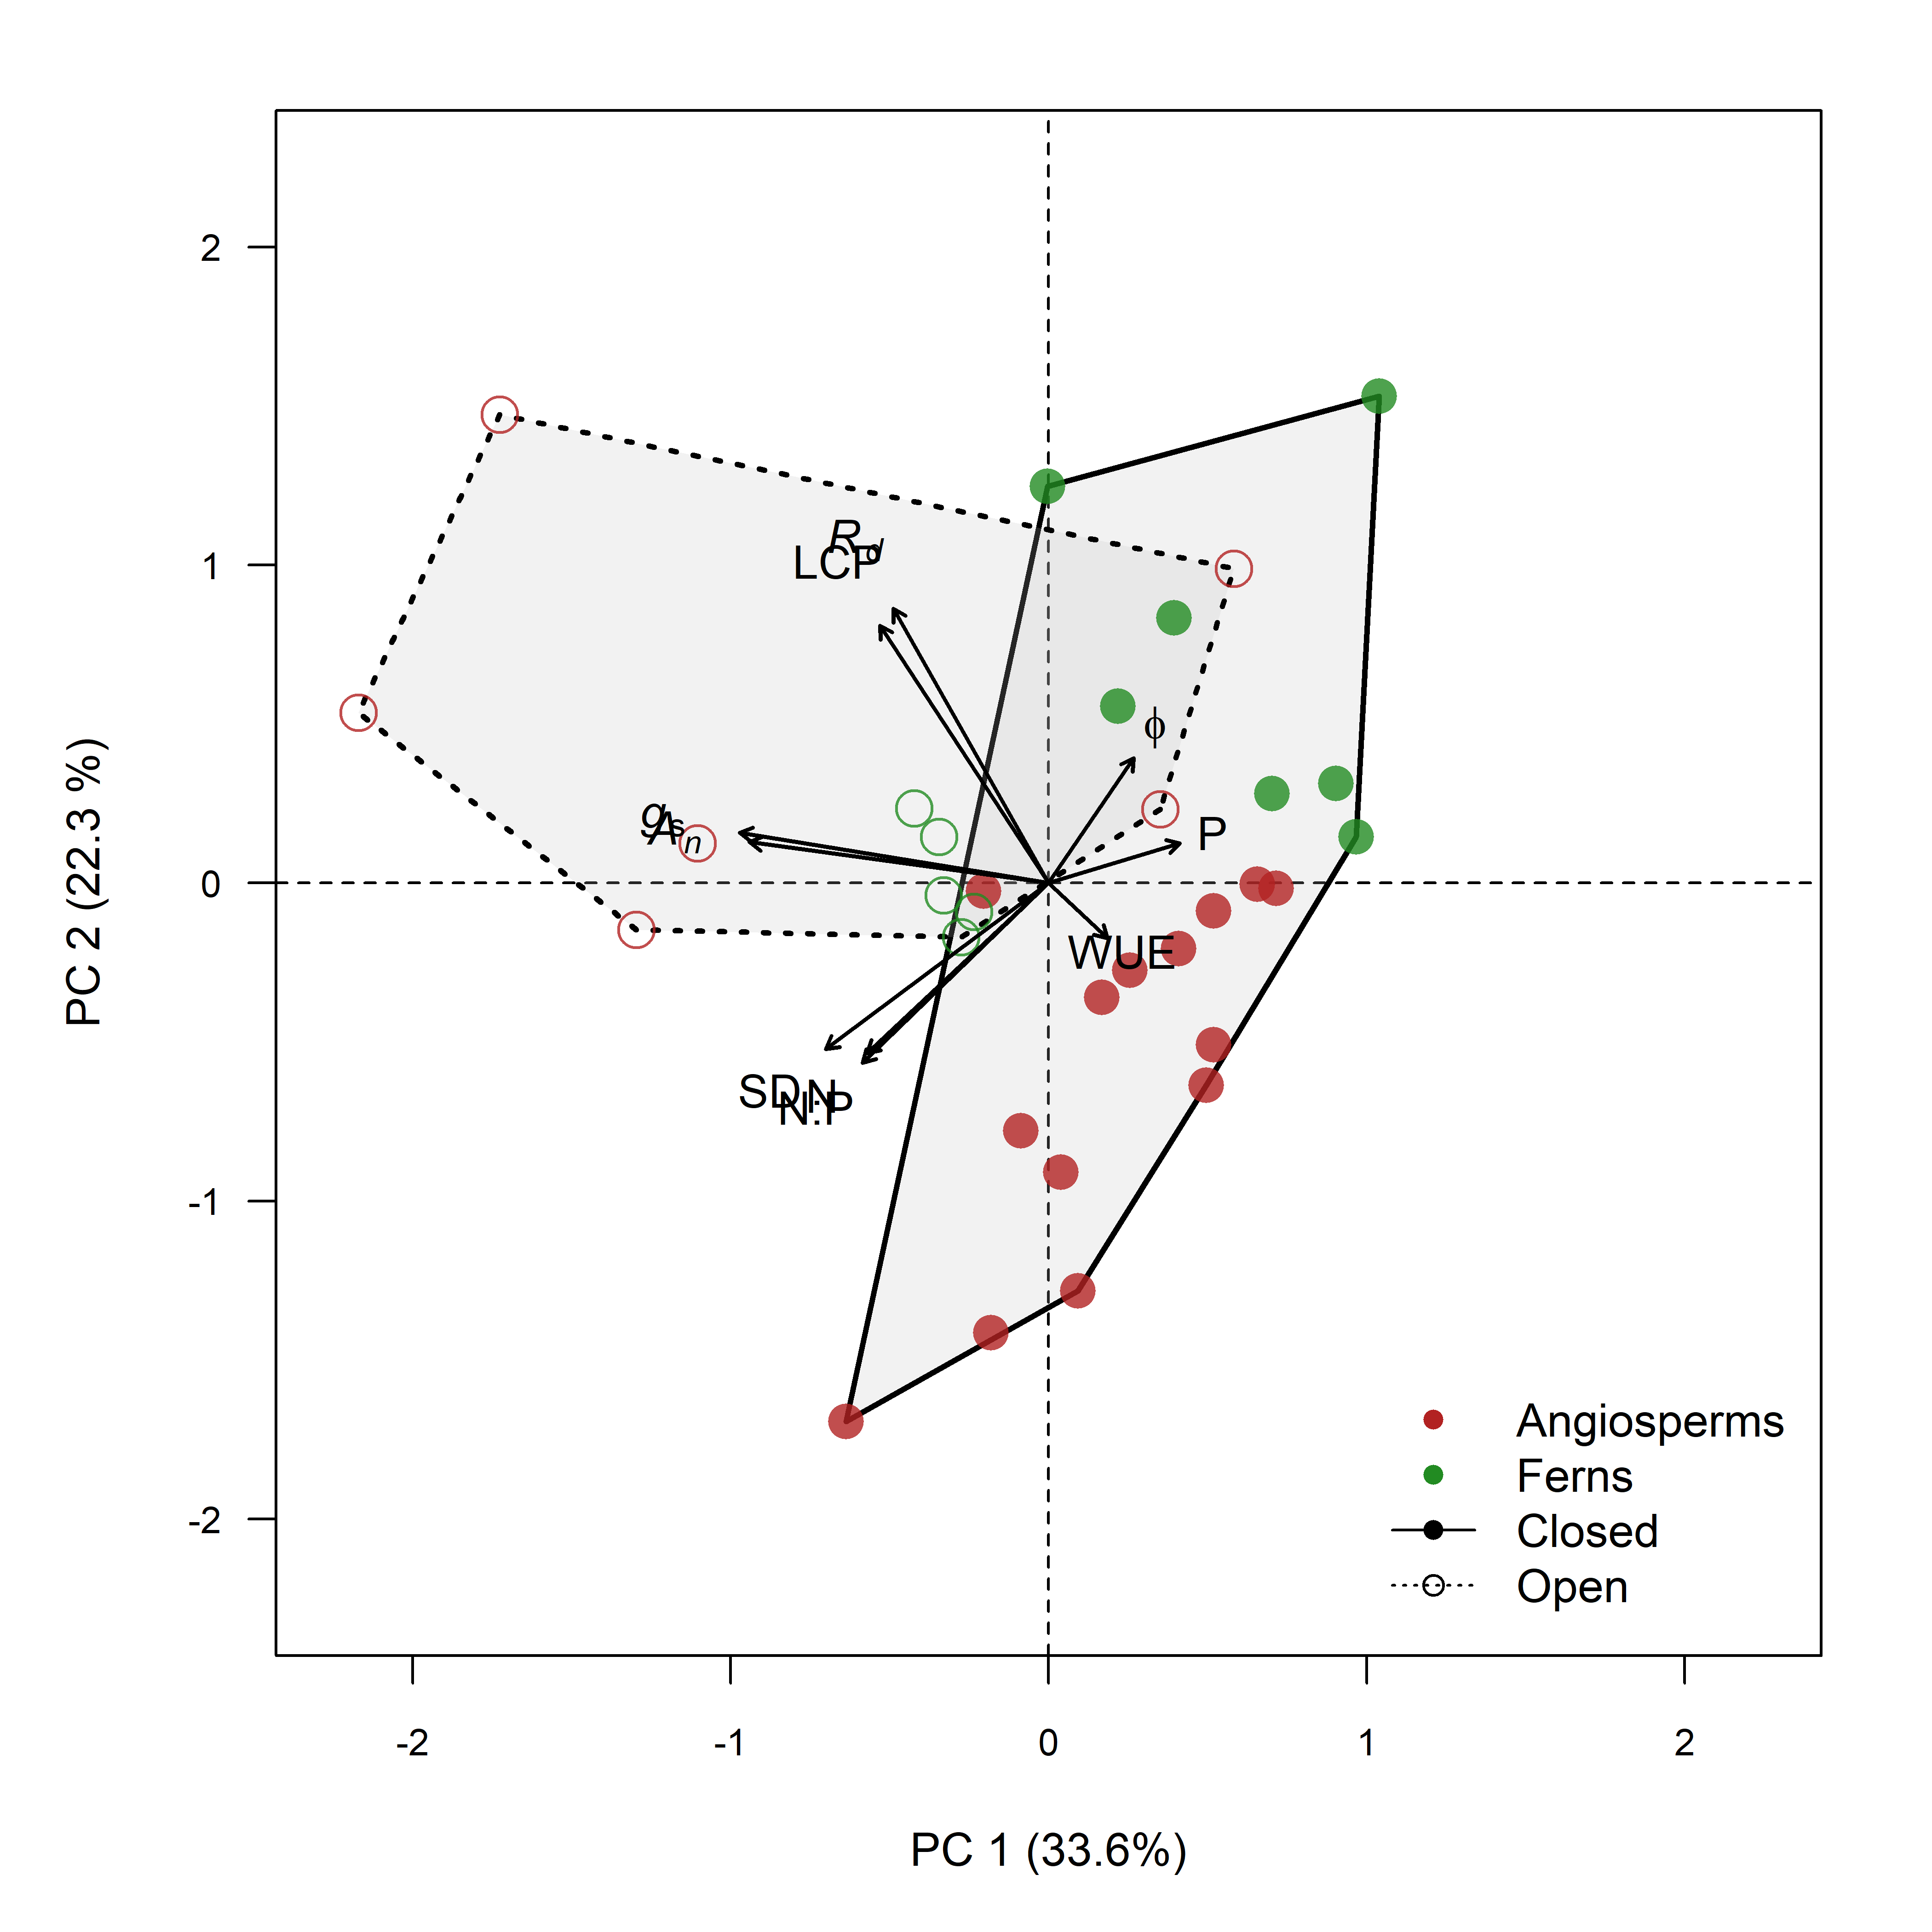 **Figure 2**. Redundancy analysis of measured functional traits across con-occuring similar statured angiosperms and fern species in open and shaded habitats. With the 10 measured variables, 55.9 % of the trait variation was accounted for in two dimensions. Variables include net photosynthesis (An), stomatal conductance (gs), instantaneous water use efficiency (WUE), stomatal density (SD), the light compensation point (LCP), quantum yield (), dark respiration (Rd), foliar nitrogen (N) and phosphorus (P) content and the leaf nitrogen to phosphorus ratio (N:P).

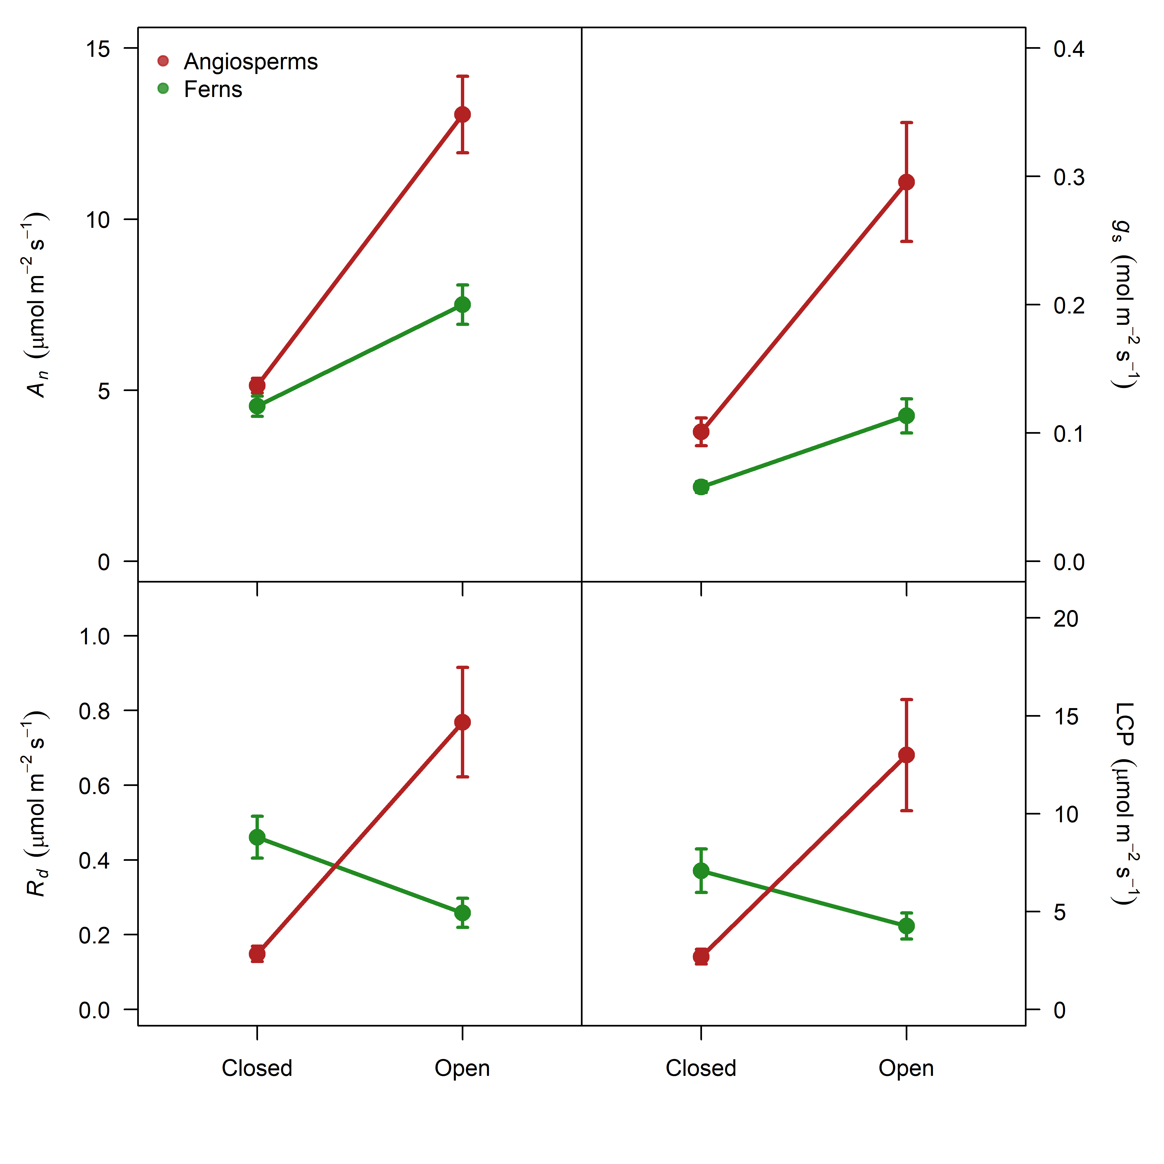 **Figure 3**. Differences in mean physiological traits between co-occuring angiosperms and fern species in open light and closed habitats.

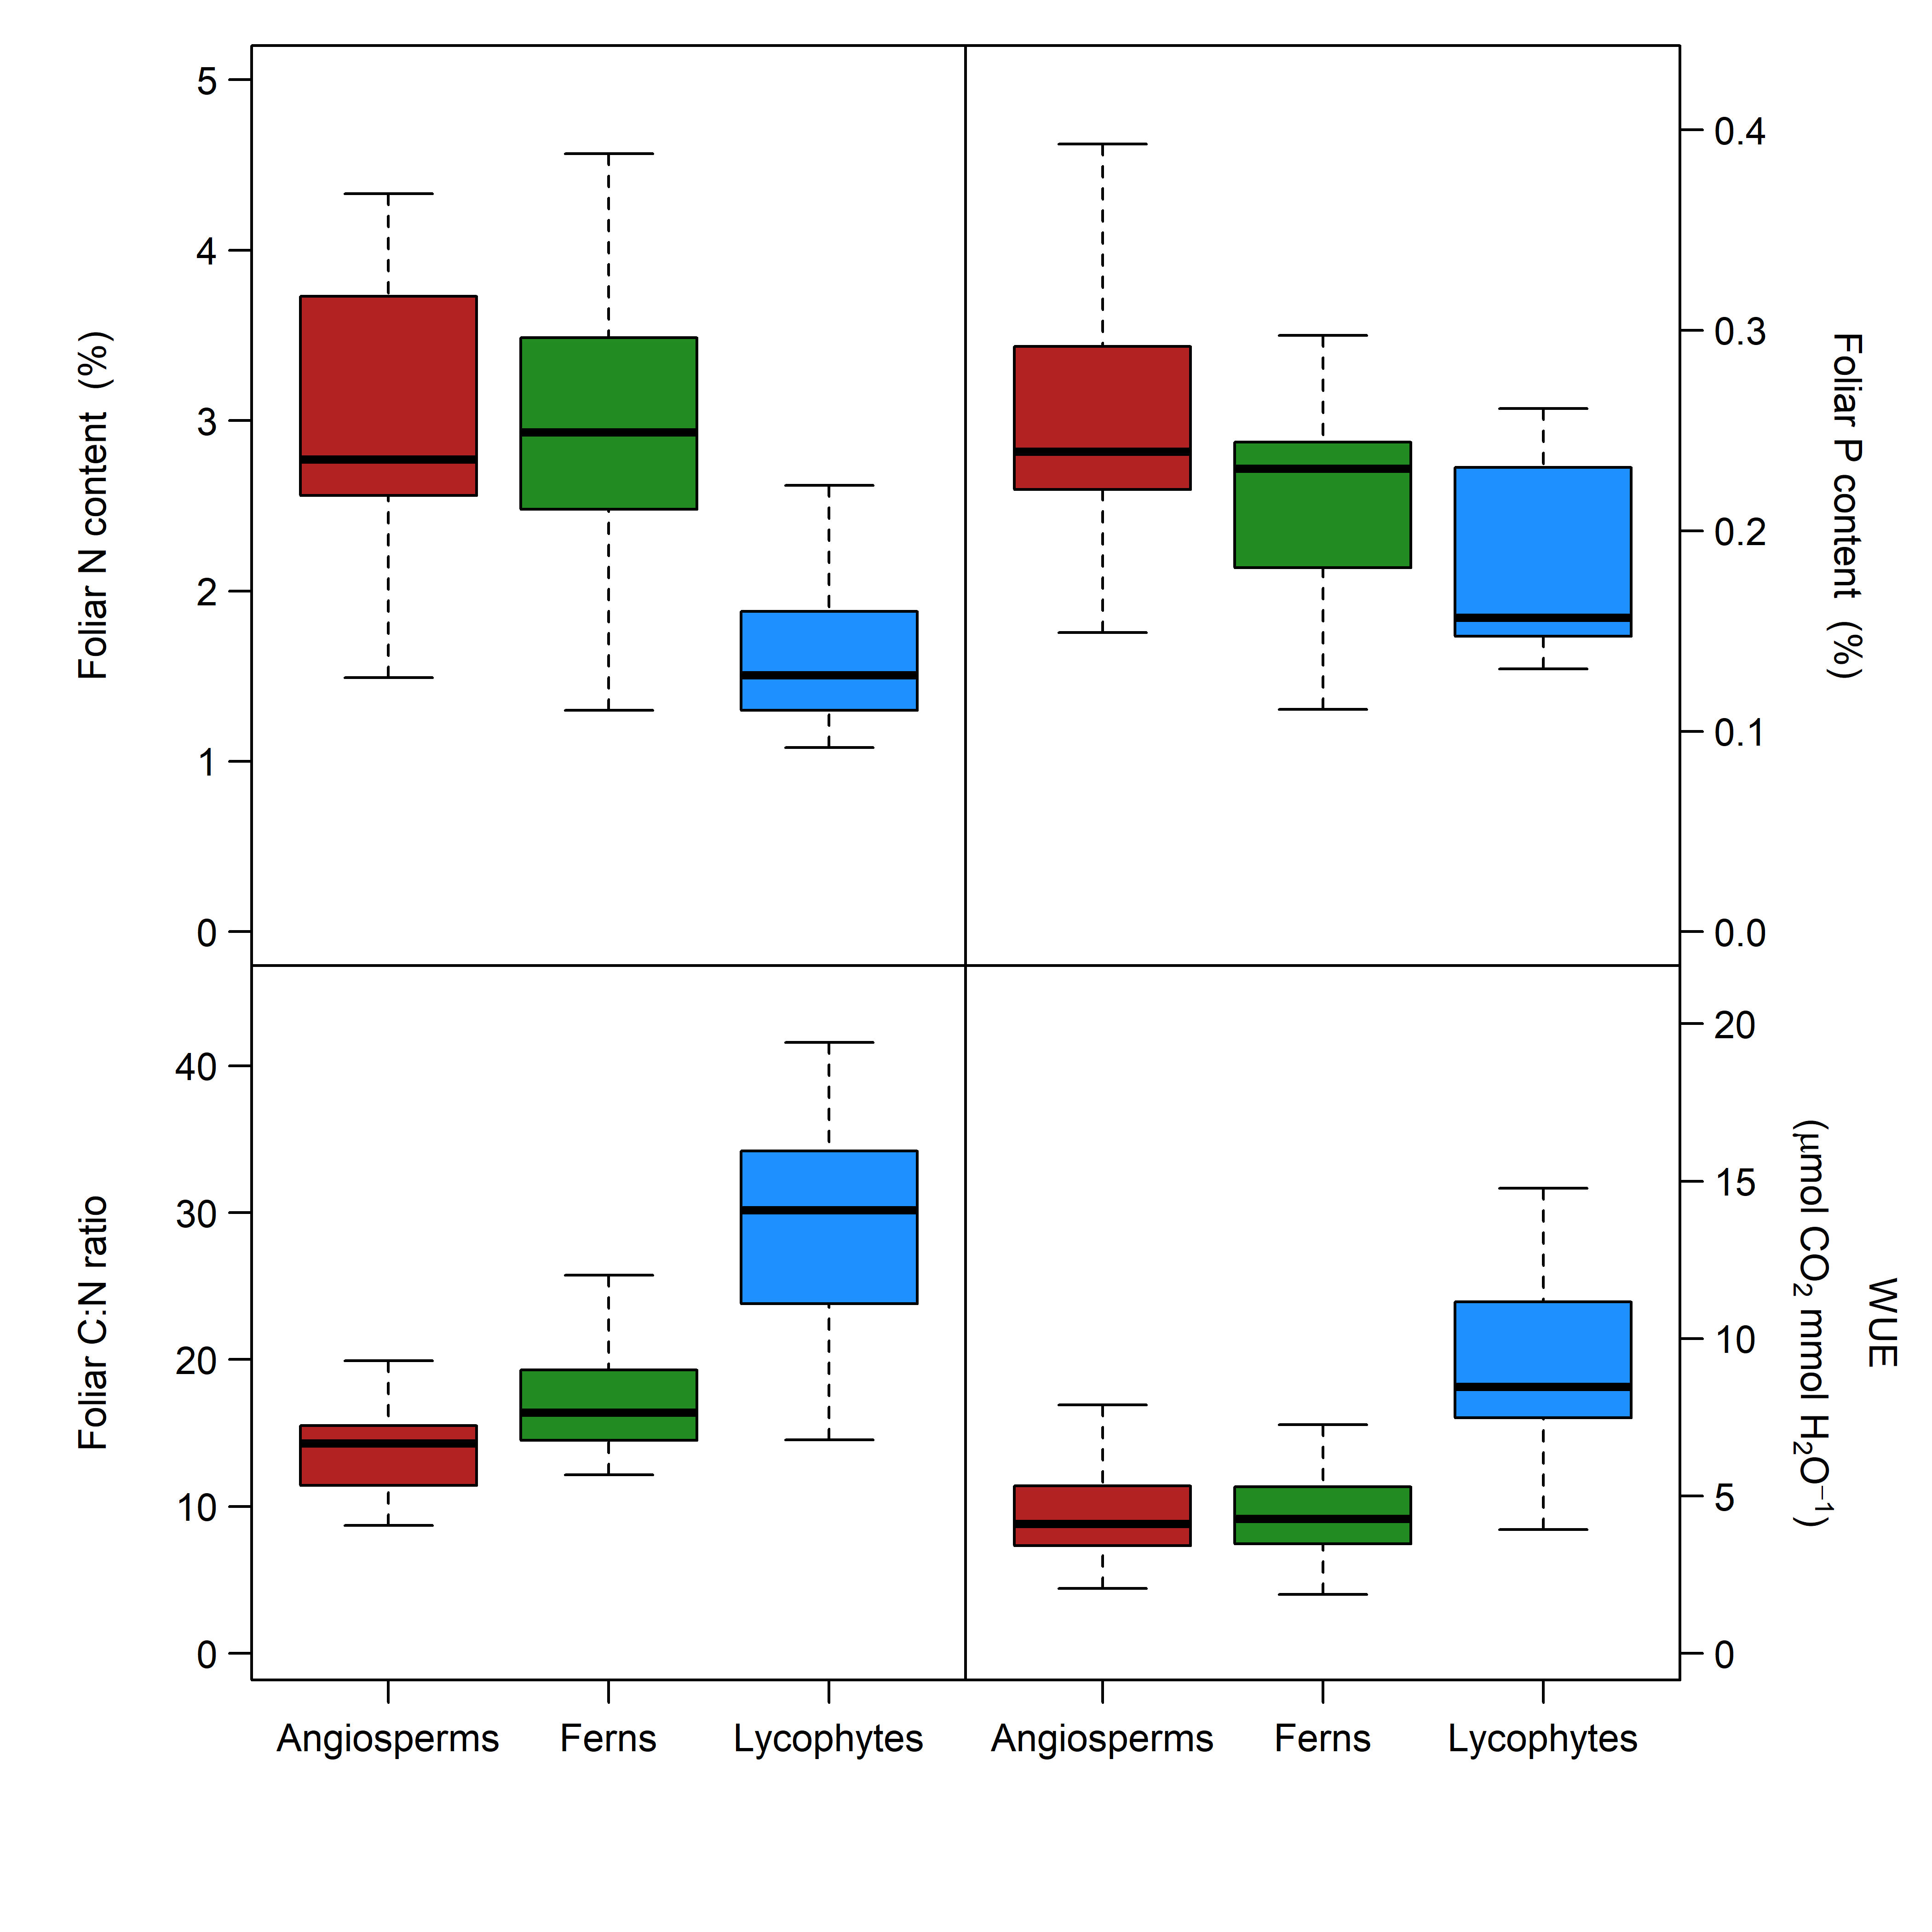 **Figure 4**. Differences in mean physiological traits between lycophytes species that are constrained to only shade habitats and ferns and angiosperms.

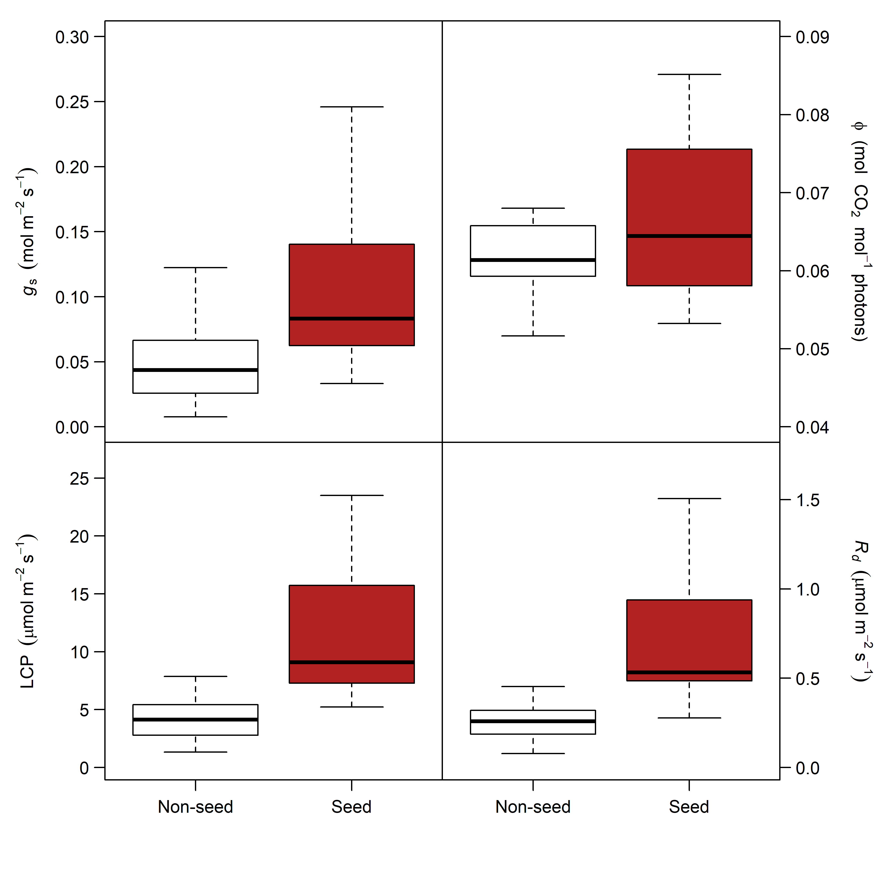 **Figure 5**. Differences in mean physiological traits between co-occuring seed (angiosperms) and non-seed plant species (ferns + lycophytes) in shade habitats.

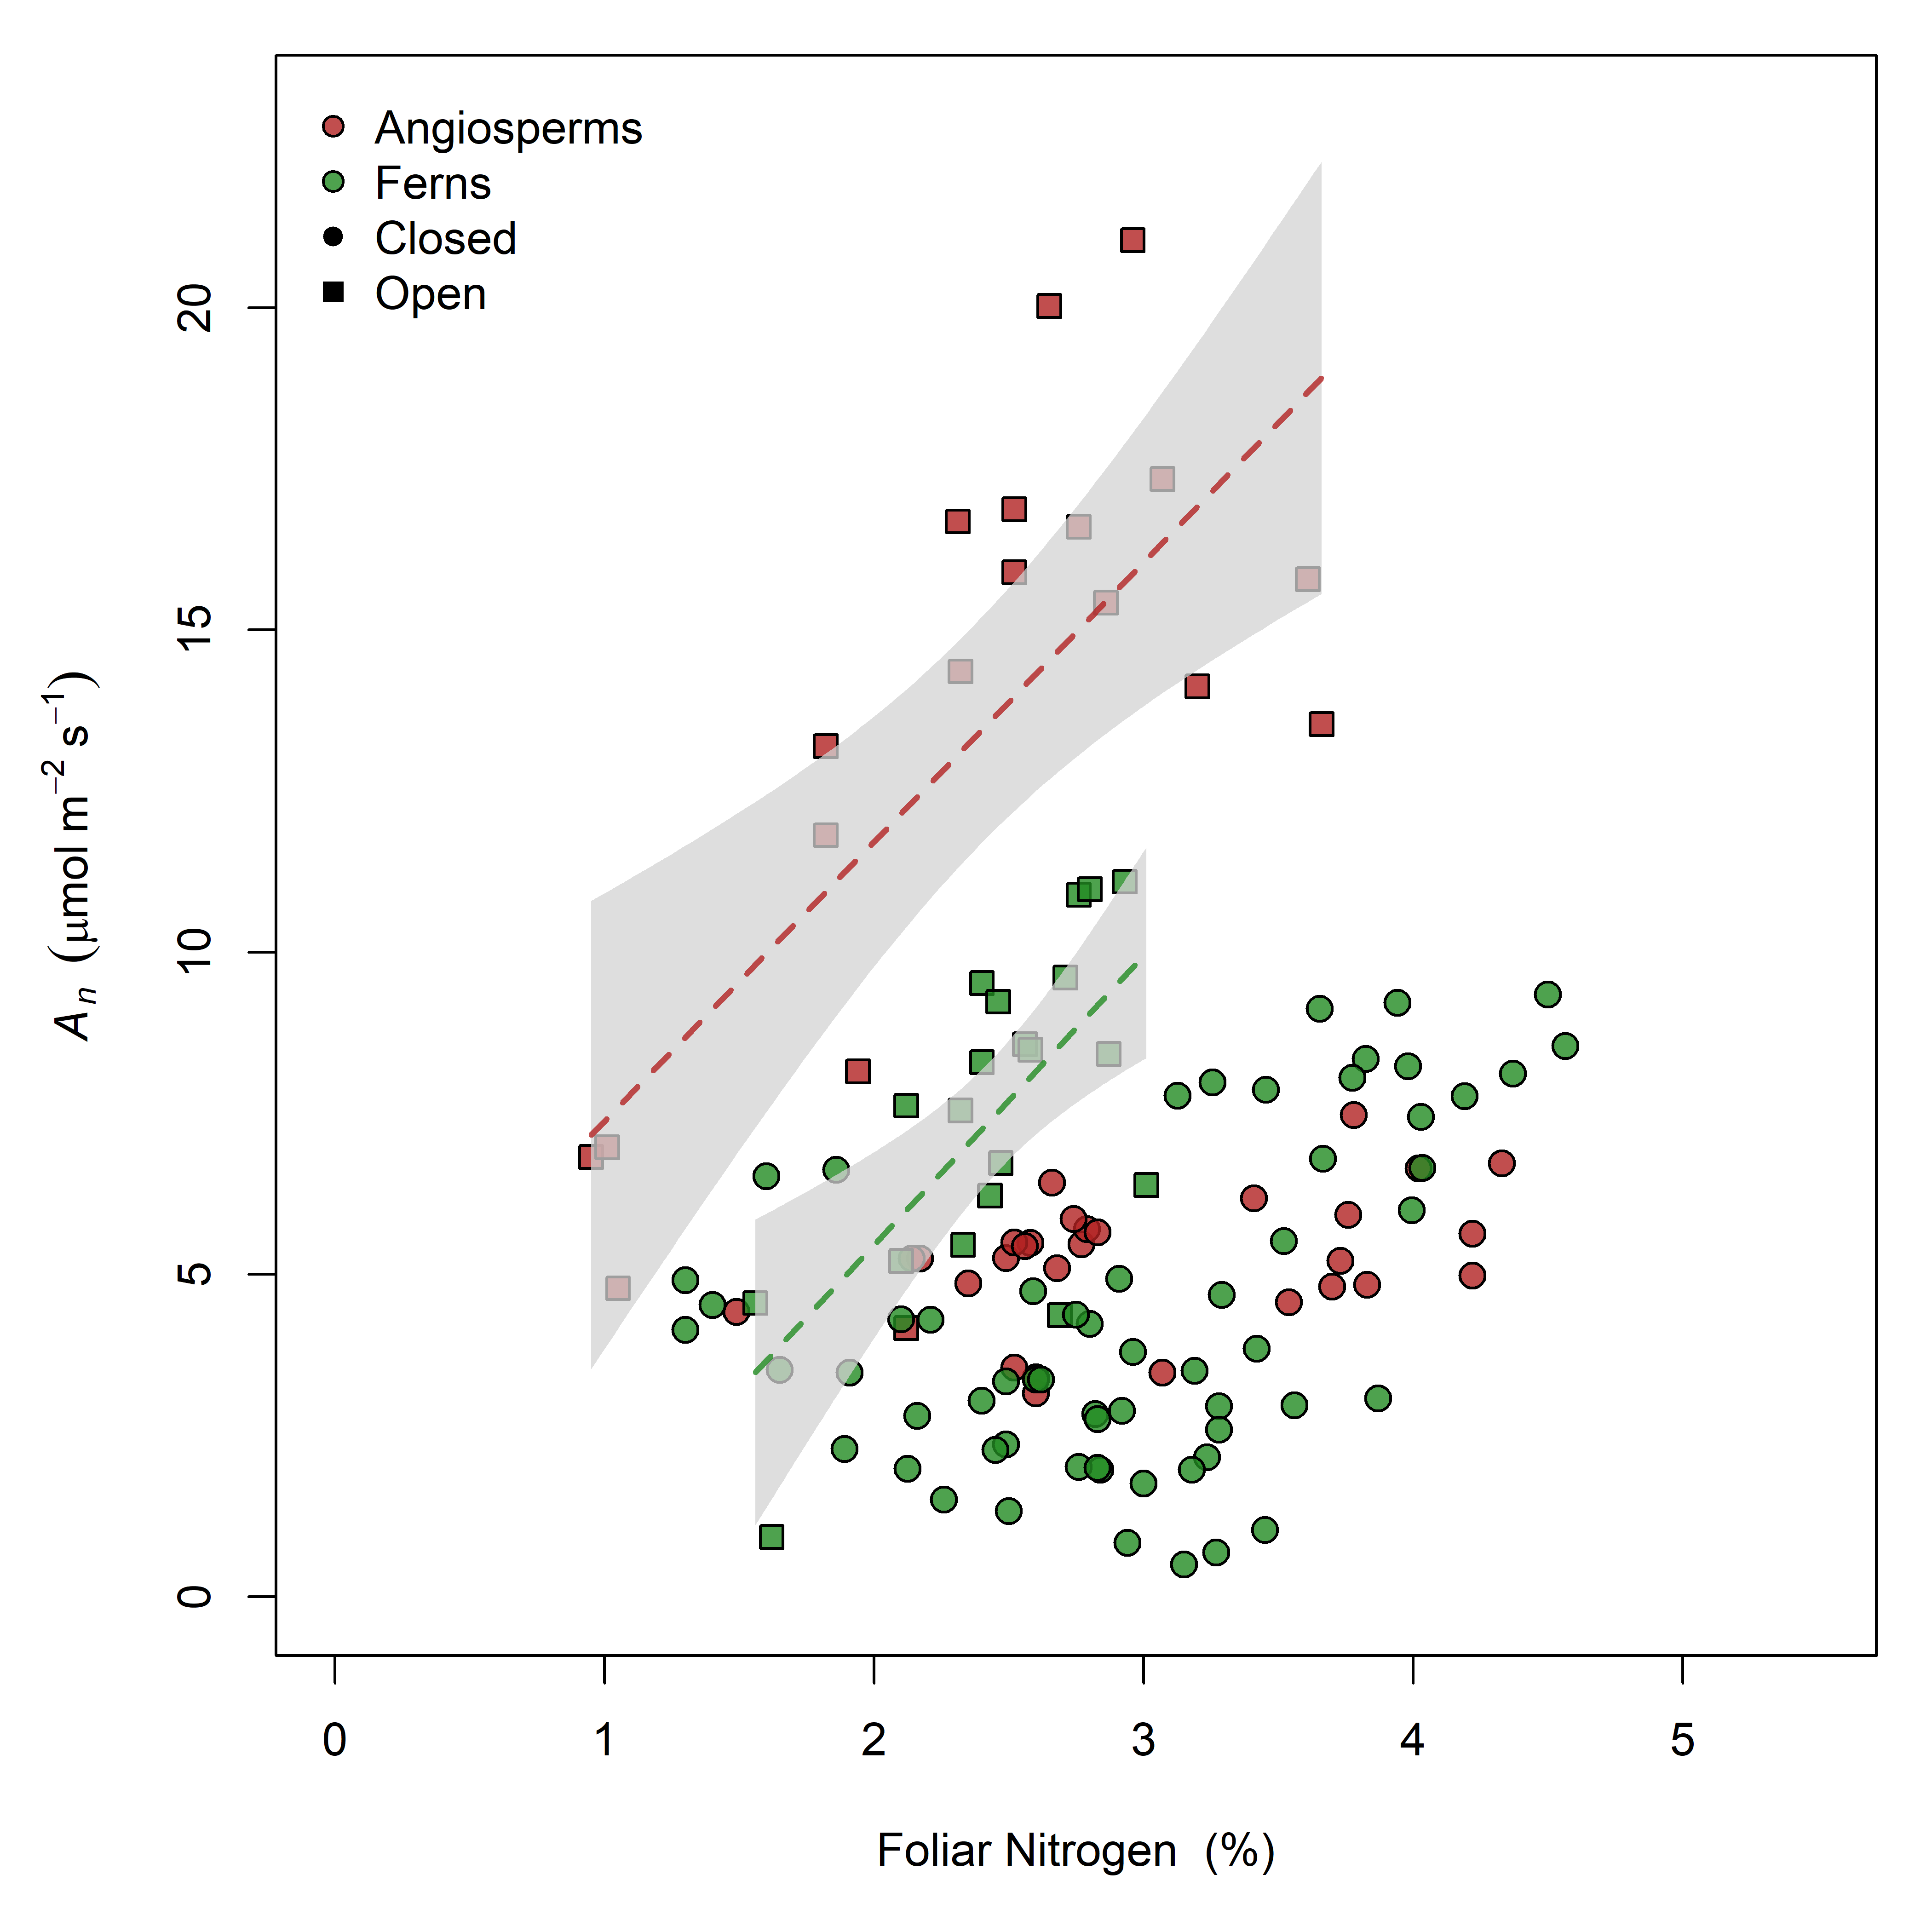 **Figure 6**. Postive relationship between photosynthesis and foliar nitrogen content exists for angiosperms and fern species in open light habitat, but not in shade habitats

# References

D’Angelo E**,** Crutchfield J**,** Vandiviere M. **2001**. Rapid, Sensitive, Microscale Determination of Phosphate in Water and Soil. *Journal of Environmental Quality* **30**: 2206–2209.

Hothorn T**,** Bretz F**,** Westfall P. **2008**. Simultaneous Inference in General Parametric Models. *Biometrical Journal* **50**: 346–363.

Lenth R. **2019**. *Emmeans: Estimated Marginal Means, aka Least-Squares Means*.

Lobo F de A**,** Barros MP de**,** Dalmagro HJ**,** Dalmolin ÂC**,** Pereira WE**,** Souza ÉC de**,** Vourlitis GL**,** Rodríguez Ortíz CE. **2013**. Fitting net photosynthetic light-response curves with Microsoft Excel — a critical look at the models. *Photosynthetica* **51**: 445–456.

Nakagawa S**,** Schielzeth H. **2013**. A general and simple method for obtaining R\textsuperscript2 from generalized linear mixed-effects models. *Methods in Ecology and Evolution* **4**: 133–142.

Oksanen J**,** Blanchet FG**,** Friendly M**,** Kindt R**,** Legendre P**,** McGlinn D**,** Minchin PR**,** O’Hara RB**,** Simpson GL**,** Solymos P ***et al.*** **2019**. *Vegan: Community Ecology Package*.

R Core Team. **2018**. *R: A Language and Environment for Statistical Computing*. Vienna, Austria: R Foundation for Statistical Computing.