Tree Allometry Data Analysis

Matthew Murphy

2/28/2018

## Examination of Tree Allometry Data

Below are five graphs examining trends in various species of trees from different ecosystems around the world.

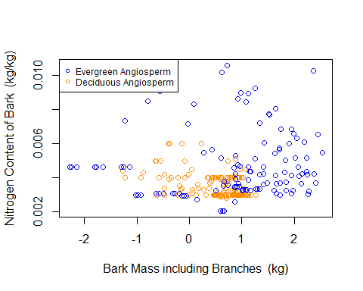

**Figure 1:** Mass of bark is not a good indicator of bark’s nitrogen concentration. The bark’s of evergreen angiosperms and deciduous angiosperms were examined, the natural logs of reported values were graphed. In general, it appears that evergreen angiosperms are capable of growing to greater masses as well as hold greater concentrations of nitrogen. However, the there is no clear correlation between mass and nitrogen content within the barks of these species. This is evident from the fact that some of the highest nitrogen contents are seen in barks with smaller masses. Interestingly, deciduous angiosperms occupy relatively similar spaces on the graph, indicating common growth patterns and nitrogen uptake. Overall, it is clear that bark on evergreen angiosperms have higher variability in both mass and nitrogen content.

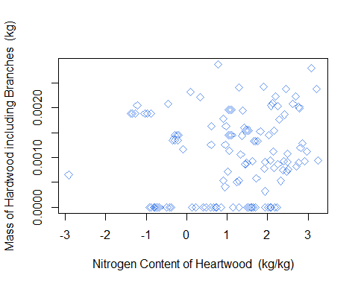

**Figure 2:** Nitrogen content of heartwood may be influenced by mass of hardwood. The mass and nitrogen content of heartwood samples were examined, and the natural log of nitrogen content was graphed against the tree’s mass. There is a general trend in this graph showing that heartwood’s of higher mass are capable of holding higher concentrations of nitrogen. There are many exceptions however, making it hard to apply a general scale to nitrogen content. Additionally, many of the samples with lower masses posses relatively high concentrations of nitrogen. This suggests that while higher masses may initially influence nitrogen content, there is a plateau at which other factors become more important in determining the amount of nitrogen stored.

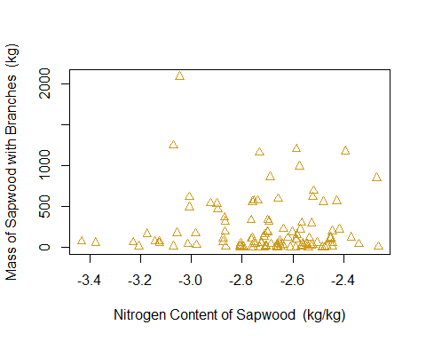

**Figure 3:** Nitrogen content of sapwood is not correlated to sapwood mass. The mass and nitrogen content of sapwood samples were examined, and the natural logs of reported values were graphed. There is no obvious trend in this graph based on the provided data. In fact, most samples of sapwood examined had relatively low masses, but there was some variation in nitrogen content at these low masses. Based on this data, it would appear that other factor(s) are more important in determining nitrogen content in sapwood’s than their mass.

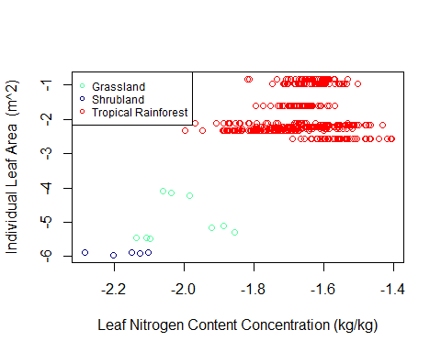

**Figure 4:** Individual leaf area and nitrogen content of trees varies by biome. The average individual leaf area and leaf nitrogen content of trees in grasslands, shrub lands, and tropical rain forests were examined, and the natural logs of reported values were graphed. There is clearly a trend in both leaf area and nitrogen content in these three biomes. Shrub lands had both the lowest leaf area and leaf nitrogen content, followed by grasslands, and tropical rain forests had the highest values for both factors examined. It is not surprising that tropical rain forests have the highest values and productivity, as these species lie at the equator and the areas they inhabit tend to have a high level of biodiversity and energy input.

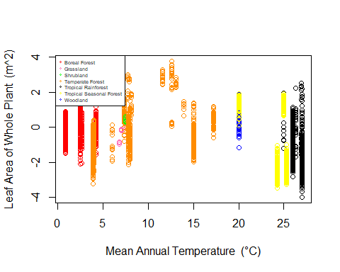

**Figure 5:** Mean annual temperature is not indicative of leaf area of whole plant. The mean annual temperature and natural log of the average total leaf area in boreal forests, grasslands, shrub lands, temperate forests, tropical rainforest, tropical seasonal forests, and woodlands were examined, and the natural logs of reported values were graphed. Unsurprisingly, the mean annual temperature varied depending on the biome examined, however, there was little variation between leaf areas. Temperate forests appear to have the greatest variation in both categories, indicating a high tolerance for variability in comparison to other species of tree. However, there does not appear to be any trends leaf area based solely on mean annual temperature.