Untitled

knitr::include_graphics("data/flood_co2.png")

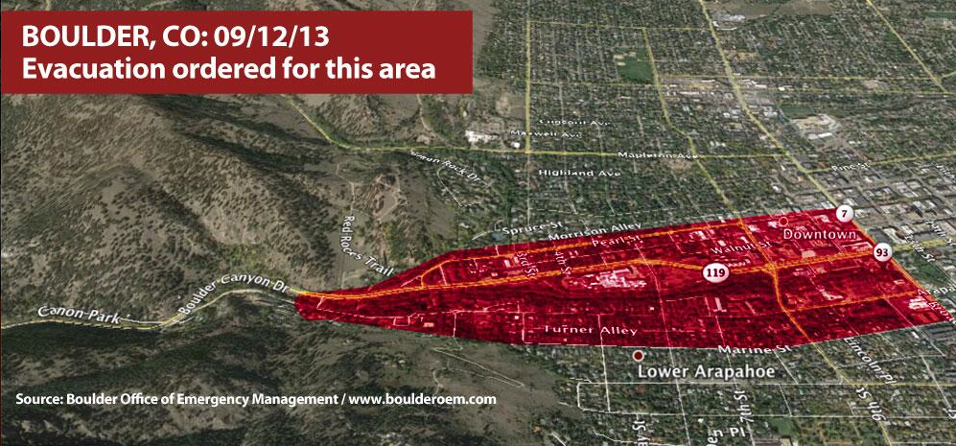

flood



