# Climate Variables’ Effect on Total Leaf Area Size

Shana Shapiro  
March 9, 2018  
  
Figure 1 visualizes the distribution of leaf samples across the United States. The size of the point correlates with the size of the leaves in the sample, which shows the variability of leaf area in the US. There are samples from all across the country but particuarly down the East Coast of the United States.  
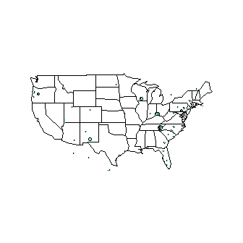  
**Figure 1. Distribution of leaf samples across the United States**

Figure 2 shows that leaf size is greatest surrounding the equator and is lowest at the highest latitude. There is a strong relationship between latitude and ecosystem, so the ecosystems with highest productivity near the equator can support plants with the highest leaf area. As latitudes increase, there is more seasonality and harsher conditions that make it more difficult for certain ecosystems to support plants with the greatest leaf area. The later relationships investigate the other factors that contribute to the relationship between leaf size and latitude.  
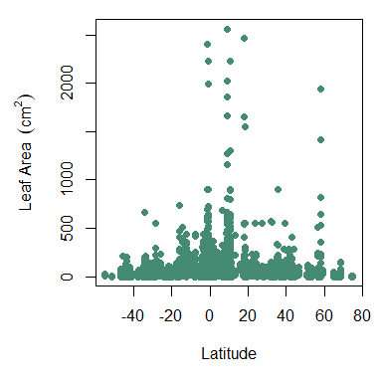  
**Figure 2. Leaf size as a function of latitude**  
  
  
Figure 3 explores the relationship between the mean growing season temperature and the latitude and graph shows a clear bell-shaped trend where global temperatures are highest at latitudes around the equator and lowest at either ends of the latitude spectrum. Compared to Figure 2 showing the relationship between leaf size and latitude, Figure 3 displays a similar trend. Figure 3 suggests that latitude may affect leaf size because of the relationship between temperature and latitude. Latitudes closer to the equator generally have greater sunlight exposure and higher temperatures during growing seasons, which spurs photosynthesis and other processes that would make larger leaves worthwhile for a plan.  
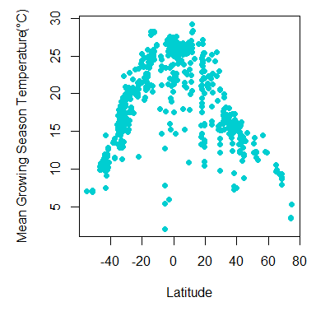  
**Figure 3. Mean temperature during growing season as a function of latitude**  
  
Figure 4 plots the leaf area as a function of the mean growing season precipitation. The R2 value for this graph is 0.2017, suggesting that precipitation is a determinant of leaf area. While water availability may not be directly responsible for leaf size, precipitation can be affected by other climatic variables. Climate and other features like nutrient availability may be responsible for the pattern evident in Figure 4. 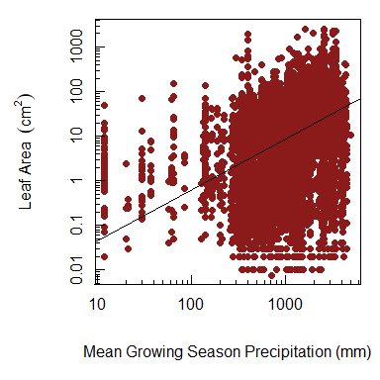  
**Figure 4. Leaf area as a function of mean growing season precipitation**  
  
  
Figure 5 shows the relationship between leaf area and irradiance of certain samples. Leaf area and irradiance does not follow the same patterns as leaf area and temperature or precipitation, as irradiance does not correlate as closely with climate patterns. Higher leaf areas are associated with specific irradiance levels of approximately 80 W/m2, 160 W/m2, and 220 W/m2. This may be due to the photosynthetic capacity of certain leaves. The relationship between leaf area and irradiance may be influenced by climatic factors like precipitation and temperature. 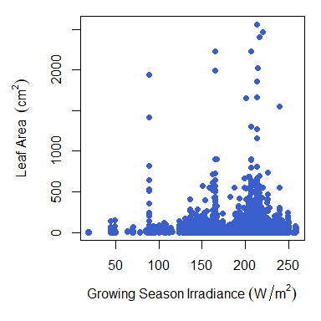  
**Figure 5. Leaf area as a function of irradiance**