Trees

Alexis Laskowski

2/13/2018

# Mystery Data Set #1

## Plot 1

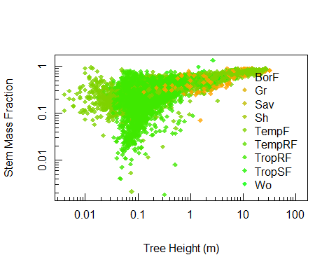

# 2nd fig

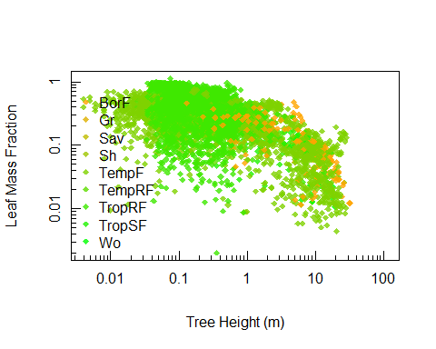

Figure 2. [caption]