Super awesome relationships of random things between students

## Social Media usage among ecology students

Intrepret findings of figure or figures here. Make sure and refer to figure just like we would in a scientific paper (Figure 1).

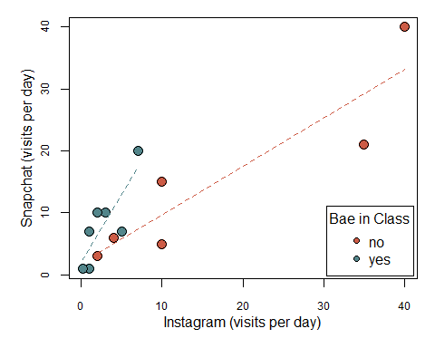  
Figure 1. Snapchat views per day as a function of Instagram views per day. Only data with at least some usage for both social media platforms was used.

## Relationships between Hogwarts Houses

Gryffindors tend to travel the least out of any of the houses, exhibiting the lowest median number of countries visited (Figure 2). This is ironic as this house prides itself in having courage. One would expect this house to be the most adventurous, but this is not the case. In contrast, the Ravenclaw house has the highest median number of countries visited (Figure 2). They may be more guided by the pursuit of knowledge. The Hufflepuff house shows the most variation in students’ travel experiences and includes the person who has traveled to the most number of countries (Figure 2). This may be due to the fact that the Hufflepuff house is known for friendliness which likely encourages interaction with people from other cultures. All of the students traveled to at least one other country though suggesting that travel is fairly common for students, even if one is not part of a house.

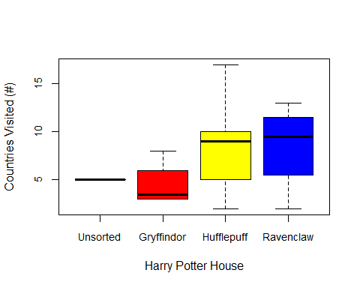  
Figure 2. Relationship between self proclaimed Hogwarts house and international travel experience.