Saccoloma inaequale

Courtney E. Campany1, Christopher Krieg2, James E. Watkins Jr.1

1 Department of Biology, Colgate University, Hamilton, NY, USA  
2 Department of Biology, University of Florida, Gainesville, Fl, USA

Corresponding author:

Key Words:

# Abstract

/ Key Words:

# Introduction

# Methods

## Site and species surveys

This study was located at La Selva Biological Research Station in Heredia, Costa Rica (84°00’12W, 10°25’52N). This site is a 600 hectare wet tropical forest, with elevation ranging from 35-137m above sea level. The site receives 4m of annual rainfall with a moderate dry season. Annual mean temperatures fluctuates between between 24-27 °C, while daily temperatures can fluctuate up to 12 °C (McDade and Hartshorn 1994).

At least once per year (insert methods from Diedra) newly formed fronds of *Saccoloma inaequale* (n = ?) were color tagged according to year. Fronds generally lasted from 3-4 years, with dissappearance mostly occuring from stem fall distubance.

## Physiological measurements

A survey of physiological and stoichiometric parameters was conducted on all present age classes of fronds for a subset of 10 *S. inaequale* individuals. For leaf gas exchange measurements, a LiCor 6400 portable photosynthesis system (LiCor BioSciences) was used with the standard leaf chamber (2 x 3 cm) equipped with blue-red light emitting diodes. The CO2 mixer was set to 400 μmol m-2 sec-1 and leaf temperature was maintained at 25 °C. Gas exchange parameters were logged once CO2 and water vapor fluxes were stable. Net photosynthetic rate (An) and stomatal conductance (gs) were logged at a standard photosynthetic photon flux density (PPFD) level of 500 mol m-2 s-1,which has been previously shown to produce maximum photosynthetic rates for tropical understory terrestrial plants (Watkins et al. 2010). All in situ gas exchange measurements were conducted during mid-morning hours.

## Leaf chemistry

Foliar tissue was collected following gas exchange measurements and used for nutrient and istopte analyses. Samples were dried to a constant mass and ground to a powder. Foliar 13C, carbon content and nitrogen content were measured using a Cornell machine (insert specs). The percentage of carbon and nitrogen in samples was calculated by comparison with certified standards and and isotopic signatures are reported relative to the standard Vienna Pee Dee Belemnite scale. Photosynthetic nitrogen use efficiency (PNUE) was defined as the ratio of photosynthesis to leaf N content on a mass basis.

## Chlorophyll content

For each Selaginella species, subsamples of fresh foliar tissue used during gas exchange measurements were used to calculate chlorophyll content (Chl). Specs for cholorphyll meter requested from Pitterman.

# Results

Below are the boxplots (excluding outliers) for physiological measurements, including; photosynthesis (An), stomatal conductance (gs), instantaneous water use efficiency (ITE), transpiration (El) and chlorophyll content. Gas exchange was performed on a subset of individuals (n=10).

There is an issue with the gas exchange data from some fronds for individual #26 (2nd and 3rd year fronds). I have deleted it from physiology figures at the moment. I pasted the raw deleted data at the bottom so you can have a look.

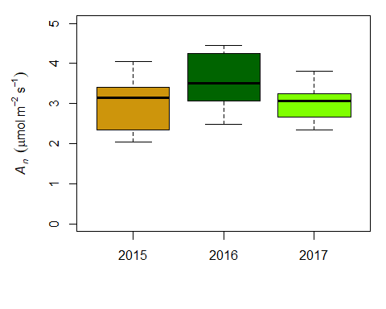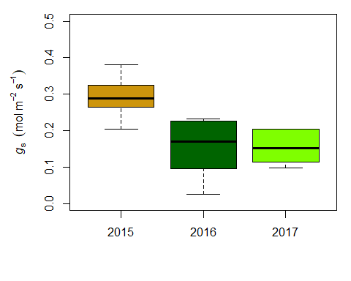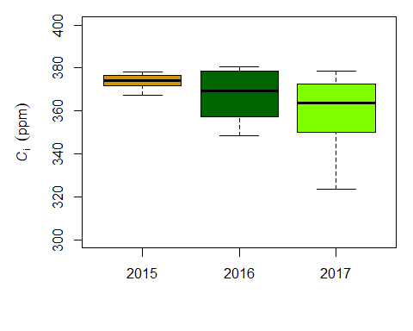

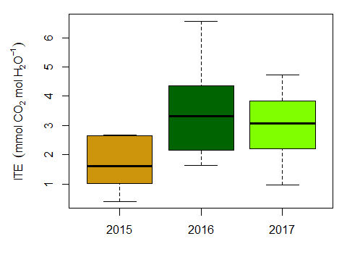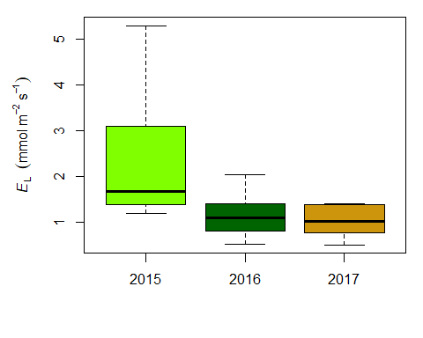 Instantaneous water use efficiency looks like it declines in year 3,likely driven by transpiration instead of An

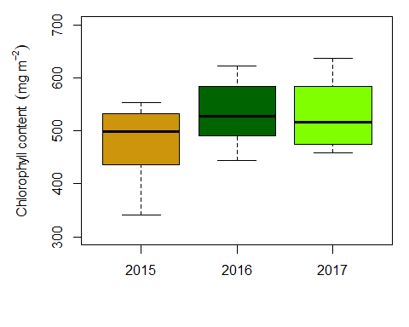

### Traits by leaf age

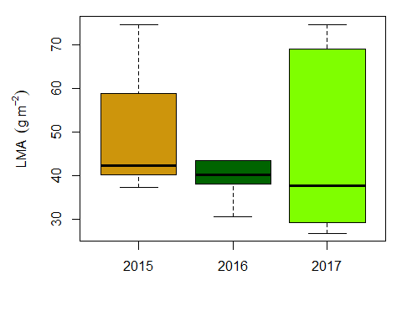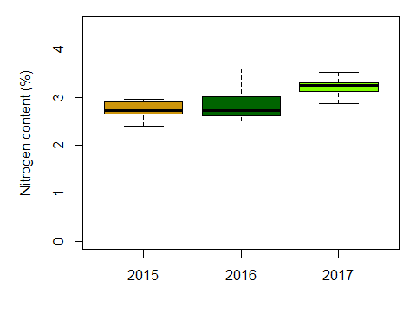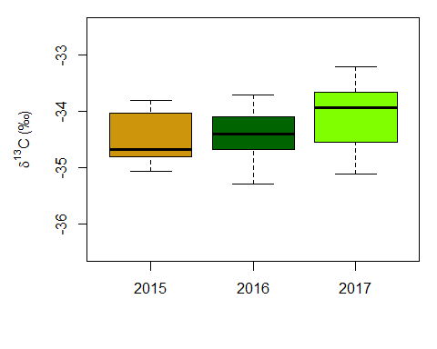

## Bivariate relationships

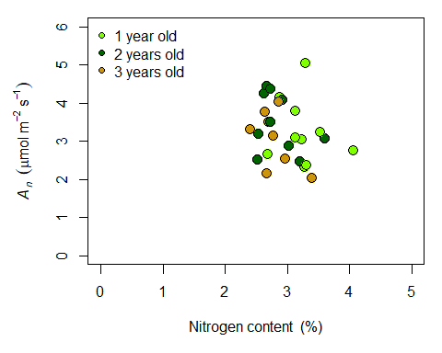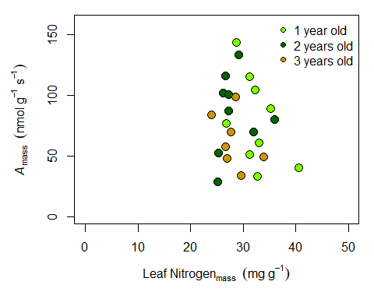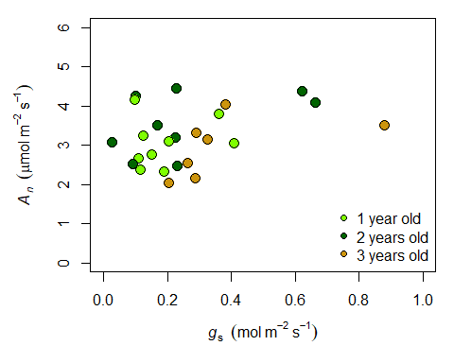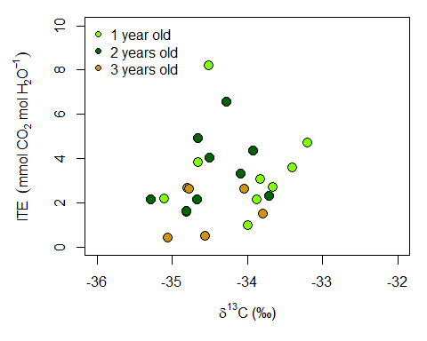

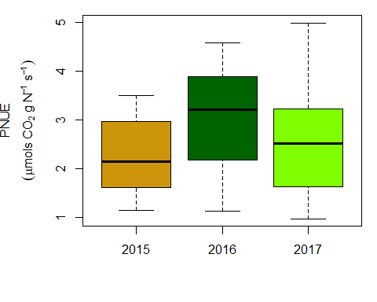

### Transpiration data seems bad for certain ages for #26

photo[photo$Indiv == 26, c("Indiv", "Photo", "Cond", "Trmmol", "Ci")]

## Indiv Photo Cond Trmmol Ci  
## 126 26 2.824424 0.04675524 0.23189451 295.715372  
## 127 26 2.904937 0.04856116 0.24026454 296.610524  
## 128 26 2.892093 0.05008391 0.24733693 299.905604  
## 129 26 2.842304 0.05027426 0.24760333 301.860485  
## 130 26 2.914478 0.05171821 0.25459295 302.094215  
## 131 26 4.609996 0.23620553 1.17445255 359.434307  
## 132 26 5.005046 0.23242589 1.15506460 356.139980  
## 133 26 6.115575 0.23133812 1.14665426 348.475770  
## 134 26 5.158546 0.22737963 1.12857218 355.295895  
## 135 26 4.904599 0.22759632 1.12539941 357.250962  
## 136 26 4.955464 0.22556127 1.11609797 356.567020  
## 137 26 4.832140 0.22344820 1.10621043 357.190813  
## 138 26 4.901738 0.22084907 1.09297862 356.095426  
## 139 26 3.501050 -0.11815613 -0.89533178 436.375503  
## 140 26 4.299755 -0.08520550 -0.59366998 470.254426  
## 141 26 3.802566 -0.05946067 -0.39221844 492.464190  
## 142 26 3.752104 -0.03605563 -0.22764603 556.507654  
## 143 26 3.652737 -0.01536409 -0.09336252 769.503156  
## 144 26 3.646284 0.00009900 0.00058572 -58274.990560  
## 145 26 3.728219 0.01488440 0.08604899 -8.000332

# Discussion

# Literature Cited

McDade LA, Hartshorn GS (1994) La Selva biological station. La Selva: Ecology and natural history of a Neotropical rain forest:6–14.

Watkins JE, Holbrook NM, Zwieniecki MA (2010) Hydraulic properties of fern sporophytes: Consequences for ecological and evolutionary diversification. American Journal of Botany 97:2007–2019. <https://onlinelibrary.wiley.com/doi/full/10.3732/ajb.1000124> (6 June 2018, date last accessed ).