Root to shoot balance in containerized Australian nursery tree stock

COURTNEY E. CAMPANY1 and MARK G. TJOELKER1

1 Hawkesbury Institute for the Environment, Western Sydney University, Locked Bag 1797, Penrith 2751 NSW, Australia

# Introduction

## Trends in Australian tree nurseries: past and present

In 1997 the Australian federal government set a target to triple the nation’s plantation estate by 2020 with the ‘2020 Vision’ initiative (www.plantations2020.com.au). This initiative led a massive decade long expansion of plantations (>50 %) in Australia to over 2 million ha, with the majority of the increase composing of *Eucalyptus* hardwood species (Gavran & Parsons, 2010). This '2020 Vision' created a shift from bare root to containerized production of tree seedlings in nurseries to meet high volume demands of forestry companies (Close, 2012). During this period, it was necessary to increase emphasis on quality seedling testing to ensure containerized seedlings had characteristics that were favorable to out-planting in a wide range of planting sites (Close *et al.*, 2003). Recently, Horticulture Innovation Australia has introduced the new '202020 Vision' that aims to increase urban green space by 20% by the year 2020 (<http://202020vision.com.au>). This new initiative represents a significant market shift towards landscape use and introduces a new set of challenges to the Australian tree nursery industry for the foreseeable future.

These new challenges are highlighted by the difficulty in establishment and survival of newly planted urban trees (Nowak *et al.*, 2004; Miller *et al.*, 2015), and the pressure this places on individual nurseries to produce tree stock that can endure increasingly harsh environments. Hot and dry conditions in Australian cities, inconsistent irrigation, infertile soils, pests, diseases and high pressure from urban heat islands threaten the survivability of urban trees, and success of green infrastructure (HIA, 2016). Additionally, valuing trees to be selected for urban planting sometimes neglects considerations of stress endurance in favor of trees with higher aesthetic appeal (Ware, 1994; Pandit *et al.*, 2013). Consequently, Australian tree nurseries are now expected to provide a large array of native and non-native trees species that are all capable of enduring less than ideal out-planting site conditions.

As planting, establishment and monitoring of trees in urban environments requires considerable investment by local Councils (Lawry & Gardner, 2001), concerns over tree stock quality and out-planting success are inevitable. Selecting the appropriate cultivar, properly preparing the out-planting site and management of out-planted trees will be wasted if the quality of the planted seedling is initially poor (Moore, 2001). Confounding with the demands for diverse high quality trees is that variability within tree stock is a near certainty during nursery production. This variability presents a unique challenge for nurseries attempting to produce tree stock with uniform morphological characteristics (Puttonen, 1997). In april 2015 the "Australian standard: Tree stock for landscape use" (**AS2303**) was adopted to fairly assess the quality of tree stock across Australian nurseries (Standards Australia Limited, 2015). This standard was designed to assess above- and belowground characteristics of production tree stock for all stages of growth. Although use of **AS2303** is not mandatory, it is likely to be increasingly called upon in order to minimize risks of out-planting failure with new landscape and green infrastructure projects.

## Assessing root:shoot balance in Australian tree nurseries for landscape use

The issue of a lack of standardized method for determining root:shoot balance in nursery plants raised by Lavender (1984) still exists today. Estimates of the size of a tree aboveground are commonly generated in forestry research using the relationship between tree height and diameter (Zianis *et al.*, 2005; Picard *et al.*, 2012; Hulshof *et al.*, 2015). The relationship between diameter and height represents stem formation in order to resist buckling related to weight or wind forcing (Dean & Long, 1986), and thus is commonly used to estimate the size of the aboveground portion of an individual tree. This is advantageous to the nursery industry as these two measurements are commonly utilized morphological characterizations of seedling quality, and can provide a method to assess the aboveground bulk of a nursery tree at any given time (Clark, 2003). However, it is difficult to determine a quantity of roots that should exist for individual tree stock (Thompson, 1985). Root volume provides a simple characterization of root system morphology (Jacobs *et al.*, 2005), but actual measurements of root volume may not be practical or cost effective for landscape-based nurseries producing large size trees.

Depending on container size and type, there is an age window where plants exhibit optimum physiology and size, eliminating issues with low rootball occupancy or being too old with defected root systems (Ford, 2014). This optimum window represents the time period for which a given tree stock is fit to be sold and when quality assessments are commonly conducted. However, this window is likely different for species with different growth rates, functional types (deciduous or evergreen trees) or origins (native/non-native). As information is gained with local nurseries, specifications for containerized plants are likely to change to more accurately match site, species and planting time to individual stock types (Nelson, 1996). If superior morphological predictors can be identified it may be possible to modify nursery cultural techniques to improve quality (Wilson & Jacobs, 2006).

In **AS2303**, a simplified aboveground volume based parameter ('Size Index') is generated from the product of stem caliper at 300 mm and total height (Standards Australia Limited, 2015). This parameter, generalized for all species, is then related to the size of the container at dispatch. The assessment criteria stipulates that root occupancy inside of the container must be high, thus allowing container volume to provide an reasonable indice of root system size. Minimum and maximum acceptable values of 'Size Index' are then specified for the extremely large range of container volumes used in Australian wholesale tree nurseries. This grading criteria provides a unique method to assess the overall balance of a nursery tree, different from most international nursery standards. These other standards usually stipulate appropriate ranges of height, caliper, canopy spread or tree slenderness for different container sizes or rootball dimensions (Canadian Nusery Landscape Association, 2006; European Nurserystock Association, 2010; AmericanHort, 2014; The British Standards Institution, 2014). Most of these existing standards do not include tree balance specifications for large container sizes which are frequently utilized for growing landscape trees. As proper balance between root and shoot systems is critical for survival of out-planted trees it likely should be evaluated in quality assessments of advanced nursery trees. If use of 'Size Index' and its relationship with rooting volume provides an accurate assessment of tree stock balance, it provides a tool for both Australian growers and buyers of landscape trees to use to better meet the increasing green space demands outlined in the "202020 Vision".

## Evaluating the Australian standard for nursery tree stock

Quality assessments for nursery tree stock generally focus on 3 core parameters (height, diameter and root system size) to assess tree stock balance, albeit in different ways. The question still remains over whether specified ranges of morphological parameters or indexes used to assess the quality of tree stock accurately encompass inherent variation that exists within and among species. Large differences in growth rates exists across species or plant types, which plays a critical role in how different trees develop within nursery environments. Differences in growth rates are linked to the habitat for which a species naturally occurs, such as fast-growing trees are found in favorable habitats that support growth or trees from nutrient-poor environments are often evergreens with higher leaf longevity (Poorter & Garnier, 1999). Whether the specified correlation between aboveground 'Size Index' and rooting volume in **AS2303** captures this variation in tree growth for the large range of deciduous, evergreen, native and non-native landscape trees produced in Australian nurseries has yet to be explicitly studied.

Although plants use all the same resources for growth; the construction, lifespan and relative allocation of leaves, stems, and roots vary between species (Westoby *et al.*, 2002). Given this variation in plant form, generalized allometric equations to predict aboveground tree size may not be suitable for all species without significant error (Hunter *et al.*, 2013). As a result, the degree to which the 'Size Index' parameter can be used as a general tool to correlate aboveground size to rooting volume needs to be tested empirically. Additionally, prevailing climate and different irrigation and fertilization regimes across nursery sites affect seedling quality during production (Mattsson, 1997). For example, diameter growth of different native eucalpyt species is related to prevailing air temperature (Bowman *et al.*, 2014), which varies tremendously across continental Australia. The degree to which nursery practices and the wide variability in regional climate in Australia affect the current quality assessment criteria in **AS2303** is unknown and requires further evaluation.

If measured variation in tree stock from species differences, climate or nursery practices suggest this new index inadequately describes overall tree stock balance, however, its usage may inhibit the long-term goals of the "202020 Vision". Many existing nursery tree standards (non-Australian) include quality specifications for different classifications of tree stock (i.e. spreading, upright, evergreen, deciduous, etc.), while **AS2303** provides one single guideline for all tree stock. If empirical evaluations suggest the specified 'Size Index' approach should be amended, then further categorization of Australian tree stock represents a potential avenue to improve tree balance assessment criteria. In should also be explicitly mentioned that robust survival and field establishment experimental trials should be undertaken to ensure that current and future iterations of tree balance criteria positively correlate to out-planting success.

Our goal in this paper was to evaluate root to shoot balance in wholesale trees nurseries across Australia through simple non-destuctive allometric measurements. This approach is necessary for production nurseries as they must evaluate the overall quality of a batch of trees at time of dispacth without sacrificing economic gains. The principal questions that we addressed were: (1) Does the evaluation of root to shoot balance in nursery stock, via 'Size Index', capture sufficient natural variation across the large diversity of ‘ready for dispatch’ trees in Australian nurseries. (2) Which of the components of Size Index (height and caliper), are the most variable across species and container volumes grown and used during nursery production. (3) In addition to within and among species variation, how much variation in Size Index (and its components) can be attributed to different growing climates and nursery practives.

# Methods

## Nursery site

Measurement campaigns were completed at 23 wholesale tree production nurseries across each of Australia's continental tree production market regions (Figure 1.). Batches of tree stock that were currently ready for sale were identified with nursery production managers at each nursery. From these batches, tree stock in containers ≥ 18 l were selected for measurements. Additionally, the 30yr mean annual temperature (MAT) and precipitation (MAP) were downloaded for each nuresry site at a 1km^2 resolution (<http://www.worldclim.org/>; Table 1).

## Visual quality assessments

Prior to data collection (explained below), an above and bewloground visual assessment of morphological quality was completed for each selected batch of tree stock. This methodology ensures that data collection was representative of trees possessed the morphological attributes required by AS2303 at dispatch. A sample tree was randomly choosen from each batch for visual assessments to represent the batch as a whole. Allometric measurements for ready to sale batches of trees stock were only compeleted if the randomly choosen representative tree passed all criteria for the above and belowground assessments. The aboveground visual testing criteria were completed on the choosen tree as specified by AS2303 (see clause 2.2 Standards Australia Limited, 2015). Briefly, the choosen tree was required to be self-supporting, have a symmetrical crown, have healthy leaves and crown strucutre and be free of injury, pest and disease.

If the choosen tree passed all aboveground assessment criteria then the belowground assessment of rootball occupancy and root form was completed. The specified bewloground quality assessment was carried out differently for different container volumes as specified in AS2303 (see appendix B Standards Australia Limited, 2015). Trees in ≤ 45 L containers were removed from the container to expose the entire rootball. First, the rootball occupancy was assessed where 90% of the growing media volume (soil + roots) must stay intact around the rootball. Second, the absense of woody circling roots was checked for the outside of the rootball. Third, a wedge shaped slice was removed from the rootball to identify if circling roots were present inside the rootball. Last, visual check for root defects (e.g. j-rooting) and proper root growth direction in an outward and downward direction from the point of initiation were assessed. For trees in >45L containers, growing media was removed from the top surface from the trunk to the container edge of sufficient depth to assess root form and check for root defects.

## Aboveground allometric parameters

Tree height and trunk diameter at 30cm were measured on a large subset of trees for each selected batch of tree stock. Up to 45 trees were measured for containers ≤ 45 L and up to 20 trees were measured for all larger sized containers, if available. The "Size Index" parameter was calculated as the product of height and trunk diameter for each measured tree.

## Canopy and leaf traits

Parameters related to canopy shape and form were measured on a subset of 10 trees per batch, if available. Maximum branch length for the trunk was recorded for the longest visible branch, which was then doubled to estimate maximum canopy spread for each tree. Total canopy length was measured from the initiation point of the lowest branch to the total height of the tree. A branchiness parameter (**b**_t) was calculated as the number of branches in a 30cm interval from the initiation point of the lowest branch.

Leaf area and dry mass were recorded for 3 fully developed full-sun leaves for each of the 10 subsetted trees, when possible. Leaves were not sampled for deciduous trees in winter or during bud-out. Trees with overly non-flat surfaces (e.g. *Araucaria* sp) were also not able to be scanned for leaf area in the field. Additionally, a small number of trees in very large size containers were too tall to sample leaves.

## Data analysis

Differences in measured size index parameters with container volume were analysed by mixed-effects models in R (R Development Core Team, 2016) with individual tree species and nurseries as random effects. The effects of climate, nursery practices, species origin, functional type and leaf and canopy traits on measured parameters were determined by adding them individually to the overall model,as either continuous of categorical fixed effects, with interactions with container volume. In some models nurseries were also considered as a fixed effect to partition the variance of different nursery practices. Mixed model analyses were perfromed with the 'lme4' package in R (Bates *et al.*, 2015). Explained variance (*R*2) of mixed models were computed as in (**???**), in which the marginal *R*2 represents variance explained by fixed factors and the conditional *R*2 by both fixed and random factors.

*log transformed data*

# Results

## size index

## height

## diameter

# Discussion

# Tables

**Table 1**. Summary infomration for each wholeslae nursery site campaign. Mean annual temperautre and precipitaion reprsent the 30 year average at each site.

|  |  |  |  |  |  |
| --- | --- | --- | --- | --- | --- |
| **Nursery** | **Latitude (°)** | **Longitude (°)** | **Mean annual Temperature (° C)** | **Mean annual precipitation (mm)** | **Trees Measured (#)** |
| Adelaide Advanced Trees | -35.064844 | 138.647758 | 15.4 | 698 | 397 |
| Adelaide Tree Farm | -34.995084 | 138.766712 | 14.3 | 862 | 89 |
| Alpine Nurseries | -33.659596 | 151.026671 | 16.7 | 1175 | 881 |
| Andreasens Green - Kemps Creek | -33.87299 | 150.780626 | 16.8 | 846 | 725 |
| Andreasens Green - Mangrove Mountain | -33.327898 | 151.157264 | 16.6 | 1062 | 217 |
| Arborwest Tree Farm | -31.72602 | 115.830227 | 18.5 | 760 | 764 |
| Benara Nurseries | -31.595196 | 115.724438 | 18.4 | 747 | 1180 |
| Cleveland Nursery | -34.942277 | 138.911917 | 13.8 | 793 | 197 |
| Darwin Plant wWholesalers | -12.573589 | 131.25268 | 27.3 | 1408 | 821 |
| Ellenby Tree Farm | -31.763484 | 115.862019 | 18.3 | 760 | 1060 |
| Established Tree Transplanters | -37.812102 | 145.461795 | 13.9 | 977 | 409 |
| Fleming's Nurseriess | -37.862445 | 145.444704 | 13.4 | 1085 | 1209 |
| Freshford Nurseries | -34.823419 | 138.883282 | 14 | 733 | 864 |
| Greenstock Nurseries | -27.256703 | 153.024981 | 20.2 | 1283 | 683 |
| Heynes's Nursery | -34.74424 | 138.609229 | 16.6 | 456 | 288 |
| Ibrox Park Nursery | -27.553837 | 153.153343 | 20.1 | 1192 | 266 |
| logans Nursery | -27.000872 | 153.029939 | 20.2 | 1414 | 451 |
| Manor Nurseries | -34.97082 | 138.864022 | 13.8 | 793 | 140 |
| Mt William Advanced Tree Nursery | -37.239562 | 144.782219 | 12.3 | 833 | 1122 |
| Pallara Trees | -27.620971 | 152.998968 | 20.1 | 1090 | 329 |
| plants direct | -26.476995 | 152.9986 | 20 | 1650 | 684 |
| Speciality Trees | -37.951617 | 145.340269 | 13.4 | 1085 | 886 |
| Trees Impact | -33.180472 | 151.571626 | 17.8 | 1266 | 158 |

# Figures

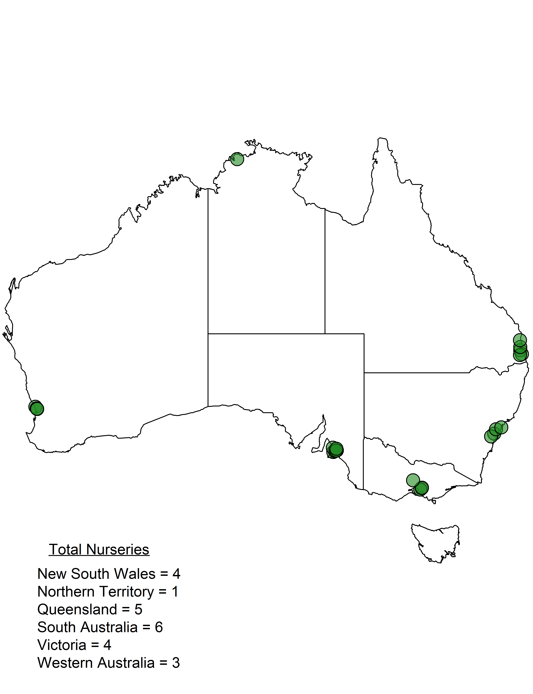 **Figure 1**. Geogrpahic location of each of the 23 nurseries were containerized trees were sampled. Measurement campaigns were conducted from April 2016 to January 2017.

AmericanHort. **2014**. *American standard for nursery stock*. Columbus, Ohio, USA.

Bates D**,** Mächler M**,** Bolker B**,** Walker S. **2015**. Fitting linear mixed-effects models using lme4. *Journal of Statistical Software* **67**: 1–48.

Bowman DM**,** Williamson GJ**,** Keenan R**,** Prior LD. **2014**. A warmer world will reduce tree growth in evergreen broadleaf forests: evidence from Australian temperate and subtropical eucalypt forests. *Global Ecology and Biogeography* **23**: 925–934.

Canadian Nusery Landscape Association. **2006**. *Canadian standards for nursery stock*. Ontario, Canada.

Clark R. **2003**. *Specifying trees: a guide to assessment of tree quality*. Sydney, Australia: NATSPEC/Construction Information.

Close DC. **2012**. A review of ecophysiologically-based seedling specifications for temperate Australian eucalypt plantations. *New Forests* **43**: 739–753.

Close DC**,** Bail I**,** Beadle CL**,** Clasen QC. **2003**. Physical and nutritional characteristics and performance after planting of *Eucalyptus globulus* Labill. seedlings from ten nurseries: implications for seedling specifications. *Australian Forestry* **66**: 145–152.

Dean T**,** Long JN. **1986**. Validity of constant-stress and elastic-instability principles of stem formation in *pinus contorta* and *trifolium pratense*. *Annals of Botany* **58**: 833–840.

European Nurserystock Association. **2010**. *European techincal & quality standards for nusery stock*. Lochristi, Belgium.

Ford C. **2014**. Improving field survival of pine seedlings and cuttings: the Sappi Plant Quality Index. *Proceedings of the International Plant Propagator’s Society-2013*: 11–16.

Gavran M**,** Parsons M. **2010**. *Australia’s plantations 2010 Inventory Update*. Canberra: National Forest Inventory, Bureau of Rural Sciences.

HIA. **2016**. Horticulture Innovation Australia.

Hulshof CM**,** Swenson NG**,** Weiser MD. **2015**. Tree height–diameter allometry across the united states. *Ecology and Evolution* **5**: 1193–1204.

Hunter MO**,** Keller M**,** Victoria D**,** Morton DC. **2013**. Tree height and tropical forest biomass estimation. *Biogeosciences* **10**: 8385–8399.

Jacobs DF**,** Salifu KF**,** Seifert JR. **2005**. Relative contribution of initial root and shoot morphology in predicting field performance of hardwood seedlings. *New Forests* **30**: 235–251.

Lavender DP. **1984**. Plant physiology and nursery environment: interactions affecting seedling growth. Forestry nursery manual: Production of bareroot seedlings. Springer, 133–141.

Lawry D**,** Gardner J. **2001**. TREENET pilot study of street tree planting in South Australia.: 63.

Mattsson A. **1997**. Predicting field performance using seedling quality assessment. *New Forests* **13**: 227–252.

Miller RW**,** Hauer RJ**,** Werner LP. **2015**. *Urban forestry: planning and managing urban greenspaces*. Long Grove, IL, USA: Waveland Press.

Moore D. **2001**. Nursery practices and the effectiveness of different containers on root development. Treenet proceedings of the 2nd National Street Tree Symposium.6–7.

Nelson W. **1996**. Container types and containerised stock for New Zealand afforestation. *New Zealand Journal of Forestry Science* **26**: 184–190.

Nowak DJ**,** Kuroda M**,** Crane DE. **2004**. Tree mortality rates and tree population projections in Baltimore, Maryland, USA. *Urban Forestry & Urban Greening* **2**: 139–147.

Pandit R**,** Polyakov M**,** Tapsuwan S**,** Moran T. **2013**. The effect of street trees on property value in Perth, Western Australia. *Landscape and Urban Planning* **110**: 134–142.

Picard N**,** Saint-André L**,** Henry M. **2012**. *Manual for building tree volume and biomass allometric equations: From field measurement to prediction*. Rome/Montpellier: FAO/CIRAD.

Poorter H**,** Garnier E. **1999**. Ecological significance of inherent variation in relative growth rate and its components. In: Pugnaire F, In: Valladares F, eds. Handbook of functional plant ecology. New York, NY, USA: Marcel Dekker, 81–120.

Puttonen P. **1997**. Looking for the ‘silver bullet’–can one test do it all? *New Forests* **13**: 9–27.

R Development Core Team R. **2016**. R: A language and environment for statistical computing (RDC Team, Ed.). **1**.

Standards Australia Limited. **2015**. *AS 2303:2015 Tree stock for landscape use*. Sydney, Australia.

The British Standards Institution. **2014**. *Trees: from nursery to independence in the landscape - Recommendations*. London, United Kingdom.

Thompson BE. **1985**. Seedling morphological evaluation: what you can tell by looking. In: Durvea M, ed. Evaluating seedling quality: Principles, procedures, and predictive abilities of major tests. Corvallis, OR: Forest Research Laboratory. Oregon State University, 59–71.

Ware GH. **1994**. Ecological bases for selecting urban trees. *Journal of Arboriculture* **20**: 98.

Westoby M**,** Falster DS**,** Moles AT**,** Vesk PA**,** Wright IJ. **2002**. Plant ecological strategies: some leading dimensions of variation between species. *Annual review of ecology and systematics*: 125–159.

Wilson BC**,** Jacobs DF. **2006**. Quality assessment of temperate zone deciduous hardwood seedlings. *New Forests* **31**: 417–433.

Zianis D**,** Muukkonen P**,** Mäkipää R**,** Mencuccini M. **2005**. Biomass and stem volume equations for tree species in Europe. *Silva Fennica Monographs* **4**: 63.