FINAL Project
SAAD1002 – TEAM 3

Courtney Hagen, Mitch Jean, Nick Lucyk, Nick White

December 10th, 2019

Contents
Background 3
Business Process and Information Flow 5
Cross Functional Flowchart 5
Admin Staff Flowchart 6
Teacher Flowchart 7
Student Flowchart 8
Additional Staff Flowchart 9
Network Diagrams 10
Network Topology – High Level 10
Network Topology – Central Area 11
Network Topology – Cafetorium 12
Network Topology – Middle School Wing 13
Network Topology – High School Wing 14
Floorplan – Central Area 15
Floorplan – Middle School Wing 16
Floorplan – High School Wing 17
Floorplan – Cafetorium and Central Corridor 18
Rack Diagrams 19
Time & Cost Estimates 20
Information Graphs 20
Pivot Tables 21
Discount Breakdown (pre-tax) 21
Price Per Unit Breakdown (after discounts) 21
Taxes Paid Breakdown 21
Labor Estimation, Cabling Cost, and Final Total 22
Ongoing Plans 22
Performance Plan 22
Security Plan 23
References 25
Appendix A – Complete Time & Cost 26
Appendix B – Work Journals 27
Courtney Hagen 27
Mitch Jean 27
Nick Lucyk 27
Nick White 28
Totals 28

Background
The Miskatonic High School has outgrown its current location, which was quite old and antiquated (and mostly likely cursed) anyway. A new building is being constructed and a modern computer network is desired as most equipment at the old school was hopelessly outdated with students and staff complaining bitterly of speed and reliability issues. No equipment from the old school will be retained for either the networking equipment or end-user workstation/laptops.
Money has been set aside in the budget for the new building to purchase new equipment, but this budget may not be exceeded, and all the following needs must be met. Your team has been tasked with presenting Mr. Herbert West, the school board superintendent, with a network system design proposal for the school board’s approval.
The following groups will form the main types of users of the new computer network:
- Approximately 50 students at each grade level (6-12) for a total of roughly 350 students. The students will mostly be bringing their own devices and attaching to the school wireless network for the most part but may also use workstations in the library and learning commons or the single one at the back of each classroom. Being teenagers, they can be counted on to hammer the network bandwidth at every possible opportunity.
- There are two full-time teachers per grade level, which means 14 in total. There are two teaching assistants/gym teachers assigned to both the middle and high school, for four additional teaching staff (so a total of 18 teaching staff). The teachers will use laptops that they will bring to the classroom, use in the staff lounge, and perhaps take home in the evenings.
- The administrative staff consists of one principal, two vice-principals, and one administrative assistant. They have also elected to go with laptops in the new school, but their laptops will mostly stay in their offices.
- Additional staff such as janitors, school bus drivers, and cooks in the cafeteria will be expected to bring their own devices. They will mostly require access to school email and timesheet applications.
The new Miskatonic High School building will consist of three wings extending off a relatively open central area.
The central area houses the main entrance and atrium of the school and measures 200 ft. by 200 ft. It also has offices for both the principal and two vice-principals. The principal’s office is connected to the office of the administrative assistant. There are two staff rooms, with cubicles in this area of the building for each of the middle and high school teaching staff. There are also public washrooms in this area, as well as a learning commons with a large, open study area for students with some comfortable seating in front of the wall of windows in the entranceway.
An entranceway off to the left of the central area (if facing it from outside the main entrance), leads to the 200 by 300 ft. middle school wing that extends lengthwise from the central area. This wing has two dedicated classrooms per grade level (Grades 6 – 9), with a wide hallway with lockers and coat racks extending through the center of the wing. Halfway down the wing, on either side of the hall, are male and female washrooms. There is an exit at the end of the wing.

An entranceway off to the right of the central area (if facing it from outside the main entrance), leads to the 200 by 300 ft. high school wing that extends lengthwise from the central area. This wing has two dedicated classrooms per grade level (Grades 10 – 12), with a wide hallway with lockers and coat racks extending through the center of the wing. Halfway down the wing, on either side of the hall, are male and female washrooms. As there is one fewer grade in this wing, there are two fewer classrooms. The extra space is used for both a multi-purpose science lab and the library. There is an exit at the end of the wing.
An entranceway to the back of the central area (if facing it from outside the main entrance), leads to first a 40 ft., by 60 ft. corridor, which eventually leads to the cafetorium. Off to one side of the central hallway are the locker rooms and equipment rooms for the gym, while the other side contains various utility rooms, janitorial closets, and the server room/ data center.
Ten-foot ceilings are standard in all the aforementioned areas of the school. Dropped ceilings will be used to allow for cabling channels/trays in the ceilings. These channels must be included as part of the network budget, though.
At the end of this corridor is the 100 by 200 ft. cafetorium that extends lengthwise from the corridor. The cafetorium is the only part of the building with a second floor, with staircases on the sides leading to a balcony/ viewing area (20 feet up), with the rest of the “second floor” open to the gym below. The first floor has space for both a regulation basketball court with seating at the sides, a stage at the back of the gym, and a kitchen area. Various emergency exits will be spread out around this part of the building.
Actual workstations will be kept to a minimum as more and more students are found to be bringing their own devices (i.e. phones/tablets) to school and to be working on those. There will be ten workstations available to students in the library and half that number in the learning commons study area in the central area. There will be a single workstation in every classroom at the back.
Teaching staff and administrative staff will all work on newly purchased laptops, which will be included in your budget. Five additional laptops will be purchased and kept under lock and key in the server/data center, to be loaned out to staff for emergencies or to visiting, substitute, and student teachers as needed.

Business Process and Information Flow

Cross Functional Flowchart
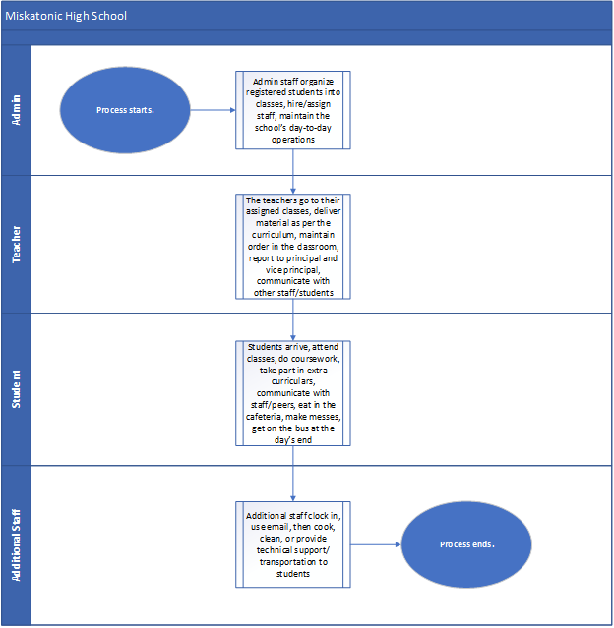

Admin Staff Flowchart
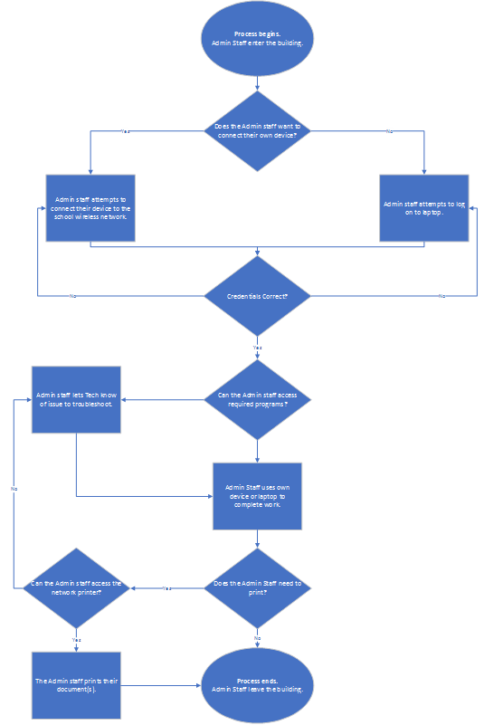

Teacher Flowchart
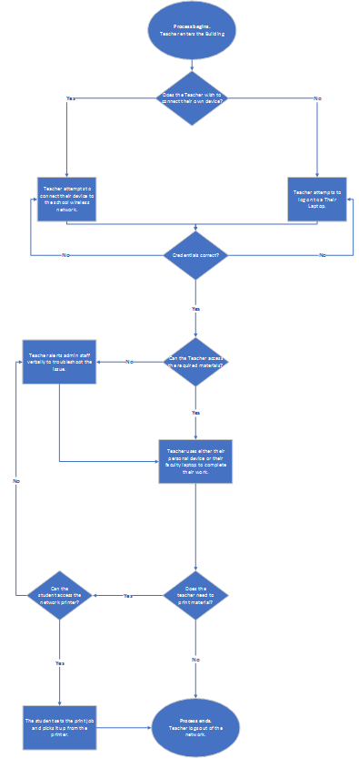

Student Flowchart

Additional Staff Flowchart

Network Diagrams

Network Topology – High Level

Network Topology – Central Area

Network Topology – Cafetorium

Network Topology – Middle School Wing

Network Topology – High School Wing

Floorplan – Central Area

Floorplan – Middle School Wing

Floorplan – High School Wing

Floorplan – Cafetorium and Central Corridor

Rack Diagrams

Time & Cost Estimates

Information Graphs
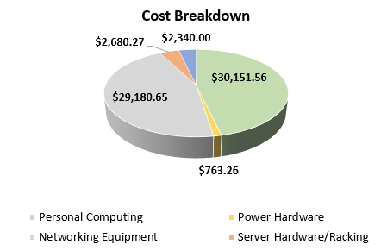

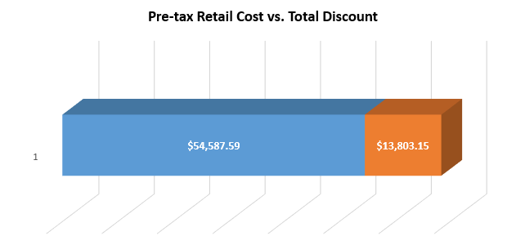

Pivot Tables

Discount Breakdown (pre-tax)
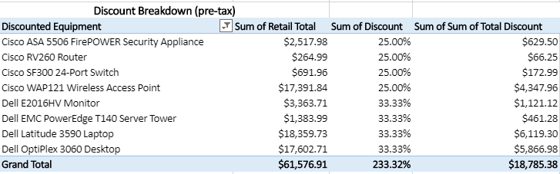

Price Per Unit Breakdown (after discounts)
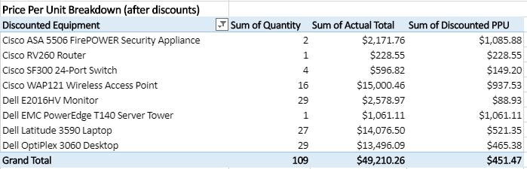

Taxes Paid Breakdown
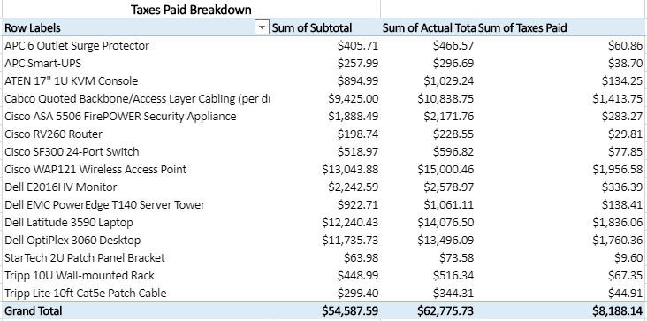

Labor Estimation, Cabling Cost, and Final Total
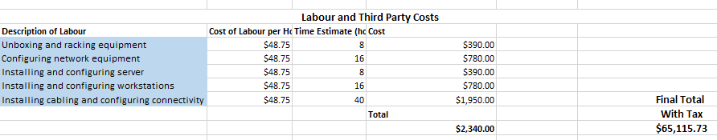

Ongoing Plans

Performance Plan
There are many stressors that can affect a network, especially schools. At Miskatonic High School there are roughly 350 students and approx. 25 teaching and admin staff. This is a lot of people who are accessing the network at the same time. The main traffic sources will come from the personal devices of the students and staff inside the school. With hundreds of personal devices such as smart phones all accessing the wireless network at the same time it will cause a lot of bandwidth use. Also, the computers in the classrooms, library, and learning commons as well as the teacher’s laptops will be using up network bandwidth. However, this will be to a much lesser extent than the personal devices. Considering the effective range of a typical wireless access point, one of our first considerations when planning out the network was the placement and overlap of wireless signals. Typically, a wireless signal will extend about 150 feet indoors, and in a school as big as Miskatonic we had to consider how to strategically place our access points to provide the most consistent connection to the network. You’ll see this mostly in the common area/cafetorium, where there is a large sprawl where we needed to create some overlap between WAPs. This should be seamless, and students/faculty shouldn’t even notice they’re crossing into the boundary of another WAP’s radius. The effective range of Cat6 cabling is typically around 328 feet, which wasn’t much of an obstacle when planning our network, and this was an area where we could cut costs on switches due to the relatively low demand for physical LAN connectivity within the school.
The main problem area within the school will be in the Cafetorium. During lunch times there will be multiple classes gathered in the same area which will all be trying to access the network through the same WAPs. When there are sporting events being hosted in the Cafetorium it will be an even bigger issue as there will be supporters such as family members of the players also trying to access the network. Depending on how popular the sporting event is it could lead to having even more numbers than the network is used to. Each of the school wings could be a potential problem area during class times, unless there are strict cell phone rules. The students will be accessing the network at multiple times throughout the day and these will all be to the same WAPs.
To attempt to mitigate the issue with the personal devices, IT management can limit the use of mobile devices to the educational applications required by the school. The firewall can be managed in a way that only allows what is required by the school, not only for security purposes but to mitigate unnecessary use. This wireless will not be open to the public, requiring a student ID to log in with only one device able to log in to the Wi-Fi at a time using that student ID.
The network at Miskatonic will be designed to handle the size of the current school assuming there is no growth. However, new WAPs can be added as needed, as extra RJ-45 jacks will be added with each necessary edition, (for example, if a workstation needs one, two will be added.) The lack of WAPs in the cafetorium is due to the fact the main purpose is not educational and should not require an influx of wireless access. However, if more use exists than expected, another WAP could be easily added.
In terms of networking backbone design for performance, extra server closets have been added to facilitate growth both in IT infrastructure and actual use. We also use a fiber backbone and many WAPs to facilitate the speed and accessibility of the network.
Potential choke points can be accessing email in the morning by staff, or any required software for grading after classes. This will be mitigated by using as many cloud services as possible due to the minimal IT infrastructure the school can afford. For example, a plan to integrate Office 365 and OneDrive to keep storage and email off the school’s end will use much less traffic in the internal network and will rely more on the backbone to the router which is much faster.
Monitoring should be done continually by the IT staff at the school to ensure that current infrastructure does not need to grow in a rate not previously predicted. If there is, there is extra room in the budget to facilitate premature additions to the IT infrastructure wherever required.

Security Plan
Ultimately, an educational institute poses a unique set of security issues. Students need to be able to use technology for their work, teachers need to be able to use technology for their teaching, administrative staff needs technology to do their work, and all of this must be able to be done while maintaining security of school data.
The primary area of concern for network security of the school should be the students access to websites. The students may attempt to access potentially malicious websites which could pose a threat to the security of the network. As student and staff’s private information will be on this network, it is important to protect from these infiltrations. The staff will have had to sign contracts and be subject to possible company policies that would lead them to be much less likely to risk committing these offenses at school, but though use policies exist for students, they are less likely to take them seriously and obey them. Along with this, students may not understand security risks as much as adults, even if they are taught to do so. They overall are more likely to participate in risky online behaviors. Thus, extra protections should be placed upon the student side of the network.
The school will combat the issue of students accessing inappropriate and potentially dangerous materials through the firewall. The firewall will be configured to only allow access to educational material when accessed on the student VLAN.
There is also the risk of students attempting to plug their devices into areas on a network that is not meant for them. Protections should also be in place to protect against that.
In the case of this school, port security will be enabled to only allow the MAC addresses configured by the IT department to let traffic go through. In this case, the port will not work if a student tries to plug any device other than the one that is meant to be there in.
Along with the issue of the nature of students accessing the network is the fact that at this school they can connect their own devices to the network. This means that the students are not controlled on their home networks and have the potential to bring issues with them on their device when connecting to the network. It also allows for less control in general over things like security and firmware updates.
The issue of bringing one's own device to school my pose a unique challenge, but where the networks are isolated in VLANs, including the wireless network, less of a risk is posed. Also, the wireless VLAN for the students will have the same restrictions through the firewall as the stationary workstations have. VLANs in general will help isolate any network security breaches.
The issue of devices being connected to home networks can also be applied to the teaching staff and administrative staff’s laptops. Though we have control over the hardware, we do not have control over their network at home and what issues are potentially existent on their network. This may also mean that the staff have remote access to materials at the school. In this case, there is a potential security risk if the remote access is not hardened. There is also the issue of the laptops potentially being stolen when they leave the school.
The issue of securing staff’s mobile technology will be mitigated by encrypting the data on them and configuring the ability to remotely wipe the hard drives on them. We will provide a VPN to protect our network when using these mobile devices.
Finally, there exists the issue of educating the staff of the school to maintain proper security measures while using the school network. Staff may not be aware of issues such as the proper storage of passwords, what a good password looks like, not sharing credentials, etc. All staff may have different levels of knowledge when it comes to cyber security. (Keeping your school network safe, n.d.)
User education will be mitigated by educational emails sent weekly by the IT staff on data security, as well as monthly presentations. Signs will also be made to create a culture of information security at the school.

References
Keeping your school network safe. (n.d.). Retrieved November 21, 2019, from https://www.cert.govt.nz/business/guides/keeping-your-school-network-safe/.
What is the typical range of a Wireless LAN? (n.d.) Retrieved December 10, 2019, from
https://www.speedguide.net/faq/what-is-the-typical-range-of-a-wireless-lan-330
Category 6 cable. (n.d.) Retrieved December 10, 2019, from
https://en.wikipedia.org/wiki/Category_6_cable#cite_note-9

Appendix A – Complete Time & Cost

Appendix B – Work Journals

Courtney Hagen
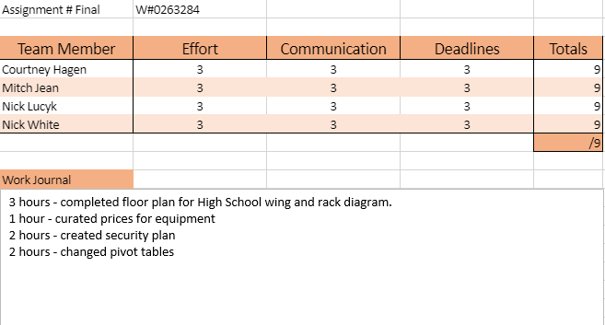

Mitch Jean
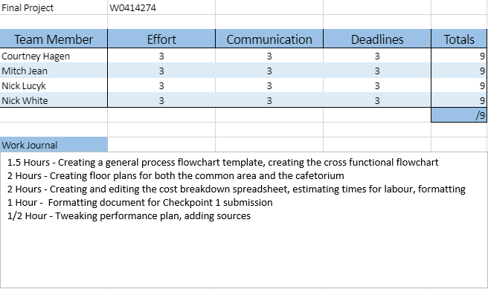

Nick Lucyk
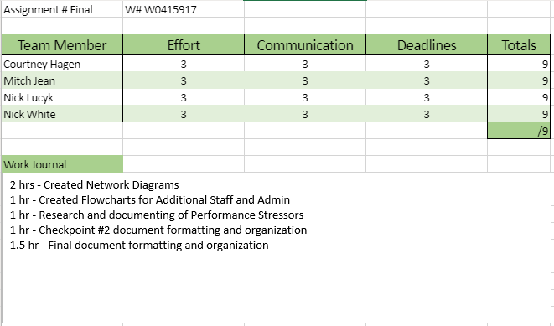

Nick White
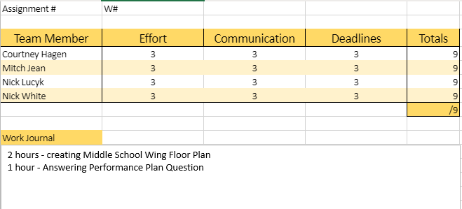

Totals

