Assignment 3

Courtney Hagen

W0263284

NETW2500

Table of Contents

Introduction 3

Install Log – NETW2500-WS01 3

Change Management Logs 3

NETW2500-WS01 3

NETW2500-FS01 3

NETW2500-DC01 3

Screenshots 3

C:\scripts Audit 4

Assignment 3

# Introduction

The purpose of this document is to reflect the creation of a workstation, configuration of a new default group policy, configuration of system monitoring, and configuration of a VPN.

# Install Log – NETW2500-CL01

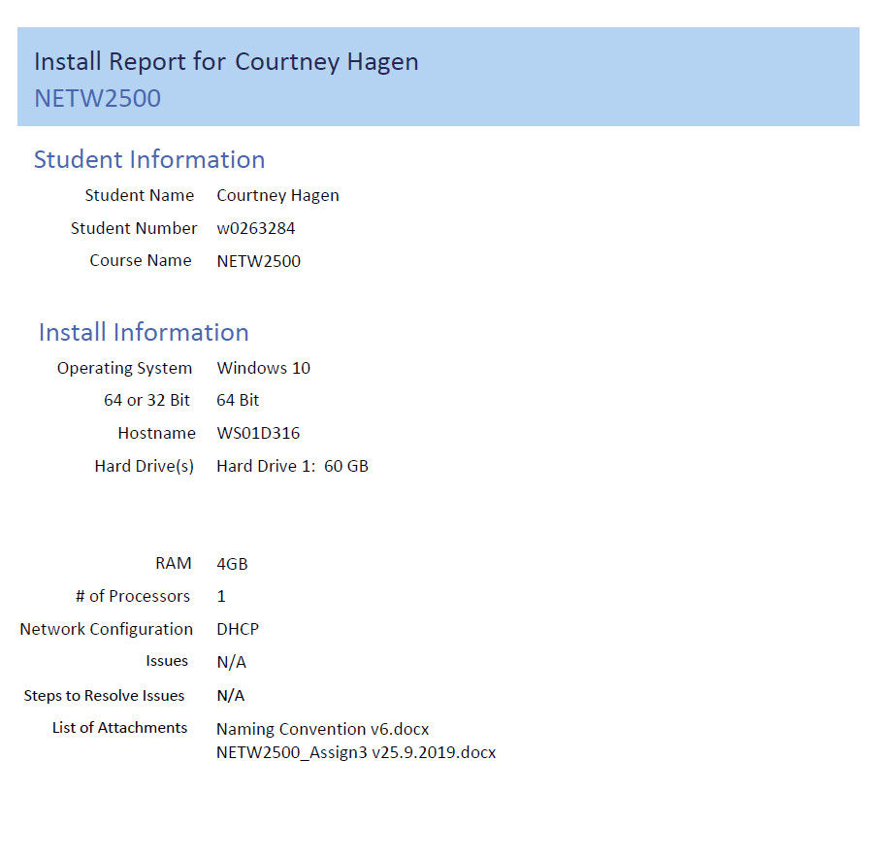

# Change Management Logs

## NETW2500-CL01

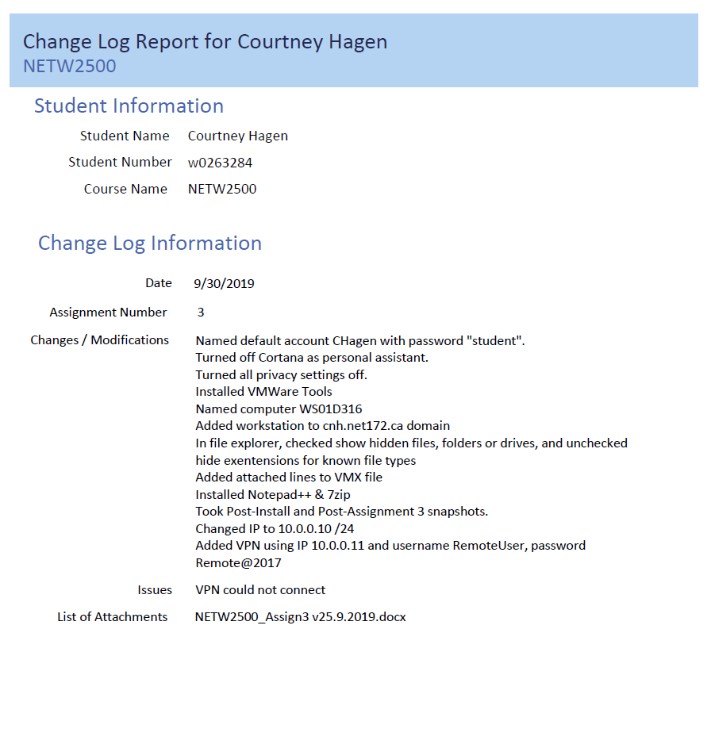

## NETW2500-FS01

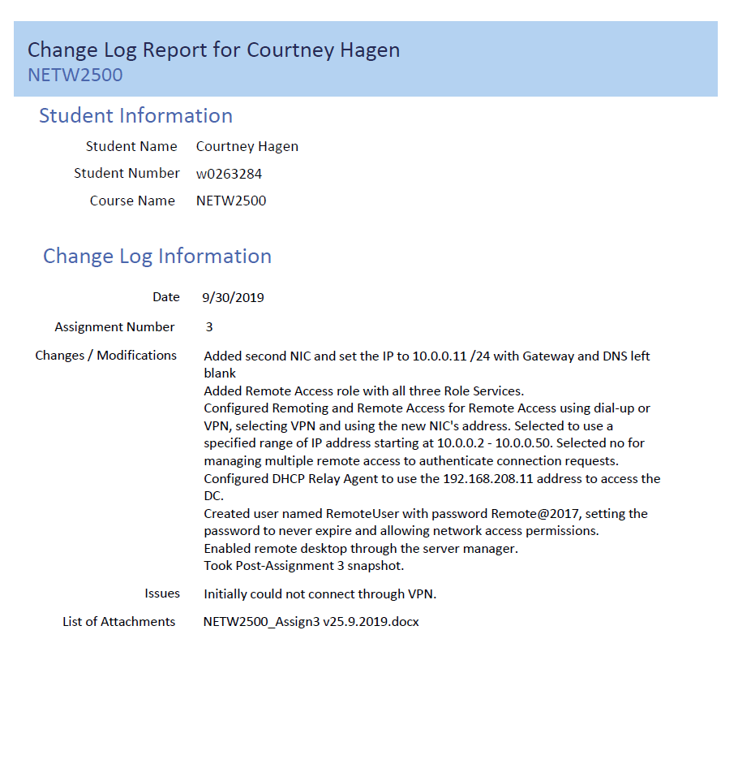

## NETW2500-DC01

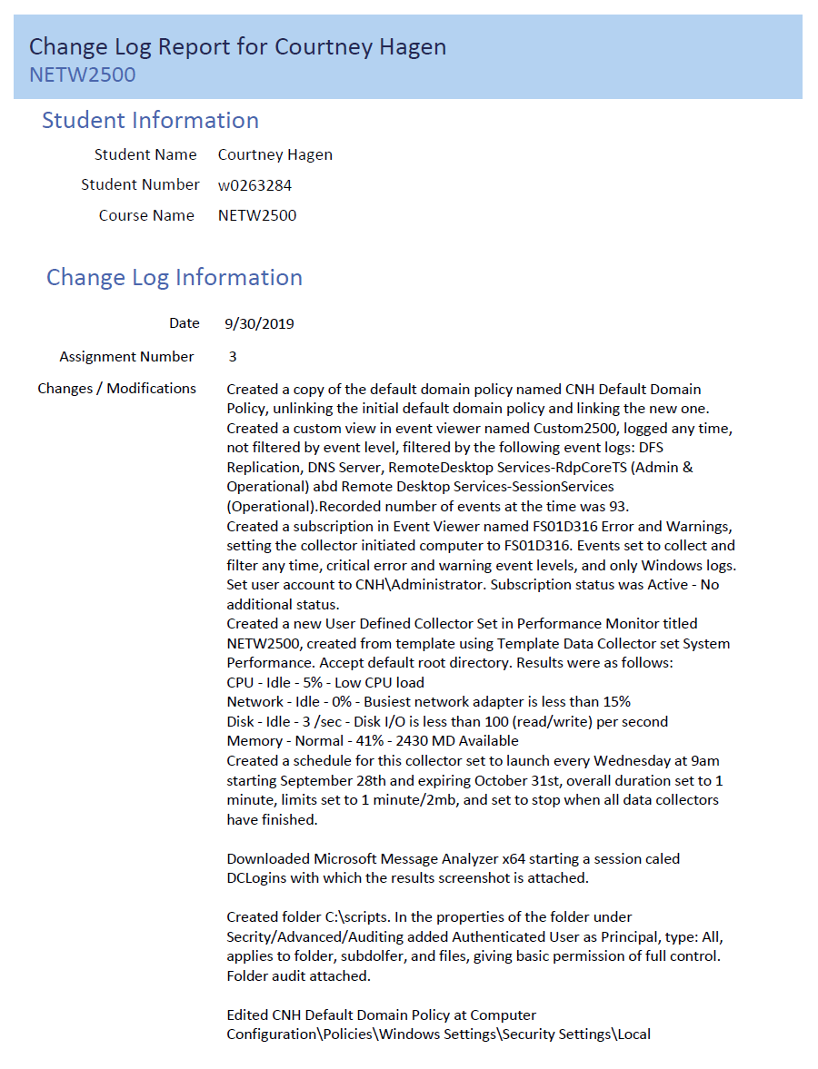

# Screenshots

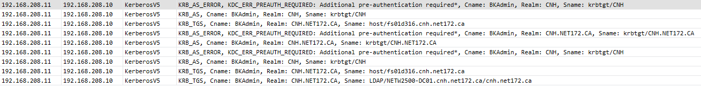

This is a screenshot of the results from the Microsoft Message Analyzer filter.

# C:\scripts Audit

A handle to an object was requested.

Subject:

Security ID: CNH\Administrator

Account Name: Administrator

Account Domain: CNH

Logon ID: 0x907B76

Object:

Object Server: Security

Object Type: File

Object Name: C:\scripts

Handle ID: 0x1c8c

Resource Attributes: -

Process Information:

Process ID: 0x17c

Process Name: C:\Windows\explorer.exe

Access Request Information:

Transaction ID: {00000000-0000-0000-0000-000000000000}

Accesses: READ_CONTROL

ReadAttributes

Access Reasons: READ_CONTROL: Granted by Ownership

ReadAttributes: Granted by D:(A;OICIID;FA;;;BA)

Access Mask: 0x20080

Privileges Used for Access Check: -

Restricted SID Count: 0