Assignment 4

Courtney Hagen

W0263284

NETW2500

Table of Contents

Introduction 3

Screenshots 3

Change Management Logs 7

NETW2500-DC01 8

NETW2500-DC02 9

Secondary DC Promotion Script 9

PDCtranscript A4 10

SDCtranscriptA4 15

Questions 16

What two indicators/options demonstrate the status of the file server after removing it from the domain? 16

Question 1 17

Question 2 17

Question 3 17

References 17

Assignment 4

# Introduction

The purpose of this assignment is to demonstrate the creation of a read-only domain controller and a secondary domain controller, as well as backing up a domain controller.

# Screenshots

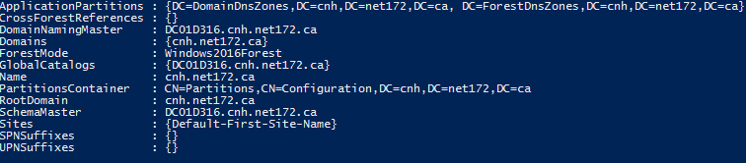

This is the screenshot of the output from the PowerShell command Get-ADForest

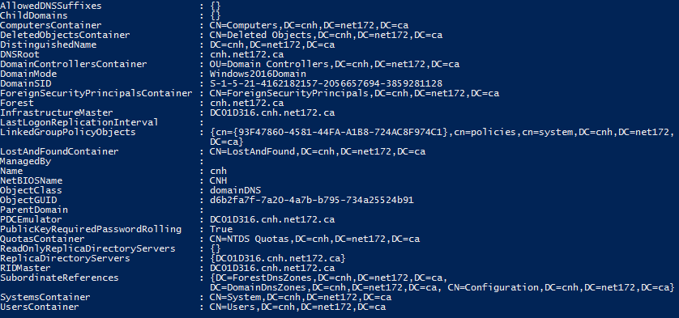

This demonstrates the output of the command Get-ADDomain



This shows the settings on the new Read-Only DC in Active Directory Users and Computers

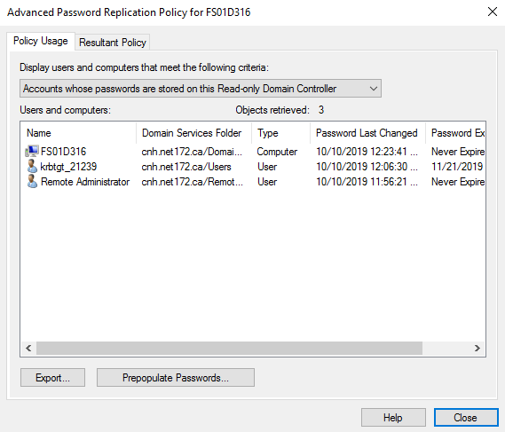

This screenshot demonstrates the change in the Advanced Password Replication Policy for FS01D316.

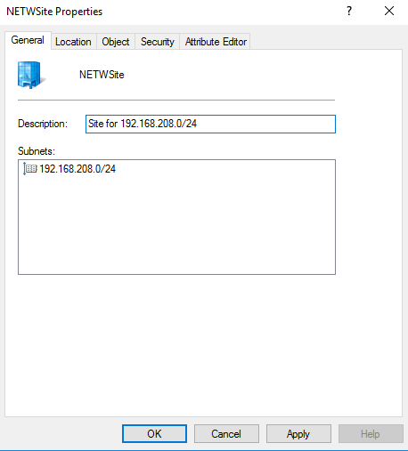

This demonstrates the properties for the new site and subnet created.

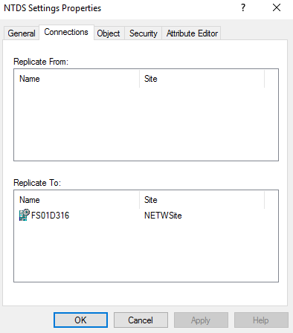

This demonstrates that FS01D316 is in the Replicate To section.

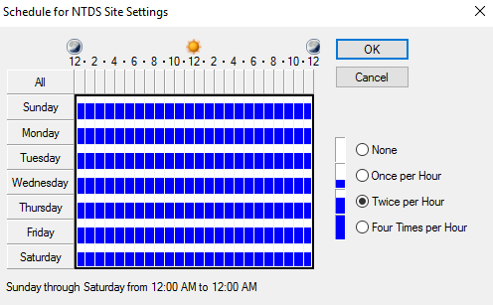

This screenshot shows that the replication schedule was changed to twice per hour.

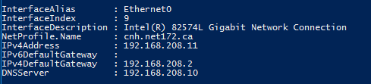

This was the result of the command Get-NetIPConfiguration.



This shows the new DC’s re-addition to the domain controller with the appropriate settings.





These screenshots demonstrates the connection settings of the DC’s for replication.

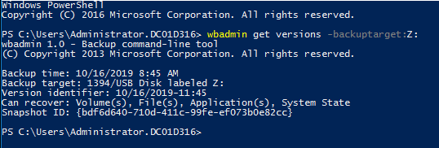

This screenshot shows the version identifier of the backup.

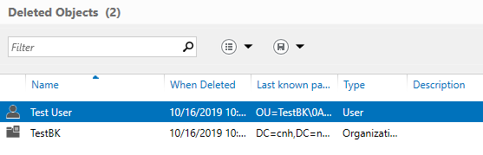

This screenshot demonstrates the deleted objects on the Primary DC.

# Change Management Logs

## NETW2500-DC01

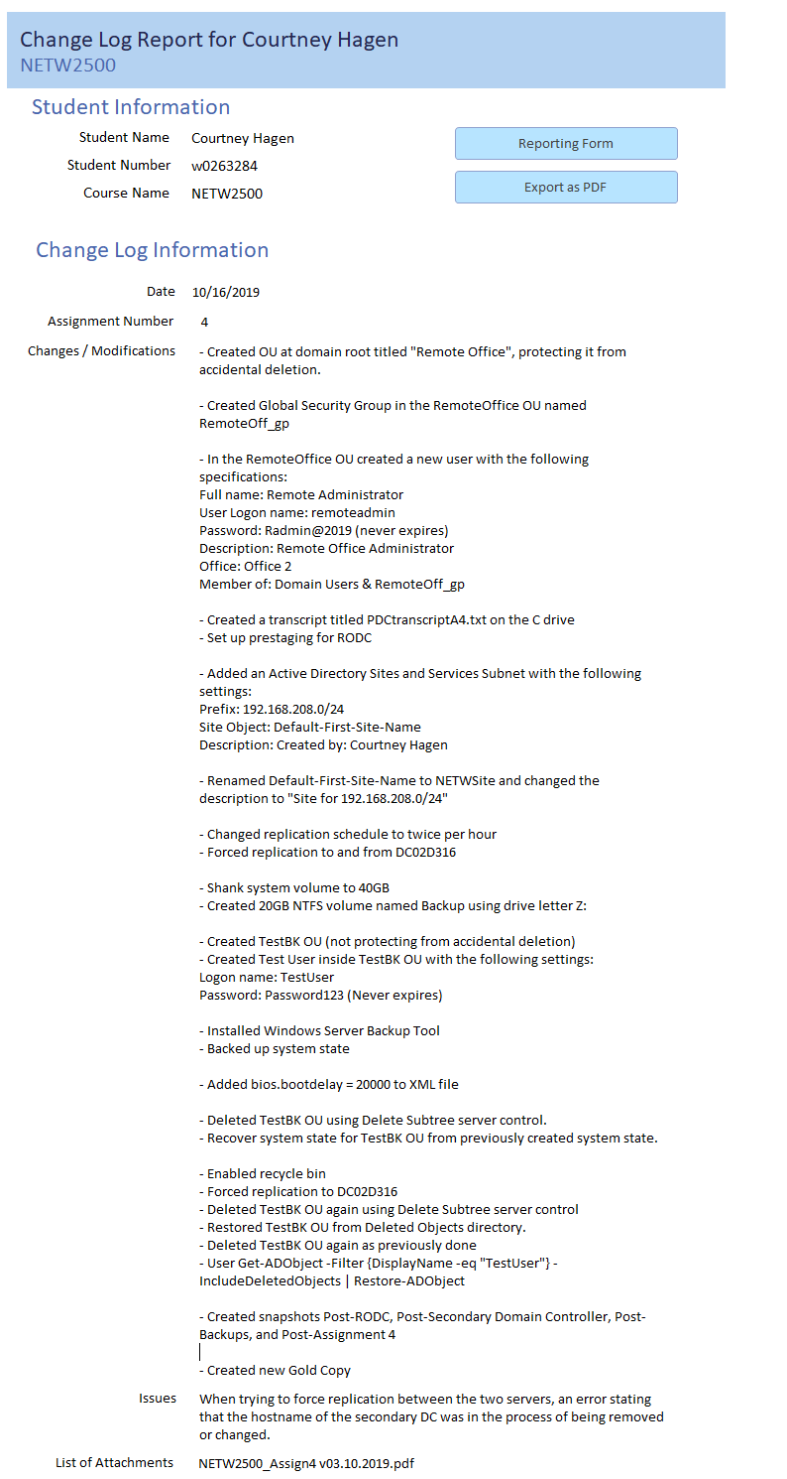

## NETW2500-DC02

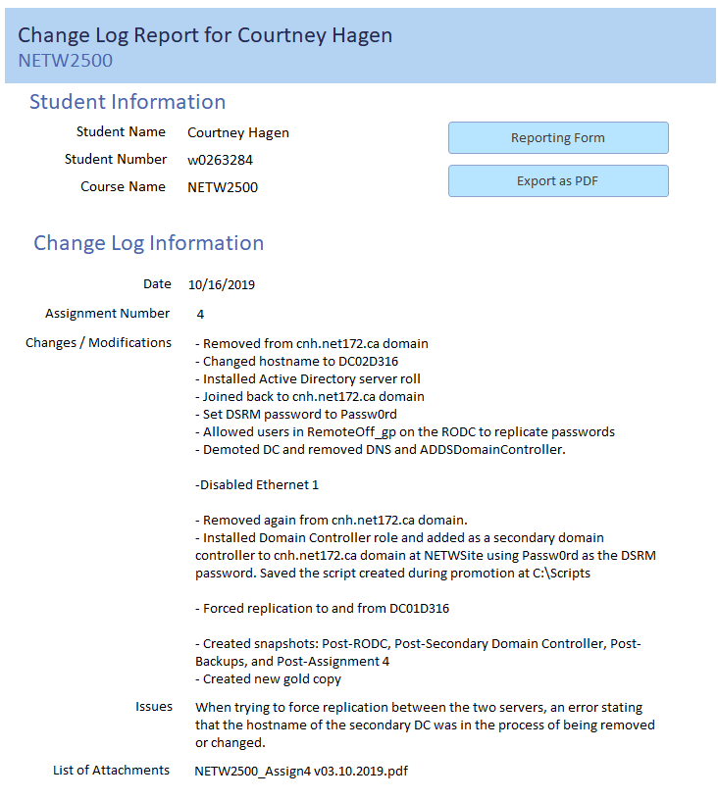

# Secondary DC Promotion Script

#

# Windows PowerShell script for AD DS Deployment

#

Import-Module ADDSDeployment

Install-ADDSDomainController `

-NoGlobalCatalog:$false `

-CreateDnsDelegation:$false `

-Credential (Get-Credential) `

-CriticalReplicationOnly:$false `

-DatabasePath "C:\Windows\NTDS" `

-DomainName "cnh.net172.ca" `

-InstallDns:$true `

-LogPath "C:\Windows\NTDS" `

-NoRebootOnCompletion:$false `

-SiteName "NETWSite" `

-SysvolPath "C:\Windows\SYSVOL" `

-Force:$true

# PDCtranscript A4

**********************

Windows PowerShell transcript start

Start time: 20191010120239

Username: CNH\Administrator

RunAs User: CNH\Administrator

Machine: DC01D316 (Microsoft Windows NT 10.0.14393.0)

Host Application: C:\Windows\System32\WindowsPowerShell\v1.0\powershell.exe

Process ID: 2824

PSVersion: 5.1.14393.3053

PSEdition: Desktop

PSCompatibleVersions: 1.0, 2.0, 3.0, 4.0, 5.0, 5.1.14393.3053

BuildVersion: 10.0.14393.3053

CLRVersion: 4.0.30319.42000

WSManStackVersion: 3.0

PSRemotingProtocolVersion: 2.3

SerializationVersion: 1.1.0.1

**********************

Transcript started, output file is C:\PDCtranscript A4.txt

PS C:\Users\Administrator> Import-Module ActiveDirectory

PS C:\Users\Administrator> Get-ADForest

ApplicationPartitions : {DC=DomainDnsZones,DC=cnh,DC=net172,DC=ca, DC=ForestDnsZones,DC=cnh,DC=net172,DC=ca}

CrossForestReferences : {}

DomainNamingMaster : DC01D316.cnh.net172.ca

Domains : {cnh.net172.ca}

ForestMode : Windows2016Forest

GlobalCatalogs : {DC01D316.cnh.net172.ca}

Name : cnh.net172.ca

PartitionsContainer : CN=Partitions,CN=Configuration,DC=cnh,DC=net172,DC=ca

RootDomain : cnh.net172.ca

SchemaMaster : DC01D316.cnh.net172.ca

Sites : {Default-First-Site-Name}

SPNSuffixes : {}

UPNSuffixes : {}

PS C:\Users\Administrator> Get-ADDomain

AllowedDNSSuffixes : {}

ChildDomains : {}

ComputersContainer : CN=Computers,DC=cnh,DC=net172,DC=ca

DeletedObjectsContainer : CN=Deleted Objects,DC=cnh,DC=net172,DC=ca

DistinguishedName : DC=cnh,DC=net172,DC=ca

DNSRoot : cnh.net172.ca

DomainControllersContainer : OU=Domain Controllers,DC=cnh,DC=net172,DC=ca

DomainMode : Windows2016Domain

DomainSID : S-1-5-21-4162182157-2056657694-3859281128

ForeignSecurityPrincipalsContainer : CN=ForeignSecurityPrincipals,DC=cnh,DC=net172,DC=ca

Forest : cnh.net172.ca

InfrastructureMaster : DC01D316.cnh.net172.ca

LastLogonReplicationInterval :

LinkedGroupPolicyObjects : {cn={93F47860-4581-44FA-A1B8-724AC8F974C1},cn=policies,cn=system,DC=cnh,DC=net172,

DC=ca}

LostAndFoundContainer : CN=LostAndFound,DC=cnh,DC=net172,DC=ca

ManagedBy :

Name : cnh

NetBIOSName : CNH

ObjectClass : domainDNS

ObjectGUID : d6b2fa7f-7a20-4a7b-b795-734a25524b91

ParentDomain :

PDCEmulator : DC01D316.cnh.net172.ca

PublicKeyRequiredPasswordRolling : True

QuotasContainer : CN=NTDS Quotas,DC=cnh,DC=net172,DC=ca

ReadOnlyReplicaDirectoryServers : {}

ReplicaDirectoryServers : {DC01D316.cnh.net172.ca}

RIDMaster : DC01D316.cnh.net172.ca

SubordinateReferences : {DC=ForestDnsZones,DC=cnh,DC=net172,DC=ca,

DC=DomainDnsZones,DC=cnh,DC=net172,DC=ca, CN=Configuration,DC=cnh,DC=net172,DC=ca}

SystemsContainer : CN=System,DC=cnh,DC=net172,DC=ca

UsersContainer : CN=Users,DC=cnh,DC=net172,DC=ca

PS C:\Users\Administrator> Add-ADDSReadOnlyDomainControllerAccount -DomainControllerAccountName "fs01d316" -DomainName "cnh.net172.ca" -SiteName Default-First-Site-Name -DelegatedAdministratorAccountName RemoteOff_gp

WARNING: Windows Server 2016 domain controllers have a default for the security setting named "Allow cryptography algorithms compatible with Windows NT 4.0" that prevents weaker cryptography algorithms when establishing security channel sessions.

For more information about this setting, see Knowledge Base article 942564 (http://go.microsoft.com/fwlink/?LinkId=104751).

WARNING: Windows Server 2016 domain controllers have a default for the security setting named "Allow cryptography algorithms compatible with Windows NT 4.0" that prevents weaker cryptography algorithms when establishing security channel sessions.

For more information about this setting, see Knowledge Base article 942564 (http://go.microsoft.com/fwlink/?LinkId=104751).

Message Context RebootRequired Status

------- ------- -------------- ------

Operation completed successfully DCPromo.General.1 False Success

PS C:\Users\Administrator> Stop-Transcript -Path "C:\PDCtranscript A4.txt" -NoClobber

>> TerminatingError(Stop-Transcript): "A parameter cannot be found that matches parameter name 'Path'."

Stop-Transcript : A parameter cannot be found that matches parameter name 'Path'.

At line:1 char:17

+ Stop-Transcript -Path "C:\PDCtranscript A4.txt" -NoClobber

+ ~~~~~

+ CategoryInfo : InvalidArgument: (:) [Stop-Transcript], ParameterBindingException

+ FullyQualifiedErrorId : NamedParameterNotFound,Microsoft.PowerShell.Commands.StopTranscriptCommand

Stop-Transcript : A parameter cannot be found that matches parameter name 'Path'.

At line:1 char:17

+ Stop-Transcript -Path "C:\PDCtranscript A4.txt" -NoClobber

+ ~~~~~

+ CategoryInfo : InvalidArgument: (:) [Stop-Transcript], ParameterBindingException

+ FullyQualifiedErrorId : NamedParameterNotFound,Microsoft.PowerShell.Commands.StopTranscriptCommand

PS C:\Users\Administrator> Stop-Transcript -Path "C:\PDCtranscript A4.txt"

>> TerminatingError(Stop-Transcript): "A parameter cannot be found that matches parameter name 'Path'."

Stop-Transcript : A parameter cannot be found that matches parameter name 'Path'.

At line:1 char:17

+ Stop-Transcript -Path "C:\PDCtranscript A4.txt"

+ ~~~~~

+ CategoryInfo : InvalidArgument: (:) [Stop-Transcript], ParameterBindingException

+ FullyQualifiedErrorId : NamedParameterNotFound,Microsoft.PowerShell.Commands.StopTranscriptCommand

Stop-Transcript : A parameter cannot be found that matches parameter name 'Path'.

At line:1 char:17

+ Stop-Transcript -Path "C:\PDCtranscript A4.txt"

+ ~~~~~

+ CategoryInfo : InvalidArgument: (:) [Stop-Transcript], ParameterBindingException

+ FullyQualifiedErrorId : NamedParameterNotFound,Microsoft.PowerShell.Commands.StopTranscriptCommand

PS C:\Users\Administrator> Stop-Transcript

**********************

Windows PowerShell transcript end

End time: 20191010120706

# SDCtranscriptA4

**********************

Windows PowerShell transcript start

Start time: 20191010121631

Username: FS01D316\Administrator

RunAs User: FS01D316\Administrator

Machine: FS01D316 (Microsoft Windows NT 10.0.14393.0)

Host Application: C:\Windows\System32\WindowsPowerShell\v1.0\powershell.exe

Process ID: 3832

PSVersion: 5.1.14393.3053

PSEdition: Desktop

PSCompatibleVersions: 1.0, 2.0, 3.0, 4.0, 5.0, 5.1.14393.3053

BuildVersion: 10.0.14393.3053

CLRVersion: 4.0.30319.42000

WSManStackVersion: 3.0

PSRemotingProtocolVersion: 2.3

SerializationVersion: 1.1.0.1

**********************

Transcript started, output file is C:\SDCtranscriptA4.txt

PS C:\Users\Administrator> Install-WindowsFeature -Name AD-Domain-Services -IncludeManagementTools

Success Restart Needed Exit Code Feature Result

------- -------------- --------- --------------

True No Success {Active Directory Domain Services, Active ...

PS C:\Users\Administrator> Install-ADDSDomainController -DomainName "cnh.net172.ca" -UseExistingAccount -Credential (Get-Credential) -NoRebootOnCompletion:$True

The target server will be configured as a domain controller. The server needs to be restarted manually when this operation is complete.

Do you want to continue with this operation?

&Yes Yes to &All &No No to A&ll &Suspend

Y

Message Context RebootRequired Status

------- ------- -------------- ------

You must restart this computer to complete the operation... DCPromo.General.2 True Success

PS C:\Users\Administrator> y

# Questions

## What two indicators/options demonstrate the status of the file server after removing it from the domain?

The first indication that fs01d316 is not a member of the domain in Active Directory Users and Computers is that it is marked with a down arrow, indicating that it is disabled. The second indicator is that if you right-click on the object, it has the option to “Enable Account”, also indicating that it is disabled.

## Question 1

Volume Shadow Copy Service (VSS) is a backup functionality that backs up volumes at specific points in time. The shadow copies are those copies of specific points in time. (What is Volume Shadow Copy Service (VSS)? N.d.) A shadow copy set is shadow copies from various volumes taken at the same time, such as all volumes from the same host machine taken at the same time. (Shadow Copies and Shadow Copy Sets, 2018)

Providers are what creates the shadow copies of the volumes being run. (Providers, 2018) Requesters requests the VSS to create the shadow copies, an example being an application that uses VSS to create backups. (Requesters, 2018) Finally, Writers are applications and services that provide the written files names and locations to the VSS, as they are the ones that store this information. (Writers, 2019)

## Question 2

In the Backup 2019-10-16 114548 folder, there is multiple XML Documents including one named BackupSpecs, and two Hard Disk Image Files. The XML documents are configuration files for the backup and the hard disk image files are a direct backup of the volume and can actually be mounted. (What is Catalog and Mediaid in WindowsImageBackup? 2015)

## Question 3

In the Catalog folder, there are two files: one titled BackupGlobalCatalog and one titled GlobalCatalog. These are a backup of the Global Catalog and tracking of the system image backup versions. (System Image Backup Structure, n.d.)

# References

Providers. (2018, May 30). Retrieved October 16, 2019, from <https://docs.microsoft.com/en-us/windows/win32/vss/providers>.

Requesters. (2018, May 30). Retrieved October 16, 2019, from https://docs.microsoft.com/en-us/windows/win32/vss/requestors.

Shadow Copies and Shadow Copy Sets. (2018, May 30). Retrieved October 16, 2019, from <https://docs.microsoft.com/en-us/windows/win32/vss/shadow-copies-and-shadow-copy-sets>.

System Image Backup Structure. (n.d.). Retrieved October 16, 2019, from https://sourcedaddy.com/windows-7/system-image-backup-structure.html.

What is Catalog and Mediaid in WindowsImageBackup? (2015, August 21). Retrieved October 16, 2019, from https://superuser.com/questions/960925/what-is-catalog-and-mediaid-in-windowsimagebackup.

What is Volume Shadow Copy Service (VSS)? . (n.d.). Retrieved October 16, 2019, from <https://www.techopedia.com/definition/27707/volume-shadow-copy-service-vss>.

Writers. (2019, May 30). Retrieved October 16, 2019, from https://docs.microsoft.com/en-us/windows/win32/vss/writers.

(cmd elevated)