Assignment 5

Courtney Hagen

W0263284

OSYS3030

Table of Contents

Knowledge Base Article – Installing and Configuring Ubuntu Server 18.04.3 and LXD 3

LAMP Server with MediaWiki Install & Configuration 9

Install and Configure Samba 10

References 11

# Knowledge Base Article – Installing and Configuring Ubuntu Server 18.04.3 and LXD

To begin the installation process on the bare metal server, an installation media must be created. In this case, a USB stick and Rufus software will be used. The Rufus software took the ISO for Ubuntu Server 18.04.3 and made the USB stick bootable.

Then plug the USB into the server and reboot it. Upon booting, enter the BIOS Boot Menu and select the USB as the drive to boot to. Upon booting, choose to start the installation process.

On the first screen, you will be prompted for your language of choice.

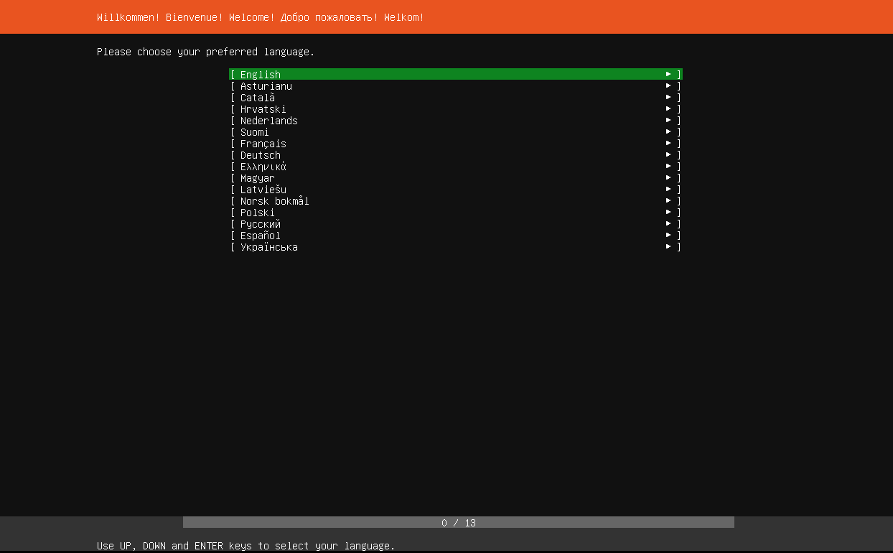It will then prompt you to confirm the language of the keyboard.

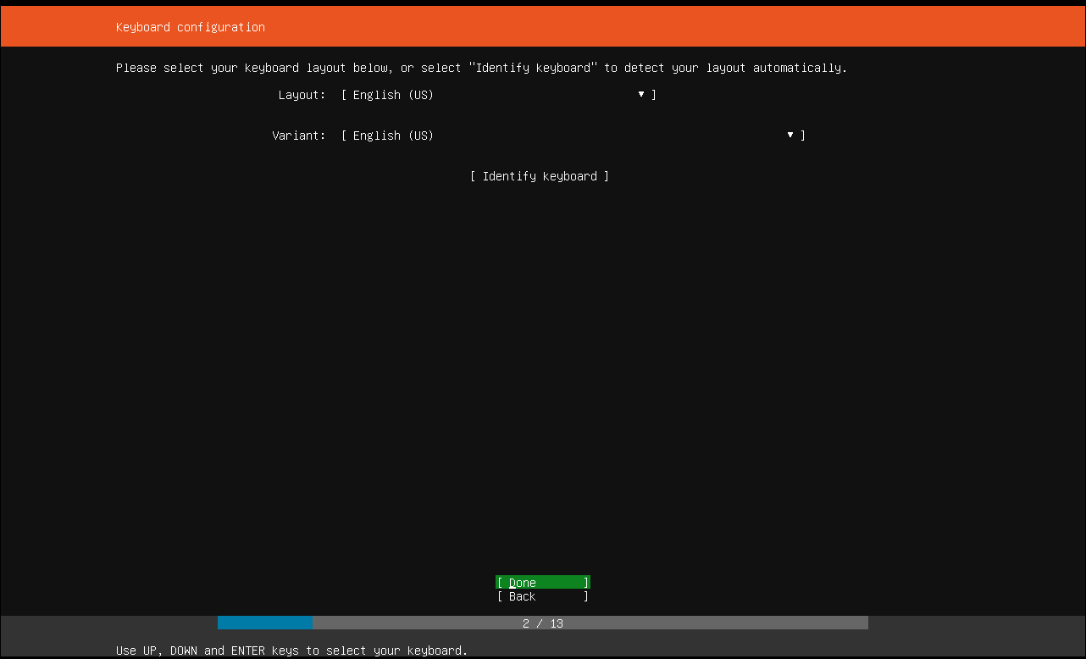

Next screen asks for network configurations. Verify all NICs are set to DHCP. (This screenshot is from a VM and does not reflect the actual IP nor number of NICs of the server)

Next screen asks about a proxy server, but this can be skipped. The following screen asks about changing the mirror address, but it can be left as default. Proceed to the next page.

The following screen will ask about how you want to partition your disk. Select Use an Entire Disk and Set Up LVM as shown below.

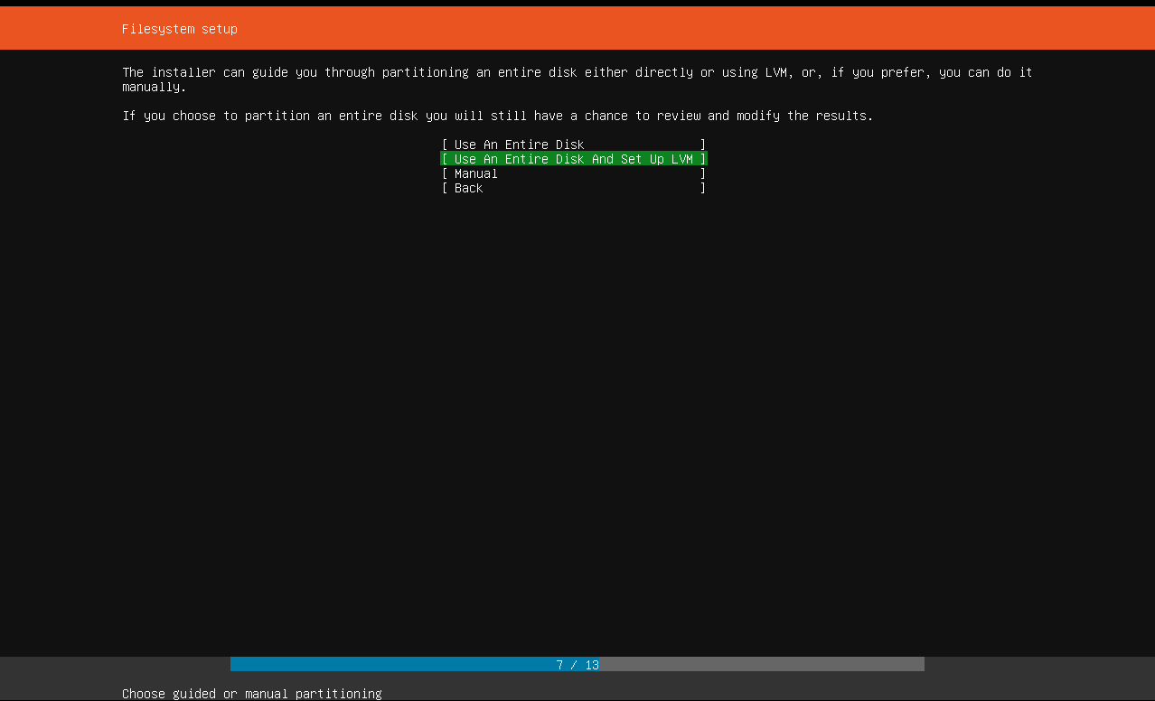

The following screen asks what disk you would like to install to. Choose the desired disk. After that, the following screen appears.

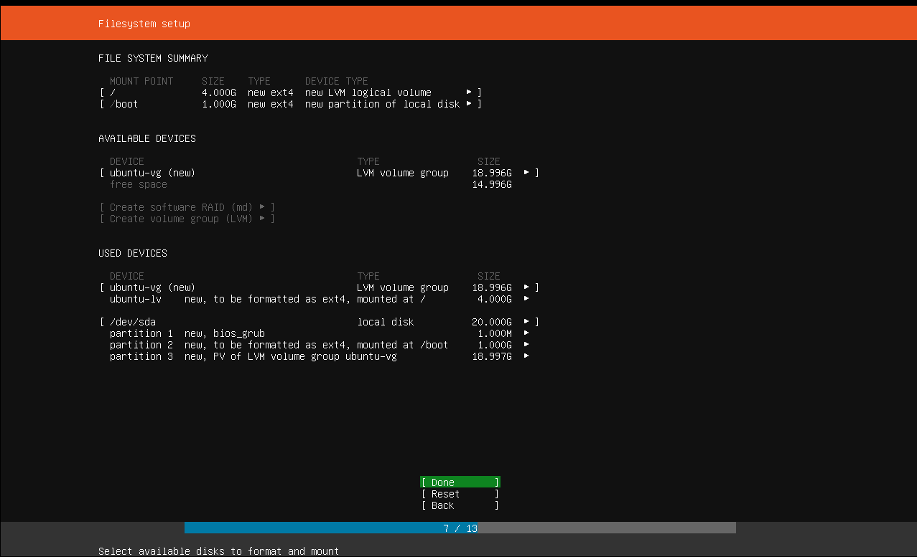

One of the requirements was that the Root partition takes the remainder of the disk. As this is a VM, this does not reflect accurately reflect the size of the hard drive on the server. However, to change the size of the partition, just highlight and press enter on the / (which represents the root) and the option to change the size will be in there. When you press enter on Done, it will have a Confirm destructive action screen asking if you want to continue. Highlight and press enter on Continue.

Next screen will ask for the server name and for you to create the default admin username and password.

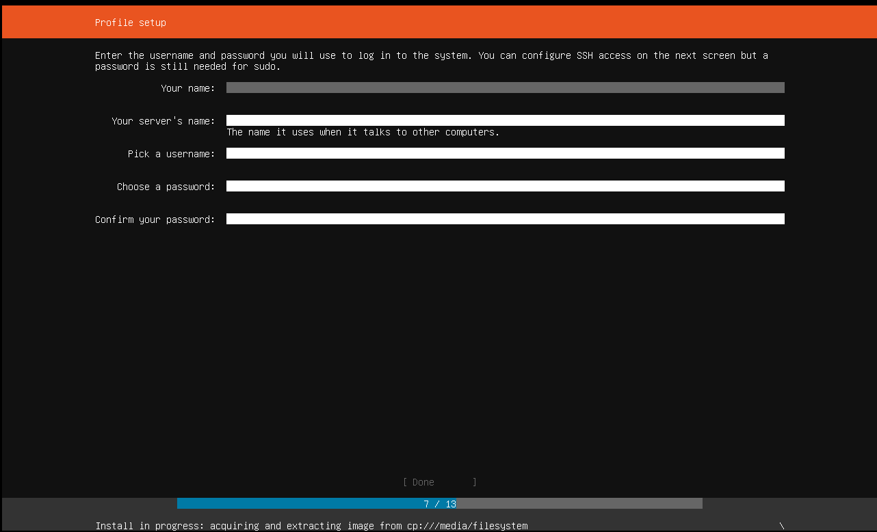

The next screen will be to configure SSH setup. Check the Install OpenSSH server box, leaving all other options default.

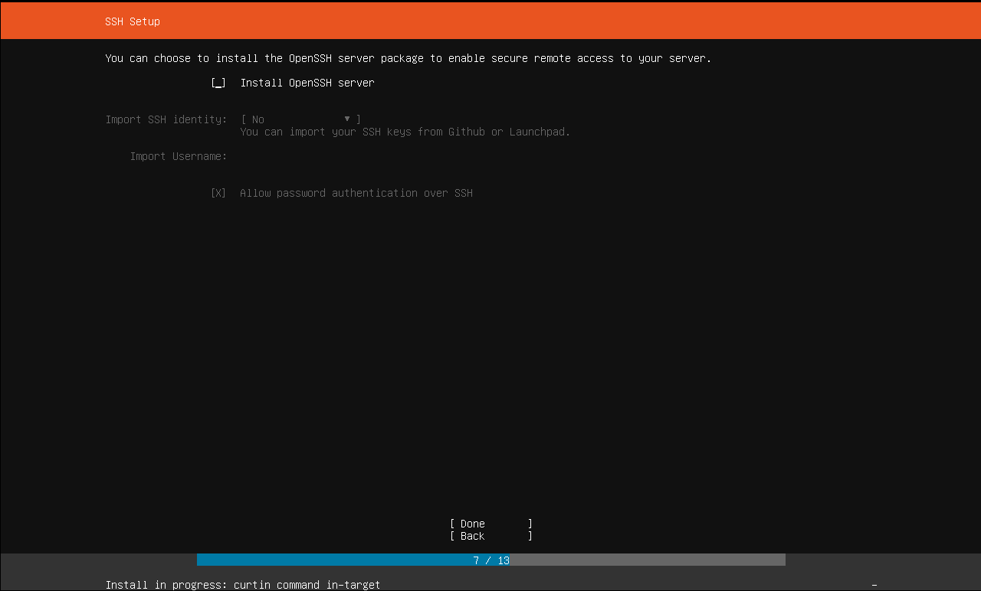

The next screen will ask if you want to install featured server snaps. Leave this blank and navigate to Done. The server will then install.

After the install is complete, reboot the server.

The next step is to complete updates. Upon boot, use the command sudo apt update && sudo apt upgrade to update the server and wait for completion.

Next step is to create users. For the purposes of this utilization of the server, all the users have to be members of the sudo group.

To create the users, use the command sudo adduser USERNAME, replacing USERNAME with the username of choice. After the users are created, set the passwords by using the command passwd USERNAME, replacing USERNAME with the username of the account you would wish to change the password of. You will then be prompted to enter the desired password.

To add the new users to the sudo group, use the command usermod –aG sudo USERNAME, replacing USERNAME with the username of the account you would like to add to the sudoers group. Verify ability to use these accounts with SSH using ssh -l USERNAME IPADDRESS, replacing USERNAME with the username to test and IPADDRESS with the IP address of the server.

The next step is to verify LXD is installed. You can do this by using command sudo apt install lxd. If it is already installed, it will alert you. If it is not installed, it will install now.

To start the configuration process, use the command sudo lxd init. The command line will prompt you for values. In the following screenshot are the values to be used:

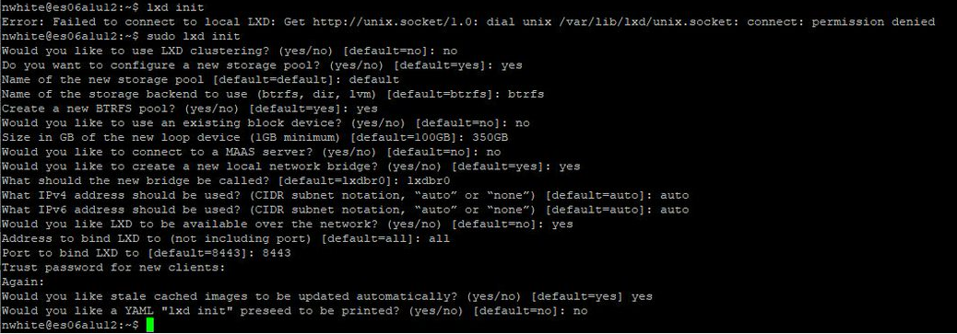

After this, create your containers using the command sudo lxd launch ubuntu:18.04 NAME, replacing NAME with the name you would like to give to your container.

To log in to the container we used the following command: sudo lxc exec CONTAINERNAME -- /bin/bash, replacing CONTAINERNAME with the name you would like to give to your container.

You can run sudo lxc list to see all containers available.

# LAMP Server with MediaWiki Install & Configuration

For the lamp server, the first thing to do is to install Tasksel using command sudo apt install tasksel.

Then, install LAMP server using tasksel with command sudo tasksel install lamp-server.

When you install LAMP this way, there will be two packages you need to install separately to make the MediaWiki page work. To do this, execute the following commands:

Sudo apt install php-mbstring

And

Sudo apt install php-xml

To download the MediaWiki files, cd to your tmp folder and download using command wget <https://releases.wikimedia.org/mediawiki/1.33/mediawiki-1.33.1.tar.gz>

You then have to extract the compressed file via the command tar -xvzf /tmp/mediawiki-*.tar.gz. Once extracted, create the directory /var/lib/mediawiki via the mkdri command and move the files to this new directory using command sudo mv mediawiki-*/* /var/lib/mediawiki

As the MediaWiki page uses SQL, some configurations need to be made to it. First, use command mysql -u root to get in to mysql. Then, create a user for sql with command CREATE USER ‘sqluser’@’localhost’ IDENTIFIED BY ‘password’;

Then, create a myql data base with command CREATE DATABASE databasename;. To use this database, use command use databasename;. To grant your previously created user access to this database you just created, use command GRANT ALL ON databasename.* TO ‘sqluser’@’localhost’;. To exit sql configurations, use command quit;.

You now should be able to access the webpage via a browser. Use <http://IPADDRESS/mediawiki> to load the page, replacing IPADDRESS with the ipaddress of the container running the LAMP server.

When you open the browser, it will lead you through an installation wizard. It will fill out most of the information for you, but you will need to add the user created in sql to continue. After the wizard, it will automatically download the LocalSettings.php file. Unfortunately, it will download it to the workstation and not the server. To remedy this, you can create a LocalSettings.php file in /var/lib/mediawiki/ and copy and paste the information from the one workstation, into the command line using sudo vim /var/lib/mediawiki/LocalSettings.php, Control+C the info on the workstation, and Control+V into vim and allow it to populate. Every line may be commented with a # so these will have to be manually removed. Your MediaWiki page will now load properly.

# Install and Configure Samba

To install and configure samba, start with insuring the container is updated using sudo apt update && sudo apt upgrade. Then install Samba using sudo apt install samba. Once Samba is installed, create the folder in the root directory, in this case, mkdir /w0263284samba. Modify the permissions so the user on the other side will be able to add files using chmod 777 /w0263284samba. Configure the new folder to be shared by editing the samba configuration file using command sudo vim /etc/samba/smb.conf, adding the following information:

[w0263284samba]

Path = /w0263284samba

Read only = no

Guest ok = yes

Browsable = yes

You can replace the w0263284samba to whatever the folder you wish to share will be. Use :wq! To save and quit. For this to apply, restart samba using command sudo systemctl restart smbd. You should now be able to access the share via \\IPADDRESS\SHARENAME replacing the appropriate variables on the Windows VM.

# References

Manual:Running MediaWiki on Debian or Ubuntu. (n.d.). Retrieved November 20, 2019, from <https://www.mediawiki.org/wiki/Manual:Running_MediaWiki_on_Debian_or_Ubuntu>.

Rendek, L. (2018, June 19). How to configure Samba Server share on Ubuntu 18.04 Bionic Beaver Linux. Retrieved November 20, 2019, from https://linuxconfig.org/how-to-configure-samba-server-share-on-ubuntu-18-04-bionic-beaver-linux.